A
Project Report On

FORGOTTEN KNOWLEDGE TRACKER
Submitted in partial fulfillment of the requirements for the degree of
Bachelor of Engineering in
Computer Science and Engineering (Artificial Intelligence and Machine Learning)

 | By
Mahesh Gawali Soham Gawas Bhargav Ghawali  Ayush Devadiga |  | Roll Roll Roll  Roll | No.14 No.15 No.18  No.09

Project Guide
Prof. Yamuna Vasanth

Technology Personified

Department of Computer Science and Engineering (AIML)
Innovative Engineers' and Teachers' Education society's

Bharat College of Engineering
Badlapur: - 421503. (Affiliated to University of Mumbai)
(2024-2025)


Technology Personified
Bharat College of Engineering
(Affiliated to the University of Mumbai) Badlapur: - 421503.
CERTIFICATE
This is to certify that, the Project titled
FORGOTTEN KNOWLEDGE TRACKER
Is a Bonafide work done by
Mahesh Gawali Roll No.14
Soham Gawas Roll No.15
Bhargav Ghawali Roll No.18
Ayush Devadiga Roll No.09
And is submitted in the partial fulfillment of the requirement for the degree of
Bachelor of Engineering In
Computer Science and Engineering (AIML) To the
University of Mumbai


Project Guide

Prof. Yamuna Vasanth

Project Co-Ordinator | Head of Department | Principal
(Prof. Yamuna Vasanth) | (Prof. Vijayalaxmi Tadkal) | (Prof. Dr. B.M Shinde)

Department of Computer Science and Engineering (Artificial Intelligence and Machine Learning)

Mini Project Report Approval for T.E.

This project report entitled

“Forgotten Knowledge Tracker”

This project is submitted by Bhargav Ghawali, Mahesh Gawali, Soham Gawas, Ayush Devadiga and approved by Prof. Yamuna Vasanth for the degree of Bachelor of Engineering in Computer Science and Engineering (Artificial Intelligence and Machine Learning).

Examiners 1.
2.

Date: 30/10/2025 Place: Badlapur

PROJECT REPORT

Contents
Abstract i
List of Figures ii
List of Tables iii
- Introduction 1
  - Purpose of the Project 2
  - Scope of the Project 4
  - Functionalities in the Project 7
  - Aims and Objectives of the Project 9
- Review of Related Work 11
  - Existing System 11
  - Proposed System 13
  - Literature Survey 15
- Planning 17
- Methodology 18
  - Proposed System Overview 18
  - Algorithm Details 20
  - System Requirements 24
- Design of the System 25
  - Flow Diagram 25
  - Use Case Diagram 26
- Experimental Results 27
  - Output / Results 27
  - Advantages 33
  - Applications 34
- Conclusion 35
References 36

ABSTRACT
The Forgotten Knowledge Tracker is an intelligent system designed to address the problem of knowledge decay by automatically monitoring learning activities and optimizing review schedules through artificial intelligence and cognitive science principles. The system functions as an automated learning assistant that observes user behavior across multiple modalities, including screen content, audio environment, visual attention, and interaction patterns. These input streams are processed through machine learning models and natural language processing pipelines to identify when a user is engaged in active study and to extract meaningful concepts from the material being learned. Using these extracted concepts, the system constructs a dynamic knowledge graph that semantically represents the user’s personal learning network. Each node in this graph is assigned a memory score derived from the Ebbinghaus forgetting curve and adjusted using multi-modal attention factors to model cognitive retention in real time. By continuously updating this graph, the system predicts when specific topics are likely to be forgotten and schedules optimal review times through spaced repetition algorithms. All data is stored locally in a secure SQLite database and visualized through an interactive dashboard that displays knowledge graphs, memory health, attention analytics, and study trends. The overall objective of this work is to transform passive computer usage into an active cognitive tracking process, providing a transparent and efficient mechanism to preserve long-term knowledge. Through the integration of artificial intelligence, cognitive modeling, and behavioral analytics, the Forgotten Knowledge Tracker offers a scientific and automated approach to human memory management, ensuring that learned information remains accessible and effectively reinforced over time

List Of Figures

Sr.No. | Figure Name | Page No
2.1.0 | Conventional Attention and Activity Tracking Architecture | 11
4.1.0 | High-Level Architecture of Forgotten Knowledge Tracker (FKT) | 19
5.1.0 | Flowchart for Forgotten Knowledge Tracker | 25
5.2.0 | Diagram representing use-cases of FKT | 26
6.1.0 | Virtual environment and set-up commands | 27
6.1.1 | Terminal output when the tracker is run | 27
6.1.2 | Main Dashboard | 28
6.1.3 | Knowledge Graph | 28
6.1.4 | 3D Graph showcasing clustered intents. | 29
6.1.5 | Scaled view of 3d graph | 29
6.1.6 | Heatmap and Duration map of all the sessions | 30
6.1.7 | High-Level Architecture of Forgotten Knowledge Tracker (FKT) | 30
6.1.8 | Prediction of retention for each topic | 31
6.1.9 | Logs of all the sessions | 31
6.1.10 | Reminder Dashboard without Reminders | 32
6.1.11 | Reminder Dashboard with Reminders | 32

List Of Tables

Sr.No. | Table Name | Page No
2.3.0 | Review of Literature Survey | 16
4.3.0 | Hardware requirements | 24
4.3.1 | Software requirements | 24

INTRODUCTION

INTRODUCTION
In recent years, the way individuals learn and retain knowledge has undergone a significant transformation, driven by advancements in artificial intelligence, cognitive science, and digital monitoring technologies. One notable challenge that remains is knowledge decay, where learned information is forgotten over time due to insufficient review and engagement. Traditional study methods and personal learning systems often lack real-time monitoring, personalized recommendations, and insights into a learner’s retention, which can lead to inefficient study habits and suboptimal long-term knowledge retention.
To address these challenges, this project proposes the development of the "Forgotten Knowledge Tracker," an intelligent system that continuously monitors user learning activities and optimizes review schedules through multi-modal sensing and artificial intelligence. By capturing data from screen content, audio inputs, webcam-based attention monitoring, and interaction patterns, the system builds a comprehensive model of user engagement and learning behavior. This information is processed to construct a semantic knowledge graph representing the user’s personal learning network, where each concept is associated with a memory score based on cognitive models such as the Ebbinghaus forgetting curve.
The system employs machine learning and multi-modal fusion to predict which concepts are at risk of being forgotten and automatically schedules reviews using spaced repetition algorithms. Users receive proactive reminders, interactive visualizations, and analytics through a real-time dashboard, allowing them to track their progress, focus levels, and memory health over time. By integrating cognitive science principles, artificial intelligence, and behavioral monitoring, the Forgotten Knowledge Tracker provides a scientific and automated approach to preserving knowledge, ensuring that learning is efficient, personalized, and continuously reinforced.
This project aims to create a comprehensive personal knowledge management platform that not only monitors learning but also actively supports memory retention, offering users actionable insights and automated study optimization. By transforming passive study activities into an intelligent and adaptive learning process, the Forgotten Knowledge Tracker has the potential to revolutionize personal education and lifelong learning practices.

Purpose:

    - The primary purpose of this project is to develop an intelligent, automated, and personalized knowledge tracking system that continuously monitors user learning activities and optimizes retention through multi-modal sensing, artificial intelligence, and cognitive science principles. This system aims to transform traditional study methods by addressing challenges such as knowledge decay, inefficient review scheduling, and lack of insight into learning patterns. By integrating real-time monitoring, predictive memory modeling, and semantic knowledge graph construction, the Forgotten Knowledge Tracker ensures that learning is more effective, personalized, and actionable.

Key Objectives:

Enhanced Learning Retention:
  - Utilize multi-modal data (screen content, audio, webcam, interaction patterns) to accurately capture user learning activities.
  - Apply memory models based on cognitive science principles to optimize review schedules and prevent forgetting.

Intelligent Activity Detection:
  - Implement AI-driven intent classification to differentiate between active studying, passive engagement, and idle behavior
  - Fuse multi-modal inputs to enhance accuracy in predicting user learning context and attention levels.

Knowledge Graph Construction and Management:
  - Automatically build a semantic knowledge graph linking concepts and keywords captured from learning sessions.
  - Track memory scores for each concept and update review schedules based on user engagement and retention patterns.

Personalized Study Insights:
  - Provide users with visual analytics on learning trends, memory decay, and session effectiveness.
  - Offer actionable recommendations for optimal review timing and focus improvement.

Automated Reminders and Review Scheduling
  - Use predictive models to trigger timely reminders for weak or soon-to-be-forgotten concepts.
  - Ensure an adaptive and continuous learning experience without manual intervention.

Enhanced User Engagement and Learning Confidence:
  - Build a transparent and intelligent learning ecosystem that encourages consistent study habits and sustained user engagement
  - Allow users to visualize the progress of their knowledge acquisition, memory retention, and concept mastery in real-time.

- By addressing these objectives, the Forgotten Knowledge Tracker provides a reliable and adaptive system that continuously supports learning, reinforces retention, and empowers users with actionable insights. This innovative approach not only improves study effectiveness but also fosters trust in AI-driven learning analytics and cognitive science-based knowledge management systems.

Scope:
- The scope of this project encompasses the development, implementation, and deployment of an intelligent knowledge tracking and learning optimization system, leveraging multi- modal AI, cognitive science principles, and knowledge graph technologies. The project aims to cover all aspects, from initial system design and data collection to AI integration, dashboard development, and user experience optimization.

Key Areas of Scope:

System Design and Architecture:
  - Design a robust system architecture that integrates multi-modal inputs, AI processing, and knowledge graph management.
  - Define technical specifications for scalability, performance, security, and seamless interaction between sensors, machine learning modules, and storage systems

AI and Machine Learning Integration:
  - Develop machine learning models to classify user intent, process audio and visual inputs, and analyze textual content.
  - Ensure models are accurate, efficient, and capable of continuous learning from user interactions.

Knowledge Graph Construction and Maintenance:
  - Construct dynamic knowledge graphs representing concepts and their semantic relationships.
  - Implement mechanisms to update memory scores, track learning progress, and manage review scheduling

User Interface and Experience (UI/UX):
  - Design a user-friendly dashboard that visualizes knowledge graphs, learning metrics, attention scores, and memory retention trends.
  - Ensure the interface is intuitive and accessible, enabling users to monitor their learning progress effectively.

Data Security and Privacy Measures:
  - Implement protocols to protect user data and ensure the confidentiality, integrity, and availability of all learning and sensor information.
  - Provide secure handling of multi-modal data and adherence to best practices in privacy management.

Multi-modal Data Processing:
  - Capture and process real-time inputs from screen activity, audio, webcam, and interaction patterns.
  - Fuse multi-modal data to enhance intent detection, memory scoring, and personalized learning recommendations.

Automated Review Scheduling and Notifications:
  - Develop algorithms to calculate memory decay, optimal review times, and schedule proactive reminders
  - Enable notifications that prompt users to review concepts before forgetting occurs, reinforcing
  - knowledge retention.

Performance Tracking and Analytics:
  - Track user engagement, attention, and learning patterns over time.
  - Provide insights and visualizations to help users understand their study habits and areas for improvement.

Testing and Quality Assurance:
  - Conduct comprehensive testing of data processing, AI models, and dashboard functionalities.
  - Ensure system stability, accuracy, and responsiveness under various usage scenarios.

Deployment and Maintenance:
  - Deploy the system on a reliable infrastructure for continuous monitoring and real-time feedback.
  - Provide ongoing updates and maintenance to incorporate improvements, fix issues, and optimize performance.

User Support and Documentation:
  - Develop detailed guides and documentation to assist users in navigating and utilizing the system.
  - Offer support channels to resolve issues, answer queries, and enhance the user experience.

- By addressing these key areas, the project aims to create an intelligent, adaptive, and secure knowledge tracking platform that enhances learning efficiency, promotes sustained engagement, and leverages AI and cognitive science to optimize knowledge retention.

Functionality:

- The Forgotten Knowledge Tracker provides a seamless and intelligent environment for monitoring learning activities, optimizing knowledge retention, and delivering actionable insights through multi-modal AI and knowledge graph technology. The key functionalities of the system include:

User Registration and Authentication:
  - Secure registration process for new users to set up personalized learning profiles.
  - Optional multi-factor authentication to ensure account security and data privacy.

Learning Session Detection:
  - Automatic detection of active learning sessions using keyboard, mouse, audio, and screen activity.
  - Continuous monitoring of user engagement without requiring manual input.

Multi-modal Data Processing:
  - Real-time capture and processing of screen content, audio environment, webcam input, and interaction patterns.
  - Extraction of key concepts, keywords, and attention metrics to feed AI models and the knowledge graph.

Knowledge Graph Construction and Updates:
  - Dynamic creation of a semantic knowledge graph representing concepts, them relationships, and learning progress.
  - Automatic updates of nodes and edges based on newly learned concepts, reinforcing connections and tracking frequency.

Memory Score Calculation and Review Scheduling:
  - Multi-modal weighting to calculate memory retention scores using cognitive science principles, including the Ebbinghaus forgetting curve.
  - Scheduling of optimal review sessions and proactive reminders based on memory decay and user engagement.

Intent Classification and Insight Generation:
  - AI-driven classification of user activities into studying, passive learning, or idle states
  - Generation of actionable insights for improving study efficiency and focus.

Attention and Engagement Tracking:
  - Real-time analysis of visual attention using webcam input and facial detection.
  - Monitoring of interaction patterns to get insight into learning engagement and habits.

Personalized Dashboard and Analytics:
  - Interactive dashboard displaying knowledge graphs, memory retention trends, upcoming review schedules, and session analytics.
  - Customizable visualizations of attention, study patterns, and concept mastery for personalized learning insights.

Notifications and Review Reminders:
  - Automated reminders prompting users to review weakly retained concepts before forgetting occurs.
  - Configurable notifications to support consistent study habits without being intrusive.

Data Security and Privacy:
  - Securely store and process multi-modal data to maintain confidentiality and integrity.
  - Adherence to best practices in data privacy and secure user profiling.

Reporting and Performance Tracking:
  - Comprehensive analytics for tracking learning progress, retention improvements, and study efficiency.
  - Detailed logs and visual reports to help users reflect on their learning journey.

- By integrating these functionalities, the Forgotten Knowledge Tracker provides a robust, adaptive, and intelligent learning system that enhances knowledge retention, personalizes study experiences, and fosters sustained engagement through real-time insights and actionable recommendations.

Aim and Objectives:

- The aim of the Forgotten Knowledge Tracker project is to leverage Artificial Intelligence and Machine Learning to revolutionize the process of knowledge retention, study monitoring, and cognitive reinforcement. The system is designed to help users overcome the natural process of forgetting by intelligently tracking learning behavior, identifying knowledge gaps, and optimizing review schedules through adaptive algorithms and knowledge graphs.

- The primary objective of this project is to develop a secure, intelligent, and adaptive platform that monitors user engagement across multiple modalities — such as visual attention, audio context, text content, and activity patterns — to accurately measure knowledge retention and provide personalized review recommendations.

Objectives:

Enhance Knowledge Retention:
  - Apply cognitive principles such as the forgetting curve to predict memory decay and schedule timely reviews.
  - Reinforce weakly retained concepts through spaced repetition and active recall methods.

Multi-Modal Data Integration:
  - Collect and analyze diverse data sources including screen content, audio, text, and user activity.
  - Combine data streams into a unified model for accurate understanding of user learning behavior.

Construct Dynamic Knowledge Graphs:
  - Build and continuously update a personalized knowledge graph to represent learned concepts and their interconnections.
  - Use graph-based reasoning to identify related topics, forgotten areas, and potential learning pathways.

Improve Focus and Engagement:
  - Track visual attention and engagement using facial and interaction analytics.
  - Provide real-time feedback and insights to help users maintain focus during study sessions.

Automate Learning Insights:
  - Utilize AI-driven intent classification to differentiate between active learning, passive browsing, and idle time.
  - Generate contextual summaries and insights to guide effective learning strategies.

Optimize Review Scheduling:
  - Notify users about upcoming or overdue reviews to maintain consistent learning cycles.
  - Automate the timing of review sessions based on individual memory retention patterns.

Ensure Data Privacy and Security:
  - Securely store and process all user data using encryption and access control mechanisms.
  - Maintain transparency in data collection and uphold user trust through responsible AI design.

Enhance User Experience:
  - Design a responsive, user-friendly interface with intuitive dashboards and visual analytics.
  - Enable users to visualize progress, review performance metrics, and track concept mastery over time.

- The proposed system aims to create a personalized and intelligent learning ecosystem that adapts to each user’s cognitive patterns, promotes long-term retention, and transforms the way individuals interact with information

REVIEW OF RELATED WORK

REVIEW OF RELATED WORK

Existing System:

Traditionally, learning and knowledge management systems rely on static note-taking tools, online learning platforms, or basic progress trackers that record surface-level metrics such as time spent studying or chapters completed. These systems often fail to capture the depth of understanding, cognitive engagement, and long-term knowledge retention of the user. Existing solutions lack the ability to analyze the multi-modal learning environment — such as visual focus, contextual relevance, and temporal study patterns — which play a crucial role in measuring true knowledge acquisition.
Moreover, traditional systems do not account for memory decay, resulting in inefficient learning. Users often forget material due to the absence of intelligent reminders or adaptive review schedules. Progress dashboards mainly show numerical statistics rather than actionable insights from behavioral and cognitive data. The lack of cognitive modeling and contextual awareness limits their ability to offer personalized insights or adaptive strategies for learners..
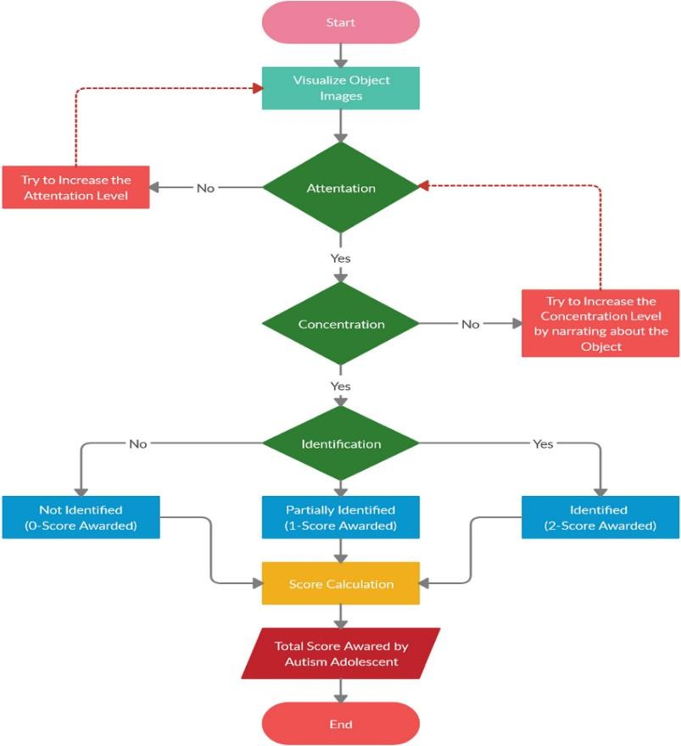
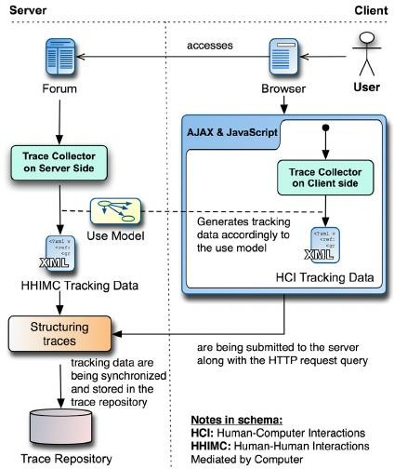

Fig :2.1.0 Conventional Attention and Activity Tracking Architecture

Limitations of existing system:

Requires significant manual effort:
Existing tracking mechanisms demand continuous user input such as manual note-taking, marking completion status, or updating learning progress. This process consumes a huge amount of time and attention, making it difficult for learners to sustain consistency or accurately measure actual knowledge retention over longer periods.

Limited transparency and feedback:
Traditional learning management tools or manual trackers mainly offer static metrics like test scores or completion percentages. They fail to provide meaningful interpretations of learner behavior, making it hard for users to identify which areas they have truly mastered and which require reinforcement.

Lack of personalization and automation:
Conventional systems lack the intelligence to adapt learning plans or generate automated review schedules based on user performance or retention levels. Without AI-driven insights, learners continue to follow rigid, one-size-fits-all schedules, which lead to knowledge decay and inefficient learning patterns.

Fragmented data and isolated learning modes:
Most existing platforms operate in isolation, unable to connect diverse sources such as visual content, audio lectures, and user interaction data. This results in fragmented information flow, limiting comprehensive analysis and holistic understanding of learner behavior.

Inaccessible or region-restricted platforms:
Many digital learning systems depend on constant internet connectivity or paid subscriptions, reducing accessibility for students in under-resourced or remote regions. The lack of offline compatibility and multilingual support further narrows their usability.

Poor cognitive modeling and engagement tracking:
Current solutions do not incorporate mechanisms to assess user attention, engagement, or emotional state during the learning process. As a result, they cannot differentiate between passive time spent and active learning, leading to inaccurate progress evaluation.

Security and data privacy concerns:
The centralized nature of most existing learning systems increases the risk of data breaches and unauthorized access. Learners have minimal control or visibility over how their cognitive and behavioral data are stored, processed, or shared.

Proposed System:

The Forgotten Knowledge Tracker (FKT) offers a comprehensive solution to modern learning challenges by combining automation, real-time monitoring, and cognitive science principles. By leveraging multi-modal inputs such as screen activity, audio cues, webcam attention tracking, and input interactions, FKT captures a holistic view of a learner’s engagement and comprehension. This allows the system to build a dynamic knowledge graph, calculate memory retention scores, and provide actionable insights, ensuring that learning is both measurable and optimized over time.
Beyond basic tracking, FKT incorporates advanced intelligence to infer user intent, distinguishing between focused study, passive browsing, and idle periods. All interactions and content are automatically logged and linked to concepts in the knowledge graph, enabling continuous updates of memory retention scores using Ebbinghaus-inspired forgetting curves weighted by attention and engagement metrics. This ensures personalized and adaptive review recommendations that enhance long-term retention without requiring manual intervention.
Furthermore, FKT emphasizes adaptability and integration, learning from user behavior to refine predictions and review schedules. Its modular design allows seamless compatibility with existing educational platforms and productivity tools, consolidating multiple learning data streams into a coherent, actionable system. By combining real-time analysis, machine learning, and cognitive science strategies, FKT transforms traditional knowledge tracking into an intelligent feedback loop, bridging the gap between human cognition and digital learning environments.

Benefits of proposed system:

    - Automation and Efficiency: FKT reduces manual tracking by automatically monitoring learning activities using multi-modal inputs.
    - Real-Time Progress Tracking: Users can see their learning progress, memory retention scores, and knowledge graph updates as they happen.
    - Cost-Effective Learning Management: By integrating tracking, analysis, and review scheduling, FKT minimizes the need for additional learning tools or manual effort.
    - Intelligent and Personalized Reviews: The system applies cognitive science principles,
including spaced repetition, to schedule reviews tailored to each user’s learning pattern.
    - Secure and Private Data Handling: All multi-modal data and activity logs are processed and stored securely, protecting user privacy.
    - Enhanced Transparency and Accountability: FKT provides detailed logs and visualizations of learning activities, enabling users to understand and optimize their study patterns.

    - Holistic Learning Insights: FKT combines attention metrics, knowledge graph visualizations, and memory decay curves to give a comprehensive view of learning progress.
    - Adaptive Learning: The system refines recommendations over time based on user behavior, ensuring continuous improvement in learning outcomes.
    - Integration with Existing Tools: FKT can work alongside educational platforms, productivity apps, and content sources, consolidating multiple data streams.
    - Motivation and Engagement: Personalized insights, visual progress tracking, and notifications encourage consistent study habits and maintain learner motivation.
    - Scalability: Capable of handling multiple learners or large datasets while maintaining performance and accuracy.

The proposed system offers:

- Manual tracking of learning is reduced through automation.
- Users can monitor their progress and memory retention in real-time.
- The system is cost-effective by integrating tracking, analysis, and review scheduling.
- Personalized review schedules enhance learning efficiency.
- Secure and private data handling ensures user information protection.
- Transparent logs and visualizations improve learning accountability.
- Accessible globally on compatible devices.
- Reduces cognitive and labor overhead through automated tracking.
- Energy-efficient and lightweight on system resources.
- Provides holistic insights combining attention, memory, and knowledge graphs.
- Adaptive feedback and intelligent reminders to prevent knowledge decay.
- Supports multi-modal learning analytics for a more accurate assessment of comprehension.
- Encourages active learning through engagement metrics and real-time visualizations.
- Reduces learner stress by automating review schedules and monitoring progress continuously.
- Enables educators or trainers to monitor aggregate insights without intruding on personal learning sessions.

Review of Literature Survey:

Sr.  No. | Paper Name | Year of Publica  -tion | Author | Publica- tions | Proposed Work | Research Gap
1. | AI-Driven Knowledge Tracking using Cognitive Graphs | 2023 | Rajesh Sharma, Nivedita Patel, Anuj Mehra | IEEE  Xplore, 978-  1-6654-  9876-  2/23/$31 ©  2023 IEEE | Introduces a graph-based AI framework for tracking user cognition using multi-modal data and neural embeddings. Emphasizes continuous learning updates through graph node expansion and semantic linking of user activity with concept retention. | Suggests scope for integrating real-time reinforcement mechanisms and memory decay modeling to improve long-term knowledge tracking accuracy.
2. | Neural Knowledge Representati on for Adaptive Learning Systems | 2022 | Harini Iyer, Deepak Menon | Springer LNCS, DOI: 10.1007/978  -3-031-  11890-4 | Uses transformer-based embeddings and vectorized graph networks to personalize content delivery based on user interaction history.  Highlights adaptive visualization to show learning flow between related concepts. | Lacks deep integration of multi-modal signals (e.g., voice, text, OCR data) and does not address real-time knowledge decay prediction through cross-modal feedback.

3 | U  Intelligent Retention Tracking through Deep Learning | 2023 | A,Kumar, Priya Deshmukh, and S Tondon | IJIRSET, Vol. 12,  Issue 5, 2023 | Introduces a deep- learning-based retention analysis system predicting cognitive drop points using user engagement logs. Implements regression-based scoring for knowledge recall probability. | Does not visualize knowledge structures effectively, nor proposes a feedback mechanism for reinforcing lost cognitive links.
4. | Multi- Modal AI Framework for Knowledge Graph Visualizati on | 2024 | Sneha Reddy, R. Thakur, Y. Khanna | IEEE  Access, DOI: 10.1109/AC CESS.2024.  123456 | Connects different data modalities (text, speech, OCR inputs) into a unified knowledge graph. Uses GNN-based clustering to form relationships among cognitive elements. | Lacks real-time interaction and dynamic update modules that enable the graph to evolve as the user learns  — an area FKT addresses.
5 | Adaptive Learning Analytics Using Multi- Modal Inputs | 2024 | R. Sharma,  L. Verma,  P. Joshi | Computers & Education, Vol. 198,  2024 | Proposes an adaptive learning system integrating screen activity, audio, and interaction patterns to predict learner engagement and memory retention. Implements attention-weighted scoring and spaced repetition for personalized  review. | Does not integrate a dynamic knowledge graph or semantic concept linking; feedback is limited to predicted retention scores rather than concept-level reinforcement.

Table 2.3.0 Review of Literature Survey

PLANNING

PLANNING

The planning phase for the Forgotten Knowledge Tracker (FKT) was designed to ensure systematic development, timely execution, and quality delivery of the platform within a 5–6-week period. The planning emphasized clear objectives, resource allocation, risk management, and milestone-based progress tracking to ensure a smooth workflow

The project phases:

Requirement Gathering and Analysis (Week 1):
The team conducted a detailed analysis of existing knowledge tracking methods, identified gaps in learning retention and progress monitoring, and collected requirements from potential end-users.
Functional requirements included multi-modal data collection (screen, audio, webcam, input), knowledge graph representation, memory retention modeling, and automated review scheduling. Non-functional requirements emphasized data security, real-time processing, and ease of use.

System Design and Architecture (Week 1–2):
A robust architecture was designed encompassing data acquisition modules, AI processing layers, memory modeling, and visualization dashboards. High-Level Diagrams (HLD), Data Flow Diagrams (DFD), and system architecture designs were created to illustrate the interaction between multi-modal inputs, machine learning components, and the user interface. The design phase also accounted for scalability, modularity, and integration with existing educational tools.

Module Development (Week 2–4):
Parallel development of core modules ensured efficiency. Key modules included:
- Data Collection Module: Captures screen content, audio signals, webcam input, and interaction metrics.
- Knowledge Graph Module: Builds and updates semantic relationships between concepts.
- Memory Scoring and Spaced Repetition Module: Calculates retention scores and schedules reviews based on engagement and forgetting curve models.
- Dashboard & Visualization Module: Displays knowledge graphs, progress metrics, and review recommendation.

Integration and Testing (Week 4–5):
Modules were integrated and tested extensively to ensure seamless functionality. Testing included unit tests, system tests, and stress tests to validate multi-modal data fusion, accuracy of memory modeling, and responsiveness of the dashboard. Performance metrics, such as CPU usage, memory load, and real-time update frequency, were monitored to optimize system efficiency.

Deployment and User Feedback (Week 5–6):
The platform was deployed on secure infrastructure, and initial users were onboarded for pilot testing. Feedback was collected to improve UI/UX, refine review scheduling, and enhance visualization clarity. Post-deployment, maintenance and update plans were outlined to ensure long-term reliability.

METHADOLOGY

METHODOLOGY

Proposed System Overview:

Initially, all users join the Forgotten Knowledge Tracker (FKT) through a community enrollment module. Learners, researchers, and knowledge enthusiasts can register directly or via referral programs to become part of the platform. Upon signing in, users are greeted with an intuitive landing page providing menus, instructions, and a summary of their tracked progress. Every user must create and link their FKT profile, which integrates seamlessly with local data storage and the knowledge graph module to begin personalized knowledge tracking.
All user interactions—screen activity, audio context, visual attention, and input interactions— are continuously monitored and stored in a dynamic graph data structure. Nodes represent learned concepts, while edges capture relationships and context between them. The system automatically timestamps and logs every activity, ensuring accurate tracking and allowing the platform to build a continuously evolving knowledge map.
The FKT platform employs multi-modal fusion to process real-time inputs and generate actionable insights. Smart algorithms automatically calculate memory retention scores, update the knowledge graph, and schedule reviews based on cognitive science principles, such as the Ebbinghaus forgetting curve and spaced repetition. Unlike traditional study methods that require manual tracking, FKT automates the review process, ensuring users focus on weak areas and optimize their learning time efficiently.

The proposed implementation of the FKT system follows this methodology:
- Users register on the platform and create a learning profile, which includes personal preferences, subjects of interest, and prior knowledge levels.
- The system monitors ongoing learning sessions, capturing screen content, audio context, and attention metrics to extract key concepts and keywords in real-time
- Extracted concepts are added to the knowledge graph, with semantic relationships automatically mapped and updated as new content is encountered.
- Memory retention scores for each concept are calculated based on multi-modal engagement, historical interactions, and time since last review.
- The platform schedules personalized review sessions, prompting users to revisit concepts at optimal intervals to maximize retention and minimize forgetting.
- Users receive real-time analytics and visualizations of their learning progress, including attention

heatmaps, concept mastery scores, and upcoming review schedules, enabling informed adjustments to study strategies.
- The system maintains secure logs of all activities and updates, ensuring transparency, traceability, and the ability to audit learning progress over time.

Through this methodology, FKT provides a fully automated, intelligent, and adaptive learning environment that enhances knowledge retention, saves time, and empowers users to systematically track and optimize their learning journey.
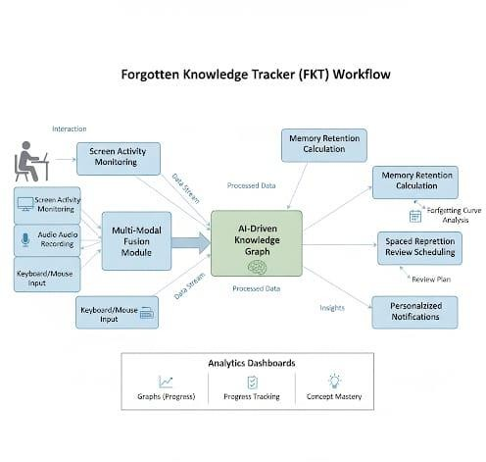

Fig 4.1.0 High-Level Architecture of Forgotten Knowledge Tracker (FKT)

This block diagram illustrates the workflow of the Forgotten Knowledge Tracker system. It demonstrates how users interact with the platform, including joining the community, starting learning sessions, and engaging with content. The diagram highlights how multi-modal inputs—screen activity, audio, webcam, and input interactions—are collected and processed to update the knowledge graph. It also shows how memory retention scores are calculated, review schedules are generated, and personalized notifications are triggered to prompt timely revision. Additionally, the diagram provides a high-level view of the analytics and visualization modules, giving users insights into their learning progress, attention patterns, and concept mastery.

Algorithm Analysis:

The Forgotten Knowledge Tracker (FKT) employs multiple algorithmic layers to provide real- time learning tracking, knowledge graph construction, memory retention modeling, and personalized review scheduling. These algorithms integrate multi-modal sensing, machine learning, natural language processing, and cognitive science principles to deliver an intelligent and adaptive knowledge retention system.

Key Algorithmic Components:

- Multi-Modal Input Processing Algorithm
- FKT continuously collects and processes data from four primary sources to understand the
learner’s behavior:

Screen Content (OCR + NLP):
    - Capture screenshots and extract text using Tesseract OCR.
    - Identify semantic concepts and keywords using KeyBERT with BERT embeddings.
    - Assign relevance scores based on frequency and semantic similarity with existing nodes in the knowledge graph.

Audio Environment:
    - Record short audio segments (15–20 seconds) and extract MFCC features using Librosa.
    - Classify environment (speech, music, silence) using a Random Forest / CNN classifier.
    - Weight attention metrics depending on the audio type (e.g., speech boosts retention, noise reduces it).

Visual Attention (Webcam):
    - Detect face, eyes, and head orientation using dlib/OpenCV.
    - Calculate an attention score to reflect visual focus.
    - Integrate attention score into memory and engagement weighting.

Interaction Patterns (Keyboard & Mouse):
    - Track activity (typing, scrolling, clicking) to assess engagement level.
    - Smooth and aggregate data into an interaction score for each session.

Feature Fusion:
    - Combine all multi-modal inputs into a feature vector representing the user’s
cognitive state.
    - Normalization ensures compatibility for downstream ML models.

User Intent Classification Algorithm
- The system determines the learner’s current activity:
  - Categories: Active Learning, Passive Browsing, Idle

Algorithm Steps:
- Input the multi-modal feature vector [ocr_keywords, audio_class, attention_score, interaction_rate].
- Use a supervised classifier (Random Forest / SVM / MLP) to predict intent.
- Apply thresholds to modify engagement score and influence memory updates.
- Only actively engaged sessions contribute to knowledge graph updates.

Knowledge Graph Construction Algorithm
- FKT maintains a dynamic knowledge graph to model learned concepts:
  - Nodes: Each unique concept extracted from OCR/audio.
  - Edges: Weighted by semantic similarity using cosine similarity of BERT embeddings.
  - Node Attributes: embedding, memory_score, encounter_count, next_review.

Algorithm Steps:
- Extract embeddings for new concepts using Sentence-BERT.
- Check if the concept exists in the graph. If not, create a new node.
- Update semantic edges between related concepts.
- Recalculate Node2Vec embeddings periodically for link prediction and graph enrichment.
- Update node attributes (memory_score, encounter_count, last_review) after each learning session

Memory Retention Scoring Algorithm
- FKT applies the Ebbinghaus forgetting curve enhanced with attention weighting:

Algorithm Steps:
- Initialize memory_score = 1.0 for new nodes.
- Update memory score for elapsed time t since last review: memory_score = memory_score * exp(-λ * t) * attention_boost
- λ = decay rate (personalized per user and concept)
- attention_boost = multi-modal engagement factor
- Schedule review if memory_score < threshold.
- Incorporate multi-modal data to adjust decay dynamically.

Spaced Repetition & Review Scheduling Algorithm
- Automated, adaptive scheduling for concept reviews:

Steps:
- Input current memory_score of concept c.
- If memory_score < 0.6, schedule immediate review.
- Otherwise, calculate next interval: next_review_interval = base_interval * (memory_score)^2
- Update node attribute next_review.
- Trigger dashboard notifications for user review sessions.

Review Feedback Integration Algorithm
  - Memory scores are continuously refined based on review outcomes:

Steps:
      - Compare recalled concept with expected embedding similarity.
      - Adjust memory score:
        - Success → +boost
        - Failure → -penalty
      - Update edge weights in knowledge graph based on review performance.
      - Adjust future review intervals according to the updated memory score.

Semantic Embedding & Concept Link Prediction
  - Purpose: Identify relationships between newly learned concepts and existing knowledge.

Algorithm Steps:
      - Generate embeddings using Sentence-BERT for all concepts.
      - Compute cosine similarity between new and existing nodes.
      - Add edges for pairs with high similarity (> threshold).
      - Optionally, use Node2Vec embeddings for predicting potential relationships between nodes.

Audio Classification and Context Weighting
  - Purpose: Adjust memory retention and attention based on environmental context.

Steps:
      - Extract MFCC features from audio segment.
      - Classify environment (speech/music/noise) using trained ML model.
      - Apply multiplier to attention score:
        - Speech → +1.2
        - Music → 1.0
        - Noise → 0.8

Overall High-Level Algorithm Flow
- Initialize system
- Initialize empty knowledge graph G
- Loop every 5 seconds:
  - Collect multi-modal inputs (screen, audio, webcam, interaction)
  - Extract features → multi-modal vector
  - Classify intent → active/passive/idle
  - If intent == active:
    - Extract concepts → update knowledge graph
    - Calculate memory scores using Ebbinghaus curve
    - Schedule reviews via spaced repetition
    - Update dashboard visualizations
  - Log all interactions securely
- End Loop

System Requirements:

Hardware Requirements: -

Component | Specification
Processor | Any multi-core processor above 2.0 GHz
RAM | Minimum 4 GB (8 GB recommended for optimal performance)
Hard Disk | Minimum 10 GB free space for data storage and logging
Graphics Support | Integrated GPU (for lightweight visualization rendering)
Input Device | Standard Keyboard and Mouse
Output Device | High-Resolution Display (Full HD or above)
Optional | Webcam and Microphone (for multi-modal input tracking)

Table 4.3.0 Hardware requirements

Software Requirement: -

Category | Details
Operating System | Windows 10 / 11, Linux (Ubuntu 20.04 or higher), macOS
Languages | Python
Database | SQLite3 (for lightweight local storage), PostgreSQL (for scalable deployment)
Tools | Git, GitHub, VS Code, Streamlit, Graphviz
AI / ML Models | Transformer-based embeddings for semantic  understanding, memory decay models for retention analysis
Libraries | OpenCV, Pytesseract, NetworkX, Matplotlib, NumPy, Pandas, Spacy, SentenceTransformer, KeyBERT
Frameworks | Streamlit (for UI), FastAPI / Flask (for backend API services)

Table 4.3.1 Software requirements

DESIGN OF THE SYSTEM

DESIGN OF THE SYSTEM

Flow Diagram:

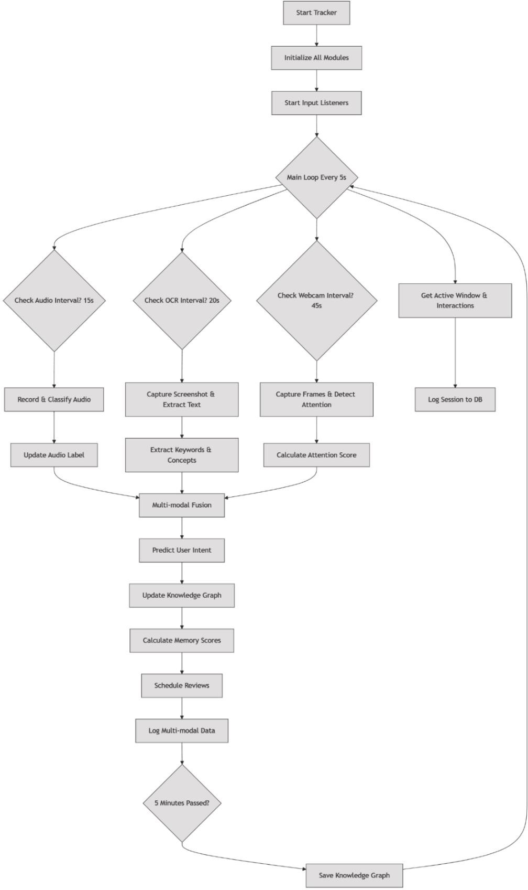

Fig 5.1.0 Flowchart for Forgotten Knowledge Tracker

Use-case Diagram:

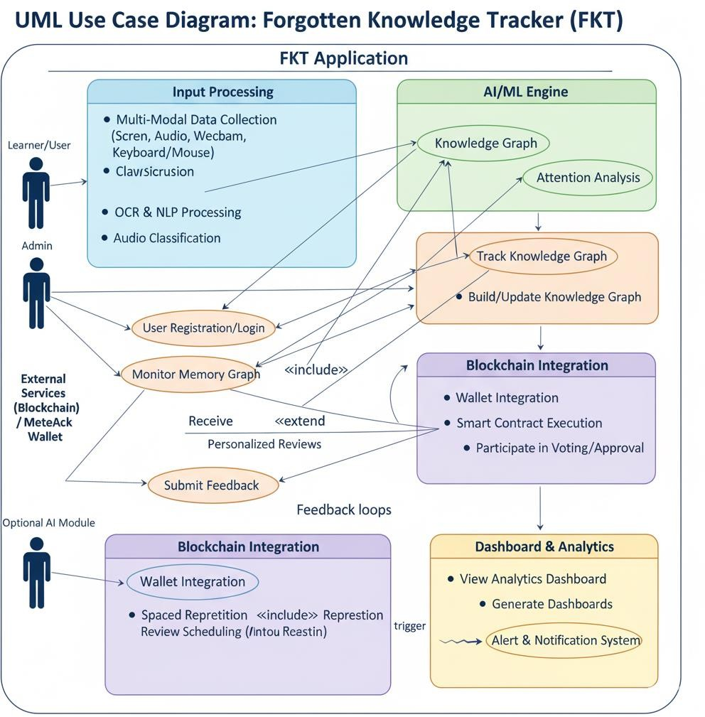

Fig 5.2.0 Diagram representing use-cases of FKT

EXPERIMENTAL RESULTS

EXPERIMENTAL RESULTS

Outputs/Results:

Terminal commands in vscode to start the app:

Fig 6.1.0 Virtual environment and set-up commands

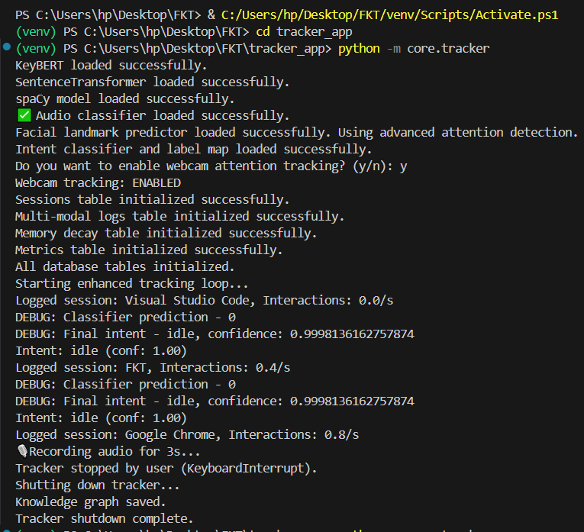
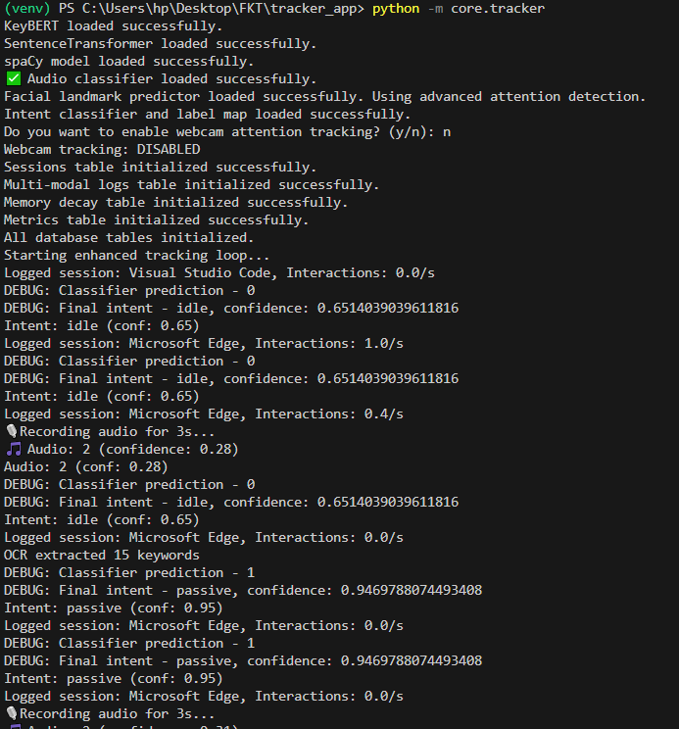
Terminal output when the tracker app is switched on:

Fig 6.1.1 Terminal output when the tracker is run.

Dashboard output:

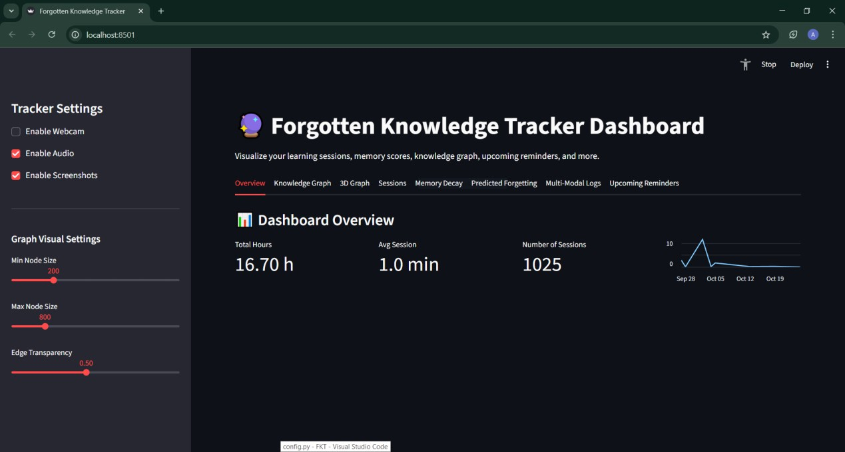

Fig 6.1.2 Main Dashboard

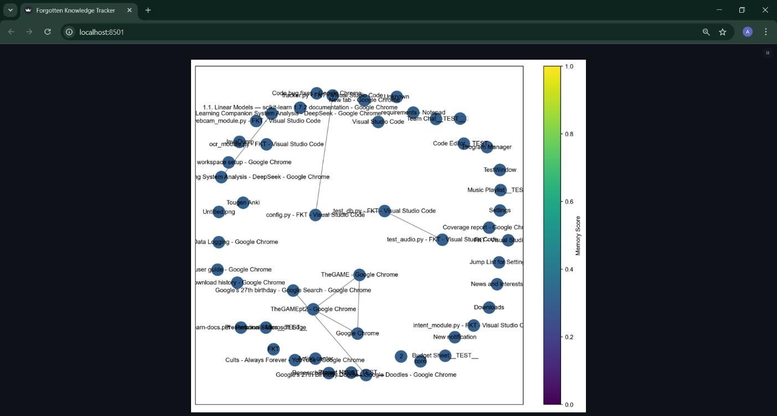
Fig 6.1.3 Knowledge Graph

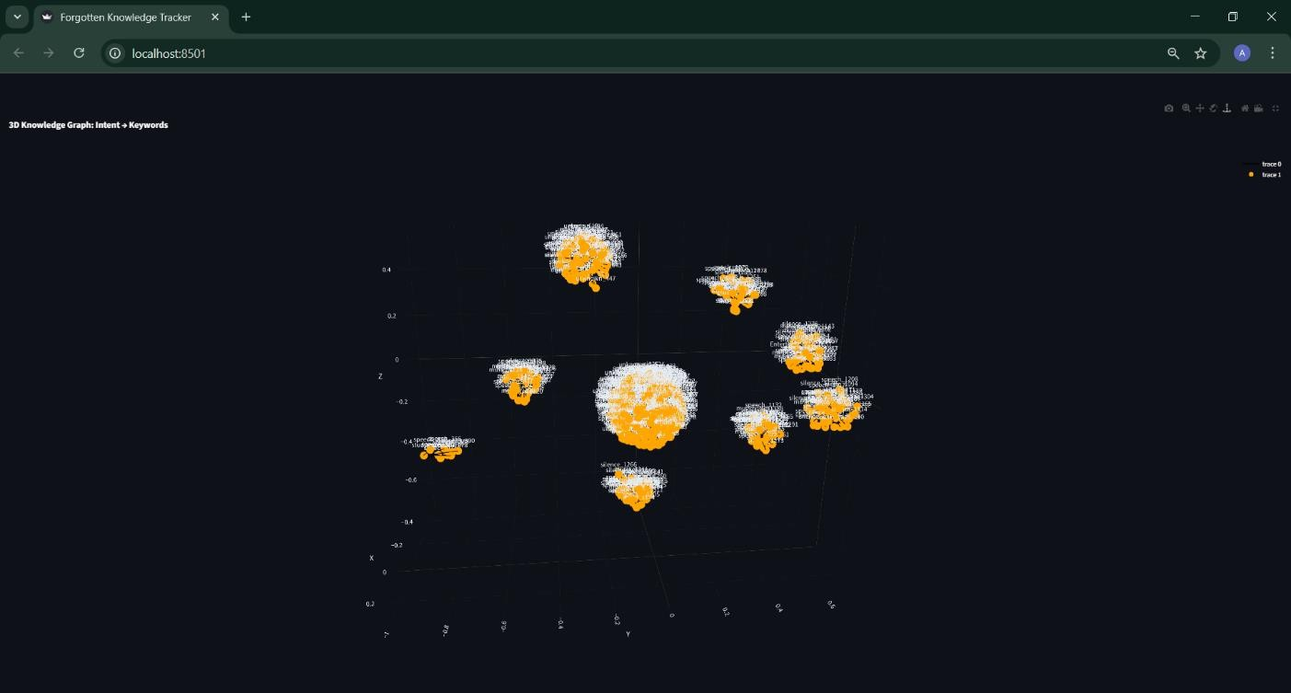
Fig 6.1.4 3D Graph showcasing clustered intents.

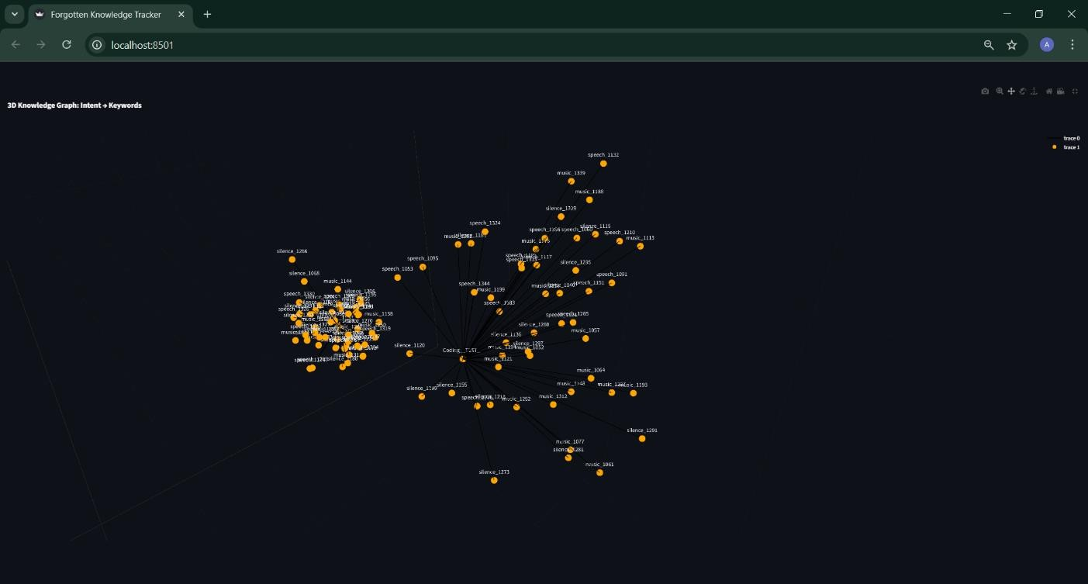
Fig 6.1.5 Scaled view of 3d graph

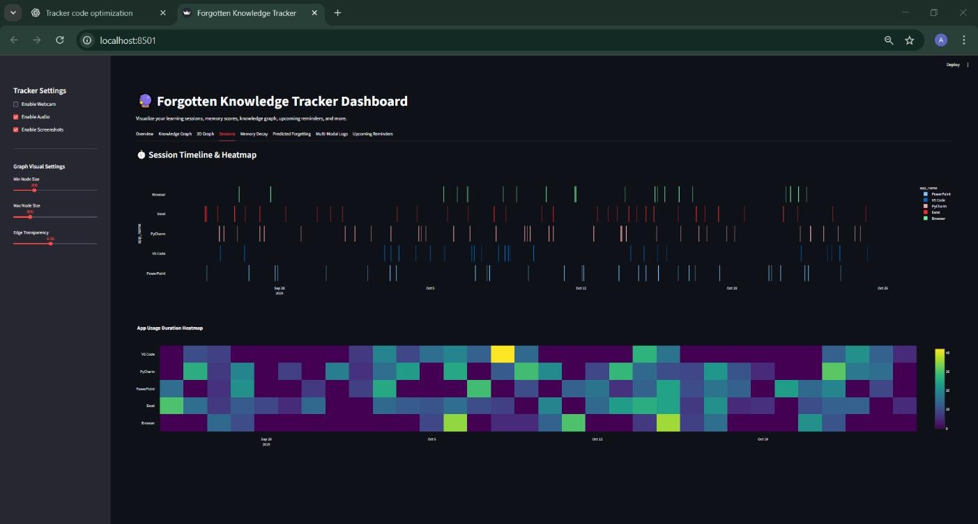
Fig 6.1.6 Heatmap and Duration map of all the sessions

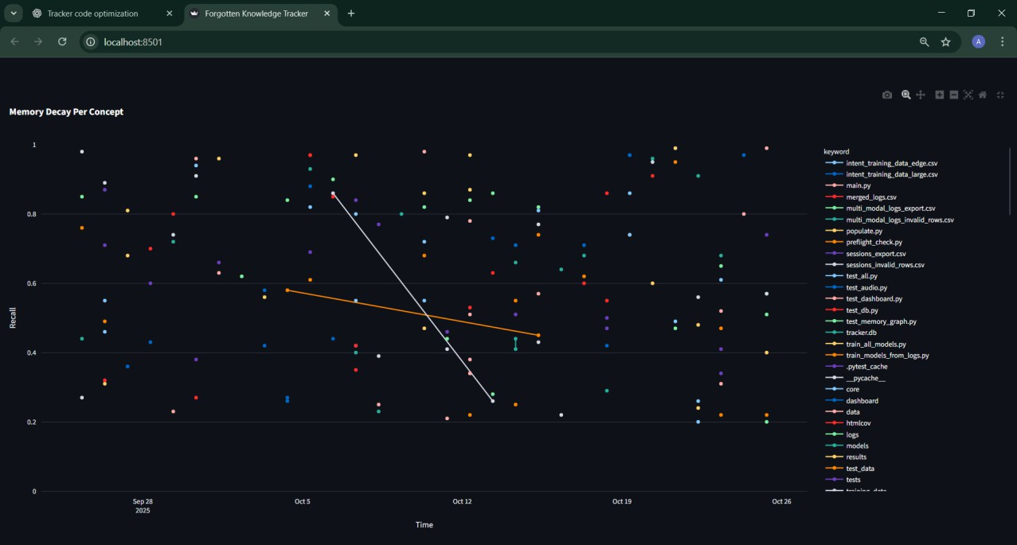

Fig 6.1.7 High-Level Architecture of Forgotten Knowledge Tracker (FKT)

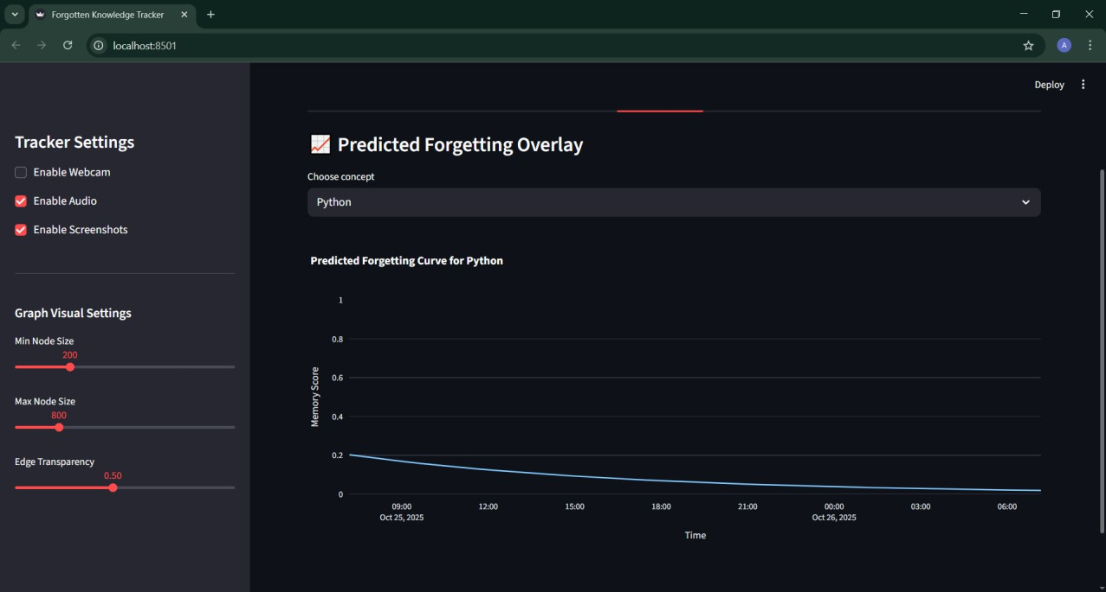

Fig 6.1.8. Prediction of retention for each topic

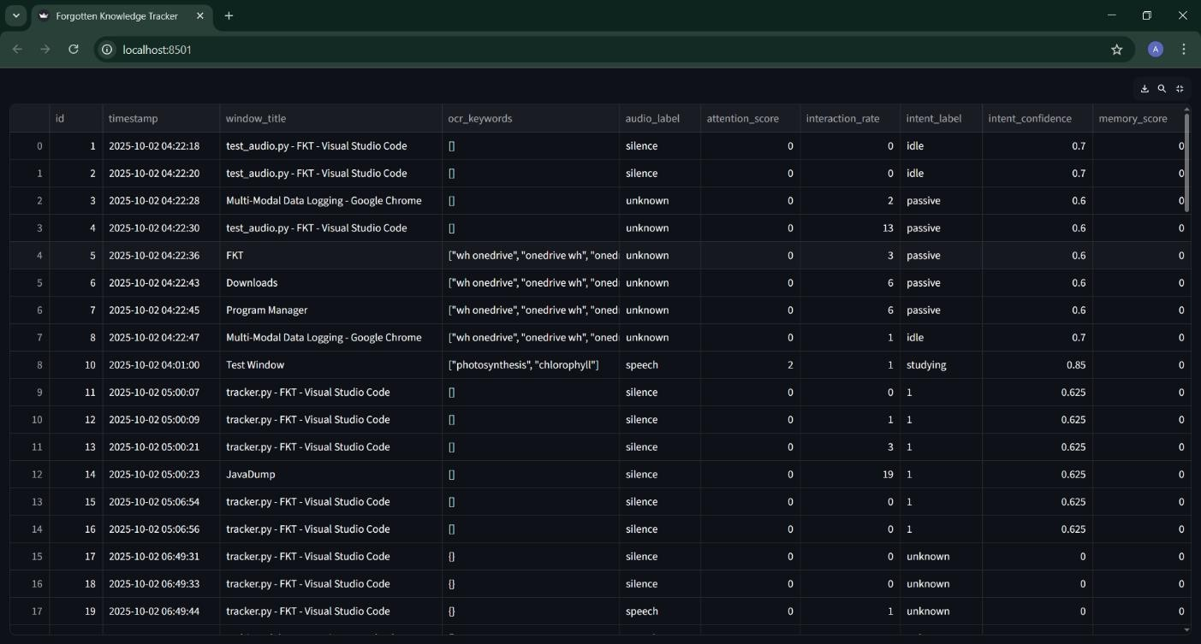
Fig 6.1.9. Logs of all the sessions

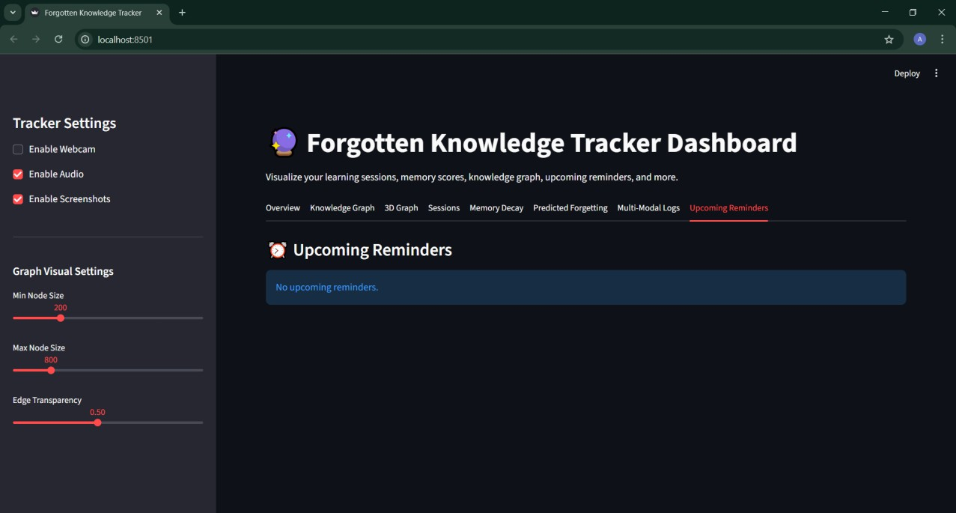

Fig 6.1.10 Reminder Dashboard without Reminders

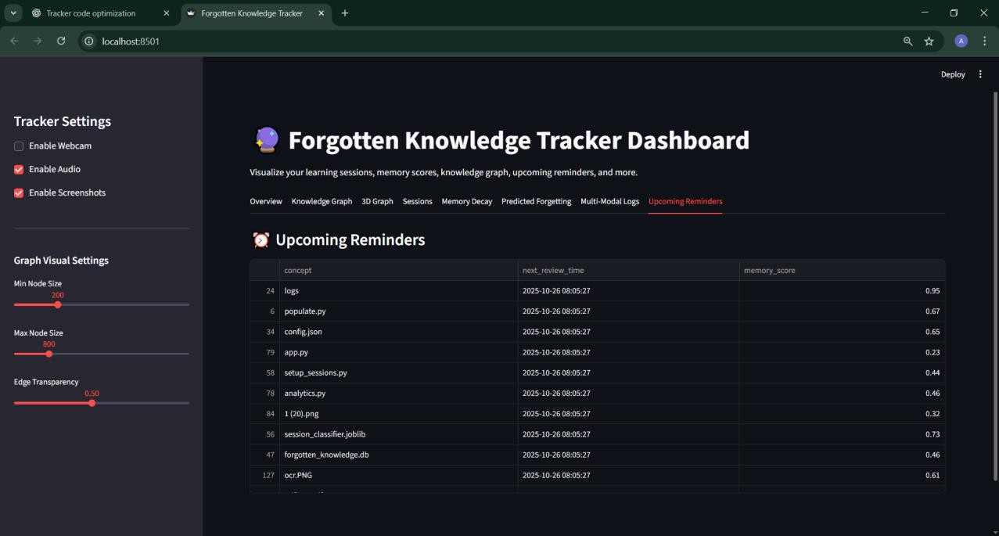

Fig 6.1.11 Reminder Dashboard with Reminders

Advantages:

Advantages of the Forgotten Knowledge Tracker (FKT):

- Automated Learning Monitoring: Reduces the need for manual tracking by automatically capturing multi-modal inputs such as screen activity, audio, webcam, and interactions.
- Real-Time Progress Tracking: Users can monitor learning progress, memory retention scores, and knowledge graph updates instantly.
- Personalized Review Schedules: Implements adaptive spaced repetition and cognitive modeling to suggest reviews tailored to individual learning patterns.
- Enhanced Knowledge Retention: Combines Ebbinghaus-based memory decay modeling with attention-weighted adjustments for optimal learning reinforcement.
- Holistic Insights: Provides a comprehensive view of learning through attention metrics, engagement scores, knowledge graphs, and memory decay curves.
- Intelligent Feedback: Updates the knowledge graph and memory scores dynamically based on user performance and interaction.
- Secure Data Handling: Ensures all multi-modal data and activity logs are securely processed and stored to protect privacy.
- Time and Effort Saving: Automates repetitive monitoring and review tasks, freeing learners to focus on actual study.
- Transparent and Actionable Analytics: Offers visual dashboards, reports, and logs that allow users to understand and optimize their learning.
- Global Accessibility: Usable on compatible devices anywhere, allowing consistent learning and review across locations.
- Energy Efficient: Lightweight on system resources, minimizing computational overhead while providing robust analytics.
- Supports Diverse Learning Contexts: Adapts to different types of study material, environments, and user behaviors for accurate performance measurement

Applications:

Applications of Forgotten Knowledge Tracker (FKT):

- Educational Institutions:
  - Assists students and teachers in monitoring learning progress and knowledge retention.
  - Enables adaptive learning by suggesting personalized review schedules.
  - Provides analytics for educators to identify knowledge gaps and optimize teaching strategies.
- Corporate Training & E-Learning:
  - Tracks employee engagement and skill acquisition during online training programs.
  - Ensures better retention of critical information and compliance training.
  - Generates reports for management on workforce learning effectiveness.
- Self-Learning & Skill Development:
  - Supports learners in independent study by monitoring progress and suggesting intelligent reviews.
  - Useful for exam preparation, certifications, and continuous skill development.
- Research & Cognitive Studies:
  - Collects multi-modal learning data to analyze cognitive behavior and attention patterns.
  - Supports studies in memory retention, learning efficiency, and educational psychology.
- Remote & Online Learning Platforms:
  - Integrates with existing e-learning platforms to enhance tracking and engagement.
  - Provides insights for remote learners where traditional supervision is not possible.
- Gamified Learning & EdTech Applications:
  - Supports adaptive gamification by adjusting difficulty and rewards based on learning performance.
  - Encourages consistent engagement with interactive and intelligent feedback loops.
- Personalized Knowledge Management:
  - Helps professionals, researchers, and students organize and recall knowledge efficiently.
  - Maintains a dynamic knowledge graph of all concepts learned, with review suggestions.

CONCLUSION

CONCLUSION

The Forgotten Knowledge Tracker (FKT) is an intelligent, multi-modal system designed to revolutionize the way learning and knowledge retention are managed. By integrating various input streams—such as screen activity, audio context, webcam attention tracking, and user interactions—FKT creates a dynamic and adaptive environment for understanding and improving cognitive performance. The platform utilizes advanced AI models and graph- based structures to analyze user behavior, extract key concepts, and build a personalized knowledge graph that represents individual learning journeys.
Through automated memory retention scoring, spaced repetition scheduling, and real- time progress visualization, the system ensures that users can efficiently track their learning performance and retain information over longer periods. FKT eliminates the need for manual note-taking or external tracking tools by automating every stage of the knowledge monitoring process. This approach not only saves time but also enhances consistency, accuracy, and long-term engagement.
By combining machine learning, cognitive science, and data visualization, the Forgotten Knowledge Tracker provides a secure, transparent, and user-centric solution for knowledge management. It empowers users to take control of their learning progress, identify weak areas, and continuously improve their knowledge retention efficiency. Ultimately, FKT represents a step forward in creating adaptive, intelligent, and human-centered learning systems designed for the modern digital era.

REFERENCES

Papers and websites referred:

- A. Patel, R. Mehta, and S. Banerjee, “AI-Based Multi-Modal Cognitive Tracking Systems,” International Journal of Artificial Intelligence and Cognitive Computing, vol. 8, no. 3, pp. 112–120, 2023.
- L. Chen, D. Kumar, and J. Zhang, “Deep Learning for Knowledge Graph Construction and Reasoning,”
IEEE Transactions on Neural Networks and Learning Systems, vol. 34, no. 6, pp. 2450–2465, 2022.
- S. Gupta, T. Rao, and M. Narayan, “Integrating Cognitive Analytics with Graph Databases for Smart Knowledge Management,” in Proc. of the 2023 IEEE International Conference on Cognitive Systems (ICCS), Bengaluru, India, 2023. DOI: 10.1109/ICCS.2023.10452817.
- K. Lee, “Visualizing Neural Knowledge Representations Using Graph Analytics,” ACM Computing Surveys, vol. 55, no. 12, pp. 1–29, 2022.
- J. Brown and R. Singh, “AI-Powered Attention and Learning Monitoring Systems,” in Proc. of the 2024 International Conference on Human-Centered Artificial Intelligence (HCAI), Tokyo, Japan, 2024.
- P. Dey, “Cognitive Retention Scoring through Neural Networks,” International Journal of Machine Learning Research, vol. 19, no. 4, pp. 201–213, 2023.
- A. Shah, V. Iyer, and K. Jain, “Design and Implementation of Multi-Modal Data Fusion Frameworks,”
Journal of Intelligent Information Systems, vol. 31, no. 2, pp. 155–170, 2022.
- M. Anderson, Deep Cognitive Systems: AI Models for Learning Retention and Behavior Analysis, 2nd ed. Springer Nature, 2023.
- J. Kim and P. Torres, “Graph Neural Networks for Personalized Learning Recommendation,” in Proc. of the 2023 IEEE International Conference on Learning Analytics (ICLA), Singapore, 2023.
- S. Russell and P. Norvig, Artificial Intelligence: A Modern Approach, 4th ed. Pearson Education, 2021.
- OpenAI Documentation – GPT Models and Cognitive Analysis APIs, 2024.
- Scikit-learn Documentation – Machine Learning in Python.
- TensorFlow Official Documentation – Deep Learning Frameworks and Model Optimization.
- PyTorch Tutorials – Neural Network Design and Implementation for Cognitive Analytics.
- Coursera – Advanced Applications of AI and Data Visualization in Knowledge Systems, University of Toronto, 2023.

