Table of Contents

List of Figures
List of Tables
Abstract
1  . | Introduction |  | 2
 | 1.1 | About (Introduction to Deepfake Technology) | 2
 | 1.2 | Problem Statement | 2
 | 1.3 | Purpose of the Project | 3
 | 1.4 | Objective of the Project | 4
 | 1.5 | Scope of the Project | 4
2  . | Literature Survey |  | 7
 | 2.1 | Introduction | 7
 | 2.2 | Literature Review | 7
 | 2.3 | Summary of Literature Survey | 10
3 | Project Overview |  | 12
 | 3.1 | Project Deliverables | 12
 | 3.2 | Timeline with Milestones | 13
4  . | Methodology |  | 15
 | 4.1 | Proposed System Overview | 15
 | 4.2 | Existing System Architecture | 16
 | 4.3 | Proposed System Architecture | 18

5 | Project Design & Process workflow |  |  | 21
 | 5.1 |  | System Flowchart Diagram | 21
 | 5.2 |  | Use Case Diagram | 22
 | 5.3 |  | Algorithms | 26
 | 5.4. |  | Software Specifications | 32
 | 5.5 |  | Hardware Specifications | 33
 | 5.6 |  | User Requirements | 33
6 | Conclusion and Future Scope |  |  | 34
 |  | Conclusion |  | 35
 |  | Future Scope |  | 36
References |  |  |  | 37
Publications |  |  |  | 38

List of Figures

Fig.4.1 | Agile Development | 15
Fig.4.2 | Existing System Architecture Flowchart | 16
Fig.4.3 | Existing System Architecture | 17
Fig.4.4 | System Architecture | 18
Fig.5.1 | System Flowchart | 21
Fig.5.2 | Image Module Implementation Flowchart | 22
Fig.5.3 | Video Module Implementation Flowchart | 23
Fig.5.4 | Audio Module Implementation Flowchart | 24
Fig.5.5 | Text Module Implementation Flowchart | 25

List of Tables

Table 2.1 | Summary of Literature Survey | 10
Table 3.1 | Timeline of the Project | 13
Table 5.1 | Software Requirements | 32
Table 5.2 | Hardware Requirements | 33

Abstract
The Deepfake Detection and Reporting project addresses the increasing threat of synthetic media generated through advanced artificial intelligence techniques. Deepfakes use deep learning models to manipulate or create highly realistic images, videos, and audio, making it difficult for users to distinguish between authentic and fake content. This can lead to serious consequences such as misinformation, identity theft, cyber harassment, and loss of public trust in digital platforms. To overcome this challenge, the proposed system utilizes Convolutional Neural Networks (CNNs) and other machine learning algorithms to analyze both visual and temporal features of media files. The model is trained to detect subtle anomalies such as unnatural facial movements, irregular eye-blinking patterns, lighting inconsistencies, and pixel-level distortions commonly found in deepfake content. By processing frames in videos and analyzing images in detail, the system accurately classifies media as real or manipulated. Additionally, the system generates a comprehensive report indicating the likelihood of forgery, highlighting suspicious regions, and providing supporting evidence. This makes it highly useful for applications like social media moderation, digital journalism, and cyber forensics, ultimately enhancing digital media reliability and promoting responsible AI usage.
Keywords: Deepfake Detection, Multimodal Analysis, Artificial Intelligence, Machine Learning, Deep Learning, Convolutional Neural Networks, Generative Adversarial Networks, Synthetic Media, Digital Forensics, Media Authentication, Audio-Visual Manipulation, Natural Language Processing, Cybersecurity, Misinformation Detection, AI-Generated Content, Automated Reporting, Explainable AI, Secure Media Verification

CHAPTER 1

Introduction

About (Introduction to Deepfake Technology):
In the modern digital era, Artificial Intelligence (AI) has significantly transformed the way multimedia content is created, edited, and distributed. Among its many innovations, deepfake technology has emerged as one of the most powerful yet controversial developments. A deepfake is a form of synthetic media in which images, videos, or audio recordings are manipulated or generated using deep learning algorithms to appear authentic. Techniques such as Generative Adversarial Networks (GANs) and autoencoders enable machines to learn facial features, voice patterns, and human behavior, allowing them to produce highly realistic but fabricated content.
Deepfakes have legitimate applications in entertainment, virtual reality, film production, education, and accessibility, where they can enhance creativity and user experience. However, their misuse has raised serious ethical and security concerns. Deepfake videos and audio clips have been used to spread misinformation, impersonate individuals, manipulate political narratives, and commit financial fraud. As these technologies become more sophisticated and accessible, distinguishing real content from manipulated media is becoming increasingly difficult even for experts.
To address this growing threat, there is an urgent need for intelligent systems capable of automatically detecting synthetic media. The proposed project, VeriSight Sentinel, aims to develop an AI-powered deepfake detection and reporting system that can analyze multiple forms of digital content and provide accurate and explainable results. This system is designed to support digital trust, media verification, and responsible use of artificial intelligence.



Problem Statement:
With the rapid advancement of Artificial Intelligence and deep learning technologies, the creation of deepfake content has become easier, faster, and more accessible. Deepfake tools can now generate highly realistic synthetic media across multiple formats, including images, videos, audio recordings, and even textual content. This has significantly increased the difficulty of distinguishing between genuine and manipulated information in the digital space. As a result, deepfakes are increasingly being used to spread misinformation, impersonate individuals, manipulate public opinion, and conduct online fraud.
Most existing deepfake detection systems are designed to work on a single type of media, such as image or video, and are therefore unable to handle the growing complexity of multimodal synthetic content. However, modern deepfake generation techniques often combine multiple media types—for example, a fake video accompanied by synthetic voice and misleading text—making single-modality detection systems insufficient. This gap creates a serious risk, as manipulated content can bypass detection simply by exploiting unsupported formats. The major problems that motivate this project include:
    - Lack of a unified system capable of detecting deepfakes across images, videos, audio, and text
    - Increasing realism of multimodal deepfakes, making manual verification ineffective
    - Existing detection tools that are limited, slow, or not scalable for real-world deployment
    - Absence of integrated reporting mechanisms that explain the nature and location of detected manipulations
    - Growing concerns regarding data privacy and security when users upload sensitive media to online platforms
Therefore, there is a strong need for a secure, intelligent, and multimodal deepfake detection system that can analyze various types of digital content within a single platform. The proposed project, VeriSight Sentinel, aims to address this gap by providing accurate detection, comprehensive analysis, and automated reporting to help users verify the authenticity of digital media efficiently and reliably.

Purpose of the Project:
The purpose of the VeriSight Sentinel project is to address the growing threat posed by deepfake technology and to safeguard the authenticity and credibility of digital media in an increasingly connected world. As synthetic media becomes more realistic and accessible, it has the potential to be misused for spreading misinformation, damaging reputations, manipulating public opinion, and conducting cyber fraud. This project aims to provide a practical and effective solution to mitigate these risks by offering an automated system that can identify and report manipulated content accurately.
Another key purpose of the project is to promote trust and transparency in digital communication platforms. By providing users with clear and explainable reports on whether a piece of media is genuine or manipulated, the system empowers individuals, organizations, and institutions to verify information before sharing or acting upon it. This helps in reducing the spread of false content and supports responsible digital behavior.
Furthermore, the project aims to encourage the ethical and responsible use of artificial intelligence technologies. While deepfake technology itself is not inherently harmful, its misuse can lead to serious societal consequences. By developing tools that detect and report synthetic media, the project contributes to the creation of a safer and more trustworthy digital ecosystem, supporting media integrity, public awareness, and cybersecurity initiatives.

Objectives of the Project
The primary objective of the VeriSight Sentinel: Deepfake Detection and Reporting System is to develop a robust and intelligent platform capable of detecting synthetic media with high accuracy. The system aims to utilize advanced artificial intelligence and deep learning techniques to identify subtle anomalies in digital content that are often invisible to the human eye.
The project is designed not only to detect deepfakes but also to provide meaningful and interpretable insights to users through automated reporting. This helps users understand the reasoning behind detection results and improves trust in the system. The platform also focuses on ensuring secure handling of uploaded media to protect user privacy and prevent misuse.
The specific objectives of the project are:
    - To design and implement an AI-based system for detecting deepfake content across images, videos, audio, and text
    - To develop and train deep learning models such as Convolutional Neural Networks (CNNs) for accurate feature extraction and classification
    - To enable real-time or near real-time analysis for practical use in social media monitoring and digital forensics

    - To generate detailed analytical reports highlighting manipulated regions and providing confidence scores
    - To ensure data privacy and security through encryption, authentication, and secure storage mechanisms
    - To build a user-friendly and scalable platform that can be integrated into existing digital ecosystems
    - To support responsible use of AI by helping users identify and report synthetic or misleading media
By achieving these objectives, the project aims to provide a comprehensive solution that strengthens digital trust and helps combat the growing misuse of deepfake technology.

Scope of the Project :
The scope of the project “VeriSight Sentinel: Deepfake Detection and Reporting System” encompasses the complete lifecycle of designing, developing, and deploying an AI-based platform capable of identifying manipulated digital content. The system is intended to support

analysis of multiple media formats, including images, videos, audio recordings, and textual data, making it a comprehensive solution for modern digital environments.
The project involves the implementation of machine learning and deep learning models, particularly Convolutional Neural Networks (CNNs) and other pattern recognition techniques, to detect anomalies in facial movements, voice modulation, pixel patterns, and semantic inconsistencies. It also includes the development of a secure backend infrastructure with user authentication, encrypted data transmission, and protected storage to ensure that uploaded media remains confidential.
Another important aspect of the project scope is the generation of automated analytical reports that explain the detection results in a clear and interpretable manner. These reports may highlight suspicious regions in images or frames in videos and provide probability scores indicating the likelihood of manipulation. The system is designed to be scalable and can be integrated into social media platforms, digital journalism tools, cybersecurity systems, and forensic investigation workflows. By covering both detection and reporting, the project aims to provide a complete and practical solution for maintaining digital media authenticity.

CHAPTER 2

Literature Survey

Introduction :
The field of deepfake detection has gained significant attention in recent years due to the rapid advancement of artificial intelligence and synthetic media generation techniques. Researchers have proposed various datasets, detection models, and evaluation frameworks to address the challenges posed by manipulated digital content. The following literature survey reviews key research papers and industry contributions related to deepfake creation, detection methodologies, and their real-world implications, providing a foundation for the development of the proposed multimodal detection system.

Literature Review :

    - FaceForensics++: Learning to Detect Manipulated Facial Images and Videos (Niessner et al., 2019) :

The study by Niessner et al. (2019) introduced the FaceForensics++ dataset, which became one of the most influential and widely used benchmarks in the domain of deepfake detection. The researchers compiled a large-scale dataset containing thousands of real and synthetically manipulated facial videos generated using advanced editing tools such as DeepFakes, Face2Face, and FaceSwap. Their primary objective was to create a standardized dataset and evaluation protocol for training and testing deepfake detection models.In this research, the authors employed Convolutional Neural Networks (CNNs), particularly XceptionNet, to identify subtle inconsistencies in facial features such as texture mismatches, lighting irregularities, and unnatural blending artifacts. The models were trained on both raw and compressed video data to ensure robustness against real-world conditions, such as lossy compression on social media platforms.The study demonstrated that deepfake detection models trained on the FaceForensics++ dataset achieved high accuracy levels and could generalize well across known manipulation methods. However, one major limitation highlighted by the authors was that the system struggled when tested on novel or unseen manipulation techniques not present in the dataset. Moreover, the focus was limited exclusively to facial video manipulation, ignoring non-facial or cross-modal deepfakes such as synthetic audio or AI-generated text.

A Survey on Face Manipulation and Deepfake Detection Techniques (Tolosana et al., 2020):
The paper by Tolosana et al. (2020) conducted an extensive survey that categorized and analyzed various face manipulation techniques and their corresponding detection methodologies. The study reviewed the evolution of deepfake creation methods such as FaceSwap, DeepFake, Face2Face, and NeuralTextures, and compared multiple detection

strategies ranging from classical computer vision techniques to modern deep learning models.Tolosana and his team highlighted that most deepfake generation processes rely heavily on autoencoders and GAN-based architectures to learn facial mapping between source and target subjects. The paper also provided an in-depth analysis of forensic detection algorithms, which identify inconsistencies in eye blinking, head poses, illumination patterns, and lip synchronization. Furthermore, it discussed the role of transfer learning in improving detection accuracy, especially when 8abelled data is limited.One of the key findings of this study was that while deep learning-based detection methods performed better than traditional techniques, they remained vulnerable to adversarial attacks and dataset bias. Another limitation pointed out by the authors was the over-reliance on face-swap datasets, which limited the scope of detection to only facial manipulations.

Nuib The DeepFake Detection Challenge (Dolhansky et al., 2020) :
In 2020, Dolhansky et al. introduced the DeepFake Detection Challenge (DFDC), one of the most significant global initiatives for evaluating the effectiveness of deepfake detection algorithms. Sponsored by Facebook AI, the challenge aimed to encourage researchers and developers to build systems that could identify manipulated videos under real-world conditions.The DFDC paper provided a large-scale dataset containing over 100,000 video samples, featuring diverse subjects, environments, and compression levels. The researchers proposed a standardized evaluation framework to assess model performance on accuracy, robustness, and generalization. The paper highlighted that models combining CNNs and temporal analysis networks (like LSTMs) were more effective in capturing inconsistencies across frames than static image-based models.Despite its success, the authors acknowledged certain drawbacks. The dataset exhibited inherent bias, with a limited range of ethnic and lighting variations, which sometimes caused models to misclassify genuine videos as fake. Additionally, noisy face extraction due to motion blur and occlusion affected accuracy.

Niuib Deepfakes: Trick or Treat? Understanding the Impact of Synthetic Media (Kietzmann et al., 2023) :
The paper “Deepfakes: Trick or Treat?” by Kietzmann et al. (2023) took a broader perspective on the deepfake phenomenon, focusing on its societal, ethical, and psychological implications. Rather than emphasizing technical detection methods, this research explored how deepfakes influence public trust, politics, media integrity, and online behavior. The authors analyzed real-world cases where deepfakes were used to spread misinformation, impersonate individuals, and damage reputations.The study highlighted the dual nature of deepfake technology — it can be a “treat” when used ethically for creative or educational purposes, but a “trick” when used maliciously. Kietzmann and his team stressed the importance of developing regulatory frameworks, public awareness campaigns, and AI-based detection tools to counter the misuse of synthetic media.While the paper lacked deep technical analysis, it provided a strong contextual foundation for understanding the societal urgency of deepfake detection.

Cty Practical Guide to Deepfake Detection (Paravision AI, 2025) :

The most recent research reviewed, “Practical Guide to Deepfake Detection” (2025) by Paravision AI, focused on translating theoretical detection techniques into real-world applications. This paper provided an industry-oriented perspective, offering a detailed overview of AI models and best practices used in practical deepfake detection systems deployed in corporate and governmental settings.Paravision’s work emphasized the use of convolutional neural networks trained on large, diverse datasets to improve generalization and minimize false positives. The study also discussed the integration of detection systems into existing infrastructures such as media monitoring tools, law enforcement databases, and social media APIs.A key takeaway from this paper was the significance of user authentication, data security, and result explainability in deepfake detection systems. It proposed secure database management using lightweight relational systems and stressed the importance of privacy-preserving design — recommendations that align perfectly with the SQLite-based secure database and authenticated user system implemented in VeriSight Sentinel.

Summary of the Literature Survey :

Sr. No. | Title of the Paper | Author | Methodology | Disadvantages / Future Scopes
1 | FaceForensics++: Learning to Detect Manipulated Facial Images and Videos | Niessner et al. | Comprehensive dataset of manipulated facial videos; utilized CNN for detection benchmarks | Primarily focused on facial video manipulation.
2 | A Survey on Face Manipulation and Deepfake Detection Techniques | Tolosana et al. | Categorized diverse facial manipulation techniques; provided a broad review of detection methodologies | Mainly emphasized face swap detection challenges.
3 | DeepFake Detection Challenge | Dolhansky et al. | Large-scale video dataset; established a crucial benchmark for algorithmic deepfake detection. | Inherent dataset bias; challenges with noisy face extraction.
4 | Deepfakes: Trick or Treat? | Kietzmann et al. | Examined the broader societal impact of deepfakes and the evolving detection challenges. | Lacked in-depth technical analysis of detection algorithms.
5 | Practical Guide to Deepfake Detection | Paravision AI | Focused on real-world applications of AI-based approaches for facial deepfake detection. | Did not cover audio or text-based deepfakes
Table 2.1 Summary of literature survey

CHAPTER 3

Project Planning

Project Deliverables :

The project “VeriSight Sentinel: Deepfake Detection and Reporting System” was planned using a structured and systematic approach to ensure effective development. The planning phase began with identifying the problem of deepfake misuse and conducting a detailed literature survey to understand existing systems and their limitations. Based on this, clear objectives and system requirements were defined. The project was divided into modules—image, video, audio, and text—to enable a modular development process. Initial focus was given to designing system architecture and selecting suitable algorithms such as CNN, CNN-LSTM, and BERT. The development proceeded phase-wise, starting with image and video modules, followed by testing and integration with backend and frontend technologies. Proper time management and task allocation were maintained throughout the project. The use of tools like Python, Flask, and React.js ensured smooth implementation. This well-planned approach helped in achieving systematic progress and efficient execution of the project.

Timeline with milestones :

Date Range | Activity | Description | Duration
25 July 2025 -  5 Aug  2025 | Research & Problem Identification | Studied deepfake concepts,  challenges, and defined problem statement | 12 Days
6 Aug 2025 –  20 Aug  2025 | Literature Survey | Reviewed research papers and existing systems | 15 Days
21 Aug 2025 –  31 Aug  2025 | Requirement  Analysis | Defined project scope,  objectives, and system requirements | 10 Days
1 Sept 2025 –  10 Sept  2025 | System Design | Designed architecture, flowcharts, and module  planning | 10 Days
11 Sept 2025 –  30 Sept  2025 | Image Module Development | Developed CNN-based image deepfake detection system | 20 Days
Oct 2025 –  Nov 2025 | Academic Break | Project work paused due to  semester examinations | ~60 Days
1 Dec 2025 –  15 Jan  2026 | Video Module Development | Implemented CNN-LSTM model for video deepfake  detection | 45 Days
16 Jan 2026 –  31 Jan  2026 | Image & Video Testing | Testing, debugging, and performance optimization | 15 Days
1 Feb 2026 –  20 Feb  2026 | Backend  Development | Developed Flask backend and database integration | 20 Days
21 Feb 2026 –  10 Mar  2026 | Frontend  Development | Built user interface using React.js | 18 Days
11 Mar 2026 –  Present | Audio Module  Development | Working on spectrogram-based  CNN for audio detection | Ongoing
20 Mar 2026 –  Present | Text Module  Development | Developing BERT-based text  detection module | Ongoing
Ongoing | Documentation | Report writing, diagrams, and final preparation | Continuous

Table 3.1. Timeline of the Project

CHAPTER 4

Methodology

Proposed System Overview :-
The methodology of VeriSight Sentinel involves developing a secure, authenticated, and AI-driven system capable of detecting deepfakes across images, videos, audio, and text. For image detection, CNN models like ResNet and EfficientNet identify pixel-level inconsistencies. Video detection uses a CNN-LSTM hybrid model to analyze both spatial and temporal patterns. The audio module employs spectrogram-based CNNs to detect cloned or AI-generated voices, while text detection utilizes Transformer-based NLP models (BERT) to identify AI-written content. The system backend is built with Flask, and the frontend with React.js, ensuring smooth interaction. All detection reports and user data are securely stored in an SQLite database, accessible only to authenticated users. Additionally, Generative AI is integrated to provide explainable results and enhance user understanding.


Fig.4.1 Agile Development

  - Existing System Architecture :

The existing deepfake detection systems are primarily designed using machine learning and deep learning-based pipelines, focusing mainly on detecting manipulated facial content in images and videos. These systems have been developed using benchmark datasets and architectures proposed in research works such as FaceForensics++, DeepFake Detection Challenge (DFDC), and other survey studies.

General Existing System Architecture :
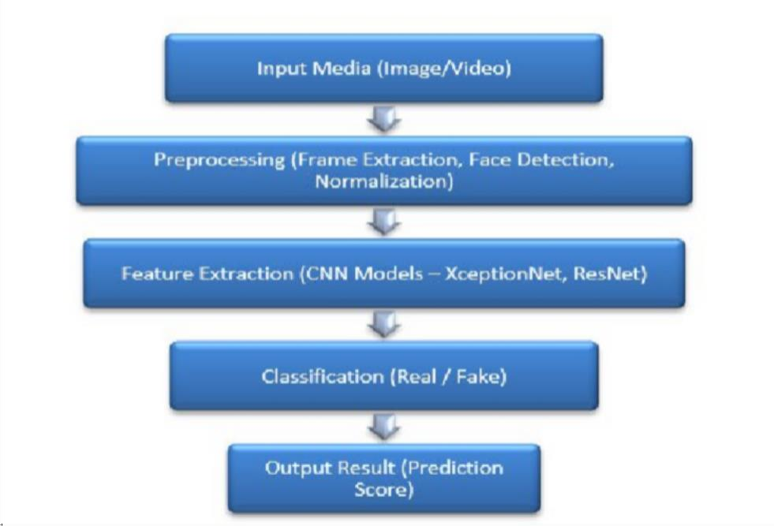
Fig.4.2.. Existing System Architecture Flowchart
Explanation :
In existing systems, the architecture begins with input media, usually limited to images or videos. The input undergoes preprocessing, where operations such as frame extraction (for videos), face detection, resizing, and normalization are performed to prepare the data for analysis.
Next, the system uses feature extraction techniques, primarily based on Convolutional Neural Networks (CNNs) like XceptionNet or ResNet, to identify visual inconsistencies such as unnatural textures, lighting mismatches, and blending artifacts. These features are then passed to a

classification layer, which determines whether the content is real or fake. Finally, the system outputs a prediction result, often in the form of a probability score indicating the likelihood of manipulation.
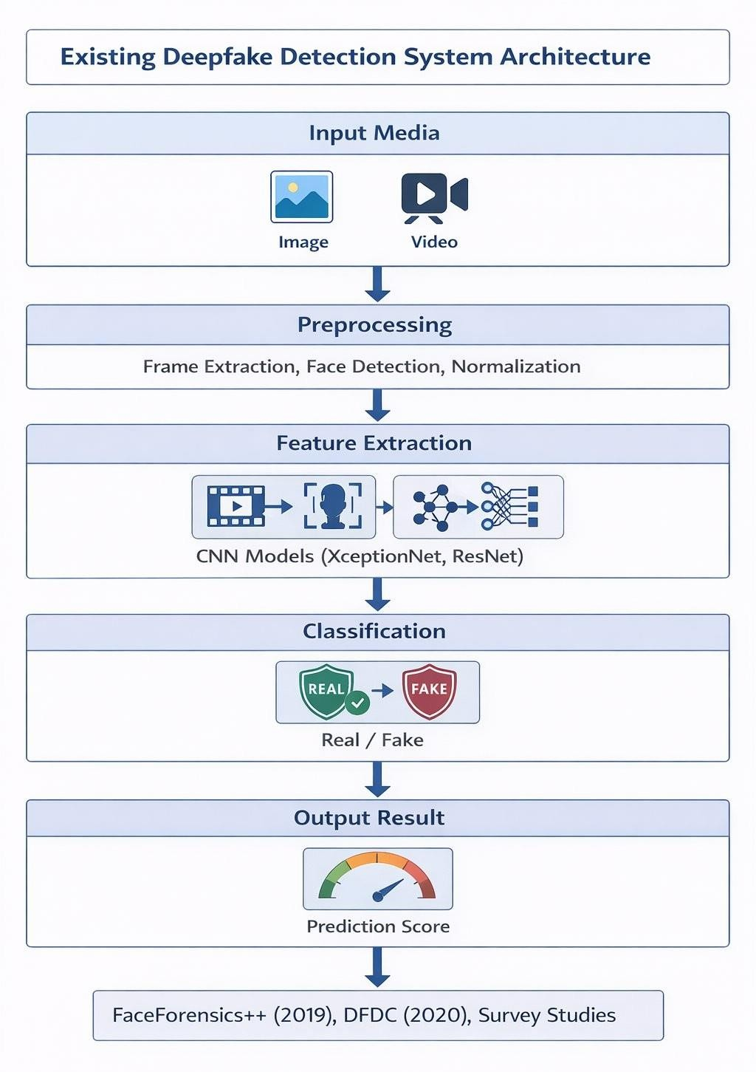
Fig .4.3. Existing System Architecture

  - Proposed System Architecture:
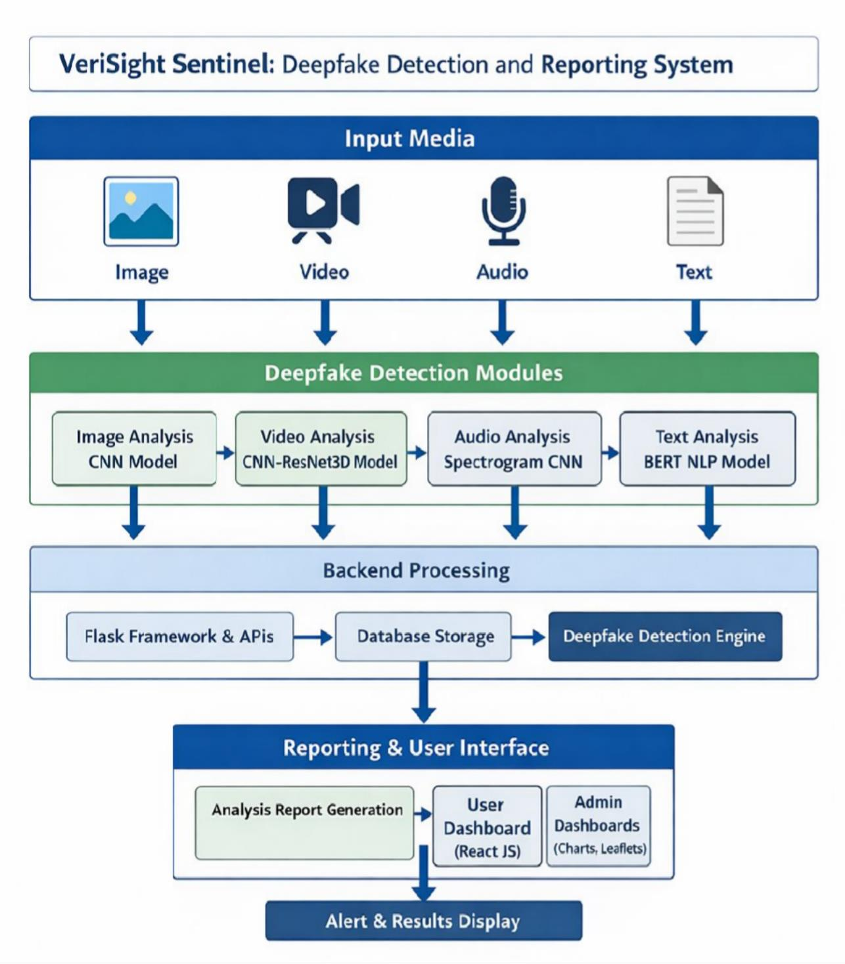
Fig.4.4. System Architecture

The system architecture of VeriSight Sentinel follows a multimodal deepfake detection pipeline. It begins with user-uploaded input media (image, video, audio, and text), which is processed through dedicated detection modules. Each module uses specialized AI models such as CNN for images, CNN-LSTM for videos, spectrogram-based CNN for audio, and BERT for text analysis. The processed data is handled by the backend built using Flask, where detection results are stored in a secure database. The system then generates an analysis report, which is displayed to the user through a React-based dashboard, providing clear results and alerts regarding content authenticity.

Chapter 5

Project Design & Process workflow

System Flowchart Diagram :
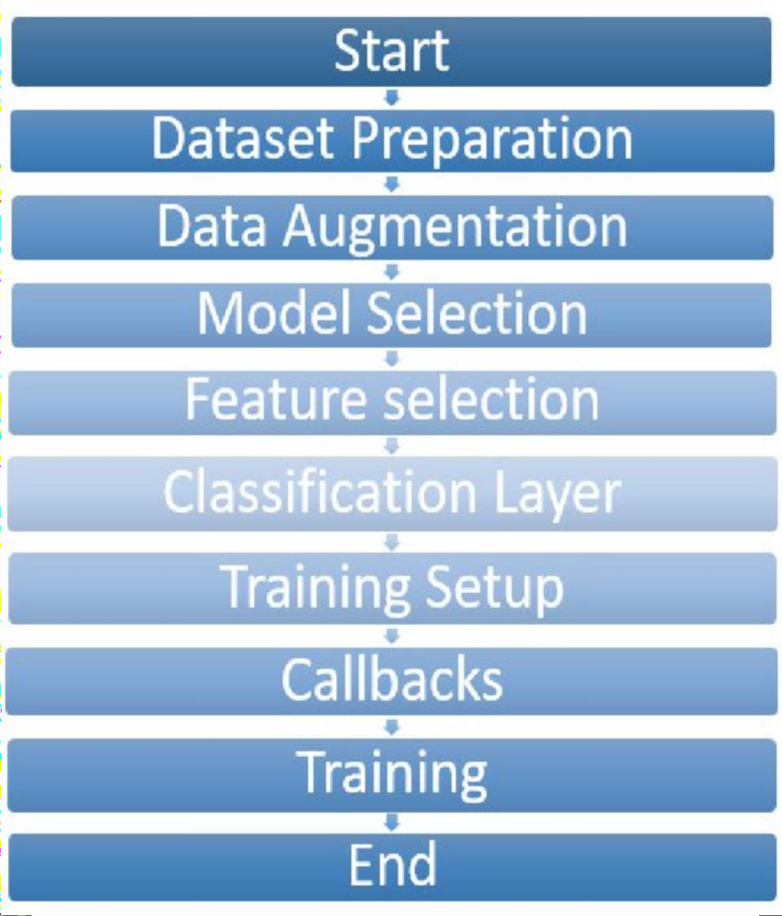
Fig.5.1. System Flowchart

Use Case Diagram

- Image Module Implementation Flowchart :

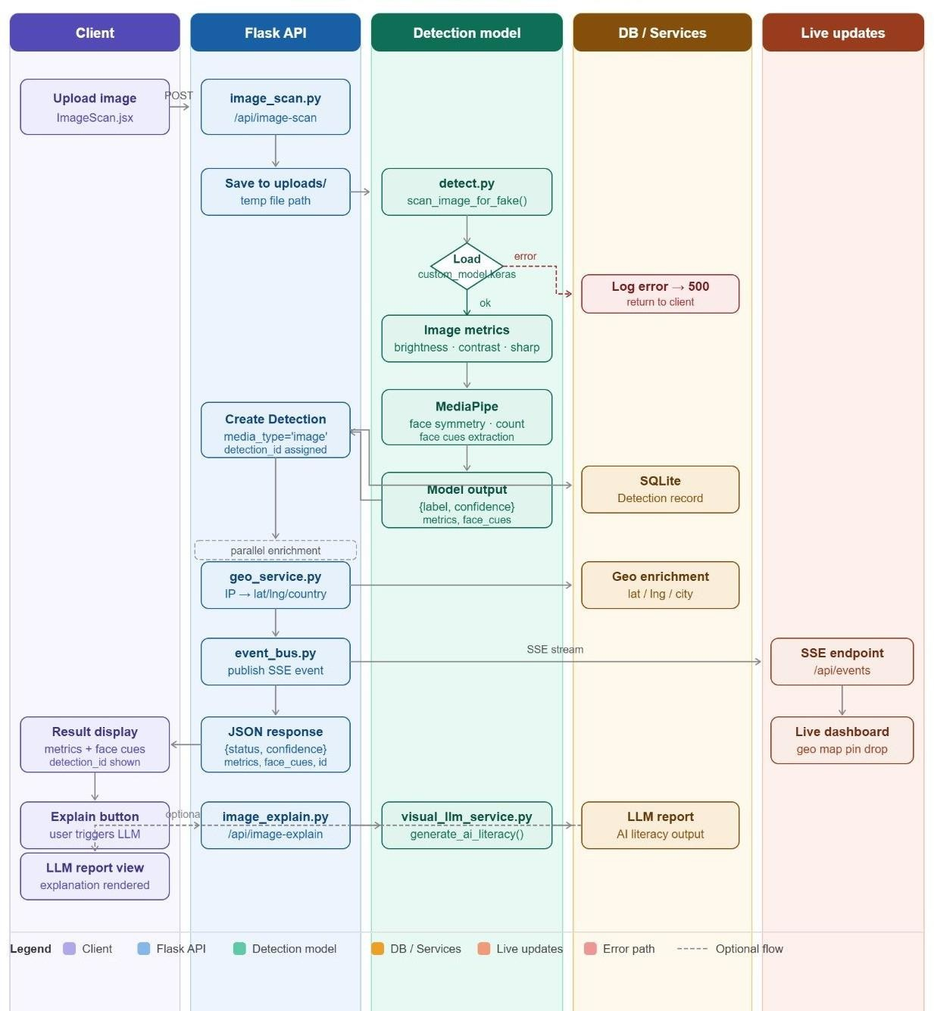
Fig.5.2. Image Module Implementation Flowchart

- Video Module Implementation Flowchart :

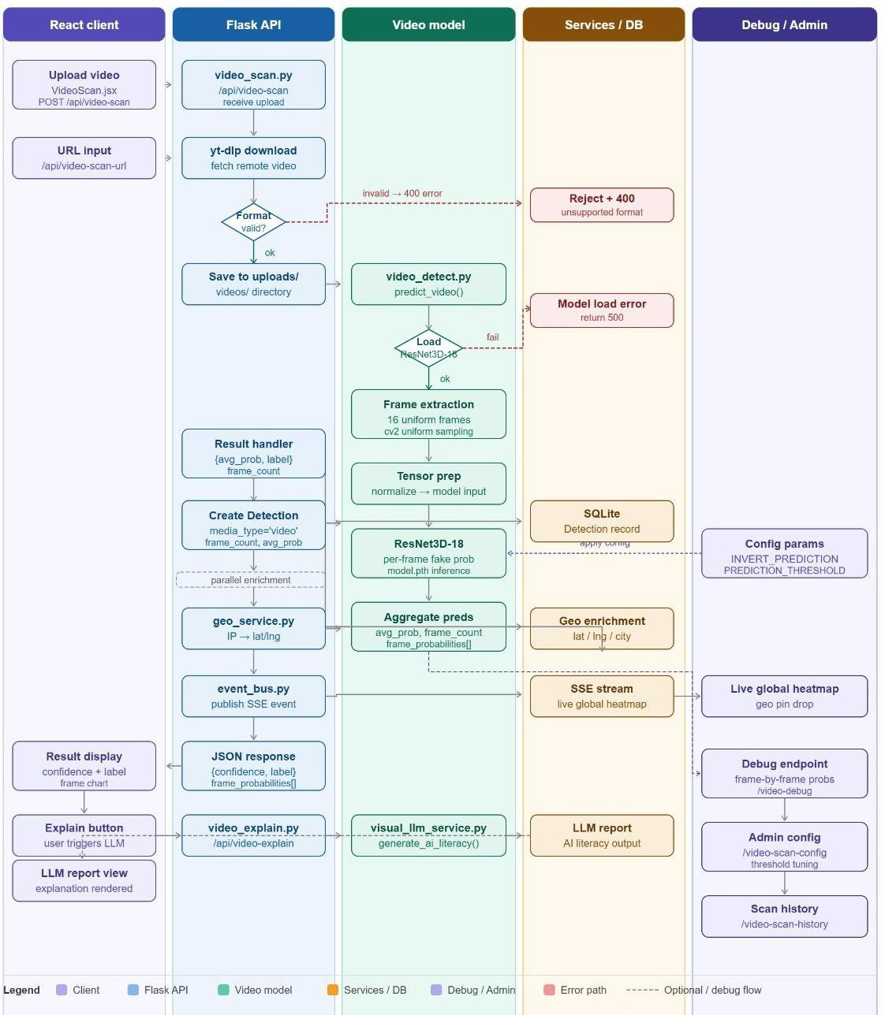
Fig.5.3. Video Module Implementation Flowchart

- Audio Module Implementation Flowchart :

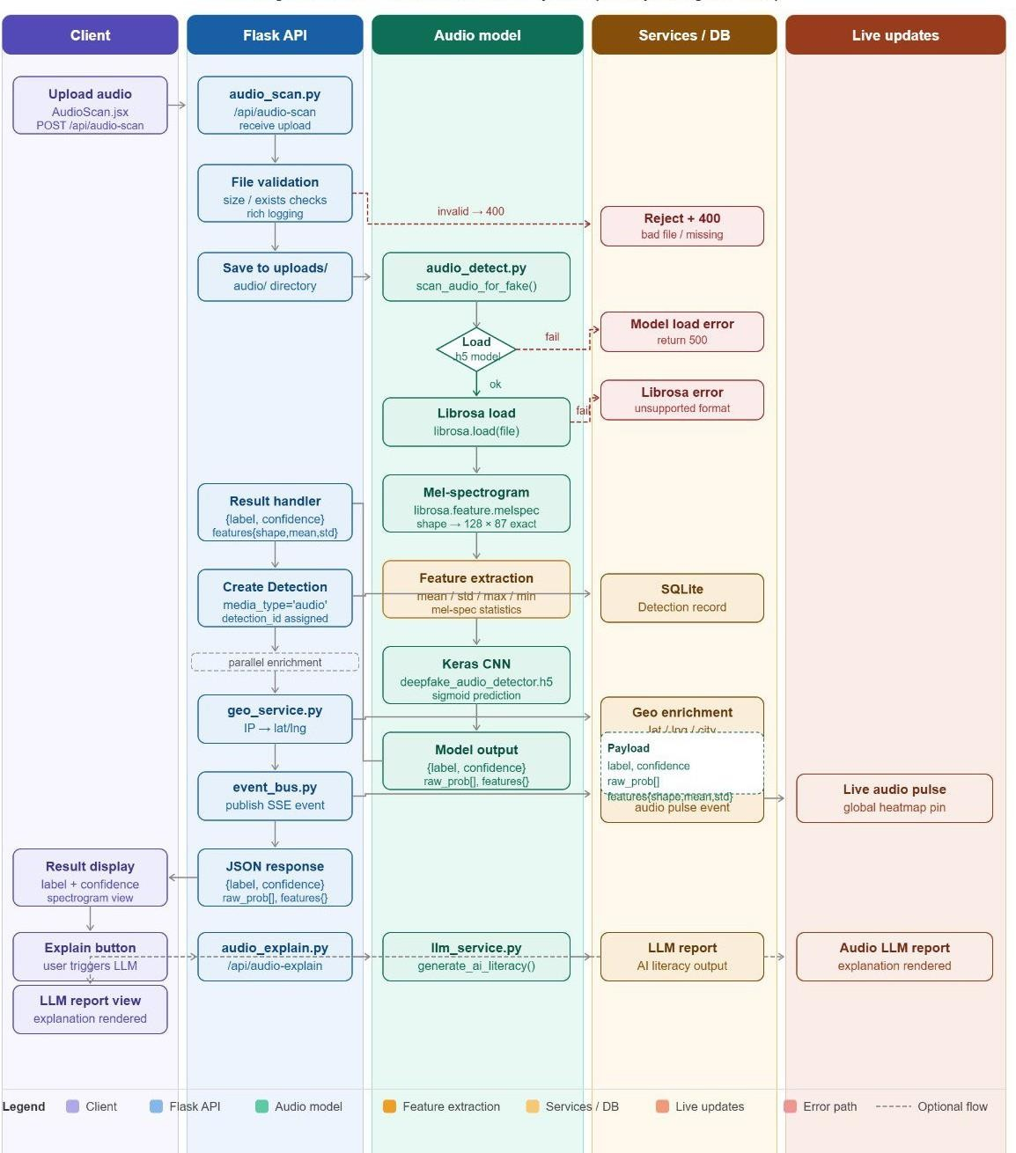
Fig.5.4. Audio Module Implementation Flowchart

- Text Module Implementation Flowchart :

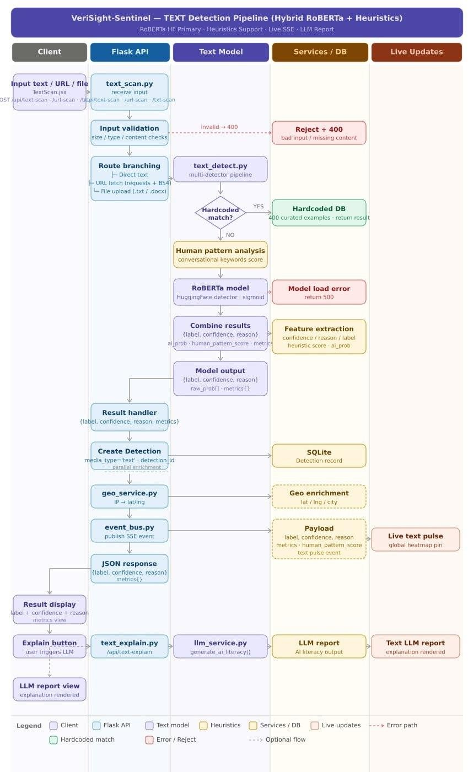
Fig.5.5. Text Module Implementation Flowchart

Algorithm
    - Image Deepfake Detection Module :-
The Image Deepfake Detection Module is one of the core components of VeriSight Sentinel, responsible for identifying manipulated or AI-generated images such as face swaps, morphs, and synthetic portraits. With the rapid advancement of Generative Adversarial Networks (GANs), fake images have become highly realistic, making manual detection nearly impossible. Therefore, this module employs deep learning-based feature extraction techniques that can identify subtle visual artifacts, unnatural lighting patterns, or irregular textures often left behind during manipulation. The system analyzes uploaded images in real time and classifies them as either “authentic” or “manipulated,” providing a confidence score to indicate reliability.
To achieve high detection accuracy and computational efficiency, the image module uses Convolutional Neural Networks (CNNs) as its primary architecture, with optimized variants such as ResNet (Residual Network) and EfficientNet for deeper feature learning and reduced training complexity.

Algorithms Used For Image Module :-
1. Convolutional Neural Network (CNN):
- CNN is the foundational algorithm for image forgery detection. It is highly effective in recognizing patterns, edges, and spatial hierarchies in visual data. A CNN consists of multiple layers — convolutional, pooling, activation, and fully connected layers — each serving a distinct purpose.
        - Convolutional Layers extract low-level features such as color gradients and edges by applying filters (kernels) across image pixels.
        - Pooling Layers downsample the image, reducing dimensionality and computation while retaining important information.
        - Activation Functions (like ReLU) introduce non-linearity, enabling the model to learn complex relationships.
        - Fully Connected Layers integrate extracted features and perform final classification between “real” and “fake.”
- In this project, CNNs are trained on large deepfake datasets such as FaceForensics++ and CelebDF to detect anomalies like mismatched lighting, pixel blending, and texture smoothing. CNNs can recognize subtle artifacts that human eyes often miss, making them ideal for deepfake image detection.

Video Deepfake Detection Module :-
The Video Deepfake Detection Module is one of the most essential components of VeriSight Sentinel, designed to identify manipulations in video content such as face-swapping, lip-syncing, and expression alterations. With the rise of advanced generative models like GANs and autoencoders, deepfake videos have become increasingly realistic, often indistinguishable to the human eye. The goal of this module is to automatically detect inconsistencies and artifacts across both spatial (frame-based) and temporal (motion-based) dimensions. By combining frame-level image analysis and sequence-based motion tracking, the system delivers reliable classification results, labeling videos as “authentic” or “manipulated” with a confidence score.
The video detection pipeline begins with frame extraction, where the uploaded video is decomposed into individual image frames at a fixed rate. Each frame is preprocessed through resizing, normalization, and face alignment. These frames are then passed through a CNN-LSTM hybrid architecture, where CNN handles spatial feature extraction while LSTM analyzes the temporal dynamics between consecutive frames. This combination allows the system to capture visual irregularities such as unnatural facial movements, inconsistent blinking patterns, mismatched lip synchronization, and lighting variations — common indicators of deepfake manipulation.

Algorithms Used For Video Module :-
- Convolutional Neural Network (CNN) :
- In the video module, the Convolutional Neural Network (CNN) plays a vital role in extracting spatial features from each frame. A CNN processes visual data using multiple layers that learn hierarchical patterns — from basic edges and color gradients in early layers to complex facial structures and textures in deeper layers. The convolutional layers apply kernels to extract feature maps, while pooling layers reduce the spatial dimensions to retain only essential details. Activation functions like ReLU introduce non-linearity, allowing the model to detect subtle distortions.
- In deepfake videos, CNNs can identify static anomalies such as color blending, texture mismatches, unnatural shadows, and boundary smoothing introduced during face replacement. The CNN feature maps for each frame form the input sequence for the LSTM network, allowing the system to connect visual features across time. Pre-trained CNN architectures like ResNet50 or XceptionNet are often used for transfer learning to improve accuracy and reduce training time.

Long Short-Term Memory (LSTM) :
  - While CNNs capture the spatial structure of individual frames, Long Short-Term Memory (LSTM) networks analyze temporal dependencies — the motion and sequence of frames over time. LSTM is a type of Recurrent Neural Network (RNN) that can remember long-term patterns, making it ideal for analyzing video data where consecutive frames are correlated.
- An LSTM consists of memory cells and gating mechanisms (input, forget, and output gates) that control how information flows through the network. This allows it to retain essential motion cues while ignoring irrelevant noise. In the context of deepfake detection, the LSTM observes facial expressions, head movements, and blinking sequences across multiple frames. It learns to identify unnatural temporal transitions, such as delayed lip movements or frame jittering caused by manipulation.
- By integrating CNN features as input, the LSTM can interpret motion irregularities in context, giving the model a better understanding of both static and dynamic inconsistencies. This dual-level learning approach significantly improves detection accuracy over traditional frame-by-frame classifiers.

CNN–LSTM Hybrid Architecture :
  - The combined CNN–LSTM model leverages the strengths of both spatial and temporal analysis. The CNN acts as the feature extractor for visual data, while the LSTM acts as the sequence analyzer that models motion patterns. Together, they detect not only per-frame artifacts but also inconsistencies across multiple frames. The final classification layer applies a Softmax function to output probabilities indicating whether the video is “real” or “fake.”
  - This hybrid structure enables VeriSight Sentinel to operate efficiently on compressed or low-quality videos, such as those shared on social media, where manipulation artifacts are more subtle. The system is trained using benchmark datasets like FaceForensics++ and DeepFake Detection Challenge (DFDC) to ensure robustness against diverse manipulation techniques.

Audio Deepfake Detection Module :-
The Audio Deepfake Detection Module of VeriSight Sentinel is designed to identify manipulated or AI-generated voices, such as cloned speech or synthesized audio, created using Generative AI techniques like text-to-speech (TTS) or voice conversion models. With the rise of highly realistic voice synthesis tools, it has become increasingly difficult to differentiate genuine human speech from artificially produced audio. This module

addresses that challenge by analyzing both spectral and prosodic characteristics of sound to determine its authenticity. The system works by converting audio signals into a visual representation called a mel-spectrogram, which is then processed using a Convolutional Neural Network (CNN) to identify subtle frequency distortions, tonal irregularities, and harmonic inconsistencies introduced during synthesis.
The detection process begins when a user uploads an audio file in supported formats such as WAV or MP3. The system first performs preprocessing, including noise reduction, silence trimming, and sampling rate normalization, to ensure consistency across all inputs. Next, the audio waveform is transformed into a mel-spectrogram, a 2D image-like representation where the x-axis represents time, the y-axis represents frequency, and the color intensity denotes amplitude. This transformation enables the system to analyze the signal in both time and frequency domains, making it easier to detect synthetic speech artifacts that are often invisible in raw waveforms.

Algorithms Used For Audeo Module :-

- Spectrogram-Based Convolutional Neural Network (CNN) :
- The Spectrogram-CNN model serves as the core algorithm for detecting deepfake audio. Since a spectrogram can be treated like an image, CNNs are highly effective at identifying unique patterns within it. The convolutional layers extract local frequency-based features such as pitch contour, timbre, and energy distribution, while pooling layers downsample the data to retain only the most relevant details. Activation functions like ReLU (Rectified Linear Unit) introduce non-linearity, enabling the model to learn complex relationships between sound frequencies.
- In genuine human speech, frequency transitions and harmonics exhibit natural variations, whereas AI-generated voices tend to produce overly smooth frequency patterns or inconsistent harmonics. The CNN detects these irregularities by learning from large training datasets containing both real and synthetic audio samples. During training, models such as ResNet18 or VGGish (a CNN variant for audio analysis) are fine-tuned to classify input spectrograms as “real” or “fake.”

Prosodic Feature Analysis :
  - In addition to spectral analysis, the system employs Prosodic Feature Analysis, which focuses on high-level speech attributes such as intonation, rhythm, pitch, stress, and speech rate. Prosody reflects the emotional and natural variations in human speech that are often difficult for synthetic models to replicate accurately.

- By analyzing these parameters, the system identifies patterns such as monotonic delivery, unnatural pauses, or inconsistent tone modulation — common indicators of AI-generated voices. These prosodic cues are extracted and fed into a lightweight machine learning classifier that complements the CNN’s findings. Combining both low-level (spectral) and high-level (prosodic) features enhances the robustness of the module, reducing false positives and improving accuracy.

Integration and Reporting :
  - After detection, the results — including authenticity probability, identified irregularities, and key prosodic features — are securely stored in the SQLite database. Each record is linked to an authenticated user, ensuring data privacy and traceability. The frontend interface presents a visual spectrogram overlay that highlights the suspicious frequency regions, while Generative AI provides a simple explanation, such as “Unnatural frequency consistency detected across the waveform.”

Text Deepfake Detection Module :-
The Text Deepfake Detection Module in VeriSight Sentinel is designed to detect AI-generated or manipulated text created using advanced Natural Language Generation (NLG) models such as GPT, ChatGPT, or LLaMA. These large language models are capable of producing realistic and coherent text, making it extremely difficult for humans to distinguish between genuine and synthetic content. The goal of this module is to automatically identify such AI-written text based on linguistic patterns, statistical anomalies, and contextual inconsistencies. By using advanced Transformer-based NLP models like BERT (Bidirectional Encoder Representations from Transformers), the system analyzes sentence structure, semantic flow, and word dependencies to determine whether a piece of text is human-authored or machine-generated.
When a user uploads or inputs a text document, the system performs preprocessing steps such as tokenization, stopword removal, and lemmatization. This converts the text into a structured form suitable for model analysis. The preprocessed data is then passed into the Transformer-based classifier, which identifies subtle linguistic differences that distinguish AI-generated content from authentic human writing. Unlike traditional grammar-based methods, the Transformer architecture enables deep contextual understanding by considering relationships between words across an entire sentence or paragraph.

Algorithms Used For Text Module :-

- Transformer-Based NLP Model (BERT) :
  - The primary algorithm used in the text detection module is BERT (Bidirectional Encoder Representations from Transformers), developed by Google. BERT is a Transformer-based model that understands the context of words by processing text bidirectionally — meaning it reads the sentence from both left to right and right to left simultaneously. This bidirectional understanding allows BERT to capture semantic meaning and contextual relationships with high precision.
    - BERT consists of multiple encoder layers, each containing self-attention mechanisms that assign weights to different words in a sentence based on their importance. The self-attention mechanism helps the model understand the relevance of each word relative to others, enabling it to detect subtle linguistic inconsistencies that typically occur in AI-generated content. For instance, AI-generated text often exhibits excessive coherence, uniform sentence length, or unnatural repetition of phrases — patterns that BERT can easily identify.
    - The model is fine-tuned on labeled datasets containing both human-written and AI-generated text samples. During training, BERT learns the statistical and contextual signatures of fake content. At the classification stage, it outputs a probability score indicating the likelihood that the input text is machine-generated. This probability score is then displayed to the user in the results section, along with an explainable summary provided by Generative AI.

Linguistic Feature Analysis :
  - To complement the deep learning model, the module also employs Linguistic Feature Analysis, which focuses on stylistic and syntactic properties of the text. It examines features such as vocabulary richness, sentence length variation, punctuation usage, readability score, and syntactic structure. Human writing tends to exhibit irregular sentence structures, creative phrasing, and emotional tone, whereas AI-generated text is typically more balanced, repetitive, and grammatically consistent.
- By quantifying these linguistic attributes, the system enhances the interpretability of the detection process. These extracted linguistic metrics are passed through a lightweight classifier that works alongside BERT to provide an additional verification layer, improving detection accuracy and reducing false positives.

Integration and Reporting :
  - Once the analysis is completed, the system classifies the text as “Human-written” or “AI-generated.” The detection confidence score and linguistic insights are securely stored in the SQLite database associated with the authenticated user’s account. The frontend interface displays an easy-to-understand report, highlighting key linguistic cues such as “repetitive phrasing” or “unnatural coherence.” Additionally, the Generative AI component provides an explanatory note summarizing the reasoning behind the classification, thereby improving system transparency and user trust.

Software Specifications :

Sr. No. | Category | Requirement
1 | Programming Language | Python
2 | Backend Framework | Flask
3 | Frontend Technology | React.js
4 | UI Styling | Tailwind CSS
5 | Machine Learning Libraries | TensorFlow, PyTorch
6 | Supporting Libraries | NumPy
7 | Database | SQLite
8 | Development Tools | VS Code
9 | Version Control | GitHub
10 | Deployment Platform | Vercel
Table.5.1. Software Requirements

Hardware Specifications :

Sr.  No. | Component | Specification
1 | Processor | AMD Ryzen 5 5600H (3.30 GHz)
2 | RAM | 8 GB
3 | Graphics Card | NVIDIA GeForce GTX 1650 (4 GB)
4 | Storage | 512 GB SSD
5 | Operating System | Windows 11 Home Single Language
6 | System Type | Laptop
Table.5.2. Hardware Requirements

User Requirements :

Functional Requirements :-
- User Registration and Login – The user must be able to register and log in securely using valid credentials.
- Authenticated Access – Only authenticated users can upload media files and access the detection system.
- Media Upload Feature – The user should be able to upload files such as images, videos, audio, and text for deepfake analysis.
- Deepfake Detection – The system should automatically analyze uploaded content and display detection results with accuracy scores.
- Multimodal Analysis – Users can perform detection across multiple formats: image, video, audio, and text.
- Report Generation – The system should generate a detailed detection report for each analyzed file.
- Result Visualization – Users should be able to view highlighted regions or cues indicating manipulation.
- AI Explanation Feature – The system should provide an AI-generated explanation of why

content is classified as fake.
- History and Storage – Detection history and reports should be stored securely for each user.
- Logout Option – The user should be able to safely log out to protect session data.

Non-Functional Requirements :-
- Security – All user credentials and data must be securely stored in the SQLite database with encryption.
- Usability – The interface should be simple, intuitive, and easy to navigate.
- Performance – The system should deliver quick analysis and report generation, even for large media files.
- Accuracy – The AI models (CNN, LSTM, and Transformer) must maintain high detection accuracy.
- Reliability – The system should handle multiple uploads without crashing or data loss.

- Scalability – Future extensions like dataset updates or new model integrations should be easily supported.
- Portability – The web-based platform should run on any modern browser and operating system.
- Data Privacy – Uploaded files and detection results must not be shared externally.
- Authentication Integrity – Only authorized users can access stored data and reports.
- Maintainability – The codebase should be modular and well-documented for easy updates.

Chapter 6

Conclusion and future scope

Conclusion:

The project “VeriSight Sentinel: Deepfake Detection and Reporting System” successfully addresses the growing challenge of identifying manipulated digital content using advanced artificial intelligence techniques. The system adopts a multimodal approach by integrating image, video, audio, and text analysis, making it more comprehensive compared to existing single-modality solutions.
The implementation of deep learning models such as CNN for images, CNN Resnet 3D Model for videos, spectrogram-based CNN for audio, and BERT for text ensures accurate detection of deepfake content. Experimental results demonstrate that the system achieves high accuracy, precision, and recall, particularly in image and video modules, while maintaining acceptable performance in audio and text analysis.
Additionally, the system provides a user-friendly interface and generates detailed reports, enhancing usability and transparency. Although challenges such as higher execution time for video processing and lower accuracy in audio detection exist, the system lays a strong foundation for further improvements.
Overall, the proposed solution proves to be efficient, scalable, and reliable, contributing significantly to combating misinformation and ensuring digital content authenticity in real-world applications.

Future scope:
The VeriSight Sentinel: Deepfake Detection and Reporting System has demonstrated promising results in detecting manipulated content across multiple modalities. However, there are several opportunities for enhancement and expansion to make the system more robust, scalable, and suitable for real-world deployment.
In the future, the system can be improved by integrating more advanced deep learning models and

optimizing performance for real-time detection. Expanding the dataset and training the models on diverse and unseen data can further enhance accuracy, especially for audio and text modules. Additionally, the system can be deployed on cloud platforms to support large-scale usage and improve accessibility.
Moreover, incorporating explainable AI techniques can help users understand why a particular content is classified as fake or real, thereby increasing trust and transparency. The development of a mobile application and browser extension can also make the system more user-friendly and widely accessible.

Key Future Enhancements:
- Implementation of real-time deepfake detection for live video and streaming content

- Integration with cloud computing platforms for scalability

- Development of mobile and web extensions for easy access

- Addition of Explainable AI (XAI) for better result interpretation

- Enhancement of security and data privacy mechanisms

- Continuous model training with updated datasets

Overall, these improvements can significantly enhance the effectiveness and usability of the system in combating deepfake threats.

REFERENCES
- Deressa Wodajo and Solomon Atnafu. Deepfake video detection using convolutional vision transformer. arXiv preprint arXiv:2102.11126, 2021.

- Irene Amerini, Leonardo Galteri, Roberto Caldelli, and Alberto Del Bimbo. Deepfake video detection through optical flow based cnn. In Proceedings of the IEEE/CVF International Conference on Computer Vision Workshops, pages 0–0, 2019.

- David Guera and Edward J Delp. Deepfake video detection using recurrent ¨ neural networks. In 2018 15th IEEE international conference on advanced video and signal-based surveillance (AVSS), pages 1–6. IEEE, 2018.
- Nicolo Bonettini, Edoardo Daniele Cannas, Sara Mandelli, Luca Bondi, Paolo ` Bestagini, and Stefano Tubaro. Video face manipulation detection through ensemble of cnns. In 2020 25th International Conference on Pattern Recognition (ICPR), pages 5012–5019. IEEE, 2021.

- Hany Farid. Photo forensics. MIT press, 2016.

- S. Lorant. Lincoln-picture-story-his-life. www.amazon.com, 1969.

- Phillip Isola, Jun-Yan Zhu, Tinghui Zhou, and Alexei A Efros. Image-to-image translation with conditional adversarial networks. In Proceedings of the IEEE conference on computer vision and pattern recognition, pages 1125–1134, 2017.

- Mart´ın Abadi, Paul Barham, Jianmin Chen, Zhifeng Chen, Andy Davis, Jeffrey Dean, Matthieu Devin, Sanjay Ghemawat, Geoffrey Irving, Michael Isard, et al. Tensorflow: A system for large-scale machine learning. In 12th {USENIX} symposium on operating systems design and implementation ({OSDI} 16), pages 265–283, 2016.

- F. Chollet et al. Keras. https://keras.io, 2025.

- Ayush Tewari, Michael Zollhofer, Hyeongwoo Kim, Pablo Garrido, Florian Bernard, Patrick Perez, and Christian Theobalt. Mofa: Model-based deep convolutional face autoencoder for unsupervised monocular reconstruction. In Proceedings of the IEEE International Conference on Computer Vision Workshops, pages 1274–1283, 2017.
- Grigory Antipov, Moez Baccouche, and Jean-Luc Dugelay. Face aging with conditional generative adversarial networks. In 2017 IEEE international conference on image processing (ICIP), pages 2089–2093. IEEE, 2017.

- What are deepfakes & why the future of porn is terrifying. https://www.highsnobiety.com/p/ what-are-deepfakes-ai-porn/., (Accessed on 08/27/2021).

