CROWD FUNDING PLATFORM

A PROJECT REPORT

Submitted by

Ayush Dey - 12404547
Abhiudhay Andotra - 12419388
Abhay Gaur - 12406495

in partial fulfillment for the award of the degree
of

BACHELOR OF TECHNOLOGY IN COMPUTER SCIENCE



Lovely Professional University, Punjab

JUNE 2026

1. Abstract
In recent years, crowdfunding has emerged as a viable alternative for raising capital for various causes, startups, and personal needs. However, traditional crowdfunding platforms often lack the engaging, interactive experience of modern social media networks, leading to lower user retention and campaign visibility. FundConnect AI bridges this gap by introducing an innovative, AI-powered social crowdfunding platform built on the robust MERN (MongoDB, Express.js, React.js, Node.js) stack. The platform reimagines campaign discovery and interaction by presenting campaigns in a dynamic, social-media-style feed format, complete with features like commenting, liking, and real-time notifications.
A key differentiator of FundConnect AI is the seamless integration of Artificial Intelligence via OpenRouter. The platform offers AI-assisted campaign creation, helping users craft compelling narratives that resonate with potential donors. Furthermore, an automated AI Trust Score system evaluates campaigns based on predefined criteria, adding a layer of transparency and credibility to the platform. The system incorporates secure payment processing through Razorpay, a comprehensive admin moderation dashboard, and robust user profiles, ensuring a safe, engaging, and highly functional ecosystem for both creators and backers.

2. Introduction
The advent of digital technology has democratized access to funding through crowdfunding platforms. Platforms like Kickstarter and GoFundMe have paved the way, yet the user experience often remains static and transactional. In parallel, social media platforms have mastered the art of user engagement through continuous feeds, instant interactions, and personalized content. FundConnect AI aims to synthesize these two paradigms by creating a crowdfunding environment that feels as interactive and engaging as a modern social network.
FundConnect AI is designed as a monolithic yet highly scalable application. The frontend utilizes React with Vite and Tailwind CSS to deliver a highly responsive, aesthetically pleasing user interface characterized by fluid animations and intuitive navigation. The backend, powered by Node.js and Express, handles complex business logic, secure authentication via JSON Web Tokens (JWT), and seamless database operations with MongoDB Atlas.
By leveraging advanced AI models (such as google/gemini-2.5-flash) through OpenRouter, the platform empowers users who may not possess professional writing skills to generate high-quality campaign descriptions. Additionally, the platform prioritizes security and trust by implementing a robust moderation system and an AI-driven trust evaluation mechanism. The integration of real-time notifications and an interactive dashboard ensures that users remain informed and engaged throughout their journey on the platform.

3. Problem Statement
Despite the proliferation of crowdfunding platforms, several challenges persist that hinder their overall effectiveness and user satisfaction:
- Low Engagement and Visibility: Traditional platforms often rely on passive discovery mechanisms, making it difficult for new or niche campaigns to gain traction. The lack of social interaction features reduces user retention and limits the organic spread of campaigns.
- Content Creation Barriers: Crafting a compelling and persuasive campaign story requires significant time and skill. Many campaign creators struggle to articulate their vision effectively, leading to underfunded projects.
- Trust and Credibility Issues: The anonymity and remote nature of online platforms make them susceptible to fraudulent or poorly planned campaigns. Users often find it challenging to assess the legitimacy and feasibility of a project.
- Complex Donation Workflows: Cumbersome or insecure payment processes can deter potential backers, resulting in high abandonment rates during the donation phase.
- Lack of Real-time Updates: Backers are frequently left in the dark regarding the progress of campaigns they have supported, leading to a disconnect between creators and their community.
FundConnect AI addresses these issues by creating a socially driven, AI-enhanced platform that promotes engagement, simplifies content creation, establishes trust, and streamlines the funding process.

4. Objectives
The primary objectives of the FundConnect AI project are as follows:
- Develop a Social-Centric Platform: To build a crowdfunding platform that features a dynamic, continuous feed similar to social media applications, encouraging users to browse, like, and comment on campaigns.
- Integrate AI Assistance: To implement AI-driven tools that assist users in generating high-quality campaign descriptions and provide objective trust scores to help backers make informed decisions.
- Ensure Secure Transactions: To integrate a reliable payment gateway (Razorpay) for processing donations securely and efficiently.
- Enhance User Engagement: To create a robust notification system that informs users of likes, comments, and updates on campaigns they follow or have created.
- Provide Comprehensive Management Tools: To develop intuitive dashboards for both users and administrators, facilitating the management of campaigns, profiles, reports, and platform moderation.
- Deliver a Premium User Experience: To design a visually stunning, responsive interface with smooth animations and modern aesthetics using Tailwind CSS and Framer Motion.

5. Scope
The scope of the FundConnect AI project encompasses the design, development, testing, and deployment of a full-stack web application. The platform is targeted towards individuals, non-profits, and startups seeking funding, as well as backers looking to support meaningful causes in an engaging environment.
In-Scope Features:
- User Registration, Authentication, and Profile Management (including password reset flows).
- Campaign Creation Wizard with AI Writing Assistant and media uploads via Cloudinary.
- Social Feed showcasing newest, trending, and category-specific campaigns.
- Interactive features: Liking, Commenting, and nested replies on campaigns.
- Donation processing via Razorpay (Test Mode integration).
- Campaign Updates tracking and automated Notification System.
- AI Trust Score evaluation based on campaign details.
- Admin Dashboard for moderating users, campaigns, reports, and handling withdrawal requests.
- Responsive design optimized for both desktop and mobile devices.
Out-of-Scope Features:
- Real-money transactions (the current implementation utilizes Razorpay Test Mode).
- Native mobile applications (iOS/Android).
- Integration with third-party social media platforms for direct login (OAuth), though this is considered for future iterations.

6. System Design & Analysis

6.1 Functional Requirements
Functional requirements define the specific behaviors and functions the system must support.
- User Module: Users must be able to sign up, log in, update their profile, upload avatars, and reset passwords securely.
- Campaign Module: Creators can initiate, edit, and manage campaigns. They can post text and media updates for their backers.
- Interaction Module: Users can interact with campaigns by liking them and posting comments or replies.
- AI Module: The system shall provide an interface to generate campaign descriptions using prompts and automatically calculate a Trust Score for published campaigns.
- Payment Module: The system must handle donation intent creation, process payments via Razorpay, and verify transaction signatures to prevent fraud.
- Notification Module: The system must generate real-time alerts for users when their campaigns receive donations, likes, or comments.
- Admin Module: Administrators must have access to a dashboard to view platform analytics, suspend malicious users, manage reports, and approve fund withdrawals.

6.2 Non-Functional Requirements
Non-functional requirements specify criteria that can be used to judge the operation of a system, rather than specific behaviors.
- Performance: The application should load the main feed within 2 seconds. API responses should be optimized to return within 300ms under normal load.
- Scalability: The architecture should support vertical and horizontal scaling. MongoDB Atlas provides seamless database scaling capabilities.
- Security: All passwords must be hashed using bcrypt. API endpoints must be protected using JWT. Input validation must be strictly enforced to prevent SQL injection and XSS attacks.
- Usability: The user interface must be intuitive, accessible, and responsive across various screen sizes (mobile, tablet, desktop).
- Reliability: The system should ensure high availability (99.9% uptime target) using reliable hosting services like Vercel and MongoDB Atlas.

6.3 Workflow
The typical user journey involves the following steps:
- Onboarding: A new user registers on the platform and sets up their profile.
- Exploration: The user navigates the social feed, filtering campaigns by categories such as Medical, Tech, or Creative.
- Engagement: The user reads campaign details, views the AI Trust Score, leaves comments, and likes the post.
- Contribution: The user clicks the "Donate" button, selects an amount, and securely completes the transaction via the Razorpay checkout modal.
- Creation: A user decides to start their own campaign. They use the 4-step wizard, optionally leverage the AI Assistant to write the story, upload images, and publish.
- Management: The creator uses their dashboard to post updates, monitor donation analytics, and eventually request a fund withdrawal.

6.4 Database Design
The system utilizes MongoDB, a NoSQL database, offering flexibility in schema design. The core collections include:
- Users: Stores user credentials, profile information, and roles (user/admin).
- Campaigns: Contains campaign details, funding goals, media links, AI scores, and references to the creator.
- Donations: Records transaction IDs, amounts, donor references, and payment statuses.
- Comments & Likes: Tracks social interactions linked to specific campaigns and users.
- Notifications: Stores alerts intended for specific users regarding various platform events.

7. Technologies Used
The project employs a modern, robust technology stack tailored for high performance and rapid development.
- React (Frontend Framework): A JavaScript library for building user interfaces. It allows for the creation of reusable UI components and efficient DOM manipulation through its virtual DOM.
- Tailwind CSS (Styling): A utility-first CSS framework that enables rapid, custom UI development without writing custom CSS. It is used extensively to enforce a consistent, premium design aesthetic.
- JavaScript (ES6+): The primary programming language used across both the frontend and backend, enabling a unified development experience.
- Node.js (Runtime Environment): A JavaScript runtime built on Chrome's V8 JavaScript engine. It executes backend code asynchronously, making it highly efficient for I/O-intensive operations.
- Express.js (Backend Framework): A minimal and flexible Node.js web application framework that provides a robust set of features for web and mobile applications, including routing and middleware support.
- MongoDB Atlas (Database): A fully managed cloud database service for MongoDB. It offers high availability, automated backups, and excellent scalability for handling complex JSON-like documents.
- JWT (JSON Web Tokens): An open standard (RFC 7519) used for securely transmitting information between parties as a JSON object. It is utilized for stateless user authentication and securing API endpoints.
- Cloudinary (Media Management): A cloud service that provides an end-to-end image and video management solution. It handles the uploading, storage, manipulation, and delivery of campaign media assets.
- Razorpay (Payment Gateway): An Indian payment solution utilized in test mode to facilitate seamless, secure donation transactions, featuring a highly customizable checkout interface.
- OpenRouter AI (AI Services): An API routing service used to access advanced Large Language Models (specifically google/gemini-2.5-flash) for generating campaign stories and evaluating Trust Scores.
- Vercel (Deployment): A cloud platform tailored for frontend frameworks and static sites, providing fast deployments, automatic CI/CD, and global edge caching.

8. Module Description

8.1 Authentication
Handles user registration, login, and secure session management. Uses bcrypt for password hashing and issues JWTs valid for specific durations. Includes middleware to protect private routes.

8.2 User Dashboard
A centralized hub where users can view their created campaigns, manage their profile details, and track their donation history.

8.3 Campaign Management
Encompasses the entire lifecycle of a campaign. Features a robust wizard for creation, tools for editing, and logic for categorizing and displaying campaigns in the feed.

8.4 Donation Module
Integrates with Razorpay to generate order intents and verify payment signatures securely, ensuring that campaign funding totals are accurately updated.

8.5 Notification System
A real-time styled alerting system that records events (e.g., a new donation) and displays them to the relevant user, enhancing platform engagement.

8.6 Campaign Updates
Allows campaign creators to post progress reports (text and images) to keep their backers informed, fostering transparency and trust.

8.7 Analytics
Provides visual representations of funding progress, donation trends over time, and user engagement metrics within the dashboards.

8.8 Admin Dashboard
A restricted-access area where administrators can view platform-wide statistics, suspend accounts, delete inappropriate campaigns, and process user withdrawal requests.

8.9 AI Integration
Connects to OpenRouter to analyze campaign parameters and generate human-like story descriptions or objective Trust Scores based on completeness and realism.

8.10 Profile Management
Allows users to update their personal information, upload avatars, and manage their saved/bookmarked campaigns for later viewing.

9. Implementation
The implementation phase involved translating the system design into functional code. The backend was constructed using an MVC (Model-View-Controller) pattern. Routes were defined to map specific URL endpoints to their respective controller functions.
For instance, the Campaign controller handles requests to fetch, create, and update campaigns. It leverages Mongoose models to interact with the database. Complex queries, such as fetching the feed with sorting and pagination, were optimized using MongoDB's aggregation framework or advanced query operators.
On the frontend, React Router was used for client-side navigation, ensuring a seamless SPA experience. State management was handled effectively, with global states (like user authentication) managed appropriately, and local states handled within functional components using hooks. The integration of Tailwind CSS allowed for the rapid implementation of the Premium SaaS UI Polish, ensuring all components adhere to a cohesive design system.

10. Code Snippets (Important Parts)

10.1 JWT Authentication Controller
This snippet demonstrates how users are authenticated and how a JWT token is generated upon successful login.
const signToken = (id) => {
return jwt.sign({ id }, process.env.JWT_SECRET, {
expiresIn: process.env.JWT_EXPIRES_IN || '7d',
});
};

const createSendToken = (user, statusCode, res) => {
const token = signToken(user._id);

// Remove password from output
user.password = undefined;

res.status(statusCode).json({
status: 'success',
token,
data: { user },
});
};

export const login = catchAsync(async (req, res, next) => {
const { email, password } = req.body;

if (!email || !password) {
return next(new AppError('Please provide email and password!', 400));
}

const user = await User.findOne({ email }).select('+password');

if (!user || !(await user.correctPassword(password, user.password))) {
return next(new AppError('Incorrect email or password', 401));
}

if (user.isBanned) {
return next(new AppError('This account has been banned', 403));
}

createSendToken(user, 200, res);
});

10.2 Protected Routes Middleware
The middleware intercepts requests to private endpoints, verifying the JWT token before allowing access.

export const protect = catchAsync(async (req, res, next) => {

let token;

if (req.headers.authorization && req.headers.authorization.startsWith('Bearer')) {

token = req.headers.authorization.split(' ')[1];

}

if (!token) {

return next(new AppError('You are not logged in! Please log in to get access.', 401));

}

const decoded = jwt.verify(token, process.env.JWT_SECRET);

const currentUser = await User.findById(decoded.id);

if (!currentUser) {

return next(new AppError('The user belonging to this token does no longer exist.', 401));

}

if (currentUser.isBanned) {

return next(new AppError('This account has been banned', 403));

}

req.user = currentUser;

next();

});

10.3 Campaign Creation Logic
Controller logic for handling the creation of a new campaign, including data validation and database insertion.

export const createCampaign = catchAsync(async (req, res, next) => {

const { title, description, goalAmount, category, deadline } = req.body;

let mediaUrls = [];

if (req.files && req.files.length > 0) {

for (let i=0; i<req.files.length; i++) {

const file = req.files[i];

const result = await uploadToCloudinary(file.buffer, 'campaigns');

mediaUrls.push({

url: result.secure_url,

type: 'image',

});

}

}

const campaign = await Campaign.create({

creator: req.user._id,

title,

description,

goalAmount,

category,

deadline,

media: mediaUrls,

});

res.status(201).json({

status: 'success',

data: { campaign },

});

});

10.4 Razorpay Payment Verification
This critical function verifies the HMAC signature returned by Razorpay to confirm a donation is legitimate.

export const verifyDonation = catchAsync(async (req, res, next) => {

const { campaignId } = req.params;

const { razorpay_order_id, razorpay_payment_id, razorpay_signature } = req.body;

const isValid = verifyRazorpaySignature(razorpay_order_id, razorpay_payment_id, razorpay_signature);

if (!isValid) {

return next(new AppError('Invalid payment signature', 400));

}

// Atomically find and update to prevent concurrent race conditions

const donation = await Donation.findOneAndUpdate(

{ razorpay_order_id, status: 'pending' },

{ razorpay_payment_id, status: 'successful' },

{ new: true }

);

if (!donation) {

return next(new AppError('Donation intent not found or already fulfilled', 400));

}

// Logic to update Campaign raisedAmount continues here...

});

11. Screenshots of Web Pages / Features
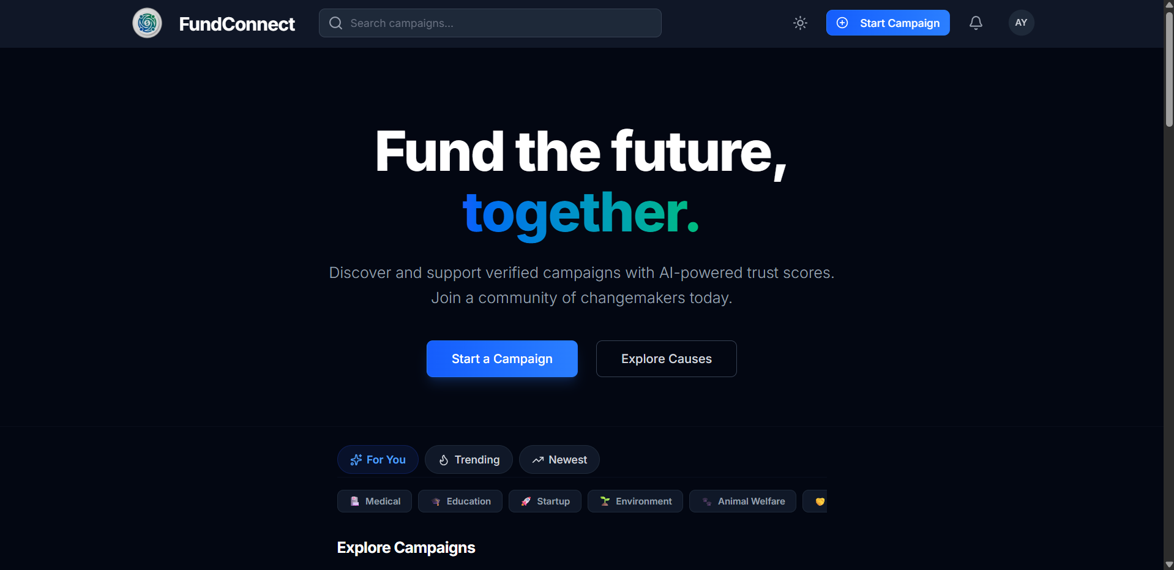

Figure 1: The Home Page displaying the hero section and featured campaigns.

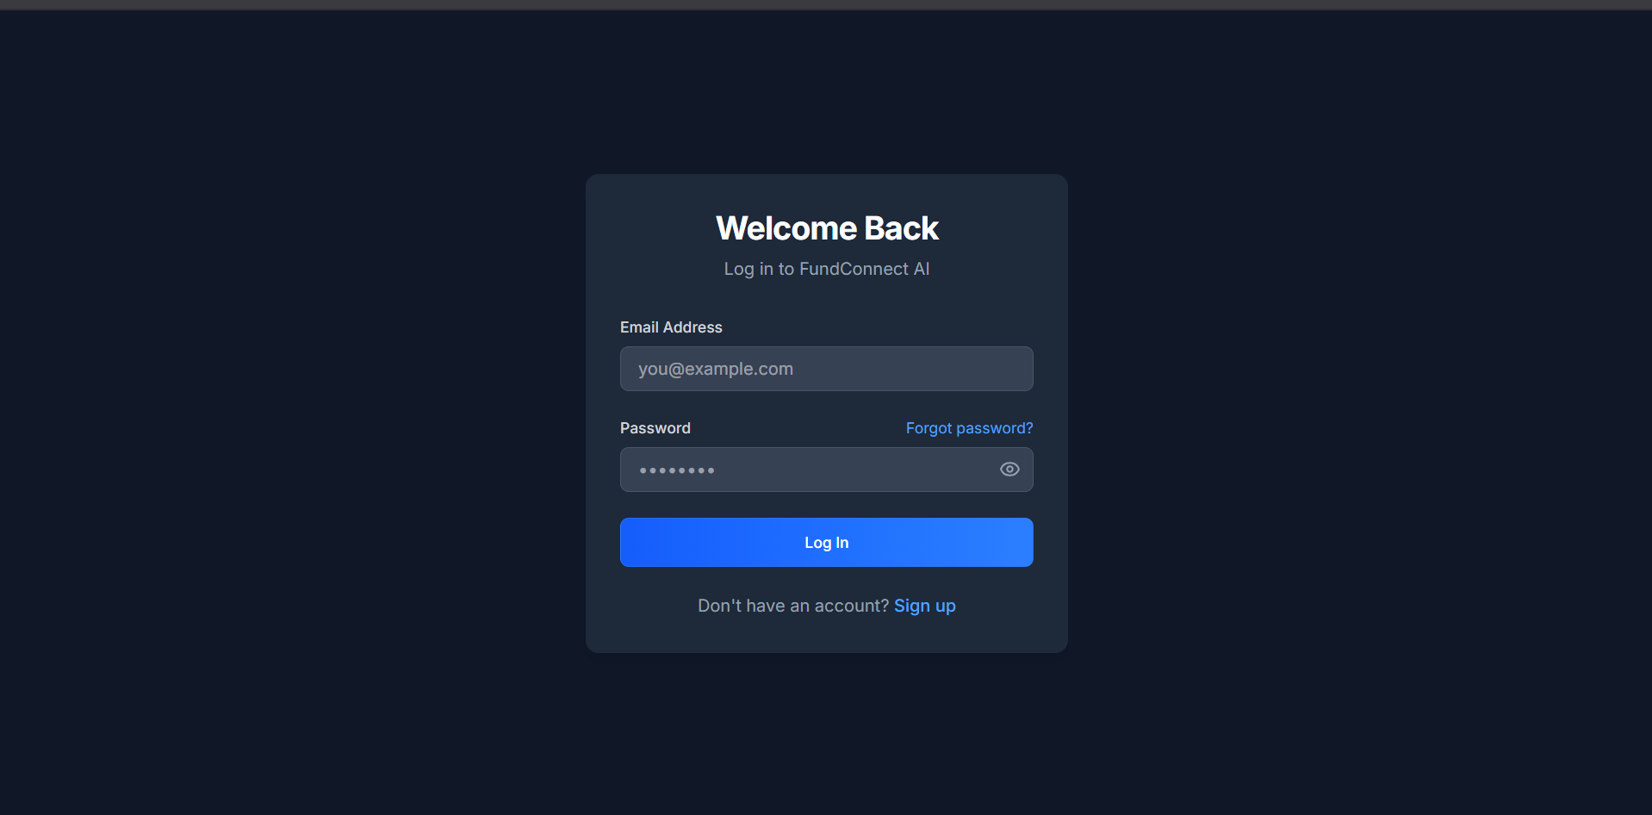

Figure 2: The secure user Login Page.

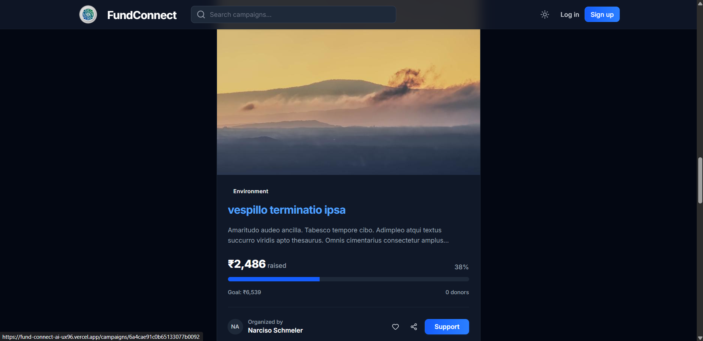

Figure 3: The dynamic Campaign Feed resembling a social media interface..
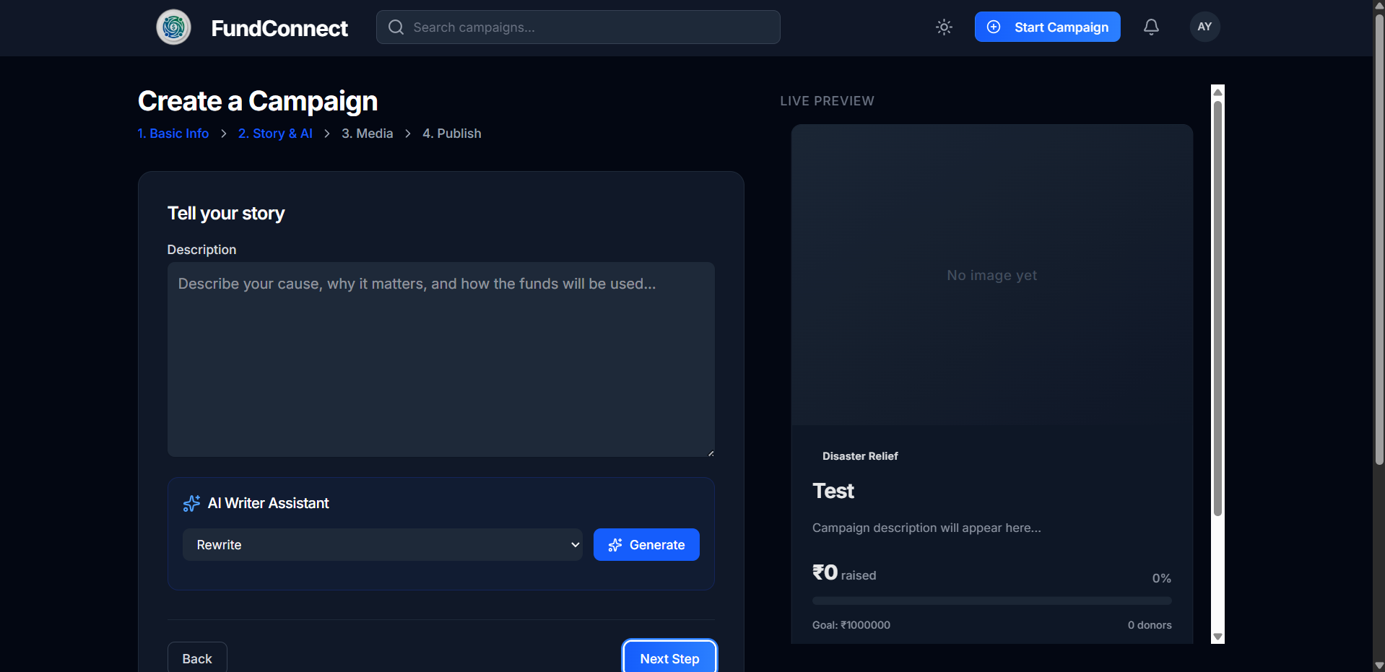Figure 5: The Campaign Creation Wizard with AI assistance tools.
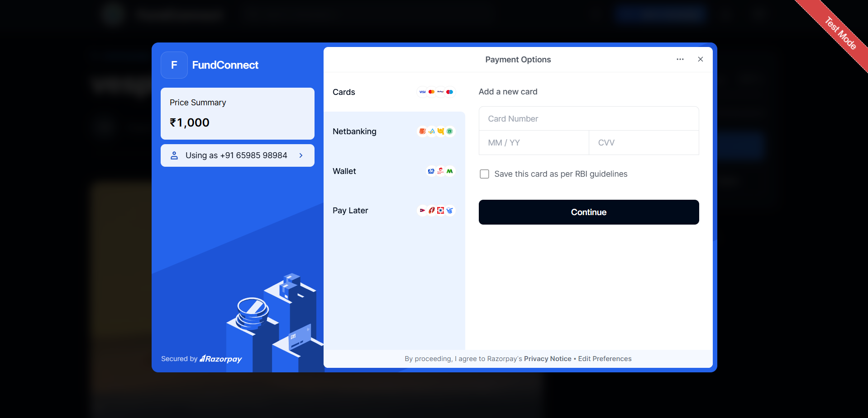Figure 6: The Razorpay checkout modal during the Donation Flow.
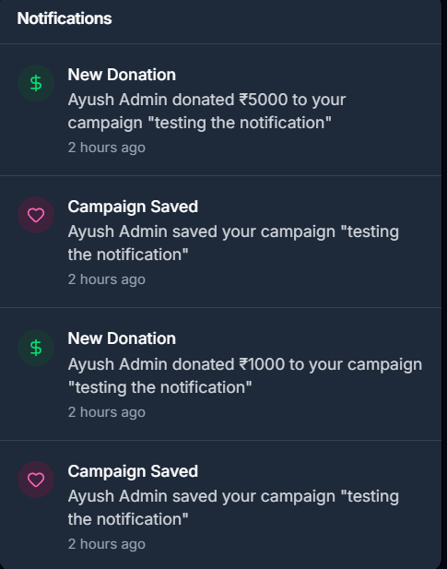Figure 7: Real-time Notifications dropdown panel.
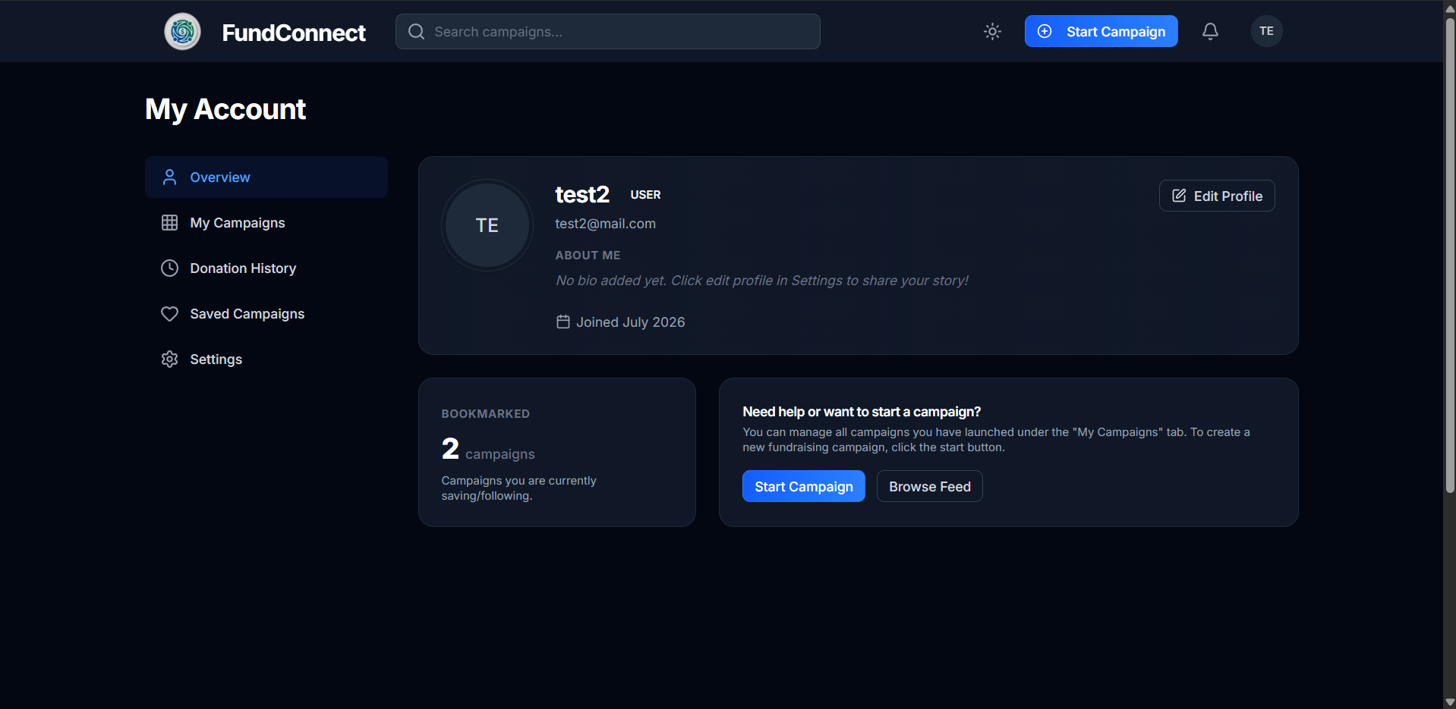Figure 8: The User Dashboard showing personal campaigns and donation history.
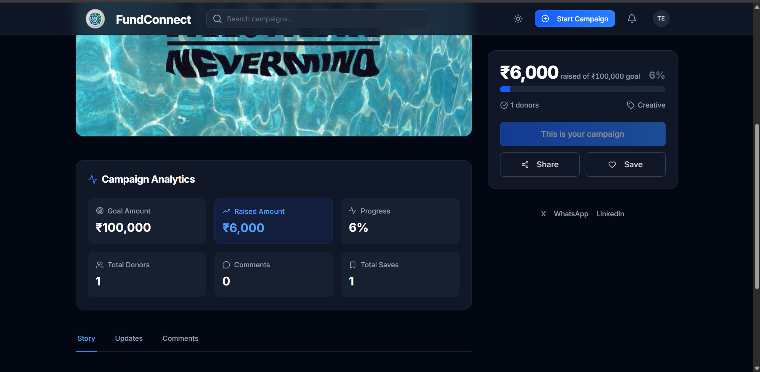Figure 9: Analytics displaying funding progress and engagement metrics.
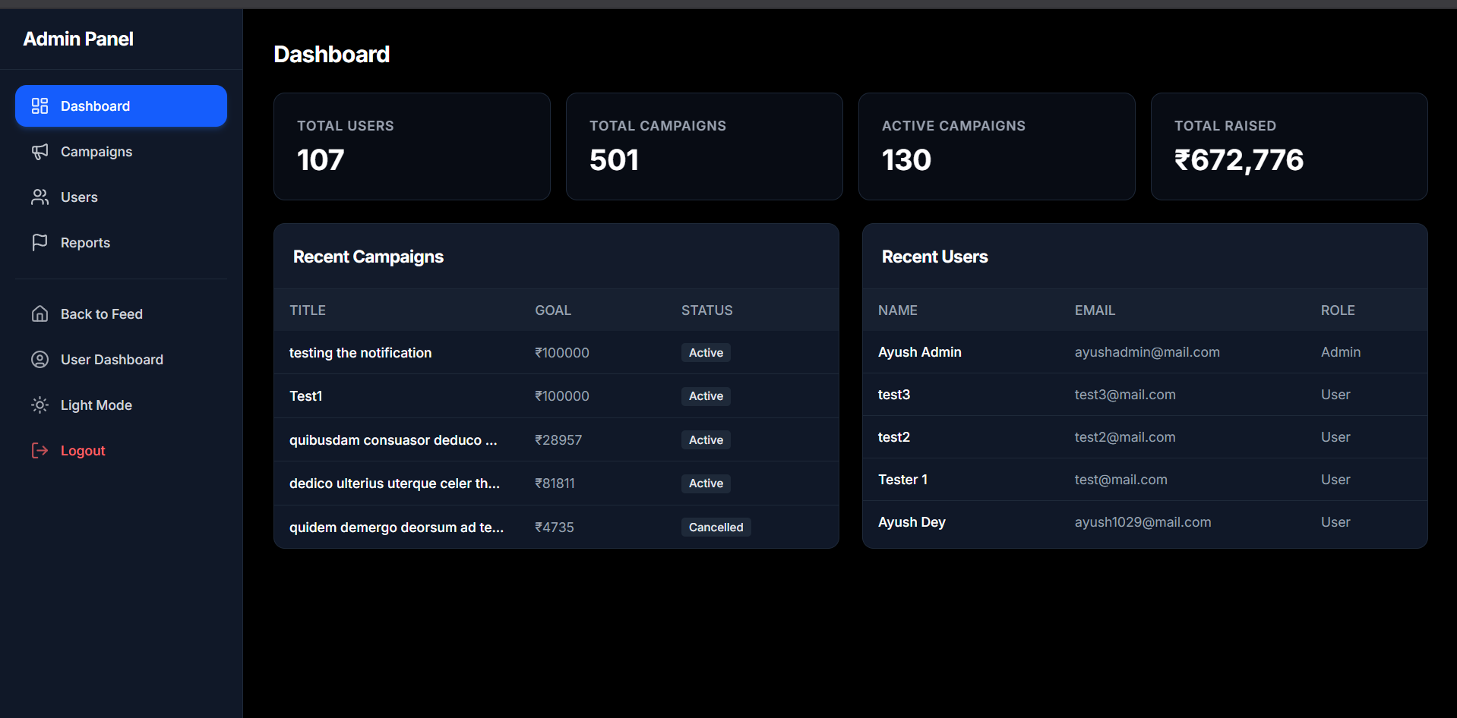Figure 10: The Admin Dashboard overview.
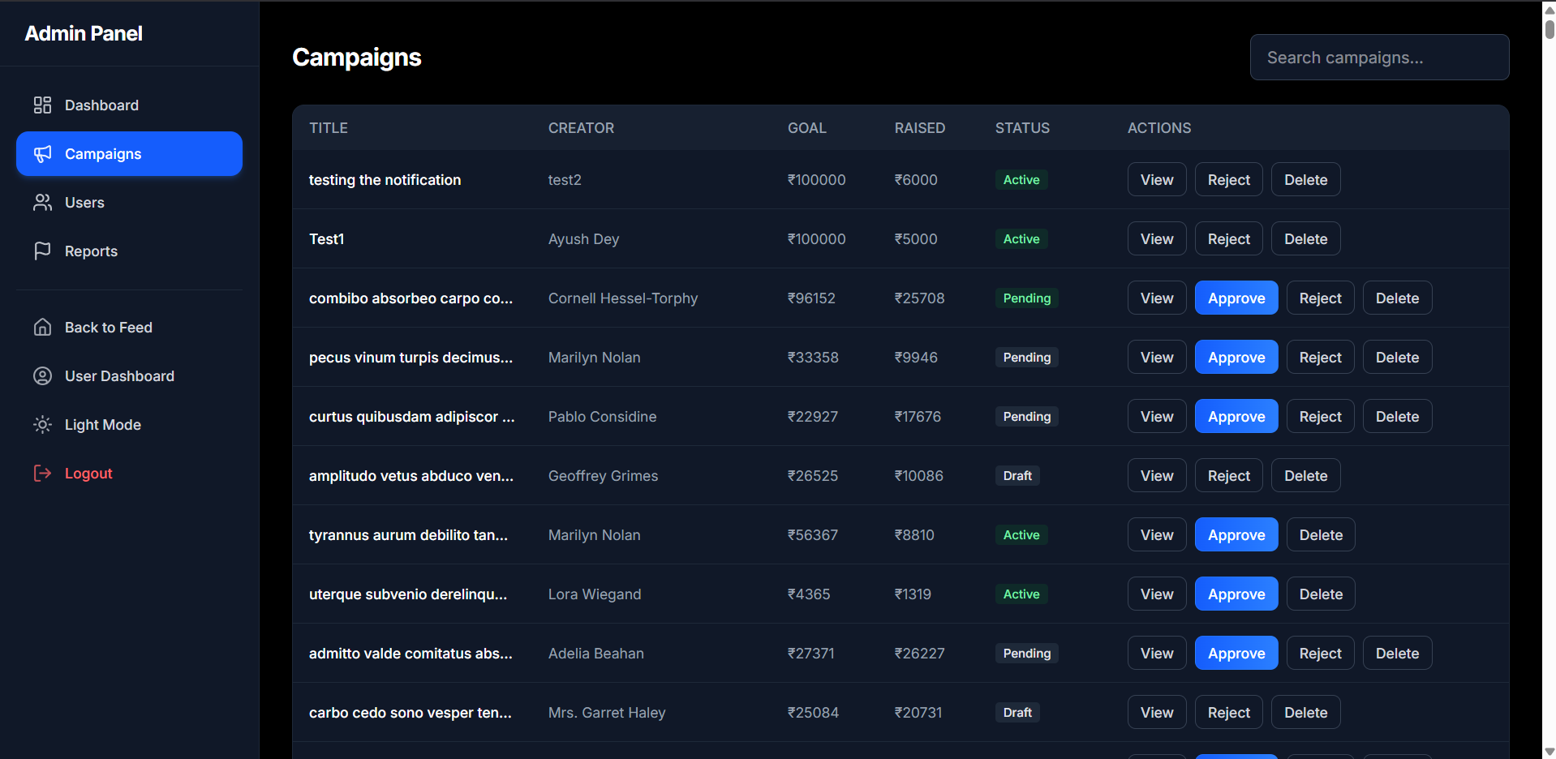Figure 11: Admin interface for Campaign Management and moderation.
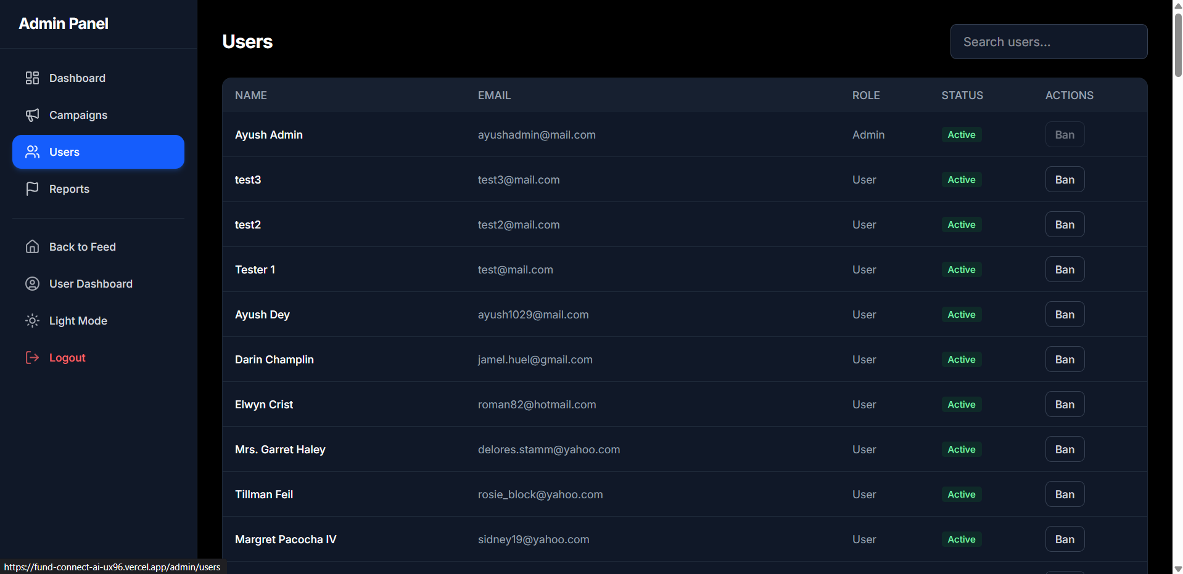Figure 12: Admin interface for User Management.
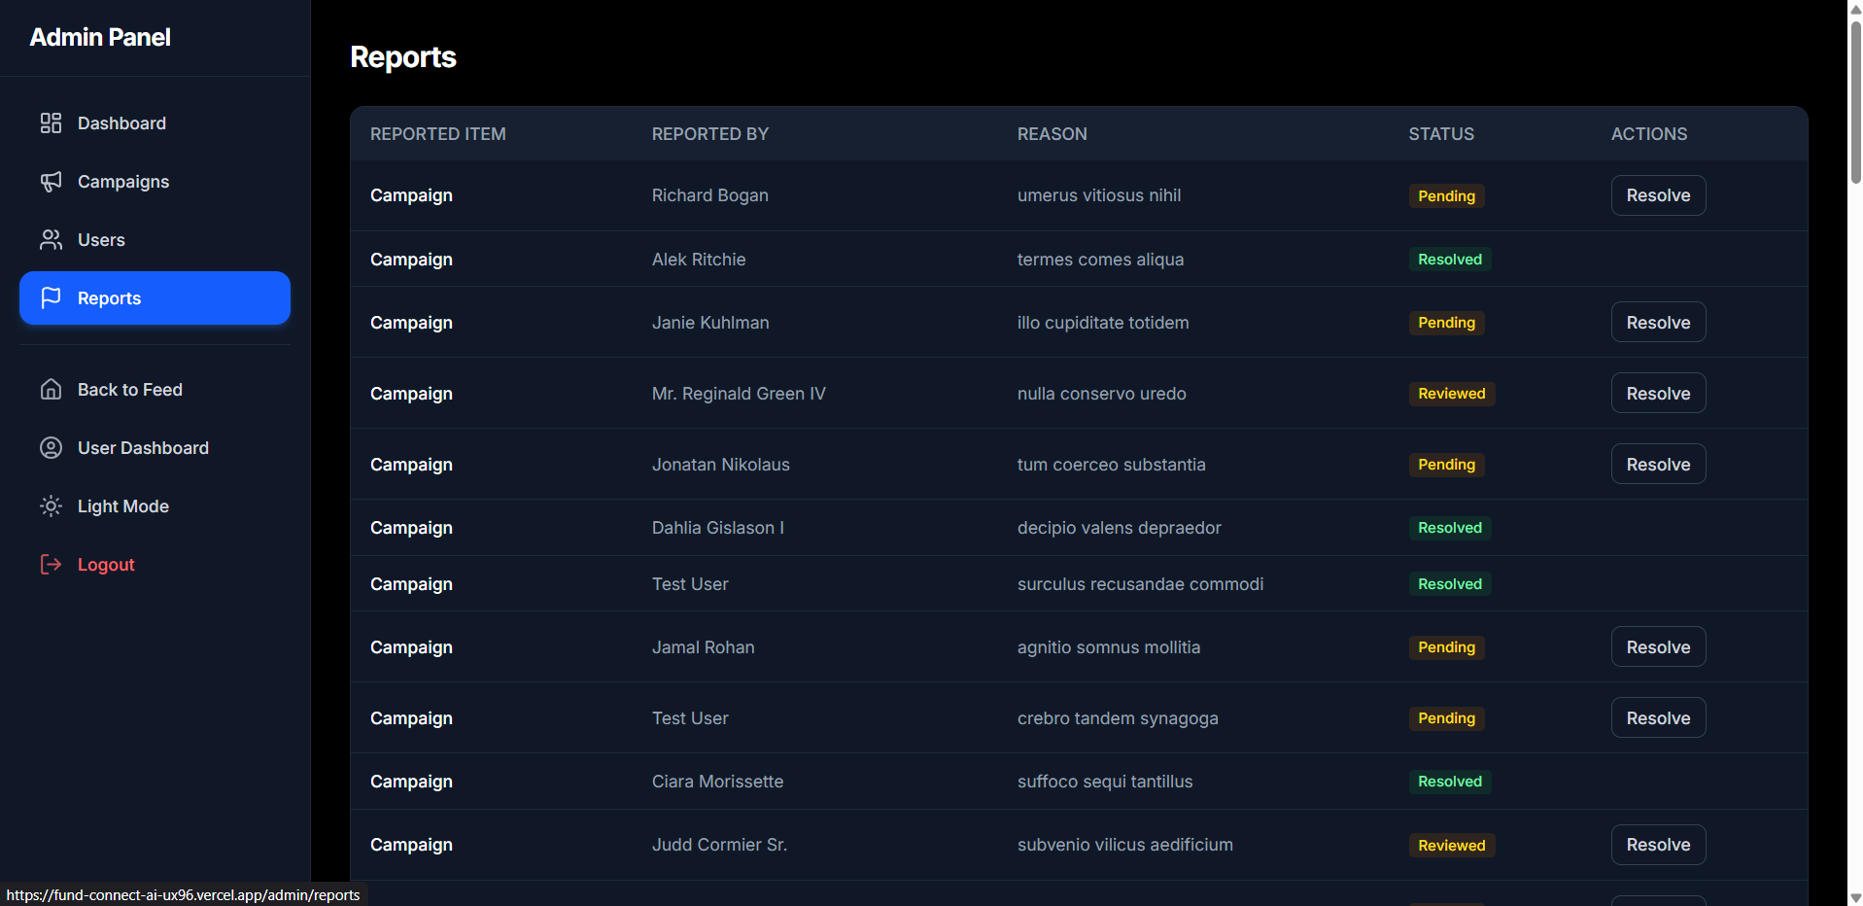Figure 13: System Reports and analytics overview.
[Insert Screenshot: Mobile View]
Figure 14: Responsive Mobile View of the platform.

12. Testing
Extensive testing was conducted to ensure system reliability, security, and usability. The following tables summarize key test cases executed across different modules.

12.1 Authentication Module Testing
Test Case | Expected Result | Actual Result | Status
Valid User Registration | User account is created, token returned. | User account created, JWT generated. | Pass
Duplicate Email Registration | Error message: Email already exists. | Error handled and displayed properly. | Pass
Valid Login Credentials | Successful login, JWT stored in client. | Successful login and navigation to feed. | Pass
Invalid Password Login | Error message: Invalid credentials. | Appropriate error message displayed. | Pass

12.2 Campaign & Donation Testing
Test Case | Expected Result | Actual Result | Status
Create Campaign (Valid Data) | Campaign saved to DB, redirects to detail page. | Campaign successfully published. | Pass
Generate AI Description | AI populates description field based on prompt. | Description populated with coherent text. | Pass
Initiate Razorpay Donation | Order ID generated, checkout modal opens. | Modal opens successfully with correct amount. | Pass
Verify Successful Payment | Signature validated, DB updated, notification sent. | Donation recorded and creator notified. | Pass

12.3 UI & Responsiveness Testing
Test Case | Expected Result | Actual Result | Status
Desktop Feed Layout | Cards align correctly, sidebar visible. | Layout renders perfectly on large screens. | Pass
Mobile Navigation | Hamburger menu works, layout stacks vertically. | Fully responsive and usable on mobile. | Pass
Scroll Restoration | Navigating back restores previous scroll position. | ScrollToTop logic works seamlessly. | Pass

13. Results
The development of FundConnect AI successfully culminated in a feature-rich, high-performance web application that meets all predefined objectives. The integration of a social media-style feed has significantly modernized the crowdfunding experience. Users interact with campaigns fluidly, resulting in a more engaging and immersive environment compared to traditional platforms.
The AI capabilities, powered by OpenRouter, performed exceptionally well during testing. The AI Writing Assistant successfully lowers the barrier to entry for campaign creators, while the AI Trust Score provides a standardized, objective evaluation metric that enhances platform credibility. The secure payment infrastructure utilizing Razorpay functions flawlessly in the test environment, ensuring that donations are processed and recorded accurately.

14. Output Screenshots
The final output of the platform is visually represented in the screenshots provided in Section 12. The responsive design ensures that the platform looks exceptional across all devices, maintaining the premium aesthetic requested during the design phase.

15. Conclusion & Future Work

Conclusion
FundConnect AI represents a significant leap forward in the crowdfunding domain by amalgamating social connectivity with advanced artificial intelligence. The MERN stack proved to be a highly effective architectural choice, providing the necessary speed, flexibility, and scalability required for a modern SPA. The platform successfully solves the problems of low user engagement and content creation barriers, establishing a secure and interactive community for creators and backers alike.

Future Work
While the current iteration fulfills all core requirements, several enhancements are planned for future releases:
- Live Payment Integration: Transitioning from Razorpay test mode to a live production environment to handle real currency transactions securely.
- Social Media OAuth: Implementing direct login capabilities via Google, Facebook, and Twitter to streamline the onboarding process.
- Advanced AI Analytics: Utilizing AI to predict campaign success rates and offer personalized recommendations to donors based on their interaction history.
- Mobile Application: Developing native iOS and Android applications using React Native to capture the mobile-first user demographic more effectively.
- Blockchain Integration: Exploring the use of smart contracts for escrow services to further enhance trust and transparency in fund disbursement.

16. References
- React Documentation. (n.d.). Retrieved from https://reactjs.org/docs/getting-started.html
- Node.js Documentation. (n.d.). Retrieved from https://nodejs.org/en/docs/
- Express API Reference. (n.d.). Retrieved from https://expressjs.com/en/4x/api.html
- MongoDB Manual. (n.d.). Retrieved from https://docs.mongodb.com/manual/
- Tailwind CSS Documentation. (n.d.). Retrieved from https://tailwindcss.com/docs
- Razorpay API Documentation. (n.d.). Retrieved from https://razorpay.com/docs/api/
- OpenRouter API Reference. (n.d.). Retrieved from https://openrouter.ai/docs

