ECEN 5623

Ayush Dhoot

Homework set 4

Due 2019/04/16

These problems should be done individually, not with your project partner.

1. Develop an example of a 32-bit Hamming encoded word (39 bits total) and show a correctable SBE scenario. Show the data word in a table like Figure 5.6 in the book.

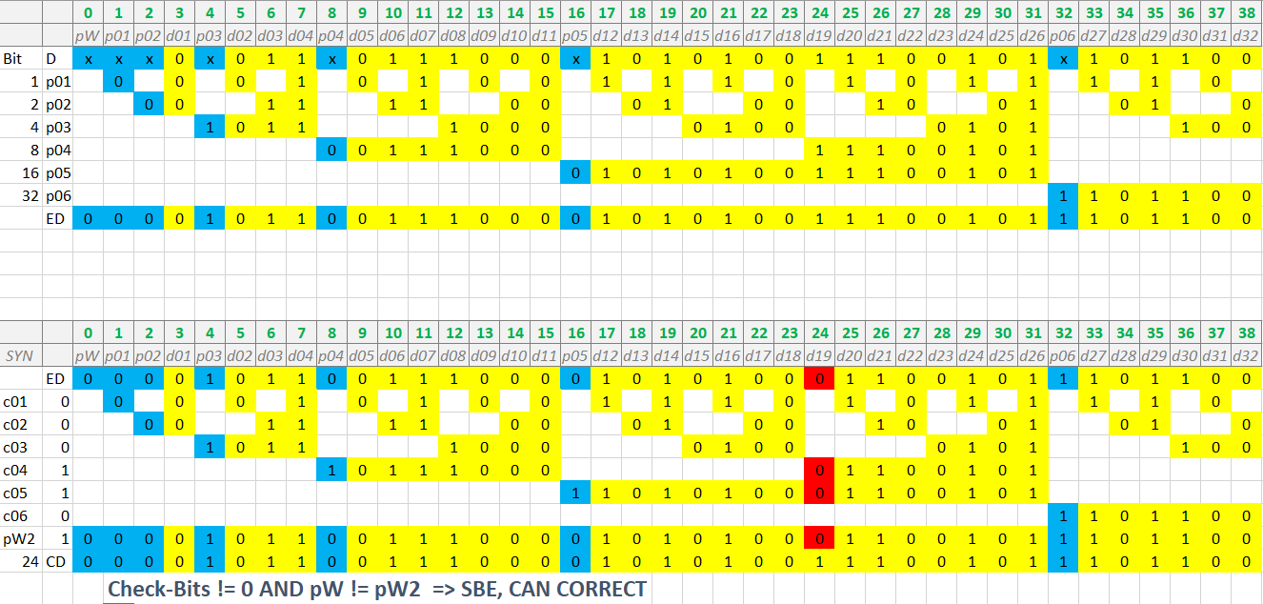

1. For the foregoing problem, now show an uncorrectable MBE scenario.

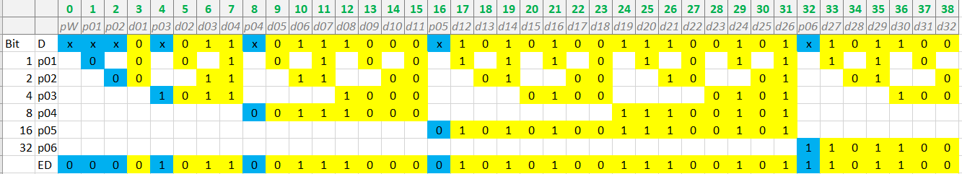

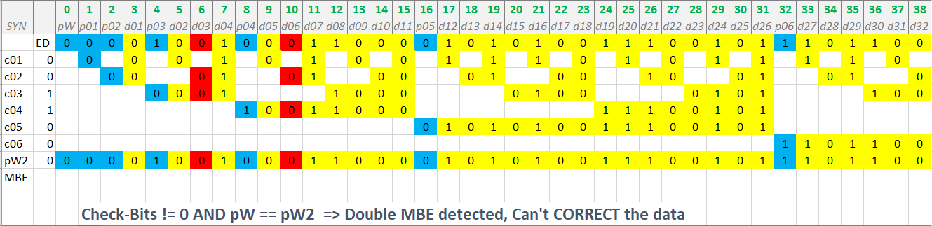

1. **For the following Nand flash block update history for 2 sectors that contain 4 blocks each (e.g. 16K sectors, with 4K blocks), fill in the missing WRITE operations as needed and compute write-amplification.**



**#1 – All blocks FREE**

**#2 – Erase S0 & S1, WRITE LB 0, 1, 2, 3**

**#3 – Read LB 0, 2, Modify, WRITE LB 0, 2**

**#4 – Read LB 1, 3, Modify, WRITE LB 1, 3**

**#5 – Read LB 0, 2, Modify and Cache**

**#6 – Buffer LB 0, 1, 2, Erase S0**

**#7 – WRITE LB 0, 1, 2 to S0**

**Write Amplification = 11/10 = 1.1**

**#8 - Read LB 1, 3, Modify and Cache**

**#9 – Erase S1**

**#10 – WRITE – Back LB 1, 3 to S1**

**#11 – Read LB 0, 2, Modify, WRITE LB 0, 2**

**#12 – Read LB 1, 3, Modify and Cache**

**#13 – Erase S0**

**#14 – WRITE – Back LB 1, 3**

**Write Amplification = 17/16 = 1.0625**

**Total sector erases for both S0 and S1 = 2 + 3 = 5**