Assignments

|- - Git

Q1. Create a directory ‘project_dir’ & cd to ‘project_dir’.

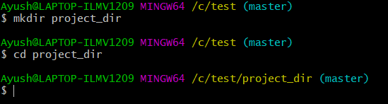

Q2. Initialize git version database.

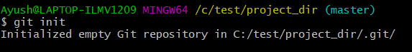

Q 3. Create a new file index.html.



Q4. Check the git status. You should find index.html as untracked file.

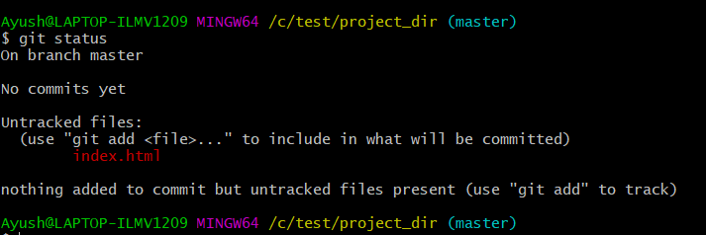

Q5. Stage the index.html file.

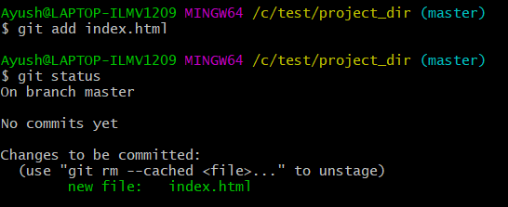

Q6. Commit index.html.

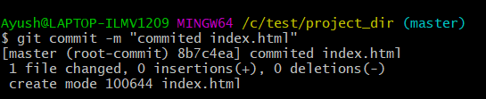

Q7.Make few changes in index.html & create a new file info.txt file.

. 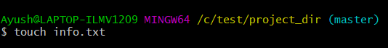

Q8. Check git status. You should find index.html & info.txt as untracked files.

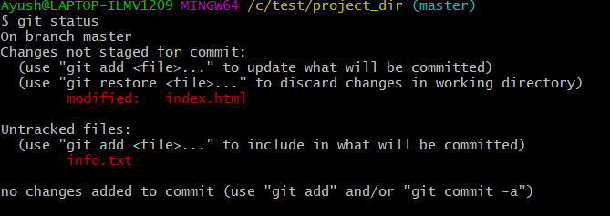

Q9. Configure GIT to ignore all txt files.

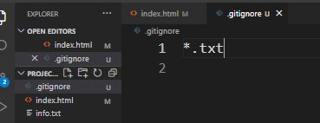

Q10. Again check the git status. You should find only index.html as untracked file.

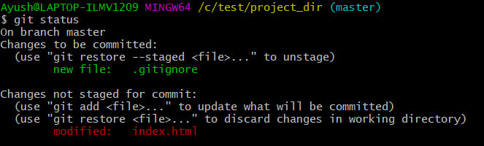

Q11. State & commit index.html.

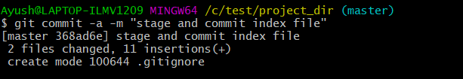

Q12. Log all your comments so far.

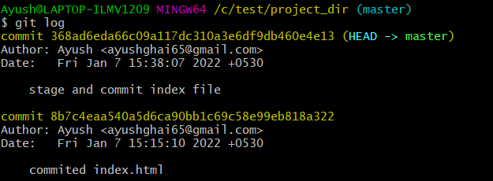

Q13. Make some changes in index.html.

Old file

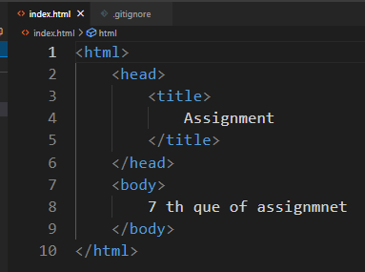

New file

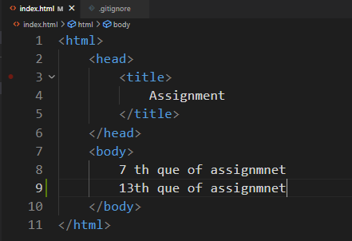 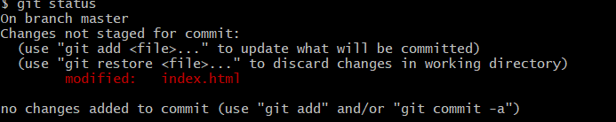

Q14. Revert the change made in the previous step using git command.

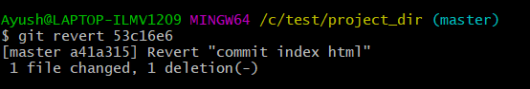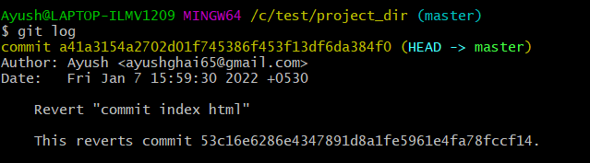

After reverting op

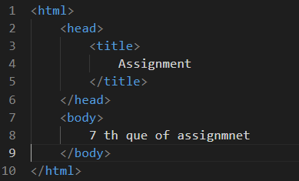

Q15. Again change index.html.

Old file new file

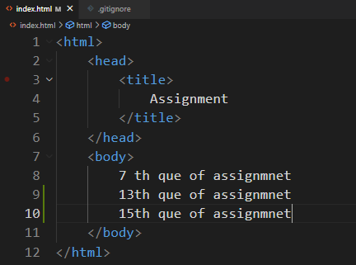

Q16. Stage index.html



Q17. Revert back the last stage

Old file

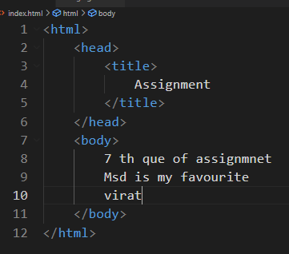

After reverting new file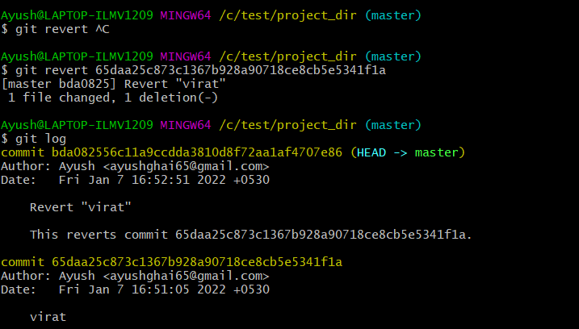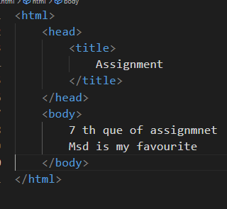

Again reverting without commiting



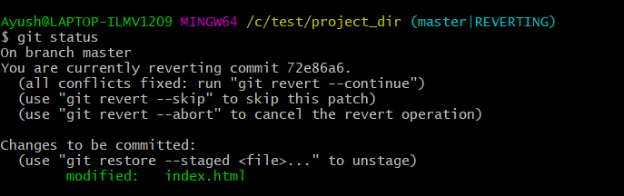

Q18 Rename ‘add’ command to ‘my-add’



Q19 Using my_add command Stage index.html again & commit the changes.

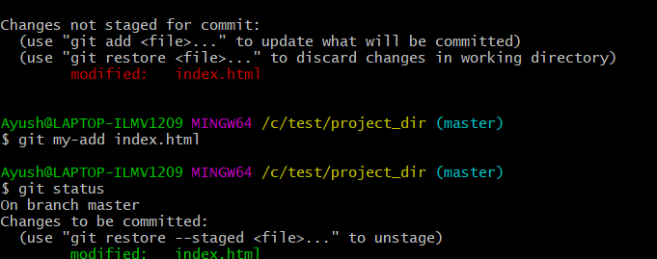

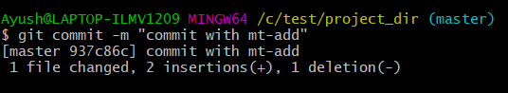

Q20 Revert the last commit.

