PLACEMENT PORTAL APPLICATION
Project Report — Modern Application Development
IIT Madras BS Data Science Programme

Author
Full Name | Ayush Ghosh
Roll Number | 24f2008987
Email | 24f2008987@ds.study.iitm.ac.in
About | Hey all! Ayush Ghosh here — a student pursuing BS in Data Science from IIT Madras. Apart from academics, I have a keen interest in cultural activities and enjoy exploring how technology can be used to solve everyday problems.

Description
This project is a web-based Placement Portal that digitises the campus recruitment process for institutes. The core idea came from the fact that most placement cells still rely on spreadsheets and emails — which makes tracking applications, managing companies, and avoiding duplicate entries a real headache.
There are three types of users in the system: Admin, Company, and Student. Companies register themselves and create placements, students can browse through the available placement drives and apply for them, and the admin handles everything from approving companies and placement drives to maintaining their records. The entire application is designed to be simple and easy to demonstrate.

Technologies Used

Backend & Database
Technology | Purpose
Flask | Core web framework — handles all routing, HTTP requests, and application logic
Flask-SQLAlchemy | ORM that lets us define database tables as Python classes and query them without writing raw SQL
Flask-Login | Manages user sessions, login/logout flow, and protects routes using the @login_required decorator
SQLite | Built-in file-based relational database. No server setup needed — the entire DB lives in one .db file, making local demos simple
Werkzeug | Handles secure password hashing and safe file uploads (resumes)

Frontend
- Jinja2 — Flask's templating engine; renders dynamic HTML pages using Python variables passed from routes
- Bootstrap 5 — CSS framework for a clean, responsive, mobile-friendly UI across all dashboards
- Bootstrap Icons — icon set used throughout the UI to improve visual clarity
- HTML5 — used for built-in form validation (required attributes, input types, min/max constraints)

DB Schema Design
The database has four tables. All are defined as SQLAlchemy model classes and created automatically via db.create_all() on app startup — no manual DB creation needed.
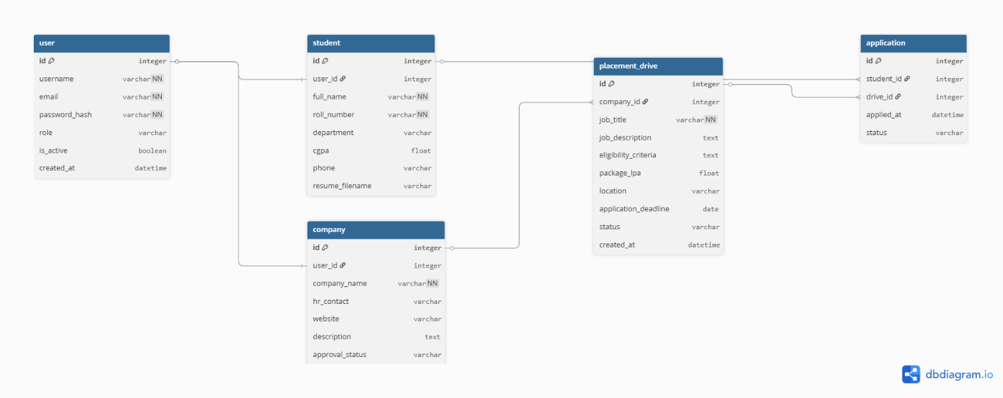

User
Central table for authentication, shared by all three roles.
- id (Integer, PK), username (String, Unique), email (String, Unique), password_hash (String)
- role (String) — one of: admin, company, student
- is_active (Boolean, default True) — set False when a user is blacklisted by admin

Student
1-to-1 with User. Holds academic profile details.
- user_id (FK -> User), full_name, roll_number (Unique), department, cgpa, phone
- resume_filename — stores the uploaded resume filename served from static/uploads/

Company
1-to-1 with User. Holds company profile and tracks approval state.
- user_id (FK -> User), company_name, hr_contact, website, description
- approval_status (String) — pending / approved / rejected

PlacementDrive
Created by companies, must be approved by admin before students can see it.
- company_id (FK -> Company), job_title, job_description, eligibility_criteria
- package_lpa, location, application_deadline (Date)
- status (String) — pending / approved / closed

Application
Records each student-to-drive application. Prevents duplicates at the DB level.
- student_id (FK -> Student), drive_id (FK -> PlacementDrive), applied_at (DateTime)
- status (String) — applied / shortlisted / selected / rejected
- UniqueConstraint on (student_id, drive_id) — enforces one application per student per drive

Schema has been designed such that authentication is completely segregated from profile information. The login process has been handled by the User table, whereas the Student table and the Company table contain information pertinent to their roles.

API Design
There is no additional REST API developed for this submission. Everything takes place using regular Flask routes that return rendered Jinja2 templates, utilizing the traditional MVC architecture. Routes function as controllers, SQLAlchemy models manage data, and Jinja2 templates provide views.
All form submissions use HTTP POST and all page loads use HTTP GET. Flask's redirect() and flash() are used to give users immediate feedback after every action (approval, rejection, application, status update, etc.).

Architecture and Features

Project Structure
The app is organised using Flask Blueprints — each role gets its own Python file with its own set of routes. This keeps the codebase clean and easy to navigate.
- app/auth.py — login, logout, and registration for all roles
- app/admin.py — company/drive approvals, student and company management, search
- app/company.py — drive creation/editing, applicant review, status updates
- app/student.py — drive browsing, applying, profile and resume management
- app/models.py — all four database models plus the admin seed function
- app/__init__.py — app factory that initialises Flask, SQLAlchemy, Flask-Login, and registers blueprints
Templates live in app/templates/ and are organised into subfolders per role. Every template extends a single base.html that contains the navbar, flash message display, and footer — so layout changes apply everywhere at once.

Core Features
- Role-based access — custom decorators (admin_required, company_required, student_required) protect every route
- Admin pre-seeded at startup — no admin registration; credentials are inserted once via create_default_admin()
- Company approval workflow — register → pending → admin approves/rejects → login unlocked
- Drive approval workflow — company creates drive → admin approves → students can see and apply
- Duplicate application prevention — enforced at both app logic level and DB UniqueConstraint
- Application status tracking — companies update statuses; students see live updates on their dashboard
- Resume upload — students upload PDF/DOC; companies can view resumes when reviewing applicants
- Search — admin searches students by name, roll number, or phone; companies by name
- Blacklist/Deactivate — admin can deactivate accounts without permanently deleting data
- Placement history — students have a dedicated history page showing all applications and outcomes
- Deadline enforcement — expired drives are filtered out from the student dashboard automatically

Additional Features
- All passwords stored as secure hashes — plain text passwords are never saved anywhere
- Flash messages on every action — immediate green/red/yellow feedback for every user interaction
- Fully responsive UI — Bootstrap 5 grid system ensures the portal works on all screen sizes
- Close drive option — companies can close a drive without deleting it, preserving application history

AI / LLM Declaration
I have not used any AI or LLM tools in the development of this project. All code, architecture decisions, and documentation were produced entirely on my own.

Video
The project walkthrough video will be uploaded and the link will be added here prior to the final submission deadline.
https://drive.google.com/file/d/1drwiJMrBTqumXtx2AV4Z4voyUOwWFTfl/view?usp=sharing

