Pytorch
Import library
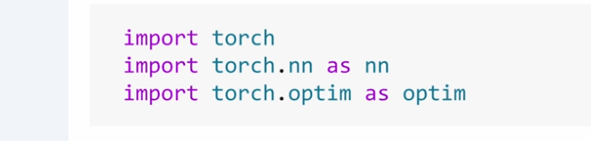

Pytorch core – torch
Components for neural network – nn
Tools for training – optim
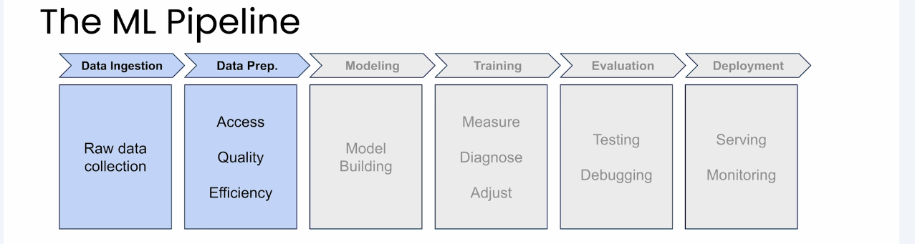

Torch size is like matrix

Initialzing with 0, 1, random
zeros = torch.zeros(3,3)
ones = torch.ones(2,4)
random = torch.rand(5,5)
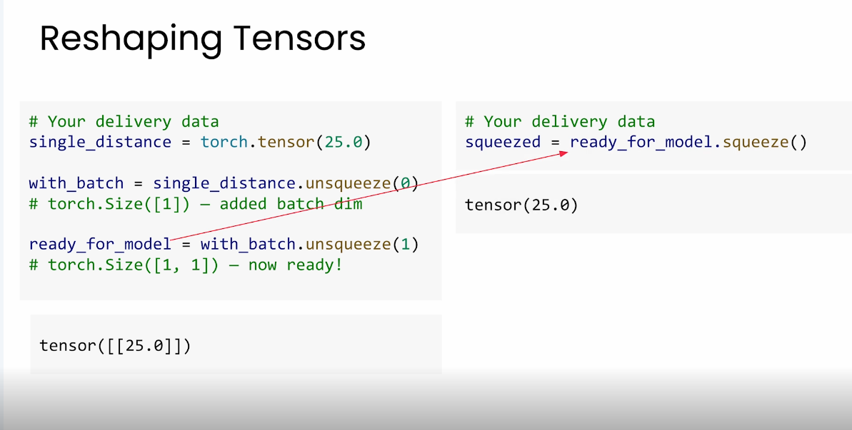

For broadcasting each pair must matct, two dimensions equal, or one is 1, or one has no dimensison

Unsqueeze adds a dimension of size 1
Unsqueeze(0) adds dimension at position 0

Squeeze removes alldimension of size 1

Transforms, dataset, dataloader

