**Attribute Binding**

In this lesson, we’re going to look at the concept of attribute binding. If you’re coding along with the repo, you can checkout the L3-start branch or the [starting code](https://codepen.io/VueMastery/project/editor/ZWEjLe) on Codepen.

**Our Goal**

In the starting code, we have a new div with the class of product-image.

📄**index.html**

<div class="product-image">

*<!-- image goes here -->*

</div>

By the end of the lesson, we’re going to have an img element here that is reactively bound to a new image property on our data. Whenever the value of that image changes, our image will update in the DOM.

**Adding an image to our data**

Remember in our **assets** directory we have an **images** folder, with images for green and blue socks? Let’s target one of those images from a new data property on our Vue app. We’ll do so by setting image equal to a path so it can grab that image.

📄**main.js**

const app = Vue.createApp({

data() {

return {

product: 'Socks',

image: './assets/images/socks_green.jpg'

}

}

})

Now we’re ready to add an img element in the template.

📄**index.html**

<div class="product-image">

<img src="image">

</div>

In the source attribute, we’ll say image. Right now, this won’t do anything. We want src to pull in the image path from our data, similar to how we pulled in the product data value in the h1 expression in the previous lesson.

So the question here is: **How do we bind the src attribute to the image data?**

**Introducing Attribute Binding**

To create a bond between an HTML element’s attribute and a value from your Vue app’s data, we’ll use a Vue directive called v-bind.

📄**index.html**

<img v-bind:src="image">

Now, we’ve created a reactive bond between what lives in this attribute ("image") and the image data itself.

Looking in the browser, we’ll now see our green socks image displaying.

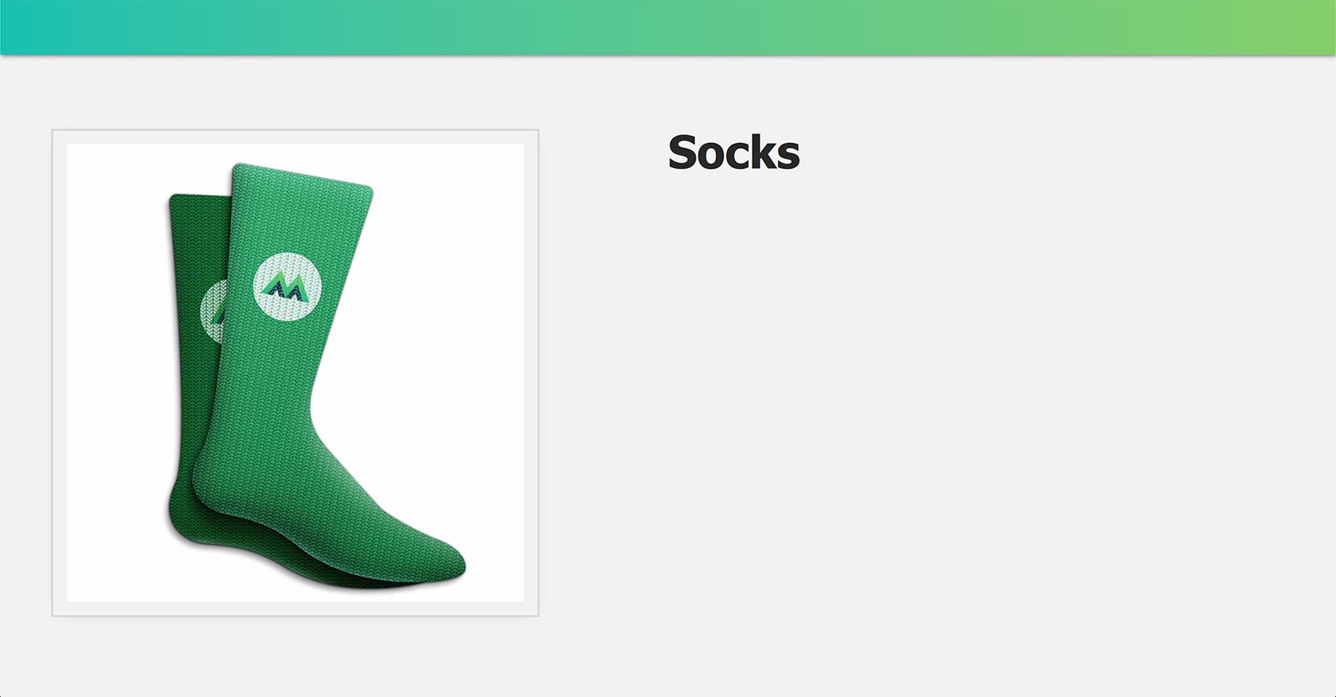

**Understanding v-bind**

How exactly is the v-bind directive working? We use this directive to dynamically bind an attribute to an expression. In this case, the attribute is src and the expression is whatever is in that attribute’s quotes: "image"

📄**index.html**

<img v-bind:src="image"> <! -- src attribute bound to the image data -->

If you’re thinking this doesn’t look like a typical JavaScript expression, you can imagine it looking like this: v-bind:src="{{ image }}". Under the hood, Vue is going to evaluate it just the same.

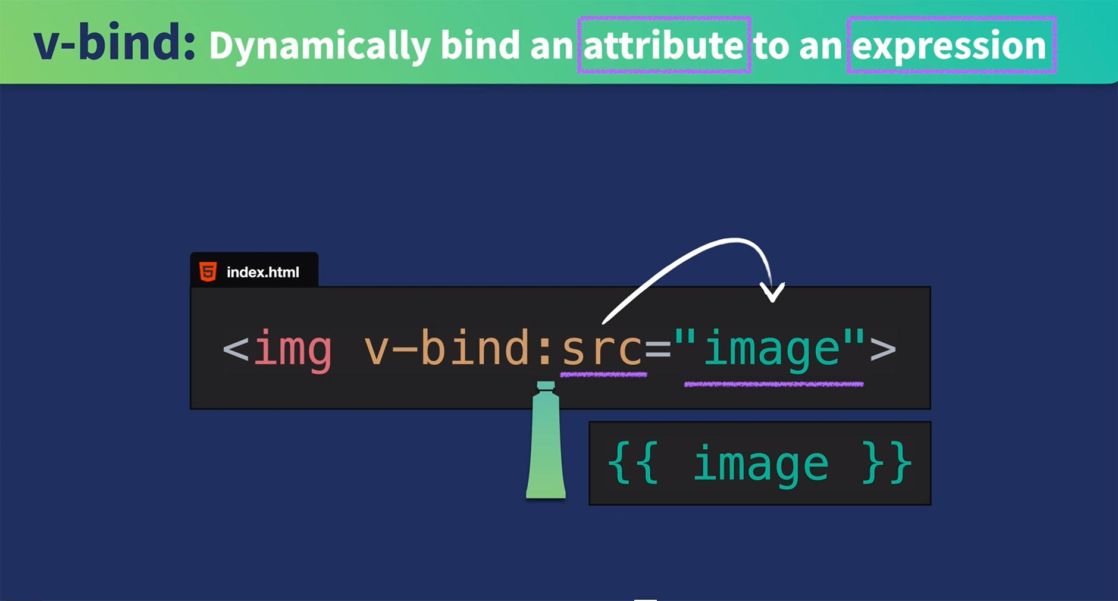

**A Reactive Bond**

Because of Vue’s reactivity system, if we updated our image data to a path that points to the image of our blue socks (image: './assets/images/socks_blue.jpg'), the expression that our src attribute is bound to would update and our browser would display the blue socks image.

**A shorthand for v-bind**

Using v-bind is super common—so common that there is a shorthand for it, and it’s just the colon, like so:

<img :src="image">

As you can imagine, since there’s so many different HTML attributes, there are many use cases for v-bind. For example, you might be binding a description to an alt attribute, binding a URL to an href, binding some dynamic styles to a class or style attribute, disabling and enabling a button, and so on.

**Coding Challenge**

We’ve reached the end of the lesson and we’re onto our second challenge:

**Add a url to the data object**

**Bind the url to an anchor tag’s href attribute**

As a reminder, if you’re coding along with our repo, you can check out L3-end branch, and you can view the [solution code](https://codepen.io/VueMastery/project/editor/AqemLM) on Codepen.