Web2Music: Page-Conditioned Music Generation with a Disclosure-Aware Classifier Cascade
Priya M  School of Computer Science and Engineering and Information Systems  Vellore Institute of Technology  Vellore, India  priya.m@vit.ac.in | Charanya R  School of Computer Science and Engineering and Information Systems  Vellore Institute of Technology  Vellore, India  charanya.r@vit.ac.in | Ayush Kumar  School of Computer Science  and Engineering  Vellore Institute of Technology  Vellore, India  theofficialayush.kumar@gmail.com | Sneha Jakhotiya  School of Computer Science and  Engineering and Information Systems  Vellore Institute of Technology  Vellore, India  sneha.rajesh2025@vitstudent.ac.in
Vedant Vidhani  School of Computer Science  and Engineering  Vellore Institute of Technology  Vellore, India  vedant.vidhani2025@vitstudent.ac.in | Tvisha Thakur  School of Computer Science  and Engineering  Vellore Institute of Technology  Vellore, India  tvisha.thakur2025@vitstudent.ac.in | Pari Khandal  School of Computer Science  and Engineering  Vellore Institute of Technology  Vellore, India  pari.khandal2025@vitstudent.ac.in

Abstract—A browser extension that plays music conditioned on the page being read must describe the page, keep page text on the device, and hide a slow generator. We present Web2Music, a Manifest V3 Chrome extension that addresses all three. The page descriptor takes 86 ms per page without the embedding model. A three-stage classifier (keywords, an on-device language-inference model, a hosted large language model) matches the macro-F1 of a keyword-then-LLM baseline on the 255-page development set (0.689) while sending 38% fewer pages off the device; the gates are tuned on those pages, with no held-out set. A mood-level clip becomes audible 36 ms after the mood is decided. Page-specific music replaces it when generation finishes, a median of 13 s for a 15 s clip on a consumer GPU, 62 s on its CPU and 20 s on an Apple M4, so in a cold-cache simulation it is heard on 52%, 34% and 48% of visits. Choosing each loop’s cut by its measured seam lowers the share of seams with an energy jump above 1 dB from 73% to 9% on 176 fresh clips. Generated audio is slightly closer to its intended mood than mismatched audio on three objective scorers; no listening study was run.
Index Terms—generative audio, context-aware computing, browser extensions, zero-shot classification, model cascades, on-device inference, ambient interfaces

I. INTRODUCTION
Background music is chosen once, for a session, and then ignored: a lo-fi playlist runs for four hours across a tax form, a horror wiki and a birthday message without registering that anything changed. Making it context-aware has meant recommending [11] from a library that anticipates every context. Text-conditioned generative audio models remove that requirement (§II): once a description can be derived from what the user is doing, music can be composed for it.
Web2Music does this for the web. Doing it well raises three engineering problems, none of them about audio quality. A page is navigation, advertising and colour, not a prompt, so a description must be derived from it. Classification is a privacy decision: the most accurate classifier is a hosted large language model (LLM), and calling one on every page would turn a music player into a browsing-history channel. And generation is slower than browsing: a cold 15 s clip takes 13 s on a laptop GPU, 20 s on an Apple M4 and about a minute on a laptop CPU, against a page load of about two seconds.
This paper gives one measured answer to each. A four-signal page descriptor (text, sentence embedding, colour, behaviour) costs 86 ms per page excluding embedding inference and 360 ms with it. A three-stage cascade (keywords, a zero-shot natural-language-inference model, an LLM) treats the share of pages sent off the device (the off-device rate) as a measured, adjustable quantity: with an on-device middle stage it matches the keyword-then-LLM baseline’s macro-F1 on the development set while disclosing 38% fewer pages. Fallback-then-swap playback keeps a sound audible 36 ms after the mood is decided whatever the generation time, and choosing each loop’s cut by measured seam cuts the share of seams with an energy jump above 1 dB from 74% to 12%.
What a listener hears falls into three levels of conditioning: L1, one of 11 pre-generated mood clips, always available and audible within 36 ms; L2, a cached clip generated earlier for a similar music profile; and L3, a clip generated for this page. We claim music conditioned on the page, not that listeners find it fits; no listening study was run.

II. RELATED WORK
Text-conditioned generators include MusicGen [21] (one autoregressive transformer over EnCodec [22] codebooks, with a 300M-parameter checkpoint that runs on consumer devices), MusicLM [23], the latent-diffusion AudioLDM [24], Stable Audio [12] and AudioGen [25]. All emit a fixed-length segment whose end is not joined to its start. LoopGen [1] makes a masked non-autoregressive model generate loops directly; for autoregressive models a loop can instead be cut after generation at a structural position found by self-supervised representations [13] or barwise self-similarity [26]. AffectMachinePop [2] generates pop music in real time from a valence–arousal trajectory [3], but the affect must be supplied.
Context-driven systems derive the prompt from the user’s situation, and all send it off the device: MetaBGM [14] sends game state to a cloud LLM, Discussion Jockey 2 [4] the meeting transcript, and Context-AI Tunes [5] a photo and a stress level. Casper [6] is a browser extension that cleanses input before a cloud LLM, but reports no corpus-level exposure rate. Model cascades such as FrugalGPT [15], Hybrid LLM [16], teacher-student caching [27] and agreement-based cascading [7] cut inference cost and latency, not what the expensive model sees; WeInfer [8] shows an LLM can run in the browser with WebGPU.

III. RESEARCH GAPS AND PROBLEM STATEMENT
Prior work leaves three gaps: system-level properties are unmeasured (evaluation ends at audio quality); cascades are tuned for cost, not for adjustable disclosure; and the seams of post-hoc loops are unmeasured. Web2Music is judged on four properties. Latency: how soon after a mood is decided something is audible, and how soon page-level audio follows. Disclosure: how much page text leaves the device, measured rather than assumed. Continuity: clips loop without gaps. Restraint: sensitive pages produce no audio and send nothing. The LLM proxy is designed to receive only the page title, a two-sentence description and keywords, and the generation service only the music profile; a network audit (§V-G) checks both.

IV. SYSTEM ARCHITECTURE
Web2Music is a Manifest V3 [17] Chrome extension plus one HTTP generation service. Fig. 1 follows a page from DOM to speaker.
Page descriptor. Four signals: text; a 384-dimensional MiniLM sentence embedding computed in-browser and matched against an IndexedDB store (2,000 entries) to flag revisits; an area-weighted HSL colour histogram; and scroll and cursor velocity, plus a readability score.
Classifier cascade. The classifier maps a descriptor to one of 13 content categories and one of 11 moods. The keyword stage stops the cascade at no cost when confidence is ≥ 0.5; moods combine the keyword score with colour and behaviour biases [9]. The zero-shot stage scores the text against 13 category hypotheses with natural-language inference [28]; with s₍₁₎, s₍₂₎ the two highest scores, it takes the top label only if
s₍₁₎ ≥ τ and s₍₁₎ − s₍₂₎ ≥ δ , (1)
and otherwise abstains [7]; the defaults are τ = 0.45, δ = 0.10. It has a hosted back end (bart-large-mnli) and an on-device one (quantised nli-deberta-v3-xsmall, ONNX, in the offscreen document). The LLM stage is gpt-oss-20b on Groq at temperature 0 with an 8 s timeout, after which keywords decide; a fully local configuration uses Qwen2.5-7B-Instruct via Ollama. The LLM stage can be switched off, which makes no LLM request at all (configuration A6). A mood must hold for 5 s before the music changes. Hosted stages sit behind a proxy that holds the keys. The share of pages that leave the device is
D = 1/N∑_{i=1}^{N} P(page i reaches an off-device stage), (2)
which the gate (τ,δ) adjusts. Every stage’s output is logged and the LLM’s raw answers are cached, so any configuration can be replayed offline.
A term list flags sensitive pages before either hosted stage, and an optional on-device entailment check scores the page against three hypotheses (personal crisis, discussion of a difficult topic, everyday content). A sensitive page produces no audio and is never sent to the LLM. A committed mood selects a row of a per-mood table (tempo range, key, timbre, instruments, reverb), tuned by page type and time of day, which fills a prompt template that ends with loop directives.
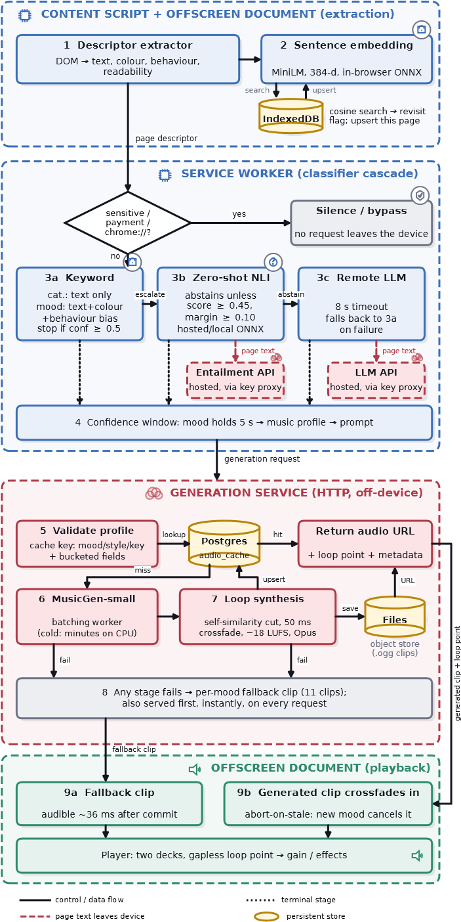
Fig. 1. System architecture of Web2Music.
Generation and loop synthesis. The service looks the profile up in a Postgres cache index (exact on mood, style and key; bucketed on energy, valence, arousal, tempo and duration) and on a miss runs MusicGen-small on one batching worker; the back end can also be MusicGen-medium or AudioLDM2-music. On any failure the mood’s pre-generated clip is used. Chroma self-similarity [26] and bar boundaries give candidate loop points (at least 3 s in); the default selector cuts at each, applies an equal-power crossfade (250 ms) and keeps the candidate with the smallest seam
J = |Δ E| + λ |Δ c| , (3)
where Δ E is the energy jump in dB across the loop, Δ c the jump in spectral centroid in Hz and λ = 1/5000, so the centroid only breaks ties. The earlier rule, cutting at the chroma-similarity maximum, remains as a switch. Loudness is normalised to −18 LUFS [29] and the clip is exported as Ogg/Opus, which adds no padding at repeats.
Playback and restraint. Two alternating decks loop the buffer through multiplicative gain stages (user volume, tab ducking, mood fade). Fallback-then-swap plays the mood clip at once and fades in the generated clip over 3 s when it arrives. Sensitive pages are skipped before any hosted stage; the player mutes when the tab itself is playing audio, ducks to 0.1 in background tabs, and skips payment, banking and browser-internal URLs. Telemetry stays in a local ring buffer with URLs replaced by a keyed HMAC-SHA-256 digest. In the fully local configuration (A6) only the music profile leaves the device; in the default (A6b), also the title, description and keywords of pages the on-device stages could not decide, sent to the LLM through the proxy.

V. RESULTS AND DISCUSSION

A. Evaluation design
Percentiles are nearest-rank; intervals are 95% percentile bootstrap (10,000 resamples). The development set is 255 real pages in seven slices (general, vocabulary mismatch, non-English, mixed-genre, sensitive, near-miss, bypass), 252 category-labelled. Every threshold is chosen on it, so the cascade results are development-set results and no held-out set was evaluated. The adversarial slice is 47 hand-written pages (29 sensitive, 18 not) built from the detector’s own term lists. Three authors labelled every page independently and the gold label is their majority, which resolves on 208 pages and agrees with the collection category on 85% of them; only category and binary sensitivity are labelled, and mood is not evaluated. No LLM chose pages, labelled them or judged any output. Krippendorff’s α [18] is 0.635 for category (just under the 0.667 reliability threshold, so cascade results are tentative), 0.419 for sensitivity and 0.195 for mood, which stays low after coarsening to valence–arousal quadrants [3] (0.121) or NRC VAD norms [10] (0.300); mood is therefore a stylistic mapping, not a classification target. Hardware is an RTX 5060 laptop GPU (8 GB), the same machine CPU-only (i7-14650HX), an Apple M4, and an i7-1255U CPU laptop for the stubbed systems benchmark.
TABLE I
Cascade configurations on the 255-page development set.
 | Configuration | Acc. | Macro-F1 [95% CI] | LLM | Off-dev.
A1 | keyword only | .190 | .315 [.25, .37] | 0 | 0
A2 | hosted zero-shot only | .556 | .595 [.53, .65] | 0 | .976
A3 | LLM only | .694 | .694 [.64, .74] | 1 | 1
A4 | keyword → LLM | .679 | .689 [.63, .74] | .757 | .757
A5 | keyword → hosted ZS → LLM | .643 | .678 [.62, .73] | .220 | .757
A6 | keyword → local ZS | .433 | .500 [.44, .55] | 0 | 0
A6b | keyword → local ZS → LLM | .671 | .689 [.63, .74] | .467 | .467

B. Descriptor cost and classification
On 105 live websites in automated Chromium, descriptor construction takes a median of 86 ms against a 1,989 ms navigation (embedding inference stubbed); with the real warm MiniLM model on 166 sites the median is 360 ms (p95 519 ms), 343 ms of it the embedding. Of 204 sites attempted, 38 failed to load and are excluded. Text extraction, colour histogram and readability take medians of 11.0, 3.9 and 1.5 ms; most of the rest, and the whole p95 tail, is the idle-scheduled vector-store search. Boilerplate removal keeps 80.8% of visible text. Removing colour changes the mood label on 7.5% of pages and reducing the descriptor to text alone changes 10.2%; with no reliable mood ground truth this shows influence, not benefit.
Table I and Fig. 2 give the cascade results. Keyword-only (A1) discloses nothing at .190 accuracy and LLM-only (A3) reaches .694 by disclosing every page. Keyword-to-LLM (A4) is within .005 of A3’s macro-F1 (paired 95% CI [−.041, +.033]) while keeping 24% of pages on the device. Every macro-F1 interval is about ±.05 wide. A local middle stage is what makes the cascade a privacy mechanism: A6b matches A4’s macro-F1 (.689; paired difference .000, CI [−.044, +.042]) while off-device pages fall from .757 to .467, a 38% reduction, and the local model answers in a median of 390 ms against 1.74 s for the hosted one.
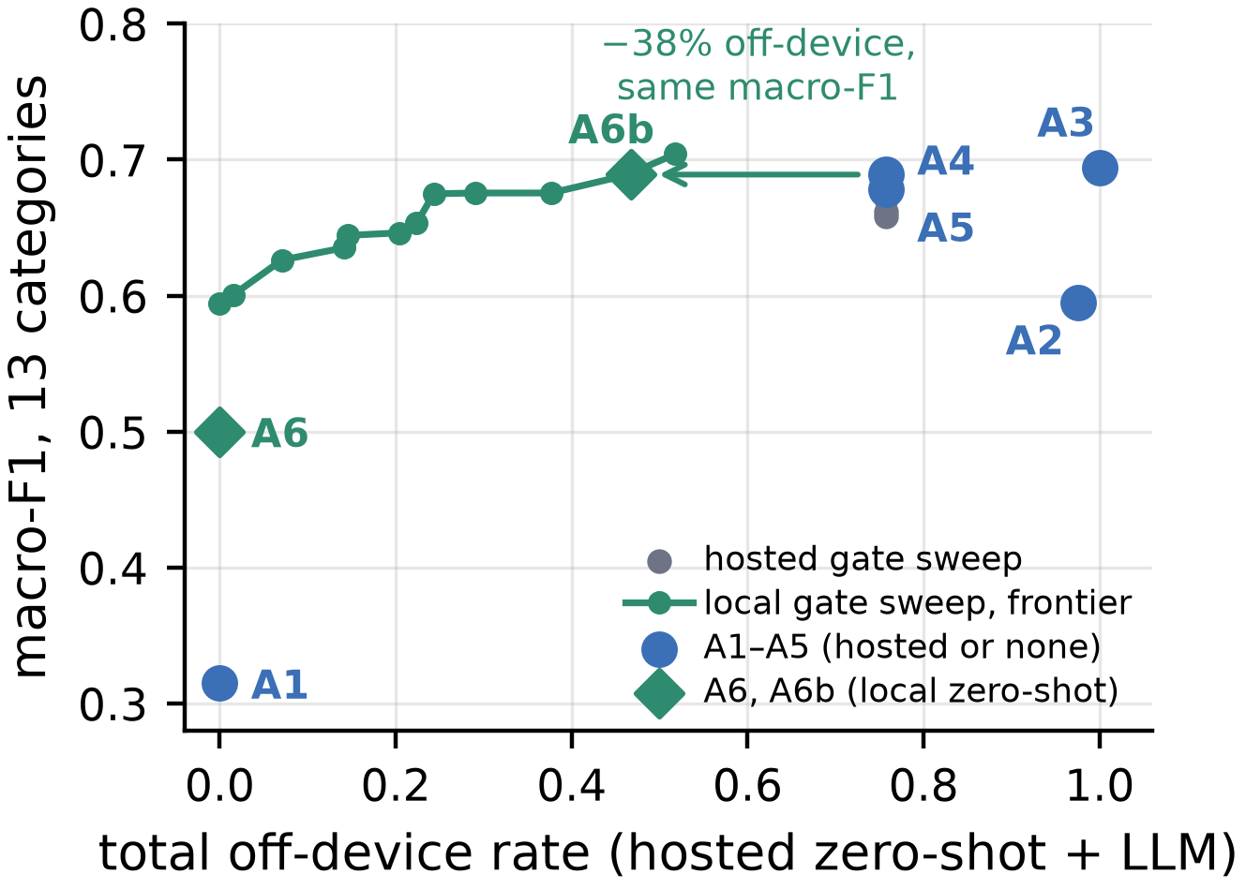
Fig. 2. Macro-F1 versus off-device rate.
The local gate is the disclosure dial: lowering the score threshold from 0.45 to 0.30 cuts off-device from .467 to .290 at macro-F1 .675, and opening the gate entirely keeps every page on the device at .594, level with the hosted zero-shot model alone (A2); A6 at the default gate reaches only .500 because declined pages fall to a default category. The gates are tuned on these pages, so the frontier locates the trade-off but is not out-of-sample, and the .689 may be optimistic. A hosted middle stage only redistributes disclosure: A5 cuts LLM exposure from .757 to .220, but the pages it keeps from the LLM reach the hosted zero-shot endpoint instead, so total off-device stays .757; across a twelve-cell sweep of the hosted gate it holds at .756–.757 while LLM exposure ranges .106–.576. Only a local back end changes whether a provider sees a page.

C. Generation latency and fallback-then-swap
TABLE II
Client-side latency by request path.
Path | HW | n | p50 | p95
Fallback clip served | CPU laptop | 33 | 7 ms | 153 ms
Cache hit, end to end | CPU laptop | 93 | 2.09 s | 2.11 s
Navigation to generated audio, A6 (LLM off) | GPU | 110 | 7.7 s | 37.6 s
Navigation to generated audio, A6b (local 7B LLM) | GPU | 110 | 7.9 s | 64.6 s
Navigation to audible, stubbed | CPU laptop | 54 | 6.86 s | 11.28 s

Table II shows the routes a request can take and Fig. 3 the cold generation time per tier. The fallback clip is served in 7 ms, so the audible start is never delayed by generation. A cache hit spends almost all of its 2.09 s in the cache lookup, which pooled database connections lower to 8 ms. Only the GPU generates faster than real time (RTF 0.83–0.85 for the generator call alone); the M4 takes 72 s for a 28 s clip (RTF 1.8–2.3) and the CPU-only host 62 s for a 15 s clip (RTF 3.9–4.2). No request failed or fell back. Concurrent requests give no throughput gain (speedup 1.01–1.02× at 2, 4 and 8 requests), so queueing delay grows linearly with the number of waiting requests.
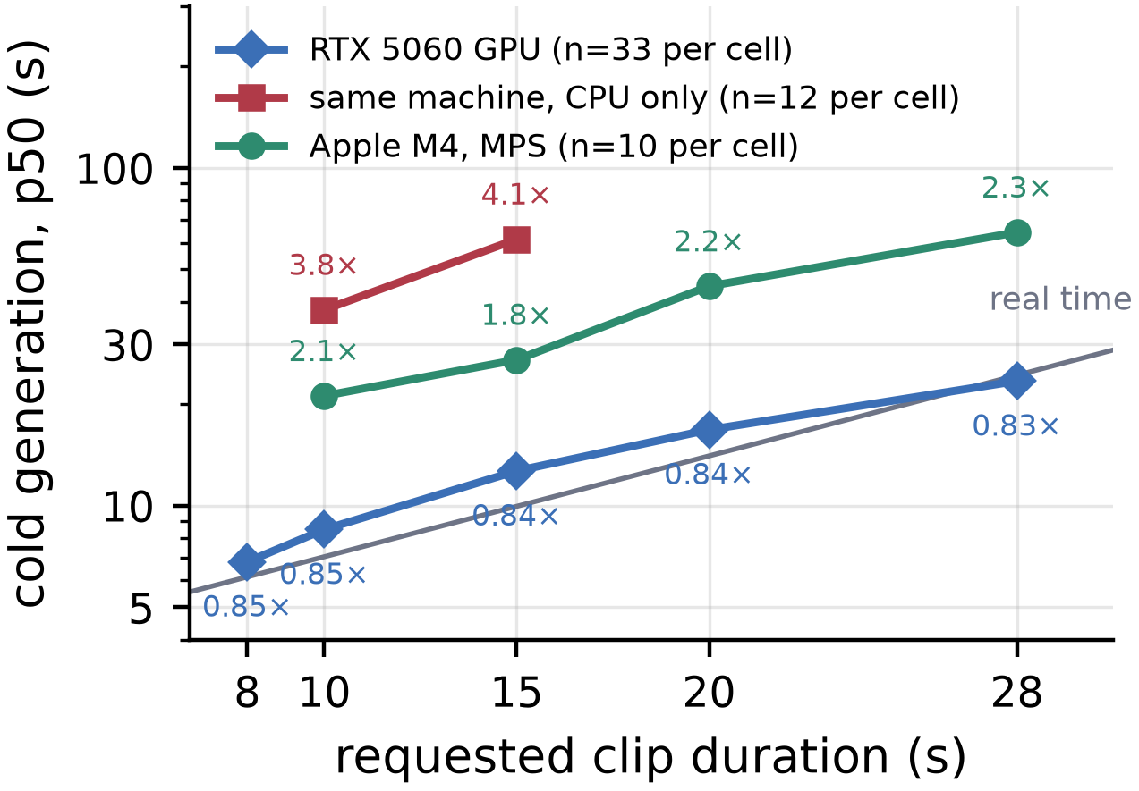
Fig. 3. Median cold generation time per tier, with real-time factors. Only the GPU stays at or below real time.
With the real classifier, embedding model and generator, the built extension loaded 11 fixture pages 10 times each per setup. With the LLM stage off (A6) the first sound arrives at a median of 7.7 s (p95 12.1 s), almost all of it the 5 s confidence window, and generated audio takes over at p95 37.6 s. With the LLM on (A6b) the first sound arrives at 7.9 s, but generated audio is later (p95 64.6 s) because the local 7B LLM shares the 8 GB GPU with MusicGen and roughly doubles generation time; a hosted LLM would not. All 220 loads became audible. With generation and classification stubbed, 54 of 55 loads became audible at a median of 6.86 s; the first extraction finishes in 0.86 s and, once the mood commits, the fallback is audible in a median of 36 ms (p95 54 ms) whatever the generator is doing. The remaining latency is the confidence window, a design parameter, not model latency.

D. How often generated audio is heard
The 36 ms figure describes the mood clip (L1), not generated audio. Whether a listener reaches the page-level clip depends on dwell time against generation time: P(L3) = P(T_{gen} + W < T_{dwell}), with W = 5 s the confidence window. We simulate browsing sessions: moods follow a Markov chain fitted to the corpus, dwell times are Weibull [19] with the median swept from 10 to 120 s (longer for long-form pages), generation times are drawn from each tier’s measured distribution, and there is one worker whose job is cancelled when the next page needs a different clip. The cache starts empty each session and the 99-entry pre-warm grid is credited only with its measured hit rate on real profiles, which is 0 of 235 pages.
TABLE III
Simulated share (%) of visits and listening time by level (30 s median dwell).
Tier | Clip | Visits L1/L2/L3 | Listening L3 | Long-form L3 | Other L3
GPU | 15 s | 14/15/52 | 75% | 62% | 49%
GPU | 28 s | 21/14/46 | 72% | 59% | 42%
CPU | 15 s | 37/10/34 | 64% | 50% | 29%
M4 | 15 s | 19/14/48 | 73% | 61% | 44%

The simulation says how often generated audio could be heard; it is not a measurement of listeners. At a 15 s clip, page-level audio is heard on 52% of visits (75% of listening time) on the GPU, 48% (73%) on the M4 and 34% (64%) on the CPU, so dwell time and the confidence window matter more than generator speed. The GPU share rises with median dwell (37%, 52% and 64% at 10, 30 and 120 s; 52%, 62% and 68% on long-form pages). If half the pages hit the pre-warm grid, which we do not observe, it would fall to 29% at 30 s, because a grid hit is served as L2. A cache persisting across sessions would serve 81% of visits as L2, a trivial upper bound since the corpus has only 75 distinct profile keys.

E. Conditioning fidelity and generator choice
With no listening study we ask a narrower question: does audio generated for a page agree with its intended mood more than audio for a page of a different mood? The cascade (with the local Qwen2.5-7B LLM) builds a profile for each of the 234 non-sensitive pages; we generate 702 clips (3 seeds each) on the GPU and compare each with a shuffled control from a page at least two steps away in valence–arousal space. Scorers are non-generative: Essentia valence/arousal regressors and the MTG-Jamendo mood tagger; LAION-CLAP, which retrieves a page’s own clip among 10 candidates from its title and lead text (chance 10%); and Audiobox Aesthetics for quality.
TABLE IV
Conditioning fidelity, matched versus shuffled clips.
Measure | Matched | Matched − shuffled [95% CI]
Valence Spearman ρ | .40 | –
Arousal Spearman ρ | .51 | –
Valence–arousal distance to target (closer) | – | +.050 [.026, .076]
Intended mood in top-5 tags | 59.9% [56.2, 63.4] | +7.5 pts [1.3, 13.8]
CLAP page-text similarity | – | +.023 [.014, .033]
CLAP top-1 retrieval (chance 10%) | 12.5% [10.1, 15.0] | –

Matched clips are closer to the intended mood on all three scorers (paired Wilcoxon p = .010, .029, 4×10⁻⁵; mixed-model intercepts accounting for the three seeds per page, p = 2×10⁻⁶, .004, 3×10⁻⁸), and valence and arousal track the intended values (ρ = .40, .51, p < 10⁻²⁷). The effects are small: the tagger’s hit rate for a shuffled mood is already 52%, and CLAP retrieves a page’s own clip in only 12.5% of cases against 10% chance, so the audio shifts toward the intended mood on average but a page’s clip cannot be picked out from its text. These are proxies inheriting the biases of their models (CLAP is trained on music captions, not web pages, and the mood-to-tag mapping is an assumption), not perceived fit. Production quality is 7.03 [6.97, 7.09], against 7.33 for the shipped fallbacks.
Table V compares generators on the same 11 moods and 5 seeds. MusicGen-medium is slower with no better seam (−0.03 dB [−0.08, 0.01]) or quality, while AudioLDM2-music is fastest but farthest from the fallback clips and lowest in quality; the data support the default only on speed and seam quality.
TABLE V
Generators (15 s, 55 clips each). FAD is against the fallback clips.
Generator | RTF | Seam |Δ E| | FAD downarrow | PQ
MusicGen-small | 0.89 | 0.11 dB | 0.33 | 7.34
MusicGen-medium | 1.61 | 0.12 dB | 0.37 | 7.47
AudioLDM2-music | 0.51 | 0.05 dB | 0.68 | 6.87

A prompt ablation (bare mood word, service template, engineered 312-character prompt; 165 clips) shows no measurable effect on seam quality (paired differences 0.00 to −0.05 dB, p ≥ .34) or on generation time (13.2–13.3 s median); the earlier M4 difference did not reproduce.

F. Loop quality
All 141 delivered clips fall within their duration bounds and land at −18.09 LUFS. Delivered loops keep a median 50.3% of the requested duration, so a 28 s request repeats about every 14 s. We compare the two levers on 113 usable clips (Fig. 4). A tenfold longer crossfade (50 to 500 ms) lowers the median energy jump by only 25% and leaves 67% of seams above 1 dB; the measured-seam selector at 50 ms brings that share to 12% (and above 3 dB from 36% to 1%), with the median falling from 2.44 to 0.14 dB, better on 102 of 113 clips and worse on two. Since the selector minimises this energy jump, the numbers show how far the candidates let it fall, not that listeners hear it.
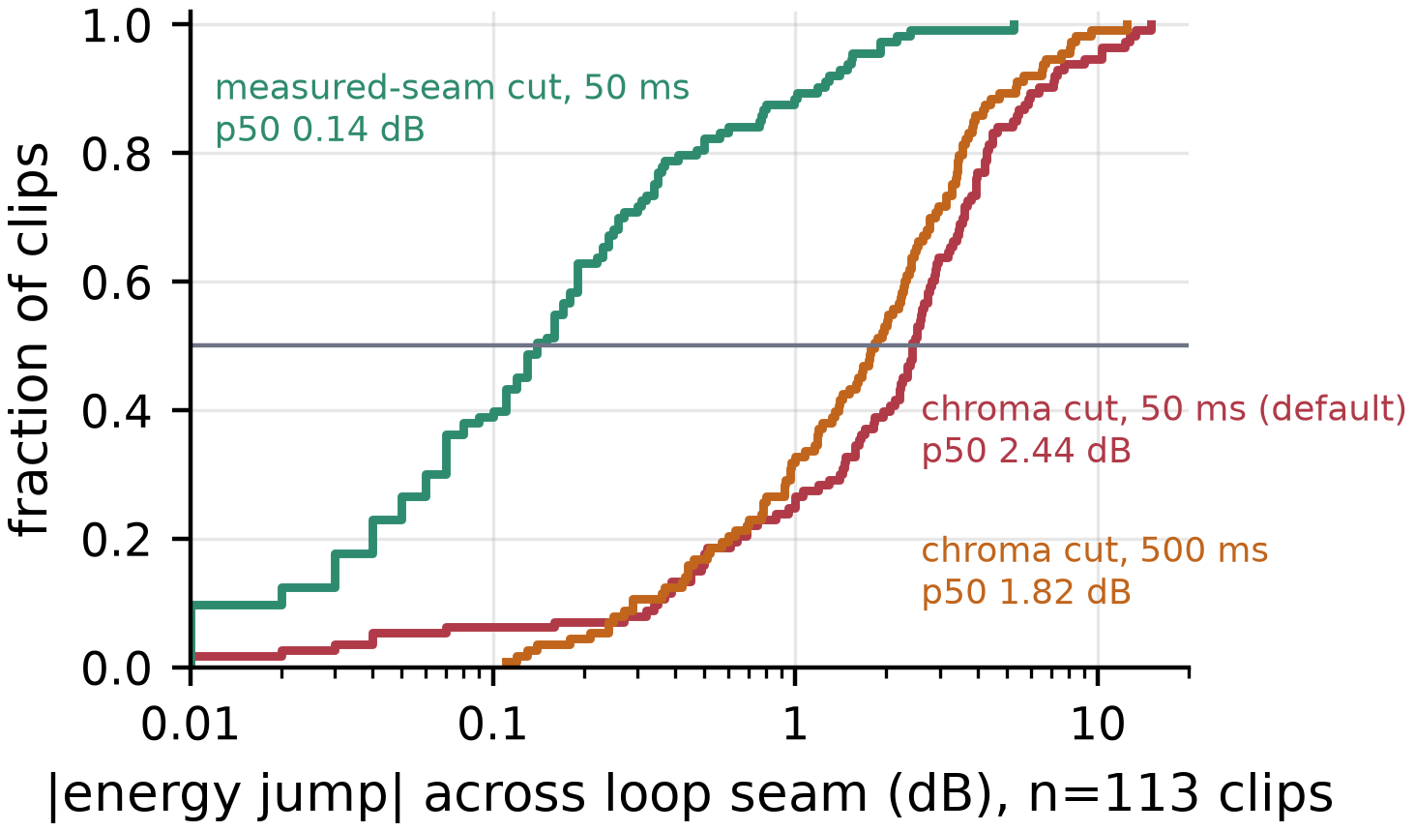
Fig. 4. Energy jump across loop seams (CDF, 113 clips) by cut method.
A fresh study of 220 seeded clips (11 moods × 20 seeds) compares the two rules at the shipped 250 ms crossfade. Of these, 176 are scoreable (39 have a tail too short for the crossfade and 5 no loop point). The median |Δ E| is 2.08 dB [1.69, 2.33] for chroma similarity and 0.16 dB [0.12, 0.23] for the measured seam, and the share above 1 dB falls from 72.7% to 8.5% (McNemar p = 2×10⁻³⁴; 71.7% to 6.2% on the 145 clips that fit the full crossfade). The seam’s spectral-centroid change, which the selector only uses to break ties, lies within the clip’s own 95th percentile of interior change in 91.4% [87.7, 95.0] of the clips. The loops are also gapless: rendered through the browser’s decoder and a looping buffer for 10 cycles, 30 of 30 clips show no inserted silence and are sample-identical from cycle to cycle. Gapless playback is shown; an inaudible seam is not claimed.

G. Restraint
All fourteen executable restraint policies pass their tests: silence on sensitive pages [20], muting and ducking, bypass of payment and browser-internal pages, hashed-URL telemetry, and seven unit cases. The term lists are precise but a white-box slice built from their own vocabulary evades them on 19 of 29 sensitive pages (Table VI): seven use out-of-list terms, four euphemisms, four are non-English and four rest on a single ambiguous term. The hosted entailment model detects all 29, including the four non-English pages, but raises 11 false alarms on 18, among them all six plainly benign pages (e.g. a Rust tutorial), because it offers no “unrelated” option, and it discloses every page not caught by a hard-severe term, so disclosure holds only with the on-device back end. The shipped check adds the third hypothesis and runs on-device; its recall on real crisis pages is unmeasured.
TABLE VI
Sensitive-page detection (29 sensitive, 18 not).
Detector | Missed | False alarms | Non-English caught
Term lists (default) | 19/29 | 3/18 | 0/4
Term lists + NLI (hosted) | 0/29 | 11/18 | 4/4

Network audit. We recorded every request made by the service worker, offscreen document, content scripts and pages while the built extension browsed 12 fixture pages (one per mood plus a crisis-support page) three times each. In the fully local configuration (A6) no request body contained page text; the only traffic was the generation service, 850 bytes per page. In the default (A6b) page text left the device on 30 of 36 visits, all to the LLM proxy and nowhere else (5.9 kB per page to the proxy, 0.8 kB to the generation service). The fixtures are not representative, so this is not the disclosure rate (47% of development pages); the audit establishes the destination of the text. No telemetry left the browser.

VI. CONCLUSION
An on-device middle stage keeps the keyword-to-LLM macro-F1 while cutting off-device pages by 38%, and the fully local configuration sends no page text. A mood clip is audible 36 ms after the mood decision, page-level audio is heard on about half of simulated GPU visits, and measured-seam cuts remove most large energy jumps. Generated audio leans slightly toward its intended mood on three objective scorers and loops without gaps; whether listeners hear that fit is the open question.

VII. LIMITATIONS AND FUTURE WORK
No listening study was run, so we make no claim that listeners find the music fits the page or that the loops sound seamless; the fidelity measures are proxies with small effects. The labellers are authors, and there is no held-out test set, so the cascade’s macro-F1 values are in-sample. The exposure results rest on a modelled dwell time, and the end-to-end and network runs use 11 and 12 fixture pages. The hardware is one laptop GPU, one Apple M4 and one CPU laptop. The hosted LLM can change behind the same model name, and the local Qwen2.5-7B configuration gives different answers. Future work includes a listening study (its protocol is released with the code) with independent annotators, loop-closed generation, and applying the pipeline to other continuous contexts such as documents and code editors.

REFERENCES
[1] D. Marincione, G. Strano, D. Crisostomi, R. Ribuoli, and E. Rodolà, “LoopGen: Training-free loopable music generation,” in Proc. Int. Soc. Music Inf. Retrieval Conf., 2025.
[2] K. R. Agres, A. Dash, P. Chua, and S. K. Ehrlich, “AffectMachinePop: A controllable expert system for real-time pop music generation,” presented at AAAI Workshop Artif. Intell. Music, 2025.
[3] J. Kang and D. Herremans, “Are we there yet? A brief survey of music emotion prediction datasets, models and outstanding challenges,” IEEE Trans. Affect. Comput., vol. 16, no. 4, pp. 2545–2559, 2025.
[4] H. Suzawa, K. Watanabe, A. Dengel, and S. Ishimaru, “Augmenting online meetings with context-aware real-time music generation,” in Proc. Augmented Humans Int. Conf., 2025, pp. 487–490.
[5] X. Wei, Z. Zhang, Z. Yue, and H.-T. Chen, “Context-AI Tunes: Context-aware AI-generated music for stress reduction,” in Artif. Intell. HCI (HCII), LNCS, 2025, pp. 330–345.
[6] C. J. Chong, C. Hou, Z. Yao, and S. M. Seyed Talebi, “Casper: Prompt sanitization for protecting user privacy in web-based large language models,” in Proc. IEEE CSCloud, 2025, pp. 122–133.
[7] S. Kolawole, D. Dennis, A. Talwalkar, and V. Smith, “Agreement-based cascading for efficient inference,” Trans. Mach. Learn. Res., 2025.
[8] Z. Chen, Y. Ma, H. Shen, and M. Liu, “WeInfer: Unleashing the power of WebGPU on LLM inference in web browsers,” in Proc. ACM Web Conf., 2025, pp. 4264–4273.
[9] D. Jonauskaite and C. Mohr, “Do we feel colours? A systematic review of 128 years of psychological research linking colours and emotions,” Psychon. Bull. Rev., vol. 32, no. 4, pp. 1457–1486, 2025.
[10] S. M. Mohammad, “NRC VAD Lexicon v2: Norms for valence, arousal, and dominance for over 55k English terms,” arXiv:2503.23547, 2025.
[11] Y. Deldjoo, M. Schedl, and P. Knees, “Content-driven music recommendation: Evolution, state of the art, and challenges,” Comput. Sci. Rev., vol. 51, Art. no. 100618, 2024.
[12] Z. Evans, C. J. Carr, J. Taylor, S. H. Hawley, and J. Pons, “Fast timing-conditioned latent audio diffusion,” in Proc. Int. Conf. Mach. Learn., 2024.
[13] M. Buisson, B. McFee, S. Essid, and H. C. Crayencour, “Self-supervised learning of multi-level audio representations for music segmentation,” IEEE/ACM Trans. Audio, Speech, Lang. Process., vol. 32, pp. 2141–2152, 2024.
[14] H. Liu et al., “MetaBGM: Dynamic soundtrack transformation for continuous multi-scene experiences with ambient awareness and personalization,” arXiv:2409.03844, 2024.
[15] L. Chen, M. Zaharia, and J. Zou, “FrugalGPT: How to use large language models while reducing cost and improving performance,” Trans. Mach. Learn. Res., 2024.
[16] D. Ding et al., “Hybrid LLM: Cost-efficient and quality-aware query routing,” in Proc. Int. Conf. Learn. Represent., 2024.
[17] N. Pantelaios and A. Kapravelos, “Manifest V3 unveiled: Navigating the new era of browser extensions,” in Proc. NDSS Workshop MADWeb, 2024.
[18] G. Marzi, M. Balzano, and D. Marchiori, “K-Alpha Calculator–Krippendorff’s Alpha Calculator: A user-friendly tool for computing Krippendorff’s alpha inter-rater reliability coefficient,” MethodsX, vol. 12, Art. no. 102545, 2024.
[19] C. Liu, R. W. White, and S. Dumais, “Understanding web browsing behaviors through Weibull analysis of dwell time,” in Proc. ACM SIGIR, 2010, pp. 379–386.
[20] H. Qiu, L. Ma, and Z. Lan, “PsyGUARD: An automated system for suicide detection and risk assessment in psychological counseling,” in Proc. Conf. Empirical Methods Natural Lang. Process., 2024, pp. 4581–4607.
[21] J. Copet et al., “Simple and controllable music generation,” in Adv. Neural Inf. Process. Syst., 2023.
[22] A. Défossez, J. Copet, G. Synnaeve, and Y. Adi, “High fidelity neural audio compression,” Trans. Mach. Learn. Res., 2023.
[23] A. Agostinelli et al., “MusicLM: Generating music from text,” arXiv:2301.11325, 2023.
[24] H. Liu et al., “AudioLDM: Text-to-audio generation with latent diffusion models,” in Proc. Int. Conf. Mach. Learn., 2023.
[25] F. Kreuk et al., “AudioGen: Textually guided audio generation,” in Proc. Int. Conf. Learn. Represent., 2023.
[26] A. Marmoret, J. E. Cohen, and F. Bimbot, “Barwise music structure analysis with the correlation block-matching segmentation algorithm,” Trans. Int. Soc. Music Inf. Retrieval, vol. 6, no. 1, pp. 167–185, 2023.
[27] I. Stogiannidis, S. Vassos, P. Malakasiotis, and I. Androutsopoulos, “Cache me if you can: An online cost-aware teacher-student framework to reduce the calls to large language models,” in Findings Assoc. Comput. Linguist.: EMNLP, 2023, pp. 14999–15008.
[28] M. Laurer, W. van Atteveldt, A. Casas, and K. Welbers, “Building efficient universal classifiers with natural language inference,” arXiv:2312.17543, 2023.
[29] European Broadcasting Union, “Loudness normalisation and permitted maximum level of audio signals,” EBU Rec. R 128, ver. 5.0, 2023.

