**Virtual Key for Your Repositories**

* Product capabilties :-

The program can perform following tasks :-

1. Display file names in ascending order
2. Add a file
3. Search for a file
4. Delete a file

* Product appearance :-

The program is a console based application.

* User interactions -

The user can interact using the command line.

* Sprint planning :-

Overall, the program has been developed in 2 sprints.

The first sprint consisted of 3 days in which the user interface was developed and similarly in the next sprint of 3 days, the functionality was developed.

* Core concepts used in the project :-

The core concepts used in this project are as follows :-

1. Java Collections

The TreeSet class has been used for creating a sorted order for the files.

1. Comparator

The comparator is used for sorting the files in theascending order in the TreeSet.

* Algorithm and flow chart :-

The following is the complete flowchart of the application.

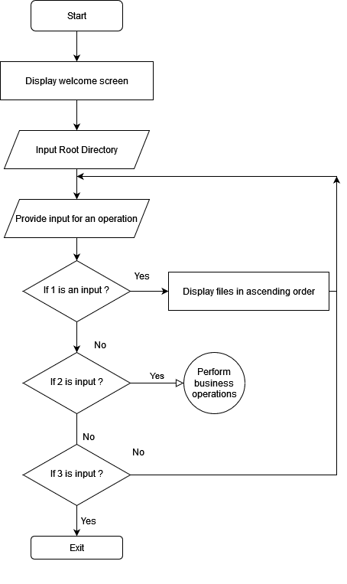

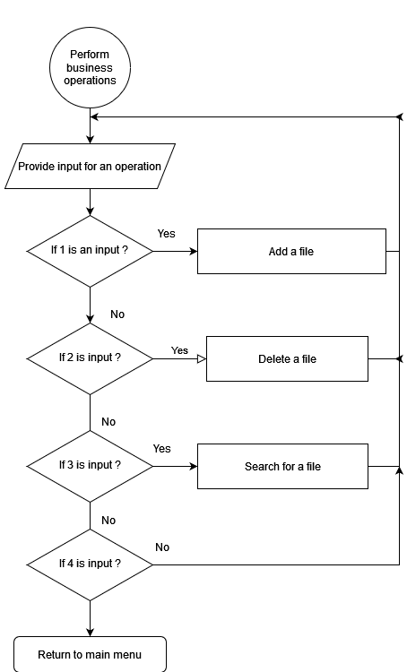

* Future Enhancements :-
* A GUI can be developed for the application so that the user can more easily navigate between UI components.
* Developer Details :-

Ayush Krishna