Sales Analysis Report

# City and Branch Level Analysis

The following table summarizes the total sales at the city and branch level:

|  |  |  |
| --- | --- | --- |
| City | Branch | Total |
| Mandalay | A | 34130.09 |
| Mandalay | B | 37215.93 |
| Mandalay | C | 29794.62 |
| Naypyitaw | A | 35985.64 |
| Naypyitaw | B | 35157.75 |
| Naypyitaw | C | 34160.14 |
| Yangon | A | 33647.27 |
| Yangon | B | 35193.51 |
| Yangon | C | 32302.43 |

# Average Price of Items Sold at Each Branch

The following table summarizes the average price of items sold at each branch:

|  |  |  |
| --- | --- | --- |
| City | Branch | Unit price |
| Mandalay | A | 53.353865546218486 |
| Mandalay | B | 56.13330508474576 |
| Mandalay | C | 57.95831578947369 |
| Naypyitaw | A | 54.12318181818182 |
| Naypyitaw | B | 57.785688073394496 |
| Naypyitaw | C | 57.94100917431192 |
| Yangon | A | 55.63929824561404 |
| Yangon | B | 56.01106194690266 |
| Yangon | C | 52.6846017699115 |

# Month-over-Month Analysis

The following table summarizes the month-over-month performance of sales and revenue:

|  |  |  |  |  |
| --- | --- | --- | --- | --- |
| Month | Product line | Gender | Payment | Total |
| 2019-01 | Electronic accessories | Female | Cash | 2731.86 |
| 2019-01 | Electronic accessories | Female | Credit card | 3045.42 |
| 2019-01 | Electronic accessories | Female | Ewallet | 1576.48 |
| 2019-01 | Electronic accessories | Male | Cash | 3380.29 |
| 2019-01 | Electronic accessories | Male | Credit card | 2248.65 |
| 2019-01 | Electronic accessories | Male | Ewallet | 4951.860000000001 |
| 2019-01 | Fashion accessories | Female | Cash | 3845.24 |
| 2019-01 | Fashion accessories | Female | Credit card | 2535.52 |
| 2019-01 | Fashion accessories | Female | Ewallet | 4475.81 |
| 2019-01 | Fashion accessories | Male | Cash | 1459.32 |
| 2019-01 | Fashion accessories | Male | Credit card | 3210.61 |
| 2019-01 | Fashion accessories | Male | Ewallet | 2897.42 |
| 2019-01 | Food and beverages | Female | Cash | 5197.05 |
| 2019-01 | Food and beverages | Female | Credit card | 3419.7699999999995 |
| 2019-01 | Food and beverages | Female | Ewallet | 2845.51 |
| 2019-01 | Food and beverages | Male | Cash | 1927.02 |
| 2019-01 | Food and beverages | Male | Credit card | 3797.24 |
| 2019-01 | Food and beverages | Male | Ewallet | 1452.01 |
| 2019-01 | Health and beauty | Female | Cash | 878.27 |
| 2019-01 | Health and beauty | Female | Credit card | 1774.4 |
| 2019-01 | Health and beauty | Female | Ewallet | 2471.17 |
| 2019-01 | Health and beauty | Male | Cash | 3732.94 |
| 2019-01 | Health and beauty | Male | Credit card | 3712.44 |
| 2019-01 | Health and beauty | Male | Ewallet | 3033.8 |
| 2019-01 | Home and lifestyle | Female | Cash | 3618.8 |
| 2019-01 | Home and lifestyle | Female | Credit card | 4388.16 |
| 2019-01 | Home and lifestyle | Female | Ewallet | 2698.07 |
| 2019-01 | Home and lifestyle | Male | Cash | 3396.24 |
| 2019-01 | Home and lifestyle | Male | Credit card | 1131.21 |
| 2019-01 | Home and lifestyle | Male | Ewallet | 4286.32 |
| 2019-01 | Sports and travel | Female | Cash | 5206.46 |
| 2019-01 | Sports and travel | Female | Credit card | 3570.03 |
| 2019-01 | Sports and travel | Female | Ewallet | 2044.82 |
| 2019-01 | Sports and travel | Male | Cash | 4407.54 |
| 2019-01 | Sports and travel | Male | Credit card | 3591.86 |
| 2019-01 | Sports and travel | Male | Ewallet | 1814.55 |
| 2019-02 | Electronic accessories | Female | Cash | 5189.16 |
| 2019-02 | Electronic accessories | Female | Credit card | 2542.08 |
| 2019-02 | Electronic accessories | Female | Ewallet | 2395.43 |
| 2019-02 | Electronic accessories | Male | Cash | 1590.25 |
| 2019-02 | Electronic accessories | Male | Credit card | 3145.49 |
| 2019-02 | Electronic accessories | Male | Ewallet | 1673.69 |
| 2019-02 | Fashion accessories | Female | Cash | 3594.98 |
| 2019-02 | Fashion accessories | Female | Credit card | 3043.29 |
| 2019-02 | Fashion accessories | Female | Ewallet | 4155.27 |
| 2019-02 | Fashion accessories | Male | Cash | 2694.9 |
| 2019-02 | Fashion accessories | Male | Credit card | 2510.46 |
| 2019-02 | Fashion accessories | Male | Ewallet | 2105.73 |
| 2019-02 | Food and beverages | Female | Cash | 3417.24 |
| 2019-02 | Food and beverages | Female | Credit card | 4499.38 |
| 2019-02 | Food and beverages | Female | Ewallet | 2814.74 |
| 2019-02 | Food and beverages | Male | Cash | 2374.27 |
| 2019-02 | Food and beverages | Male | Credit card | 3377.46 |
| 2019-02 | Food and beverages | Male | Ewallet | 2564.87 |
| 2019-02 | Health and beauty | Female | Cash | 4218.83 |
| 2019-02 | Health and beauty | Female | Credit card | 1792.37 |
| 2019-02 | Health and beauty | Female | Ewallet | 1344.95 |
| 2019-02 | Health and beauty | Male | Cash | 1406.58 |
| 2019-02 | Health and beauty | Male | Credit card | 2438.87 |
| 2019-02 | Health and beauty | Male | Ewallet | 2705.31 |
| 2019-02 | Home and lifestyle | Female | Cash | 2424.18 |
| 2019-02 | Home and lifestyle | Female | Credit card | 2369.27 |
| 2019-02 | Home and lifestyle | Female | Ewallet | 1520.9900000000002 |
| 2019-02 | Home and lifestyle | Male | Cash | 2656.4 |
| 2019-02 | Home and lifestyle | Male | Credit card | 839.8100000000001 |
| 2019-02 | Home and lifestyle | Male | Ewallet | 2031.62 |
| 2019-02 | Sports and travel | Female | Cash | 2449.13 |
| 2019-02 | Sports and travel | Female | Credit card | 1842.21 |
| 2019-02 | Sports and travel | Female | Ewallet | 4039.41 |
| 2019-02 | Sports and travel | Male | Cash | 2028.21 |
| 2019-02 | Sports and travel | Male | Credit card | 1466.0 |
| 2019-02 | Sports and travel | Male | Ewallet | 1327.0500000000002 |
| 2019-03 | Electronic accessories | Female | Cash | 2759.66 |
| 2019-03 | Electronic accessories | Female | Credit card | 3052.9 |
| 2019-03 | Electronic accessories | Female | Ewallet | 2518.46 |
| 2019-03 | Electronic accessories | Male | Cash | 4091.62 |
| 2019-03 | Electronic accessories | Male | Credit card | 658.81 |
| 2019-03 | Electronic accessories | Male | Ewallet | 4197.92 |
| 2019-03 | Fashion accessories | Female | Cash | 1445.19 |
| 2019-03 | Fashion accessories | Female | Credit card | 3578.36 |
| 2019-03 | Fashion accessories | Female | Ewallet | 2314.34 |
| 2019-03 | Fashion accessories | Male | Cash | 3735.41 |
| 2019-03 | Fashion accessories | Male | Credit card | 1631.35 |
| 2019-03 | Fashion accessories | Male | Ewallet | 2486.7000000000003 |
| 2019-03 | Food and beverages | Female | Cash | 3601.07 |
| 2019-03 | Food and beverages | Female | Credit card | 2566.32 |
| 2019-03 | Food and beverages | Female | Ewallet | 3230.27 |
| 2019-03 | Food and beverages | Male | Cash | 1779.42 |
| 2019-03 | Food and beverages | Male | Credit card | 1611.44 |
| 2019-03 | Food and beverages | Male | Ewallet | 2996.2 |
| 2019-03 | Health and beauty | Female | Cash | 1555.04 |
| 2019-03 | Health and beauty | Female | Credit card | 1767.17 |
| 2019-03 | Health and beauty | Female | Ewallet | 1874.93 |
| 2019-03 | Health and beauty | Male | Cash | 4578.92 |
| 2019-03 | Health and beauty | Male | Credit card | 3723.77 |
| 2019-03 | Health and beauty | Male | Ewallet | 3841.42 |
| 2019-03 | Home and lifestyle | Female | Cash | 2748.51 |
| 2019-03 | Home and lifestyle | Female | Credit card | 2300.39 |
| 2019-03 | Home and lifestyle | Female | Ewallet | 6538.18 |
| 2019-03 | Home and lifestyle | Male | Cash | 2859.6800000000003 |
| 2019-03 | Home and lifestyle | Male | Credit card | 2288.37 |
| 2019-03 | Home and lifestyle | Male | Ewallet | 3200.86 |
| 2019-03 | Sports and travel | Female | Cash | 1799.53 |
| 2019-03 | Sports and travel | Female | Credit card | 2863.86 |
| 2019-03 | Sports and travel | Female | Ewallet | 3398.57 |
| 2019-03 | Sports and travel | Male | Cash | 2084.19 |
| 2019-03 | Sports and travel | Male | Credit card | 3633.9 |
| 2019-03 | Sports and travel | Male | Ewallet | 4930.61 |

# Visualizations

Sales Trends Over Time:

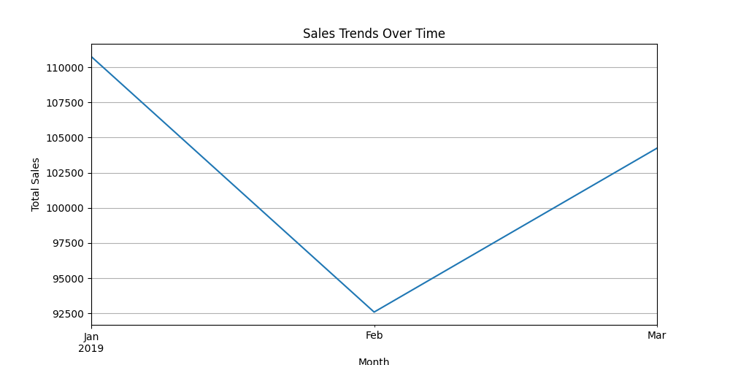

Revenue Trends Over Time:

