**Business Report**

**By – Ayush Kumar**

**This Business report contains 2 data sets.**

**Case 1 – Automobile - Analyse and identify the purchasing patterns of various customers that influence the price of different segment of cars.**

* The dataset provide to us has 1581 customers and their information such as age, salary, gender, profession etc.
* Our objective is to find which factors influence the total revenue and who are our target customers, what steps can be taken to increase the revenue.

**Case 2 – Godigt Bank Data – Customer details like income, card type, hot list flag, net-worth category etc. Find relevant patterns of all variables.**

* The data set contains 8448 rows and 28 columns.
* There are many categorical data, we have to find all the relevant patterns when compared with annual income, average spending and credit card limit.
* Identify defaulter customers and reduce the card limit and increase card limit of high earning customers.

**Contents**

**Automobile Data Analysis------------------------------------------------4**

**Objective-------------------------------------------------------------------------4**

**Data dictionary-----------------------------------------------------------------4**

**Top variables--------------------------------------------------------------------5**

**Top Questions that can be asked------------------------------------------5**

**Null values and Irregularities treatment--------------------------------7**

**Outlier Treatment-------------------------------------------------------------9**

**Answers-------------------------------------------------------------------------11**

**Q.14 What can be done to increase revenue?------------------------22**

**Summary & Recommendations-------------------------------------------26**

**GODIGT Bank Data Analysis--------------------------------------------27**

**Objective------------------------------------------------------------------------27**

**Data dictionary----------------------------------------------------------------27**

**Top variables-------------------------------------------------------------------29**

**Data description--------------------------------------------------------------29**

**Outlier and null values identification-----------------------------------31**

**Top Questions that can be asked-----------------------------------------33**

**Automobile Data Analysis**

**Objective:**

Try to generate relevant insights to understand the purchase pattern of customers belonging to diverse field and category based on various attributes. The dataset given to us is Automobile data which contains 14 columns and 1581 rows.

**Data dictionary:**

|  |  |  |
| --- | --- | --- |
| **Variable** | **Data Description** | **Variable Data Type** |
| Age | The age of the individual in years. | Continuous |
| Gender | The gender of the individual, categorized as male or female. | Categorical |
| Profession | The occupation or profession of the individual. (Business or Salaried) | Categorical |
| Marital_status | The marital status of the individual, such as married &, single | Categorical |
| Education | The educational qualification of the individual Graduate and Post Graduate | Categorical |
| No_of_Dependents | The number of dependents (e.g., children, elderly parents) that the individual supports financially. (0,1,2,3,4) | Categorical |
| Personal_loan | A binary variable indicating whether the individual has taken a personal loan "Yes" or "No" | Categorical |
| House_loan | A binary variable indicating whether the individual has taken a housing loan "Yes" or "No" | Categorical |
| Partner_working | A binary variable indicating whether the individual's partner is employed "Yes" or "No" | Categorical |
| Salary | The individual's salary or income. | Continuous |
| Partner_salary | The salary or income of the individual's partner, if applicable. | Continuous |
| Total_salary | The total combined salary of the individual and their partner (if applicable). | Continuous |
| Price | The price of a product or service | Continuous |
| Make | The type of automobile (SUV, Sedan, Hatchback) | Categorical |

**The top variables are as follows:**

1. Age
2. Marital Status
3. House Loan
4. Total Salary
5. Price
6. Make

**Top Questions that can be asked initially:**

* Which Make (Car type) is the highest selling?
* What is the total revenue and individual Make (Car type) is generating how much revenue?
* Explore variables like No of dependents and partner working?
* Which car type price is highest and who is the customer? (Gender, Age)
* Which age group customers are purchasing most cars?
* Does marital status influence the purchasing pattern of cars?
* Does Education of customers have any relevance in the purchase pattern?
* Does House loans and personal loans customers are buying more cars?
* Does partner working has any impact on purchasing cars?
* Which profession of customers are mostly purchasing cars and what type of car is preferred?
* What is the relevance of Total salary with other variables?
* What is the output of customers who has taken both loans? (House and personal)
* What is the output of customers who has not taken any loan?
* What can be done to increase the revenue of the company?

**Note:**

* **We created a new column Age Category and divided age in 4 groups. Age 20-30, 30-40,40-50 and 50-60. This will increase readability and make our analysis more precise.**
* **We have combined House loan and personal loan to check how many customers have taken both the loans. Does this effect and influence the purchasing pattern.**

**Null Values and Irregularities treatment**

There are some irregularities and null values in the data set which is highlighted below:

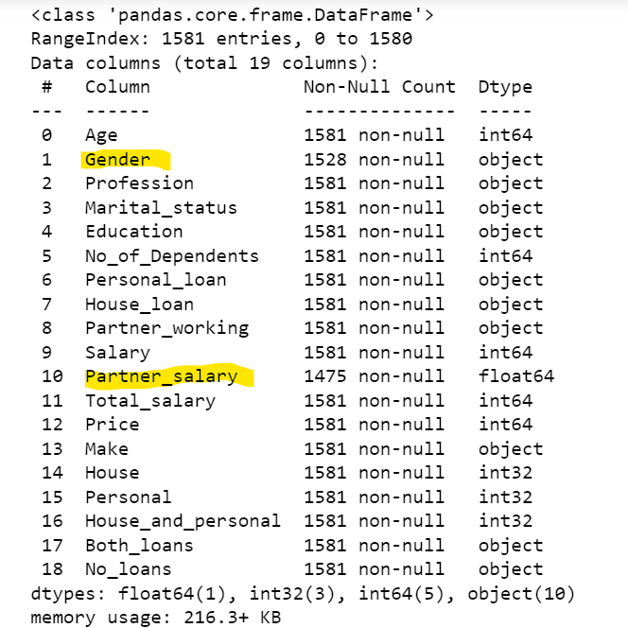

Gender is a categorical variable and Partner salary is a Continuous variable. Below is the screenshot after resolving errors in both the columns

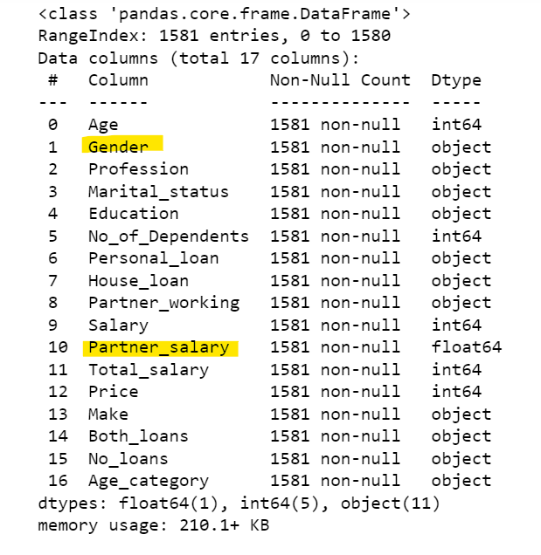

**Outlier treatment**

After checking all the numerical variables, in column **Total Salary** there are some outliers. We can see there is a huge difference between min and max value which is resulting in the outlier, below is the boxplot graph and Total Salary summary:

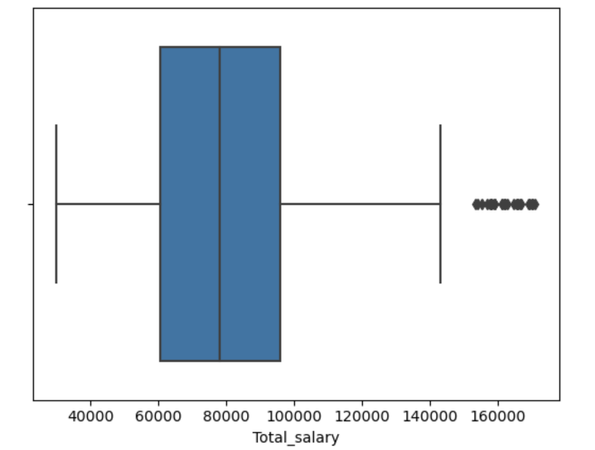 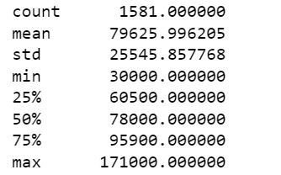

Below is the data summary of all the numerical variables **before treating the outlier**:

**Data description before removing outlier:**

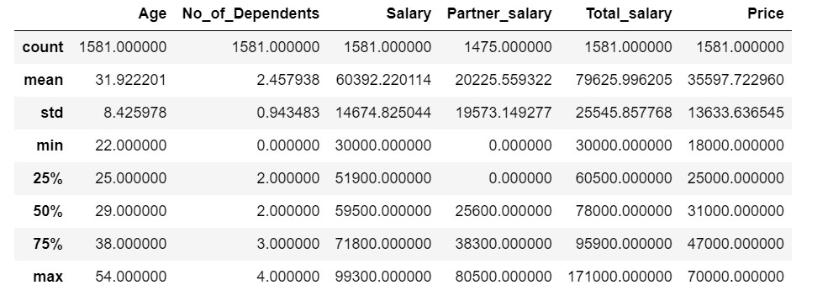

We will use the **Box-Plot method** to resolve the outliers, now we can see that the difference between the min and max has reduced however the median remains the same as shown in the graph and summary below:

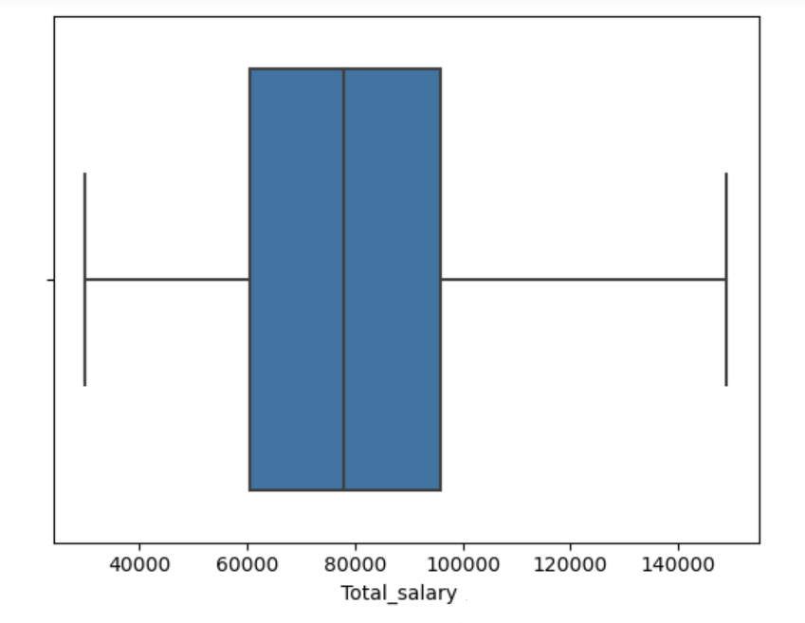 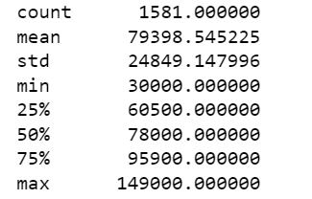

Below is the data summary of all the numerical variables **after treating the outlier**:

**Data description after removing outlier:**

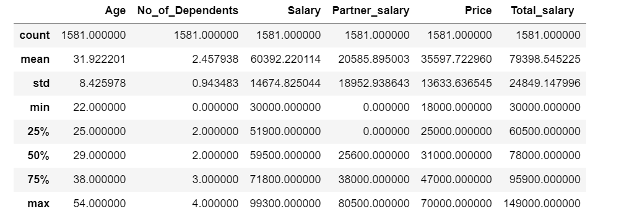

**Q.1 Which Make (Car type) is the highest selling? (Uni-Variate)**

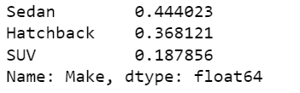

In terms of count, Sedan is the highest and contributes at 44% of entire sales of car.

**Q.2 What is the total revenue and individual Make (Car type) is generating how much revenue? (Uni-Variate)**

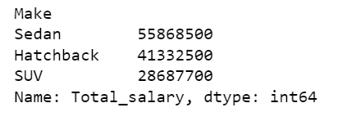

Sedan generates highest revenue with 43% of the entire revenue.

**Q.3 Explore variables like No of dependents and partner working?**

**(Bi-Variate)**

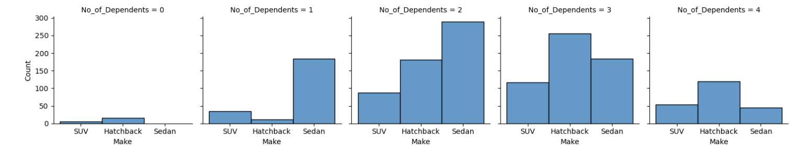

Customers who have dependents equal to 2 or 3 are purchasing more cars and sedan is the most preferred choice amongst all.

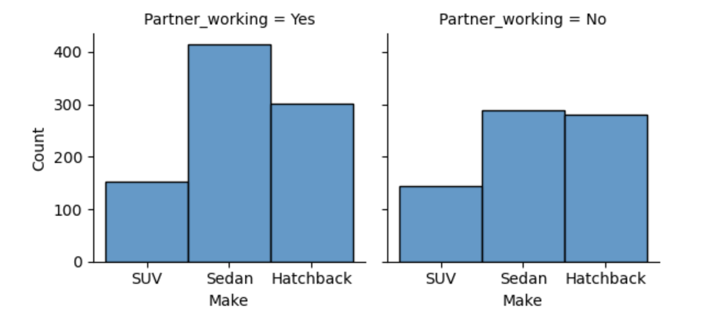

Working partners purchase more cars and in that also sedans are mostly preferred by all.

**Q.4 Which car type price is highest and who is the customer? (Gender, Age) (Multi-Variate)**

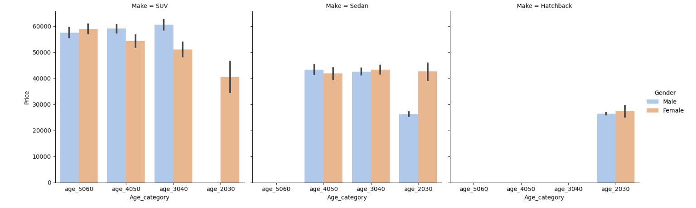

Below are some observations:

* SUVs are mostly preferred by all age categories.
* Females of all age category are very active in purchasing cars, SUVs is the most diverse amongst all age groups.
* Sedans are preferred by all age group except age group between 50-60 – It mean old customers are mostly purchasing SUVs.
* Hatchback are least preferred and only young customers of age between 20-30 are going after Hatchback.

**Q.5 Which age group customers are purchasing most cars? (Bi-Variate)**

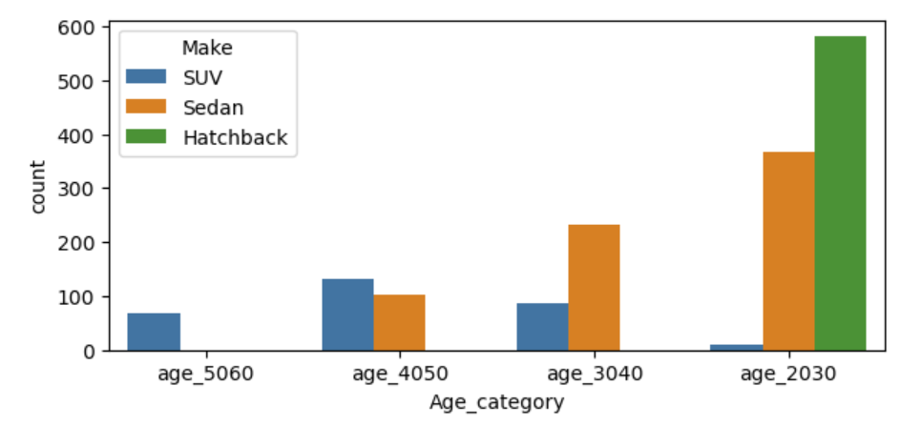

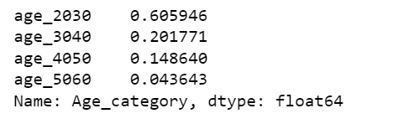

Age group between 20-30 are purchasing 60% cars and the count of sedans is highest amongst all.

**Q.6 Does marital status influence the purchasing pattern of cars? (Multi-Variate)**

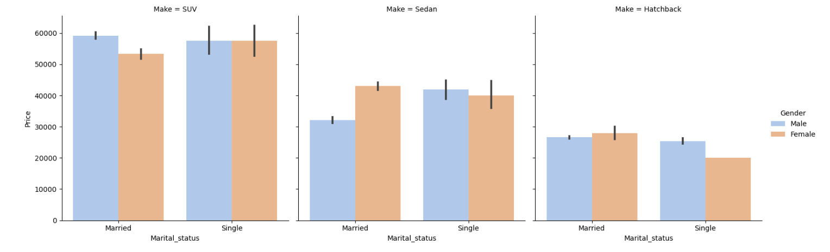

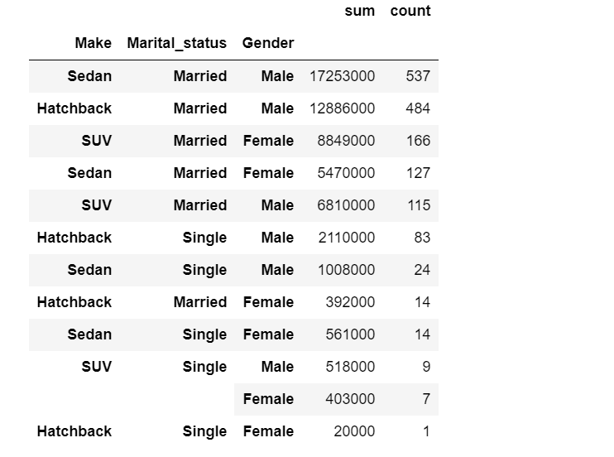

91% of married customers are purchasing cars. In married customers 34% married males are purchasing Sedans, 31% married males are purchasing Hatchbacks and 10% married females are purchasing SUVs. – So, we can say females are mostly interested in purchasing SUVs rather than males.

**Q.7 Does Education of customers have any relevance in the purchase pattern? (Multi-Variate)**

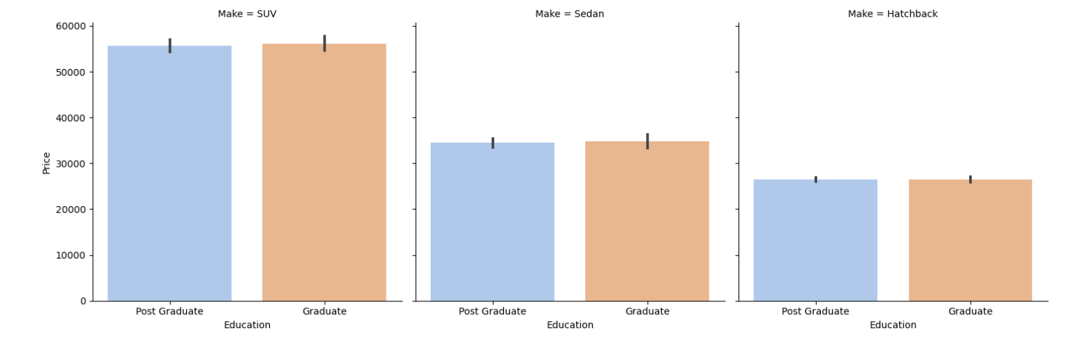

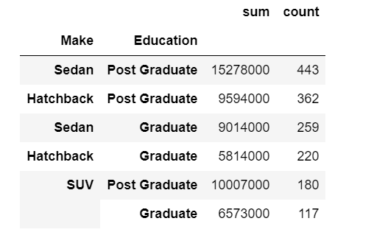

By looking at the graph we can say that most of the Education doesn’t show any significant pattern but when we look at the table the numbers shows that sedans and hatchbacks are mostly purchased by post graduate customers with 28% and 23% respectively.

**Q.8 Does House loans and personal loans customers are buying more cars? (Multi-Variate)**

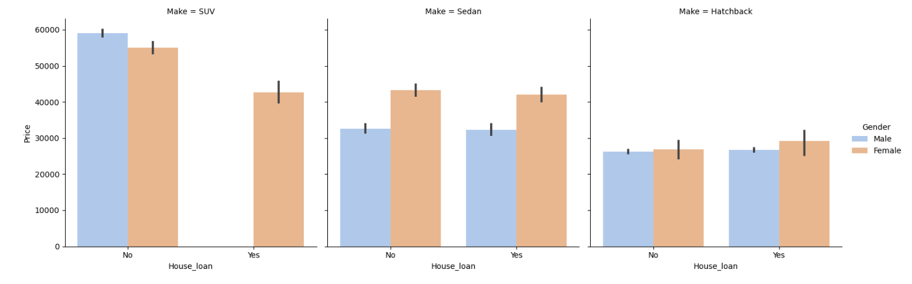

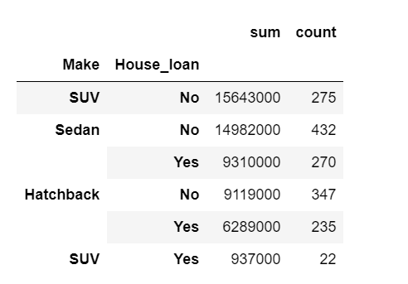

Males who have taken house loan are not purchasing more SUVs. For sedans and hatchbacks females who have taken house loan show more interest than males.

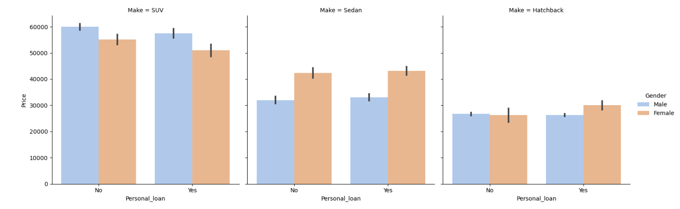

Personal loans don’t show much impact when compared with Home loan. Males who have taken personal loans are showing more interest in SUVs but when compared with home loans males are not purchasing SUVs. Sedan and hatchback pattern is similar for both House and personal loan.

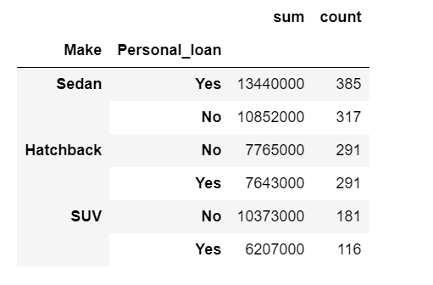

Customers who have taken personal loans are going after Sedans and in terms of money and quantity sedan is the highest. **It means that most of the customers are purchasing sedans on personal loans.**

**Q9. Does partner working has any impact on purchasing cars? (Bi-Variate)**

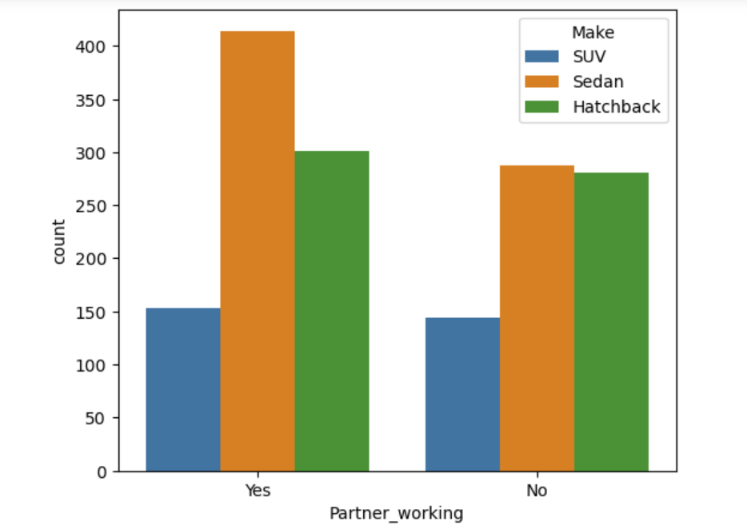

Clearly working partners purchase more cars because they contribute more in terms of revenue, also they are purchasing more sedans. But for SUVs partner working doesn’t show much impact.

**Q10. Which profession of customers are mostly purchasing cars and what type of car is preferred?**

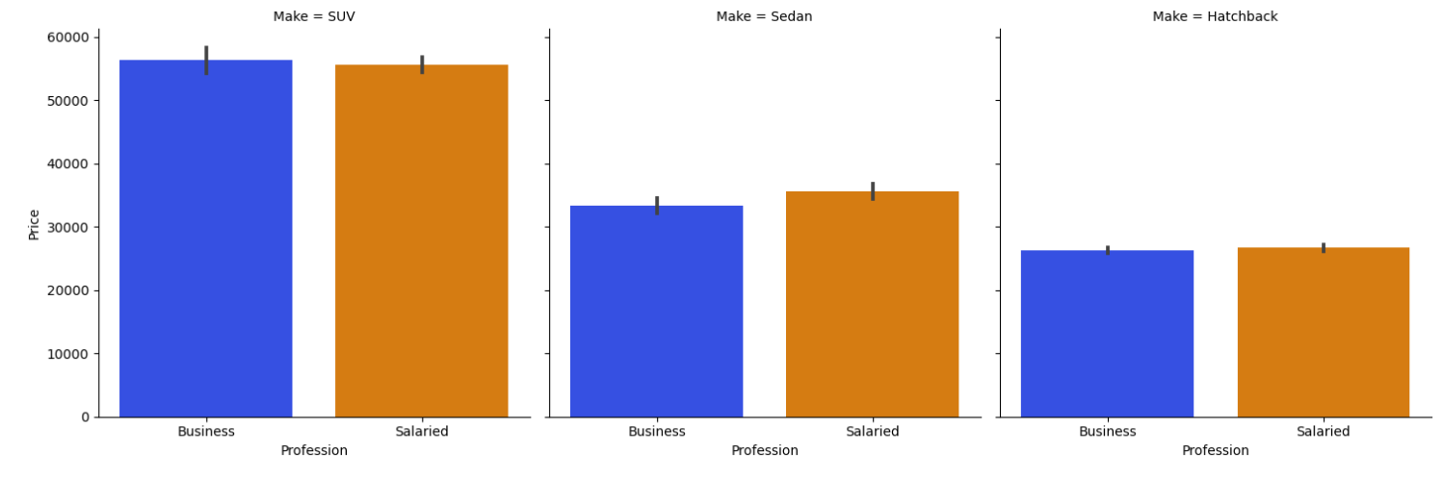

Profession weather it is business or salaried doesn’t show much impact on the purchase pattern.

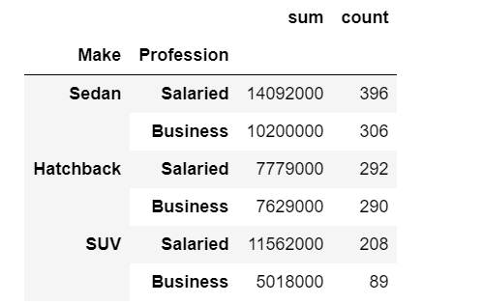

But if we dive deep then salaried customers are mostly purchasing sedans. 25% of salaried customers are purchasing sedans.

**Q11. What is the relevance of Total salary with other variables? (Multi-Variate)**

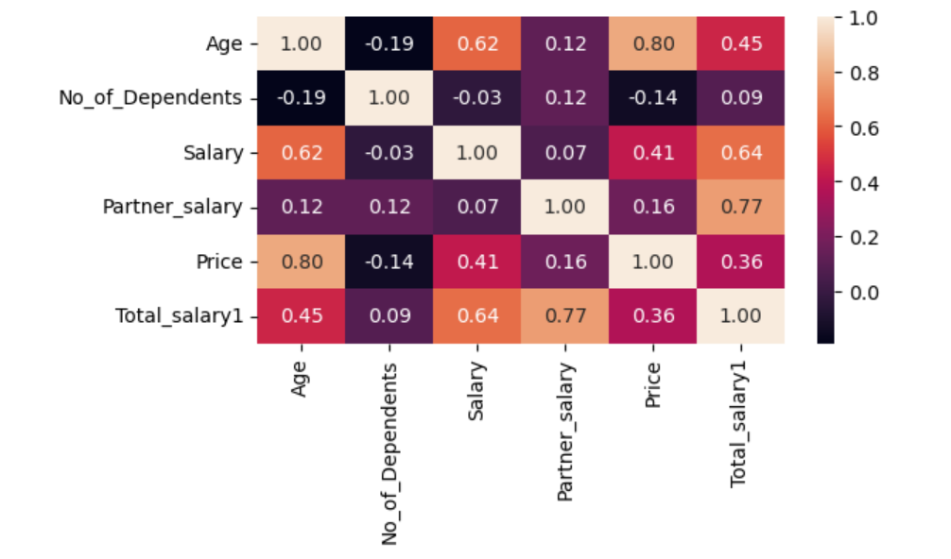

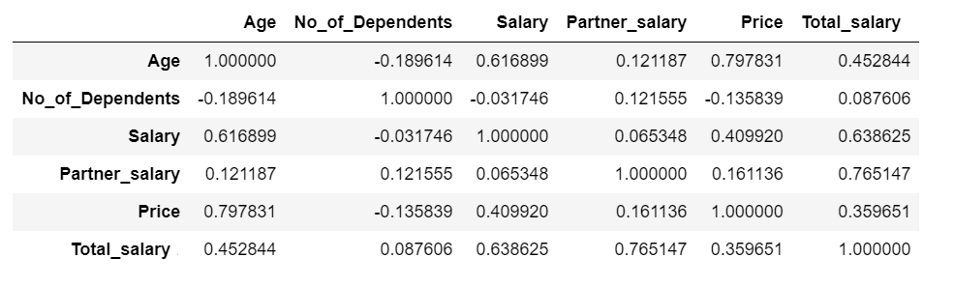

Total Salary of customer has 36% corelation with price of car. If the partner is working then partner salary contributes in the total salary and has a good corelation of 77%.

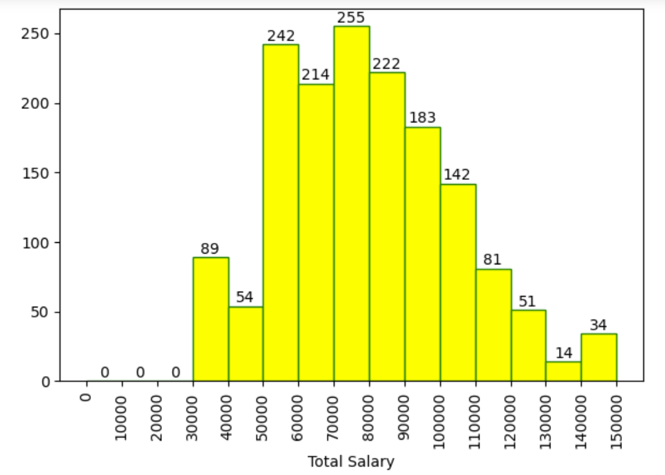

71 % employee total salary is between the 50000-100000 and 16% employee total salary falls between 70000-80000.

**Q12. What is the output of customers who *has taken both loans*? (House and personal) (Multi-Variate)**

When compared with total salary, males who have taken both loans are not buying SUVs only Sedans and Hatchbacks are preferred but women of high salary with both loans are purchasing SUVs also. **(Personal loan doesn’t have much impact when compared with house loan)**

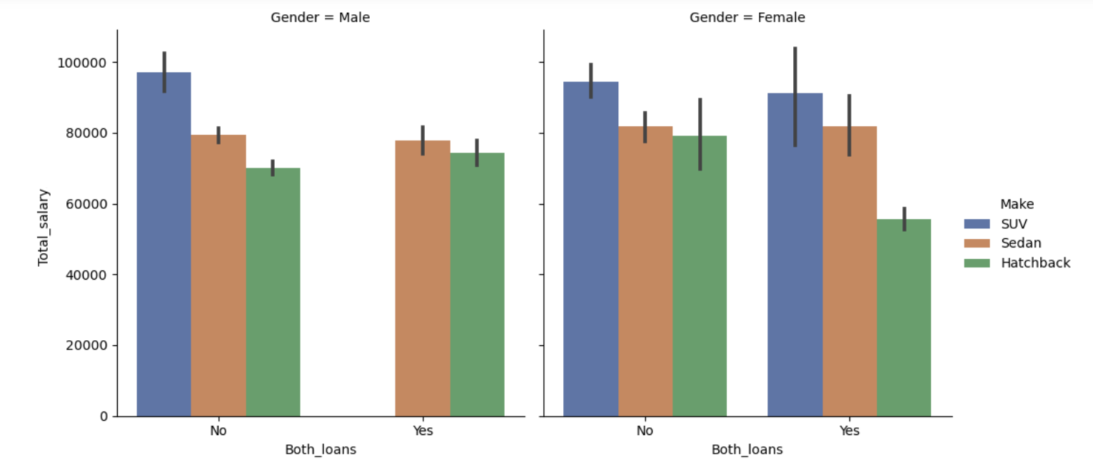

In terms of car price also, same pattern as above males with both loans are not buying SUVs only Sedans and Hatchbacks but women with both loans are buying expensive SUVs.

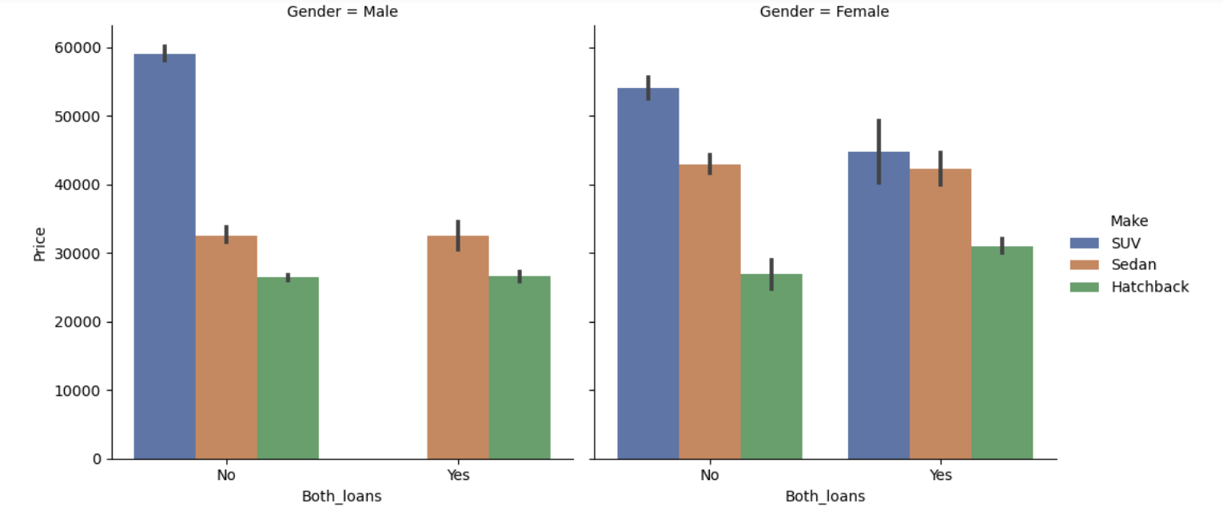

Customers with 2 and 3 dependents are purchasing more cars and have also taken both loans.

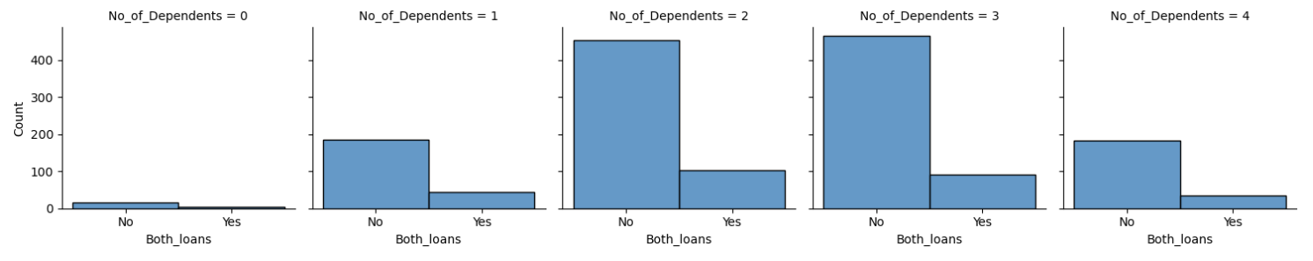

**Q13. What is the output of customers who has *not taken any loan*? (House and personal) (Multi-Variate)**

Below is the graph for customers who has not taken any kind of loan in terms of car price.

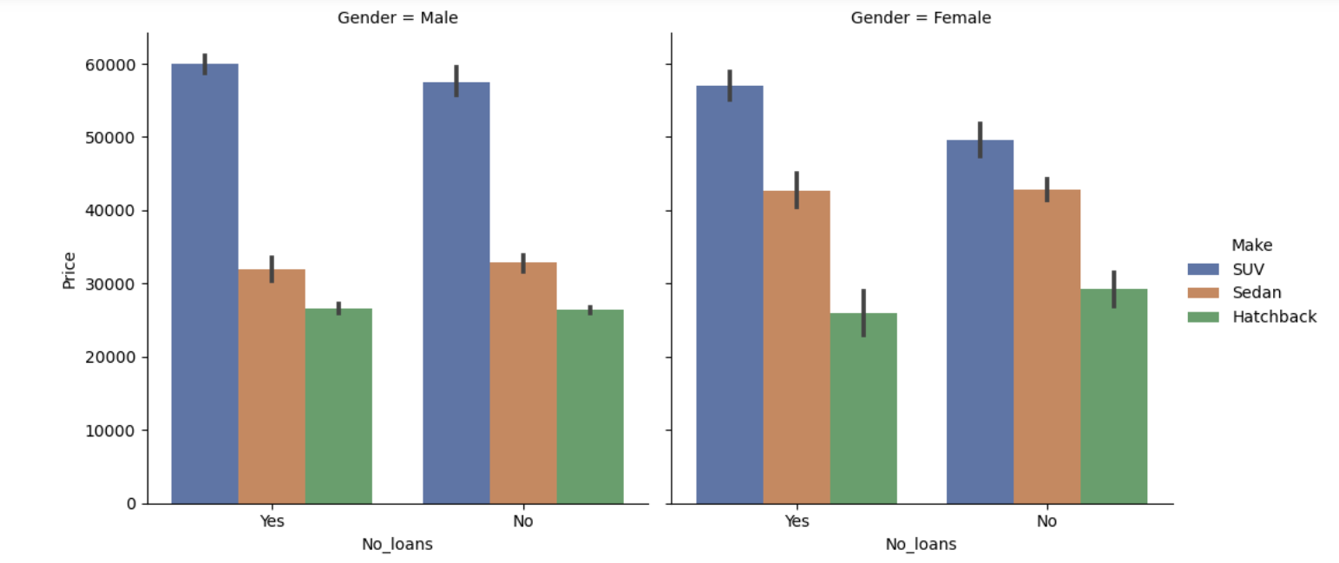

Below is the graph for customers who has not taken any kind of loan in terms of Total Salary.

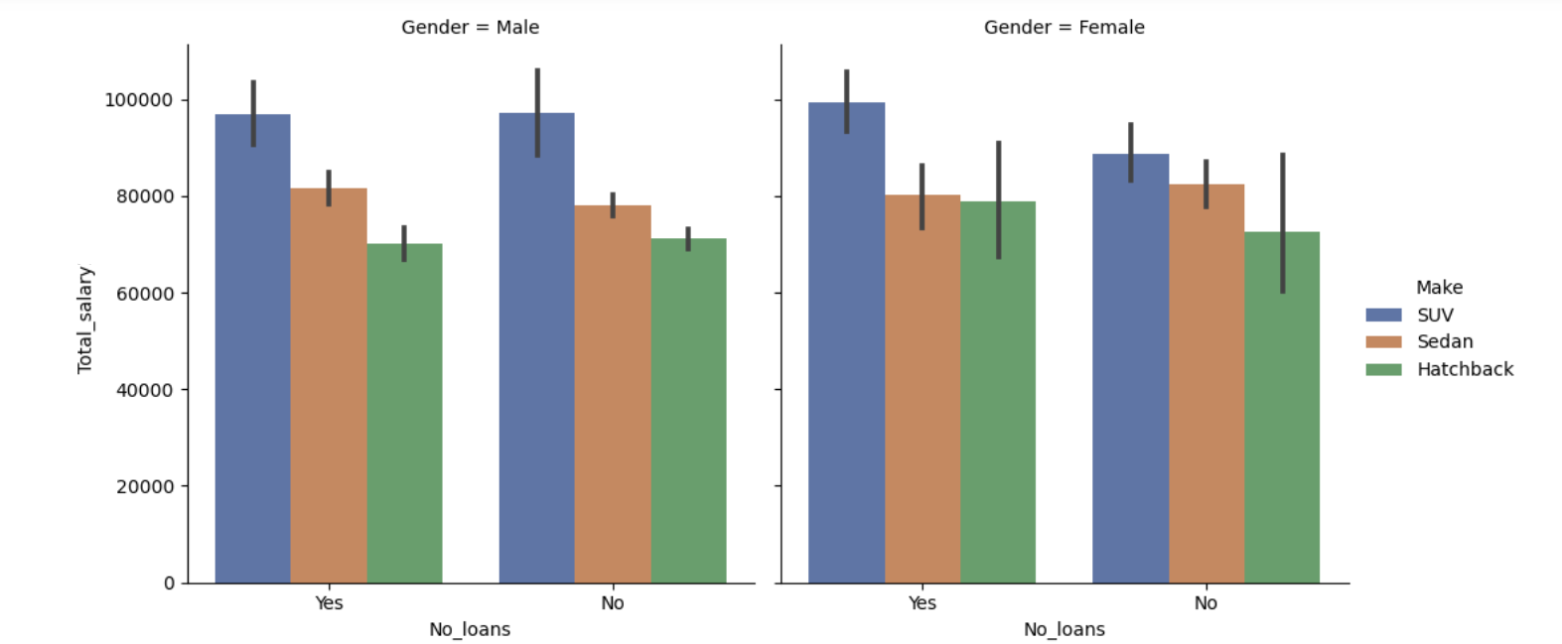

Customers with 2 and 3 dependents are purchasing more cars who has not taken any loans.

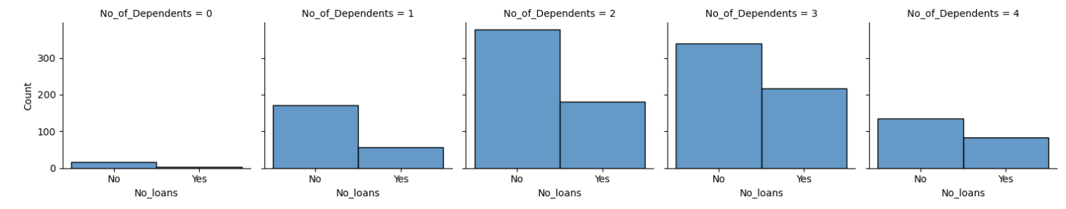

**Q.14 What can be done to increase the revenue of the company?**

Before commenting first let’s analyse the different data points below:

1. The Count of different car type. (Sedan, SUV, Hatchback)

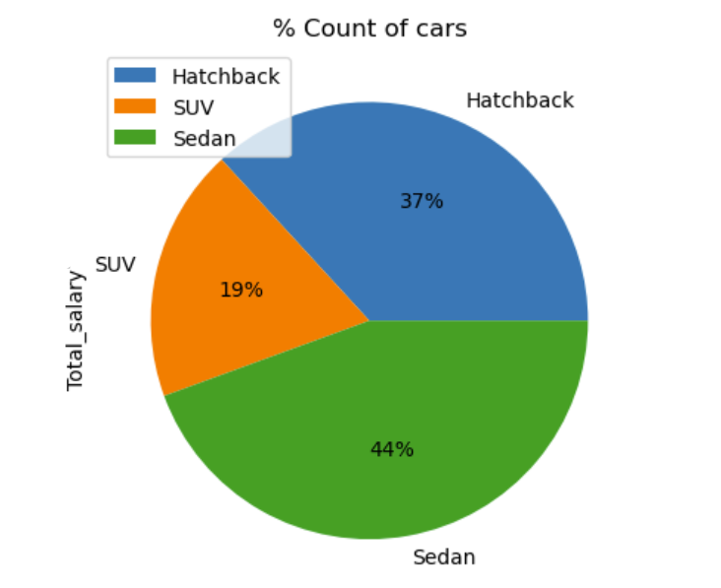 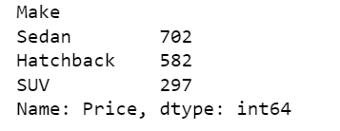

We can say that 44% purchase is of sedans which is the highest in the category.

1. Sum and average Total salary of customers.

Below is the **Sum of total salary** of customers and sedan is contributing the most about 45%.

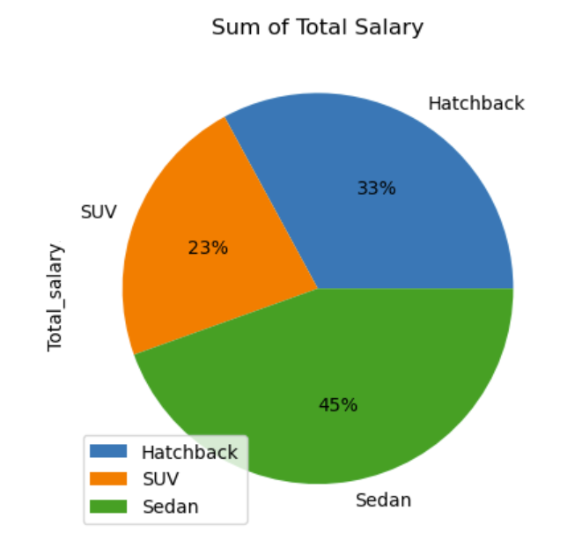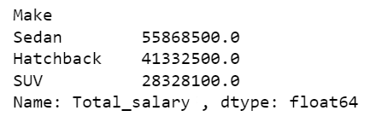

Below is the **average (mean) total salary** of customers and here SUVs is contributing more because SUVs are expensive.

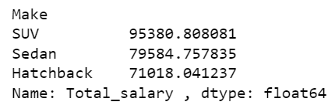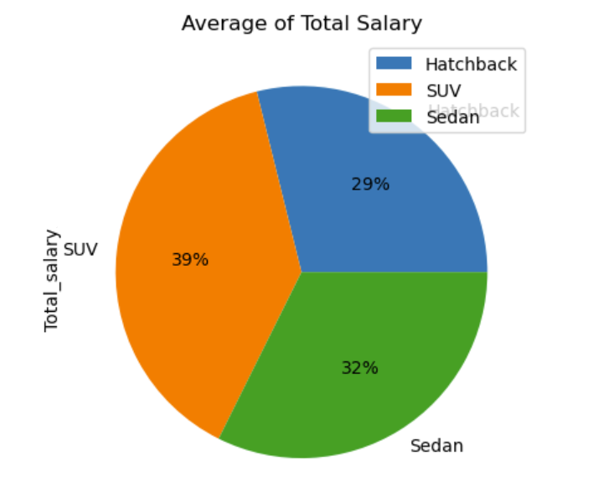

1. Sum and average price of different car Make. (Sedan, SUV, Hatchback)

Below is the pie chart of **car total price** and sedan is contributing the most around 43% of the total revenue.

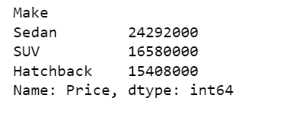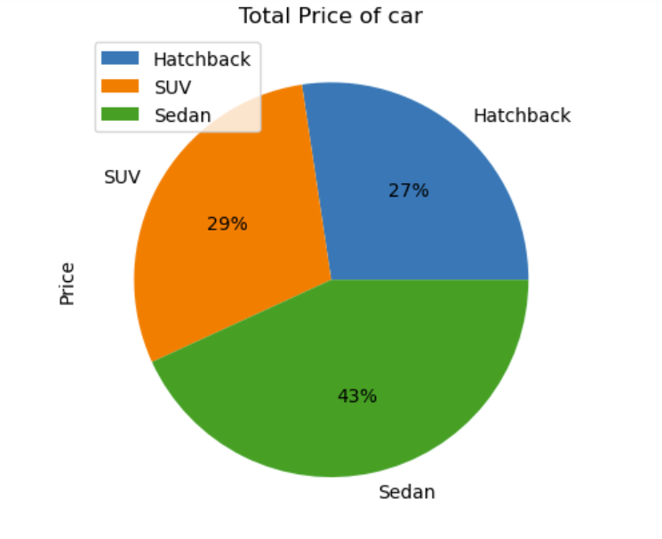

Below pie chart shows **average car price** and here SUVs is the highest amongst all and contribute around 48%

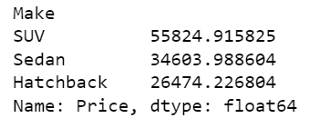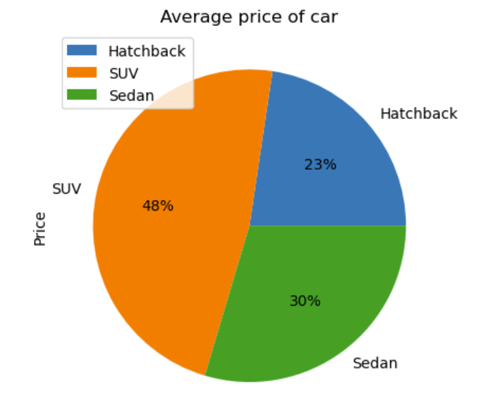

**The above cohorts say that, some customers who are buying sedans and hatchbacks have high salary and can be pitched to buy SUVs which will increase the revenue. Now we will identify which customers to pitch.**

***Target customers to pitch:***

1. **Let’s consider customers of salary 1,00,000 and above to be rich customers, the count of these customers is 322 out of 1581 which is around 20%.**
2. **Out of those 20% rich customers 9% customers are buying sedans and 4% are buying hatchbacks. We should target women because mostly women show more interest in purchasing SUVs.**
3. **If we target these rich customers to buy SUVs then our revenue will increase.**

***What Steps can we take to target the rich customers to increase the SUVs sales:***

1. **Give customers spot offers discount for first time visitors.**
2. **Give customers first 2 car servicing free if they go for SUVs.**
3. **Give them some offers in bank loans if applicable.**
4. **Organise an event regarding SUVs purchase and put some offers like spin-the-wheel and give them some gift vouchers to increase sales.**

**Summary & recommendations:**

1. Sedan contributes 44% of the entire sales and 43% of the total revenue.
2. Sedans are preferred by all age group except age group between 50-60, old customers are mostly purchasing SUVs.
3. 20-30 age group customers are purchasing 60% cars.
4. In terms of marital status as married 34% Males are purchasing Sedans, 31% males are purchasing Hatchbacks. 10% females are purchasing SUVs and also females are mostly interested in purchasing SUVs.
5. Males who have taken house loan are not purchasing SUVs. For sedans and hatchbacks females who have taken house loan show more interest than males.
6. Customers who have taken personal loans are going after Sedans and in terms of money and quantity sedan is the highest. It means that most of the customers are purchasing sedans on personal loans.
7. Working partners purchase more cars because they contribute more in terms of revenue, also they are purchasing more sedans. But for SUVs partner working doesn’t show much impact.
8. Profession weather it is business or salaried doesn’t show much impact on the purchase pattern.
9. 57% employee total salary is between the 50000-100000 and 16% employee total salary falls between 70000-80000.

**GODIGT Bank Data Analysis**

**Objective:**

In Godigt bank data find out relevant customer pattern in all categorical variables, how to increase the bank revenue, which customers to target, which customer to avoid and reduce their cc limit also what steps can be taken to avoid bad customers in future.

**Data dictionary:**

|  |  |  |
| --- | --- | --- |
| **Variable** | **Data Description** | **Variable Data Type** |
| Userid | Unique bank customer-id | Continuous |
| Card_no | Masked credit card number | Continuous |
| Card_bin_no | Credit card IIN number | Continuous |
| Issuer | Card network issuer | Categorical |
| Card_type | Credit card type | Categorical |
| Card_source_date | Credit card sourcing date | Date Time |
| High_networth | Customer category based on their net-worth value (A: High to E: Low) | Categorical |
| Active_30 | Savings/Current/Salary etc. account activity in last 30 days | Categorical |
| Active_60 | Savings/Current/Salary etc. account activity in last 60 days | Categorical |
| Active_90 | Savings/Current/Salary etc. account activity in last 90 days | Categorical |
| Cc_active_30 | Credit Card activity in the last 30 days | Categorical |
| Cc_active_60 | Credit Card activity in the last 60 days | Categorical |
| Cc_active_90 | Credit Card activity in the last 90 days | Categorical |
| Hotlist_flag | Whether card is hot-listed (Any problem noted on the card) | Categorical |
| Widget_products | Number of convenience products customer holds (dc, cc, net-banking active, mobile banking active, wallet active, etc.) | Categorical |
| Engagement_products | Number of investment/loan products the customer holds (FD, RD, Personal loan, auto loan) | Categorical |
| Annual_income_at_source | Annual income recorded in the credit card application | Continuous |
| Other_bank_cc_holding | Whether the customer holds another bank credit card | Categorical |
| Bank_vintage | Vintage with the bank (in months) as on Tthmonth | Continuous |
| T+1_month_activity | Whether customer uses credit card in T+1 month (future) | Categorical |
| T+2_month_activity | Whether customer uses credit card in T+2 month (future) | Categorical |
| T+3_month_activity | Whether customer uses credit card in T+3 month (future) | Categorical |
| T+6_month_activity | Whether customer uses credit card in T+6 month (future) | Categorical |
| T+12_month_activity | Whether customer uses credit card in T+12 month (future) | Categorical |
| Transactor_revolver | Revolver: Customer who carries balances over from one month to the next. Transactor: Customer who pays off their balances in full every month. | Categorical |
| Avg_spends_l3m | Average credit card spends in last 3 months | Continuous |
| Occupation_at_source | Occupation recorded at the time of credit card application | Categorical |
| Cc_limit | Current credit card limit | Continuous |

**The top variables are as follows:**

1. High Net Worth
2. Hot List Flag
3. Annual Income
4. Average Credit card spend in 3 months
5. CC limit
6. Occupation
7. Card Source Date

**Data Description:**

There are 8448 rows and 28 columns, below is the data description of all the variables.

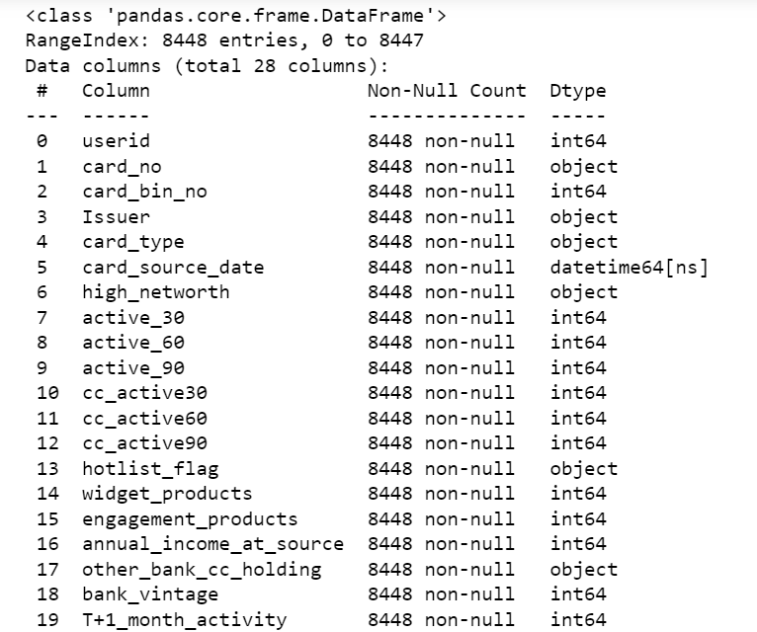

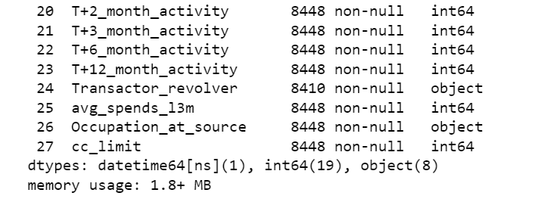

There are 3 numerical variables which are **“annual_income_at_source”, “avg_spends_l3m” and “cc_limit”**. Below is the summary of the numerical data and corelation between them.

Data Summary:

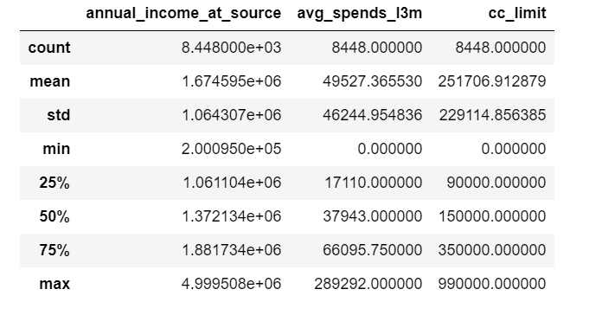

Data Corelation:

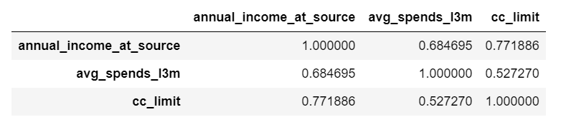

**Outlier and null values identification**

All 3 numerical columns **“annual_income_at_source”, “avg_spends_l3m” and “cc_limit”** contain outliers. We can use the boxplot method to treat the outliers. Below is the screenshot attached:

***Note: Here we are only identifying the null values and outliers and not treating them.***

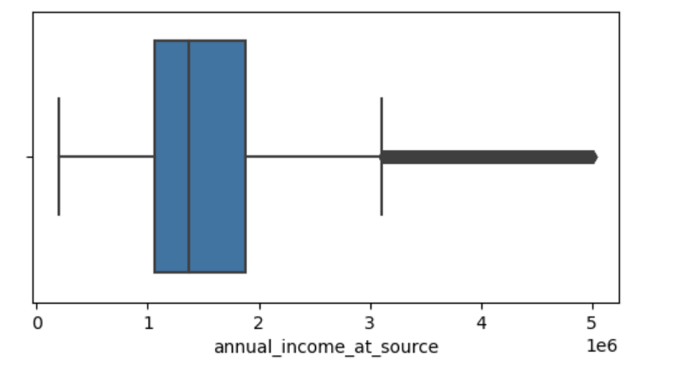

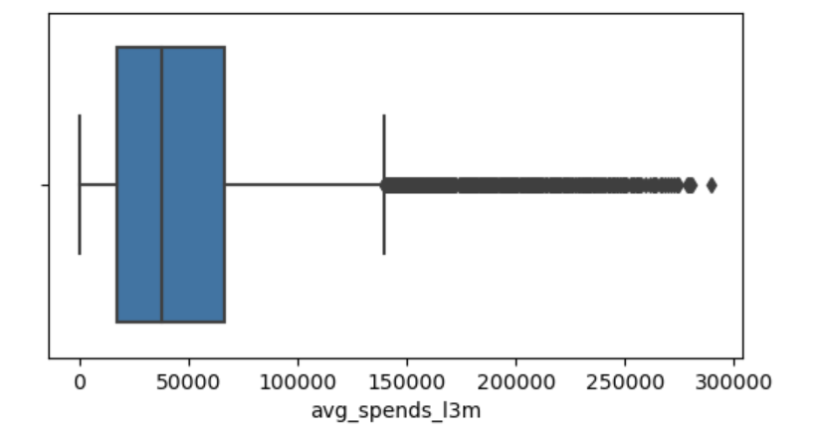

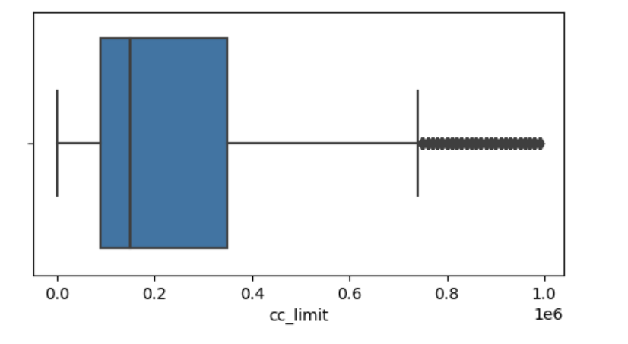

In “Transactor_revolver” variable there are 38 null values, the count is 8410 rows. We can consider the mode to treat the null values. In the below screenshot the mode is “**Transactor**”.

Data summary of column “Transactor_revolver”

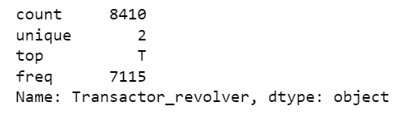

Value counts of column “Transactor_revolver”

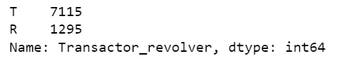

**Note:**

**We can break the *date variable column into three columns like Day, month and year*. This will add more value in our analysis and we can dive deeper into the data.**

**Top Questions that can be asked initially:**

* Which issuer does most transaction and what is the total annual income?
* Which card type is widely used and what is the total annual income?
* Which year the count and annual income are highest?
* Which year contributes the highest count of customer’s hotlist flag?
* How many customer’s salary accounts are active within 30 days, 60 days and 90 days?
* How many widget products are popular when compared with card type?
* Which card type has different engagement products?
* How many customers have accounts in other bank, are they high net worth customers?
* How many customer’s credit card are active within 30 days, 60 days and 90 days?
* Show count and annual income of T+1 month activity, T+2 month activity, T+3 month activity, T+6 month activity, T+12 month activity and compare which one is highest?
* Which occupation is highest in terms of count and annual income?
* Which card type and has more CC limit?
* Which customer comes most under hotlist flag?
* In which month the count and annual income is the highest?
* What is the count and annual income of high net-worth customers?
* How many high net-worth customers are under hotlist flag?
* What is the corelation between all variables?
* How many customers have not activated their savings account in past 90 days?
* How many customers have not done any transactions by their credit card in past 90 days?
* What is the relevance of bank vintage with other columns?
* What is the relevance of high net-worth customers with widget products?
* What is the relevance of high net-worth customers with engagement products?
* What is the average spending of high net-worth customers, in which year and month it is highest?
* What steps can be taken to increase the average spending of customers?
* How can we encourage and convert inactive customers to active customers?
* How many customers are transactor and how many are revolvers?
* What is the relevance transactor revolver column with other variables like hotlist flag, annual income, CC limit and high net-worth?
* What is the count of transactor and revolver column year and month wise?
* What is the average spending of customers based on Occupation and transactor and revolver variable?
* Can we say that customers having other bank accounts are less active and do less transaction?
* What is the relevance between occupation of customer and card type?

**The End**