
Project Proposal for
PSPF Record Tracking System

Public Service Pension Fund

Document Version 1.1

Prepared By:
Amit Kumar
Business Development Manager
Misha Infotech Private Limited
Email ID- amit@mishainfotech.com www.mishainfotech.com
Tel No: 011-65732683
Cell: +91-9891408881
USA: +1-(917) 503-0924,+1-(917) 688-4201

Table of Contents
- Executive Summary………………….………………………….…………………………5

  - Introduction……………………….……………………………………….…………...5

  - Objective of Developing Application………………………………………………….6

  - Requirement Overview…………………….…………………………………………..6

  - About Misha Infotech…………………………….………..…………………………..7

  - Overview of Proposed Methodology……………………………..………………….10

  - Advantage of Proposed Methodology……………………………………………….15

- Requirement Scope……………….…...………………………...………………………..16

  - Defined Scope…………………………………………………………........................16

- Solution Description……………………………………………………………………...18

  - Proposed Solution…………………………………………………………………….18

  - Technical Solution……………………………………………………………………22

  - Physical Architecture…………………………………………………………………23

  - Solution Architecture ……………………………………………….……………….24

  - Project Receivables……………………………………..……….……........................25

- Time & Effort Estimation………………………………………………………………..26
Exhibit A………………….………………………………………………........................28
ExhibitB…………………………………...………………………………………...…...30

Introduction
PSPF is a Public Sector Unit established by Government of Anguilla which manages the contribution collected from all the employers & employees in various government & Public Sector organizations. PSPF is as well responsible for disbursing pension amount to Pensioners/ Beneficiaries.

Present Contributors of the Fund
Employer | # of Contributors
PSPF | 880
Royal Anguilla Police Force | 90
Water Corporation of Anguilla | 22
Health Authority of Anguilla | 174
Anguilla Development Board | 9
Anguilla Tourist Board | 9
Public Utilities Commission | 3
Financial Services Commission | 11
Anguilla Community College | 5
Anguilla Air & Sea Ports Authority | 62 expecting additional 50 contributors
Public Service Pension Fund | 3
TOTAL CONTRIBUTORS | 1268

Objective for Developing Application:
PSPF would like to achieve following objective from the application:
- To eliminate the manual process of handling pension.
- To avoid managing the paperwork involved in maintaining the records of the employees/pensioners/Beneficiary.
- To keep a track of payment done/ contribution collected to/from Pensioners/Beneficiary/Employees
- To enable quick decision making based on available data
- To provide a interface from which information can be easily accessible to employees, Administrator & Management

1.3 Requirements Overview
At present PSPB is a board through which all pension related processes/activities are managed. All the activities are managed manually which makes it difficult to have access to the analysis, facts & figures instantly for quick decision making. The entireemployees with the employer list mentioned above have a Account with the PSPF & their employers submit their contribution as per law to PSPF. In order to make system effective, fast decision making & optimum utilization of available resources,PSPF is looking to develop a Web based application which will reduce their dependency & quick access to the reports/details.

1.4 About Misha InfoTech
Misha InfoTech Private Limited is a customized process-driven software solutions provider based in India. Misha InfoTech provides bespoke technological solutions to many entrepreneurs, enterprises and start up ventures, to help them gain maximum ROI for their business.
Over the years, our committed professionals have provided solutions par excellence. Some of these include bespoke application development, systems migration, Database fine-tuning&auditing, web marketing, technology audits, third party integration, e-learning tools etc. Today, with our experience and skills, we have been able to create a global footprint of clients and partners across multiple continents.
Some of our clients include business from industry verticals like multimedia and games, beverage, travel and tourism, finance, E-commerce, E-learning, IT solutions & consultancy organizations, young entrepreneurs, Corporate, NGOs, Government organizations etc. Misha InfoTech Provides solutions for business at all levels.
Misha InfoTech is started by the principles ofARYAN E-SOFT Private Limited (formally ARYAN Softwares) Established in year 2000 was formed and serving with its Solution for Language based Products. Aryan Softwares has been dedicated to provide multilingual Softwares solutions and IT consulting services to a client base diversified in size, geography and Industry.
Our Strengths
- Our rich experience in design, development and maintaining IT solutions helps us in understanding Clients’ requirement better.
- Our team of functional experts helps clients in reconstructing existing process & infrastructure to implementing new methodologies for better productivity.
- Our strong technical team continuously upgrades existing products and introduce new technologies and products.Our Implementation team helps in Installing, Implementation Solutions in a Systematic manner, Training and handling over the system. Use of latest technologies for application development.
- Our team of experts updates their skills with the latest technical skills.

Clientele
Our esteem clientele* in India includes President House, Prime Minister Office, and Cabinet Secretariats

CENTRAL MINISTRIES
- Ministry of External Affairs, India
- Ministry of Urban Development ,India
- Ministry of Defence (ITBP,BSF,DGBR,SSB) ,India
- Ministry of Home Affairs ,India
- Ministry of Science &Technology ,India
- Ministry of Law, Justice & Company Affairs ,India
- Ministry of Health and Family Welfare ,India
- Ministry of Urban Development ,India
- Ministry of I&B ,India

Research and Educational Institute
- T.B.R.L (Chandigarh)
- Department of Forensic Science, Chandigarh
- Survey of India, Chandigarh
- IIFT
- Delhi University
- DRDO
- NDRI
- AICTE






Note - * Includes Joint Client List with Aryan E-Soft Pvt. Ltd., Misha InfoTech Pvt. Ltd.

Some of clients served by our team in Caribbean
Ministry of Finance, St Kitts & Nevis
Youth Empowerment through Skills (YES) program, St Kitts & Nevis


1.5 Overview of Proposed Methodology
Misha InfoTech Private Limited and DITES, Anguilla will follow industry proven 4D methodology to develop the Web Application. The four phases are depicted in figure below.
This phased methodology has been derived from strong software engineering principles. To complete each phase, Misha Infotech Private Limited process model uses comprehensive guidelines; templates, checklists and historical information. It helps in executing the project seamlessly to produce a robust application. Our process model is quiet flexible to adopt inputs that may be provided by PSPF.
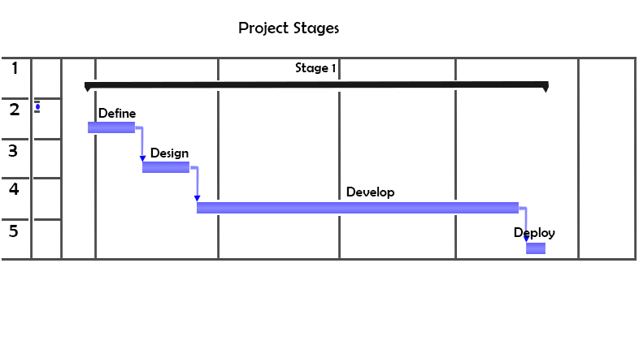

Collaboration Approach
DITES, Anguilla
Misha Infotech Private Limited
Planning
Project Management
Co-ordination
Training
Implementation
PSPF
New Development
Continues Knowledge Transfer
Application Testing Plan
Support After Implementation

Detailed Testing Plan
Unit testing of the Application
Misha Infotech would develop the identified application modules in collaboration with DITES, Anguillaas per the indicated scope and submit it to Client. If there are any changes to the Requirements, these changes have to be processed according to the Change Management Procedures stated in this proposal.
Inputs:
- Signed-off system specifications document(s)
- Signed-off design document(s)
Activities:
- Development of the new application modules
- Merge common sections and services
Outputs:
- Developed and unit tested application modules
- Approved changes, if any, to the requirements/design which were agreed earlier
System Integration Testing
The product will be tested module-wise at on-site in the UAT environment after setting up the same. And the interdependencies among the modules will be validated.
Inputs:
- Developed Modules
- Updated Integration Plans
Activities:
- System Integration testing
Output:
- Bug fixes to already tested modules/design requirements
- Integrated System

User Acceptance Testing and Sign-Off
In this phase, PSPF user will test for functionality of the system in the UAT environment. To be able to test the system for acceptance, PSPF person has to review the User Acceptance Test Plan provided by DITES, Anguilla/MIPL and make necessary modifications to suit their requirements. The modified User Acceptance Test Plan and test data has to be as close to the real life scenario as possible. Relevance of the user acceptance test plan and test data to the real life scenario play an important role in deciding the effectiveness in migration of the business from the current modus operandi to the web scenario.
Inputs:
- Well-defined Acceptance Test Criteria
- Acceptance Test Plan and data
Activity:
- Acceptance Test the applications
Output:
- Acceptance Application

Knowledge Transfer:
We would like to highlight that there will be a continuos process of knowledge transfer will be established for smooth transition of knowledge from MIPL to DITES, Anguilla so that DITES, Anguilla can support the PSPF even after complete implementation of application for any kind of requirement related to bug resolution, Training, new customization/development.

Training:
DITES, Anguilla will conduct the onsite training for various users of the PSPF which will include the complete details related to functional & technical aspect of the application

Proposed Mode of Collaboration

Misha Infotech Private Limited along with DITES, Anguilla proposes a collaborative approach to develop and implement Web Application. Misha Infotech Private Limited consultants,DITES, Anguilla and PSPFstaff will work together to develop application.

Following points enumerate proposed mode of collaboration:
- Misha Infotech Private Limited&DITES, Anguilla understands and fully appreciates that business knowledge lies with the personnel working for PSPF,Misha Infotech Private Limited &DITES, Anguilla wants to utilize this wealth of experience and knowledge to create a robust and scalable system.
Misha Infotech Private Limited&DITES, Anguilla proposes to start the project with business analysis. Misha Infotech Private Limited&DITES, Anguilla business analysts will closely observe and interact with the PSPF’s staff to understand the operations of PSPF. DITES, Anguilla will produce a document (Software Requirement Specifications - SRS) that will have complete details of business requirements. Once the requirements are approved Misha Infotech Private Limited will architect, design, develop and test the system in stages.
- At the end of each stage, Misha Infotech Private Limited &DITES, Anguilla will deliver a working version to PSPF.
- After the system has been developed and tested (at the end of third stage), Misha Infotech Private Limited will setup the complete system at its Test Servers for acceptance testing. PSPFstaff will do acceptance testing and give a formal approval for deployment.
Once acceptance testing finishes, deployment will begin as a last step. Misha Infotech Private Limited engineers along with PSPFIT team will setup and install the system on PSPFservers. DITES, Anguilla will also provide on the job training to PSPFpersonnel if required.

1.6 Advantages of Proposed Approach
- MISHA INFOTECH PRIVATE LIMITED&DITES, Anguilla proposes to develop the system in multiple stages.
- It will reduce the complexity of overall application
- The software architecture will remain simple while retaining its elegance, maintainability and scalability.
- MISHA INFOTECH PRIVATE LIMITED&DITES, Anguilla will closely and collaboratively work with PSPFpersonnel (under their experienced guidance)to create a robust and scalable system. Close and continuous association will give rise to many benefits:
  - It will ascertain and ensure that there is no ambiguity in understanding the requirements thus guaranteeing required needs are fulfilled to the satisfaction.
- Cost of Development & implementation will be reduced due to complete control of DITES, Anguilla
- Application Source code & knowledge will be retained by PSPF & DITES, Anguilla will be solely responsible for its maintenance.
- Cost of training is substantially reduced due to involvement of local authority/body.
- PSPF can easily rely for any further development/ support on DITES, Anguilla
- PSPF need not to pay Annual maintenance contract as support is provided by DITES, Anguilla

2 Requirements Scope

2.1Defined Scope
The scope of the current engagement involves undertaking and completing of the project. It involves acquiring complete operational knowledge of PSPF and defining requirements for creating software application. Following activities will be done during the project:
- Understand existing operations of PSPF.
- Prepare High Level Design of the proposed solution which will provide details of:
  - System architecture
  - DB schema
  - Object model
  - User Interface forms and reports.
  - Designing custom email notification service and email message templates
- Develop user forms, code components and data elements as described in documentation.
- Code reviews and approval.
- Unit testing of developed components and application.
- Perform System Testing and ensure quality standards are achieved.
- Provide deployment support to the production environment.
- Collect and consolidate feedback from users.
- Overall project management.

3. Solution Description

Proposed Solution
After thoroughly analysing your requirement & based on our discussion& meetingwe comprehend that PSPFis looking to have following functionality/modules in their application
- Employee Registration
- Employer Registration
- Pension Calculation
- Benefit Calculation
- Reporting & Integration
- Monthly Pension Process

Employer Registration
Employer
PSPF
Employer Unique Identifier
PSPF Record Tracking System

Employee Registration

Employee
PSPF
Employer Unique Identifier
PSPF Record Tracking System
Fills Out Specific info on a form prescribed and send to PSPF

Process Workflow
Monthly Transaction
Employer
PSP
PSPF Record Tracking System
Monthly sheet with details of Contribution
Manual Entry
Automatic Entry
/Validation of Data
All Monthly Reports Available
Automatic Notification of Retirement
PSPF Record Tracking System
Send Alert to Assigned PSPF Employee on Email/Dashboard
Necessary Action taken
Notification
System
Administrator will be able to do the settings on when we want to receive the Alerts
Example –Retirement date , Alert Duration Dependent Maturity Rule with
Employee type –Alert duration As soon as a dependent achieve the maturity age
defined , a notification sent to all the employees who are set to receive notifications .

Yearly Statement Print
PSPF Record Tracking System
PSPF user will be able to print yearly Statement , which will include information on Current year contribution with details of each month as well the Total Contribution made till yet
Employee can Keep It for their Record

Pension
PSPF Record Tracking System
Pensions processed at PSPF office each month and a check being created each month from system
Pensioner can come and collect the check , if the option of Direct Deposit is selected , A list of direct d to bank deposit will be created to sent to the bank
Notification

Listing for Life/Medical Insurance
PSPF Record Tracking System
After pension process ,PSPF will be able to get the list for insurance , so that a list can be sent to Insurance for medical and Life insurance of persons who has opted for the same .
A Detailed report can be printed , which will show the Amount which was charged as commission by PSPF and What is paid for medical and what is paid for life insurance .
Notification
For Administrator:
- Administrator will be defining the access right of all the users
- Administrators will be able to add/delete/edit any information which is present in the system whether related with Employee/Employer/Beneficiary/Pensioner.
- Administrator will be able to access all the reports Daily/weekly/Monthly/Between period for all the Employee/Employer/Beneficiary/Pensioner.
- Administrator can as well access graphical format of reports related with No of Pensioners/Total amount disbursed in a month/yearly. This will help in analysing the productivity of the PSPF & will as well be useful for PSPF.

Security
Application will have role based security throughwhich access can be defined by the administrator & all the username password will be kept in the encrypted format.

3.2 Technical Solution
We understand that PSPF needs a scalable solution to cater to expanding pension fund. At the same time PSPF needs a solution quickly so as to improve process productivity, employee/employer/Pensioner/Beneficiary satisfaction and increase management bandwidth very quickly. MISHA INFOTECH PRIVATE LIMITED&DITES, Anguilla, after due consideration, of challenging requirements would like to propose a technical alternative based on Microsoft technology.
MISHA INFOTECH PRIVATE LIMITED&DITES, Anguilla proposes to build a MicrosoftTechnology based solutions to take care of PSPF’s Web Application requirement. This solution will be eminently usable and will provide immediate benefits for existing operations at the same time will give scalability option as well.
In order to provide accessibility, flexibility, robustness, security and extensibility, the application should be based on multi-tier architecture. The advantage behind multi-tier architecture is that, one tier can be changed without affecting or least affecting the code in any other tier.
Please check the Technical solution Details Below:
Platform
Suggested solution is a web based platform access by various departments through a secured channel.
Technology –
Front End – ASP.net C#, Jquery, Java Script
Back End – Microsoft Sql Server 2010
Security -There will be different roles based on Work associated with different roles, Users Permissions will be there. So if a user has Permissions to enter the application details, then he will just able to enter
Audit Trail -history of every update will be maintained in the system

Hosting Requirement:
- Microsoft Sql Server 2010
- IIS 7.0/7.5
- Supporting Crystal Reports
- Microsoft Office component

Physical Architecture


Intranet
Web Server
Windows 2008 Ent. Ed. Sp2 64 bit
IIS 7.0 / DotNET 3.5
Application Server
Windows 2008 Ent. Ed. Sp2 64 bit
Rules Engine / Business Process
Database Server
Windows 2008 Ent. Ed. Sp2 64 bit
SQL Server 2008

3.4 Solution Architecture
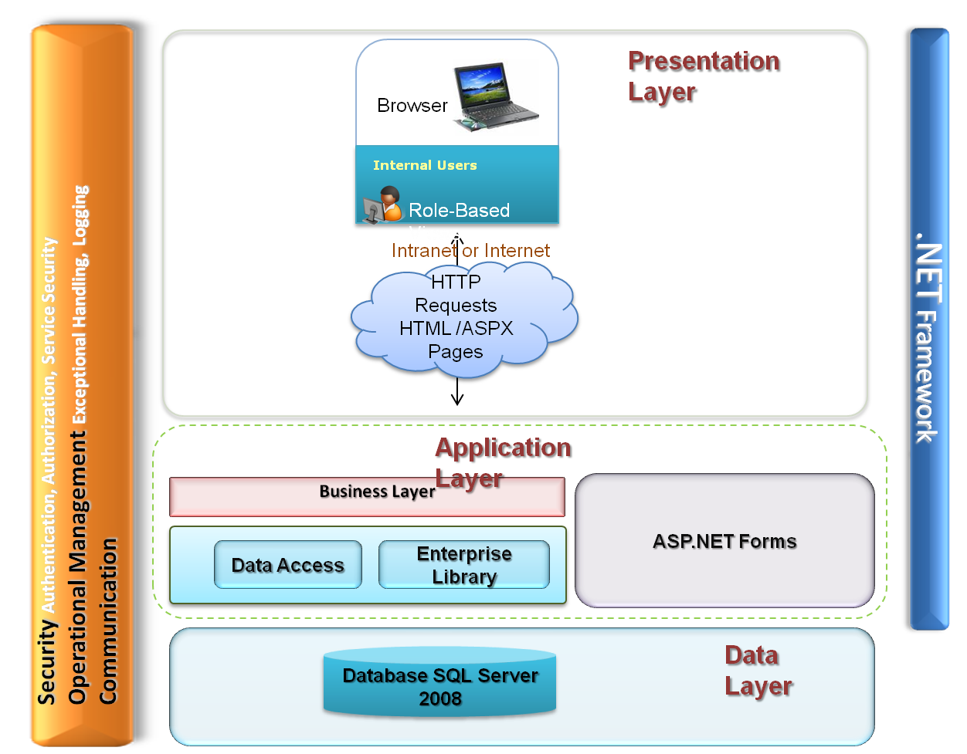

3.5 Project Receivables

Item | Description | When
Document(s) about existing system | Any relevant Documents | On project start
Report formats of existing operations | All the Output formats for existing operations | On project start
UAT Test Cases | Test cases that shall be executed by PSPF during the acceptance testing phase | After ‘Design’ phase

Project Assumptions
- Project execution will start only after the Contract/SOW has been signed between PSPFand MISHA INFOTECH PRIVATE LIMITED.
- PSPFwill keep MISHA INFOTECH PRIVATE LIMITED&DITES, Anguilla informed of any events and entities under its control that could have bearing on the start, progress and/or successful completion of the project. Any material change in requirements or assumptions may change the effort and/or the cost of this project.
- PSPFwill make available to MISHA INFOTECH PRIVATE LIMITED
&DITES, Anguilla all necessary and appropriate documentation and existing business processes and any other documentation deemed relevant to the project in a timely manner.
- In case of delays in receivables, the project duration & schedule will be adjusted accordingly.
- PSPFwill provide the MISHA INFOTECH PRIVATE LIMITED project team&DITES, Anguilla with prompt access to required personnel, including but not limited to business users and IT staffs that are knowledgeable about PSPFbusiness.
- The IT staff of PSPFwill work under the guidance of DITES, Anguilla &MISHA INFOTECH PRIVATE LIMITED consultants for the duration of the project.
- PSPFwill assign a full time coordinator for the duration of the project.
- PSPFwill provide the project team with designated, dedicated users for the requirements artefacts review & verification as well as the User Acceptance Test cases artefacts. The timely review comments are critical to the project schedule. Delay in receiving so will extend the duration of the project. Participation will be based upon the modules and functionality addressed.
- All the escalations will be resolved in timely fashion. Failure to do so will impact the duration of the project.
- The system will support only English language.
These assumptions have been made while arriving at the effort and cost estimates. MISHA INFOTECH PRIVATE LIMITED&DITES, Anguilla can present the impact on the cost and schedules if there are any deviations in the assumptions.

