DEPARTMENT OF COMPUTER SCIENCE & ENGINEERING
INTERNET PROGRAMMING LABORATORY RECORD
SKYBOOK - ONLINE FLIGHT RESERVATION SYSTEM
AYUSH MOHAPATRA 192411263

1. AIM
To design and develop an Online Flight Reservation Web Application ('SkyBook') using HTML5, CSS3, and JavaScript, providing passengers with multi-city domestic flight search, schedule discovery, dynamic class-based seat selection (Economy and Business), passenger booking form validation, demo payment gateway simulation, PNR generation, printable e-ticket rendering, ticket cancellation, and administrative flight schedule and occupancy management.
2. SYSTEM SPECIFICATIONS & REQUIREMENTS
The system executes in the Chromium DOM engine with HTML5, CSS3, and modular ES6 JavaScript utilizing LocalStorage for persistence.
Category | Specification / Tool | Details / Role
Hardware Requirements | Processor | Intel Core i5 / AMD Ryzen 5 or higher
Hardware Requirements | Memory (RAM) | 8 GB DDR4 RAM or higher
Hardware Requirements | Display | 1920x1080 Full HD Monitor
Software Requirements | Operating System | Microsoft Windows 10 / Windows 11 (64-bit)
Software Requirements | Execution Engine | Google Chrome / Chromium DOM Engine
Software Requirements | Code Editor | Visual Studio Code / Integrated Development Environment
Frontend Technologies | Markup Language | HTML5 (Semantic Elements, Form Controls, Tables)
Frontend Technologies | Styling Language | CSS3 (Flexbox, Grid, Responsive Media Queries)
Frontend Technologies | Scripting & DOM | JavaScript (ES6+, DOM API, Event Listeners)
Client-Side Storage | Web Storage API | Browser LocalStorage for persistent client data

3. ALGORITHM
The step-by-step procedure for designing and executing the SkyBook Flight Reservation System is given below:
Step 1: Multi-Page Application Layout Setup - Construct semantic HTML5 documents (index.html, search-flight.html, booking.html, payment.html, my-ticket.html, booking-status.html, cancel-ticket.html, feedback.html, admin.html, admin-flights.html) establishing header navigation, search bars, flight cards, booking forms, and admin tables.
Step 2: Aviation Brand Styling & Print Rules - Apply CSS styling (style.css) featuring deep aero-blue (#003580), crisp white card elevation, departure/arrival timeline diagrams, responsive dropdown navigation, and @media print rules for boarding passes.
Step 3: Flight Schedule Database Initialization - In JavaScript (script.js), configure a comprehensive flight dataset containing flight numbers (SKY 101, SKY 102, SKY 201), origins (Chennai, Delhi, Mumbai, Bangalore), departure/arrival times, durations, class fares, and seat quotas.
Step 4: Flight Search & Availability Filter - Parse origin airport, destination airport, journey date, and travel class; query the flight dataset; dynamically construct HTML flight cards displaying departure timings, duration, pricing, and 'Book Now' triggers.
Step 5: Dynamic Seat Selection & Passenger Form - Extract selected flight parameters from URL query parameters; dynamically populate travel class options (Economy / Business) and available seat count dropdowns; capture passenger details (Name, Age, Gender, ID).
Step 6: Fare Computation & Tax Breakdown - Compute total fare including base tariff, class multipliers, fuel surcharge, and taxes; pass reservation data to the payment gateway module.
Step 7: Simulated Payment & PNR Generation - Simulate card/UPI checkout in payment.html; validate card credentials; generate a unique 6-character alphanumeric PNR code (e.g., SKY-849201); save confirmed ticket in localStorage.
Step 8: Printable E-Ticket Generation (my-ticket.html) - Dynamically construct a digital boarding pass ticket with flight number, PNR, passenger name, seat number, and barcode; attach window.print() for paper printing.
Step 9: Ticket Cancellation & Refund Computation - Lookup booked tickets by PNR in cancel-ticket.html; calculate cancellation refund according to airline fare rules; mark ticket status as 'Cancelled' and restore seat availability.
Step 10: Airline Administration & Manifest Control - In admin.html and admin-flights.html, provide tools to manage flight routes, view passenger manifests, inspect occupancy rates, and generate operational revenue reports.
4. SYSTEM ARCHITECTURE & MODULE DESCRIPTION
The SkyBook application features an enterprise-grade modular architecture:
File Name | Module Name | Functional Role
index.html | Home Portal | Aviation showcase banner, quick flight search widget, popular destination cards
search-flight.html | Flight Search Engine | Multi-city flight lookup, route filtering, schedule and fare cards
booking.html | Passenger Booking | Passenger details form, dynamic Economy/Business seat selection
payment.html | Payment Gateway | Demo credit/debit card and UPI payment processing with validation
my-ticket.html | E-Ticket Boarding Pass | Printable electronic flight ticket with PNR, barcode, and seat allocation
booking-status.html | PNR Status Enquiry | Real-time PNR inquiry portal displaying live booking state
cancel-ticket.html | Ticket Cancellation | PNR-based self-service ticket cancellation and refund processing
admin.html | Admin Dashboard | Overview of flight operations, booked passenger counts, and revenue
admin-flights.html | Fleet Management | Add new flight schedules, update route fares, and seat inventories
css/style.css | Aviation Theme | Blue corporate styling, responsive dropdowns, card layouts, print stylesheets
js/script.js | Core Flight Engine | Flight search algorithms, dynamic seat math, PNR generation, and ticket rendering

5. KEY SOURCE CODE HIGHLIGHTS
HTML Structure: Flight Search Interface (search-flight.html)
<section class="search-container">
<h2>Search Domestic Flights</h2>
<div class="search-form">
<select id="from">
<option value="">Select Origin</option>
<option value="Chennai">Chennai (MAA)</option>
<option value="Delhi">Delhi (DEL)</option>
<option value="Mumbai">Mumbai (BOM)</option>
<option value="Bangalore">Bangalore (BLR)</option>
</select>
<select id="to">
<option value="">Select Destination</option>
<option value="Delhi">Delhi (DEL)</option>
<option value="Chennai">Chennai (MAA)</option>
<option value="Mumbai">Mumbai (BOM)</option>
</select>
<input type="date" id="flightDate">
<select id="flightClass">
<option value="All">All Classes</option>
<option value="Economy">Economy</option>
<option value="Business">Business</option>
</select>
<button onclick="searchFlights()">Find Flights</button>
</div>
<div id="flightResults"></div>
</section>

JavaScript: Flight Search & Result Card Rendering (js/script.js)
const flights = [
{no:"SKY 101", from:"Chennai", to:"Delhi", time:"06:30 AM", arrival:"09:30 AM", duration:"3h", economy:42, business:8, fare:5450},
{no:"SKY 102", from:"Chennai", to:"Delhi", time:"04:15 PM", arrival:"07:20 PM", duration:"3h 5m", economy:31, business:5, fare:5890},
{no:"SKY 201", from:"Bangalore", to:"Mumbai", time:"08:00 AM", arrival:"09:45 AM", duration:"1h 45m", economy:55, business:12, fare:3490}
];
function searchFlights() {
const from = document.getElementById("from").value;
const to = document.getElementById("to").value;
const results = document.getElementById("flightResults");
const matched = flights.filter(f => (!from || f.from === from) && (!to || f.to === to));
if (matched.length === 0) {
results.innerHTML = "<p>No flights found for selected route.</p>";
return;
}
results.innerHTML = matched.map(f => `
<div class="flight-card">
<div class="flight-info">
<h3>${f.no} (${f.from} &rarr; ${f.to})</h3>
<p>Departure: ${f.time} | Arrival: ${f.arrival} | Duration: ${f.duration}</p>
<p>Seats: Economy (${f.economy}), Business (${f.business})</p>
</div>
<div class="flight-fare">
<span class="price">₹${f.fare}</span>
<a href="booking.html?flight=${encodeURIComponent(f.no)}" class="btn-book">Book Flight</a>
</div>
</div>
`).join("");
}

6. CHROME DOM OUTPUT & SCREENSHOT VERIFICATION
The SkyBook Flight Reservation application was executed inside Google Chrome DOM. The following screenshots document the rendered user flows, search results, booking screens, and administrative panels.
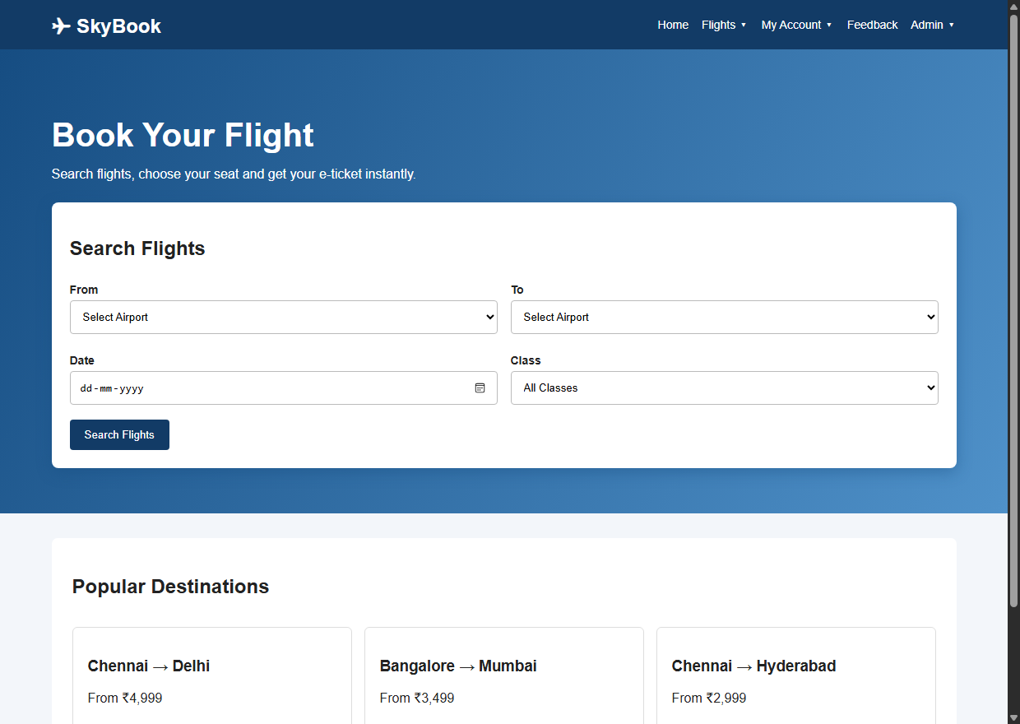
Figure 6.1: Chrome DOM Rendering of SkyBook Flight Portal Home (index.html)
Output Observation: Shows the aviation portal homepage featuring brand navigation, quick flight search bar, and popular domestic destination cards.
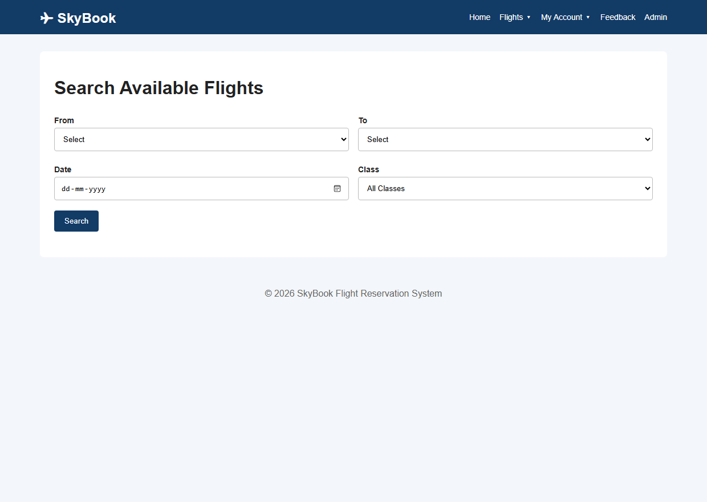
Figure 6.2: Flight Search Results & Route Availability (search-flight.html)
Output Observation: Illustrates the flight search interface dynamically rendering available flight cards, timings, seat availability, and fare options.
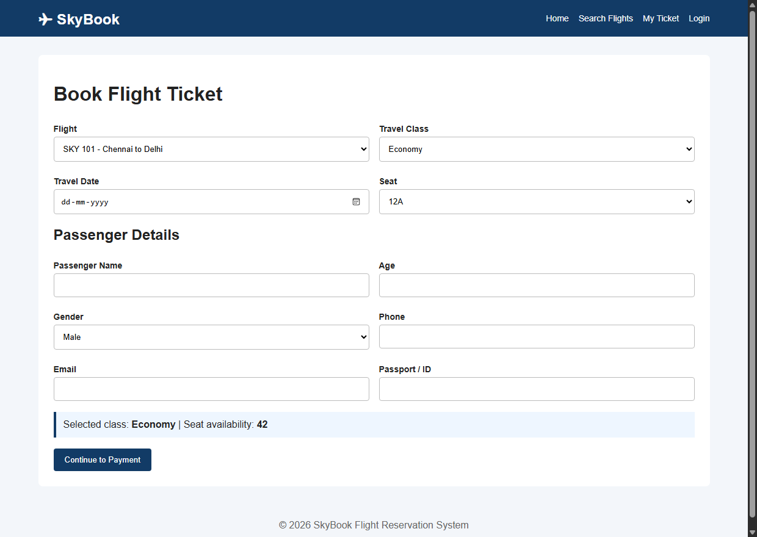
Figure 6.3: Passenger Seat Booking & Details Form (booking.html)
Output Observation: Displays the passenger booking form with dynamic class selection, seat number assignment, and passenger details capture.
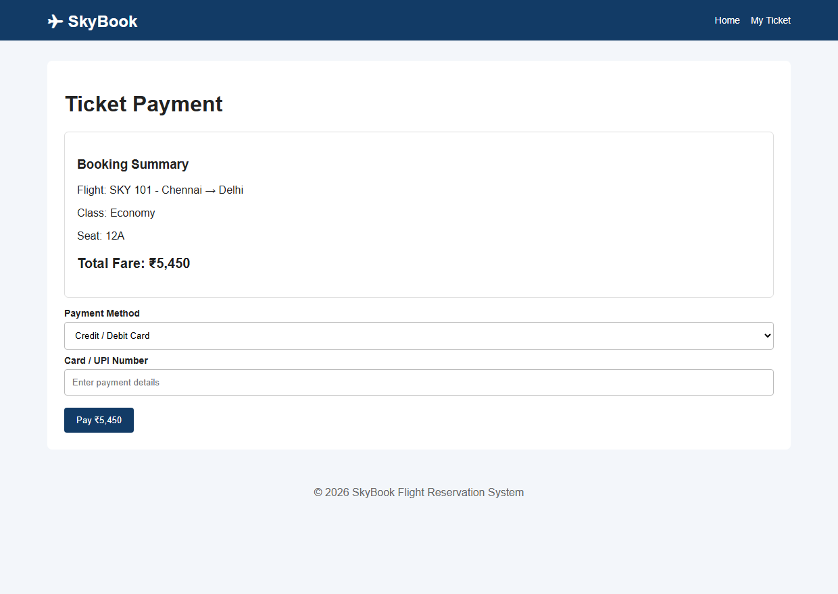
Figure 6.4: Simulated Payment Gateway & Checkout (payment.html)
Output Observation: Presents the payment gateway screen capturing card details, calculating fare totals, and simulating checkout verification.
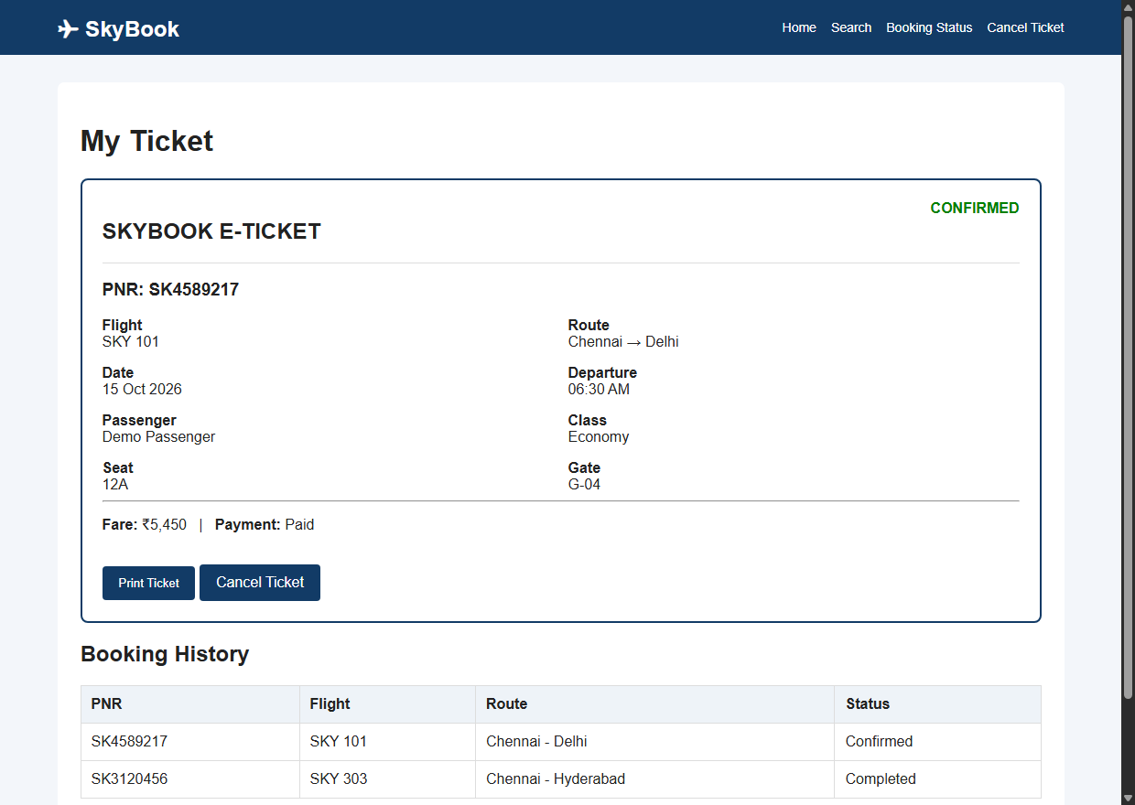
Figure 6.5: Confirmed Electronic Flight Ticket with PNR (my-ticket.html)
Output Observation: Shows the generated electronic boarding pass displaying unique PNR, flight schedule, seat number, and print action.
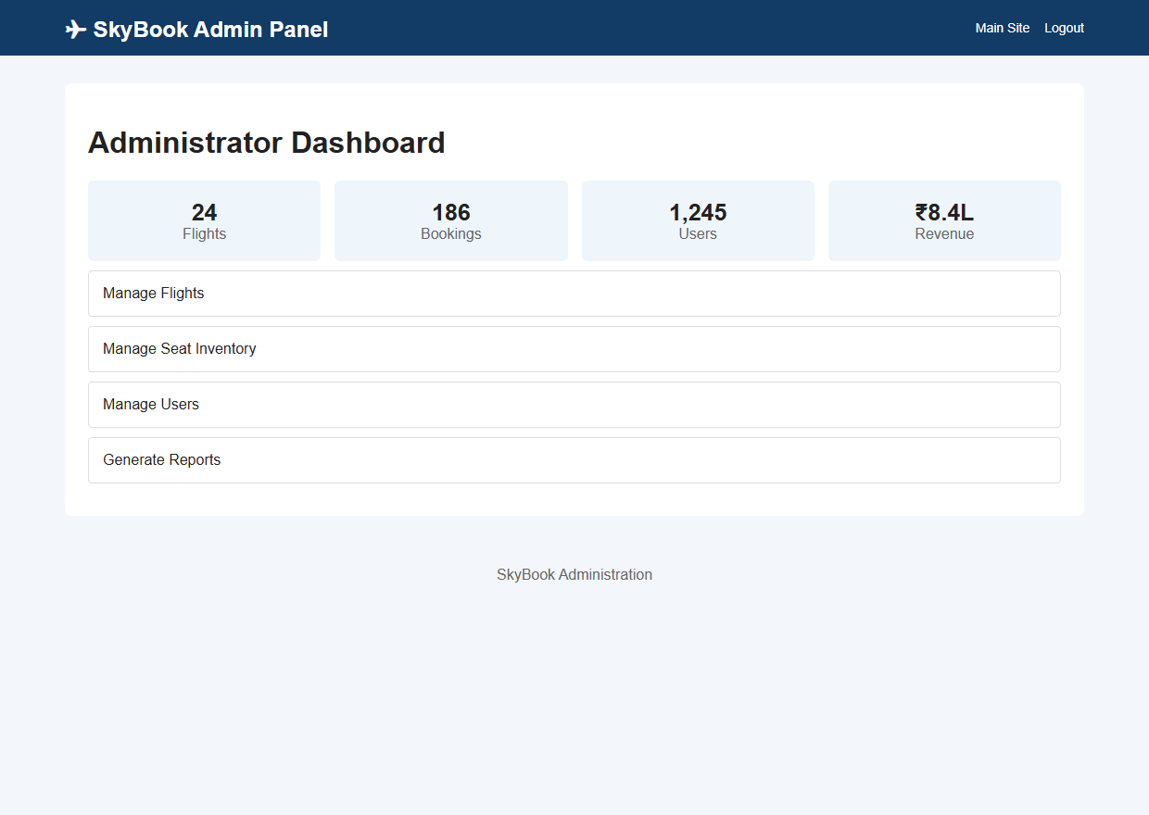
Figure 6.6: Airline Administrator Operations Dashboard (admin.html)
Output Observation: Captures the administrative dashboard providing operational summaries, booked passenger manifests, and revenue metrics.
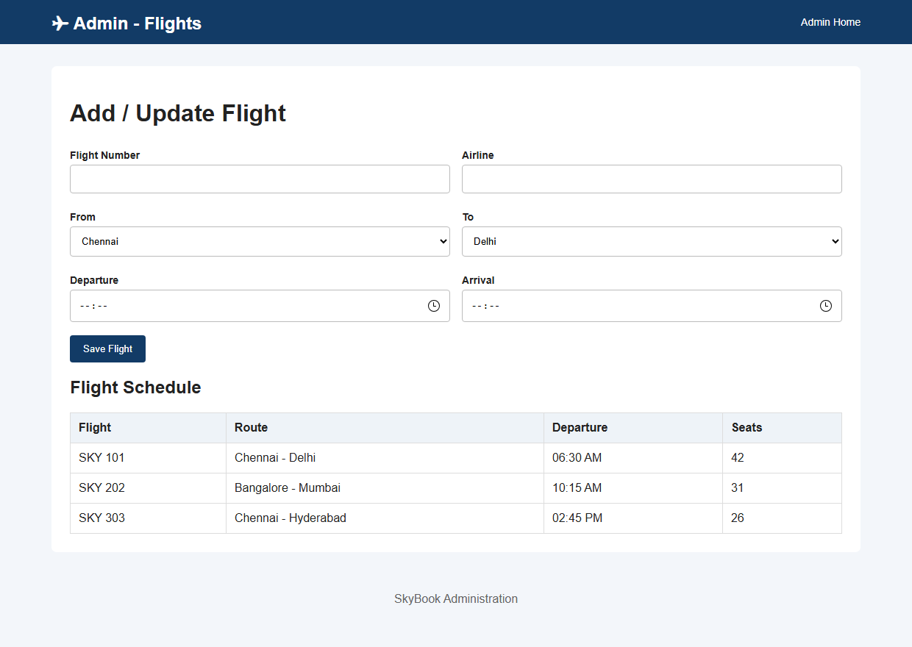
Figure 6.7: Flight Fleet & Schedule Inventory Management (admin-flights.html)
Output Observation: Depicts the flight management interface allowing administrators to add new routes, modify schedules, and manage seat inventories.
7. RESULT
EXPERIMENT CONCLUSION / RESULT:
The SkyBook Online Flight Reservation Web Application was successfully created, executed, and validated within the Google Chrome DOM environment using HTML5, CSS3, and JavaScript. All modules—including flight route discovery, dynamic seat reservation, simulated payment, 6-character PNR ticket issuance, and administrator fleet controls—executed seamlessly with reliable client-side data persistence.

