DEPARTMENT OF COMPUTER SCIENCE & ENGINEERING
INTERNET PROGRAMMING LABORATORY RECORD
ONLINE BUS BOOKING SYSTEM

1. AIM
To design and develop an Online Bus Booking Web Application using HTML5, CSS3, and JavaScript, providing passengers with intercity bus route search, bus category selection (AC Sleeper, Non-AC Seater, Volvo Multi-Axle), seat reservation with passenger detail capture, booking confirmation receipts, customer feedback submission, and an administrative dashboard for bus fleet scheduling, passenger reports, and user management.

2. ALGORITHM
The step-by-step procedure for developing and executing the Online Bus Booking System is detailed below:
Step 1: Multi-Page Web Interface Construction - Construct semantic HTML5 documents (index.html, buses.html, booking.html, dashboard.html, admin.html, report.html, comments.html, login.html, register.html) establishing header brand navigation, route search forms, bus cards, booking forms, and admin panels.
Step 2: Travel Portal Theme & Responsive CSS - Implement CSS styling (style.css) featuring vibrant travel crimson (#d90429) and slate tones, responsive card containers, amenity badges (Wi-Fi, AC, Charging Point), and intuitive form controls.
Step 3: Bus Fleet & Route Dataset Setup - In JavaScript (script.js), configure bus service datasets comprising operator names (Orange Travels, SRS Travels, KPN Travels), origin cities, destination cities, departure/arrival times, durations, bus categories, and ticket prices.
Step 4: Intercity Route Search & Availability Filter - Capture origin city, destination city, and travel date from search inputs; dynamically filter matching bus options; inject styled bus cards into the DOM with timings, amenities, ratings, and 'Book Seat' actions.
Step 5: Passenger Seat Reservation Form Handling - Capture passenger details (Full Name, Contact Number, Email, Age, Boarding Point); select number of seats; dynamically calculate gross fare based on bus category.
Step 6: Booking Reference Generation & Storage - Validate form inputs; generate a unique alphanumeric booking reference ID (e.g., BUS-9214); serialize booking record into localStorage; clear input forms.
Step 7: Instant Booking Receipt & DOM Feedback - Dynamically render a booking confirmation voucher in the DOM displaying ticket reference ID, operator name, departure time, seat numbers, and boarding point instructions.
Step 8: Passenger Reviews & Feedback Submission (comments.html) - Provide rating and feedback forms for travelers; attach form event listeners; dynamically format review cards and append to the DOM.
Step 9: Bus Operator & Admin Center (dashboard.html, admin.html, report.html) - Provide administrators with tools to add new buses, update route frequencies, modify fare tariffs, and inspect detailed booking reports, occupancy metrics, and user manifests.
Step 10: Chrome DOM Validation & Workflow Verification - Test and verify route search, seat reservation, feedback submissions, and administrative reports within the Google Chrome DOM environment.
3. SYSTEM ARCHITECTURE & MODULE DESCRIPTION
The bus booking platform is structured into modular client-side components:
File Name | Module Name | Functional Role
index.html | Home Portal | Intercity route search bar, date selector, popular routes, and company banner
buses.html | Available Buses | Bus operator listings, timings, seat availability badges, and fare cards
booking.html | Seat Reservation | Passenger details form, boarding point selection, and fare calculator
dashboard.html | Operator Dashboard | Overview of upcoming trips, booked seat count, and departure alerts
admin.html | Fleet Administration | Master bus fleet control, route updates, and operator scheduling
report.html | Booking Reports | Operational reports displaying passenger manifests and ticket revenue
comments.html | Customer Feedback | Passenger rating and feedback submission interface with dynamic reviews
login.html | User Login | Authentication interface for registered passengers and bus operators
css/style.css | Design System | Travel-themed crimson color palette, responsive cards, and form styling
js/script.js | Core Bus Engine | Route search logic, booking validation, reference generation, and DOM handlers

4. KEY SOURCE CODE HIGHLIGHTS
HTML Structure: Bus Search Form (index.html / buses.html)
<section class="search-section">
<h2>Search Intercity Buses</h2>
<form onsubmit="searchBuses(event)">
<div class="search-grid">
<select id="fromCity" required>
<option value="">Leaving From</option>
<option value="Chennai">Chennai</option>
<option value="Bangalore">Bangalore</option>
<option value="Coimbatore">Coimbatore</option>
</select>
<select id="toCity" required>
<option value="">Going To</option>
<option value="Bangalore">Bangalore</option>
<option value="Chennai">Chennai</option>
<option value="Madurai">Madurai</option>
</select>
<input type="date" id="journeyDate" required>
<button type="submit">Search Buses</button>
</div>
</form>
</section>

JavaScript: Bus Ticket Booking & Feedback Handlers (js/script.js)
function bookTicket(event) {
event.preventDefault();
const name = document.getElementById("passengerName").value;
const phone = document.getElementById("passengerPhone").value;
const seats = document.getElementById("seats").value;
const boarding = document.getElementById("boardingPoint").value;
const bookingId = "BUS-" + Math.floor(1000 + Math.random() * 9000);
const booking = {
id: bookingId,
passenger: name,
phone: phone,
seats: seats,
boarding: boarding,
status: "Confirmed"
};
localStorage.setItem("bus_booking_" + bookingId, JSON.stringify(booking));
alert(`Ticket Booked Successfully! Booking ID: ${bookingId}`);
window.location.href = "dashboard.html";
}
function addComment(event) {
event.preventDefault();
const name = document.getElementById("reviewerName").value;
const rating = document.getElementById("rating").value;
const comment = document.getElementById("commentText").value;
alert(`Thank you ${name}! Your feedback (${rating} Stars) has been submitted.`);
window.location.reload();
}

5. SCREENSHOT VERIFICATION
The Online Bus Booking application was loaded and tested inside Google Chrome DOM. The following screenshots document the rendered user pages, search forms, booking flows, and admin screens.
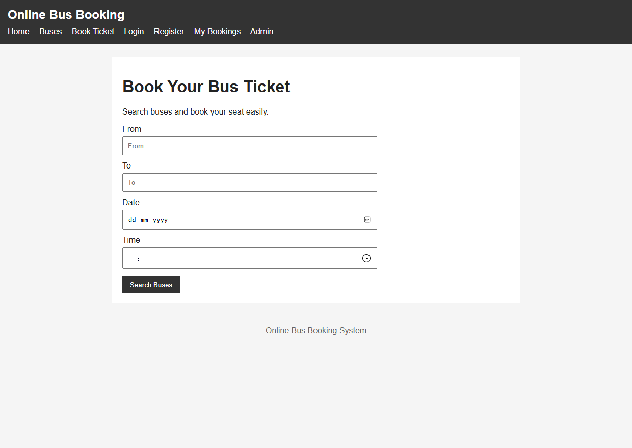
Figure 6.1: Chrome DOM Rendering of Online Bus Booking Home (index.html)
Output Observation: Shows the bus booking homepage featuring red brand styling, intercity route search form, and destination shortcuts.
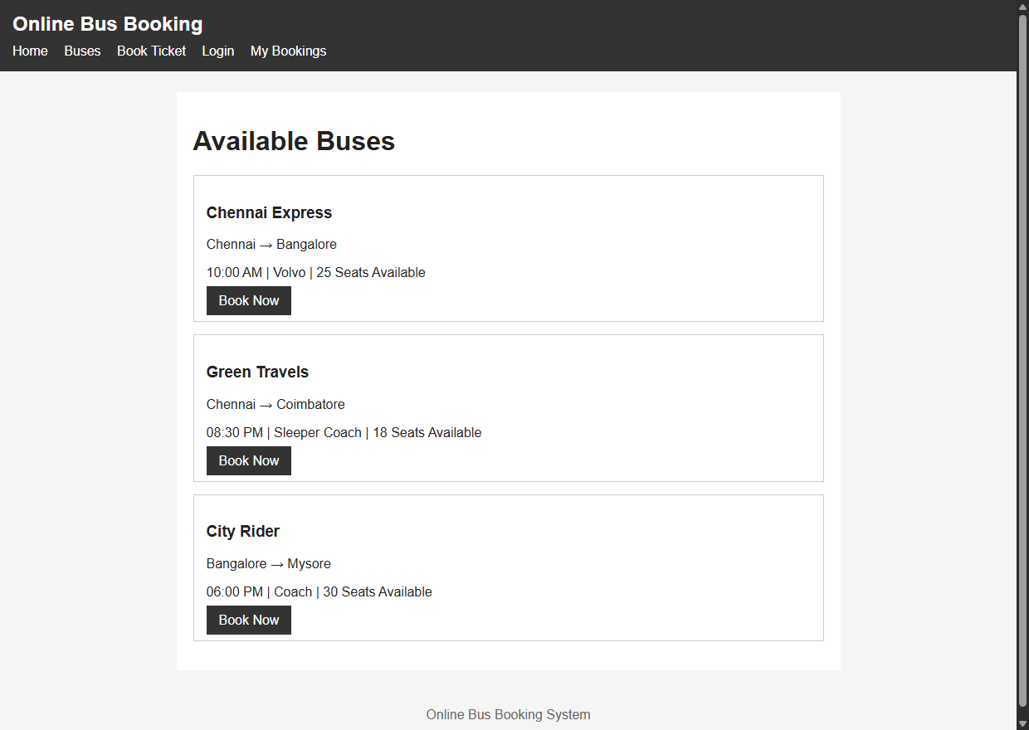
Figure 6.2: Available Bus Routes, Operators & Fare List (buses.html)
Output Observation: Illustrates the bus route search results displaying available bus operators, timings, bus categories, and fare cards.
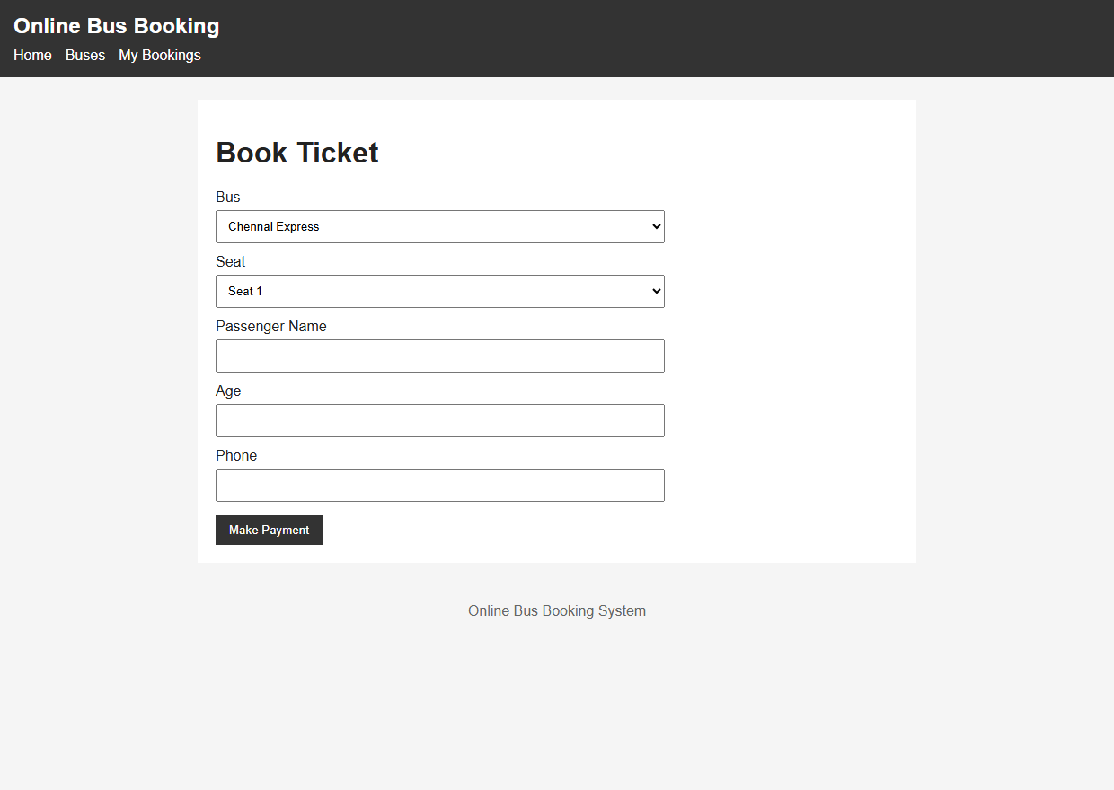
Figure 6.3: Passenger Seat Booking & Boarding Point Form (booking.html)
Output Observation: Displays the seat reservation interface capturing passenger details, seat quantity, and boarding point selection.
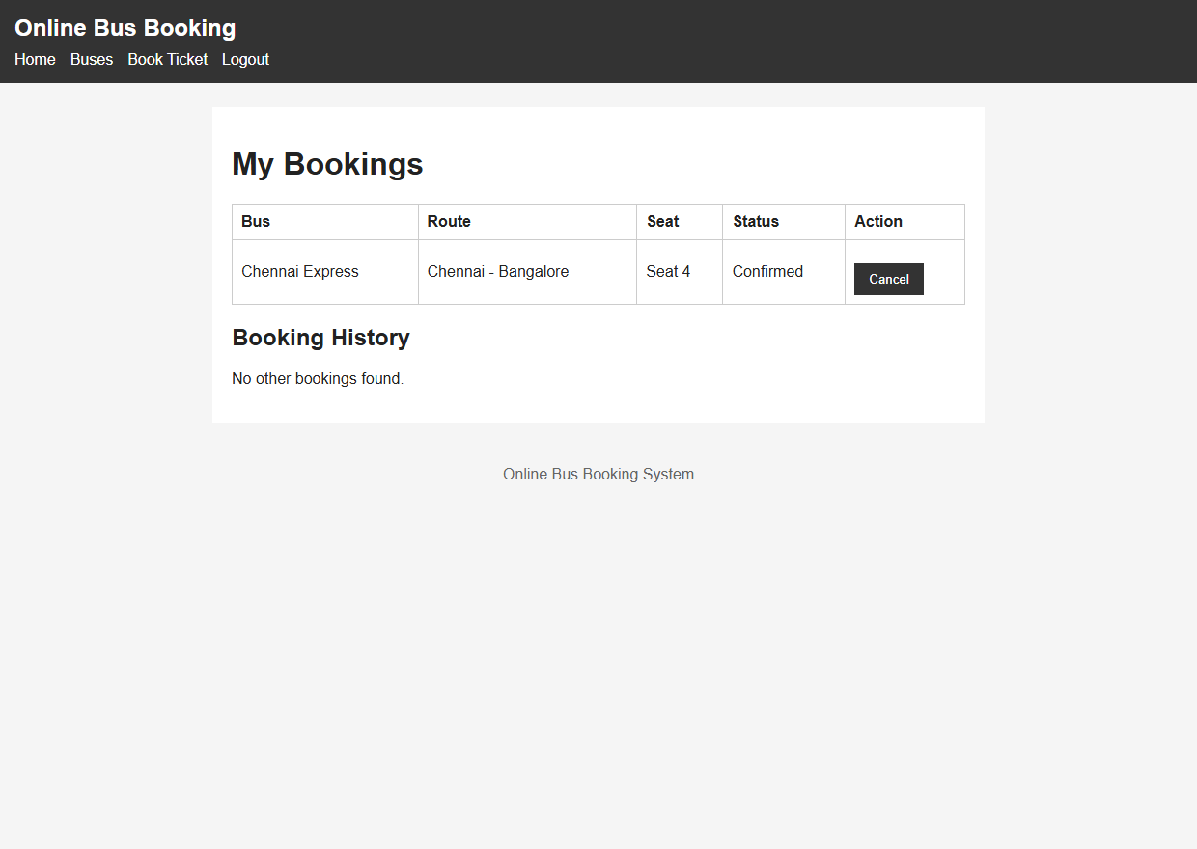
Figure 6.4: Operator & Passenger Journey Dashboard (dashboard.html)
Output Observation: Presents the user and operator dashboard displaying active bookings, seat allocations, and trip departure countdowns.
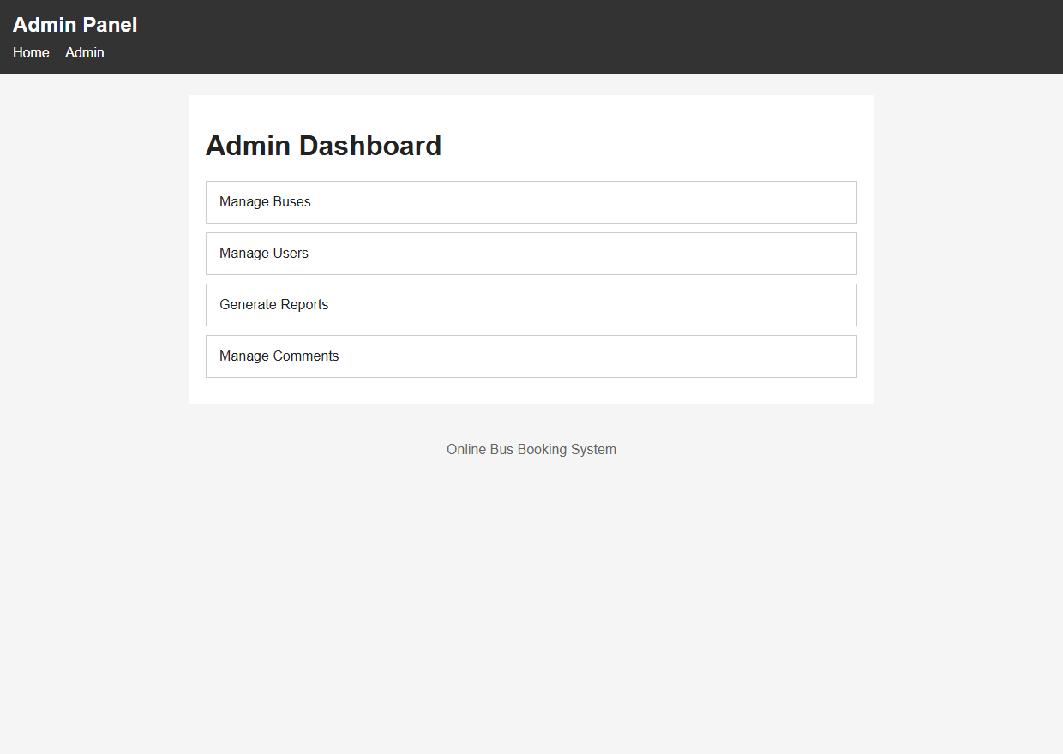
Figure 6.5: Bus Fleet Administration Dashboard (admin.html)
Output Observation: Captures the administration console providing master controls for bus fleets, route timings, and fare structures.
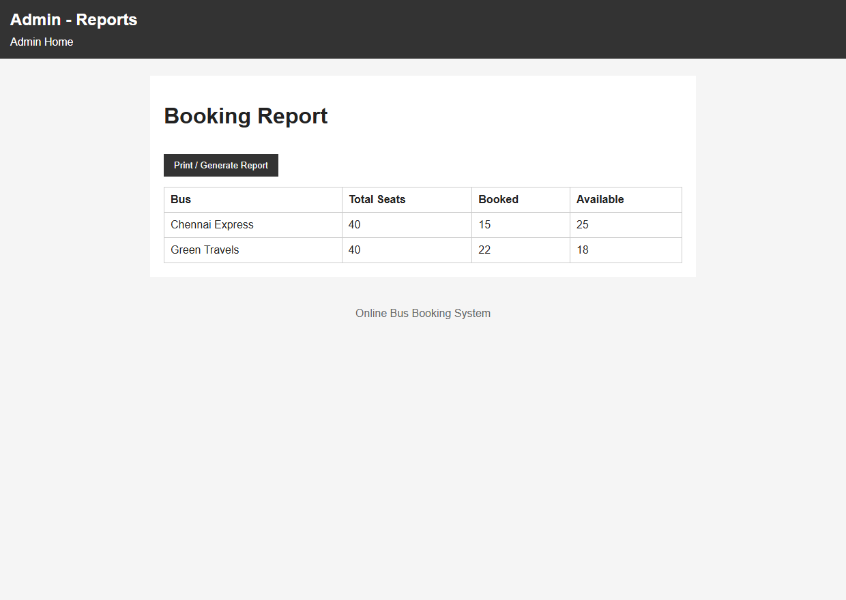
Figure 6.6: Bus Booking Operational Reports (report.html)
Output Observation: Shows the reporting interface summarizing passenger manifests, seat occupancy rates, and revenue collections.
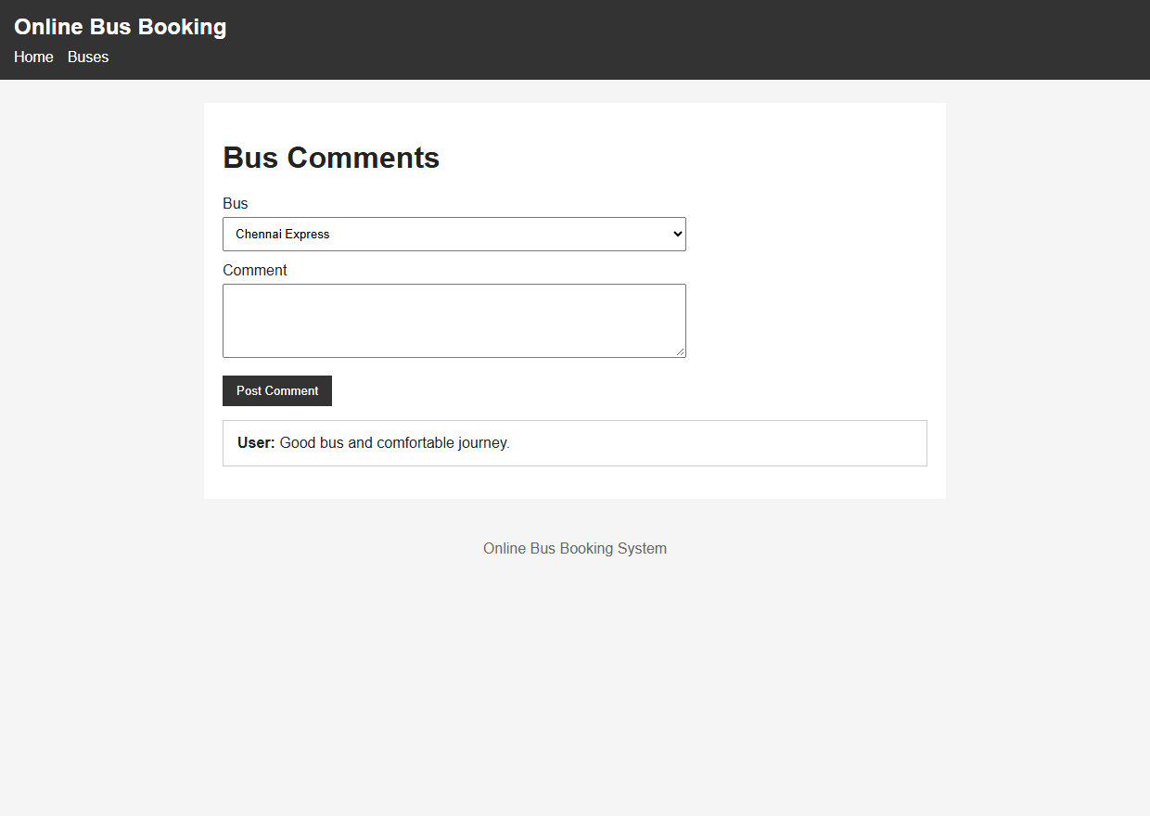
Figure 6.7: Customer Reviews & Ratings Submission (comments.html)
Output Observation: Depicts the customer feedback module allowing passengers to submit service ratings and comments.
7. RESULT
EXPERIMENT CONCLUSION / RESULT:
The Online Bus Booking Web Application was successfully created, executed, and validated within the Google Chrome DOM environment using HTML5, CSS3, and JavaScript. All functional modules—including route discovery, seat booking, confirmation receipt generation, passenger feedback, and administrative fleet reporting—operated reliably with persistent client-side LocalStorage data.

