HomeFinder Real Estate Property Portal
A property marketplace for apartments, luxury villas, commercial spaces, and plots.

AIM
To develop a real estate property portal featuring verified property listings, property type categorization, interactive EMI calculator, site visit scheduling, and locality search using responsive web technologies.

ALGORITHM
1. Requirement Analysis: Formulate system specifications, interactive workflows, data schemas, and role hierarchies (Customer / User and Administrator).
2. Architecture & Modular Page Design: Construct multi-page application structure using semantic HTML5 elements without third-party framework overhead.
3. Styling & Presentation: Develop a cohesive responsive design system in style.css utilizing CSS variables, Flexbox containers, and CSS Grid layouts.
4. Client-side Persistence: Initialize structured state in localStorage to maintain dynamic records, session data, user carts, and administrative logs.
5. Interactive Logic Implementation: Program JavaScript event handlers for real-time search, category navigation, subcategory discovery, and sorting algorithms.
6. Administrative Operations: Build dedicated administrator desk capabilities allowing authorized users to manage inventory particulars, modify pricing, and review customer submissions.
7. Verification & DOM Testing: Validate form submissions, hyperlink navigation, cross-browser compatibility, and DOM responsiveness across device viewports.

SOURCE CODE

1. HTML Structure (index.html)
<!DOCTYPE html>
<html lang="en">
<head>
<meta charset="UTF-8">
<meta name="viewport" content="width=device-width, initial-scale=1.0">
<title>HomeFinder Real Estate | Home Finder Real Estate</title>
<link rel="stylesheet" href="style.css">
<style>
.cat-pill {
background: white; border: 1px solid #cbd5e1; padding: 8px 16px; border-radius: 20px;
cursor: pointer; font-weight: 600; font-size: 0.9rem; transition: all 0.2s;
}
.cat-pill:hover, .cat-pill.active {
background: var(--primary); color: white; border-color: var(--primary);
}
.controls-grid {
display: grid; grid-template-columns: 2fr 1fr 1fr; gap: 0.75rem;
background: white; padding: 1rem; border-radius: 8px; border: 1px solid #e2e8f0;
margin-bottom: 1.5rem; align-items: center;
}
@media (max-width: 850px) {
.controls-grid { grid-template-columns: 1fr; }
}
</style>
</head>
<body>
<nav class="navbar">
<a href="index.html" class="logo">Home Finder Real Estate</a>
<div class="nav-links">
<a href="index.html" class="active">Properties</a>
<a href="calculator.html">EMI Calculator</a>
<a href="visit.html">Schedule Visit</a>
<a href="login.html">Login</a>
<a href="register.html">Register</a>
</div>
</nav>
<div class="container">
<div class="hero" style="background: linear-gradient(135deg, #1e3a8a, #0369a1);">
<h1>Verified Homes, Luxury Villas & Commercial Spaces</h1>
<p>Browse verified property listings across top residential neighborhoods with RERA approvals and instant home loan calculation.</p>
</div>
<!-- Category Pills -->
<div style="margin-bottom: 1.5rem;">
<h3 style="font-size: 1.1rem; margin-bottom: 0.75rem;">Property Types</h3>
<div style="display: flex; gap: 0.5rem; flex-wrap: wrap;">
<button class="cat-pill active" onclick="selectPropPill('all')">All Properties</button>
<button class="cat-pill" onclick="selectPropPill('Apartments')">🏢 Gated Apartments (Popular)</button>
<button class="cat-pill" onclick="selectPropPill('Villas')">🏡 Luxury Villas</button>
<button class="cat-pill" onclick="selectPropPill('Commercial')">🏢 Commercial Offices</button>
<button class="cat-pill" onclick="selectPropPill('Plots')">📐 CMDA Approved Plots</button>
</div>
</div>
<!-- Search, Category & Sorting Controls -->
<div class="controls-grid">
<div>
<input type="text" id="propSearch" placeholder="Search by locality, project name, or type..." oninput="filterAndSortProperties()" style="width:100%; padding:8px 12px; border:1px solid #cbd5e1; border-radius:6px;">
</div>
<div>
<select id="propCategory" onchange="filterAndSortProperties()" style="width:100%; padding:8px; border:1px solid #cbd5e1; border-radius:6px;">
<option value="all">All Property Categories</option>
<option value="Apartments">Apartments</option>
<option value="Villas">Villas</option>
<option value="Commercial">Commercial</option>
<option value="Plots">Plots</option>
</select>
</div>
<div>
<select id="propSort" onchange="filterAndSortProperties()" style="width:100%; padding:8px; border:1px solid #cbd5e1; border-radius:6px;">
<option value="price_low">Price: Low to High</option>
<option value="price_high">Price: High to Low</option>
<option value="title">Project Name: A to Z</option>
</select>
</div>
</div>
<!-- Property Grid -->
<div class="card-grid" id="propGrid"></div>
</div>
<footer>
<p>&copy; 2026 HomeFinder Real Estate. All rights reserved.</p>
</footer>
<script src="script.js"></script>
</body>
</html>

2. CSS Stylesheet (style.css)
/* HomeFinder Real Estate - Main Stylesheet */
:root {
--primary: #2563eb;
--primary-hover: #1d4ed8;
--secondary: #475569;
--accent: #0ea5e9;
--success: #16a34a;
--warning: #d97706;
--danger: #dc2626;
--bg: #f8fafc;
--card-bg: #ffffff;
--text: #0f172a;
--text-muted: #64748b;
--border: #e2e8f0;
--shadow: 0 4px 6px -1px rgba(0,0,0,0.08), 0 2px 4px -2px rgba(0,0,0,0.04);
}
* {
box-sizing: border-box;
margin: 0;
padding: 0;
font-family: -apple-system, BlinkMacSystemFont, "Segoe UI", Roboto, Helvetica, Arial, sans-serif;
}
body {
background-color: var(--bg);
color: var(--text);
line-height: 1.5;
min-height: 100vh;
display: flex;
flex-direction: column;
}
/* Navigation Bar */
.navbar {
background-color: #ffffff;
border-bottom: 1px solid var(--border);
display: flex;
justify-content: space-between;
align-items: center;
padding: 0.75rem 1.5rem;
position: sticky;
top: 0;
z-index: 100;
box-shadow: 0 1px 3px rgba(0,0,0,0.05);
}
.logo {
font-weight: 700;
font-size: 1.2rem;
color: var(--primary);
display: flex;
align-items: center;
gap: 0.5rem;
text-decoration: none;
}
.badge-tag {
background: #eff6ff;
color: var(--primary);
font-size: 0.75rem;
padding: 2px 8px;
border-radius: 999px;
border: 1px solid #bfdbfe;
font-weight: 600;
}
.nav-links {
display: flex;
gap: 0.5rem;
align-items: center;
}
.nav-links a {
text-decoration: none;
color: var(--secondary);
padding: 0.45rem 0.85rem;
border-radius: 6px;
font-size: 0.9rem;
font-weight: 500;
transition: all 0.15s ease;
}
.nav-links a:hover, .nav-links a.active {
background-color: #eff6ff;
color: var(--primary);
}
.nav-links a.portal-btn {
background-color: #0f172a;
color: #ffffff;
font-size: 0.8rem;
padding: 0.4rem 0.75rem;
border-radius: 6px;
}
.nav-links a.portal-btn:hover {
background-color: #334155;
color: #fff;
}
/* Main Container */
.container {
max-width: 1000px;
width: 95%;
margin: 1.5rem auto;
flex: 1;
}
/* Hero section */
.hero {
background: linear-gradient(135deg, #1e3a8a, #3b82f6);
color: white;
padding: 2rem;
border-radius: 10px;
margin-bottom: 1.5rem;
box-shadow: var(--shadow);
}
.hero h1 {
font-size: 1.8rem;
margin-bottom: 0.5rem;
}
.hero p {
color: #e0e7ff;
font-size: 0.95rem;
}
/* Cards & Layout */
.card-grid {
display: grid;
grid-template-columns: repeat(auto-fit, minmax(280px, 1fr));
gap: 1.25rem;
margin-bottom: 1.5rem;
}
.card {
background: var(--card-bg);
border: 1px solid var(--border);
border-radius: 8px;
padding: 1.25rem;
box-shadow: var(--shadow);
}
.card h3 {
color: var(--text);
margin-bottom: 0.5rem;
font-size: 1.15rem;
}
.card p {
color: var(--text-muted);
font-size: 0.9rem;
margin-bottom: 0.75rem;
}
/* Forms & Inputs */
.form-group {
margin-bottom: 1rem;
}
label {
display: block;
font-size: 0.85rem;
font-weight: 600;
margin-bottom: 0.35rem;
color: var(--text);
}
input, select, textarea {
width: 100%;
padding: 0.55rem 0.75rem;
border: 1px solid var(--border);
border-radius: 6px;
font-size: 0.9rem;
background-color: #ffffff;
outline: none;
}
input:focus, select:focus, textarea:focus {
border-color: var(--primary);
box-shadow: 0 0 0 3px rgba(37, 99, 235, 0.15);
}
/* Buttons */
.btn {
display: inline-block;
background: var(--primary);
color: white;
padding: 0.5rem 1rem;
border-radius: 6px;
border: none;
font-size: 0.9rem;
font-weight: 600;
cursor: pointer;
text-decoration: none;
transition: background 0.15s ease;
text-align: center;
}
.btn:hover {
background: var(--primary-hover);
}
.btn-secondary {
background: #e2e8f0;
color: var(--text);
}
.btn-secondary:hover {
background: #cbd5e1;
}
.btn-danger {
background: var(--danger);
}
.btn-danger:hover {
background: #b91c1c;
}
.btn-sm {
padding: 0.3rem 0.6rem;
font-size: 0.8rem;
}
/* Tables */
table {
width: 100%;
border-collapse: collapse;
margin-top: 1rem;
font-size: 0.9rem;
background: white;
border-radius: 6px;
overflow: hidden;
box-shadow: var(--shadow);
}
th, td {
padding: 0.75rem 1rem;
text-align: left;
border-bottom: 1px solid var(--border);
}
th {
background: #f1f5f9;
font-weight: 600;
color: var(--secondary);
}
/* Result / Alert Boxes */
.alert {
padding: 1rem;
border-radius: 6px;
margin-top: 1rem;
border-left: 4px solid var(--primary);
background: #eff6ff;
color: #1e3a8a;
font-size: 0.9rem;
}
.alert-success {
border-left-color: var(--success);
background: #f0fdf4;
color: #14532d;
}
.alert-warning {
border-left-color: var(--warning);
background: #fffbeb;
color: #78350f;
}
/* Footer */
footer {
margin-top: auto;
border-top: 1px solid var(--border);
padding: 1rem;
text-align: center;
font-size: 0.85rem;
color: var(--text-muted);
background: #ffffff;
}
/* Responsive */
@media (max-width: 640px) {
.navbar { flex-direction: column; gap: 0.5rem; align-items: flex-start; }
.nav-links { flex-wrap: wrap; }
}

3. JavaScript Application Logic (script.js)
const defaultProperties = [
{ id: 1, title: "Emerald Bay Luxury Sea-Facing Villa", cat: "Villas", loc: "ECR, Chennai", price: 27500000, area: "3,800 sq.ft", emi: "₹1,85,000/mo" },
{ id: 2, title: "Skyline Green Heights 3BHK Apartment", cat: "Apartments", loc: "OMR IT Corridor", price: 8500000, area: "1,650 sq.ft", emi: "₹58,000/mo" },
{ id: 3, title: "TechPark Grade-A Commercial Office", cat: "Commercial", loc: "Guindy Cyber Hub", price: 42000000, area: "5,200 sq.ft", emi: "₹2,90,000/mo" },
{ id: 4, title: "Palm Meadows CMDA Approved Plot", cat: "Plots", loc: "Tambaram West", price: 3800000, area: "1,800 sq.ft", emi: "₹26,000/mo" },
{ id: 5, title: "The Grandeur 4BHK Penthouse", cat: "Apartments", loc: "Nungambakkam", price: 35000000, area: "4,100 sq.ft", emi: "₹2,40,000/mo" },
{ id: 6, title: "Serene Crest Gated Community Villa", cat: "Villas", loc: "Perungudi OMR", price: 19500000, area: "2,900 sq.ft", emi: "₹1,32,000/mo" }
];
function filterAndSortProperties() {
const grid = document.getElementById('propGrid');
if (!grid) return;
const searchInput = document.getElementById('propSearch');
const catFilter = document.getElementById('propCategory');
const sortFilter = document.getElementById('propSort');
const query = searchInput ? searchInput.value.toLowerCase().trim() : '';
const selectedCat = catFilter ? catFilter.value : 'all';
const sortVal = sortFilter ? sortFilter.value : 'price_low';
let list = [...defaultProperties];
if (query) {
list = list.filter(p =>
p.title.toLowerCase().includes(query) ||
p.loc.toLowerCase().includes(query) ||
p.cat.toLowerCase().includes(query)
);
}
if (selectedCat !== 'all') {
list = list.filter(p => p.cat === selectedCat);
}
if (sortVal === 'price_low') {
list.sort((a, b) => a.price - b.price);
} else if (sortVal === 'price_high') {
list.sort((a, b) => b.price - a.price);
} else if (sortVal === 'title') {
list.sort((a, b) => a.title.localeCompare(b.title));
}
renderProperties(list);
}
function selectPropPill(cat) {
const catFilter = document.getElementById('propCategory');
if (catFilter) {
catFilter.value = cat;
filterAndSortProperties();
}
}
function renderProperties(list) {
const grid = document.getElementById('propGrid');
if (!grid) return;
if (list.length === 0) {
grid.innerHTML = '<div style="grid-column:1/-1; padding:2rem; text-align:center; color:#64748b;">No real estate properties match your criteria.</div>';
return;
}
grid.innerHTML = '';
list.forEach(p => {
grid.innerHTML += `
<div class="card">
<div style="display:flex; justify-content:space-between; align-items:center;">
<span class="badge-tag">${p.cat}</span>
<span style="font-size:0.8rem; color:#64748b;">📍 ${p.loc}</span>
</div>
<h3 style="margin-top:0.5rem;">${p.title}</h3>
<p style="font-size:0.85rem; color:#64748b;">Built-up: <strong>${p.area}</strong> | Est. EMI: ${p.emi}</p>
<p style="font-weight:700; color:var(--primary); font-size:1.25rem; margin:0.5rem 0;">₹${(p.price / 100000).toFixed(1)} Lakhs</p>
<a href="visit.html?prop=${encodeURIComponent(p.title)}" class="btn btn-sm" style="display:block; text-align:center;">Schedule Site Visit</a>
</div>
`;
});
}
function calcEMI() {
const p = parseFloat(document.getElementById('loanP').value);
const rYear = parseFloat(document.getElementById('loanR').value);
const nYear = parseFloat(document.getElementById('loanN').value);
const r = (rYear / 12) / 100;
const n = nYear * 12;
const emi = (p * r * Math.pow(1 + r, n)) / (Math.pow(1 + r, n) - 1);
const total = emi * n;
const interest = total - p;
document.getElementById('emiResult').innerHTML = `
<div style="padding:1rem; background:#f0fdf4; border-radius:8px; border:1px solid #bbf7d0; margin-top:1rem;">
<p>Monthly EMI Payable: <strong style="font-size:1.3rem; color:#15803d;">₹${Math.round(emi).toLocaleString('en-IN')}</strong></p>
<p>Total Interest Payable: ₹${Math.round(interest).toLocaleString('en-IN')}</p>
<p>Total Payment (Principal + Interest): ₹${Math.round(total).toLocaleString('en-IN')}</p>
</div>
`;
}
document.addEventListener('DOMContentLoaded', () => {
filterAndSortProperties();
});

OUTPUT
Web Application Browser User Interface Rendering:
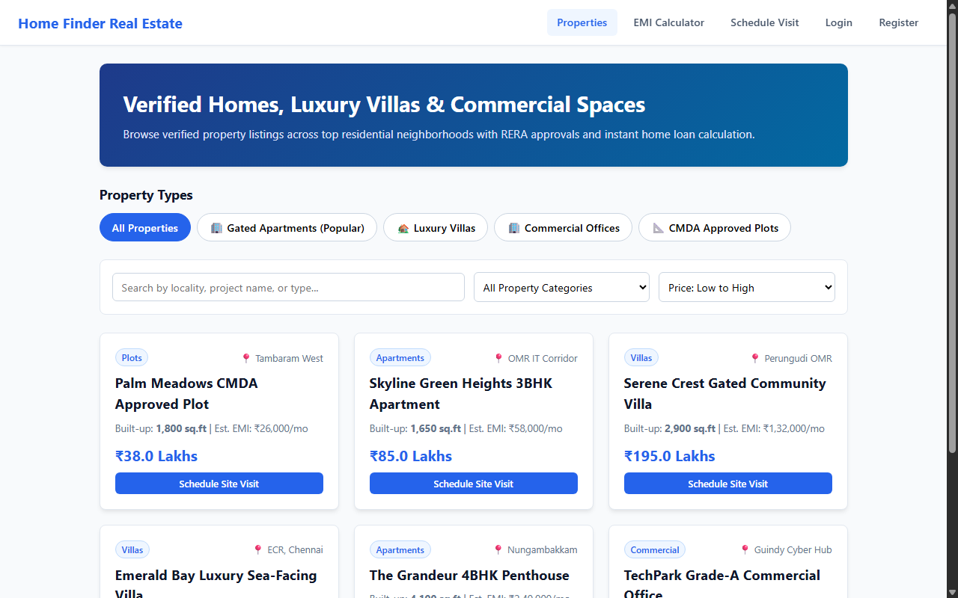

RESULT
The HomeFinder Real Estate Property Portal web application was successfully designed, implemented, and tested. All client-side interactions, data persistence models, category filtering and sorting mechanisms, and administrative functionalities were verified to perform accurately across browser environments.

