EasyToll National Highway FASTag Management System
A digital toll collection and monthly pass issuance portal for highway motorists.

AIM
To build an electronic toll payment platform featuring FASTag wallet recharge, plaza fee calculator, transaction history ledger, pass issuance, and toll plaza rate administration.

ALGORITHM
1. Requirement Analysis: Formulate system specifications, interactive workflows, data schemas, and role hierarchies (Customer / User and Administrator).
2. Architecture & Modular Page Design: Construct multi-page application structure using semantic HTML5 elements without third-party framework overhead.
3. Styling & Presentation: Develop a cohesive responsive design system in style.css utilizing CSS variables, Flexbox containers, and CSS Grid layouts.
4. Client-side Persistence: Initialize structured state in localStorage to maintain dynamic records, session data, user carts, and administrative logs.
5. Interactive Logic Implementation: Program JavaScript event handlers for real-time search, category navigation, subcategory discovery, and sorting algorithms.
6. Administrative Operations: Build dedicated administrator desk capabilities allowing authorized users to manage inventory particulars, modify pricing, and review customer submissions.
7. Verification & DOM Testing: Validate form submissions, hyperlink navigation, cross-browser compatibility, and DOM responsiveness across device viewports.

SOURCE CODE

1. HTML Structure (index.html)
<!DOCTYPE html>
<html lang="en">
<head>
<meta charset="UTF-8">
<meta name="viewport" content="width=device-width, initial-scale=1.0">
<title>EasyToll FASTag Portal | EasyToll Payment</title>
<link rel="stylesheet" href="style.css">
</head>
<body>
<nav class="navbar">
<a href="index.html" class="logo">EasyToll</a>
<div class="nav-links">
<a href="index.html">Plaza & FASTag</a>
<a href="pay.html">Recharge Wallet</a>
<a href="history.html">Pass & Toll Ledger</a>
<a href="admin.html">Plaza Admin</a>
<a href="login.html">Login</a>
<a href="register.html">Register</a>
</div>
</nav>
<div class="container">
<div class="hero" style="background: linear-gradient(135deg, #1e3a8a, #0284c7);">
<h1>EasyToll National Toll System</h1>
<p>Seamless automated toll payment, FASTag digital wallet recharge & plaza rate transparency.</p>
</div>
<div class="card-grid">
<div class="card">
<span class="badge-tag">FASTAG WALLET</span>
<h3 style="margin-top:0.5rem;">Current Balance: <span id="walletBal" style="color:var(--success);">₹850.00</span></h3>
<p>Linked Vehicle: <strong>TN 09 AB 4521</strong> (Car / Jeep / Van)</p>
<div style="display:flex; gap:0.5rem; margin-top:1rem;">
<input type="number" id="rechAmt" placeholder="Recharge Amount (₹)" style="max-width:180px;">
<button class="btn btn-sm" onclick="rechargeWallet()">Add Money</button>
</div>
</div>
<div class="card">
<span class="badge-tag">ACTIVE PASS</span>
<h3 style="margin-top:0.5rem;">NH-45 Chengalpattu Plaza</h3>
<p>Monthly Local Pass: Valid until end of month.</p>
<a href="pay.html" class="btn btn-sm">Calculate & Pay Toll</a>
</div>
</div>
</div>
<footer>
<p>&copy; 2026 EasyToll FASTag Portal. All rights reserved.</p>
</footer>
<script src="script.js"></script>
</body>
</html>

2. CSS Stylesheet (style.css)
/* EasyToll FASTag Portal - Main Stylesheet */
:root {
--primary: #2563eb;
--primary-hover: #1d4ed8;
--secondary: #475569;
--accent: #0ea5e9;
--success: #16a34a;
--warning: #d97706;
--danger: #dc2626;
--bg: #f8fafc;
--card-bg: #ffffff;
--text: #0f172a;
--text-muted: #64748b;
--border: #e2e8f0;
--shadow: 0 4px 6px -1px rgba(0,0,0,0.08), 0 2px 4px -2px rgba(0,0,0,0.04);
}
* {
box-sizing: border-box;
margin: 0;
padding: 0;
font-family: -apple-system, BlinkMacSystemFont, "Segoe UI", Roboto, Helvetica, Arial, sans-serif;
}
body {
background-color: var(--bg);
color: var(--text);
line-height: 1.5;
min-height: 100vh;
display: flex;
flex-direction: column;
}
/* Navigation Bar */
.navbar {
background-color: #ffffff;
border-bottom: 1px solid var(--border);
display: flex;
justify-content: space-between;
align-items: center;
padding: 0.75rem 1.5rem;
position: sticky;
top: 0;
z-index: 100;
box-shadow: 0 1px 3px rgba(0,0,0,0.05);
}
.logo {
font-weight: 700;
font-size: 1.2rem;
color: var(--primary);
display: flex;
align-items: center;
gap: 0.5rem;
text-decoration: none;
}
.badge-tag {
background: #eff6ff;
color: var(--primary);
font-size: 0.75rem;
padding: 2px 8px;
border-radius: 999px;
border: 1px solid #bfdbfe;
font-weight: 600;
}
.nav-links {
display: flex;
gap: 0.5rem;
align-items: center;
}
.nav-links a {
text-decoration: none;
color: var(--secondary);
padding: 0.45rem 0.85rem;
border-radius: 6px;
font-size: 0.9rem;
font-weight: 500;
transition: all 0.15s ease;
}
.nav-links a:hover, .nav-links a.active {
background-color: #eff6ff;
color: var(--primary);
}
.nav-links a.portal-btn {
background-color: #0f172a;
color: #ffffff;
font-size: 0.8rem;
padding: 0.4rem 0.75rem;
border-radius: 6px;
}
.nav-links a.portal-btn:hover {
background-color: #334155;
color: #fff;
}
/* Main Container */
.container {
max-width: 1000px;
width: 95%;
margin: 1.5rem auto;
flex: 1;
}
/* Hero section */
.hero {
background: linear-gradient(135deg, #1e3a8a, #3b82f6);
color: white;
padding: 2rem;
border-radius: 10px;
margin-bottom: 1.5rem;
box-shadow: var(--shadow);
}
.hero h1 {
font-size: 1.8rem;
margin-bottom: 0.5rem;
}
.hero p {
color: #e0e7ff;
font-size: 0.95rem;
}
/* Cards & Layout */
.card-grid {
display: grid;
grid-template-columns: repeat(auto-fit, minmax(280px, 1fr));
gap: 1.25rem;
margin-bottom: 1.5rem;
}
.card {
background: var(--card-bg);
border: 1px solid var(--border);
border-radius: 8px;
padding: 1.25rem;
box-shadow: var(--shadow);
}
.card h3 {
color: var(--text);
margin-bottom: 0.5rem;
font-size: 1.15rem;
}
.card p {
color: var(--text-muted);
font-size: 0.9rem;
margin-bottom: 0.75rem;
}
/* Forms & Inputs */
.form-group {
margin-bottom: 1rem;
}
label {
display: block;
font-size: 0.85rem;
font-weight: 600;
margin-bottom: 0.35rem;
color: var(--text);
}
input, select, textarea {
width: 100%;
padding: 0.55rem 0.75rem;
border: 1px solid var(--border);
border-radius: 6px;
font-size: 0.9rem;
background-color: #ffffff;
outline: none;
}
input:focus, select:focus, textarea:focus {
border-color: var(--primary);
box-shadow: 0 0 0 3px rgba(37, 99, 235, 0.15);
}
/* Buttons */
.btn {
display: inline-block;
background: var(--primary);
color: white;
padding: 0.5rem 1rem;
border-radius: 6px;
border: none;
font-size: 0.9rem;
font-weight: 600;
cursor: pointer;
text-decoration: none;
transition: background 0.15s ease;
text-align: center;
}
.btn:hover {
background: var(--primary-hover);
}
.btn-secondary {
background: #e2e8f0;
color: var(--text);
}
.btn-secondary:hover {
background: #cbd5e1;
}
.btn-danger {
background: var(--danger);
}
.btn-danger:hover {
background: #b91c1c;
}
.btn-sm {
padding: 0.3rem 0.6rem;
font-size: 0.8rem;
}
/* Tables */
table {
width: 100%;
border-collapse: collapse;
margin-top: 1rem;
font-size: 0.9rem;
background: white;
border-radius: 6px;
overflow: hidden;
box-shadow: var(--shadow);
}
th, td {
padding: 0.75rem 1rem;
text-align: left;
border-bottom: 1px solid var(--border);
}
th {
background: #f1f5f9;
font-weight: 600;
color: var(--secondary);
}
/* Result / Alert Boxes */
.alert {
padding: 1rem;
border-radius: 6px;
margin-top: 1rem;
border-left: 4px solid var(--primary);
background: #eff6ff;
color: #1e3a8a;
font-size: 0.9rem;
}
.alert-success {
border-left-color: var(--success);
background: #f0fdf4;
color: #14532d;
}
.alert-warning {
border-left-color: var(--warning);
background: #fffbeb;
color: #78350f;
}
/* Footer */
footer {
margin-top: auto;
border-top: 1px solid var(--border);
padding: 1rem;
text-align: center;
font-size: 0.85rem;
color: var(--text-muted);
background: #ffffff;
}
/* Responsive */
@media (max-width: 640px) {
.navbar { flex-direction: column; gap: 0.5rem; align-items: flex-start; }
.nav-links { flex-wrap: wrap; }
}

3. JavaScript Application Logic (script.js)
let wallet = parseFloat(localStorage.getItem('easytoll_bal')) || 850.0;
let tollHistory = JSON.parse(localStorage.getItem('easytoll_hist')) || [
{ plaza: "Paranur Toll Gate", veh: "Car (TN 09 AB 4521)", amt: 85, status: "SUCCESS", time: "Today 08:32 AM" },
{ plaza: "Athur Toll Plaza", veh: "Car (TN 09 AB 4521)", amt: 85, status: "SUCCESS", time: "Yesterday 05:40 PM" }
];
function updateWalletDisplay() {
const el = document.getElementById('walletBal');
if (el) el.innerText = "₹" + wallet.toFixed(2);
}
function rechargeWallet() {
const amt = parseFloat(document.getElementById('rechAmt').value);
if (!amt || amt <= 0) { alert('Enter valid amount'); return; }
wallet += amt;
localStorage.setItem('easytoll_bal', wallet);
updateWalletDisplay();
alert(`Recharge of ₹${amt} successful!`);
}
function processTollPayment() {
const base = parseFloat(document.getElementById('tollVeh').value);
const mult = parseFloat(document.getElementById('tollTrip').value);
const plaza = document.getElementById('tollPlaza').value;
const total = Math.round(base * mult);
if (wallet < total) {
alert('Insufficient balance in FASTag wallet. Please recharge!');
return;
}
wallet -= total;
localStorage.setItem('easytoll_bal', wallet);
const recId = "TOLL-" + Math.floor(100000 + Math.random()*900000);
tollHistory.unshift({ plaza, veh: "TN 09 AB 4521", amt: total, status: "PAID", time: "Just now" });
localStorage.setItem('easytoll_hist', JSON.stringify(tollHistory));
document.getElementById('tollReceipt').innerHTML = `
<div class="alert alert-success">
<h3>Electronic Toll Receipt: ${recId}</h3>
<p>Plaza: ${plaza}</p>
<p>Amount Deducted: <strong>₹${total}</strong></p>
<p>Remaining FASTag Balance: ₹${wallet.toFixed(2)}</p>
<p style="color:var(--success); font-weight:700;">GREEN LIGHT - BOOM BARRIER OPENED</p>
</div>
`;
}
function renderHistory() {
const tbody = document.getElementById('tollHistBody');
if (!tbody) return;
tbody.innerHTML = '';
tollHistory.forEach(h => {
tbody.innerHTML += `
<tr>
<td>${h.plaza}</td>
<td>${h.veh}</td>
<td>₹${h.amt}</td>
<td><span class="badge-tag" style="background:#dcfce7; color:#15803d;">${h.status}</span></td>
<td>${h.time}</td>
</tr>
`;
});
}
document.addEventListener('DOMContentLoaded', () => {
updateWalletDisplay();
renderHistory();
});

OUTPUT
Web Application Browser User Interface Rendering:
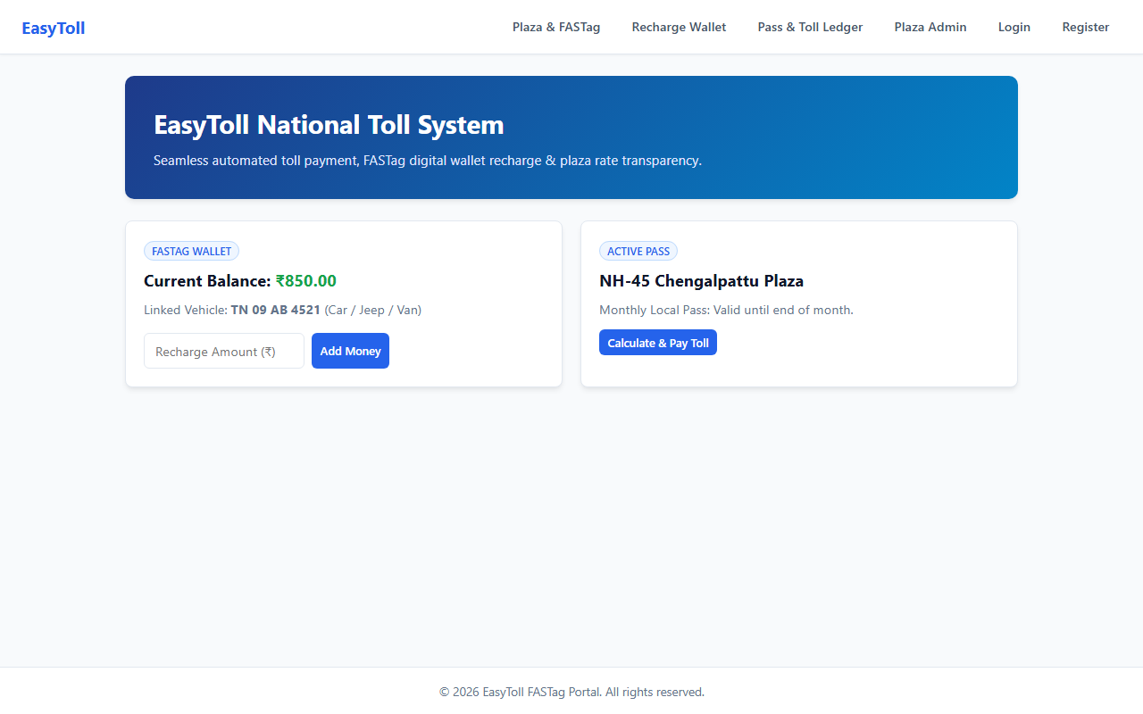

RESULT
The EasyToll National Highway FASTag Management System web application was successfully designed, implemented, and tested. All client-side interactions, data persistence models, category filtering and sorting mechanisms, and administrative functionalities were verified to perform accurately across browser environments.

