AgriMart Agricultural Supplies & Farmer Advisory Platform
An agro-store and consultation portal for farmers and agriculturalists.

AIM
To create an agricultural marketplace and advisory platform featuring seeds and fertilizer catalog, category filtering, farmer cart, order dispatch tracking, and veterinary health consultations.

ALGORITHM
1. Requirement Analysis: Formulate system specifications, interactive workflows, data schemas, and role hierarchies (Customer / User and Administrator).
2. Architecture & Modular Page Design: Construct multi-page application structure using semantic HTML5 elements without third-party framework overhead.
3. Styling & Presentation: Develop a cohesive responsive design system in style.css utilizing CSS variables, Flexbox containers, and CSS Grid layouts.
4. Client-side Persistence: Initialize structured state in localStorage to maintain dynamic records, session data, user carts, and administrative logs.
5. Interactive Logic Implementation: Program JavaScript event handlers for real-time search, category navigation, subcategory discovery, and sorting algorithms.
6. Administrative Operations: Build dedicated administrator desk capabilities allowing authorized users to manage inventory particulars, modify pricing, and review customer submissions.
7. Verification & DOM Testing: Validate form submissions, hyperlink navigation, cross-browser compatibility, and DOM responsiveness across device viewports.

SOURCE CODE

1. HTML Structure (index.html)
<!DOCTYPE html>
<html lang="en">
<head>
<meta charset="UTF-8">
<meta name="viewport" content="width=device-width, initial-scale=1.0">
<title>AgriMart Agricultural Supplies | AgriMart</title>
<link rel="stylesheet" href="style.css">
<style>
.cat-pill {
background: white; border: 1px solid #cbd5e1; padding: 8px 16px; border-radius: 20px;
cursor: pointer; font-weight: 600; font-size: 0.9rem; transition: all 0.2s;
}
.cat-pill:hover, .cat-pill.active {
background: var(--primary); color: white; border-color: var(--primary);
}
.controls-grid {
display: grid; grid-template-columns: 2fr 1fr 1fr; gap: 0.75rem;
background: white; padding: 1rem; border-radius: 8px; border: 1px solid #e2e8f0;
margin-bottom: 1.5rem; align-items: center;
}
@media (max-width: 850px) {
.controls-grid { grid-template-columns: 1fr; }
}
</style>
</head>
<body>
<nav class="navbar">
<a href="index.html" class="logo">AgriMart Farming</a>
<div class="nav-links">
<a href="index.html" class="active">Seeds & Equipment</a>
<a href="cart.html">Agri Cart</a>
<a href="advisory.html">Vet Advisory</a>
<a href="orders.html">Orders & Dispatches</a>
<a href="login.html">Login</a>
<a href="register.html">Register</a>
</div>
</nav>
<div class="container">
<div class="hero" style="background: linear-gradient(135deg, #15803d, #22c55e);">
<h1>AgriMart Farmer Support & Store</h1>
<p>High-yield hybrid seeds, certified organic fertilizers, solar equipment, and pest management tools.</p>
</div>
<!-- Category Pills -->
<div style="margin-bottom: 1.5rem;">
<h3 style="font-size: 1.1rem; margin-bottom: 0.75rem;">Agricultural Categories</h3>
<div style="display: flex; gap: 0.5rem; flex-wrap: wrap;">
<button class="cat-pill active" onclick="selectAgriPill('all')">All Supplies</button>
<button class="cat-pill" onclick="selectAgriPill('Seeds')">🌾 Hybrid Seeds (Popular)</button>
<button class="cat-pill" onclick="selectAgriPill('Fertilizers')">🌱 Bio Fertilizers</button>
<button class="cat-pill" onclick="selectAgriPill('Pesticides')">🛡️ Crop Protection</button>
<button class="cat-pill" onclick="selectAgriPill('Equipment')">🚜 Farm Sprayers & Tools</button>
</div>
</div>
<!-- Search, Category & Sorting Controls -->
<div class="controls-grid">
<div>
<input type="text" id="agriSearch" placeholder="Search seeds, fertilizers, equipment..." oninput="filterAndSortAgri()" style="width:100%; padding:8px 12px; border:1px solid #cbd5e1; border-radius:6px;">
</div>
<div>
<select id="agriCategory" onchange="filterAndSortAgri()" style="width:100%; padding:8px; border:1px solid #cbd5e1; border-radius:6px;">
<option value="all">All Categories</option>
<option value="Seeds">Hybrid Seeds</option>
<option value="Fertilizers">Fertilizers</option>
<option value="Pesticides">Pesticides</option>
<option value="Equipment">Farm Equipment</option>
</select>
</div>
<div>
<select id="agriSort" onchange="filterAndSortAgri()" style="width:100%; padding:8px; border:1px solid #cbd5e1; border-radius:6px;">
<option value="rating">Sort: Highest Farmer Rating</option>
<option value="price_low">Price: Low to High</option>
<option value="price_high">Price: High to Low</option>
<option value="name">Name: A to Z</option>
</select>
</div>
</div>
<!-- Agri Grid -->
<div class="card-grid" id="agriGrid"></div>
</div>
<footer>
<p>&copy; 2026 AgriMart Farming Supplies. All rights reserved.</p>
</footer>
<script src="script.js"></script>
</body>
</html>

2. CSS Stylesheet (style.css)
/* AgriMart Agricultural Supplies - Main Stylesheet */
:root {
--primary: #2563eb;
--primary-hover: #1d4ed8;
--secondary: #475569;
--accent: #0ea5e9;
--success: #16a34a;
--warning: #d97706;
--danger: #dc2626;
--bg: #f8fafc;
--card-bg: #ffffff;
--text: #0f172a;
--text-muted: #64748b;
--border: #e2e8f0;
--shadow: 0 4px 6px -1px rgba(0,0,0,0.08), 0 2px 4px -2px rgba(0,0,0,0.04);
}
* {
box-sizing: border-box;
margin: 0;
padding: 0;
font-family: -apple-system, BlinkMacSystemFont, "Segoe UI", Roboto, Helvetica, Arial, sans-serif;
}
body {
background-color: var(--bg);
color: var(--text);
line-height: 1.5;
min-height: 100vh;
display: flex;
flex-direction: column;
}
/* Navigation Bar */
.navbar {
background-color: #ffffff;
border-bottom: 1px solid var(--border);
display: flex;
justify-content: space-between;
align-items: center;
padding: 0.75rem 1.5rem;
position: sticky;
top: 0;
z-index: 100;
box-shadow: 0 1px 3px rgba(0,0,0,0.05);
}
.logo {
font-weight: 700;
font-size: 1.2rem;
color: var(--primary);
display: flex;
align-items: center;
gap: 0.5rem;
text-decoration: none;
}
.badge-tag {
background: #eff6ff;
color: var(--primary);
font-size: 0.75rem;
padding: 2px 8px;
border-radius: 999px;
border: 1px solid #bfdbfe;
font-weight: 600;
}
.nav-links {
display: flex;
gap: 0.5rem;
align-items: center;
}
.nav-links a {
text-decoration: none;
color: var(--secondary);
padding: 0.45rem 0.85rem;
border-radius: 6px;
font-size: 0.9rem;
font-weight: 500;
transition: all 0.15s ease;
}
.nav-links a:hover, .nav-links a.active {
background-color: #eff6ff;
color: var(--primary);
}
.nav-links a.portal-btn {
background-color: #0f172a;
color: #ffffff;
font-size: 0.8rem;
padding: 0.4rem 0.75rem;
border-radius: 6px;
}
.nav-links a.portal-btn:hover {
background-color: #334155;
color: #fff;
}
/* Main Container */
.container {
max-width: 1000px;
width: 95%;
margin: 1.5rem auto;
flex: 1;
}
/* Hero section */
.hero {
background: linear-gradient(135deg, #1e3a8a, #3b82f6);
color: white;
padding: 2rem;
border-radius: 10px;
margin-bottom: 1.5rem;
box-shadow: var(--shadow);
}
.hero h1 {
font-size: 1.8rem;
margin-bottom: 0.5rem;
}
.hero p {
color: #e0e7ff;
font-size: 0.95rem;
}
/* Cards & Layout */
.card-grid {
display: grid;
grid-template-columns: repeat(auto-fit, minmax(280px, 1fr));
gap: 1.25rem;
margin-bottom: 1.5rem;
}
.card {
background: var(--card-bg);
border: 1px solid var(--border);
border-radius: 8px;
padding: 1.25rem;
box-shadow: var(--shadow);
}
.card h3 {
color: var(--text);
margin-bottom: 0.5rem;
font-size: 1.15rem;
}
.card p {
color: var(--text-muted);
font-size: 0.9rem;
margin-bottom: 0.75rem;
}
/* Forms & Inputs */
.form-group {
margin-bottom: 1rem;
}
label {
display: block;
font-size: 0.85rem;
font-weight: 600;
margin-bottom: 0.35rem;
color: var(--text);
}
input, select, textarea {
width: 100%;
padding: 0.55rem 0.75rem;
border: 1px solid var(--border);
border-radius: 6px;
font-size: 0.9rem;
background-color: #ffffff;
outline: none;
}
input:focus, select:focus, textarea:focus {
border-color: var(--primary);
box-shadow: 0 0 0 3px rgba(37, 99, 235, 0.15);
}
/* Buttons */
.btn {
display: inline-block;
background: var(--primary);
color: white;
padding: 0.5rem 1rem;
border-radius: 6px;
border: none;
font-size: 0.9rem;
font-weight: 600;
cursor: pointer;
text-decoration: none;
transition: background 0.15s ease;
text-align: center;
}
.btn:hover {
background: var(--primary-hover);
}
.btn-secondary {
background: #e2e8f0;
color: var(--text);
}
.btn-secondary:hover {
background: #cbd5e1;
}
.btn-danger {
background: var(--danger);
}
.btn-danger:hover {
background: #b91c1c;
}
.btn-sm {
padding: 0.3rem 0.6rem;
font-size: 0.8rem;
}
/* Tables */
table {
width: 100%;
border-collapse: collapse;
margin-top: 1rem;
font-size: 0.9rem;
background: white;
border-radius: 6px;
overflow: hidden;
box-shadow: var(--shadow);
}
th, td {
padding: 0.75rem 1rem;
text-align: left;
border-bottom: 1px solid var(--border);
}
th {
background: #f1f5f9;
font-weight: 600;
color: var(--secondary);
}
/* Result / Alert Boxes */
.alert {
padding: 1rem;
border-radius: 6px;
margin-top: 1rem;
border-left: 4px solid var(--primary);
background: #eff6ff;
color: #1e3a8a;
font-size: 0.9rem;
}
.alert-success {
border-left-color: var(--success);
background: #f0fdf4;
color: #14532d;
}
.alert-warning {
border-left-color: var(--warning);
background: #fffbeb;
color: #78350f;
}
/* Footer */
footer {
margin-top: auto;
border-top: 1px solid var(--border);
padding: 1rem;
text-align: center;
font-size: 0.85rem;
color: var(--text-muted);
background: #ffffff;
}
/* Responsive */
@media (max-width: 640px) {
.navbar { flex-direction: column; gap: 0.5rem; align-items: flex-start; }
.nav-links { flex-wrap: wrap; }
}

3. JavaScript Application Logic (script.js)
const defaultAgri = [
{ id: 1, name: "Hybrid Paddy Seed (IR-64)", cat: "Seeds", price: 650, rating: 4.8 },
{ id: 2, name: "Bio-NPK Organic Fertilizer (50kg)", cat: "Fertilizers", price: 1100, rating: 4.9 },
{ id: 3, name: "Neem Power Bio-Insecticide (5L)", cat: "Pesticides", price: 850, rating: 4.6 },
{ id: 4, name: "Battery Powered Knapsack Sprayer", cat: "Equipment", price: 2800, rating: 4.7 },
{ id: 5, name: "Hybrid Maize Seeds (High Yield)", cat: "Seeds", price: 480, rating: 4.5 },
{ id: 6, name: "Granular Micronutrient Mix (25kg)", cat: "Fertilizers", price: 920, rating: 4.6 },
{ id: 7, name: "Solar Insect Light Trap", cat: "Equipment", price: 1950, rating: 4.9 },
{ id: 8, name: "Copper Oxychloride Fungicide (1kg)", cat: "Pesticides", price: 380, rating: 4.4 }
];
let agriCart = JSON.parse(localStorage.getItem('agri_cart')) || [];
function filterAndSortAgri() {
const grid = document.getElementById('agriGrid');
if (!grid) return;
const searchInput = document.getElementById('agriSearch');
const catFilter = document.getElementById('agriCategory');
const sortFilter = document.getElementById('agriSort');
const query = searchInput ? searchInput.value.toLowerCase().trim() : '';
const selectedCat = catFilter ? catFilter.value : 'all';
const sortVal = sortFilter ? sortFilter.value : 'rating';
let list = [...defaultAgri];
if (query) {
list = list.filter(i =>
i.name.toLowerCase().includes(query) ||
i.cat.toLowerCase().includes(query)
);
}
if (selectedCat !== 'all') {
list = list.filter(i => i.cat === selectedCat);
}
if (sortVal === 'price_low') {
list.sort((a, b) => a.price - b.price);
} else if (sortVal === 'price_high') {
list.sort((a, b) => b.price - a.price);
} else if (sortVal === 'name') {
list.sort((a, b) => a.name.localeCompare(b.name));
} else {
list.sort((a, b) => b.rating - a.rating);
}
renderAgri(list);
}
function selectAgriPill(cat) {
const catFilter = document.getElementById('agriCategory');
if (catFilter) {
catFilter.value = cat;
filterAndSortAgri();
}
}
function renderAgri(list) {
const grid = document.getElementById('agriGrid');
if (!grid) return;
if (list.length === 0) {
grid.innerHTML = '<div style="grid-column:1/-1; padding:2rem; text-align:center; color:#64748b;">No agricultural supplies found.</div>';
return;
}
grid.innerHTML = '';
list.forEach(item => {
grid.innerHTML += `
<div class="card">
<div style="display:flex; justify-content:space-between; align-items:center;">
<span class="badge-tag">${item.cat}</span>
<span style="font-size:0.8rem; color:#059669; font-weight:600;">★ Rating: ${item.rating} / 5</span>
</div>
<h3 style="margin-top:0.5rem;">${item.name}</h3>
<p style="font-weight:700; color:var(--primary); font-size:1.2rem; margin:0.5rem 0;">₹${item.price.toLocaleString('en-IN')}</p>
<button class="btn btn-sm" style="width:100%;" onclick="addAgriToCart(${item.id})">Add to Farm Cart</button>
</div>
`;
});
}
function addAgriToCart(id) {
const item = defaultAgri.find(i => i.id === id);
agriCart.push({ id: item.id, name: item.name, price: item.price });
localStorage.setItem('agri_cart', JSON.stringify(agriCart));
alert(`${item.name} added to your farm cart!`);
}
function renderAgriCart() {
const tbody = document.getElementById('agriCartBody');
const total = document.getElementById('agriTotal');
if (!tbody) return;
tbody.innerHTML = '';
let sum = 0;
agriCart.forEach((item, idx) => {
sum += item.price;
tbody.innerHTML += `
<tr>
<td><strong>${item.name}</strong></td>
<td>₹${item.price}</td>
<td>1</td>
<td>₹${item.price}</td>
<td><button class="btn btn-danger btn-sm" onclick="removeAgri(${idx})">Remove</button></td>
</tr>
`;
});
if (total) total.innerText = "₹" + sum.toLocaleString('en-IN');
}
function removeAgri(idx) {
agriCart.splice(idx, 1);
localStorage.setItem('agri_cart', JSON.stringify(agriCart));
renderAgriCart();
}
document.addEventListener('DOMContentLoaded', () => {
filterAndSortAgri();
renderAgriCart();
});

OUTPUT
Web Application Browser User Interface Rendering:
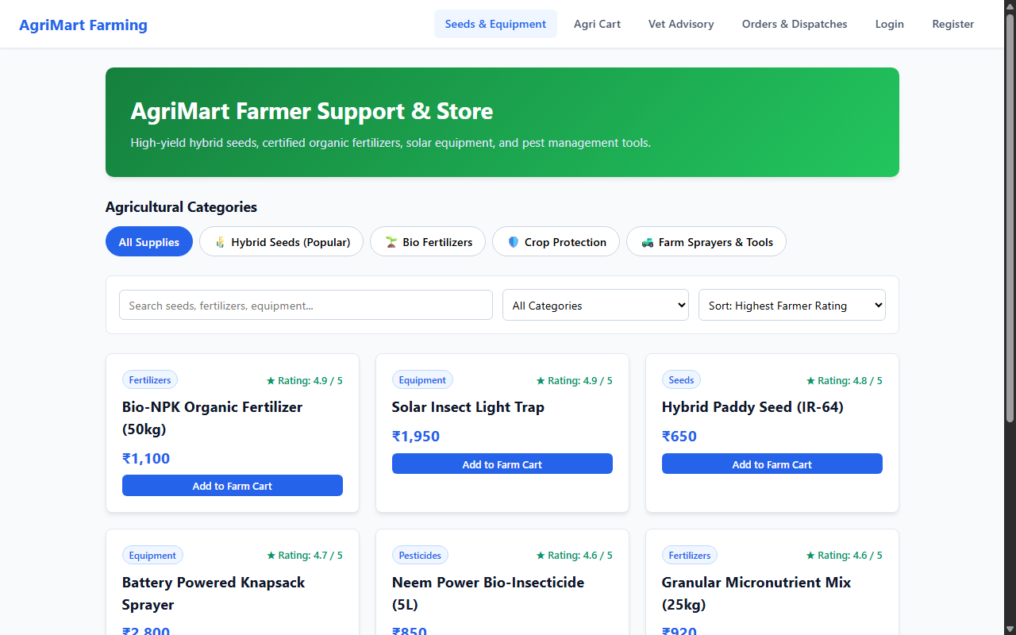

RESULT
The AgriMart Agricultural Supplies & Farmer Advisory Platform web application was successfully designed, implemented, and tested. All client-side interactions, data persistence models, category filtering and sorting mechanisms, and administrative functionalities were verified to perform accurately across browser environments.

