RentRide Self-Drive Vehicle Rental Platform
A car and vehicle rental booking service across multiple vehicle classifications.

AIM
To design and develop a vehicle rental booking platform featuring fleet categorization, pickup hub filtering, fare calculation, rental reservations, booking history, and administrative booking approvals.

ALGORITHM
1. Requirement Analysis: Formulate system specifications, interactive workflows, data schemas, and role hierarchies (Customer / User and Administrator).
2. Architecture & Modular Page Design: Construct multi-page application structure using semantic HTML5 elements without third-party framework overhead.
3. Styling & Presentation: Develop a cohesive responsive design system in style.css utilizing CSS variables, Flexbox containers, and CSS Grid layouts.
4. Client-side Persistence: Initialize structured state in localStorage to maintain dynamic records, session data, user carts, and administrative logs.
5. Interactive Logic Implementation: Program JavaScript event handlers for real-time search, category navigation, subcategory discovery, and sorting algorithms.
6. Administrative Operations: Build dedicated administrator desk capabilities allowing authorized users to manage inventory particulars, modify pricing, and review customer submissions.
7. Verification & DOM Testing: Validate form submissions, hyperlink navigation, cross-browser compatibility, and DOM responsiveness across device viewports.

SOURCE CODE

1. HTML Structure (index.html)
<!DOCTYPE html>
<html lang="en">
<head>
<meta charset="UTF-8">
<meta name="viewport" content="width=device-width, initial-scale=1.0">
<title>RentRide Vehicle Rentals | RentRide</title>
<link rel="stylesheet" href="style.css">
<style>
.cat-pill {
background: white; border: 1px solid #cbd5e1; padding: 8px 16px; border-radius: 20px;
cursor: pointer; font-weight: 600; font-size: 0.9rem; transition: all 0.2s;
}
.cat-pill:hover, .cat-pill.active {
background: var(--primary); color: white; border-color: var(--primary);
}
.controls-grid {
display: grid; grid-template-columns: 2fr 1fr 1fr 1fr; gap: 0.75rem;
background: white; padding: 1rem; border-radius: 8px; border: 1px solid #e2e8f0;
margin-bottom: 1.5rem; align-items: center;
}
@media (max-width: 850px) {
.controls-grid { grid-template-columns: 1fr; }
}
</style>
</head>
<body>
<nav class="navbar">
<a href="index.html" class="logo">RentRide</a>
<div class="nav-links">
<a href="index.html" class="active">Fleet Browse</a>
<a href="book.html">Reserve Vehicle</a>
<a href="history.html">Booking History</a>
<a href="admin.html">Fleet Admin</a>
<a href="login.html">Login</a>
<a href="register.html">Register</a>
</div>
</nav>
<div class="container">
<div class="hero" style="background: linear-gradient(135deg, #0284c7, #2563eb);">
<h1>RentRide Self-Drive Vehicle Fleet</h1>
<p>Sanitized hatchbacks, sedans, 7-seater family SUVs & luxury rentals with zero security deposit options.</p>
</div>
<!-- Category Pills -->
<div style="margin-bottom: 1.5rem;">
<h3 style="font-size: 1.1rem; margin-bottom: 0.75rem;">Vehicle Classifications</h3>
<div style="display: flex; gap: 0.5rem; flex-wrap: wrap;">
<button class="cat-pill active" onclick="selectFleetPill('all')">All Fleet</button>
<button class="cat-pill" onclick="selectFleetPill('Hatchback')">🚗 Economy Hatchbacks</button>
<button class="cat-pill" onclick="selectFleetPill('Sedan')">🚘 Premium Sedans</button>
<button class="cat-pill" onclick="selectFleetPill('SUV')">🚙 7-Seater SUVs (Popular)</button>
<button class="cat-pill" onclick="selectFleetPill('Luxury')">⭐ Luxury Class</button>
</div>
</div>
<!-- Search, Location, Category & Sorting Controls -->
<div class="controls-grid">
<div>
<input type="text" id="fleetSearch" placeholder="Search by model or type..." oninput="filterAndSortFleet()" style="width:100%; padding:8px 12px; border:1px solid #cbd5e1; border-radius:6px;">
</div>
<div>
<select id="fleetCat" onchange="filterAndSortFleet()" style="width:100%; padding:8px; border:1px solid #cbd5e1; border-radius:6px;">
<option value="all">All Vehicle Types</option>
<option value="Hatchback">Hatchback</option>
<option value="Sedan">Sedan</option>
<option value="SUV">SUV</option>
<option value="Luxury">Luxury</option>
</select>
</div>
<div>
<select id="fleetLoc" onchange="filterAndSortFleet()" style="width:100%; padding:8px; border:1px solid #cbd5e1; border-radius:6px;">
<option value="all">All Pickup Hubs</option>
<option value="Airport Hub">Airport Hub</option>
<option value="City Center">City Center</option>
<option value="Suburban Hub">Suburban Hub</option>
<option value="Metro Station">Metro Station</option>
</select>
</div>
<div>
<select id="fleetSort" onchange="filterAndSortFleet()" style="width:100%; padding:8px; border:1px solid #cbd5e1; border-radius:6px;">
<option value="price_low">Fare: Low to High</option>
<option value="price_high">Fare: High to Low</option>
<option value="name">Model: A to Z</option>
</select>
</div>
</div>
<!-- Fleet Grid -->
<div class="card-grid" id="fleetGrid"></div>
</div>
<footer>
<p>&copy; 2026 RentRide Vehicle Rentals. All rights reserved.</p>
</footer>
<script src="script.js"></script>
</body>
</html>

2. CSS Stylesheet (style.css)
/* RentRide Vehicle Rentals - Main Stylesheet */
:root {
--primary: #2563eb;
--primary-hover: #1d4ed8;
--secondary: #475569;
--accent: #0ea5e9;
--success: #16a34a;
--warning: #d97706;
--danger: #dc2626;
--bg: #f8fafc;
--card-bg: #ffffff;
--text: #0f172a;
--text-muted: #64748b;
--border: #e2e8f0;
--shadow: 0 4px 6px -1px rgba(0,0,0,0.08), 0 2px 4px -2px rgba(0,0,0,0.04);
}
* {
box-sizing: border-box;
margin: 0;
padding: 0;
font-family: -apple-system, BlinkMacSystemFont, "Segoe UI", Roboto, Helvetica, Arial, sans-serif;
}
body {
background-color: var(--bg);
color: var(--text);
line-height: 1.5;
min-height: 100vh;
display: flex;
flex-direction: column;
}
/* Navigation Bar */
.navbar {
background-color: #ffffff;
border-bottom: 1px solid var(--border);
display: flex;
justify-content: space-between;
align-items: center;
padding: 0.75rem 1.5rem;
position: sticky;
top: 0;
z-index: 100;
box-shadow: 0 1px 3px rgba(0,0,0,0.05);
}
.logo {
font-weight: 700;
font-size: 1.2rem;
color: var(--primary);
display: flex;
align-items: center;
gap: 0.5rem;
text-decoration: none;
}
.badge-tag {
background: #eff6ff;
color: var(--primary);
font-size: 0.75rem;
padding: 2px 8px;
border-radius: 999px;
border: 1px solid #bfdbfe;
font-weight: 600;
}
.nav-links {
display: flex;
gap: 0.5rem;
align-items: center;
}
.nav-links a {
text-decoration: none;
color: var(--secondary);
padding: 0.45rem 0.85rem;
border-radius: 6px;
font-size: 0.9rem;
font-weight: 500;
transition: all 0.15s ease;
}
.nav-links a:hover, .nav-links a.active {
background-color: #eff6ff;
color: var(--primary);
}
.nav-links a.portal-btn {
background-color: #0f172a;
color: #ffffff;
font-size: 0.8rem;
padding: 0.4rem 0.75rem;
border-radius: 6px;
}
.nav-links a.portal-btn:hover {
background-color: #334155;
color: #fff;
}
/* Main Container */
.container {
max-width: 1000px;
width: 95%;
margin: 1.5rem auto;
flex: 1;
}
/* Hero section */
.hero {
background: linear-gradient(135deg, #1e3a8a, #3b82f6);
color: white;
padding: 2rem;
border-radius: 10px;
margin-bottom: 1.5rem;
box-shadow: var(--shadow);
}
.hero h1 {
font-size: 1.8rem;
margin-bottom: 0.5rem;
}
.hero p {
color: #e0e7ff;
font-size: 0.95rem;
}
/* Cards & Layout */
.card-grid {
display: grid;
grid-template-columns: repeat(auto-fit, minmax(280px, 1fr));
gap: 1.25rem;
margin-bottom: 1.5rem;
}
.card {
background: var(--card-bg);
border: 1px solid var(--border);
border-radius: 8px;
padding: 1.25rem;
box-shadow: var(--shadow);
}
.card h3 {
color: var(--text);
margin-bottom: 0.5rem;
font-size: 1.15rem;
}
.card p {
color: var(--text-muted);
font-size: 0.9rem;
margin-bottom: 0.75rem;
}
/* Forms & Inputs */
.form-group {
margin-bottom: 1rem;
}
label {
display: block;
font-size: 0.85rem;
font-weight: 600;
margin-bottom: 0.35rem;
color: var(--text);
}
input, select, textarea {
width: 100%;
padding: 0.55rem 0.75rem;
border: 1px solid var(--border);
border-radius: 6px;
font-size: 0.9rem;
background-color: #ffffff;
outline: none;
}
input:focus, select:focus, textarea:focus {
border-color: var(--primary);
box-shadow: 0 0 0 3px rgba(37, 99, 235, 0.15);
}
/* Buttons */
.btn {
display: inline-block;
background: var(--primary);
color: white;
padding: 0.5rem 1rem;
border-radius: 6px;
border: none;
font-size: 0.9rem;
font-weight: 600;
cursor: pointer;
text-decoration: none;
transition: background 0.15s ease;
text-align: center;
}
.btn:hover {
background: var(--primary-hover);
}
.btn-secondary {
background: #e2e8f0;
color: var(--text);
}
.btn-secondary:hover {
background: #cbd5e1;
}
.btn-danger {
background: var(--danger);
}
.btn-danger:hover {
background: #b91c1c;
}
.btn-sm {
padding: 0.3rem 0.6rem;
font-size: 0.8rem;
}
/* Tables */
table {
width: 100%;
border-collapse: collapse;
margin-top: 1rem;
font-size: 0.9rem;
background: white;
border-radius: 6px;
overflow: hidden;
box-shadow: var(--shadow);
}
th, td {
padding: 0.75rem 1rem;
text-align: left;
border-bottom: 1px solid var(--border);
}
th {
background: #f1f5f9;
font-weight: 600;
color: var(--secondary);
}
/* Result / Alert Boxes */
.alert {
padding: 1rem;
border-radius: 6px;
margin-top: 1rem;
border-left: 4px solid var(--primary);
background: #eff6ff;
color: #1e3a8a;
font-size: 0.9rem;
}
.alert-success {
border-left-color: var(--success);
background: #f0fdf4;
color: #14532d;
}
.alert-warning {
border-left-color: var(--warning);
background: #fffbeb;
color: #78350f;
}
/* Footer */
footer {
margin-top: auto;
border-top: 1px solid var(--border);
padding: 1rem;
text-align: center;
font-size: 0.85rem;
color: var(--text-muted);
background: #ffffff;
}
/* Responsive */
@media (max-width: 640px) {
.navbar { flex-direction: column; gap: 0.5rem; align-items: flex-start; }
.nav-links { flex-wrap: wrap; }
}

3. JavaScript Application Logic (script.js)
const defaultVehicles = [
{ id: 1, name: "Maruti Swift ZXi (Manual)", cat: "Hatchback", location: "Airport Hub", price: 1400, mileage: "22 kmpl" },
{ id: 2, name: "Hyundai Verna SX Turbo", cat: "Sedan", location: "City Center", price: 2200, mileage: "18 kmpl" },
{ id: 3, name: "Mahindra Thar 4x4 Hardtop", cat: "SUV", location: "Suburban Hub", price: 3200, mileage: "15 kmpl" },
{ id: 4, name: "Toyota Innova Crysta (7-Seater)", cat: "SUV", location: "Airport Hub", price: 3500, mileage: "14 kmpl" },
{ id: 5, name: "BMW 3 Series Gran Limousine", cat: "Luxury", location: "City Center", price: 7500, mileage: "16 kmpl" },
{ id: 6, name: "Tata Tiago EV (Electric)", cat: "Hatchback", location: "Metro Station", price: 1600, mileage: "250 km/charge" }
];
let rentals = JSON.parse(localStorage.getItem('rentride_bookings')) || [
{ id: "RR-701", name: "Siddharth V", veh: "Swift ZXi", days: 2, fare: 2800, status: "APPROVED" }
];
function filterAndSortFleet() {
const grid = document.getElementById('fleetGrid');
if (!grid) return;
const searchInput = document.getElementById('fleetSearch');
const catFilter = document.getElementById('fleetCat');
const locFilter = document.getElementById('fleetLoc');
const sortFilter = document.getElementById('fleetSort');
const query = searchInput ? searchInput.value.toLowerCase().trim() : '';
const selectedCat = catFilter ? catFilter.value : 'all';
const selectedLoc = locFilter ? locFilter.value : 'all';
const sortVal = sortFilter ? sortFilter.value : 'price_low';
let list = [...defaultVehicles];
if (query) {
list = list.filter(v =>
v.name.toLowerCase().includes(query) ||
v.cat.toLowerCase().includes(query) ||
v.location.toLowerCase().includes(query)
);
}
if (selectedCat !== 'all') {
list = list.filter(v => v.cat === selectedCat);
}
if (selectedLoc !== 'all') {
list = list.filter(v => v.location === selectedLoc);
}
if (sortVal === 'price_low') {
list.sort((a, b) => a.price - b.price);
} else if (sortVal === 'price_high') {
list.sort((a, b) => b.price - a.price);
} else if (sortVal === 'name') {
list.sort((a, b) => a.name.localeCompare(b.name));
}
renderFleet(list);
}
function selectFleetPill(cat) {
const catFilter = document.getElementById('fleetCat');
if (catFilter) {
catFilter.value = cat;
filterAndSortFleet();
}
}
function renderFleet(list) {
const grid = document.getElementById('fleetGrid');
if (!grid) return;
if (list.length === 0) {
grid.innerHTML = '<div style="grid-column:1/-1; padding:2rem; text-align:center; color:#64748b;">No rental vehicles match your selection.</div>';
return;
}
grid.innerHTML = '';
list.forEach(v => {
grid.innerHTML += `
<div class="card">
<div style="display:flex; justify-content:space-between; align-items:center;">
<span class="badge-tag">${v.cat}</span>
<span style="font-size:0.8rem; color:#64748b;">📍 ${v.location}</span>
</div>
<h3 style="margin-top:0.5rem;">${v.name}</h3>
<p style="font-size:0.85rem; color:#64748b;">Efficiency: <strong>${v.mileage}</strong></p>
<p style="font-weight:700; color:var(--primary); font-size:1.2rem; margin:0.5rem 0;">₹${v.price} <span style="font-size:0.85rem; font-weight:normal; color:#64748b;">/ day</span></p>
<a href="book.html?veh=${encodeURIComponent(v.name)}&rate=${v.price}" class="btn btn-sm" style="display:block; text-align:center;">Reserve Vehicle</a>
</div>
`;
});
}
function calcRental() {
const rate = parseFloat(document.getElementById('rentVeh').value);
const days = parseInt(document.getElementById('rentDays').value) || 1;
const total = rate * days;
const fareEl = document.getElementById('fareTotal');
if (fareEl) fareEl.innerText = "₹" + total.toLocaleString('en-IN');
}
function confirmBooking(e) {
e.preventDefault();
const name = document.getElementById('bkName').value;
const vehSelect = document.getElementById('rentVeh');
const vehName = vehSelect.options[vehSelect.selectedIndex].text.split('(')[0].trim();
const rate = parseFloat(vehSelect.value);
const days = parseInt(document.getElementById('rentDays').value) || 1;
const fare = rate * days;
const id = "RR-" + Math.floor(100 + Math.random()*900);
rentals.push({ id, name, veh: vehName, days, fare, status: "PENDING APPROVAL" });
localStorage.setItem('rentride_bookings', JSON.stringify(rentals));
document.getElementById('bookAlert').innerHTML = `
<div class="card" style="background:#ecfdf5; color:#065f46; margin-top:1rem;">
<h3>Reservation Submitted!</h3>
<p>Booking ID: <strong>${id}</strong></p>
<p>Customer: ${name} | Vehicle: ${vehName} (${days} Days)</p>
<p>Total Fare: <strong>₹${fare.toLocaleString('en-IN')}</strong></p>
<p>Status: <span class="badge-tag" style="background:#fef3c7; color:#92400e;">PENDING APPROVAL</span></p>
</div>
`;
}
document.addEventListener('DOMContentLoaded', () => {
filterAndSortFleet();
});

OUTPUT
Web Application Browser User Interface Rendering:
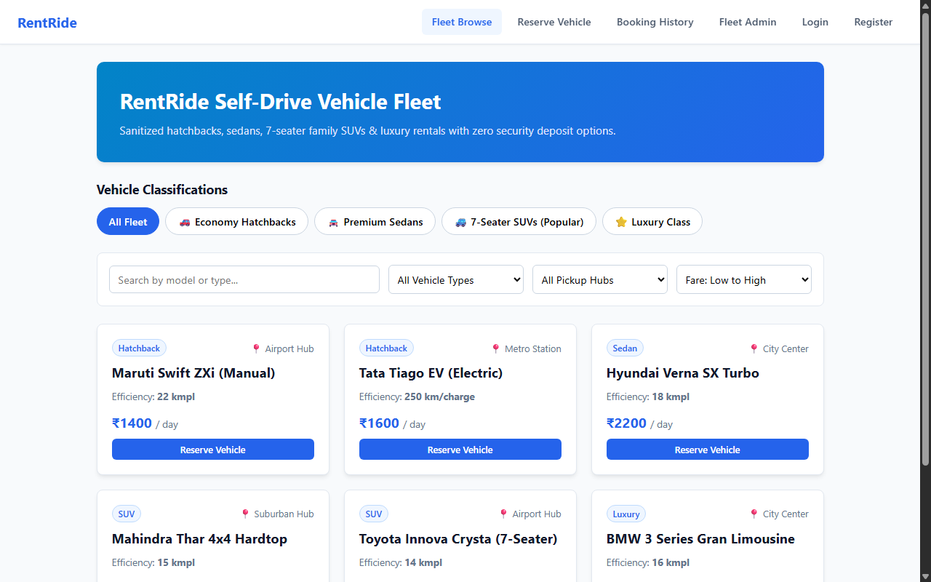

RESULT
The RentRide Self-Drive Vehicle Rental Platform web application was successfully designed, implemented, and tested. All client-side interactions, data persistence models, category filtering and sorting mechanisms, and administrative functionalities were verified to perform accurately across browser environments.

