Wanderlust Travels Agency & Holiday Booking Portal
A holiday travel agency portal for domestic and international vacation itineraries.

AIM
To build an online travel agency platform featuring curated holiday packages, custom travel budget calculator, online tour booking, and administrative tour package management.

ALGORITHM
1. Requirement Analysis: Formulate system specifications, interactive workflows, data schemas, and role hierarchies (Customer / User and Administrator).
2. Architecture & Modular Page Design: Construct multi-page application structure using semantic HTML5 elements without third-party framework overhead.
3. Styling & Presentation: Develop a cohesive responsive design system in style.css utilizing CSS variables, Flexbox containers, and CSS Grid layouts.
4. Client-side Persistence: Initialize structured state in localStorage to maintain dynamic records, session data, user carts, and administrative logs.
5. Interactive Logic Implementation: Program JavaScript event handlers for real-time search, category navigation, subcategory discovery, and sorting algorithms.
6. Administrative Operations: Build dedicated administrator desk capabilities allowing authorized users to manage inventory particulars, modify pricing, and review customer submissions.
7. Verification & DOM Testing: Validate form submissions, hyperlink navigation, cross-browser compatibility, and DOM responsiveness across device viewports.

SOURCE CODE

1. HTML Structure (index.html)
<!DOCTYPE html>
<html lang="en">
<head>
<meta charset="UTF-8">
<meta name="viewport" content="width=device-width, initial-scale=1.0">
<title>Wanderlust Travels Agency | Wanderlust Travels</title>
<link rel="stylesheet" href="style.css">
</head>
<body>
<nav class="navbar">
<a href="index.html" class="logo">Wanderlust Travels</a>
<div class="nav-links">
<a href="index.html">Tour Packages</a>
<a href="book.html">Book Tour</a>
<a href="custom.html">Budget Calculator</a>
<a href="admin.html">Travel Admin</a>
<a href="login.html">Login</a>
<a href="register.html">Register</a>
</div>
</nav>
<div class="container">
<div class="hero" style="background: linear-gradient(135deg, #0e7490, #06b6d4);">
<h1>Wanderlust Travel Experiences</h1>
<p>Curated domestic & international vacation packages with inclusive flights, luxury stays & sightseeing.</p>
</div>
<div class="card-grid">
<div class="card">
<span class="badge-tag">GOA • 4D / 3N</span>
<h3 style="margin-top:0.5rem;">Sun-Kissed Beaches of Goa</h3>
<p>Resort stay, beach cruise, scuba diving & North Goa heritage tour.</p>
<p style="font-weight:700; color:var(--primary);">₹14,999 / person</p>
<a href="book.html" class="btn btn-sm">Reserve Package</a>
</div>
<div class="card">
<span class="badge-tag">KASHMIR • 6D / 5N</span>
<h3 style="margin-top:0.5rem;">Paradise on Earth: Kashmir</h3>
<p>Srinagar Shikara ride, Gulmarg gondola & Pahalgam valley stay.</p>
<p style="font-weight:700; color:var(--primary);">₹24,500 / person</p>
<a href="book.html" class="btn btn-sm">Reserve Package</a>
</div>
<div class="card">
<span class="badge-tag">BALI • 5D / 4N</span>
<h3 style="margin-top:0.5rem;">Bali Tropical Escape</h3>
<p>Ubud jungle swings, Nusa Penida island tour & private pool villa.</p>
<p style="font-weight:700; color:var(--primary);">₹38,000 / person</p>
<a href="book.html" class="btn btn-sm">Reserve Package</a>
</div>
</div>
</div>
<footer>
<p>&copy; 2026 Wanderlust Travels Agency. All rights reserved.</p>
</footer>
<script src="script.js"></script>
</body>
</html>

2. CSS Stylesheet (style.css)
/* Wanderlust Travels Agency - Main Stylesheet */
:root {
--primary: #2563eb;
--primary-hover: #1d4ed8;
--secondary: #475569;
--accent: #0ea5e9;
--success: #16a34a;
--warning: #d97706;
--danger: #dc2626;
--bg: #f8fafc;
--card-bg: #ffffff;
--text: #0f172a;
--text-muted: #64748b;
--border: #e2e8f0;
--shadow: 0 4px 6px -1px rgba(0,0,0,0.08), 0 2px 4px -2px rgba(0,0,0,0.04);
}
* {
box-sizing: border-box;
margin: 0;
padding: 0;
font-family: -apple-system, BlinkMacSystemFont, "Segoe UI", Roboto, Helvetica, Arial, sans-serif;
}
body {
background-color: var(--bg);
color: var(--text);
line-height: 1.5;
min-height: 100vh;
display: flex;
flex-direction: column;
}
/* Navigation Bar */
.navbar {
background-color: #ffffff;
border-bottom: 1px solid var(--border);
display: flex;
justify-content: space-between;
align-items: center;
padding: 0.75rem 1.5rem;
position: sticky;
top: 0;
z-index: 100;
box-shadow: 0 1px 3px rgba(0,0,0,0.05);
}
.logo {
font-weight: 700;
font-size: 1.2rem;
color: var(--primary);
display: flex;
align-items: center;
gap: 0.5rem;
text-decoration: none;
}
.badge-tag {
background: #eff6ff;
color: var(--primary);
font-size: 0.75rem;
padding: 2px 8px;
border-radius: 999px;
border: 1px solid #bfdbfe;
font-weight: 600;
}
.nav-links {
display: flex;
gap: 0.5rem;
align-items: center;
}
.nav-links a {
text-decoration: none;
color: var(--secondary);
padding: 0.45rem 0.85rem;
border-radius: 6px;
font-size: 0.9rem;
font-weight: 500;
transition: all 0.15s ease;
}
.nav-links a:hover, .nav-links a.active {
background-color: #eff6ff;
color: var(--primary);
}
.nav-links a.portal-btn {
background-color: #0f172a;
color: #ffffff;
font-size: 0.8rem;
padding: 0.4rem 0.75rem;
border-radius: 6px;
}
.nav-links a.portal-btn:hover {
background-color: #334155;
color: #fff;
}
/* Main Container */
.container {
max-width: 1000px;
width: 95%;
margin: 1.5rem auto;
flex: 1;
}
/* Hero section */
.hero {
background: linear-gradient(135deg, #1e3a8a, #3b82f6);
color: white;
padding: 2rem;
border-radius: 10px;
margin-bottom: 1.5rem;
box-shadow: var(--shadow);
}
.hero h1 {
font-size: 1.8rem;
margin-bottom: 0.5rem;
}
.hero p {
color: #e0e7ff;
font-size: 0.95rem;
}
/* Cards & Layout */
.card-grid {
display: grid;
grid-template-columns: repeat(auto-fit, minmax(280px, 1fr));
gap: 1.25rem;
margin-bottom: 1.5rem;
}
.card {
background: var(--card-bg);
border: 1px solid var(--border);
border-radius: 8px;
padding: 1.25rem;
box-shadow: var(--shadow);
}
.card h3 {
color: var(--text);
margin-bottom: 0.5rem;
font-size: 1.15rem;
}
.card p {
color: var(--text-muted);
font-size: 0.9rem;
margin-bottom: 0.75rem;
}
/* Forms & Inputs */
.form-group {
margin-bottom: 1rem;
}
label {
display: block;
font-size: 0.85rem;
font-weight: 600;
margin-bottom: 0.35rem;
color: var(--text);
}
input, select, textarea {
width: 100%;
padding: 0.55rem 0.75rem;
border: 1px solid var(--border);
border-radius: 6px;
font-size: 0.9rem;
background-color: #ffffff;
outline: none;
}
input:focus, select:focus, textarea:focus {
border-color: var(--primary);
box-shadow: 0 0 0 3px rgba(37, 99, 235, 0.15);
}
/* Buttons */
.btn {
display: inline-block;
background: var(--primary);
color: white;
padding: 0.5rem 1rem;
border-radius: 6px;
border: none;
font-size: 0.9rem;
font-weight: 600;
cursor: pointer;
text-decoration: none;
transition: background 0.15s ease;
text-align: center;
}
.btn:hover {
background: var(--primary-hover);
}
.btn-secondary {
background: #e2e8f0;
color: var(--text);
}
.btn-secondary:hover {
background: #cbd5e1;
}
.btn-danger {
background: var(--danger);
}
.btn-danger:hover {
background: #b91c1c;
}
.btn-sm {
padding: 0.3rem 0.6rem;
font-size: 0.8rem;
}
/* Tables */
table {
width: 100%;
border-collapse: collapse;
margin-top: 1rem;
font-size: 0.9rem;
background: white;
border-radius: 6px;
overflow: hidden;
box-shadow: var(--shadow);
}
th, td {
padding: 0.75rem 1rem;
text-align: left;
border-bottom: 1px solid var(--border);
}
th {
background: #f1f5f9;
font-weight: 600;
color: var(--secondary);
}
/* Result / Alert Boxes */
.alert {
padding: 1rem;
border-radius: 6px;
margin-top: 1rem;
border-left: 4px solid var(--primary);
background: #eff6ff;
color: #1e3a8a;
font-size: 0.9rem;
}
.alert-success {
border-left-color: var(--success);
background: #f0fdf4;
color: #14532d;
}
.alert-warning {
border-left-color: var(--warning);
background: #fffbeb;
color: #78350f;
}
/* Footer */
footer {
margin-top: auto;
border-top: 1px solid var(--border);
padding: 1rem;
text-align: center;
font-size: 0.85rem;
color: var(--text-muted);
background: #ffffff;
}
/* Responsive */
@media (max-width: 640px) {
.navbar { flex-direction: column; gap: 0.5rem; align-items: flex-start; }
.nav-links { flex-wrap: wrap; }
}

3. JavaScript Application Logic (script.js)
function bookTour(e) {
e.preventDefault();
const name = document.getElementById('trvName').value;
const destSelect = document.getElementById('trvDest');
const destName = destSelect.options[destSelect.selectedIndex].text.split('(')[0].trim();
const price = parseFloat(destSelect.value);
const count = parseInt(document.getElementById('trvCount').value) || 1;
const total = price * count;
const pnr = "WND-" + Math.floor(100000 + Math.random()*900000);
document.getElementById('tourAlert').innerHTML = `
<div class="alert alert-success">
<h3>Holiday Confirmed: ${pnr}</h3>
<p>Lead Traveler: <strong>${name}</strong></p>
<p>Package: ${destName} for ${count} Travelers</p>
<p>Total Cost: <strong>₹${total.toLocaleString('en-IN')}</strong></p>
<p>Your itinerary voucher and hotel vouchers have been generated.</p>
</div>
`;
}
function calcCustomTrip() {
const daily = parseFloat(document.getElementById('cDest').value);
const days = parseInt(document.getElementById('cDays').value) || 1;
const pax = parseInt(document.getElementById('cTravelers').value) || 1;
const estimate = daily * days * pax;
document.getElementById('customResult').innerHTML = `
<div class="alert alert-success">
<h3>Estimated Budget: ₹${estimate.toLocaleString('en-IN')}</h3>
<p>Includes accommodation, daily breakfast, and internal city transfers for ${pax} people for ${days} days.</p>
</div>
`;
}
const origBookTour = window.bookTour;
window.bookTour = function(e) {
e.preventDefault();
const name = document.getElementById('trvName').value.trim();
const destSelect = document.getElementById('trvDest');
const destName = destSelect.options[destSelect.selectedIndex].text.split('(')[0].trim();
const price = parseFloat(destSelect.value);
const count = parseInt(document.getElementById('trvCount').value) || 1;
const total = price * count;
const ref = "WND-" + Math.floor(1000 + Math.random()*9000);
const list = JSON.parse(localStorage.getItem('wanderlust_bookings') || '[]');
list.unshift({ ref, name, dest: destName, count, total, date: new Date().toLocaleDateString() });
localStorage.setItem('wanderlust_bookings', JSON.stringify(list));
document.getElementById('bookingResult').innerHTML = `
<div class="alert alert-success">
<p>Booking Confirmed!</p>
<p>Booking Ref: <strong>${ref}</strong></p>
<p>Lead Traveler: ${name}</p>
<p>Package: ${destName} (${count} Persons)</p>
<p>Total Estimated Cost: <strong>₹${total.toLocaleString('en-IN')}</strong></p>
<p>Itinerary vouchers emailed to traveler.</p>
</div>
`;
};

OUTPUT
Web Application Browser User Interface Rendering:
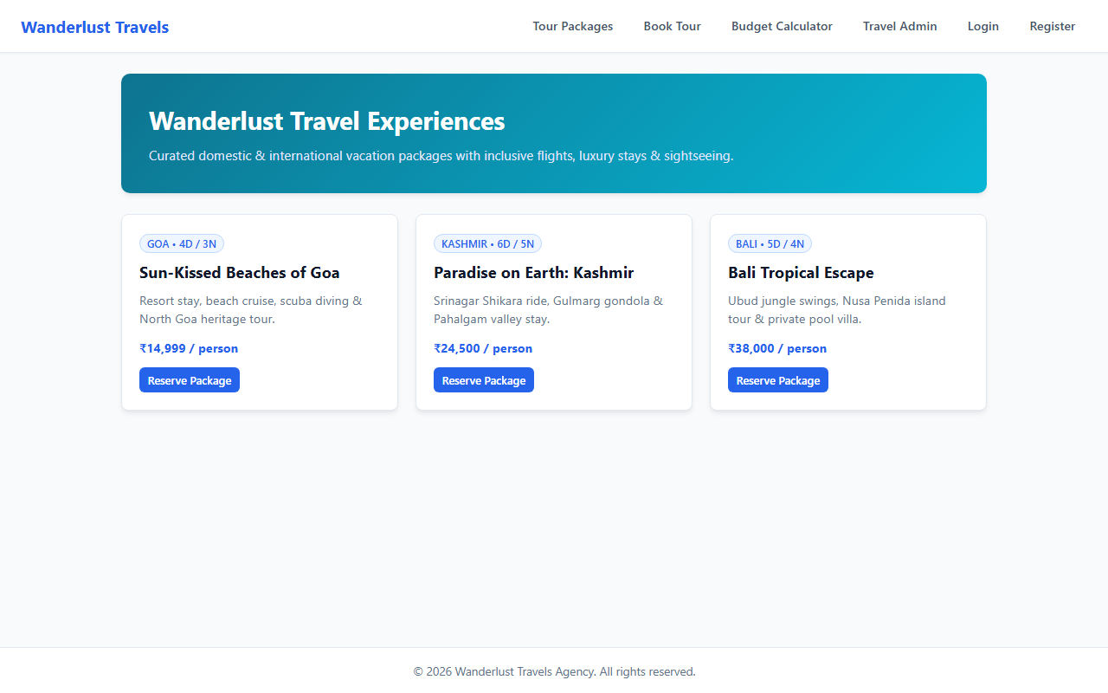

RESULT
The Wanderlust Travels Agency & Holiday Booking Portal web application was successfully designed, implemented, and tested. All client-side interactions, data persistence models, category filtering and sorting mechanisms, and administrative functionalities were verified to perform accurately across browser environments.

