ArtistryHub Visual Artist Exhibition & Portfolio Showcase
A modern portfolio showcase for fine art exhibitions, sculptures, and paintings.

AIM
To design an artist portfolio platform showcasing artwork galleries, exhibition schedules, artist biography, interactive gallery inquiries, and newsletter subscription.

ALGORITHM
1. Requirement Analysis: Formulate system specifications, interactive workflows, data schemas, and role hierarchies (Customer / User and Administrator).
2. Architecture & Modular Page Design: Construct multi-page application structure using semantic HTML5 elements without third-party framework overhead.
3. Styling & Presentation: Develop a cohesive responsive design system in style.css utilizing CSS variables, Flexbox containers, and CSS Grid layouts.
4. Client-side Persistence: Initialize structured state in localStorage to maintain dynamic records, session data, user carts, and administrative logs.
5. Interactive Logic Implementation: Program JavaScript event handlers for real-time search, category navigation, subcategory discovery, and sorting algorithms.
6. Administrative Operations: Build dedicated administrator desk capabilities allowing authorized users to manage inventory particulars, modify pricing, and review customer submissions.
7. Verification & DOM Testing: Validate form submissions, hyperlink navigation, cross-browser compatibility, and DOM responsiveness across device viewports.

SOURCE CODE

1. HTML Structure (index.html)
<!DOCTYPE html>
<html lang="en">
<head>
<meta charset="UTF-8">
<meta name="viewport" content="width=device-width, initial-scale=1.0">
<title>ArtistryHub Artist Portfolio | ArtistryHub - Emily Harris</title>
<link rel="stylesheet" href="style.css">
</head>
<body>
<nav class="navbar">
<a href="index.html" class="logo">ArtistryHub - Emily Harris</a>
<div class="nav-links">
<a href="index.html" class="active">Gallery</a>
<a href="about.html">About Artist</a>
<a href="exhibitions.html">Exhibitions & News</a>
<a href="login.html">Login</a>
<a href="register.html">Register</a>
</div>
</nav>
<div class="container">
<div class="hero" style="background: linear-gradient(135deg, #4c1d95, #8b5cf6);">
<h1>ArtistryHub • Emily Harris Portfolio</h1>
<p>Contemporary oil, watercolor & digital fine art exploring human emotion and natural landscapes.</p>
</div>
<div style="display:flex; gap:0.5rem; margin-bottom:1rem;">
<button class="btn btn-secondary btn-sm" onclick="filterArt('all')">All Works</button>
<button class="btn btn-secondary btn-sm" onclick="filterArt('Oil')">Oil on Canvas</button>
<button class="btn btn-secondary btn-sm" onclick="filterArt('Watercolor')">Watercolor</button>
</div>
<div class="card-grid" id="artGrid"></div>
</div>
<footer>
<p>&copy; 2026 ArtistryHub Artist Portfolio. All rights reserved.</p>
</footer>
<script src="script.js"></script>
</body>
</html>

2. CSS Stylesheet (style.css)
/* ArtistryHub Artist Portfolio - Main Stylesheet */
:root {
--primary: #2563eb;
--primary-hover: #1d4ed8;
--secondary: #475569;
--accent: #0ea5e9;
--success: #16a34a;
--warning: #d97706;
--danger: #dc2626;
--bg: #f8fafc;
--card-bg: #ffffff;
--text: #0f172a;
--text-muted: #64748b;
--border: #e2e8f0;
--shadow: 0 4px 6px -1px rgba(0,0,0,0.08), 0 2px 4px -2px rgba(0,0,0,0.04);
}
* {
box-sizing: border-box;
margin: 0;
padding: 0;
font-family: -apple-system, BlinkMacSystemFont, "Segoe UI", Roboto, Helvetica, Arial, sans-serif;
}
body {
background-color: var(--bg);
color: var(--text);
line-height: 1.5;
min-height: 100vh;
display: flex;
flex-direction: column;
}
/* Navigation Bar */
.navbar {
background-color: #ffffff;
border-bottom: 1px solid var(--border);
display: flex;
justify-content: space-between;
align-items: center;
padding: 0.75rem 1.5rem;
position: sticky;
top: 0;
z-index: 100;
box-shadow: 0 1px 3px rgba(0,0,0,0.05);
}
.logo {
font-weight: 700;
font-size: 1.2rem;
color: var(--primary);
display: flex;
align-items: center;
gap: 0.5rem;
text-decoration: none;
}
.badge-tag {
background: #eff6ff;
color: var(--primary);
font-size: 0.75rem;
padding: 2px 8px;
border-radius: 999px;
border: 1px solid #bfdbfe;
font-weight: 600;
}
.nav-links {
display: flex;
gap: 0.5rem;
align-items: center;
}
.nav-links a {
text-decoration: none;
color: var(--secondary);
padding: 0.45rem 0.85rem;
border-radius: 6px;
font-size: 0.9rem;
font-weight: 500;
transition: all 0.15s ease;
}
.nav-links a:hover, .nav-links a.active {
background-color: #eff6ff;
color: var(--primary);
}
.nav-links a.portal-btn {
background-color: #0f172a;
color: #ffffff;
font-size: 0.8rem;
padding: 0.4rem 0.75rem;
border-radius: 6px;
}
.nav-links a.portal-btn:hover {
background-color: #334155;
color: #fff;
}
/* Main Container */
.container {
max-width: 1000px;
width: 95%;
margin: 1.5rem auto;
flex: 1;
}
/* Hero section */
.hero {
background: linear-gradient(135deg, #1e3a8a, #3b82f6);
color: white;
padding: 2rem;
border-radius: 10px;
margin-bottom: 1.5rem;
box-shadow: var(--shadow);
}
.hero h1 {
font-size: 1.8rem;
margin-bottom: 0.5rem;
}
.hero p {
color: #e0e7ff;
font-size: 0.95rem;
}
/* Cards & Layout */
.card-grid {
display: grid;
grid-template-columns: repeat(auto-fit, minmax(280px, 1fr));
gap: 1.25rem;
margin-bottom: 1.5rem;
}
.card {
background: var(--card-bg);
border: 1px solid var(--border);
border-radius: 8px;
padding: 1.25rem;
box-shadow: var(--shadow);
}
.card h3 {
color: var(--text);
margin-bottom: 0.5rem;
font-size: 1.15rem;
}
.card p {
color: var(--text-muted);
font-size: 0.9rem;
margin-bottom: 0.75rem;
}
/* Forms & Inputs */
.form-group {
margin-bottom: 1rem;
}
label {
display: block;
font-size: 0.85rem;
font-weight: 600;
margin-bottom: 0.35rem;
color: var(--text);
}
input, select, textarea {
width: 100%;
padding: 0.55rem 0.75rem;
border: 1px solid var(--border);
border-radius: 6px;
font-size: 0.9rem;
background-color: #ffffff;
outline: none;
}
input:focus, select:focus, textarea:focus {
border-color: var(--primary);
box-shadow: 0 0 0 3px rgba(37, 99, 235, 0.15);
}
/* Buttons */
.btn {
display: inline-block;
background: var(--primary);
color: white;
padding: 0.5rem 1rem;
border-radius: 6px;
border: none;
font-size: 0.9rem;
font-weight: 600;
cursor: pointer;
text-decoration: none;
transition: background 0.15s ease;
text-align: center;
}
.btn:hover {
background: var(--primary-hover);
}
.btn-secondary {
background: #e2e8f0;
color: var(--text);
}
.btn-secondary:hover {
background: #cbd5e1;
}
.btn-danger {
background: var(--danger);
}
.btn-danger:hover {
background: #b91c1c;
}
.btn-sm {
padding: 0.3rem 0.6rem;
font-size: 0.8rem;
}
/* Tables */
table {
width: 100%;
border-collapse: collapse;
margin-top: 1rem;
font-size: 0.9rem;
background: white;
border-radius: 6px;
overflow: hidden;
box-shadow: var(--shadow);
}
th, td {
padding: 0.75rem 1rem;
text-align: left;
border-bottom: 1px solid var(--border);
}
th {
background: #f1f5f9;
font-weight: 600;
color: var(--secondary);
}
/* Result / Alert Boxes */
.alert {
padding: 1rem;
border-radius: 6px;
margin-top: 1rem;
border-left: 4px solid var(--primary);
background: #eff6ff;
color: #1e3a8a;
font-size: 0.9rem;
}
.alert-success {
border-left-color: var(--success);
background: #f0fdf4;
color: #14532d;
}
.alert-warning {
border-left-color: var(--warning);
background: #fffbeb;
color: #78350f;
}
/* Footer */
footer {
margin-top: auto;
border-top: 1px solid var(--border);
padding: 1rem;
text-align: center;
font-size: 0.85rem;
color: var(--text-muted);
background: #ffffff;
}
/* Responsive */
@media (max-width: 640px) {
.navbar { flex-direction: column; gap: 0.5rem; align-items: flex-start; }
.nav-links { flex-wrap: wrap; }
}

3. JavaScript Application Logic (script.js)
const artworks = [
{ id: 1, title: "Echoes of Twilight", medium: "Oil", year: "2025", desc: "48x36 in. Deep cobalt blue and golden ochre." },
{ id: 2, title: "Whispering Rain", medium: "Watercolor", year: "2026", desc: "Delicate washes on 300gsm cold-press paper." },
{ id: 3, title: "Symphony of the Dunes", medium: "Oil", year: "2024", desc: "Rich textured impasto depicting desert winds." },
{ id: 4, title: "Morning Mist on Lake Como", medium: "Watercolor", year: "2026", desc: "Reflective water study in pastel tones." }
];
function renderArt(list) {
const grid = document.getElementById('artGrid');
if (!grid) return;
grid.innerHTML = '';
list.forEach(a => {
grid.innerHTML += `
<div class="card">
<span class="badge-tag">${a.medium.toUpperCase()} • ${a.year}</span>
<h3 style="margin-top:0.5rem;">${a.title}</h3>
<p>${a.desc}</p>
<button class="btn btn-sm" onclick="alert('Inquiry for "${a.title}" sent to studio representative.')">Inquire Artwork</button>
</div>
`;
});
}
function filterArt(med) {
if (med === 'all') renderArt(artworks);
else renderArt(artworks.filter(a => a.medium === med));
}
document.addEventListener('DOMContentLoaded', () => {
renderArt(artworks);
});

OUTPUT
Web Application Browser User Interface Rendering:
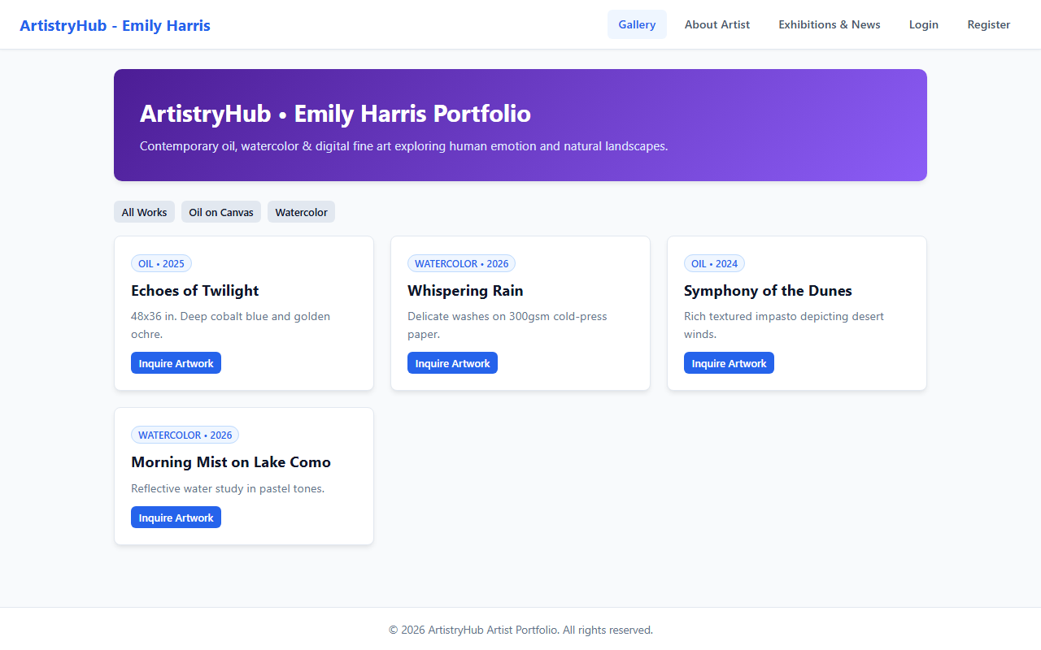

RESULT
The ArtistryHub Visual Artist Exhibition & Portfolio Showcase web application was successfully designed, implemented, and tested. All client-side interactions, data persistence models, category filtering and sorting mechanisms, and administrative functionalities were verified to perform accurately across browser environments.

