DEPARTMENT OF COMPUTER SCIENCE & ENGINEERING
INTERNET PROGRAMMING LABORATORY RECORD
RAILWAY RESERVATION SYSTEM
AYUSH MOHAPATRA 192411263

1. AIM
To design and develop a Railway Reservation Web Application using HTML5, CSS3, and JavaScript, facilitating train route search between railway junctions, live seat availability checking across travel classes (1A, 2A, 3A, SL, CC), passenger ticket booking with berth preference selection, PNR enquiry, ticket cancellation with refund computation, and railway administrative route and fare management.
2. SYSTEM SPECIFICATIONS & REQUIREMENTS
The railway ticketing system runs as a client-side web application rendered in the Chromium DOM engine with Web Storage persistence.
Category | Specification / Tool | Details / Role
Hardware Requirements | Processor | Intel Core i5 / AMD Ryzen 5 or higher
Hardware Requirements | Memory (RAM) | 8 GB DDR4 RAM or higher
Hardware Requirements | Display | 1920x1080 Full HD Monitor
Software Requirements | Operating System | Microsoft Windows 10 / Windows 11 (64-bit)
Software Requirements | Execution Engine | Google Chrome / Chromium DOM Engine
Software Requirements | Code Editor | Visual Studio Code / Integrated Development Environment
Frontend Technologies | Markup Language | HTML5 (Semantic Elements, Form Controls, Tables)
Frontend Technologies | Styling Language | CSS3 (Flexbox, Grid, Responsive Media Queries)
Frontend Technologies | Scripting & DOM | JavaScript (ES6+, DOM API, Event Listeners)
Client-Side Storage | Web Storage API | Browser LocalStorage for persistent client data

3. ALGORITHM
The systematic procedure for designing and executing the Railway Reservation System is outlined below:
Step 1: Multi-Page Web Portal Architecture - Construct semantic HTML5 documents (index.html, trains.html, booking.html, ticket.html, pnr.html, cancel.html, dashboard.html, admin.html, admin-trains.html, admin-fares.html) organizing navigation, train search, booking forms, ticket printing, and administration.
Step 2: Railway Themed UI & Responsive Styling - Apply CSS styling (style.css) featuring Indian Railways navy blue (#003366) and white styling, structured tabular data layouts, clear status badges, and mobile-friendly responsive containers.
Step 3: Train Timetable & Route Initialization - In JavaScript (script.js), configure train datasets containing train numbers, train names (Chennai Express, Vaigai Superfast, Rajdhani Express), source stations, destinations, timings, travel classes, and seat quotas.
Step 4: Train Route Search & Station Filtering - Capture origin station, destination station, and journey date; filter matching train services; dynamically render train cards into the DOM displaying departure timings, duration, and class buttons.
Step 5: Class Selection & Passenger Booking - Extract train selection parameters; dynamically populate travel classes (Sleeper, 3A, 2A, 1A, Chair Car) with seat availability; capture passenger names, ages, genders, and berth preferences (Lower, Middle, Upper).
Step 6: Fare Calculation & 10-Digit PNR Generation - Calculate total fare based on distance and class tariffs; generate a unique 10-digit PNR number on booking confirmation; commit ticket object to localStorage.
Step 7: Printable E-Ticket Generation (ticket.html) - Dynamically construct a printable railway e-ticket voucher displaying 10-digit PNR, train number, coach number, allocated seat/berth, and passenger details with window.print() integration.
Step 8: Live PNR Status Enquiry (pnr.html) - Implement PNR lookup input; query stored ticket records; render current reservation status ('CNF - Confirmed', coach, and seat allocation) dynamically in the DOM.
Step 9: Ticket Cancellation & Refund Processing - In cancel.html, retrieve booking by PNR; calculate cancellation charges according to railway refund policy; update ticket status to 'Cancelled' and restore seat counts.
Step 10: Railway Administration & Route Management - In admin.html and admin-trains.html, provide railway controllers with tools to add new train services, update timetables, modify fare tariffs, and inspect passenger manifests.
4. SYSTEM ARCHITECTURE & MODULE DESCRIPTION
The railway system includes modular subsystems handling passenger and administrative operations:
File Name | Module Name | Functional Role
index.html | Home Portal | Station search widget, route lookup, quick booking shortcuts, railway notices
trains.html | Train Search Engine | Train schedule directory, origin-destination route filters, availability
booking.html | Passenger Booking | Berth preference selection, passenger details form, class tariff calculator
ticket.html | E-Ticket View | Printable railway ticket receipt with 10-digit PNR, coach and seat allocation
pnr.html | PNR Status Enquiry | Live PNR search portal retrieving current ticket confirmation state
cancel.html | Ticket Cancellation | PNR lookup and refund computation according to railway rules
dashboard.html | Passenger Dashboard | User booking history, upcoming journeys, and e-ticket reprints
admin.html | Railway Control Panel | Administrative overview, passenger occupancy statistics, train fleet status
admin-trains.html | Train Management | Add new trains, edit station schedules, and update seat quotas
css/style.css | Railway Theme | Navy blue railway styling, responsive tables, badge highlights, and print styles
js/script.js | Railway Logic Engine | Station search algorithm, PNR generator, fare math, and DOM handlers

5. KEY SOURCE CODE HIGHLIGHTS
HTML Structure: Train Search Form (index.html / trains.html)
<section class="card">
<h2>Railway Reservation - Search Trains</h2>
<form onsubmit="searchTrains(event)">
<div class="form-row">
<select id="fromStation" required>
<option value="">Source Station</option>
<option value="Chennai Central">Chennai Central (MAS)</option>
<option value="Madurai">Madurai Junction (MDU)</option>
<option value="Coimbatore">Coimbatore Junction (CBE)</option>
</select>
<select id="toStation" required>
<option value="">Destination Station</option>
<option value="Madurai">Madurai Junction (MDU)</option>
<option value="Chennai Central">Chennai Central (MAS)</option>
<option value="Bangalore">Bangalore City (SBC)</option>
</select>
<input type="date" id="journeyDate" required>
<button type="submit">Search Trains</button>
</div>
</form>
<div id="trainResults"></div>
</section>

JavaScript: Train Search & 10-Digit PNR Booking Logic (js/script.js)
function searchTrains(event) {
event.preventDefault();
const from = document.getElementById("fromStation").value;
const to = document.getElementById("toStation").value;
alert(`Searching available trains from ${from} to ${to}...`);
window.location.href = `trains.html?from=${encodeURIComponent(from)}&to=${encodeURIComponent(to)}`;
}
function bookTrainTicket(event) {
event.preventDefault();
const trainNo = document.getElementById("trainNumber").value;
const passenger = document.getElementById("passengerName").value;
const travelClass = document.getElementById("travelClass").value;
const berth = document.getElementById("berthPreference").value;
// Generate 10-digit Indian Railways PNR
const pnr = Math.floor(1000000000 + Math.random() * 9000000000).toString();
const ticket = {
pnr: pnr,
train: trainNo,
passenger: passenger,
travelClass: travelClass,
coach: "S4",
berth: "36 (" + berth + ")",
status: "CNF (Confirmed)"
};
localStorage.setItem("train_ticket_" + pnr, JSON.stringify(ticket));
alert(`Ticket Booked Successfully! PNR: ${pnr}`);
window.location.href = `ticket.html?pnr=${pnr}`;
}

6. CHROME DOM OUTPUT & SCREENSHOT VERIFICATION
The Railway Reservation Web Application was executed inside the Google Chrome DOM environment. The following screenshots document the rendered user pages, search forms, booking flows, and admin screens.
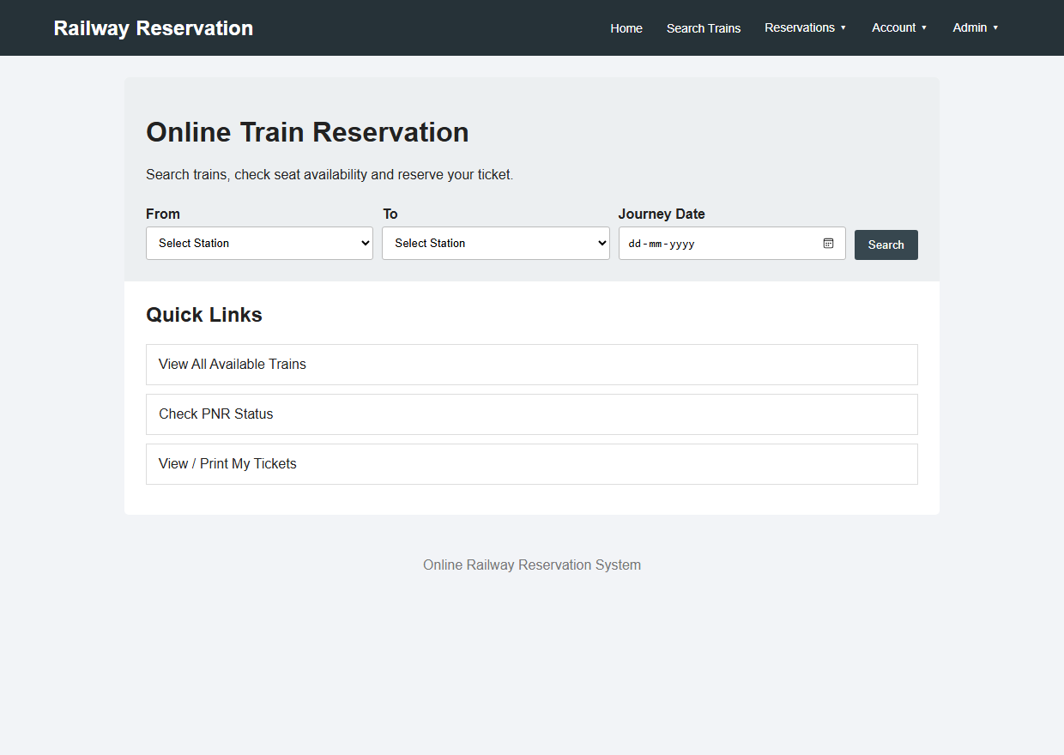
Figure 6.1: Chrome DOM Rendering of Railway Portal Home (index.html)
Output Observation: Shows the railway reservation homepage featuring brand header, route search widgets, station dropdown selectors, and service shortcuts.
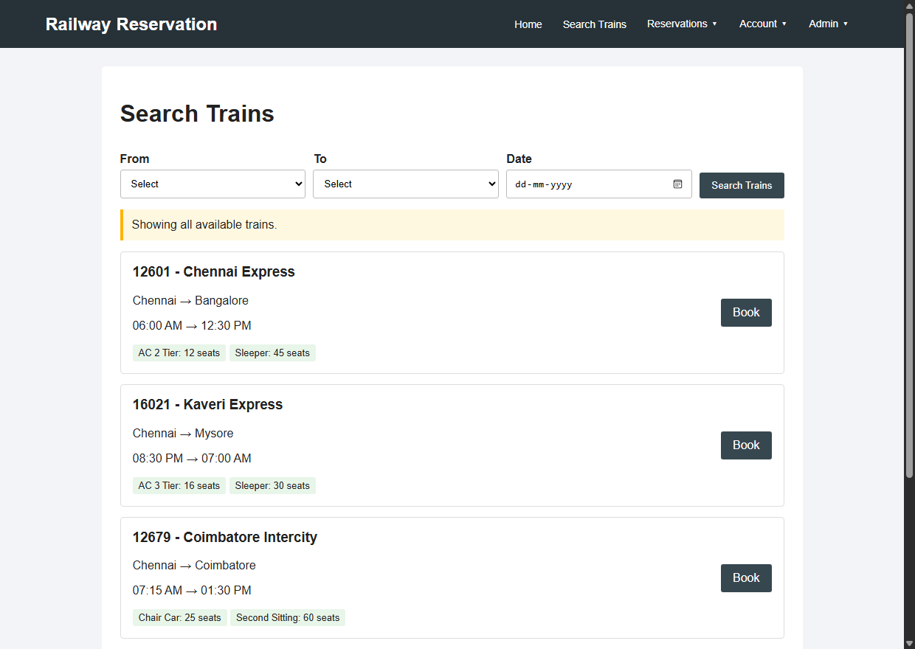
Figure 6.2: Available Trains, Routes & Schedules (trains.html)
Output Observation: Illustrates the search results screen dynamically presenting train cards with timings, intermediate stations, class options, and booking triggers.
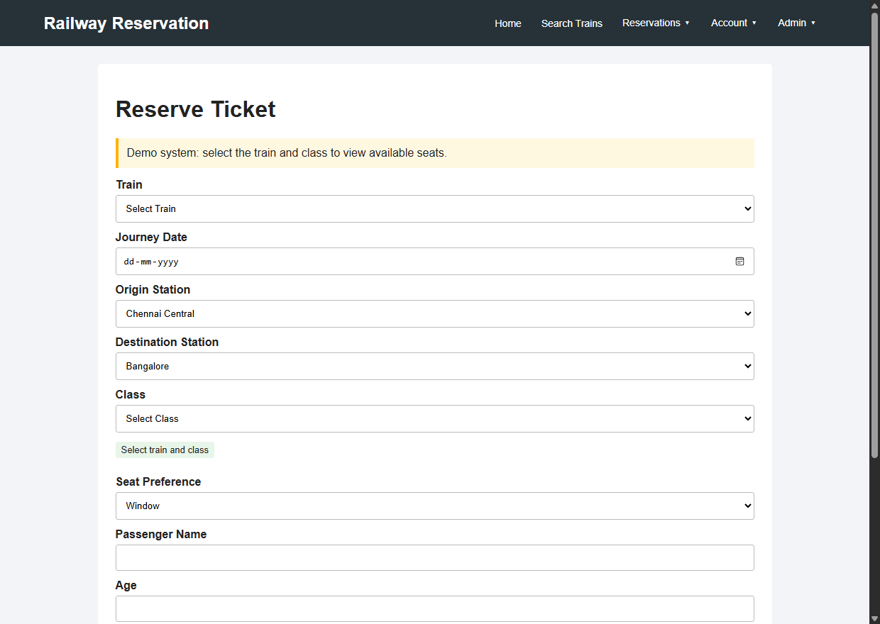
Figure 6.3: Passenger Ticket Booking & Berth Preference (booking.html)
Output Observation: Displays the passenger booking form with class selection (Sleeper, AC tiers), berth preference allocation, and fare summaries.
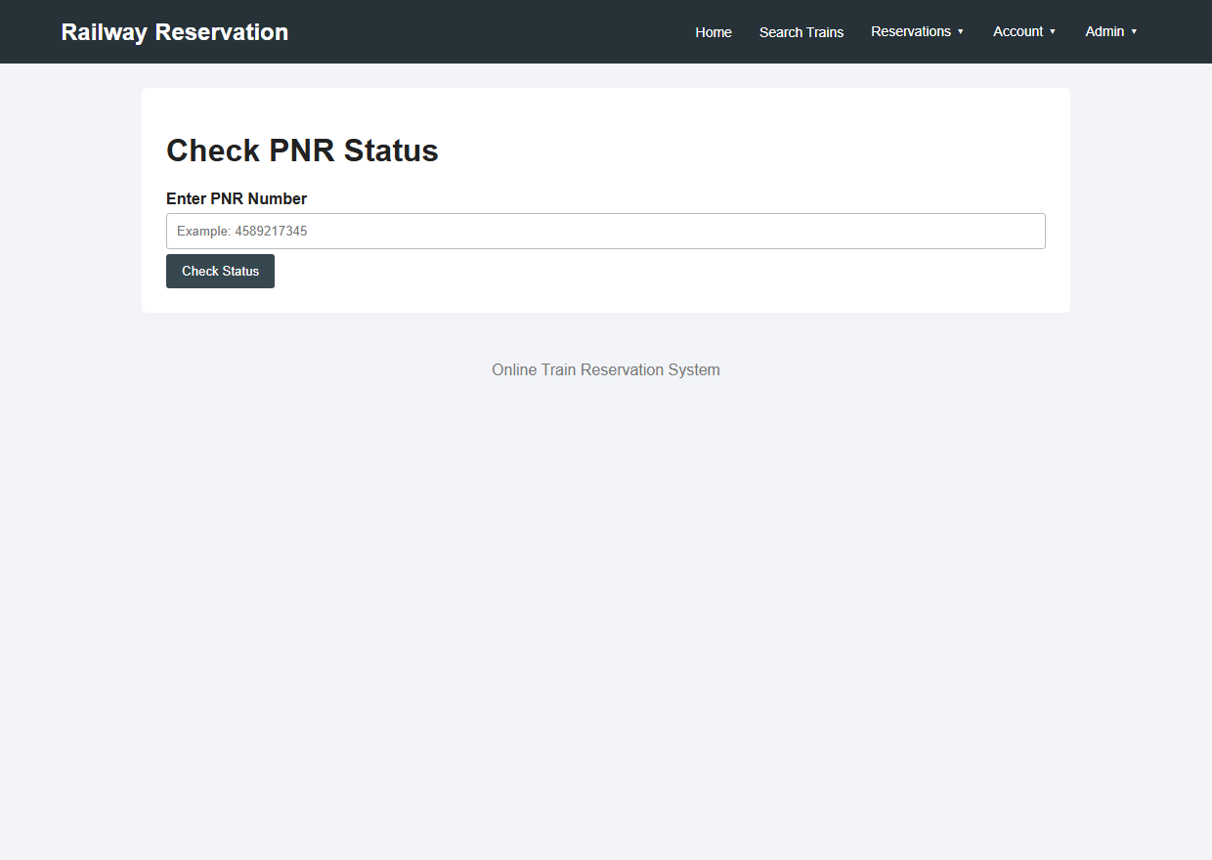
Figure 6.4: Live PNR Status Enquiry Portal (pnr.html)
Output Observation: Presents the PNR inquiry interface allowing passengers to look up reservation confirmations and allocated coach/seat numbers.
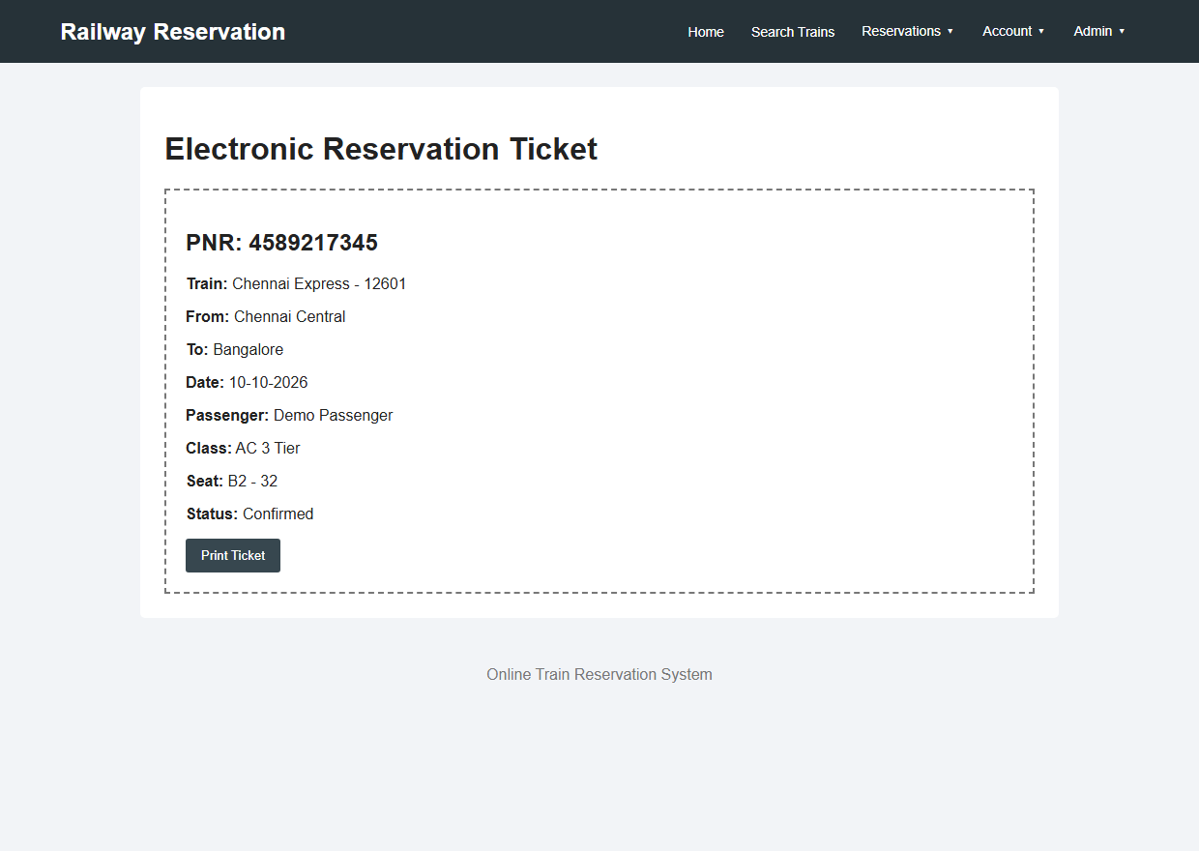
Figure 6.5: Printable Railway E-Ticket with 10-Digit PNR (ticket.html)
Output Observation: Depicts the confirmed electronic railway reservation ticket featuring PNR, train details, passenger names, coach/berth, and print action.
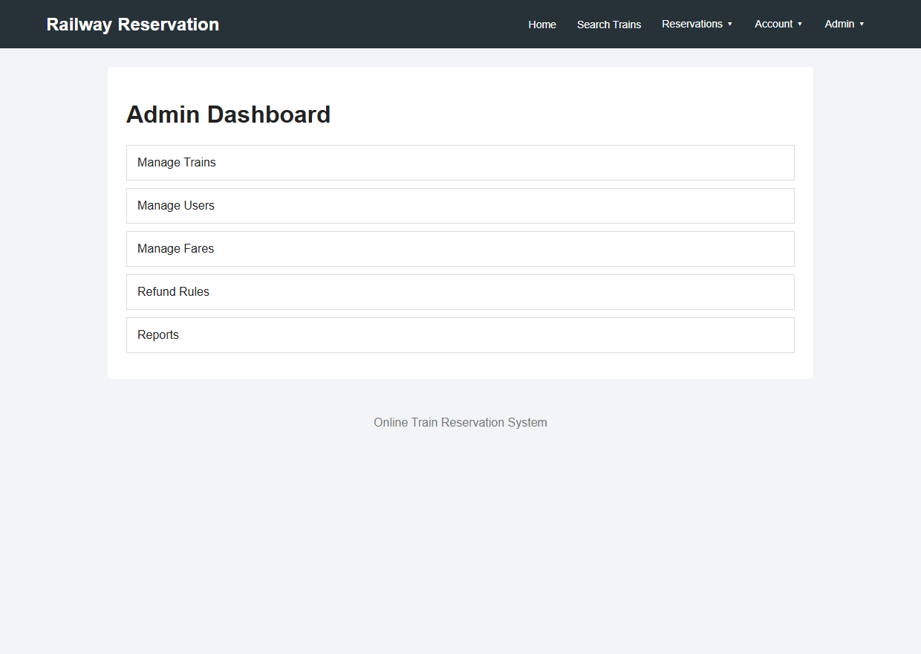
Figure 6.6: Railway Administration Control Dashboard (admin.html)
Output Observation: Captures the administrative dashboard providing overview metrics of train operations, bookings, and revenue summaries.
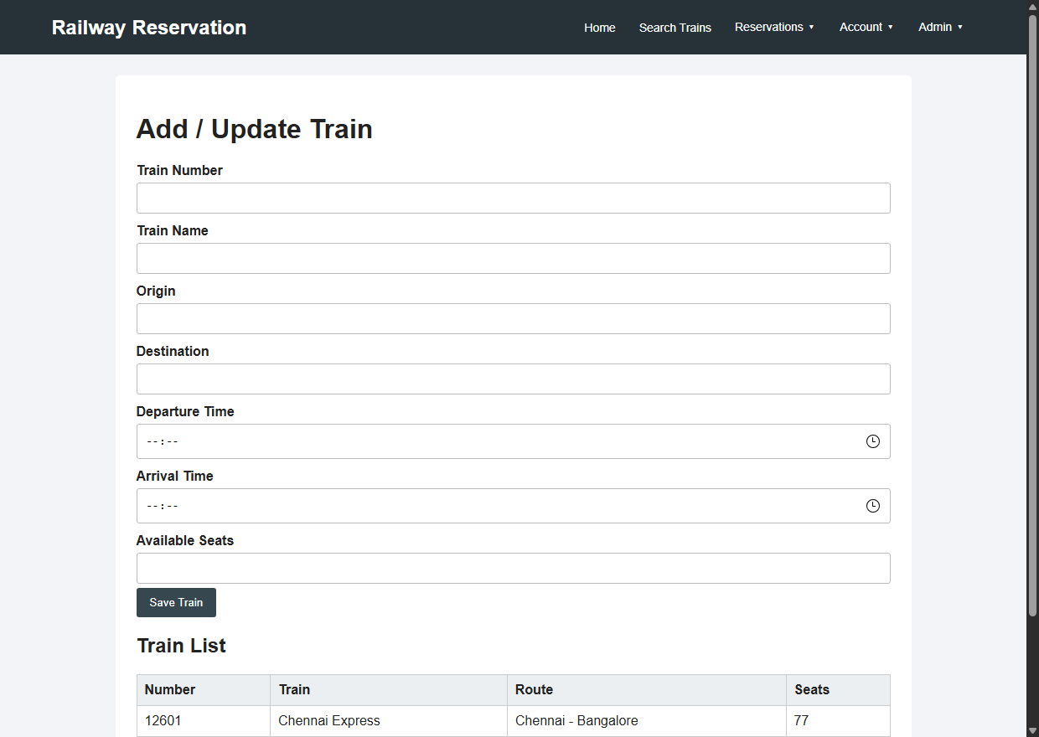
Figure 6.7: Train Fleet & Timetable Management (admin-trains.html)
Output Observation: Shows the railway management interface enabling administrators to update train timetables, add routes, and manage seat quotas.
7. RESULT
EXPERIMENT CONCLUSION / RESULT:
The Railway Reservation Web Application was successfully created, executed, and validated within the Google Chrome DOM environment using HTML5, CSS3, and JavaScript. All features—including station-to-station route search, dynamic class selection, 10-digit PNR ticket generation, live PNR status lookup, and railway administration—operated accurately with reliable client-side LocalStorage data persistence.

