DEPARTMENT OF COMPUTER SCIENCE & ENGINEERING
INTERNET PROGRAMMING LABORATORY RECORD
BEAUTY PARLOUR APPOINTMENT BOOKING SYSTEM
AYUSH MOHAPATRA 192411263

1. AIM
To design and develop an interactive Beauty Parlour Appointment Booking Web Application using HTML5, CSS3, and JavaScript, enabling clients to browse salon grooming services and transparent pricing, select preferred beauty stylists and appointment slots while preventing double booking conflicts, and providing salon managers with centralized controls to manage reservations, track appointments, and lock unavailable time slots using DOM manipulation and LocalStorage.
2. SYSTEM SPECIFICATIONS & REQUIREMENTS
The application operates entirely on client-side web technologies utilizing Chromium DOM rendering and LocalStorage API for data persistence.
Category | Specification / Tool | Details / Role
Hardware Requirements | Processor | Intel Core i5 / AMD Ryzen 5 or higher
Hardware Requirements | Memory (RAM) | 8 GB DDR4 RAM or higher
Hardware Requirements | Display | 1920x1080 Full HD Monitor
Software Requirements | Operating System | Microsoft Windows 10 / Windows 11 (64-bit)
Software Requirements | Execution Engine | Google Chrome / Chromium DOM Engine
Software Requirements | Code Editor | Visual Studio Code / Integrated Development Environment
Frontend Technologies | Markup Language | HTML5 (Semantic Elements, Form Controls, Tables)
Frontend Technologies | Styling Language | CSS3 (Flexbox, Grid, Responsive Media Queries)
Frontend Technologies | Scripting & DOM | JavaScript (ES6+, DOM API, Event Listeners)
Client-Side Storage | Web Storage API | Browser LocalStorage for persistent client data

3. ALGORITHM
The step-by-step procedure for designing and executing the Beauty Parlour Appointment Booking System is detailed below:
Step 1: Interface Architecture Construction - Construct semantic HTML5 documents (index.html, admin.html, login.html, register.html) establishing service display grids, stylist selection dropdowns, booking forms, appointment lookup panels, and manager controls.
Step 2: Salon Aesthetic & Responsive Styling - Implement CSS3 styling (style.css) featuring an elegant rose (#d63384) aesthetic, rounded card containers, responsive flexbox layout, styled badges, and smooth hover state transitions.
Step 3: Service Catalog & Stylist Data Setup - In JavaScript (app.js), declare salon services (Haircut, Facial, Manicure, Hair Colour, Pedicure, Bridal Makeup) with prices and descriptions; define stylist rosters (Priya, Kavitha, Sneha) and store in memory/localStorage.
Step 4: Dynamic Service Catalog DOM Rendering - Listen for search box input events; filter service catalogs in real time and dynamically inject formatted service cards containing pricing and descriptions into the DOM.
Step 5: Booking Input Parsing & Form Validation - Capture customer reservation submissions; extract customer full name, contact number, selected grooming service, chosen stylist, appointment date, and time slot.
Step 6: Conflict Detection & Double-Booking Prevention - Read existing bookings from localStorage; evaluate whether the chosen stylist is already reserved for the specified date and time slot; also verify whether the manager has locked that particular slot.
Step 7: Booking Token Generation & Storage - If no scheduling conflict exists, generate a unique reservation code (e.g., BTY-5021); serialize the booking object into 'parlour_bookings' in localStorage; clear the input form.
Step 8: Instant DOM Confirmation & Price Badge - Dynamically render a confirmation voucher in the DOM displaying booking token, assigned stylist, service cost (₹), and customer instructions.
Step 9: Manager Dashboard & Slot Locking (admin.html) - Authenticate salon manager credentials (manager / salon123); render reservations in an interactive management table; provide controls to mark bookings completed or lock specific stylist time slots.
Step 10: Chrome DOM Validation & Workflow Verification - Test and verify all customer booking pathways, double-booking prevention alerts, and manager administrative operations using the Google Chrome DOM inspector.
4. SYSTEM ARCHITECTURE & MODULE DESCRIPTION
The parlour system comprises modular components handling client interactions and backend-free data management:
File Name | Module Name | Functional Role
index.html | Client Portal | Service catalog, stylist booking form, booking status inquiry, feedback form
admin.html | Manager Dashboard | Live reservation list, appointment status toggles, slot lock manager
login.html | Authentication Portal | Dual login for customers and salon managers with demo credentials
register.html | Registration Form | New client registration interface with input validation
css/style.css | Aesthetic Styling | Rose theme, responsive card layouts, form styling, and badge indicators
js/app.js | Booking Engine | Service rendering, conflict validation algorithm, booking token generation
js/admin.js | Manager Logic | Reservation filtering, status modification, and slot locking engine
js/auth.js | Auth Handler | Session login validation against hardcoded and stored credentials

5. KEY SOURCE CODE HIGHLIGHTS
HTML Structure: Service Booking Form (index.html)
<section class="card">
<h2>Book an Appointment</h2>
<form onsubmit="bookAppointment(event)">
<input type="text" id="custName" placeholder="Customer Name" required>
<input type="tel" id="custPhone" placeholder="Phone Number" required>
<select id="serviceSelect" required></select>
<select id="stylistSelect" required>
<option value="Priya">Priya (Senior Stylist)</option>
<option value="Kavitha">Kavitha (Hair Specialist)</option>
<option value="Sneha">Sneha (Makeup Artist)</option>
</select>
<input type="date" id="bookDate" required>
<select id="bookTime" required>
<option value="10:00 AM">10:00 AM</option>
<option value="12:00 PM">12:00 PM</option>
<option value="03:00 PM">03:00 PM</option>
<option value="05:00 PM">05:00 PM</option>
</select>
<button type="submit">Confirm Reservation</button>
</form>
</section>

JavaScript: Conflict-Free Booking & Slot Validation (js/app.js)
function bookAppointment(e) {
e.preventDefault();
const name = document.getElementById("custName").value;
const stylist = document.getElementById("stylistSelect").value;
const date = document.getElementById("bookDate").value;
const time = document.getElementById("bookTime").value;
const service = document.getElementById("serviceSelect").value;
const bookings = read("parlour_bookings", []);
const lockedSlots = read("lockedSlots", []);
// Check if slot is locked by manager
const isLocked = lockedSlots.some(s => s.date === date && s.time === time && s.stylist === stylist);
if (isLocked) {
alert("Sorry! This time slot has been locked by the salon manager.");
return;
}
// Check double-booking conflict
const isTaken = bookings.some(b => b.date === date && b.time === time && b.stylist === stylist && b.status !== "Cancelled");
if (isTaken) {
alert("Stylist is already booked for this slot. Please choose another time or stylist.");
return;
}
const newBooking = {
id: "BTY-" + Math.floor(1000 + Math.random() * 9000),
name, stylist, service, date, time,
status: "Confirmed"
};
bookings.push(newBooking);
save("parlour_bookings", bookings);
alert(`Booking Confirmed! Your Reservation ID is: ${newBooking.id}`);
}

6. CHROME DOM OUTPUT & SCREENSHOT VERIFICATION
The Beauty Parlour Appointment Booking System was executed in the Google Chrome browser DOM. The following screenshots document the rendered user interfaces and operational workflows.
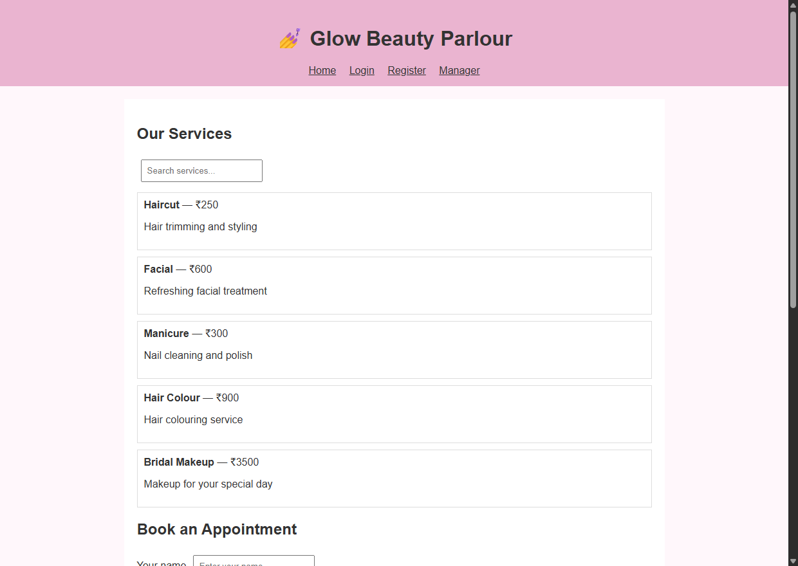
Figure 6.1: Chrome DOM Rendering of Parlour Catalog & Booking Form (index.html)
Output Observation: Displays the client-facing homepage featuring salon branding, interactive service price cards, real-time search filters, and the conflict-checked booking form.
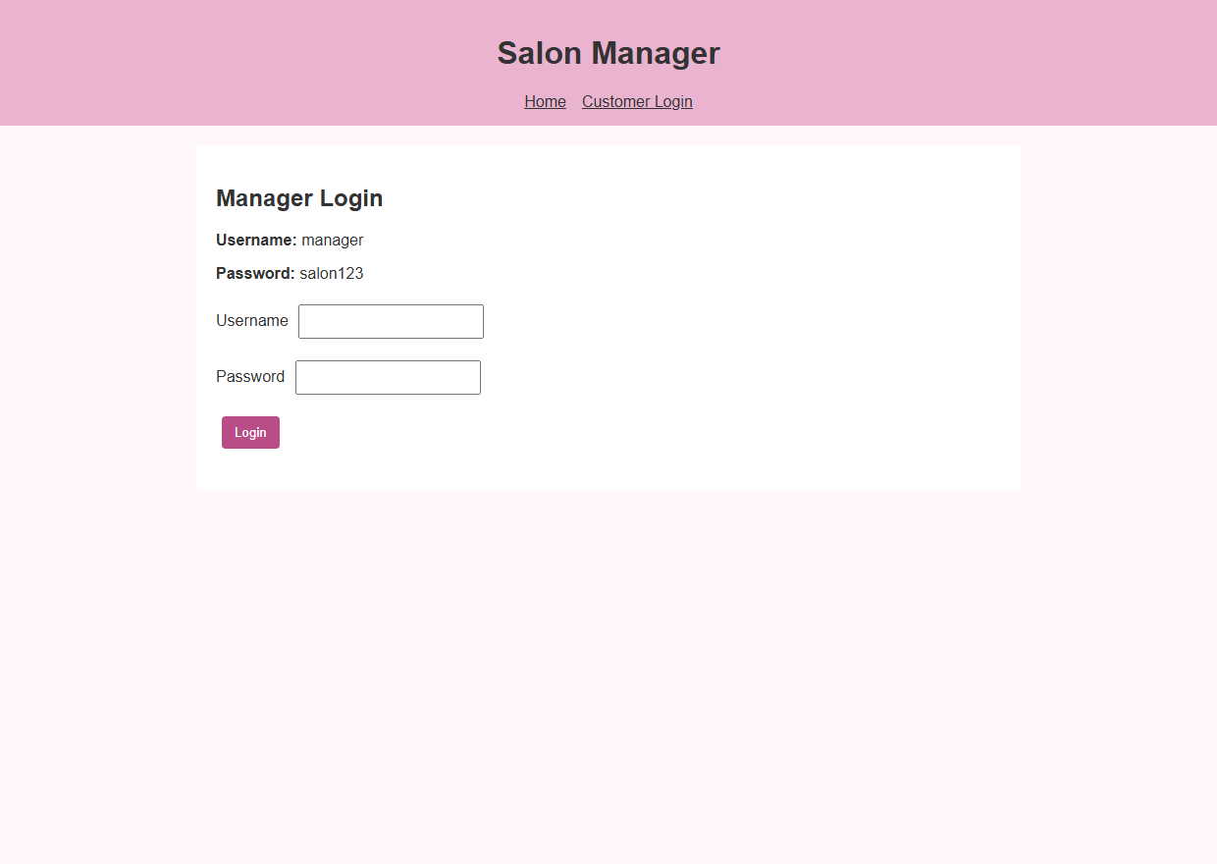
Figure 6.2: Salon Manager Dashboard & Slot Reservation Management (admin.html)
Output Observation: Shows the manager console rendering the live appointment table with controls to complete bookings, cancel appointments, and lock specific stylist time slots.
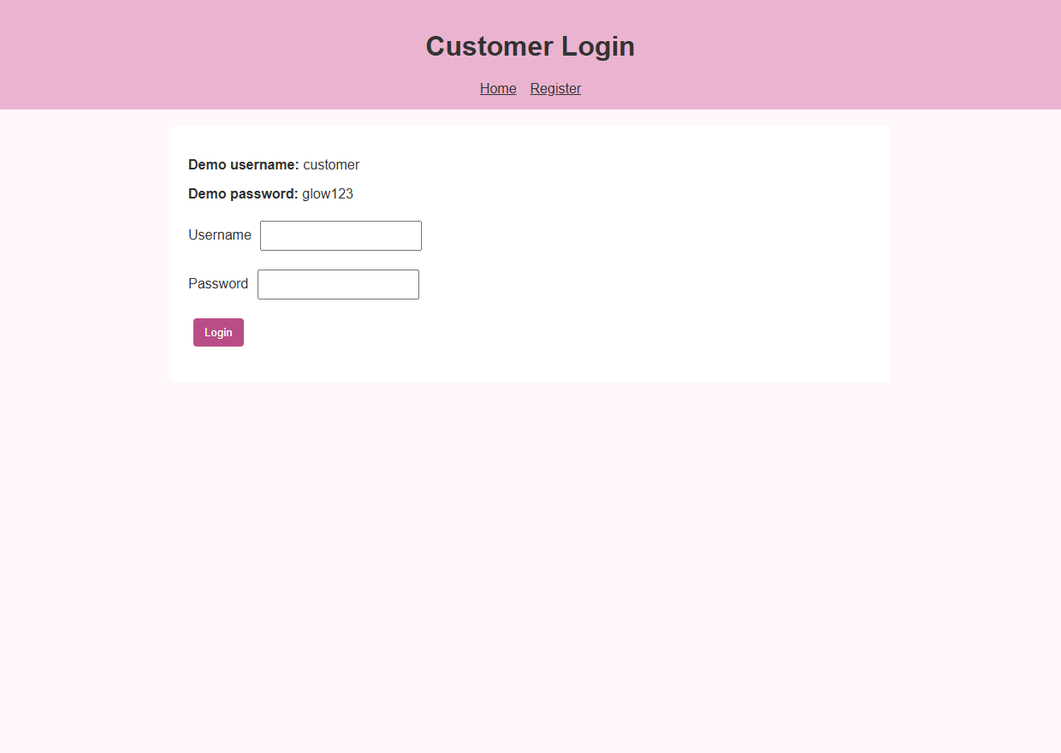
Figure 6.3: Customer & Salon Manager Authentication Interface (login.html)
Output Observation: Presents the dual login portal supporting secure authentication for registered clients and salon managers.
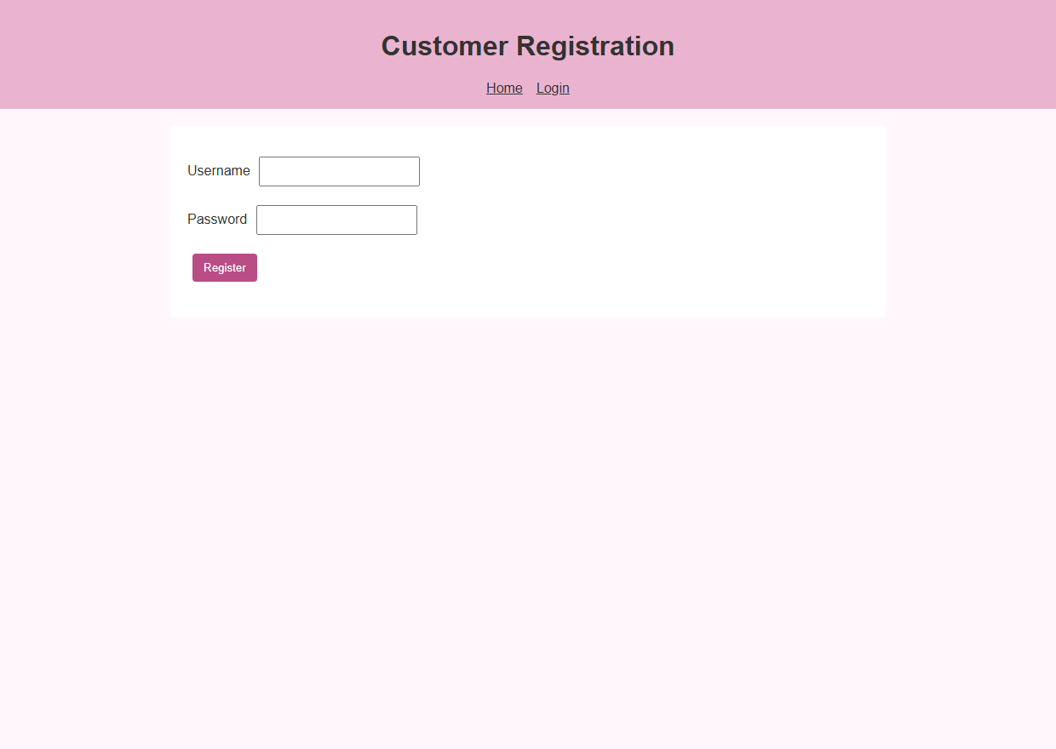
Figure 6.4: New Client Registration Interface (register.html)
Output Observation: Illustrates the customer registration screen equipped with client-side form validation before storing profiles.
7. RESULT
EXPERIMENT CONCLUSION / RESULT:
The Beauty Parlour Appointment Booking Web Application was successfully created and validated using HTML5, CSS3, and JavaScript within the Google Chrome DOM environment. All features—including service discovery, conflict-free stylist scheduling, self-service cancellation, and manager slot locking—functioned accurately with client-side LocalStorage data persistence.

