DEPARTMENT OF COMPUTER SCIENCE & ENGINEERING
INTERNET PROGRAMMING LABORATORY RECORD
BUY A CAKE - ONLINE BAKERY & ORDERING SYSTEM
AYUSH MOHAPATRA 192411263

1. AIM
To design and develop an Online Bakery and Cake Ordering Web Application ('Buy a Cake') using HTML5, CSS3, and JavaScript, enabling customers to search and filter cakes by category, manage an interactive shopping cart with automated total calculation, place delivery orders with shipping details, and provide store administrators with inventory CRUD controls and order fulfillment tracking via DOM manipulation and browser LocalStorage.
2. SYSTEM SPECIFICATIONS & REQUIREMENTS
The project is implemented as a lightweight, database-free web application executing in the Chromium DOM engine with persistent Web Storage.
Category | Specification / Tool | Details / Role
Hardware Requirements | Processor | Intel Core i5 / AMD Ryzen 5 or higher
Hardware Requirements | Memory (RAM) | 8 GB DDR4 RAM or higher
Hardware Requirements | Display | 1920x1080 Full HD Monitor
Software Requirements | Operating System | Microsoft Windows 10 / Windows 11 (64-bit)
Software Requirements | Execution Engine | Google Chrome / Chromium DOM Engine
Software Requirements | Code Editor | Visual Studio Code / Integrated Development Environment
Frontend Technologies | Markup Language | HTML5 (Semantic Elements, Form Controls, Tables)
Frontend Technologies | Styling Language | CSS3 (Flexbox, Grid, Responsive Media Queries)
Frontend Technologies | Scripting & DOM | JavaScript (ES6+, DOM API, Event Listeners)
Client-Side Storage | Web Storage API | Browser LocalStorage for persistent client data

3. ALGORITHM
The systematic procedure for creating and running the Buy a Cake ordering application is described below:
Step 1: Application Layout Formulation - Construct semantic HTML5 documents (index.html, admin.html, login.html, register.html) establishing header brand navigation, category filter dropdowns, search inputs, cake card containers, shopping cart displays, and order history tables.
Step 2: Bakery Theme & Responsive Styling - Implement CSS styling (style.css) utilizing soft pink hues (#e64980), warm cream backgrounds, rounded product cards, price badges, and responsive flex/grid layouts.
Step 3: Initial Inventory & Data Setup - In JavaScript (app.js), declare default bakery items (Chocolate Cake, Birthday Cake, Strawberry Cake, Red Velvet) with prices (₹) and category tags; store in localStorage['cakes'] if absent.
Step 4: Dynamic Search & Category Filtering - Bind input and change event listeners to search inputs and category dropdowns; filter cake arrays in real-time and trigger showCakes() to dynamically redraw DOM product cards.
Step 5: Shopping Cart Interaction & Price Calculation - On clicking 'Add to Cart', locate product details by name; push item to in-memory cart array; recalculate total bill amount (₹); dynamically update cart count and itemized list in the DOM.
Step 6: Checkout & Order Placement Engine - When 'Place Order' is clicked, validate that cart contains items; prompt customer for delivery address; generate unique Order ID (e.g., ORD-7012); serialize order record to localStorage['orders']; reset cart.
Step 7: Customer Order History Rendering - Retrieve saved orders from localStorage; dynamically construct order history cards showing order IDs, item names, bill totals, and current status badges.
Step 8: Administrator Inventory Management (admin.html) - Authenticate administrator credentials (admin@cake.test / admin123); render the product catalog in an editable table; enable adding new cake products (name, category, price) and deleting items.
Step 9: Order Status Fulfillment Workflow - Render customer orders in the admin table; provide controls to update order status ('Pending' -> 'Baking' -> 'Delivered') which reflects immediately in the customer portal.
Step 10: Chrome DOM Validation & End-to-End Verification - Test catalog filtering, cart additions, dynamic totals, order placement, and admin status updates within the Google Chrome DOM environment.
4. SYSTEM ARCHITECTURE & MODULE DESCRIPTION
The application is structured into interconnected client-side modules:
File Name | Module Name | Functional Role
index.html | Storefront Portal | Cake catalog, category search, dynamic shopping cart, order placement, history
admin.html | Admin Dashboard | Inventory management, add/delete cake products, order fulfillment status
login.html | User & Admin Login | Authentication gateway supporting student demo and admin accounts
register.html | Registration Form | New customer registration interface with input validation
css/style.css | Bakery Styling | Pink bakery theme, product grid styling, cart badge, and checkout modal
js/app.js | Storefront Engine | Catalog rendering, category filtering, cart math, and order submission
js/admin.js | Admin Logic | Product CRUD operations and order fulfillment state transitions
js/auth.js | Auth Handler | Credential authentication and session storage management

5. KEY SOURCE CODE HIGHLIGHTS
HTML Layout: Catalog Search & Shopping Cart (index.html)
<section class="card">
<h2>Available Cakes</h2>
<div class="filters">
<input type="text" id="search" placeholder="Search cakes..." oninput="showCakes()">
<select id="category" onchange="showCakes()">
<option value="">All Categories</option>
<option value="Chocolate">Chocolate</option>
<option value="Birthday">Birthday</option>
<option value="Fruit">Fruit</option>
</select>
</div>
<div id="cakeList"></div>
</section>
<section class="card">
<h2>My Cart</h2>
<div id="cartItems"><p>Cart is empty.</p></div>
<p><strong>Total: ₹<span id="cartTotal">0</span></strong></p>
<button onclick="placeOrder()">Place Order</button>
</section>

JavaScript: Dynamic Catalog & Shopping Cart Logic (js/app.js)
let cakes = JSON.parse(localStorage.getItem("cakes") || "null") || [
{ name: "Chocolate Cake", category: "Chocolate", price: 500 },
{ name: "Birthday Cake", category: "Birthday", price: 700 },
{ name: "Strawberry Cake", category: "Fruit", price: 450 }
];
let cart = [];
function showCakes() {
const search = (document.getElementById("search").value || "").toLowerCase();
const category = document.getElementById("category").value;
const list = cakes.filter(c =>
(!search || c.name.toLowerCase().includes(search)) &&
(!category || c.category === category)
);
document.getElementById("cakeList").innerHTML = list.map(c => `
<div class="cake-item">
<span><strong>${c.name}</strong> - ${c.category} - ₹${c.price}</span>
<button onclick="addToCart('${c.name}')">Add to Cart</button>
</div>
`).join("");
}
function addToCart(name) {
const cake = cakes.find(c => c.name === name);
if (cake) {
cart.push(cake);
renderCart();
}
}
function renderCart() {
const total = cart.reduce((sum, item) => sum + item.price, 0);
document.getElementById("cartTotal").textContent = total;
document.getElementById("cartItems").innerHTML = cart.length === 0
? "<p>Cart is empty.</p>"
: cart.map((item, idx) => `<div>${item.name} - ₹${item.price}</div>`).join("");
}

6. CHROME DOM OUTPUT & SCREENSHOT VERIFICATION
The Buy a Cake web application was loaded and tested inside Google Chrome DOM. The figures below illustrate the rendered frontend interface, shopping cart interactions, and administrative screens.
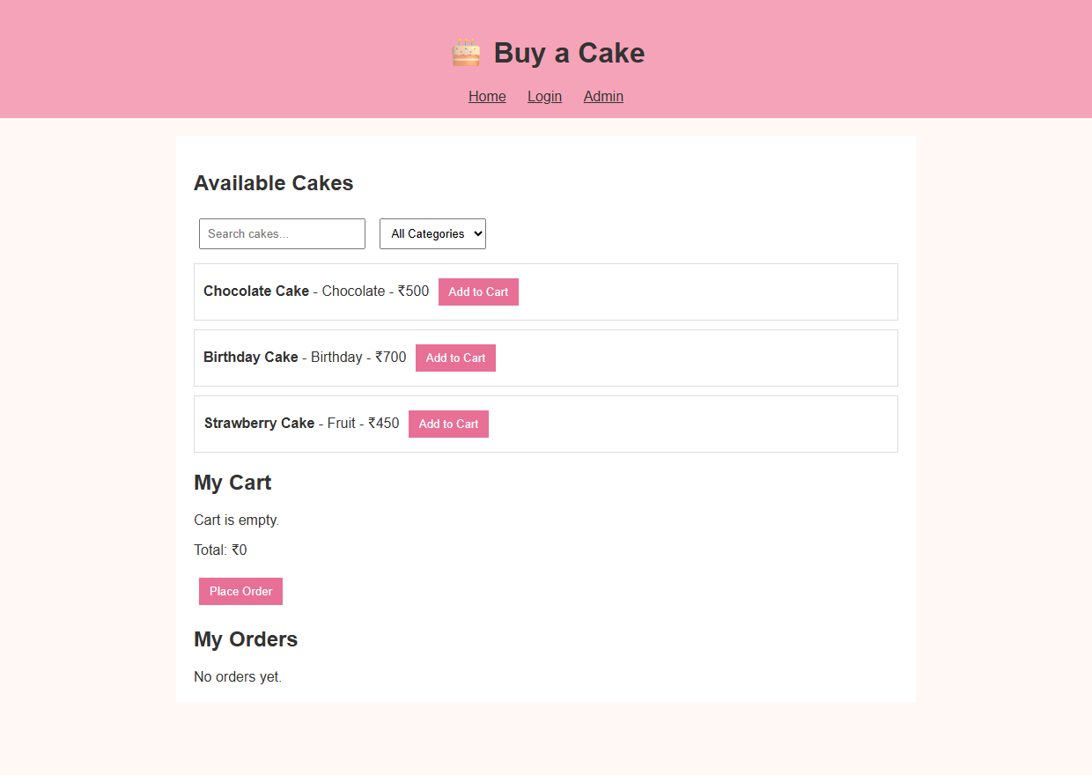
Figure 6.1: Chrome DOM Rendering of Cake Storefront & Shopping Cart (index.html)
Output Observation: Shows the online bakery storefront featuring cake search, category dropdowns, dynamically rendered cake listings with pricing, and the interactive shopping cart.
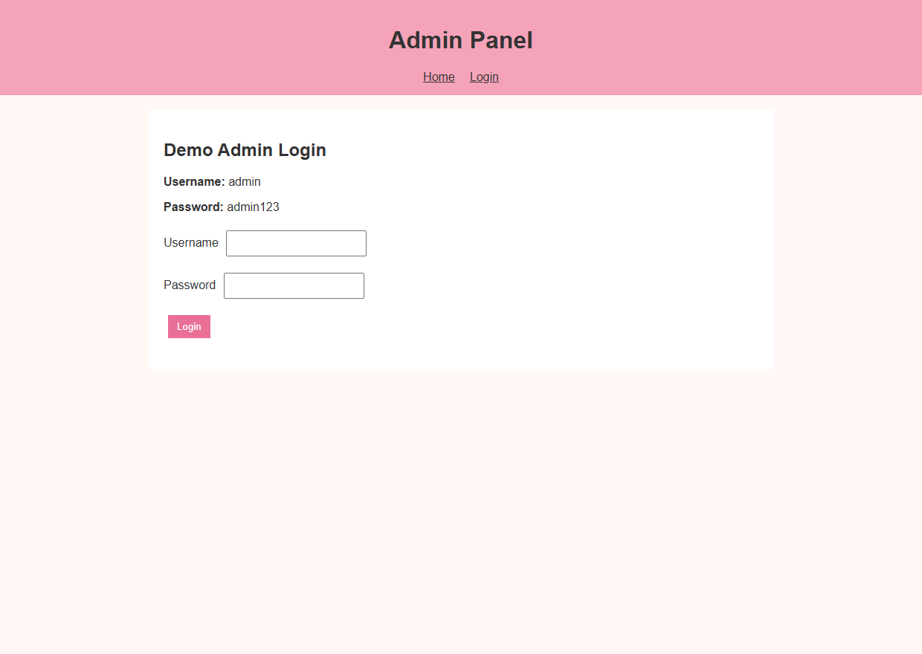
Figure 6.2: Bakery Administrator Inventory & Order Management (admin.html)
Output Observation: Illustrates the administrative console enabling staff to manage product inventories, add/delete cake items, and track placed customer orders.
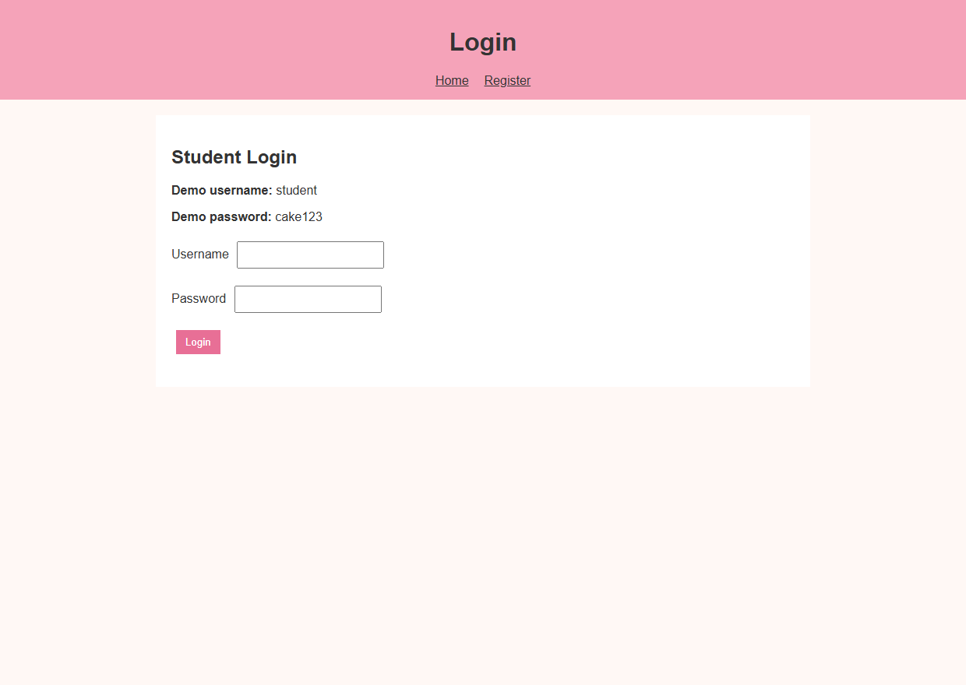
Figure 6.3: User & Administrator Authentication Interface (login.html)
Output Observation: Displays the login screen allowing customers and demo administrators to log in using verified credentials.
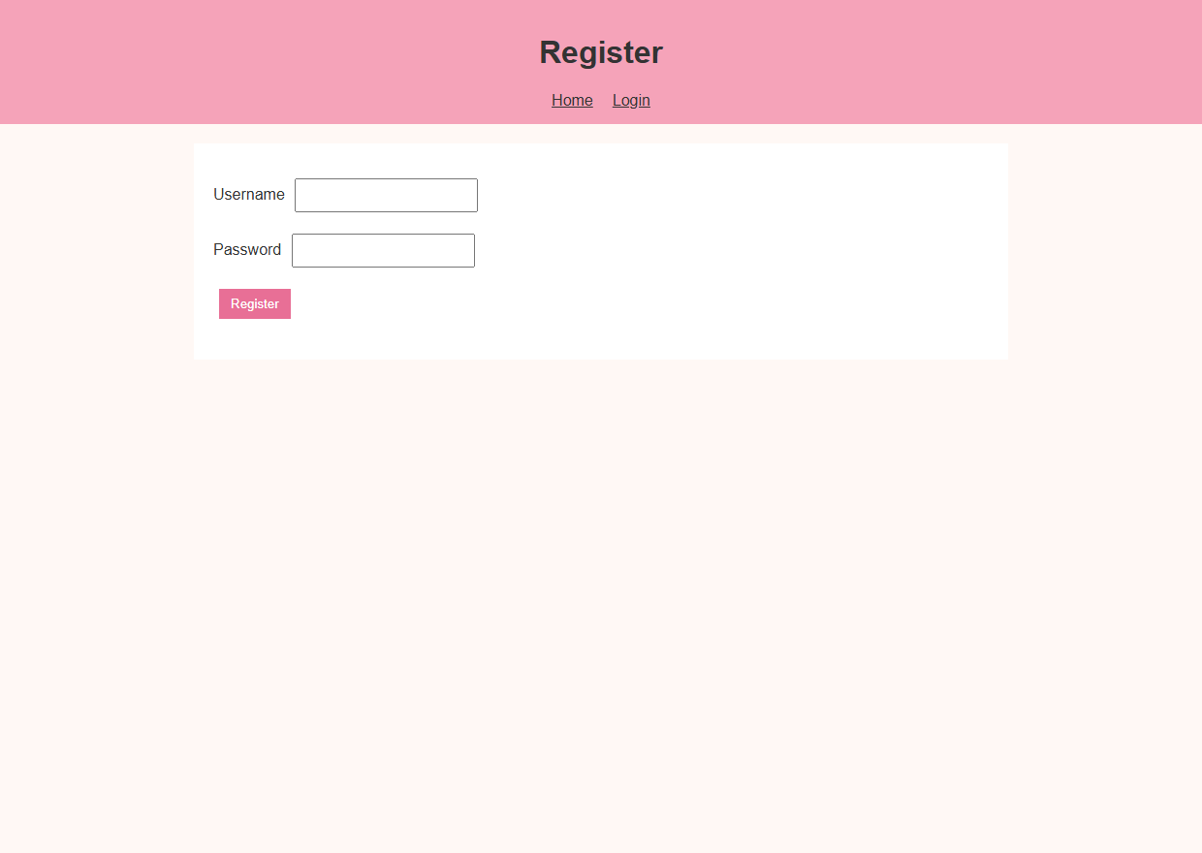
Figure 6.4: Customer Registration Interface (register.html)
Output Observation: Presents the new user sign-up form validating client-side credentials before storing user profiles in localStorage.
7. RESULT
EXPERIMENT CONCLUSION / RESULT:
The Buy a Cake Online Bakery and Ordering Web Application was successfully created, executed, and verified within the Google Chrome DOM environment using HTML5, CSS3, and JavaScript. Real-time product filtering, dynamic cart calculation, order placement, and administrator inventory management operated seamlessly with browser LocalStorage data persistence.

