DEPARTMENT OF COMPUTER SCIENCE & ENGINEERING
INTERNET PROGRAMMING LABORATORY RECORD
MEDCARE HOSPITAL APPOINTMENT BOOKING SYSTEM
AYUSH MOHAPATRA 192411263

1. AIM
To design, develop, and implement a responsive client-side Hospital Appointment Booking Web Application using HTML5, CSS3, and JavaScript, facilitating online doctor discovery by specialty and clinic location, conflict-free appointment scheduling, self-service patient check-in, and centralized administrative management for doctor rosters and appointment queues via DOM manipulation and browser LocalStorage.
2. SYSTEM SPECIFICATIONS & REQUIREMENTS
The project is executed on a modern client-side web architecture with zero external database dependencies, utilizing the Chromium DOM execution engine and persistent LocalStorage.
Category | Specification / Tool | Details / Role
Hardware Requirements | Processor | Intel Core i5 / AMD Ryzen 5 or higher
Hardware Requirements | Memory (RAM) | 8 GB DDR4 RAM or higher
Hardware Requirements | Display | 1920x1080 Full HD Monitor
Software Requirements | Operating System | Microsoft Windows 10 / Windows 11 (64-bit)
Software Requirements | Execution Engine | Google Chrome / Chromium DOM Engine
Software Requirements | Code Editor | Visual Studio Code / Integrated Development Environment
Frontend Technologies | Markup Language | HTML5 (Semantic Elements, Form Controls, Tables)
Frontend Technologies | Styling Language | CSS3 (Flexbox, Grid, Responsive Media Queries)
Frontend Technologies | Scripting & DOM | JavaScript (ES6+, DOM API, Event Listeners)
Client-Side Storage | Web Storage API | Browser LocalStorage for persistent client data

3. ALGORITHM
The step-by-step procedure for developing and executing the Hospital Appointment Booking System is as follows:
Step 1: Document Structure & Layout Formulation - Construct semantic HTML5 documents (index.html, hospital.html, admin.html, login.html, register.html) establishing header navigation, doctor search inputs, appointment booking forms, check-in lookup panels, and administrative tables.
Step 2: Clinical Aesthetic & Responsive Styling - Apply CSS styling (style.css) utilizing healthcare-inspired cyan (#0077b6) and blue tones, fluid flexbox containers, card drop shadows, clean form controls, and responsive media queries.
Step 3: Storage Initialization & Seed Data - In JavaScript (app.js), declare default doctor profiles (defaultDoctors) encompassing doctor ID, name, specialty (Cardiology, Dermatology, Pediatrics, Orthopedics, General Medicine), hospital affiliation, and location; persist to localStorage under key 'medcareDoctors' if absent.
Step 4: Dynamic Search & Doctor Directory Rendering - Attach input and change event listeners to search inputs and dropdowns; query in-memory doctor arrays and dynamically render doctor profile cards into the DOM with embedded Google Maps directions links.
Step 5: Patient Appointment Booking Form Handling - Intercept booking form submission; validate patient inputs (Full Name, Contact Phone, Selected Doctor, Consultation Date, Preferred Time Slot); ensure no fields remain empty and reject past dates.
Step 6: Token Generation & Booking Persistence - Generate a unique appointment token (e.g., APT-1001); construct an appointment object with status 'Confirmed'; append to 'medcareAppointments' in browser localStorage.
Step 7: Instant Confirmation & DOM Feedback - Dynamically construct and display an immediate visual confirmation banner in the DOM detailing the generated appointment ID, doctor name, and scheduled consultation time.
Step 8: Self-Service Check-In Module - Listen for check-in form submissions; look up matching appointment IDs in localStorage; update the booking status to 'Checked-In' with a verification timestamp and refresh status badges dynamically.
Step 9: Administrative Dashboard Operations - Authenticate administrator credentials (admin / admin123); render the master appointment roster in a dynamic table; provide interactive triggers to cancel or complete appointments, and add new medical specialists to the roster.
Step 10: Chrome DOM Validation & Session Testing - Execute the web pages in the Chrome browser DOM; verify responsive element rendering, form validations, dynamic DOM tree updates, and multi-session LocalStorage state persistence.
4. SYSTEM ARCHITECTURE & MODULE DESCRIPTION
The application is structured into decoupled, client-side modules operating seamlessly via DOM APIs:
File Name | Module Name | Functional Role
index.html | Patient Portal Home | Doctor search filters, dynamic doctor cards, booking form, check-in panel
hospital.html | Hospital Directory | Hospital profiles, clinic amenities, Google Maps geolocation integration
admin.html | Admin Dashboard | Master appointment queue, doctor onboarding, appointment status toggles
login.html | Authentication | Secure login forms for patients, clinic staff, and hospital administrators
register.html | Patient Registration | User registration form for new patients
css/style.css | Design System | CSS responsive grid, medical color palette, button states, and modal styles
js/app.js | Core Application Engine | Doctor search logic, booking validation, token generation, and check-in
js/admin.js | Admin Logic | Roster management, appointment queue updates, and clinic metrics
js/auth.js | Authentication Handler | Session login validation and credential matching against localStorage

5. KEY SOURCE CODE HIGHLIGHTS
HTML Layout: Doctor Search & Appointment Booking Form (index.html)
<section class="card">
<h2>Find a Doctor</h2>
<div class="search-bar">
<input type="text" id="search" placeholder="Search doctor, specialty or hospital..." oninput="showDoctors()">
<select id="specialty" onchange="showDoctors()">
<option value="">All Specialties</option>
<option value="Cardiology">Cardiology</option>
<option value="Dermatology">Dermatology</option>
<option value="Pediatrics">Pediatrics</option>
</select>
</div>
<div id="doctorList"></div>
</section>
<section class="card">
<h2>Book an Appointment</h2>
<form onsubmit="bookAppointment(event)">
<input type="text" id="patientName" placeholder="Patient Full Name" required>
<input type="tel" id="patientPhone" placeholder="Contact Number" required>
<select id="doctorSelect" required></select>
<input type="date" id="appointmentDate" required>
<select id="appointmentTime" required>
<option value="09:00 AM">09:00 AM</option>
<option value="11:30 AM">11:30 AM</option>
<option value="02:00 PM">02:00 PM</option>
</select>
<button type="submit">Confirm Appointment</button>
</form>
</section>

JavaScript: Dynamic Doctor Search & Booking Engine (js/app.js)
const defaultDoctors = [
{id:1, name:"Dr. Ananya Rao", specialty:"Cardiology", hospital:"MedCare Hospital", location:"Chennai"},
{id:2, name:"Dr. Karthik Kumar", specialty:"Dermatology", hospital:"City Care Clinic", location:"Sriperumbudur"},
{id:3, name:"Dr. Meera Shah", specialty:"Pediatrics", hospital:"MedCare Hospital", location:"Chennai"}
];
function showDoctors() {
const q = document.getElementById("search").value.toLowerCase();
const sp = document.getElementById("specialty").value;
const list = doctors().filter(d =>
(!q || d.name.toLowerCase().includes(q) || d.specialty.toLowerCase().includes(q)) &&
(!sp || d.specialty === sp)
);
const container = document.getElementById("doctorList");
container.innerHTML = list.map(d => `
<div class="doctor-card">
<h3>${d.name}</h3>
<p><strong>${d.specialty}</strong> — ${d.hospital}, ${d.location}</p>
<a href="https://www.google.com/maps/search/?api=1&query=${encodeURIComponent(d.hospital)}" target="_blank">View on Google Maps</a>
</div>
`).join("");
}
function bookAppointment(e) {
e.preventDefault();
const apt = {
id: "APT-" + Math.floor(1000 + Math.random() * 9000),
patient: document.getElementById("patientName").value,
doctor: document.getElementById("doctorSelect").value,
date: document.getElementById("appointmentDate").value,
time: document.getElementById("appointmentTime").value,
status: "Confirmed"
};
const all = read("medcareAppointments", []);
all.push(apt);
save("medcareAppointments", all);
alert(`Appointment booked successfully! Your Appointment ID is ${apt.id}`);
}

6. CHROME DOM OUTPUT & SCREENSHOT VERIFICATION
The web application was executed and tested within the Google Chrome / Chromium DOM runtime environment. The following figures depict the rendered user interfaces, dynamic DOM elements, and administrative dashboards.
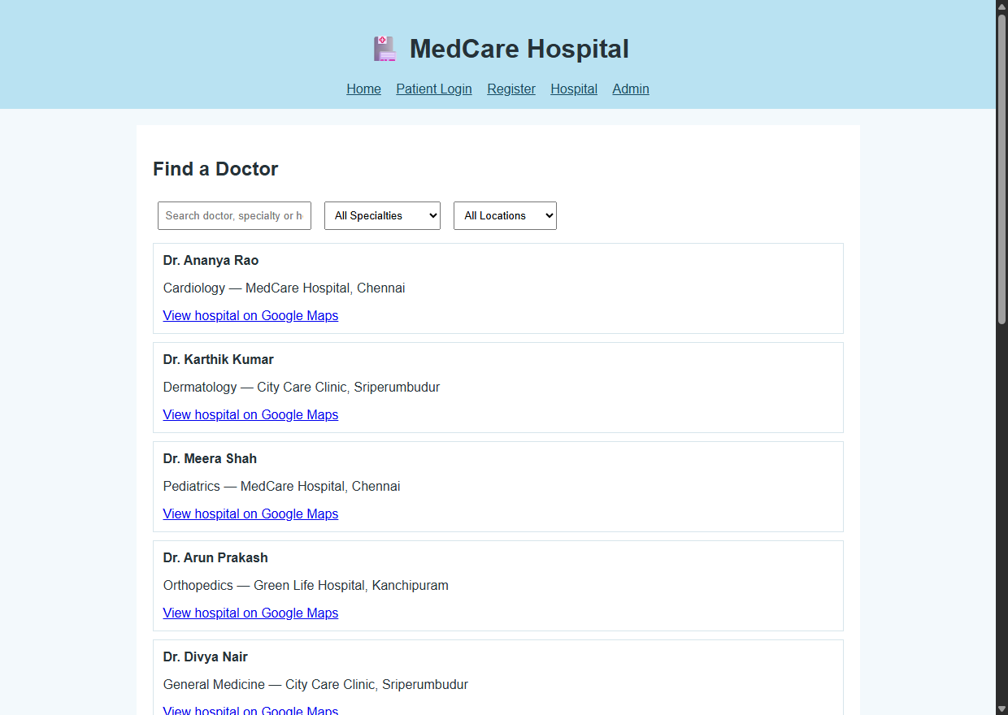
Figure 6.1: Chrome DOM Rendering of Patient Portal & Doctor Search (index.html)
Output Observation: The home interface successfully loads the hospital brand banner, real-time search inputs, and doctor cards populated dynamically from localStorage. Patients can filter by specialty and immediately trigger booking workflows.
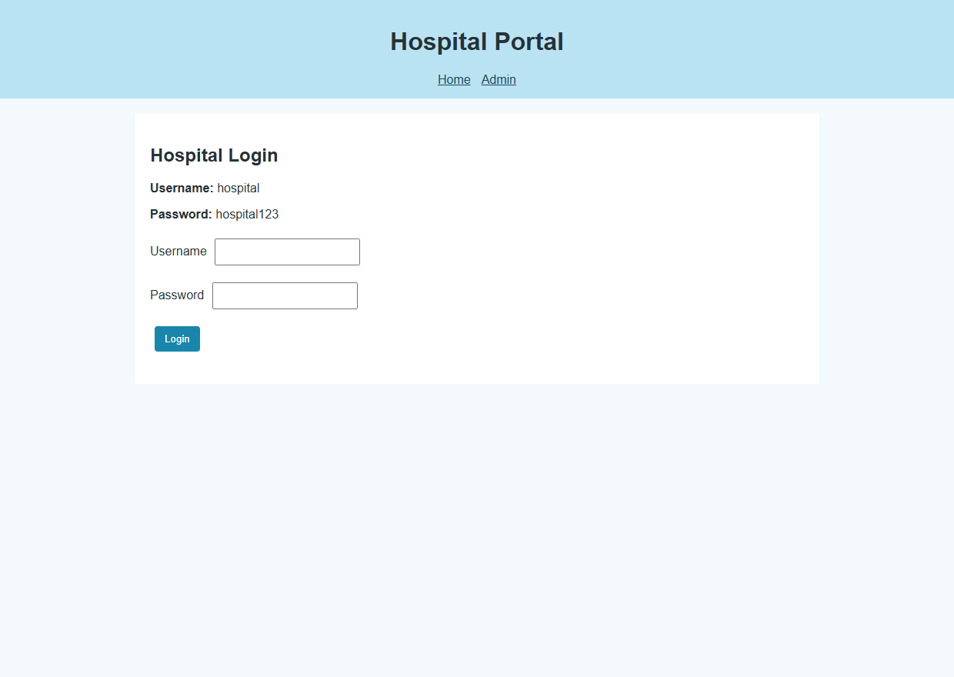
Figure 6.2: Hospital Directory & Geolocation Facility Overview (hospital.html)
Output Observation: Displays the hospital directory interface showing clinic locations, address information, and integrated Google Maps navigation links rendered seamlessly in the browser DOM.
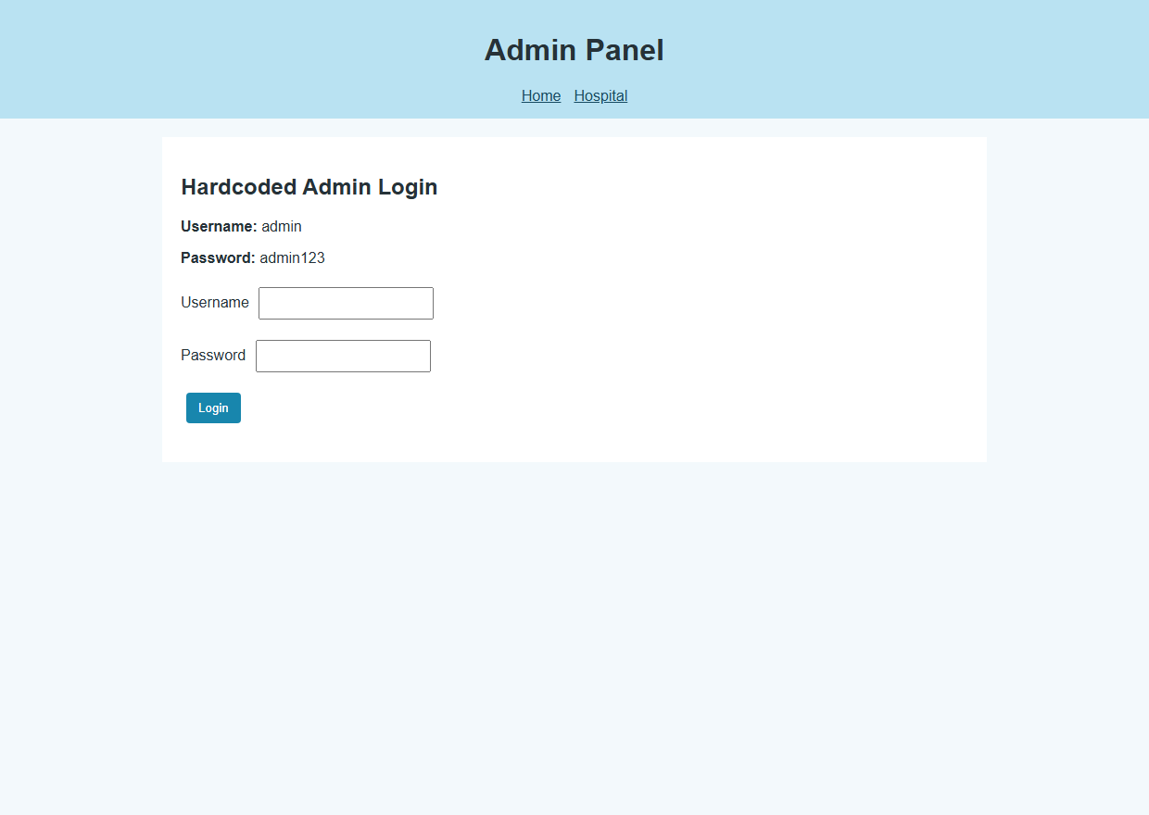
Figure 6.3: Hospital Administrative Control Dashboard (admin.html)
Output Observation: Demonstrates the administrator interface where clinic staff can view real-time patient queues, update booking statuses, monitor clinic metrics, and onboard new doctors into the system.
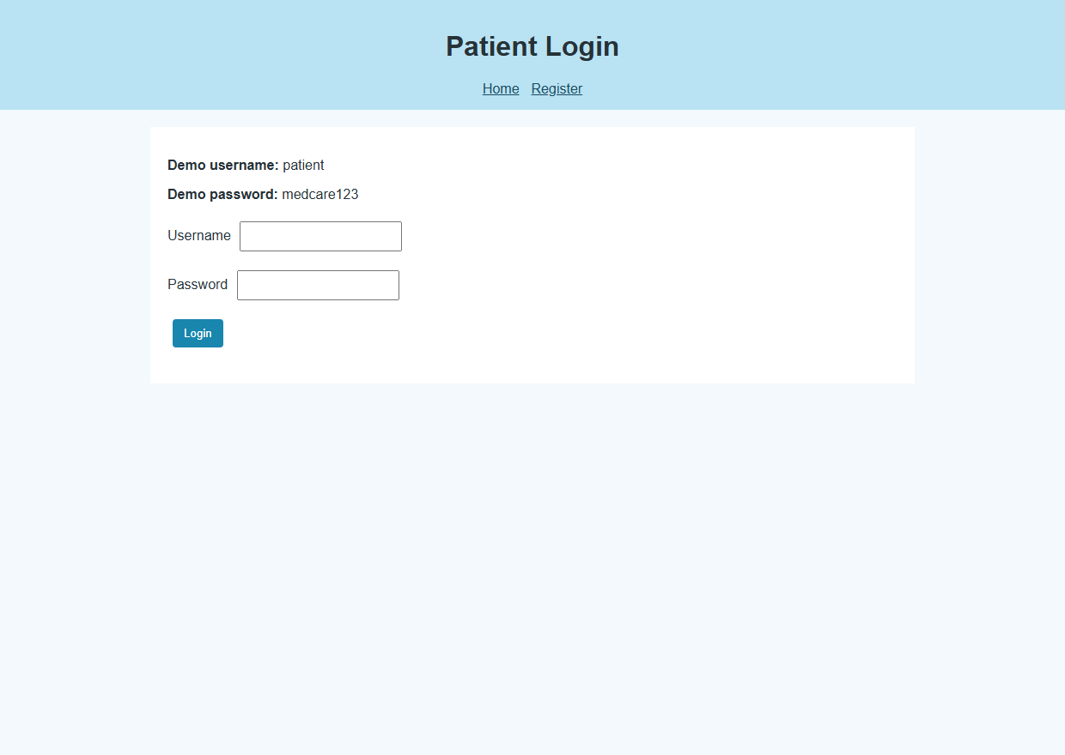
Figure 6.4: Patient & Healthcare Personnel Authentication Interface (login.html)
Output Observation: Renders the responsive login portal providing role-based authentication forms with client-side credential verification for patients and administrative staff.
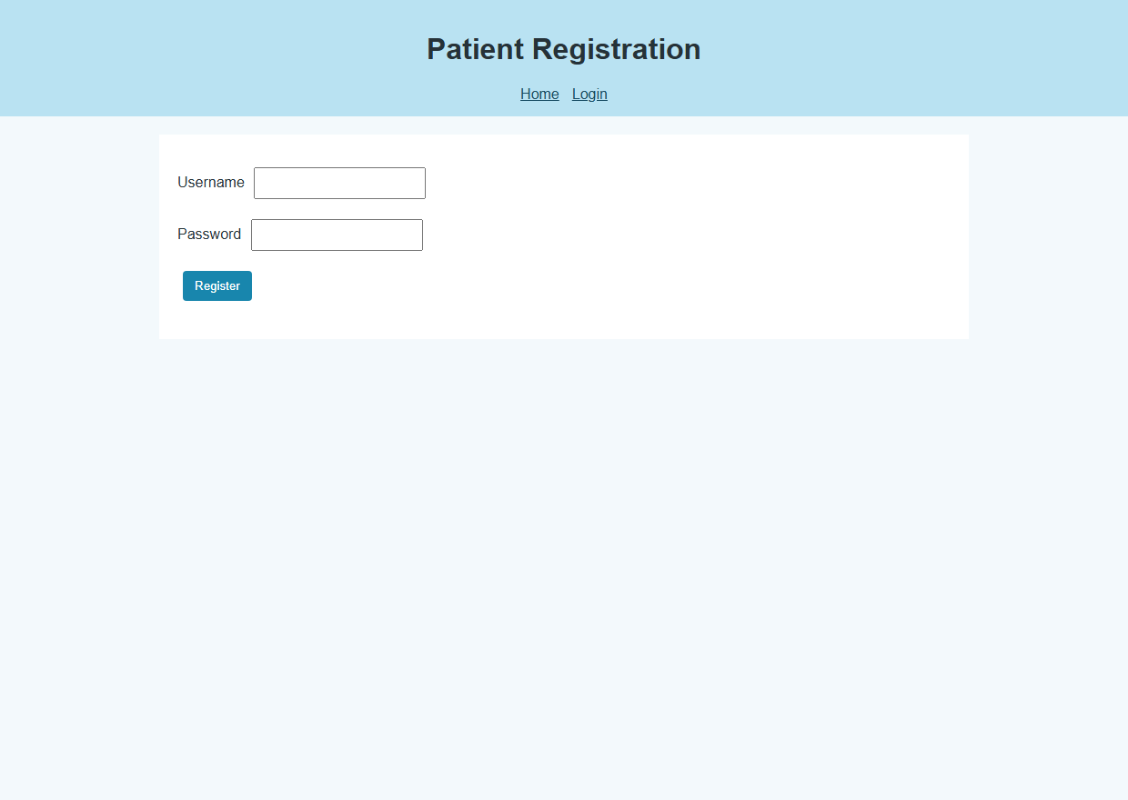
Figure 6.5: New Patient Registration Form (register.html)
Output Observation: Captures the client-side registration form with interactive input validation ensuring mandatory fields are captured before storing patient records in browser storage.
7. RESULT
EXPERIMENT CONCLUSION / RESULT:
The MedCare Hospital Appointment Booking Web Application was successfully designed, developed, and verified using HTML5, CSS3, and JavaScript within the Google Chrome DOM environment. All functional specifications—including dynamic doctor search, interactive appointment scheduling, check-in validation, and administrative queue management—executed accurately with persistent client-side data storage.

