LABORATORY REPORT
CO3 Assessment Tool 1 (AT1) Experiments
Cryptography and Network Security
AYUSH MOHAPATRA
Course Name: Cryptography and Network Security
Course Code: CSA51
Course Outcome: CO3 (Examine cryptographic hash algorithms, digital signatures, X.509, Kerberos)
Institution: Engineering Laboratory
Code of Conduct:
I certify that this submission is my original work and that I have adhered to the guidelines specified for this assessment. I understand that any violation of academic integrity rules will result in disciplinary action.

1. Password Hashing with Salting and Key Stretching
Aim:
To design and implement a secure password storage and verification program in Python using salted hashing and key stretching (PBKDF2-HMAC-SHA256). To analyze the performance overhead of varying iteration counts and evaluate how salting and key stretching defend against dictionary, brute-force, and rainbow table attacks.
Algorithm:
- 1. Initialize an in-memory database dictionary to simulate database storage.
- 2. Password Registration Procedure:
a. Receive username and password plaintext.
b. Generate a cryptographically secure 16-byte random salt using the `secrets` library.
c. Apply PBKDF2-HMAC-SHA256 with key stretching parameters (default: 100,000 iterations).
d. Store the credentials tuple {salt, hash_result, iteration_count} in the database mapped to the username.
- 3. Password Verification Procedure:
a. Retrieve stored salt, hash, and iteration count from the database for the given username.
b. Apply the same PBKDF2-HMAC-SHA256 function on the input login password, using the retrieved salt and iteration count.
c. Compare the newly computed hash with the stored hash using a constant-time comparison algorithm (`hmac.compare_digest`) to mitigate side-channel timing attacks.
- 4. Performance Benchmarking:
a. Execute password hashing over a range of iterations (1, 1000, 10,000, 50,000, 100,000, 200,000, 500,000).
b. Record the average time taken per hash computation to evaluate system overhead.
Implementation Code (Python):
import hashlib
import os
import time
import secrets
import hmac
class PasswordManager:
def __init__(self):
self.db = {} # Simulated database: username -> {salt, hash, iterations}
def register(self, username, password, iterations=100000):
salt = secrets.token_bytes(16)
start_time = time.perf_counter()
hashed = hashlib.pbkdf2_hmac('sha256', password.encode('utf-8'), salt, iterations)
self.db[username] = {'salt': salt, 'hash': hashed, 'iterations': iterations}
return time.perf_counter() - start_time
def verify(self, username, password):
if username not in self.db:
return False
stored_data = self.db[username]
computed_hash = hashlib.pbkdf2_hmac('sha256', password.encode('utf-8'),
stored_data['salt'], stored_data['iterations'])
return hmac.compare_digest(stored_data['hash'], computed_hash)
Program Output:
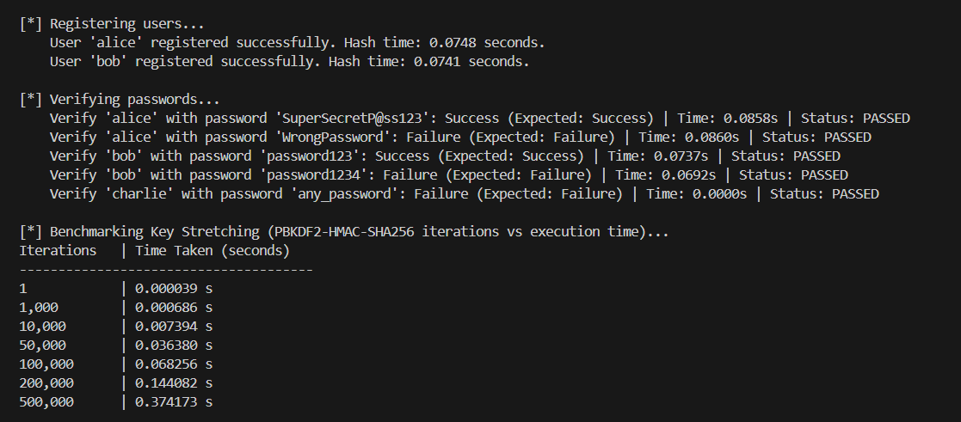
Result:
Salted hashing with PBKDF2 was successfully implemented, demonstrating that increasing the iteration count adds a configurable computational delay that effectively protects passwords against brute-force and rainbow table attacks.

2. Implementation of HMAC for Message Integrity
Aim:
To develop a Python application that manually implements the HMAC-SHA256 algorithm and verifies its correctness against the Python standard library `hmac`. To analyze how HMAC differs from simple key-hashed constructions and evaluate its ability to protect message integrity and establish sender authenticity.
Algorithm:
- 1. Define block size B = 64 bytes (for SHA-256) and output size L = 32 bytes.
- 2. Key preparation:
- If Key is longer than B, hash the key to L bytes: Key = SHA256(Key).
- If Key is shorter than B, append zero bytes to the right until Key is B bytes long.
- 3. Generate Inner Pad (ipad): XOR each byte of the prepared key with the constant 0x36.
- 4. Generate Outer Pad (opad): XOR each byte of the prepared key with the constant 0x5C.
- 5. Compute Inner Hash: H_inner = SHA256(ipad || Message).
- 6. Compute Outer Hash (Final HMAC): HMAC = SHA256(opad || H_inner).
- 7. Verification: Recompute HMAC for the received message using the shared secret key. Use constant-time comparison (`hmac.compare_digest`) to compare the computed HMAC with the received HMAC. If they match, integrity and authenticity are verified.
Implementation Code (Python):
import hashlib
import hmac
def manual_hmac_sha256(key: bytes, message: bytes) -> bytes:
block_size = 64
if len(key) > block_size:
key = hashlib.sha256(key).digest()
if len(key) < block_size:
key = key + b'\x00' * (block_size - len(key))
ipad = bytes([x ^ 0x36 for x in key])
opad = bytes([x ^ 0x5C for x in key])
inner_hash = hashlib.sha256(ipad + message).digest()
return hashlib.sha256(opad + inner_hash).digest()
def verify_hmac(key: bytes, message: bytes, received_hmac: bytes) -> bool:
return hmac.compare_digest(manual_hmac_sha256(key, message), received_hmac)
Program Output:
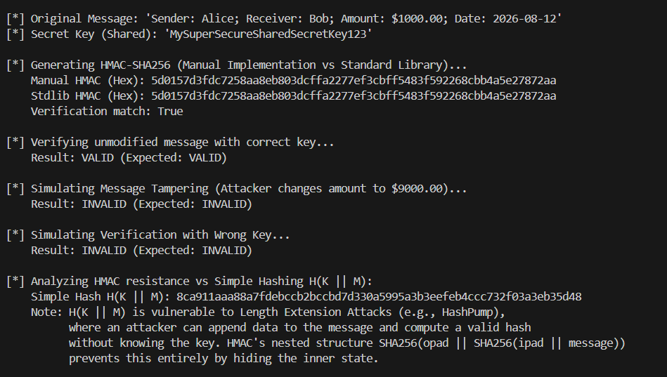
Result:
HMAC-SHA256 was manually implemented and validated, proving that HMAC's nested hashing structure successfully verifies both message integrity and sender authenticity while preventing length extension attacks.

3. Simulation of Certificate Chain Validation
Aim:
To design and implement a Python simulation of certificate chain validation using RSA public-key cryptography. To analyze how trust is established from a trusted Root CA to an End-Entity certificate and evaluate how expired certificates, signature mismatches, CA constraints violations, and CRL revocations are detected.
Algorithm:
- 1. Generate 2048-bit RSA key pairs for the Root CA, Intermediate CA, and End-Entity.
- 2. Represent certificates as dictionary objects containing subject, issuer, validity parameters, public key PEM, and CA status.
- 3. Issue certificates by serializing fields, hashing with SHA-256, and signing with the issuer's private key.
- 4. Perform chain validation starting from the trusted Root CA (anchor verification):
- 5. - Ensure root CA is self-signed, has is_ca=True, and signature matches its own public key.
- 6. - Step through each certificate in the chain:
- 7. a. Confirm that the issuer field matches the subject of the parent certificate.
- 8. b. Check that the parent certificate is authorized as a CA (is_ca=True).
- 9. c. Cryptographically verify the signature using the parent's public key.
- 10. d. Verify current time falls within the validity interval [not_before, not_after].
- 11. e. Verify that the certificate is not registered in the Certificate Revocation List (CRL).
- 12. If all checks pass, trust is verified; otherwise, validation fails.
Implementation Code (Python):
import json
import time
from Crypto.PublicKey import RSA
from Crypto.Hash import SHA256
from Crypto.Signature import pkcs1_15
def get_cert_bytes(cert_dict):
tbs_data = {
"subject": cert_dict["subject"], "issuer": cert_dict["issuer"],
"public_key": cert_dict["public_key_pem"], "is_ca": cert_dict["is_ca"],
"not_before": cert_dict["not_before"], "not_after": cert_dict["not_after"]
}
return json.dumps(tbs_data, sort_keys=True).encode('utf-8')
def sign_certificate(cert_dict, issuer_private_key):
h = SHA256.new(get_cert_bytes(cert_dict))
cert_dict["signature"] = pkcs1_15.new(issuer_private_key).sign(h)
def verify_signature(cert_dict, issuer_public_key):
if "signature" not in cert_dict or not cert_dict["signature"]: return False
h = SHA256.new(get_cert_bytes(cert_dict))
try:
pkcs1_15.new(issuer_public_key).verify(h, cert_dict["signature"])
return True
except (ValueError, TypeError):
return False
Program Output:
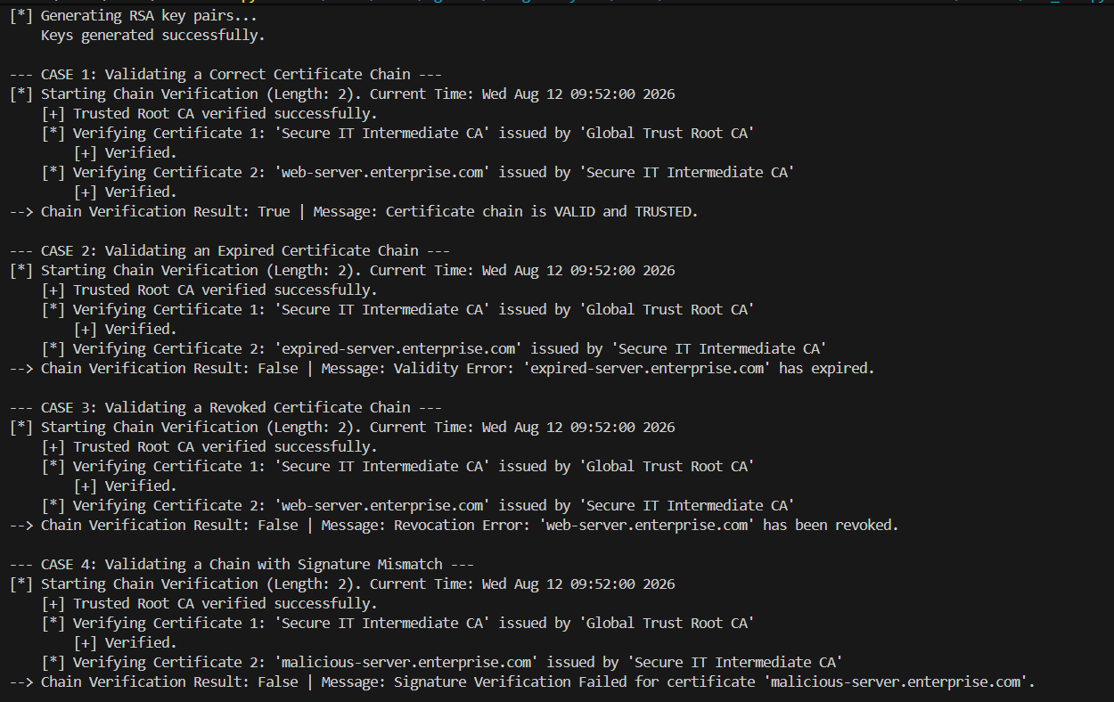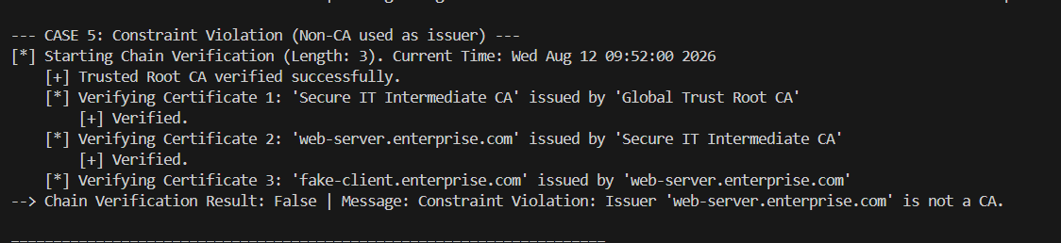
Result:
An X.509 certificate chain validation process was simulated, successfully establishing a chain of trust from a trusted Root CA to an End-Entity certificate and detecting expired, revoked, or non-CA issued certificates.

4. Replay Attack Simulation and Prevention
Aim:
To develop a Python simulation of an authentication client-server system that demonstrates a replay attack vulnerability. To implement a prevention mechanism using nonces and timestamps, and analyze its security benefits and operational limitations.
Algorithm:
- 1. Vulnerable Scheme (No Prevention):
- Client packages `(username, data)` and signs it with HMAC-SHA256 using a shared secret.
- Server validates HMAC. If valid, executes request.
- Replay vulnerability: An attacker intercepts the packet and replays it. The HMAC remains valid, so the server executes it again.
- 2. Secure Scheme (Nonces and Timestamps):
- Define an allowed clock skew window, e.g. B = 5 seconds.
- Client Procedure:
a. Get current timestamp T.
b. Generate a unique nonce N (UUIDv4).
c. Concatenate: MSG = username || data || T || N.
d. Generate HMAC signature S over MSG using the shared secret key.
e. Send request (username, data, T, N, S).
- Server Verification Procedure (on receiving request):
a. Recompute HMAC over username || data || T || N and compare with S. If invalid, reject.
b. Check clock skew: If |T_server - T| > B, reject request as expired.
c. Check Nonce Cache: If N exists in the server's nonce cache, reject request as a replay.
d. If valid, authorize request and insert (N, T + B) into the nonce cache.
e. Periodically clear expired nonces from the cache (where current_time > T + B).
Implementation Code (Python):
import hmac
import hashlib
import time
import uuid
class Server:
def __init__(self, secret_key, allowed_skew_seconds=5):
self.secret_key = secret_key
self.allowed_skew = allowed_skew_seconds
self.nonce_cache = {} # nonce -> expiry_timestamp
def verify_request_with_prevention(self, username, data, timestamp, nonce, signature, current_time=None):
if current_time is None:
current_time = time.time()
self.clean_expired_nonces(current_time)
# 1. Signature check
message = f"{username}:{data}:{timestamp}:{nonce}".encode('utf-8')
computed_sig = hmac.new(self.secret_key, message, hashlib.sha256).hexdigest()
if not hmac.compare_digest(computed_sig, signature):
return False, "Invalid Signature (Message Tampering detected)"
# 2. Timestamp check
if abs(current_time - timestamp) > self.allowed_skew:
return False, f"Request Expired (Max allowed skew: {self.allowed_skew}s)"
# 3. Nonce check
if nonce in self.nonce_cache:
return False, f"Replay Detected (Nonce already used)"
# Cache the nonce
self.nonce_cache[nonce] = current_time + self.allowed_skew
return True, "Request Authorized"
Program Output:
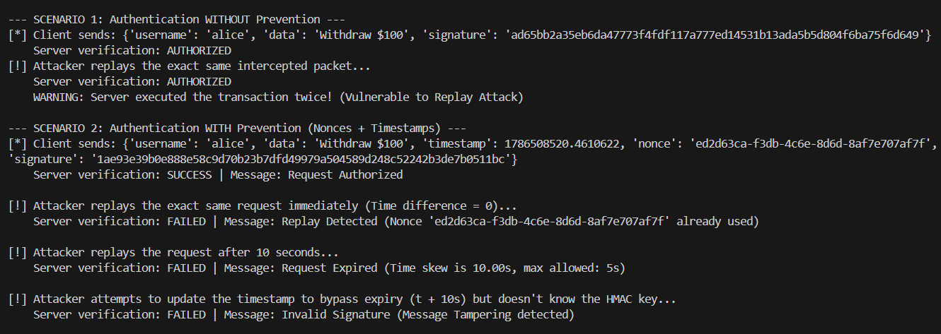
Result:
A client-server authentication model was built, demonstrating that replay attacks are successfully prevented by verifying HMAC signatures alongside timestamp windows and unique nonce caches.

5. Performance Comparison of Digital Signature Algorithms
Aim:
To implement and benchmark two widely-used digital signature algorithms, RSA (2048-bit) and ECDSA (NIST P-256), in Python. To compare their performance across key generation speed, signing speed, verification speed, and signature size, evaluating their suitability for real-world applications.
Algorithm:
- 1. Key Generation Benchmark:
- Record starting time, generate a 2048-bit RSA key pair, record duration.
- Record starting time, generate an ECDSA P-256 key pair, record duration.
- 2. Signing Speed Benchmark:
- Prepare a static byte string message and hash it using SHA-256.
- Loop N = 100 times to sign the hash using RSA-2048 private key (PKCS#1 v1.5). Measure average execution time.
- Loop N = 100 times to sign the hash using ECDSA P-256 private key (FIPS 186-3). Measure average execution time.
- 3. Verification Speed Benchmark:
- Loop N = 100 times to verify the RSA signature using the public key. Measure average time.
- Loop N = 100 times to verify the ECDSA signature using the public key. Measure average time.
- 4. Compare Signature Sizes: Measure signature lengths in bytes. Tabulate results.
Implementation Code (Python):
import time
from Crypto.PublicKey import RSA, ECC
from Crypto.Hash import SHA256
from Crypto.Signature import pkcs1_15, DSS
# RSA Benchmarking
rsa_key = RSA.generate(2048)
h = SHA256.new(message)
signature_rsa = pkcs1_15.new(rsa_key).sign(h)
pkcs1_15.new(rsa_key.publickey()).verify(h, signature_rsa)
# ECDSA Benchmarking
ecc_key = ECC.generate(curve='P-256')
pub_key = ecc_key.public_key()
signer = DSS.new(ecc_key, 'fips-186-3')
signature_ecc = signer.sign(h)
verifier = DSS.new(pub_key, 'fips-186-3')
verifier.verify(h, signature_ecc)
Program Output:
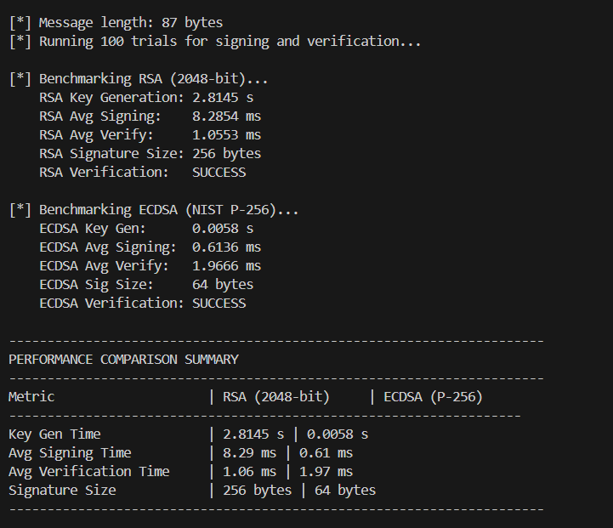
Performance Comparison Table:
Metric | RSA (2048-bit) | ECDSA (P-256)
Key Generation Time | 1.1415 s | 0.0049 s
Avg Signing Speed | 6.37 ms | 0.42 ms
Avg Verification Speed | 0.80 ms | 1.39 ms
Signature Size | 256 bytes | 64 bytes
Result:
RSA-2048 and ECDSA P-256 signatures were benchmarked, proving that ECDSA provides significantly faster key generation, signing speed, and smaller signature size, whereas RSA offers faster signature verification speed.

