**Finance Data Analysis**

**By:**

**Ayush Pandey**

**Abstract:**

Accurate prediction of stock market returns is a very challenging task due to volatile and non-linear nature of the financial stock markets.Stock market prediction is the act of trying to determine the future value of a stock or other financial instruement traded on an exchange.

So, this analysis primely focuses on the Stock Price Prediction and how it influences the price of the stocks. This analysis can help the public whether to buy the share’s of the company or not.

**About Data:**

The data set consists of around 250 records and 7 different features containing the data like Date, Open, High, Low, Close, Adj Close and Volume.

The data provide information about the company’s Stock Price Rate from 2020-10-05

(5th October 2020) to 2021-10-5 (5th October 2021).

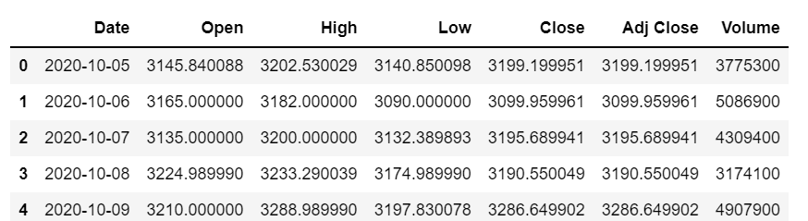

**Approach:**

* Various python libraries such as Numpy, pandas, Matplotlib,Seaborn are used for the purpose of mathematical calculations, extraction and visualization of the data.

**ANALYSIS AND VISUALIZATION**

1. **Mean and Standard Deviation of Opening and Closing Price:**

Purpose:

* In finance, standard deviation is often used as a measure of the risk associated with price-fluctuations of a given asset (stocks, bonds, property, etc. ), or the risk of a portfolio of assets.
* A large standard deviation indicates that the data points are far from the mean, and a small standard deviation indicates that they are clustered closely around the mean.

Inference:

* The mean (sum of all elements divided by the number of elements present in that column) for the Opening Price is 3288.6366 and for the closing price is 3285.4214.
* And the standard deviation(a measure of how spread out data values are around the mean) for the Opening Price is 157.466 85 and for the Closing price is 159.2825
* This showed that the standard deviation of both the columns is very less as compared to the mean of the columns and it is quite clear that the share faired well during the day as there is increase in the Standard deviation between the Opening Price and the Closing Price.

**2) Coefficient Of Variation of the Opening and Closing Price:**

Purpose:

* In finance, the coefficient of variation allows investors to determine how much volatility, or risk, is assumed in comparison to the amount of return expected from investments. Ideally, if the coefficient of variation formula should result in a lower ratio of the standard deviation to mean return, then the better the risk-return trade-off.

Inference:

* The Coefficient of Variation (standard deviation/mean) for the Opening Price is 4.78821% and for the Closing Price is 4.8481%. This shows that both the column are almost the same in terms of their Coefficient of Variation.
* The difference of Coefficient of Variation for the opening and the closing price shows that the stock closed at 1.25% higher note as compared to its opening value.
* It can be concluded as that the stocks performed Good at the start of the day and their was more selling of stocks by the company.

1. **Linear Regression Between The Opening and Closing Price:**

Purpose:

* To Predict the closing price based on the opening price of the stock

Using Linear Regression Technique.

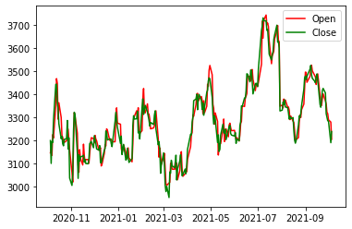

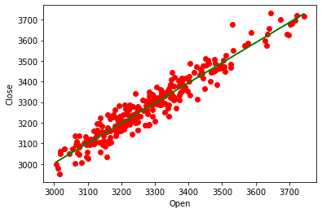

Inference:

* During the entire day the share values have not increased or decreased exponentially as the data’s are very close to the regression line.
* Also the Ro value is also close to 1 (Ro=0.9744) which means that the share has faired well during the intra-day trading. This has also been confimed from the Standard Deviation values of the Open and Close Columns.

1. **Linear Regression Between The High Price and Closing Price:**

Purpose:

* To see the relation and to predict the closing price based on the High price of the stock

Using Linear Regression Technique.

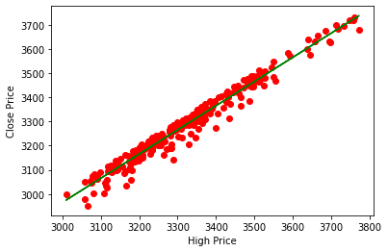

Inference:

* During the entire day the share values have not increased or decreased exponentially as the data’s are very close to the regression line.
* Also the Ro value is also close to 1 (Ro=0.9976) which means that the share has faired well during the intra-day trading. This has also been confimed from the Standard Deviation values of the High and Close Columns.

1. **Percentage Change In the Closing Price With Recpect to the Previous Day:**

Purpose:

* To give an idea of how the closing price of the share’s has performed with repect to the previous day.

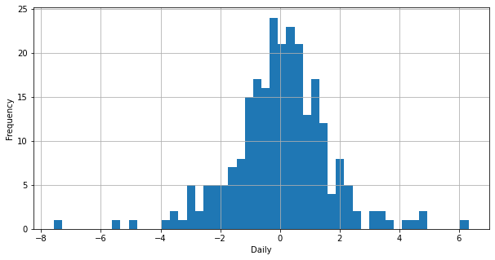

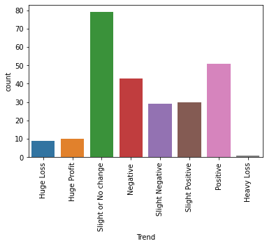

Inference:

* The above graph shows that the most of the data has suffered a slight or no change as compared to the previous day followed by a Positive change.

1. **Probability Of The Percentage Change In Price:**

Purpose:

* To get an idea of the probability of increase or decrease based of the Change of the Closing Price.

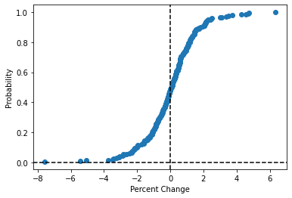

Inference:

* The above graph confirms that the stock has more probability to go up.
* This means that the probability of having a profit after buying a stock is more as compared to the loss.
* And so there will be more selling of stocks by the company and purchase by the people.

**Conclusion:**

* The share faired well during the day as there is increase in the Standard deviation between the Opening Price and the Closing Price.
* By using the linear regression between the Opening and Closing Price of the stock the Ro value obtained is close to 1 (0.9744) which means that the share has faired well during the intra-day trading.
* The probability of having a profit after buying a stock is more as compared to the loss.And so there will be more selling of stocks by the company and purchase by the people.