**Report**

**On**

**Finance Data**

**By:**

**Ayush Pandey**

I am having csv file of finance data which consists of columns such as Date, Open, High, Low, Close, Adj Close and Volume.

Some of the values of the file are listed below

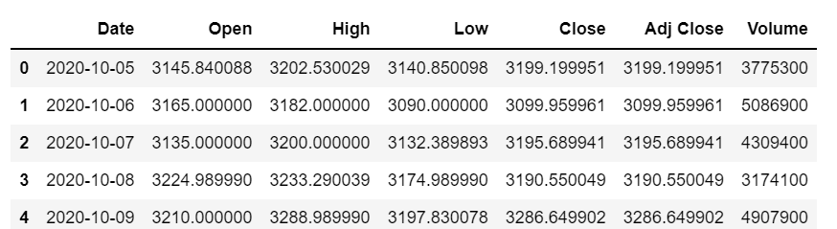

Now I decided to proceed with columns Open and Close and to obtain the inference based on these two columns.

I first calculated the mean(sum of all elements divided by the number of elements present in that column) of both the columns, for Open Column my mean is 3288.6366 and for my Close Column my mean is 3285.4214.

Then I calculated standard deviation(a measure of how spread out data values are around the mean) and obtained a standard deviation of 157.466 85 for Open Column and 159.2825 for my Close Column.

This showed that the standard deviation of both the columns is very less as compared to the mean of the columns.

A large standard deviation indicates that the data points are far from the mean, and a small standard deviation indicates that they are clustered closely around the mean.

In finance, standard deviation is often used as a measure of the risk associated with price-fluctuations of a given asset (stocks, bonds, property, etc. ), or the risk of a portfolio of assets.

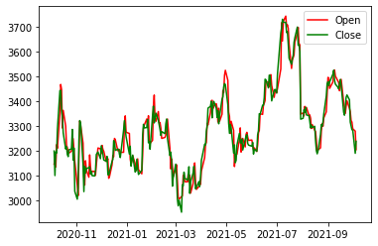

Now to get more inference out of the data I calculated the Coefficient of Variation (standard deviation/mean) for the column Open and Close

and obtained 4.78821% for the Open Column and 4.8481% for the Close Column. This shows that both the column are almost the same in terms of their Coefficient of Variation

The reason I calculated the coefficient of Variation is that in finance, the coefficient of variation allows investors to determine how much volatility, or risk, is assumed in comparison to the amount of return expected from investments. Ideally, if the coefficient of variation formula should result in a lower ratio of the standard deviation to mean return, then the better the risk-return trade-off.

Now when I calculated the difference of Coefficient of Variation for Close and Open Column, the stock closed at 1.25% higher note as compared to its opening value. Thus,we can say that the stocks performed Good at the end of the day and their was more selling than Purchase.

I also calculated the Percentage Change of the Close Column to see how the stocks close price has been varied with repect to the previous day.

And based on that result I found that the maximum data has suffered a slight or no change as campared to the previous day followed by a Positive change.

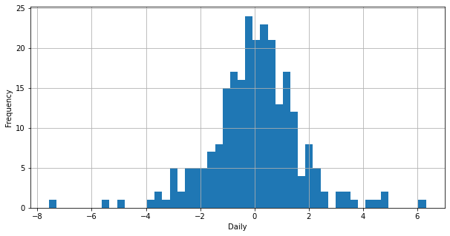

Percent Change Vs Frequency Graph

From the above graph I have made a bar plot comparing the changes along with their count.

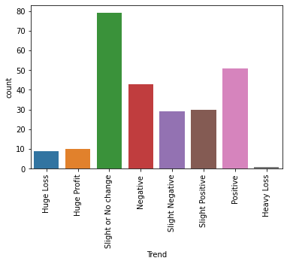

From this I can infer that the company’s closing share price has suffered a slight or no change followed by a Positive change in most of the days.