**Report**

**On**

**Finance Data**

**By:**

**Ayush Pandey**

I am having csv file of finance data which consists of columns such as Date, Open, High, Low, Close, Adj Close and Volume.

Some of the values of the file are listed below:

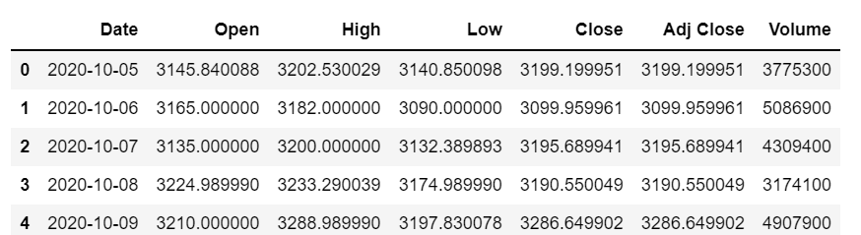

Now I decided to proceed with columns Open and Close and to obtain the inference based on these two columns.

I first calculated the mean(sum of all elements divided by the number of elements present in that column) of both the columns, for Open Column my mean is 3288.6366 and for my Close Column my mean is 3285.4214.

Then I calculated standard deviation(a measure of how spread out data values are around the mean) and obtained a standard deviation of 157.466 85 for Open Column and 159.2825 for my Close Column.

This showed that the standard deviation of both the columns is very less as compared to the mean of the columns and it is quite clear that the share faired well during the day as there is increase in the Standard deviation between the Open and the Close column.

A large standard deviation indicates that the data points are far from the mean, and a small standard deviation indicates that they are clustered closely around the mean.

In finance, standard deviation is often used as a measure of the risk associated with price-fluctuations of a given asset (stocks, bonds, property, etc. ), or the risk of a portfolio of assets.

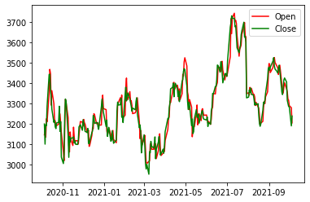

Also, during the entire day the share values have not increased or decreased exponentially as the data’s are very close to the regression line.

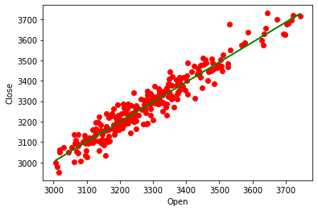

In the above graph the green line is the “line of best fit” and during the entire day the share values have not increased or decreased exponentially as the data’s are very close to the regression line.

Also the Ro value is also close to 1 (Ro=0.9744) which means that the share has faired well during the intra-day trading. This has also been confimed from the Standard Deviation values of the Open and Close Columns.

Now to get more inference out of the data I calculated the Coefficient of Variation (standard deviation/mean) for the column Open and Close

and obtained 4.78821% for the Open Column and 4.8481% for the Close Column. This shows that both the column are almost the same in terms of their Coefficient of Variation

The reason I calculated the coefficient of Variation is that in finance, the coefficient of variation allows investors to determine how much volatility, or risk, is assumed in comparison to the amount of return expected from investments. Ideally, if the coefficient of variation formula should result in a lower ratio of the standard deviation to mean return, then the better the risk-return trade-off.

Now when I calculated the difference of Coefficient of Variation for Close and Open Column, the stock closed at 1.25% higher note as compared to its opening value. Thus,we can say that the stocks performed Good at the end of the day and their was more selling of stocks by the company.

I also calculated the Percentage Change of the Close Column to see how the stocks close price has been varied with repect to the previous day.

And based on that result I found that the maximum data has suffered a slight or no change as compared to the previous day followed by a Positive change.

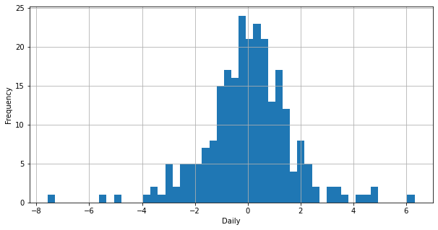

Percent Change Vs Frequency Graph

From the above graph I have made a bar plot comparing the changes along with their count.

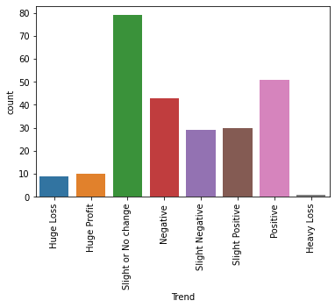

From this I can infer that the company’s closing share price has suffered a slight or no change followed by a Positive change in most of the days.

With the help of the Percent Change Column I have also calculated the probability of the occuring of the Change to get an idea of the increase or decrease based on the past results.

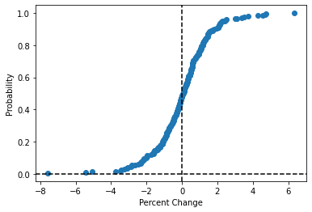

The above graph confirms that the stock has more probability to go up.

This means that the probability of having a profit after buying a stock is more as comared to the loss.

And so there will be more selling of stocks by the company and purchase by the people.