**Data Analysis of COVID-19 Vaccination in Different Countries**

**By:**

**Ayush Pandey**

**Abstract**

The coronavirus is an infection caused by severe acute respiratory syndrome (SARS) coronavirus, known as SARS-CoV-2. It was first determined in Wuhan, China in December 2019. WHO named this virus as COVID-19. This deadly disease affected worldwide economically, hammering people lifestyle and the environmental condition.

Covid-19 pandemic has hit almost all the countries in the world and vaccinations have proven to be effective in reducing the severity, to minimize deaths and to reduce overall burden.

So, this analysis focuses on the number of vaccinations done in various countries.

**Data Collection**

The data set consists of around 4000 records and 15 different features containing the data like total vaccinations, people vaccinated, daily vaccinations, etc. of 102 countries on different dates.

**Approach:**

* Various python libraries such as NumPy, pandas, Matplotlib, Seaborn are used for the purpose of mathematical calculations, extraction and visualization of the data.
* The datasets to be used for analysis was found to be highly skewed (Right Skewed). Although skewness will not have much effect on descriptive analysis, it is handled for the purpose of predictive analysis to accomplish better decisions from the model. The cube root transformation was used to handle skewness in the datasets.

**ANALYSIS AND VISUALIZATION**

1. **Which Vaccine Is Used The Most:**

Purpose:

* To get an idea of the most used vaccines by different countries.

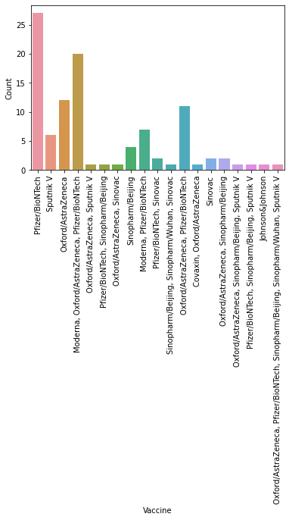

Inference:

* The above graph clearly shows that the most used vaccine is Pfizer/BioNTech which is used by 27 countries.

1. **Countries where people vaccinated is more than 1,00,00,000**

**Purpose:**

* To know which country has the highest number of people vaccinated.

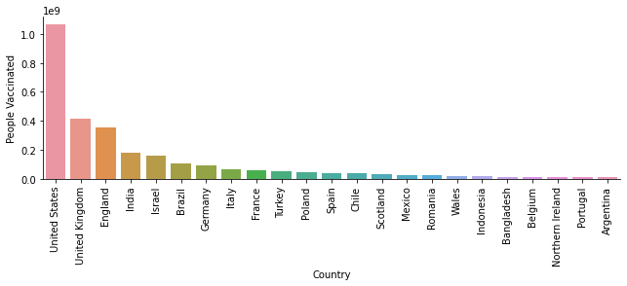

Inference:

* From the visualization above it is clear that The United States leads the world in terms of the number of people vaccinated, where the number of people vaccinated till

2021-02-22 is 1,06,45,79,940.

**3)Which Country is vaccinating its citizens in a faster**

**rate:**

Purpose:

* Vaccination is done in almost all the countries and it is also necessary to do the

vaccination of the citizens in a faster rate.

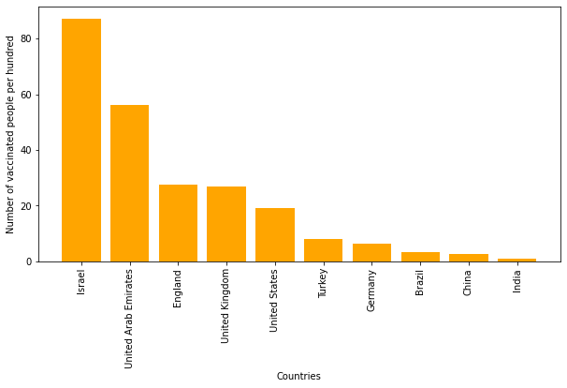

Inference:

* From the visualization above it is clear that **Israel**leads the world in terms of the number of doses per head of population, with**around 90 doses** given for every 100 people.

1. **People Fully Vaccinated In Each Country:**

Purpose:

* It is important for people to be fully vaccinated as it is important for getting the full

benefit of vaccination.

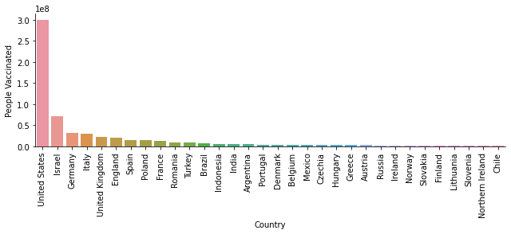

Inference:

* From the visualization above it is clear that United States leads the world in terms of the number of people fully vaccinated, where the number of people fully vaccinated till

2021-02-22 is close to 30,00,00,000.

**4)Comparing the people vaccinated in India And United States**.

Purpose:

* To understand the scale of vaccinations happened in both the countries.

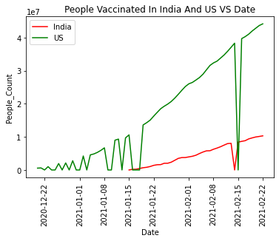

Inference:

* From the visualization it is evident that the vaccinations in United States have started

much earlier as compared to India. As a result, the rate of vaccination in United States

is much higher as compared to India.

* Also In the month of February 2021, the graph shows a dip in the number of people

vaccinated, one of the main reasons is because of the shortage of vaccines in that

month in different parts of the country.

**5)Comparing the fully vaccinated people in India And United States**

**Purpose:**

* To get a view of thenumber of people who are fully vaccinated per day.

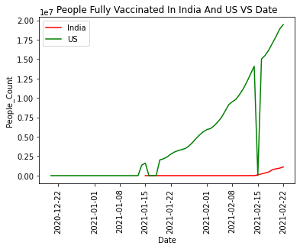

Inference:

* From the visualization it is evident that the vaccinations have started in United States

much earlier as compared to India. As a result, the rate of Fully vaccinated people in

United States is much higher as compared to India.

* The drop in the number of fully vaccinated people in the month of February 2021 in

United States is due to the shortage of vaccines in the country.

**Conclusion:**

* The United States has done the highest number of vaccinations to its people with around 100 million followed by the United Kingdom, England and India.

Since these are developed countries the accessibility of the vaccine is easier to its

public.

* The rate of applying vaccines to people is highest in Israel.

It is because of its small size (in terms of both area and population), a relatively young

population, relatively warm weather in December 2020, a centralized national system

of government, and well-developed infrastructure for implementing prompt responses

to large-scale national emergencies.

* Moderna, Pfizer/BioNTech are the most popular vaccine used worldwide, since it has

almost negligible side effects (known till date).

Also, India uses Covaxin, Oxford/AstraZeneca (Covishield) for vaccinating its citizens.