**ANALYSIS AND VISUALIZATION**

**By:Ayush Pandey**

**1)Comparing the ‘Unsafe water source’, ‘Unsafe sanitation’,**

**‘No access to handwashing facility’ in India And Pakistan**.

**Purpose:**

* To get an idea of the number of deaths in both the countries

based on ‘Unsafe water source’, ‘Unsafe sanitation’,

‘No access to handwashing facility factors’.

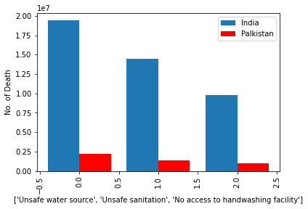

**Inference:**

* From the above visualization it is clear that the number of death due to ‘Unsafe water source’, ‘Unsafe sanitation’, ‘No access to handwashing facility’ factors in India is more as compared To Pakistan.
* Number of death in India due to ‘Unsafe water source’ is 19381797.52 and in Pakistan is 2180227.56
* Number of death in India due to ‘Unsafe sanitation’ is 14427951.31 and in Pakistan is 1396614.61
* Number of death in India due to ‘No access to handwashing facility’ is 9789742.32 and in Pakistan is 988069.29

1. **Multiple Regression between ‘Unsafe water source’, ‘Unsafe sanitation’, ‘No access to handwashing facility’ for the country India and Pakistan**

**Purpose:**

* To predict the ‘No access to handwashing facilty’ for both the countries with the help of ‘Unsafe water source’, ‘Unsafe sanitation’.

**Inference:**

* In India, from the regression coefficient it is clear that the Unsafe water source is contributing much to no access to handwashing facility as compared to Unsafe sanitisation that is with one unit downfall in the water souce purity leads to 54% (53.94%) decrease in access to handwashing facility.
* In Pakistan, from the regression coefficient it is clear that the Unsafe sanitation is contributing much to no access to handwashing facility as compared to Unsafe water source that is with one unit downfall in the sanitation facility leads to 38% (38.34%) decrease in access to handwashing facility.

**Conclusion:**

* The number of death due to ‘Unsafe water source’, ‘Unsafe sanitation’, ‘No access to handwashing facility’ factors in India is more as compared to Pakistan.It is because of India’s large size and population as compared to Pakistan.
* In India, unsafe water affect more on access to handwash as compared to sanitation. So in order to increase the handwashing facility in India more efforts has to be done to improve the water sources.
* In Pakistan, improper sanitation affect more on access to handwash as compared to water sources. So in order to increase the handwashing facility in Pakistan more efforts has to be done to improve the sanitation process in the country.