Container to Kubernetes: Hands-On Assignment
Deploying the CampusConnect Flask app on Kubernetes
Reading Copy — Study Guide
Reference walkthrough for revision (not a submission)
Kubernetes Hands-On Lab — Assignment | 25 October 2026

Objective
Take the CampusConnect app built in the Docker practical (a Python Flask service using FROM python:3.12-slim, EXPOSE 8000 and python app.py), build it as an image, make the image available to the Kubernetes cluster, run it as a Deployment, and confirm the Service is reachable.

Summary
Assignment step | What was done / result
1. Identify the app | CampusConnect from Docker lab 7.1–7.2: app.py, requirements.txt, Dockerfile.v1
2. docker build | campusconnect:v1 built (48.3 MB) and tested with docker run
3. kind load docker-image | Image copied into all three kind nodes
4. deployment.yaml | Deployment (2 replicas, port 8000, /health probe) + NodePort Service 30001
5. kubectl apply / rollout status | "deployment campusconnect successfully rolled out", 2/2 Pods Running
6. Test | Works inside the cluster (Service DNS) and outside (localhost:30001, HTTP 200)
Extra | Scaled to 3, Pod self-healing, cleanup

Kubernetes cluster from the lab is running
The kind cluster from the Kubernetes lab (one control plane, two workers) is running and kubectl points at it.
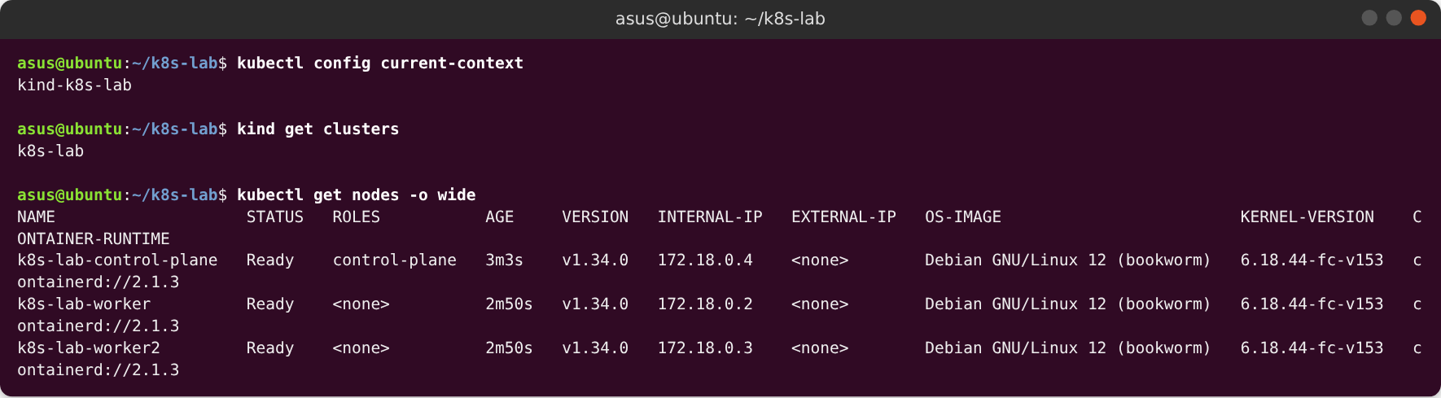
Figure 1: The kind cluster k8s-lab with three Ready nodes

Step 1 - The CampusConnect app from the Docker lab (7.1 / 7.2)
The CampusConnect project recreated exactly from Docker lab sections 7.1 and 7.2: requirements.txt (flask==3.0.3), app.py (Flask visit counter on port 8000 with / and /health) and Dockerfile.v1 (FROM python:3.12-slim, EXPOSE 8000, python app.py).
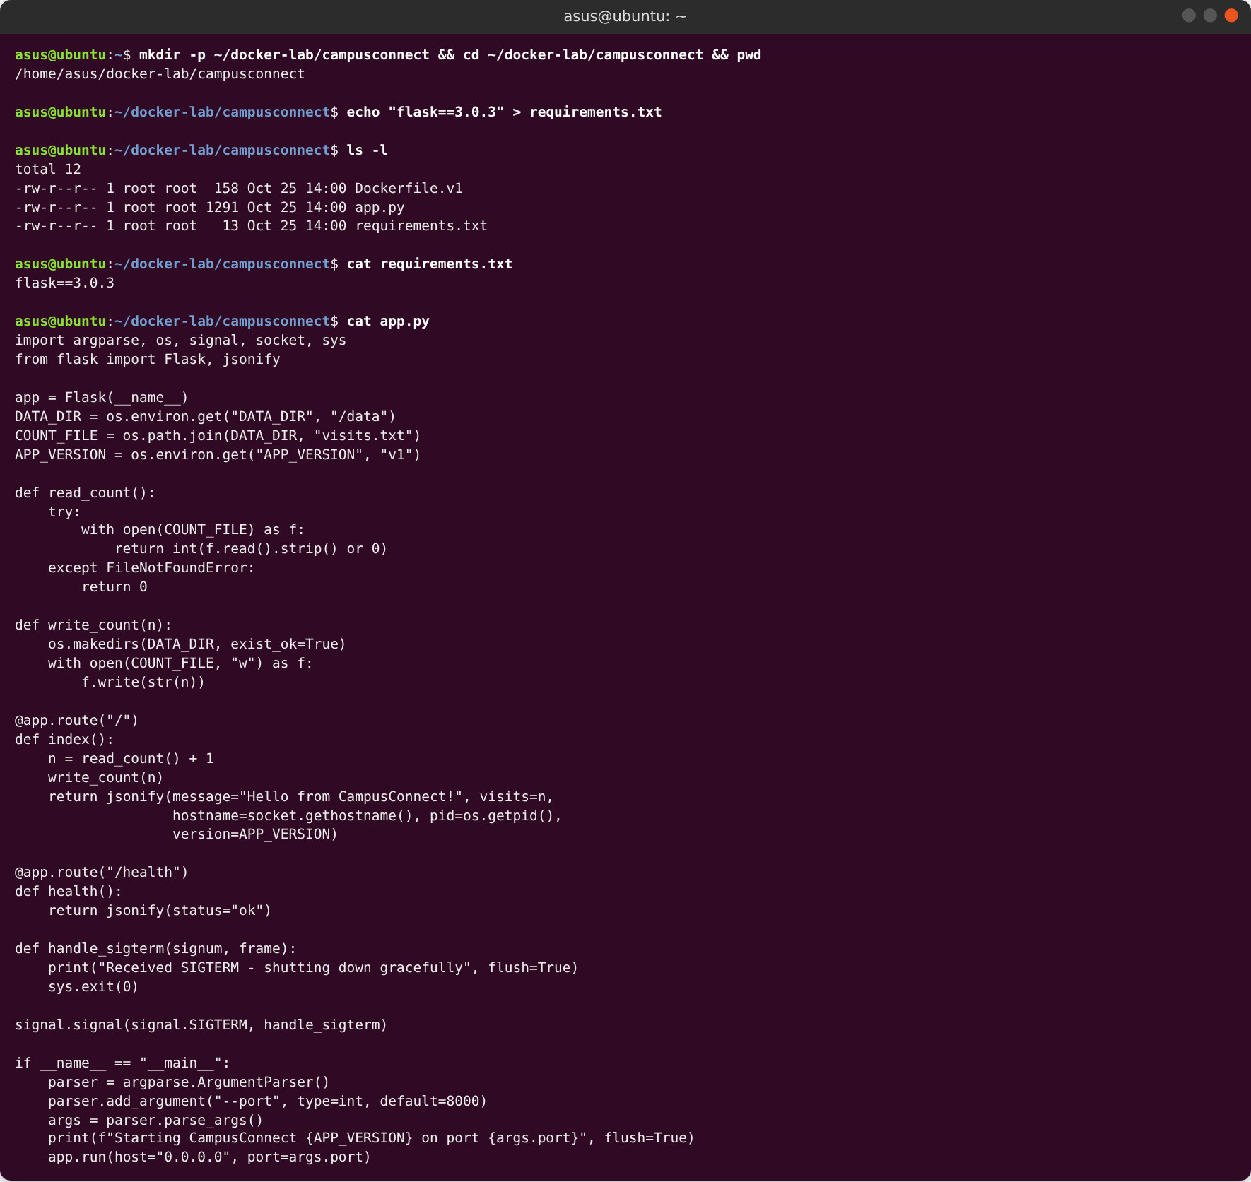
Figure 2: CampusConnect project files (part 1 of 2)
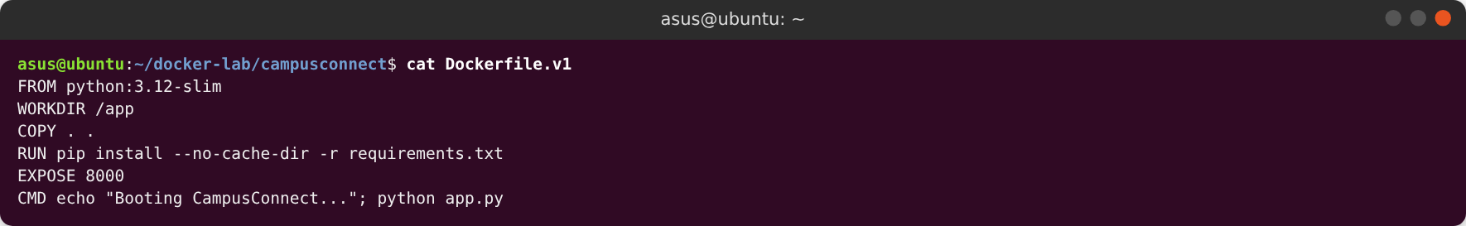
Figure 3: CampusConnect project files (part 2 of 2)

Step 2 - Build the image campusconnect:v1
Assignment step 2: build the image with docker build -t campusconnect:v1 -f Dockerfile.v1 . — pip installs Flask and the image is tagged campusconnect:v1.
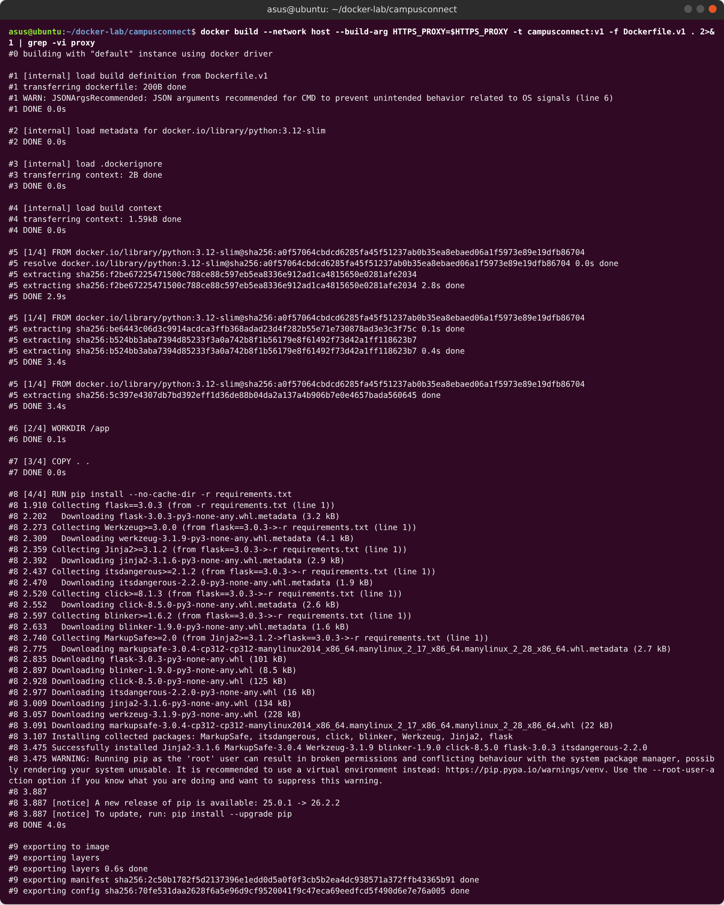
Figure 4: Building campusconnect:v1 from Dockerfile.v1 (part 1 of 2)
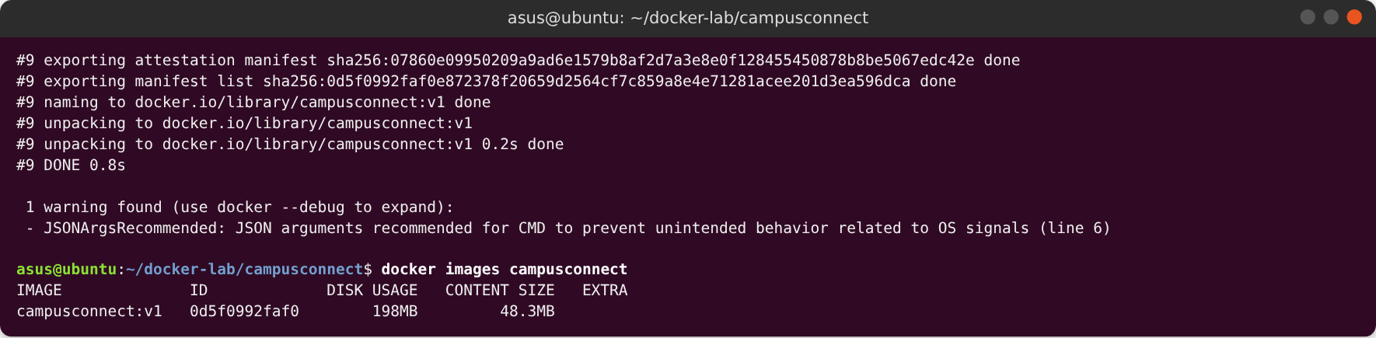
Figure 5: Building campusconnect:v1 from Dockerfile.v1 (part 2 of 2)

Step 2 - Quick test with plain Docker
Before moving to Kubernetes, the image was run once with plain Docker to confirm it works: / returns the JSON greeting with a visit counter and /health returns {"status":"ok"}.
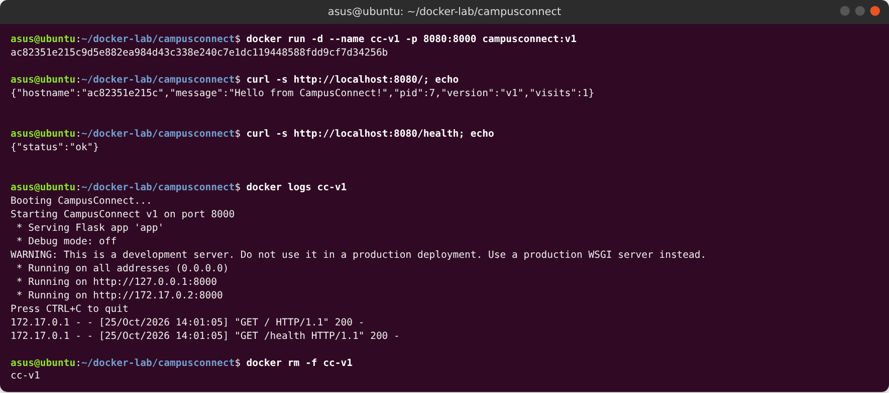
Figure 6: Running campusconnect:v1 with plain Docker

Step 3 - Make the image available to the kind cluster
Assignment step 3: a kind cluster cannot see images on the host, so the local image was copied into every node with kind load docker-image. crictl confirms it is present on both workers.
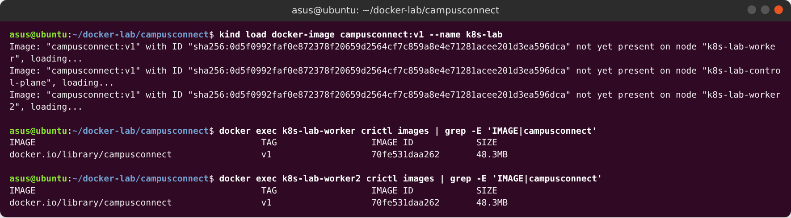
Figure 7: Loading the image into the kind nodes

Step 4 - Write deployment.yaml (Deployment + NodePort Service)
Assignment step 4: deployment.yaml holds a Deployment (2 replicas of campusconnect:v1, containerPort 8000, readiness probe on /health) and a NodePort Service (port 80 → targetPort 8000, nodePort 30001).
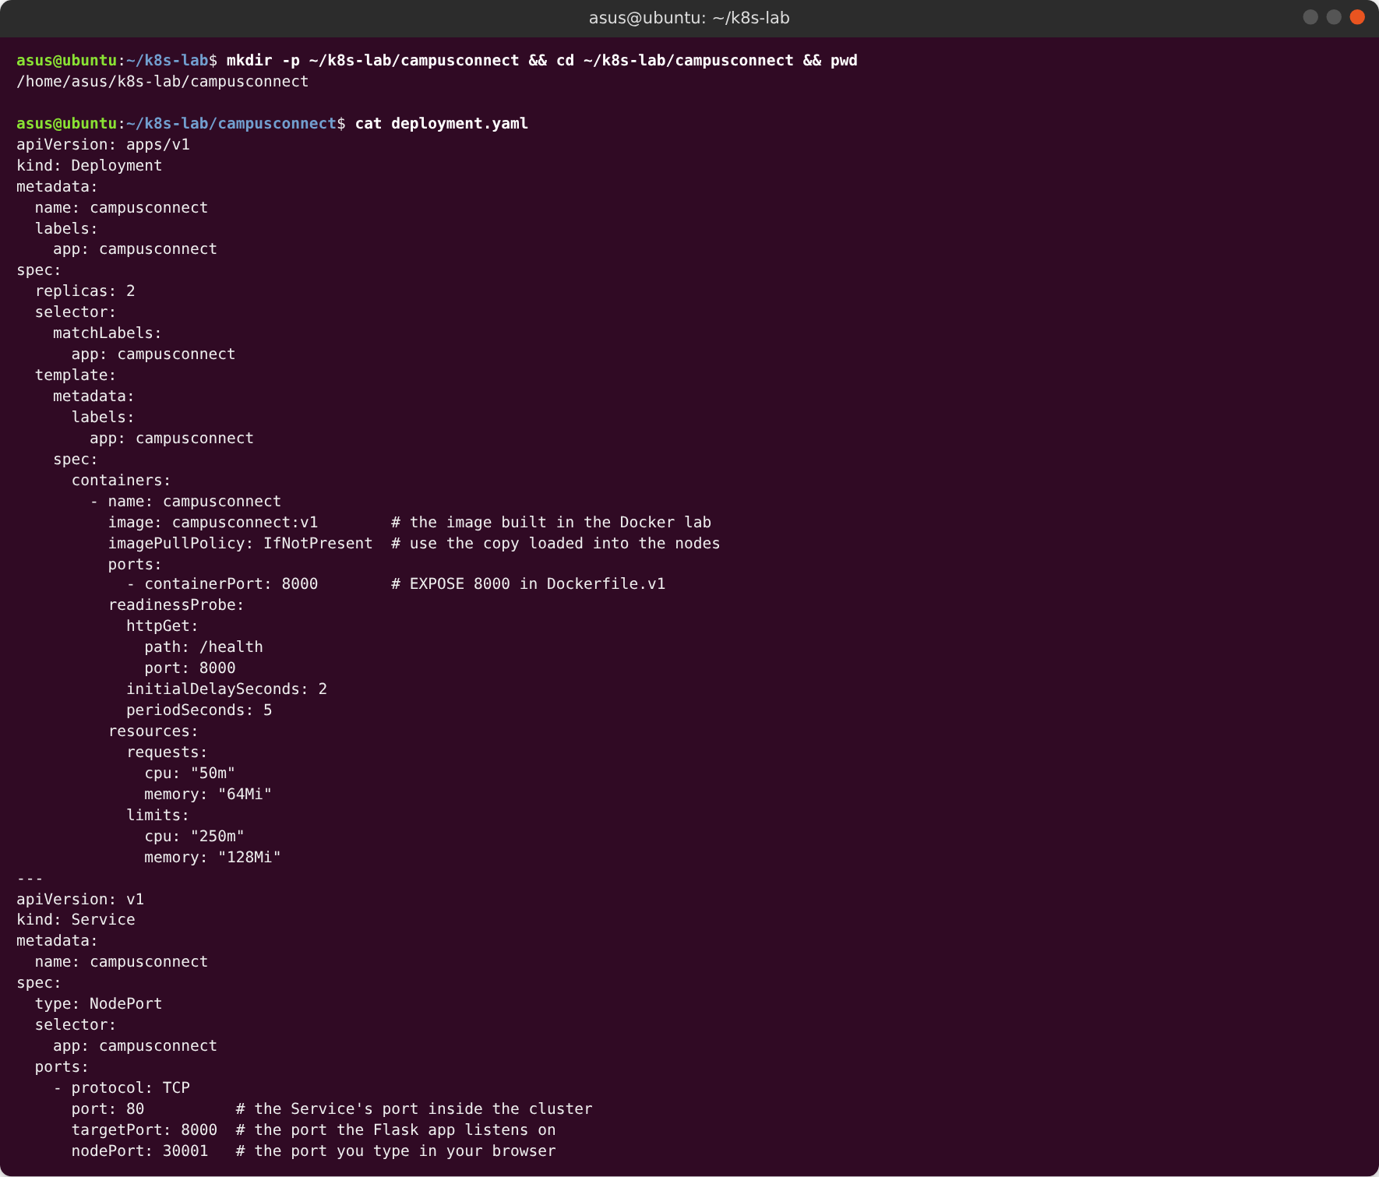
Figure 8: deployment.yaml for CampusConnect

Step 5 - Deploy and check the rollout
Assignment step 5: kubectl apply -f deployment.yaml created both objects, kubectl rollout status deployment/campusconnect reported success, and the Service has two endpoints (one per Pod), which proves the labels match.
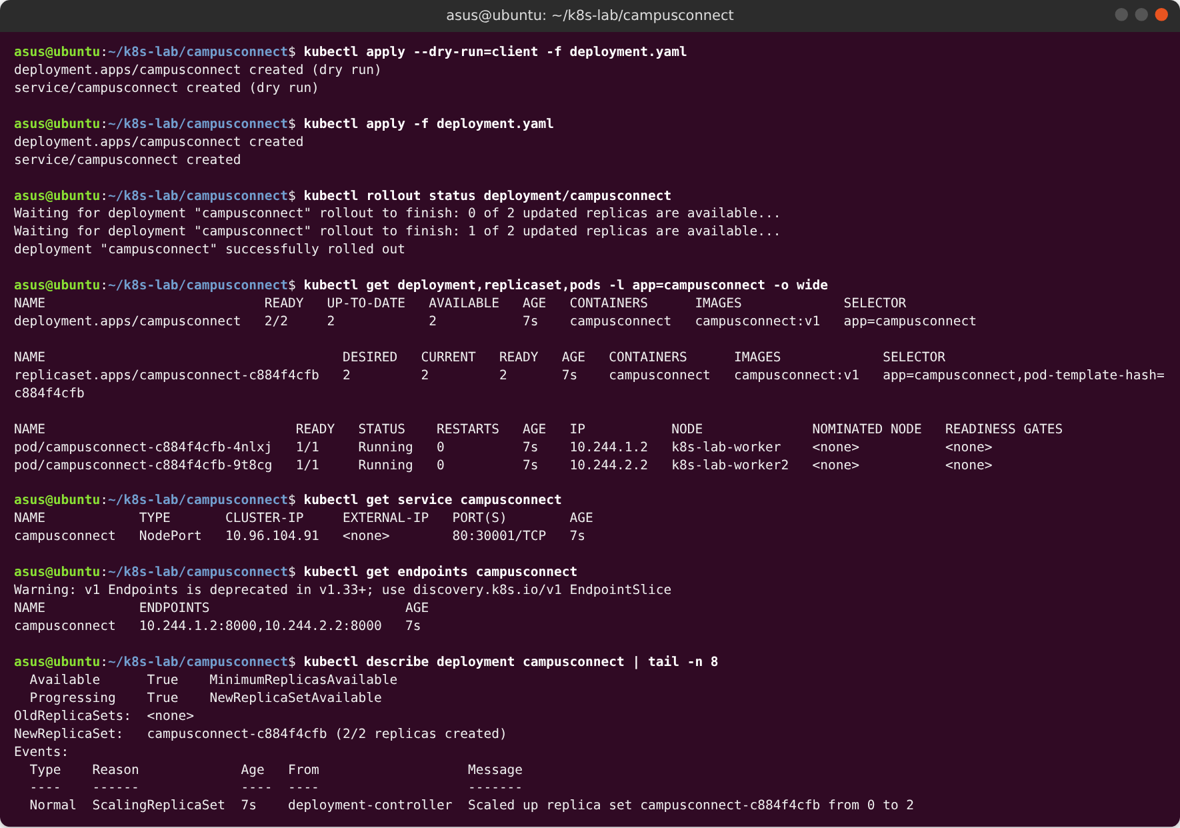
Figure 9: Deploying CampusConnect and checking the rollout

Step 6 - Test the app from inside the cluster
Assignment step 6 (inside the cluster): a temporary Pod called the Service by its DNS name http://campusconnect. Requests were answered by both Pods (different hostnames), and /health returned ok through the full name campusconnect.default.svc.cluster.local.
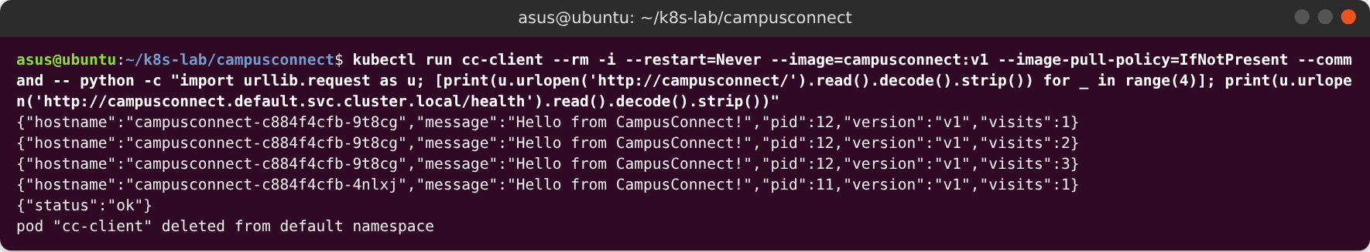
Figure 10: Testing the app from inside the cluster

Step 6 - Confirm the Service is reachable from outside (NodePort 30001)
Assignment step 6 (outside the cluster): the app answers on the NodePort http://localhost:30001 (HTTP 200) and through kubectl port-forward. The application log shows the startup lines from app.py and the readiness probe calling /health every 5 seconds.
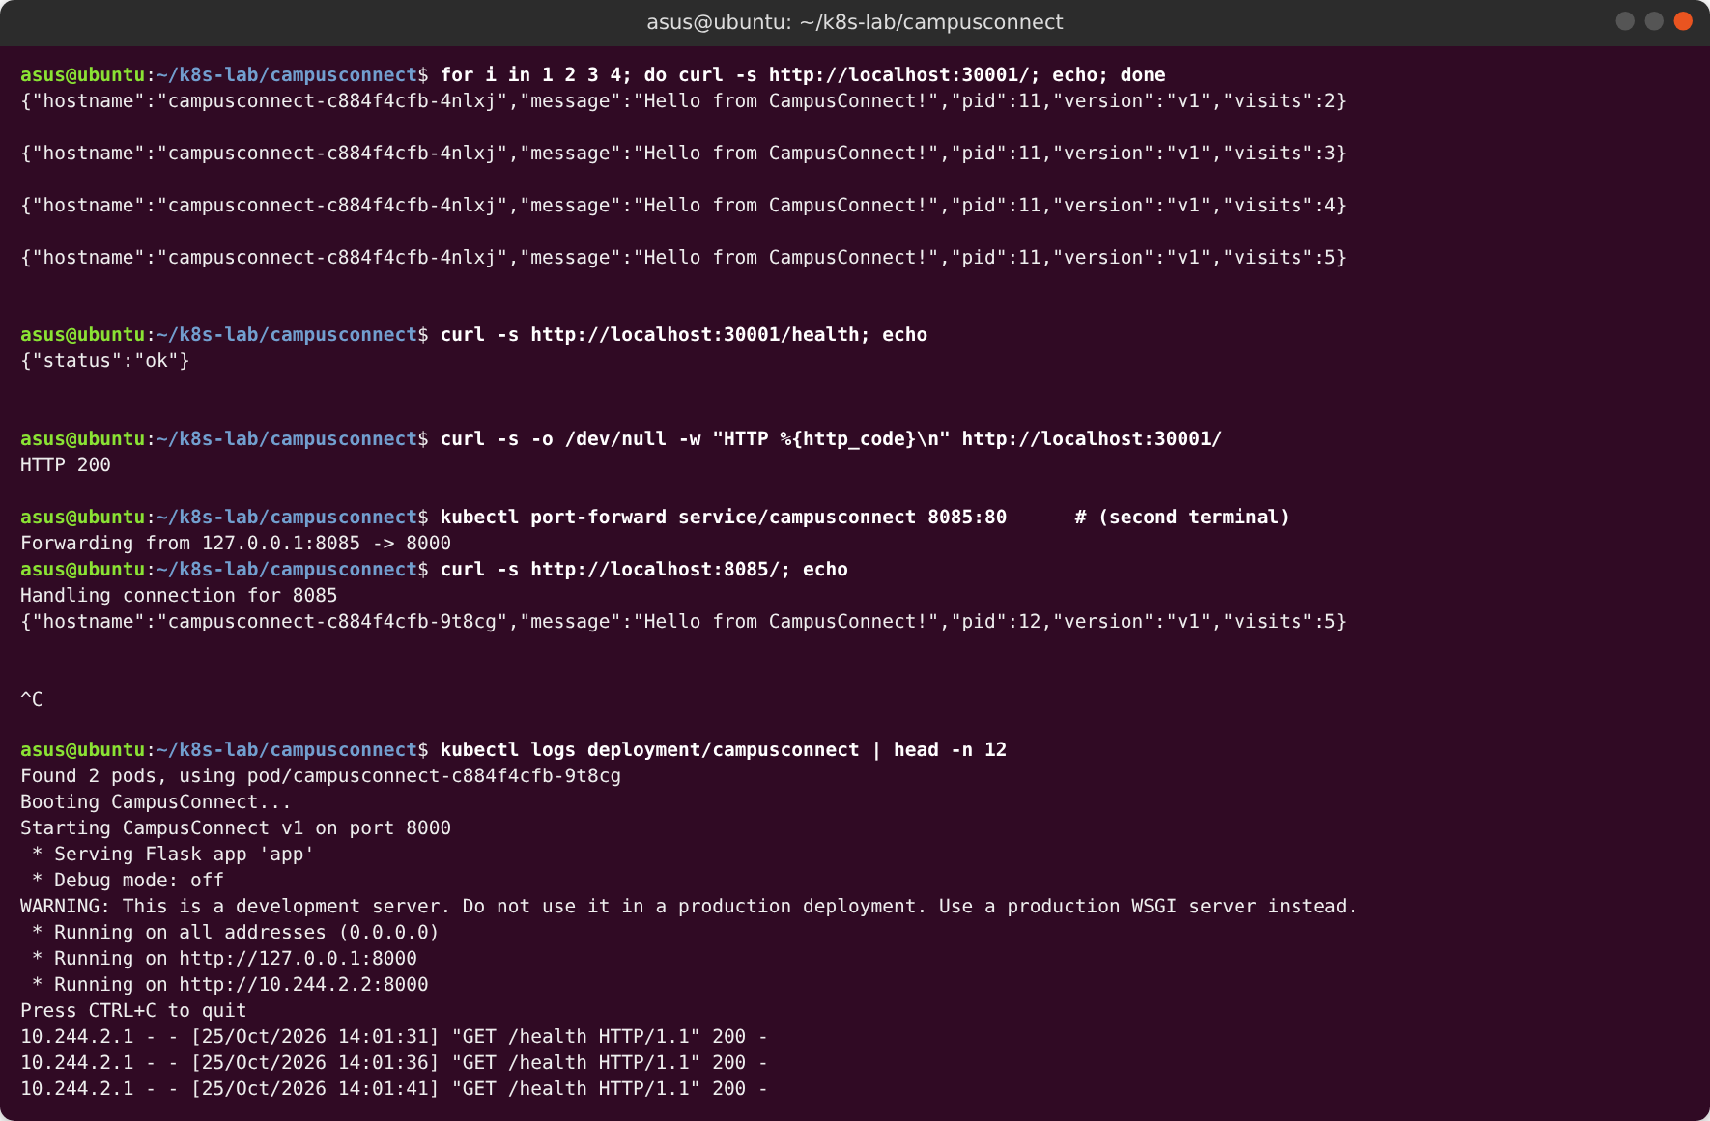
Figure 11: Reaching the Service from outside the cluster

Step 6 - The app in the browser
The same NodePort opened in Chromium. The JSON response shows which Pod answered (hostname) and its visit counter.
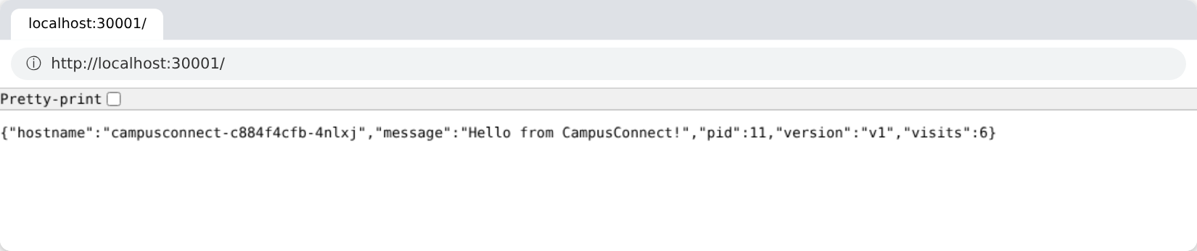
Figure 12: CampusConnect at http://localhost:30001/ served by a Kubernetes Pod
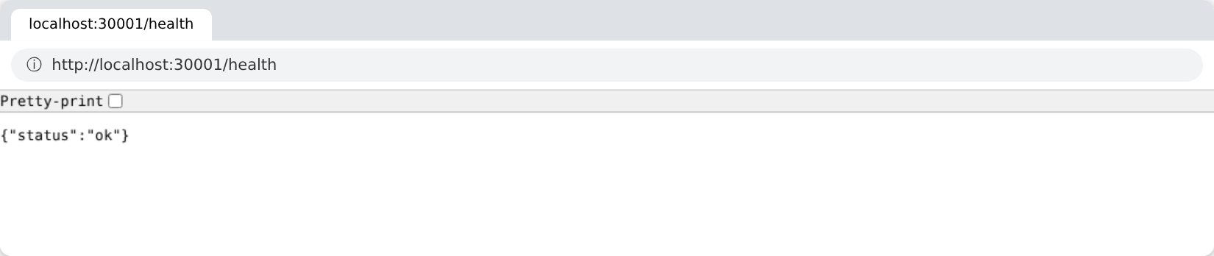
Figure 13: Health endpoint at http://localhost:30001/health

Extra - Scale to 3 replicas
Extra: scaled to 3 replicas. The new Pod joined the Service automatically (three endpoints) without editing the Service.
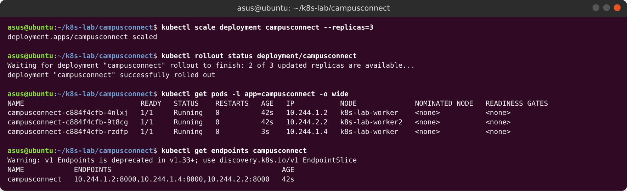
Figure 14: Scaling CampusConnect to 3 replicas

Extra - Delete a Pod and watch Kubernetes replace it
Extra: a Pod was deleted on purpose. The ReplicaSet created a replacement (new name, new IP) and the site kept returning HTTP 200 throughout.
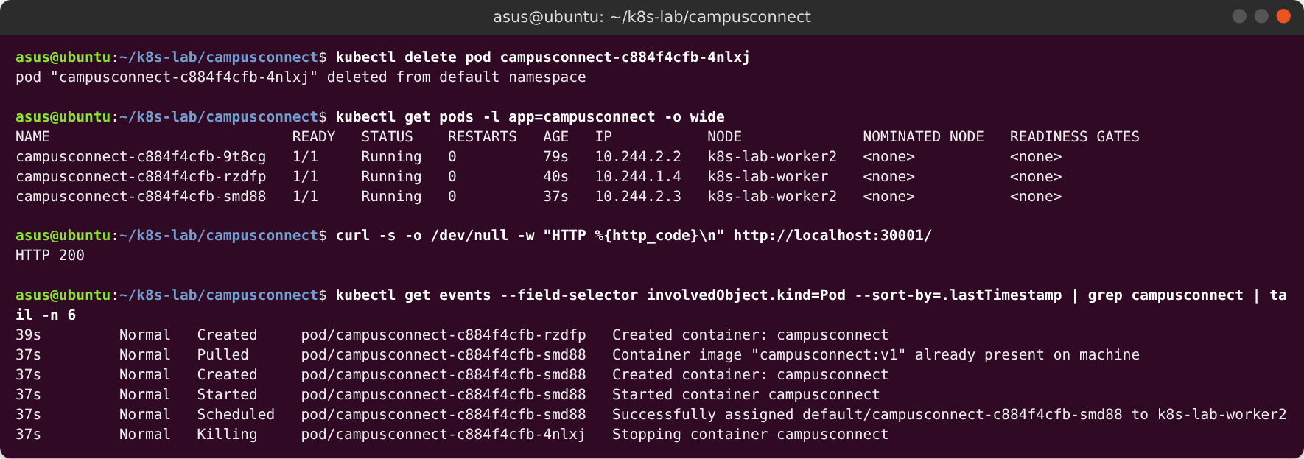
Figure 15: Self-healing after deleting a Pod

Cleanup
Cleanup: kubectl delete -f deployment.yaml removed the Deployment, its ReplicaSet and Pods, and the Service. Only the built-in kubernetes Service remains.
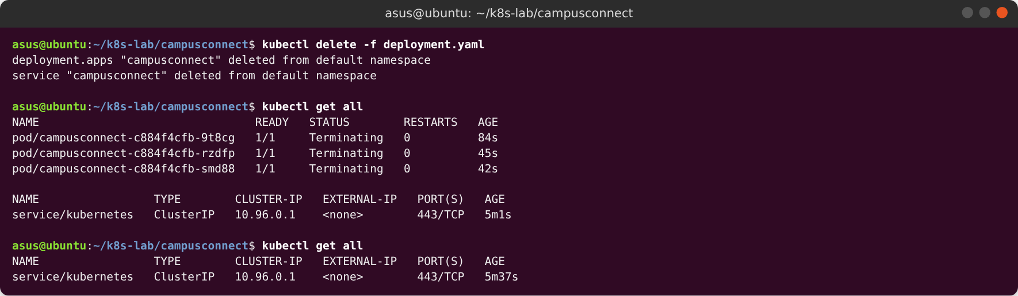
Figure 16: Cleaning up the CampusConnect objects

Observations
- Each Pod has its own visit counter. The counter is saved in /data/visits.txt inside the container, so each Pod counts separately (the numbers restart in a new Pod). A shared PersistentVolume would be needed for one counter, just like the Docker volume in Docker lab step 8.
- Deleting a Pod took about 30 seconds. Dockerfile.v1 uses the shell form of CMD, so /bin/sh is PID 1 and Python never receives SIGTERM (Docker lab 7.4). Kubernetes waits its 30-second grace period and then force-kills the container. Using the exec form ENTRYPOINT ["python","app.py"] from Dockerfile.v2 would make shutdown instant.
- The Service balances load. Responses came from different Pod hostnames for the same Service address.

Notes on the environment
- The assignment was run in a cloud Linux machine with Docker, kind v0.30.0 and kubectl. The kind cluster is the same one used in the main Kubernetes lab (kind-config.yaml includes one containerd setting needed on that machine).
- That machine reaches the internet only through a proxy, so docker build was given --network host --build-arg HTTPS_PROXY=… so that pip could download Flask. Dockerfile.v1 itself is unchanged; on a normal laptop the plain command docker build -t campusconnect:v1 -f Dockerfile.v1 . is enough.
- The browser screenshots were taken with Chromium on the same machine.

Conclusion
The CampusConnect image built in the Docker practical now runs as a Kubernetes Deployment: Docker built the image, kind made it available on the nodes, deployment.yaml described the desired state, and Kubernetes kept that state true — rolling it out, routing traffic through a Service on NodePort 30001, scaling it, and replacing a deleted Pod automatically.

