Docker Lab Submission
Name: Ayush Patel
Roll No: 202301084
All steps were performed on a Linux machine (user ayushpatel) with Docker Engine 29.6.2 and Docker Compose v5.3.1. Every screenshot is the real output of the commands listed above it.

Project Files

Dockerfile
# Base image: lightweight Nginx web server on Alpine Linux
FROM nginx:alpine

# Metadata about the image author
LABEL maintainer="Ayush Patel (202301084)"

# Copy our web page into Nginx's default web root
COPY app/index.html /usr/share/nginx/html/index.html

# Document that the container listens on port 80
EXPOSE 80

# Start Nginx in the foreground so the container keeps running
CMD ["nginx", "-g", "daemon off;"]

docker-compose.yml
services:
web:
build: .
image: ayushpatel/docker-lab-web:1.0
container_name: ayushpatel-compose-web
ports:
- "8081:80"
volumes:
- web-logs:/var/log/nginx
restart: unless-stopped

volumes:
web-logs:

app/index.html
<!DOCTYPE html>
<html lang="en">
<head>
<meta charset="UTF-8">
<title>Docker Lab - Ayush Patel</title>
<style>
body { font-family: Arial, sans-serif; background: #fff; color: #000;
display: flex; align-items: center; justify-content: center; height: 100vh; margin: 0; }
.card { background: #fff; color: #000; padding: 40px 60px; border: 2px solid #000; text-align: center; }
h1 { color: #000; margin-top: 0; }
</style>
</head>
<body>
<div class="card">
<h1>Hello from Docker!</h1>
<p><b>Name:</b> Ayush Patel</p>
<p><b>Roll No:</b> 202301084</p>
<p>This page is served by an Nginx container built from my own Dockerfile.</p>
</div>
</body>
</html>

Step 1: Check Docker installation
Command | Purpose
docker --version | Shows the installed Docker client version, confirming Docker is installed.
docker compose version | Shows the Docker Compose plugin version (used later for multi-container deployment).
docker info --format 'Server: {{.ServerVersion}} | Containers: {{.Containers}} | Images: {{.Images}} | OS: {{.OperatingSystem}}' | Prints key details about the Docker daemon (engine version, number of containers/images, OS) to confirm the daemon is running.
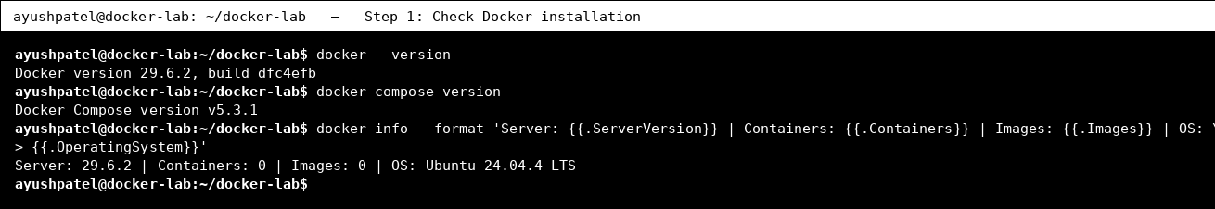

Step 2: Run the first container (hello-world)
Command | Purpose
docker run hello-world | Downloads the hello-world image (if not present), creates a container from it and runs it. The container prints a message and exits - proving Docker works end to end.
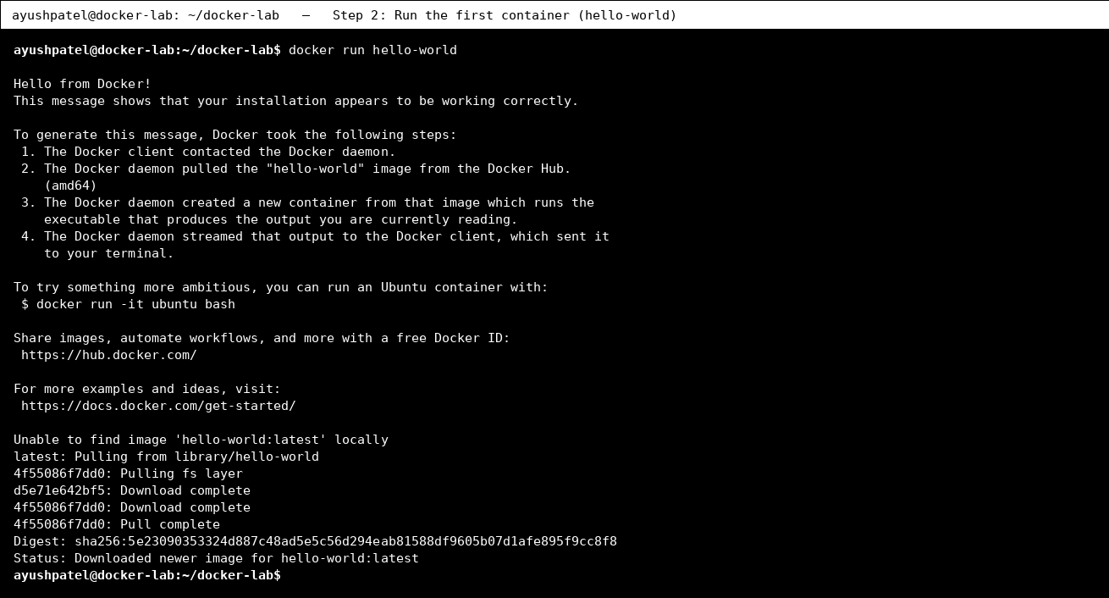

Step 3: Pull images and list them
Command | Purpose
docker pull nginx:alpine | Downloads the official Nginx web-server image (small Alpine variant) from Docker Hub.
docker pull alpine:latest | Downloads the tiny Alpine Linux base image.
docker images | Lists all images stored locally with their repository, tag, ID and size.
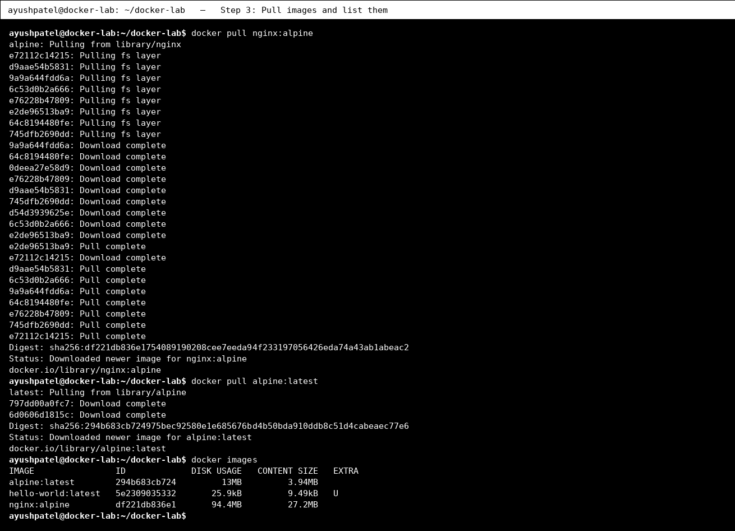

Step 4: Run a command inside a container
Command | Purpose
docker run --rm alpine cat /etc/os-release | Starts an Alpine container, runs one command inside it (shows the container's OS) and removes the container afterwards (--rm).
docker run --rm alpine sh -c 'echo Hello from Ayush Patel, Roll No 202301084; hostname' | Runs a small shell script inside a container. The hostname printed is the container ID, showing each container is an isolated environment. (Interactive form: docker run -it alpine sh)
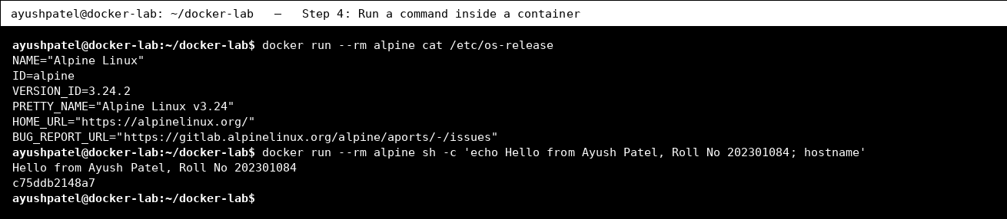

Step 5: Run a container in background with port mapping
Command | Purpose
docker run -d --name ayushpatel-nginx -p 8080:80 nginx:alpine | Starts Nginx in detached mode (-d, background), names it ayushpatel-nginx and maps host port 8080 to container port 80 (-p).
docker ps | Lists running containers with ID, image, status and port mappings.
curl -s http://localhost:8080 | grep -i '<title>' | Sends an HTTP request to the container through the mapped port to prove the web server is reachable.
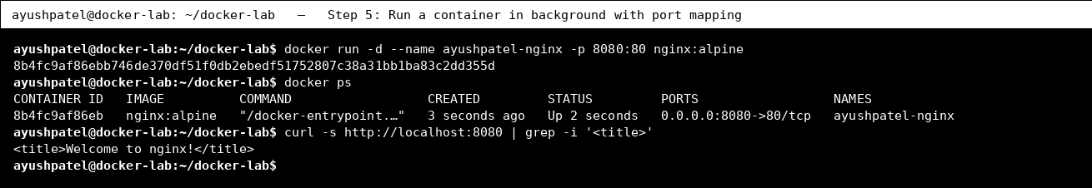

Step 6: Logs, exec and inspect
Command | Purpose
docker logs ayushpatel-nginx 2>&1 | tail -n 4 | Shows the output/logs written by the container (here the last 4 lines, including our curl request).
docker exec ayushpatel-nginx ls -l /usr/share/nginx/html | Runs a command inside the already-running container (docker exec) - here listing Nginx's web folder.
docker inspect --format 'Name={{.Name}} IP={{range .NetworkSettings.Networks}}{{.IPAddress}}{{end}} Status={{.State.Status}}' ayushpatel-nginx | Shows low-level details of the container (name, internal IP address, state) using a Go template filter.
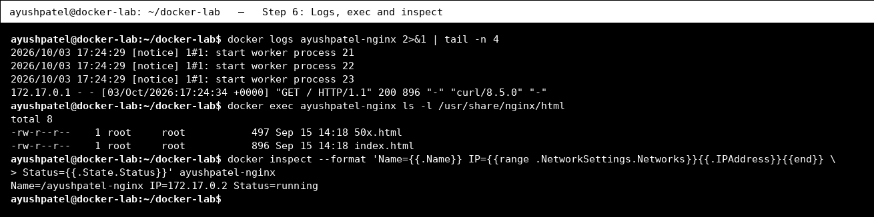

Step 7: Container lifecycle: stop, start, remove
Command | Purpose
docker stop ayushpatel-nginx | Gracefully stops the running container.
docker ps -a --filter name=ayushpatel-nginx | Lists all containers including stopped ones (-a); status is now Exited.
docker start ayushpatel-nginx | Starts the stopped container again (same container, same settings).
docker ps --filter name=ayushpatel-nginx | Confirms the container is Up again.
docker rm -f ayushpatel-nginx | Force-removes the container (stops it first because of -f).
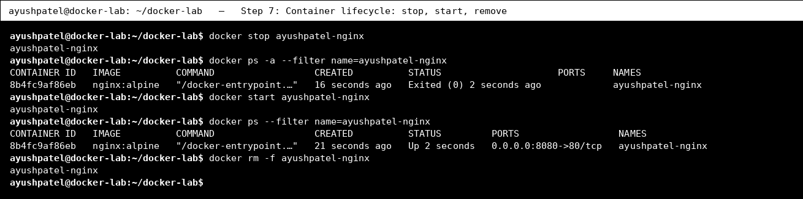

Step 8: Write a Dockerfile
Command | Purpose
ls -R | Shows the project files: the Dockerfile, the web page in app/, and the Compose file.
cat Dockerfile | Displays the Dockerfile. FROM picks the base image, LABEL adds metadata, COPY adds our page, EXPOSE documents the port, CMD sets the start command.
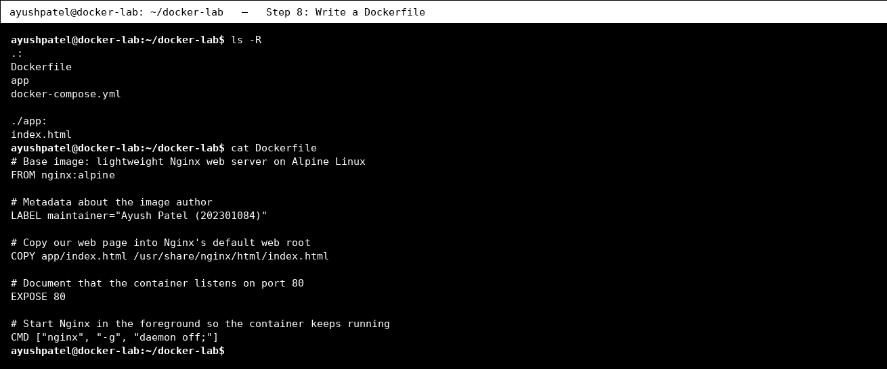

Step 9: Build a custom image
Command | Purpose
docker build -t ayushpatel/docker-lab-web:1.0 . | Builds a new image from the Dockerfile in the current folder (.) and tags it (-t) as ayushpatel/docker-lab-web:1.0.
docker images ayushpatel/docker-lab-web | Lists the newly built image.
docker history ayushpatel/docker-lab-web:1.0 | head -n 6 | Shows the layers of the image; the top layers correspond to our Dockerfile instructions.
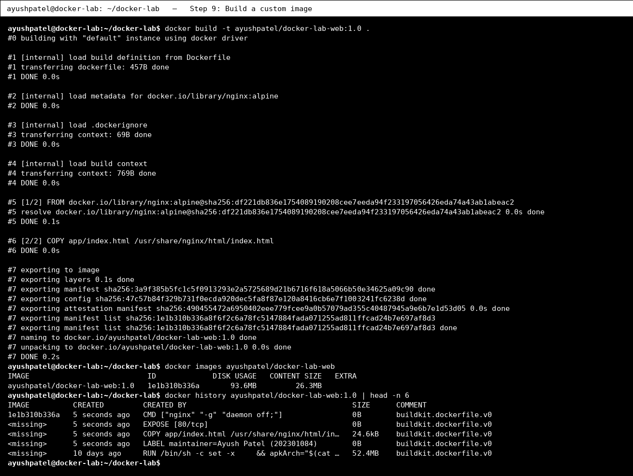

Step 10: Run the custom image (deployment)
Command | Purpose
docker run -d --name ayushpatel-web -p 8082:80 ayushpatel/docker-lab-web:1.0 | Deploys our own image as a container on host port 8082.
docker ps --filter name=ayushpatel-web | Confirms the container is running.
curl -s http://localhost:8082 | grep -E 'Name|Roll' | Fetches the page from the container - it shows my name and roll number, proving the custom image works.
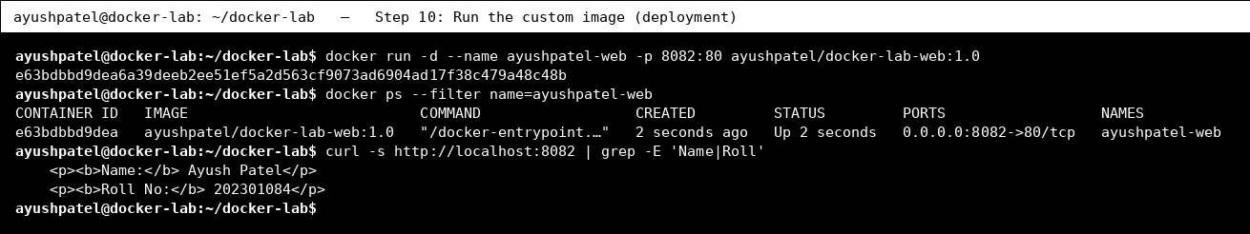
Browser view of the custom image running with docker run (port 8082).
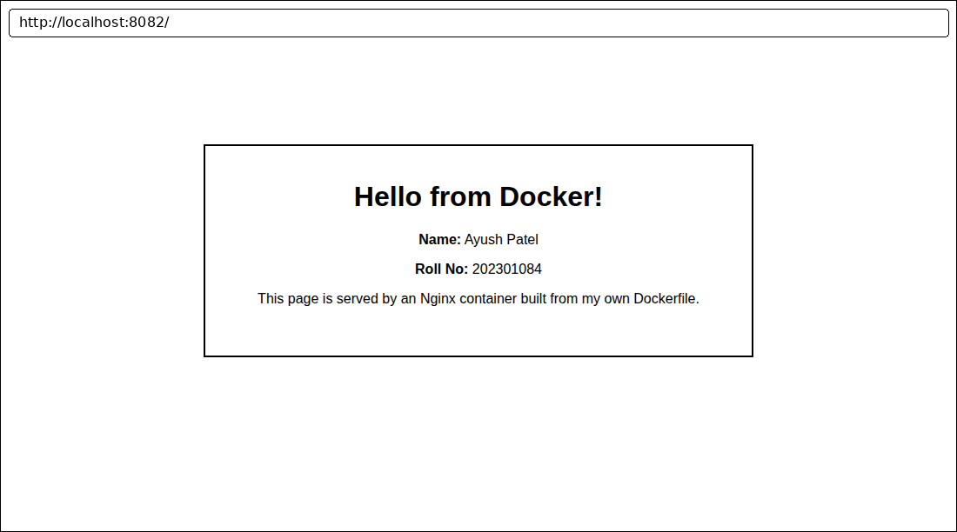

Step 11: Named volumes (persistent data)
Command | Purpose
docker volume create ayush-data | Creates a named volume - storage managed by Docker that lives outside any container.
docker volume ls | Lists all volumes.
docker run --rm -v ayush-data:/data alpine sh -c "echo 'Ayush Patel - 202301084' > /data/student.txt" | Container #1 mounts the volume at /data and writes a file, then is deleted (--rm).
docker run --rm -v ayush-data:/data alpine cat /data/student.txt | Container #2 (a brand new one) mounts the same volume and reads the file - data persisted after container #1 was removed.
docker volume inspect ayush-data | Shows volume details such as where Docker stores it on the host (Mountpoint).
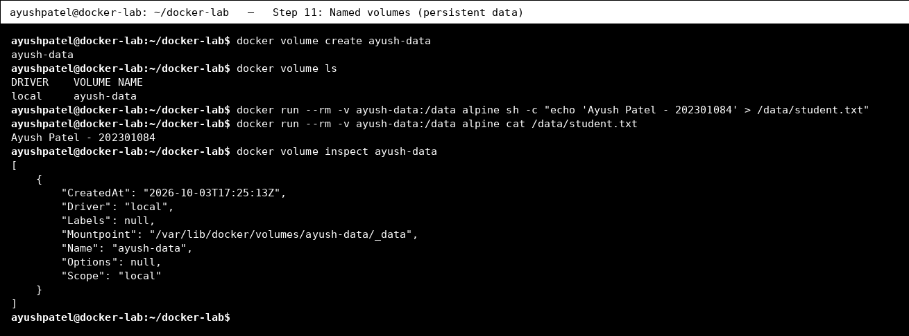

Step 12: Bind mount (host folder into container)
Command | Purpose
mkdir -p site && echo '<h1>Bind mount page by Ayush Patel (202301084)</h1>' > site/index.html | Creates a folder on the host with a simple HTML page.
docker run -d --name ayushpatel-bind -p 8083:80 -v "$(pwd)/site":/usr/share/nginx/html:ro nginx:alpine | Runs Nginx and mounts the host folder into the container's web root (read-only, :ro).
curl -s http://localhost:8083 | The container serves the host file.
echo '<h1>Updated on the host - no rebuild needed!</h1>' > site/index.html && curl -s http://localhost:8083 | Edit the file on the host; the container immediately serves the new content because it is the same folder.
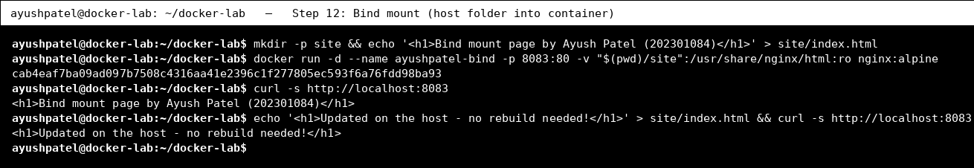

Step 13: Docker networks
Command | Purpose
docker network create ayush-net | Creates a user-defined bridge network so containers can talk to each other by name.
docker run -d --name ayush-server --network ayush-net nginx:alpine | Starts a web server container attached to the network.
docker run --rm --network ayush-net alpine wget -qO- http://ayush-server | grep -i '<title>' | A second container on the same network reaches the server using its container name (built-in DNS).
docker network ls | Lists networks (bridge, host, none and our ayush-net).
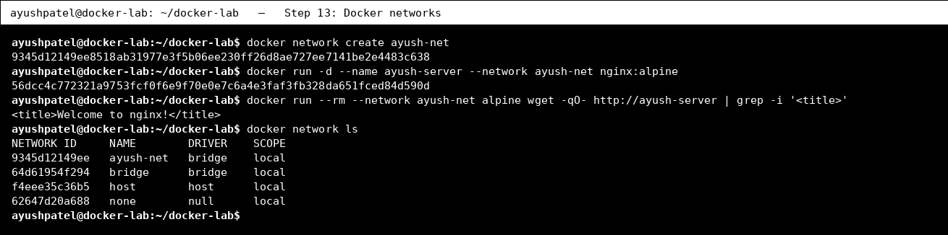

Step 14: Tag and save an image
Command | Purpose
docker tag ayushpatel/docker-lab-web:1.0 ayushpatel/docker-lab-web:latest | Adds another tag (name) to the same image - this is how images are prepared for pushing to a registry (docker login + docker push).
docker images ayushpatel/docker-lab-web | Both tags point to the same IMAGE ID.
docker save -o docker-lab-web.tar ayushpatel/docker-lab-web:1.0 && ls -lh docker-lab-web.tar | Exports the image to a .tar file so it can be copied to another machine and loaded with docker load.
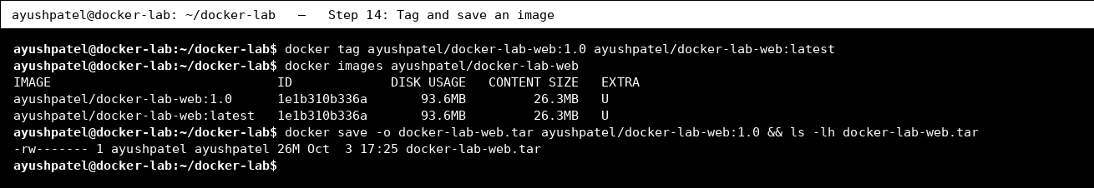

Step 15: Deploy with Docker Compose
Command | Purpose
cat docker-compose.yml | Shows the Compose file: one service built from our Dockerfile, port 8081, and a named volume for Nginx logs.
docker compose up -d --build | Builds the image and starts all services in the background with a single command.
docker compose ps | Lists the containers managed by this Compose project.
curl -s http://localhost:8081 | grep -E 'Name|Roll' | Verifies the Compose deployment is serving the page.
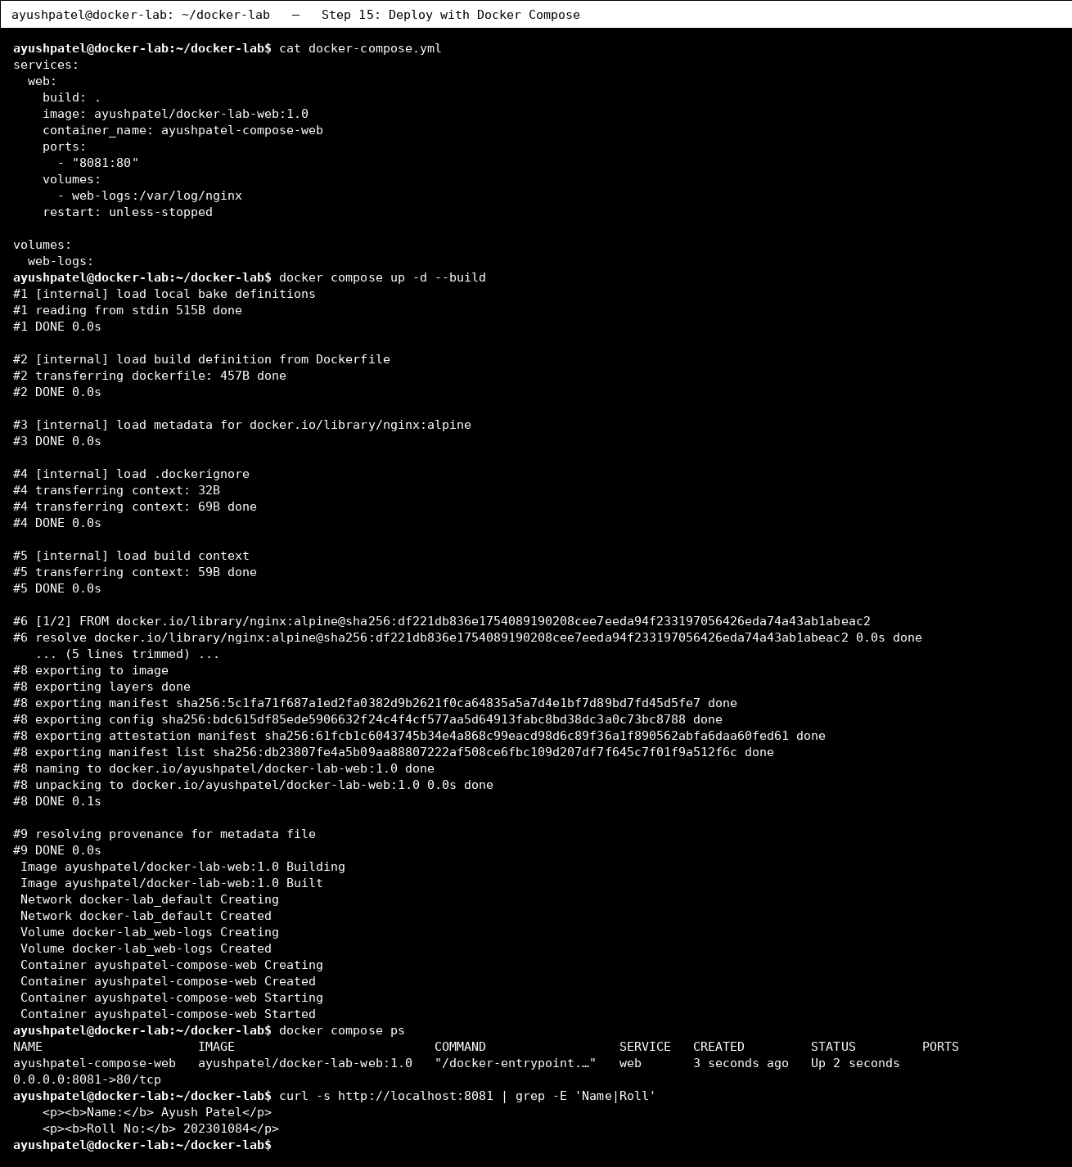
Browser view of the same app deployed with Docker Compose (port 8081).
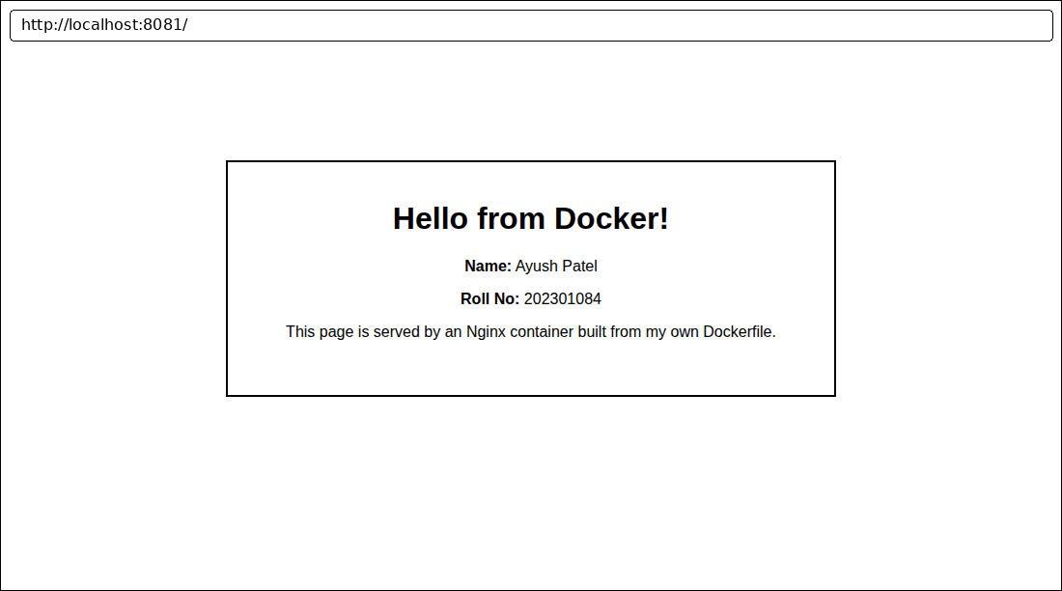

Step 16: Monitoring: stats and compose logs
Command | Purpose
docker stats --no-stream --format 'table {{.Name}}\t{{.CPUPerc}}\t{{.MemUsage}}' | Shows a one-time snapshot of CPU and memory usage of running containers.
docker compose logs --tail 3 | Shows the last log lines of the Compose services.
docker system df | Shows how much disk space images, containers and volumes use.
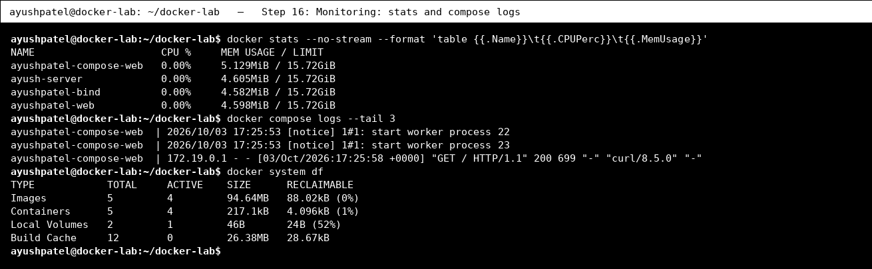

Step 17: Clean up
Command | Purpose
docker compose down -v | Stops and removes the Compose containers, network and volume (-v).
docker rm -f ayushpatel-web ayushpatel-bind ayush-server | Removes the remaining containers.
docker network rm ayush-net && docker volume rm ayush-data | Removes the custom network and volume.
docker container prune -f | Deletes all stopped containers (e.g. the hello-world one).
docker ps -a | Confirms no containers are left.
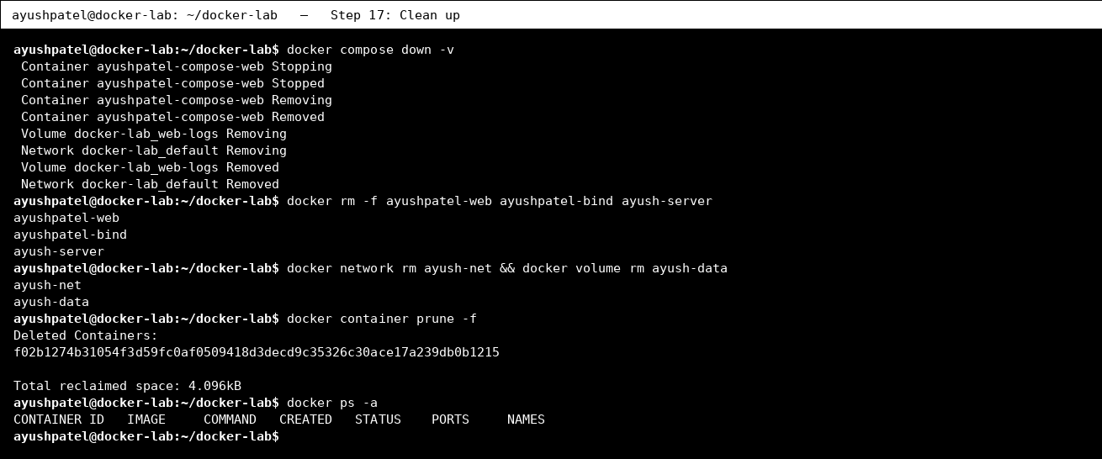

Conclusion
In this lab I installed and verified Docker, ran containers from public images, managed the container lifecycle, wrote a Dockerfile and built my own image, used named volumes and bind mounts for data, connected containers with a custom network, tagged/saved the image, and deployed the application with Docker Compose. The browser screenshots confirm the application ran successfully.

