**EXPERIMENT NO:-1**

**Name:- Patel Ayush P. Branch:- CS (13) Roll No:-CS 32**

* **AIM:** TO STUDY AND VERIFY TRUTH TABLES OF VARIOUS LOGIC GATES.

* **APPARATUS:** Logic trainer, IC 7402, IC 7400, IC 7408, IC 7432, IC 74266, IC 7486, IC 7404, Connecting wires, LEDs, Multimeter.

* **THEORY:**

A gate is a logic circuit that has one or more outputs. The outputs of the gate will depend upon the set of input conditions. The digital signal has two states LOW (0) and HIGH (1). Using gates we can implement variety of logic circuit that performs a particular task. For an example we can implement various arithmetic, logical and control units depending upon our requirement. Various types of gates are described below.

**[1] NOT Gate**: This gate has one input and one output. This gate inverts input at the output.

When input is LOW output is HIGH and vice versa.

SYMBOL:

A Y

BOOLEAN EXPRESSION:

|  |  |  |
| --- | --- | --- |
| Input | Output | Voltages |
| A | Y = A’ | (V) |
| 0 | 1 | 5 |
| 1 | 0 | 5 |

Y = A’

TRUTH TABLE:

# Table 1: NOT GATE

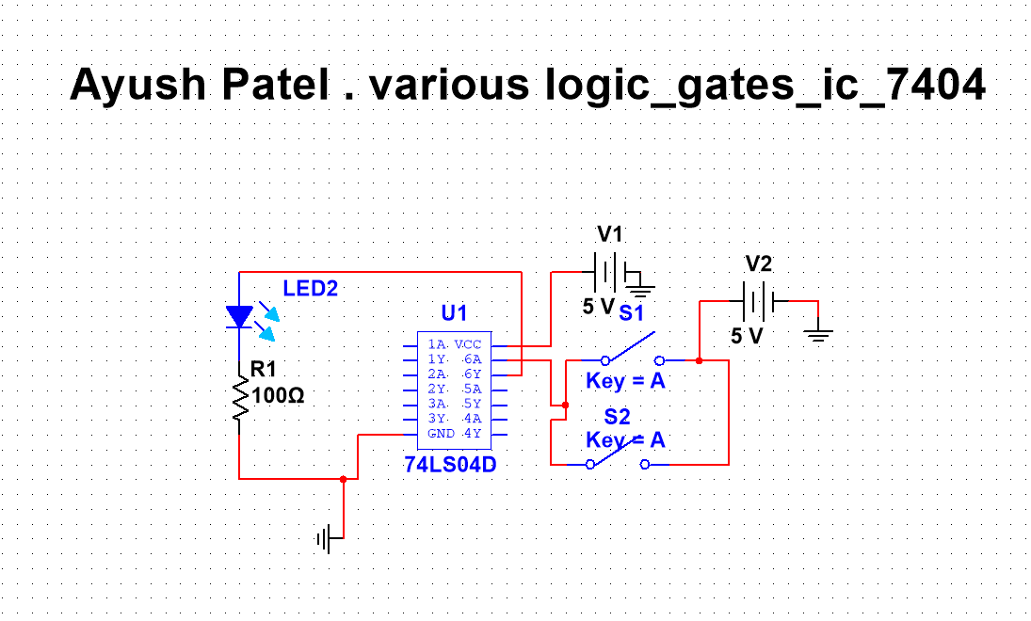

**[2]AND Gate**: This gate has two or more inputs and one output. Output of AND gate will go HIGH when all inputs are HIGH, otherwise output will remain LOW.

SYMBOL:

A

Y

|  |  |  |  |
| --- | --- | --- | --- |
| Inputs | | Output | Voltages |
| A | B | Y= A B | (V) |
| 0 | 0 | 0 | 5 |
| 0 | 1 | 0 | 5 |
| 1 | 0 | 0 | 5 |
| 1 | 1 | 1 | 5 |

B

BOOLEAN EXPRESSION: Y =  **A B**

TRUTH TABLE:

# Table 2 : AND GATE

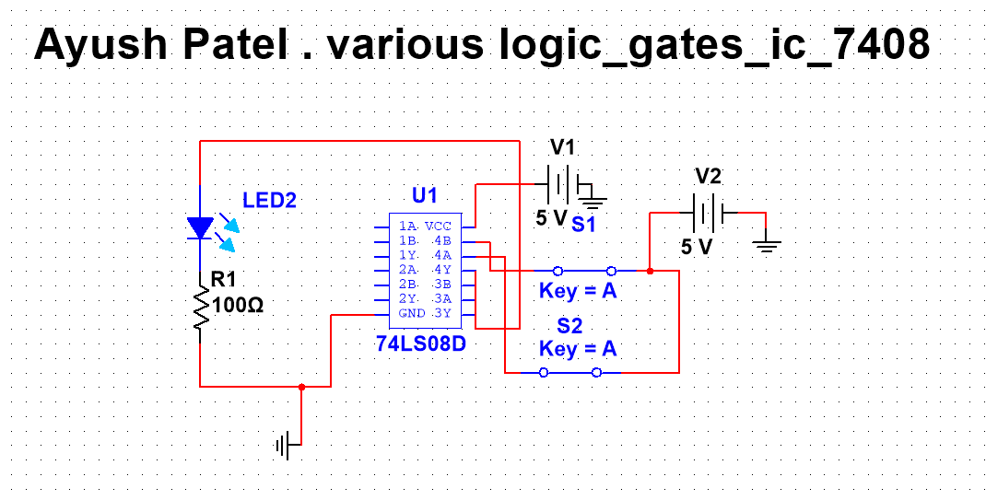

**[3] OR Gate**: This gate has two or more inputs and one output. Output of OR gate will go HIGH when any of the input is HIGH. Output is LOW when all inputs are LOW.

SYMBOL:

A

Y

B

BOOLEAN EXPRESSION: Y = A + B

|  |  |  |  |
| --- | --- | --- | --- |
| Inputs | | Output | Voltages |
| A | B | Y=A+B | (V) |
| 0 | 1 | 0 | 5 |
| 0 | 1 | 1 | 5 |
| 1 | 0 | 1 | 5 |
| 1 | 1 | 1 | 5 |

TRUTH TABLE:

# Table 3: OR GATE

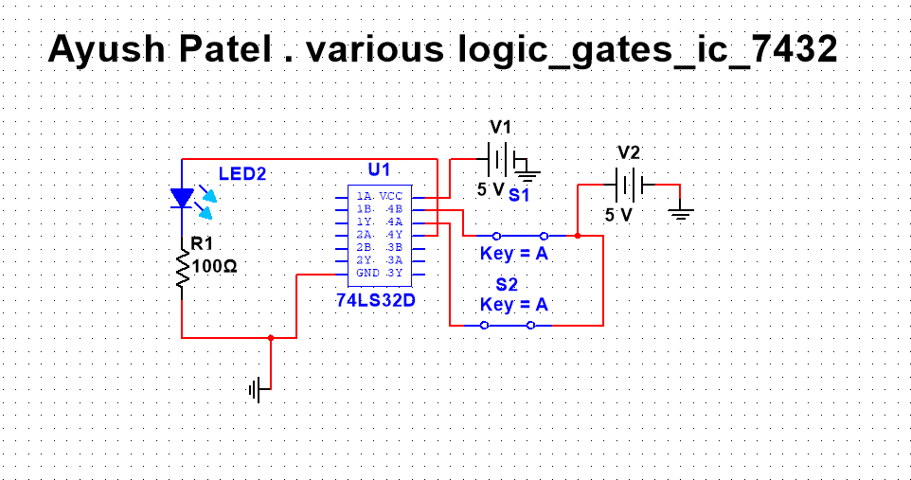

**[4] XOR Gate:** This gate has two inputs and one output. Output will go HIGH when all inputs are not of the same logic level (i.e. all inputs are not LOW or not HIGH at a time).

|  |  |  |  |
| --- | --- | --- | --- |
| Inputs | | Output | Voltages |
| A | B | Y= A + B | (V) |
| 0 | 0 | 0 | 5 |
| 0 | 1 | 1 | 5 |
| 1 | 0 | 1 | 5 |
| 1 | 1 | 0 | 5 |

SYMBOL:

A

Y

B

BOOLEAN EXPRESSION: Y= A + B

TRUTH TABLE:

# Table 4: XOR GATE

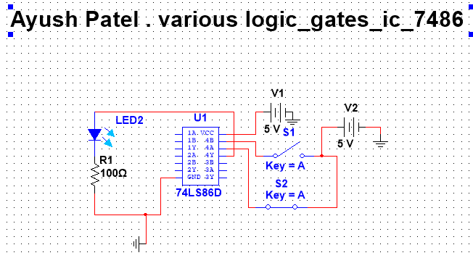

**[5] XNOR Gate:** This gate has two inputs and one output. Output will go HIGH when all inputs are of same logic level (i.e. all inputs are LOW or HIGH at a time).

SYMBOL:

|  |  |  |  |
| --- | --- | --- | --- |
| Inputs | | Output | Voltages |
| A | B | Y= A + B | (V) |
| 0 | 0 | 1 | 5 |
| 0 | 1 | 0 | 5 |
| 1 | 0 | 0 | 5 |
| 1 | 1 | 1 | 5 |

A

Y

B

BOOLEAN EXPRESSION: Y = A + B

TRUTH TABLE:

# Table 5: XNOR GATE

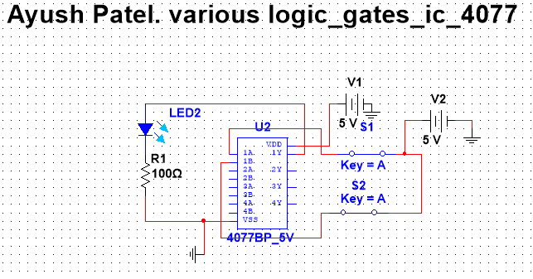

**6] NAND Gate:** If we put one inverter at the output of AND logic gate will be NAND gate.

SYMBOL:

A Y

B

BOOLEAN EXPRESSION: Y = A B

TRUTH TABLE:

|  |  |  |  |
| --- | --- | --- | --- |
| Inputs | | Output | Voltages |
| A | B | Y= A B | (V) |
| 0 | 0 | 1 | 5 |
| 0 | 1 | 1 | 5 |
| 1 | 0 | 1 | 5 |
| 1 | 1 | 0 | 5 |

# Table 6: NAND GATE

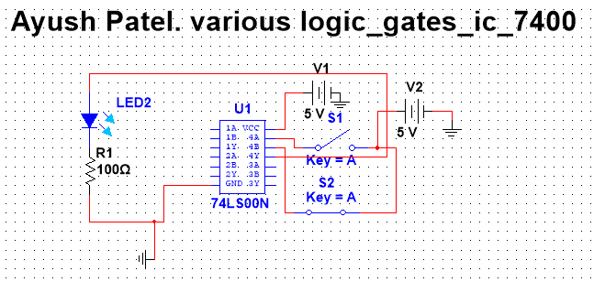

**[7] NOR Gate:** If we put one inverter at the output of OR logic gate will be NOR gate.

SYMBOL:

A

B Y

BOOLEAN EXPRESSION: Y = A+B

TRUTH TABLE:

# Table 7: NOR GATE

|  |  |  |  |
| --- | --- | --- | --- |
| Inputs | | Output | Voltages |
| A | B | Y= A+B | (V) |
| 0 | 0 | 1 | 5 |
| 0 | 1 | 0 | 5 |
| 1 | 0 | 0 | 5 |
| 1 | 1 | 0 | 5 |

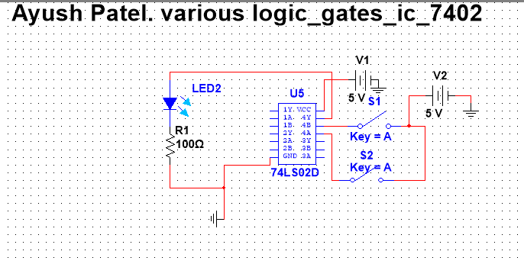

* **PROCEDURE:** 
  1. Select appropriate IC for each logic gate
  2. Make the connections according to the requirements.
  3. Make sure the connections of Vcc and grounds are at their respective pins
  4. Switch on the power and apply sequence of inputs and observe outputs.

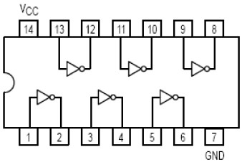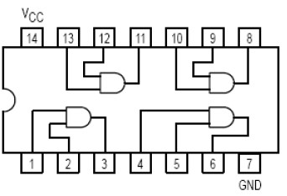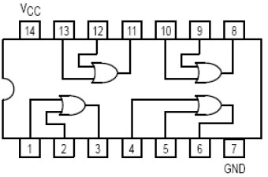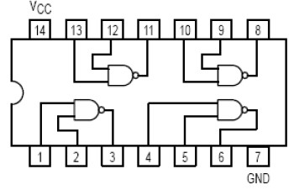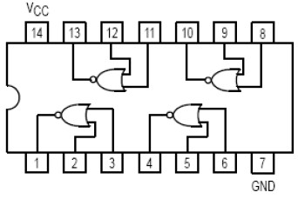

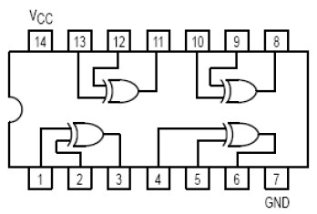

2- Input EX-NOR Ic: 74266

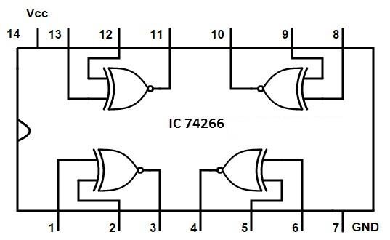

* Conclusion:

BY performing this practical we study and verify truth tables of various logic gates .