EXPERIMENT NO:-2

Name:- Patel Ayush P. Branch:- CS (13) Roll No:-CS 32

- AIM: To verify the De’Morgan’s Theorems.

- APPARATUS :

  - IC 7400 : Quad - Dual input NAND Gate

  - IC 7402 : Quad – Dual input NOR Gate

  - IC 7408 : Quad – Dual input AND Gate

  - IC 7432 : Quad – Dual input OR gate

  - IC 7404 : Hex – Not gate

- THEORY:

Inverting all inputs to a gate reverses that gate’s essential function from AND to

OR, or vice versa, and also inverts the output. So, an OR gate with all inputs inverted (a Negative-OR gate) behaves the same as a NAND gate, and an AND gate with all inputs inverted (a Negative-AND gate) behaves the same as a NOR gate. DeMorgan’s theorems state the same equivalence in “backward” form: that inverting the output of any gate results in the same function as the opposite type of gate (AND vs. OR) with inverted inputs:
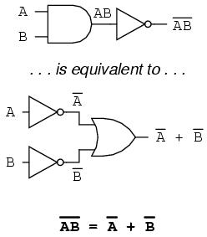

- Statement and Proof of De’Morgan’s First Law:

The complement of sum is equal to the product of compliments of complements of individuals variable

[B] Statement and proof of De’Morgan’s second Law :

The compliment of the product is equal to the sum of compliment of individual variables
- PROCEDURE:

- Connect the circuit on the bread board using ICs.

- Switch ON the power supply.

- Test the truth table of different gates by changing the input levels (i.e. ‘1’ means HIGH & ‘0’ means LOW) and check the level of output voltage.(if LED glows it is at level
‘1’ and if LED doesn’t glow output is at level ‘0’).

- Verify that the De’Morgan’s laws are proved.

For De’Morgan’s First Law:

When Input A=1 & B=1 Output will be:-

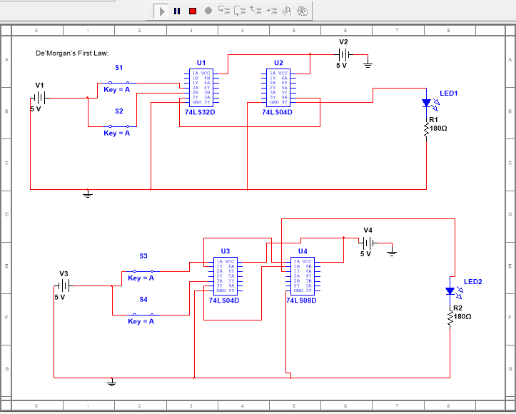

When Input A=1 & B=0 Output will be:-
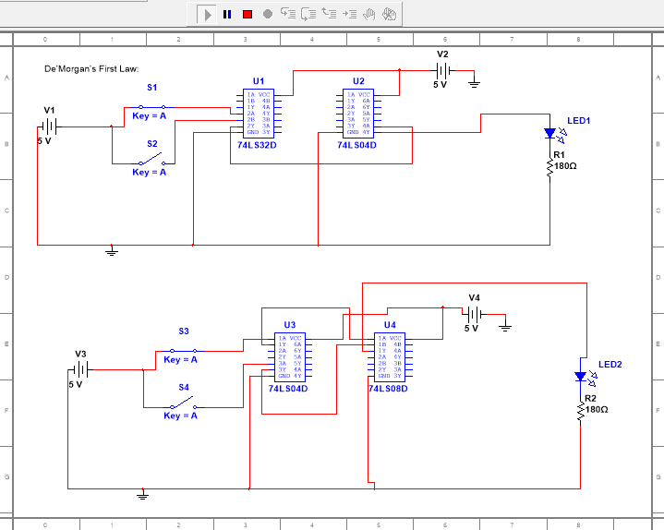

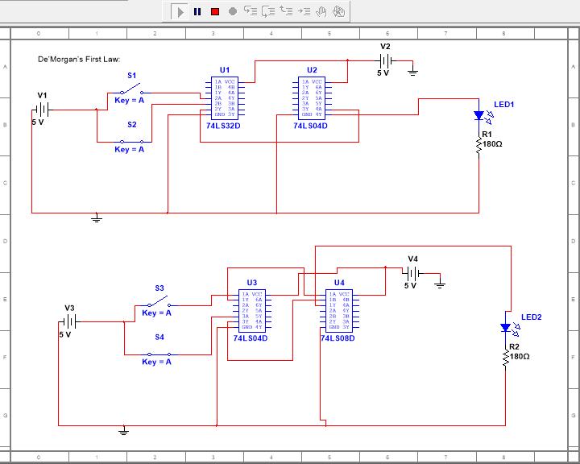
When Input A=0 & B=1 Output will be:-

When Input A=0 & B=0 Output will be:-

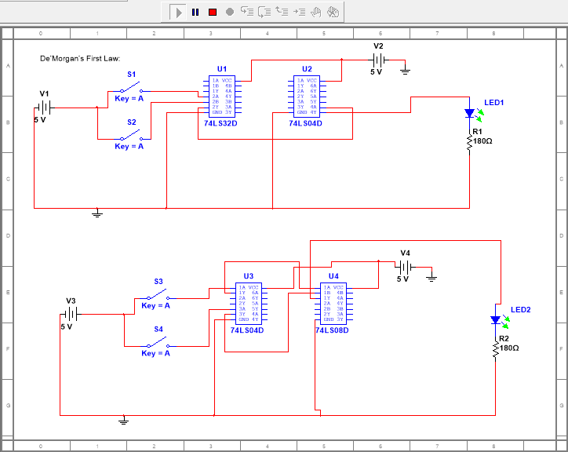

For De’Morgan’s Second Law:-

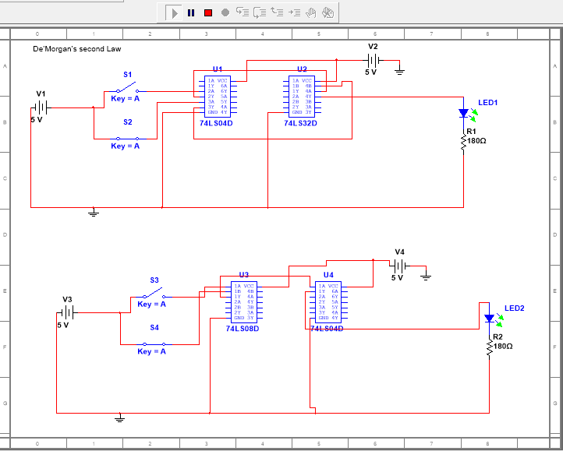
When Input A=0 & B=0 Output will be:-
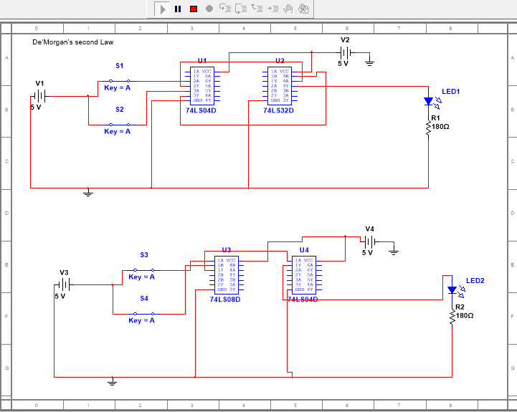
When Input A=0 & B=1 Output will be:-

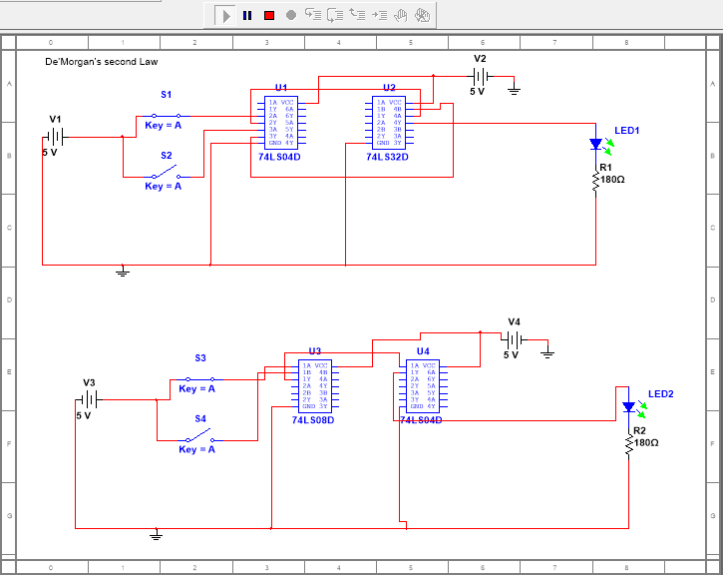
When Input A=1 & B=0 Output will be:-

When Input A=1 & B=1 Output will be:-

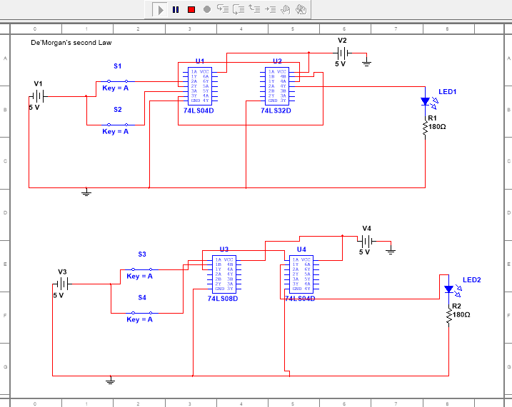
- CONCLUSION:

By performing this practical, we have proved De Moragan's law by using IC's, logic gates, and truth tables.

