**Name:- Patel Ayush Padminkumar**

**Branch:- Cyber security (13)**

**Batch :- CS 32**

**Practical-4**

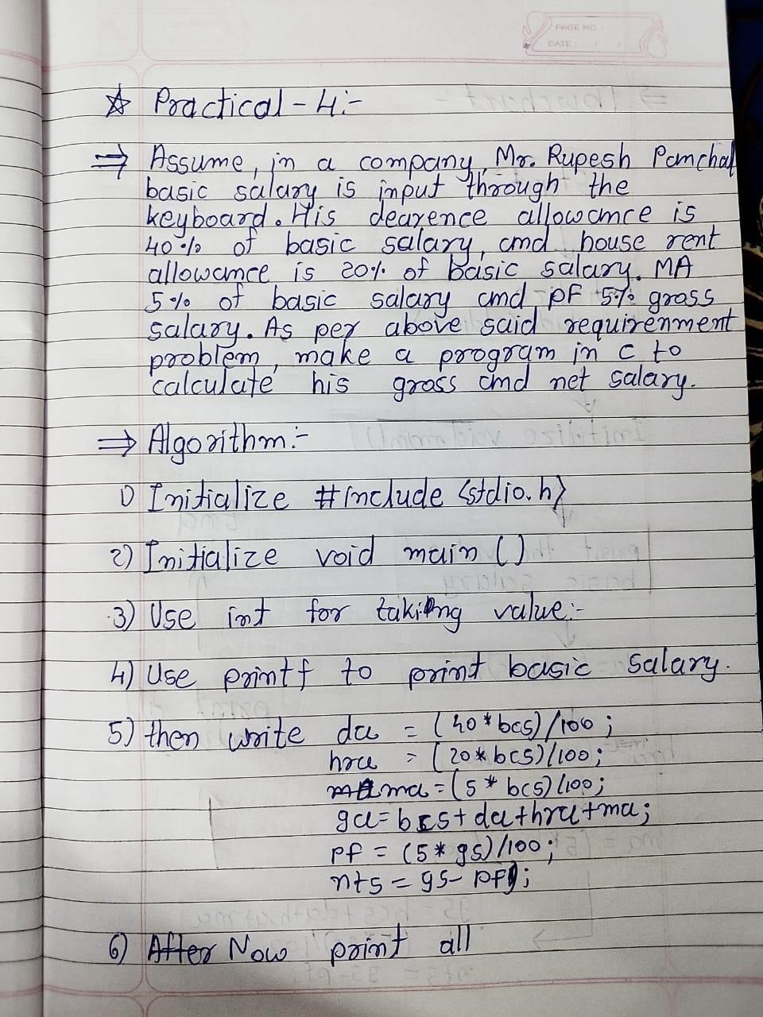

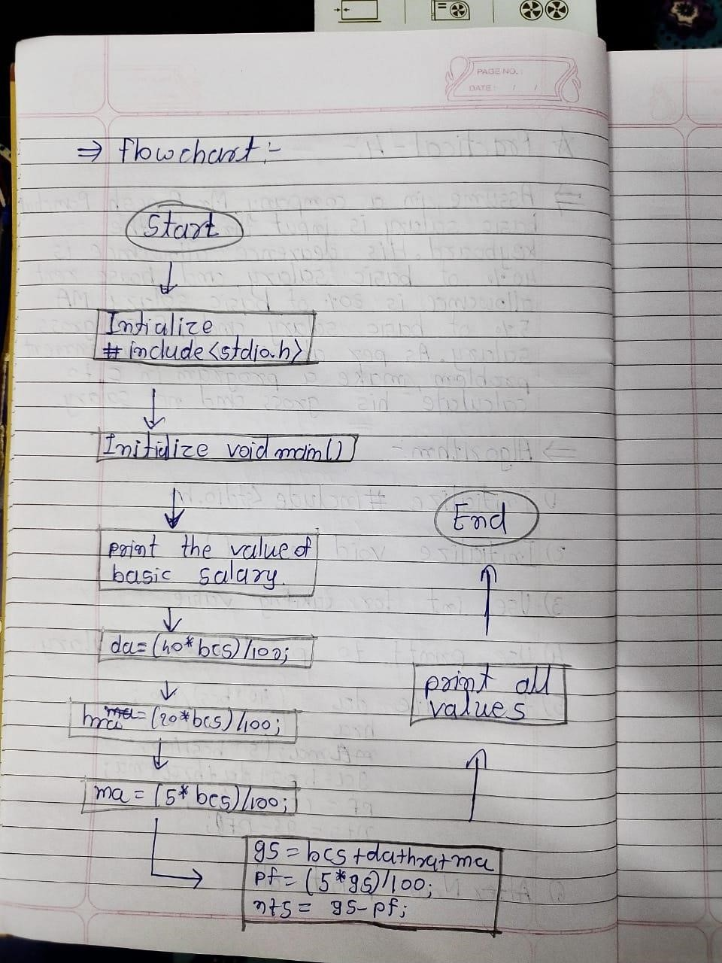

Code:-

#include<stdio.h> void main()

{

int bcs,da,hra,ma,gs,nts,pf; printf("Enter the basic salary:"); scanf("%d",&bcs); da=(40*bcs)/100; hra=(20*bcs)/100; ma=(5*bcs)/100; gs=bcs+da+hra+ma; pf=(5*gs)/100; nts=gs-pf; printf("\nbasic salary:%d",bcs); printf("\ndearness allowance:%d",da); printf("\nhouse rent allowance:%d",hra); printf("\nM A:%d",ma); printf("\ngross salary:%d",gs); printf("\nprovident fund:%d",pf); printf("\nnet salary:%d",nts);

}

Output:-

