LOGIN PAGE AND SIGNUP PAGE

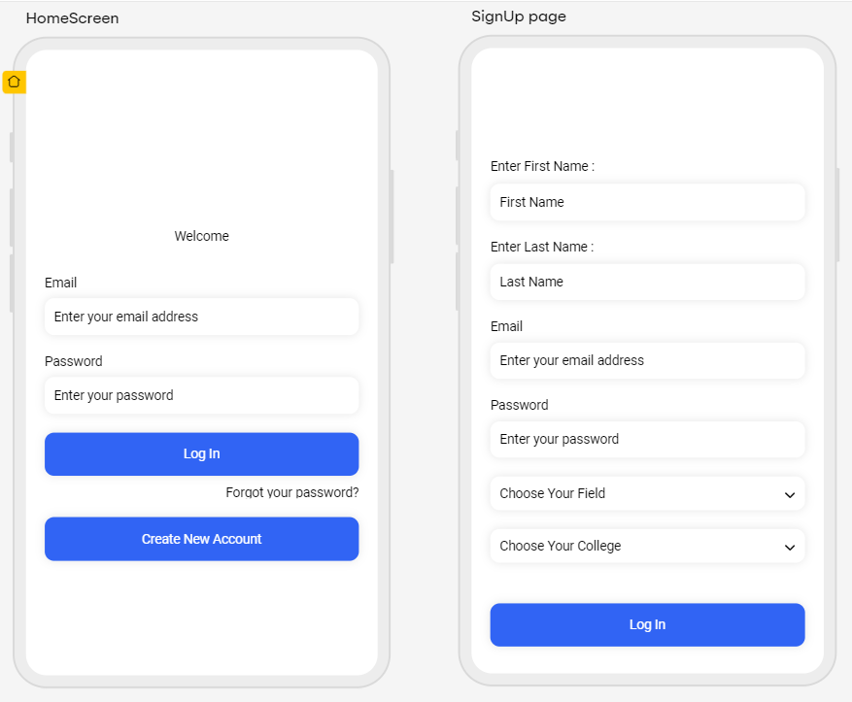

This is MAIN Home page that containts POSTS

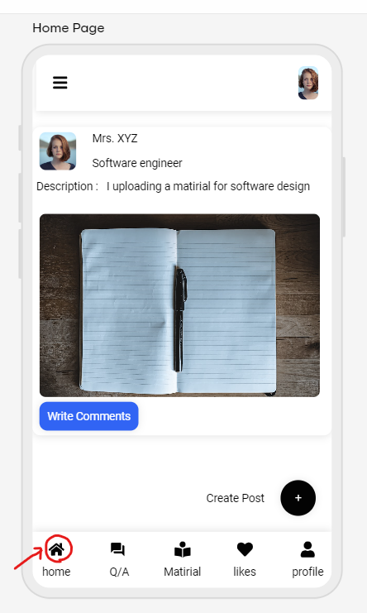

This is Q/A page that contains the Questions and answers

we can answer the question and we ask a questios

Questions and answers page.

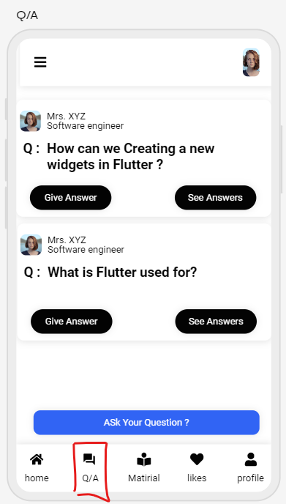

Matirials page

1. Select branch
2. Select Subject.
3. What matirial ypu want (book , notes , assignment)

