Express Js

* Is server side framework.
* If you want to use Node Js on server side then you will use Express Js.
* We can create our API.
* Unopinionated (You can write code on own opnion)
* Open vs code in particular folder.
* Open terminal and type: npm init

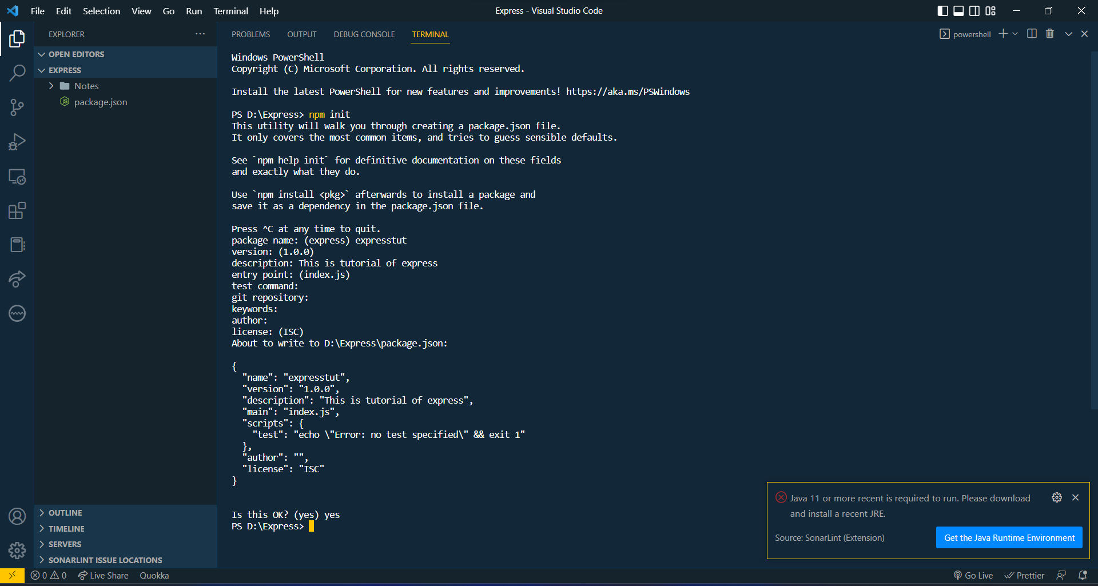

* Create index.js (because it is entry point: we define in above image.)
* We write code in index.js

**Node js:** browser per je javaScript run thay che ene server per run karva mate no ek tariko che.

* Run this command in terminal : $ npm install express --save

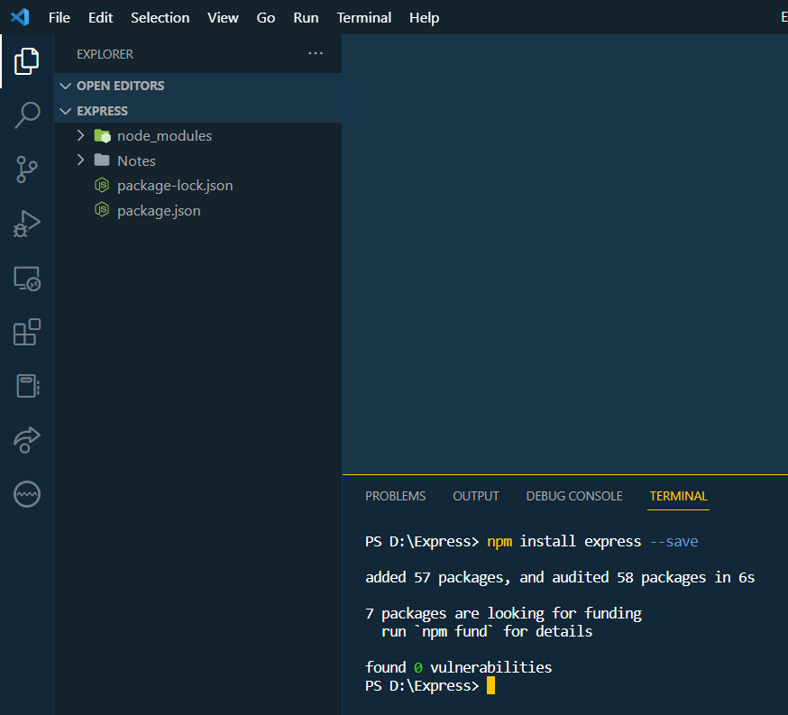

**npm** 🡪 is a package manager of node. With help of we can download other packages in node_modules. Also we can use other package using npm.

**node_modules**: is a very big folder. When we run ***npm i*** or ***npm init*** that time this folder is created

[Docs: of Hello world](https://expressjs.com/en/starter/hello-world.html)

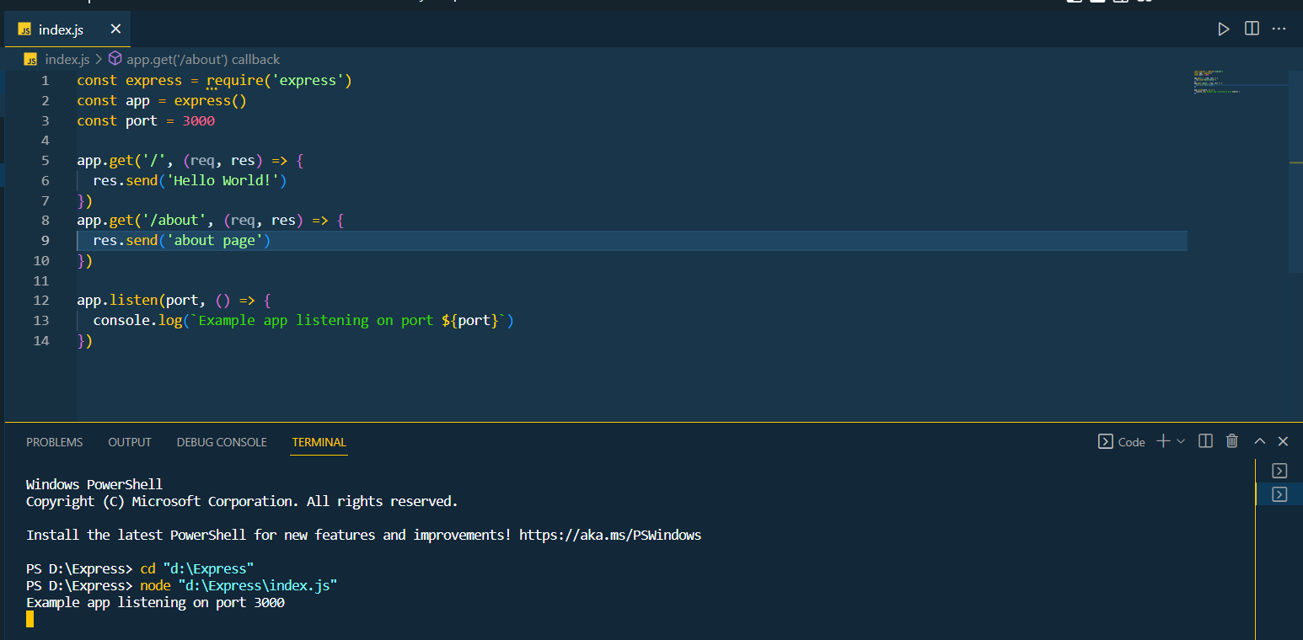

Open any browser and type:

localhost:3000 🡪 This page show message “Hello World!”

here 3000 is our port number which is we define in code.  
localhost:3000/about 🡪 This page show message “about page”

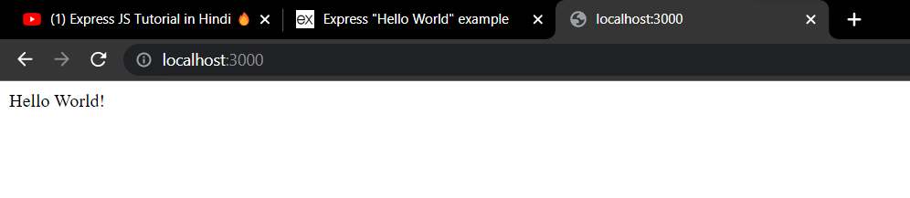

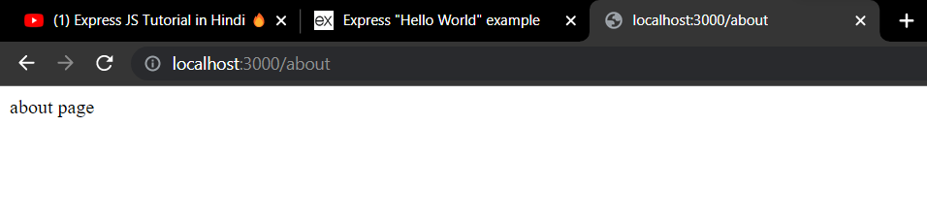

Now, install extension thunder client.

It is use to run code inner vs code.

Which is use for pass get request. Like to run above program in vs code. Open thunder client and type:

<http://localhost:3000>

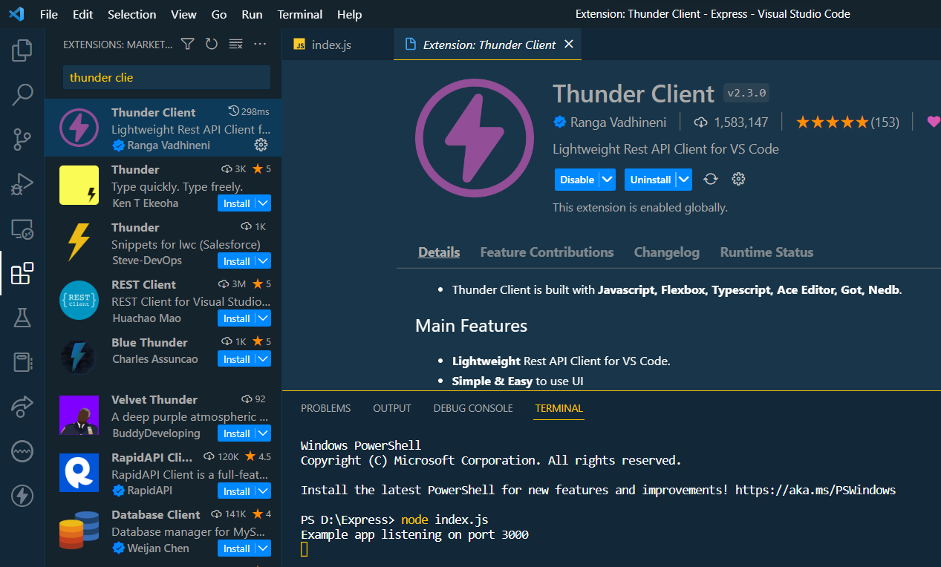

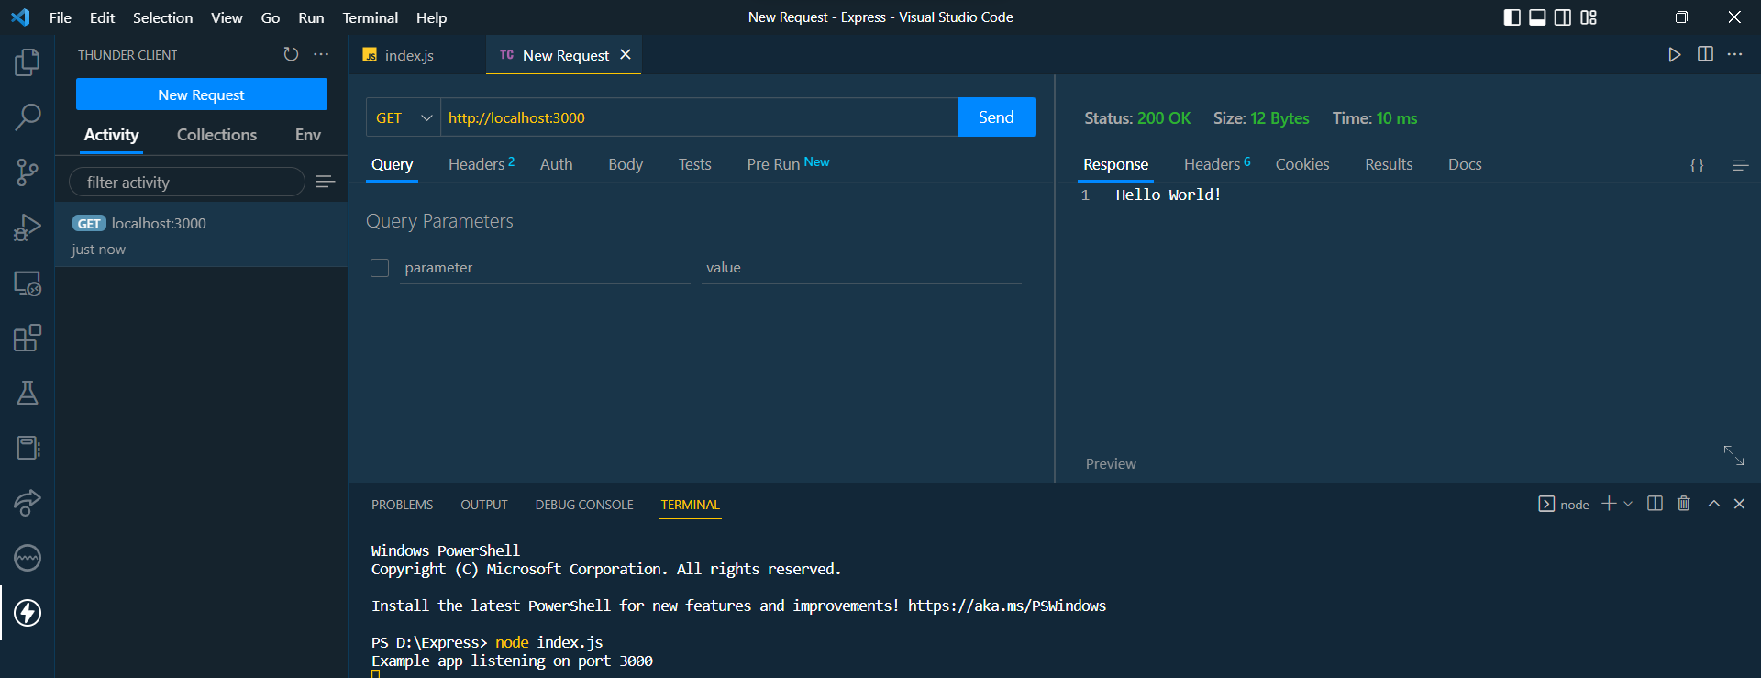

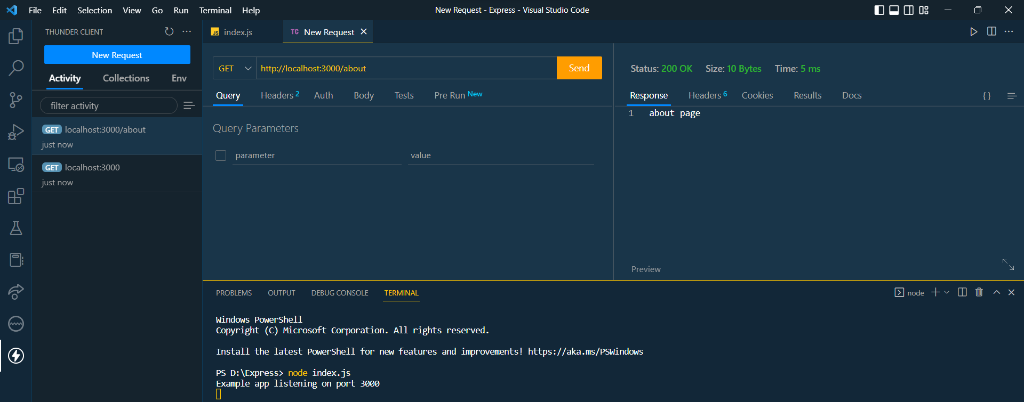

We can also pass the file. Like inde.html , etc. use below code like that

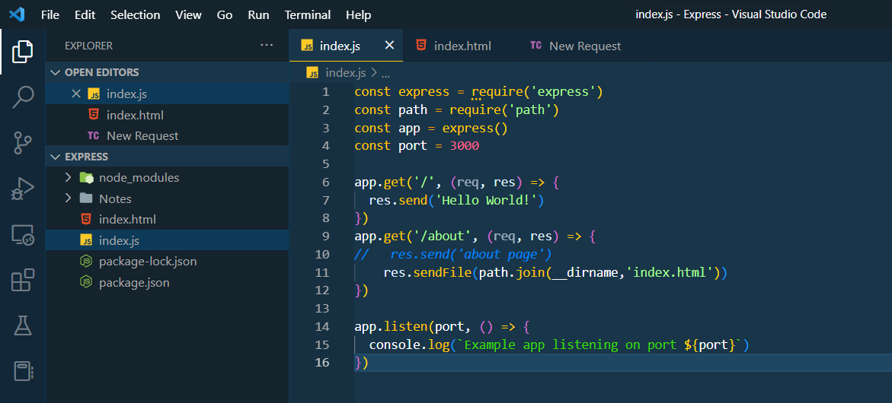

Open terminal: npm install -g nodemon

It is use to automatic execute code

Now type: nodemon index.js

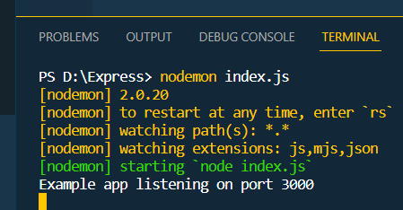

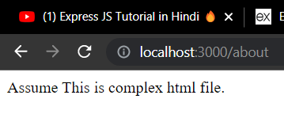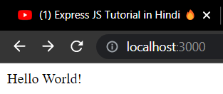

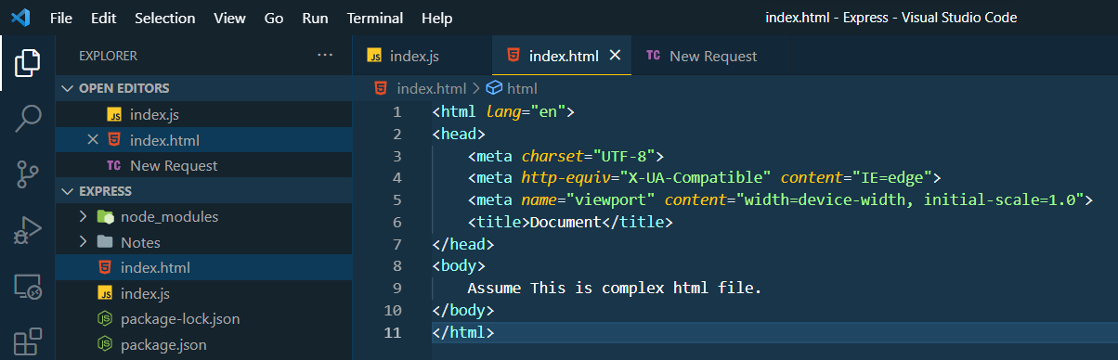

We add bootstrap in index.html

With help of express we can also create static website.

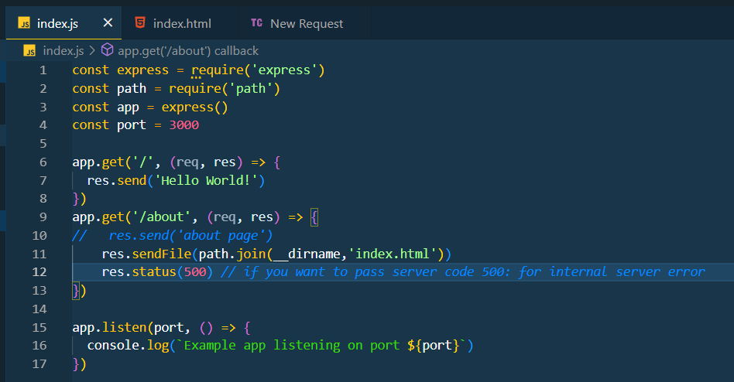

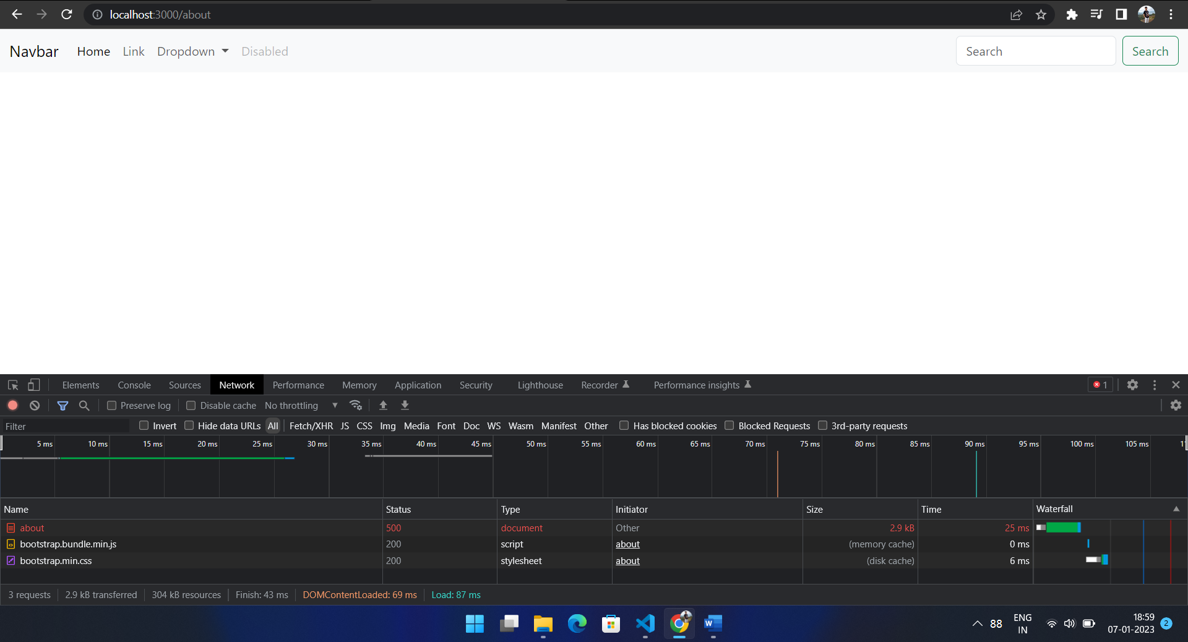

Pass json:

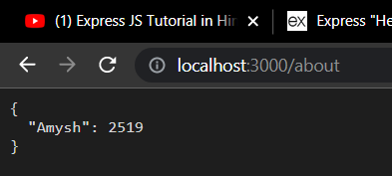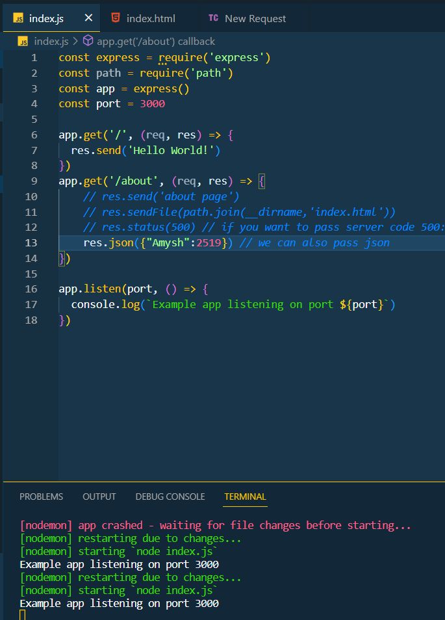

Now we will serve static folder.

* We use middle ware: app.use()

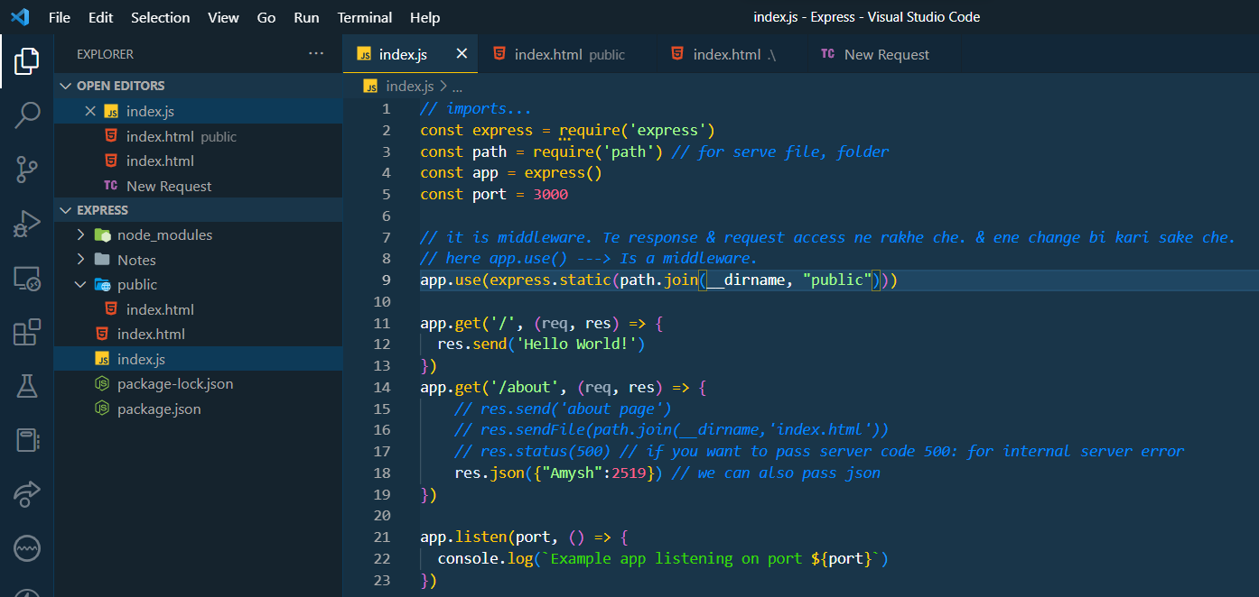

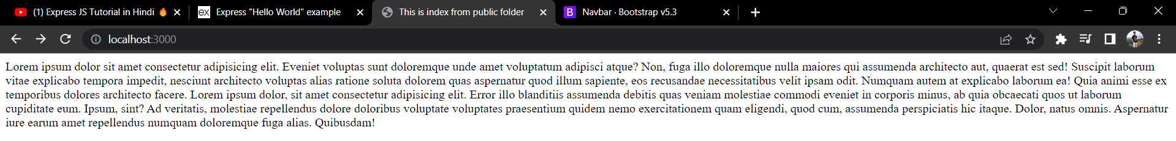

* We can also write our own middle ware.

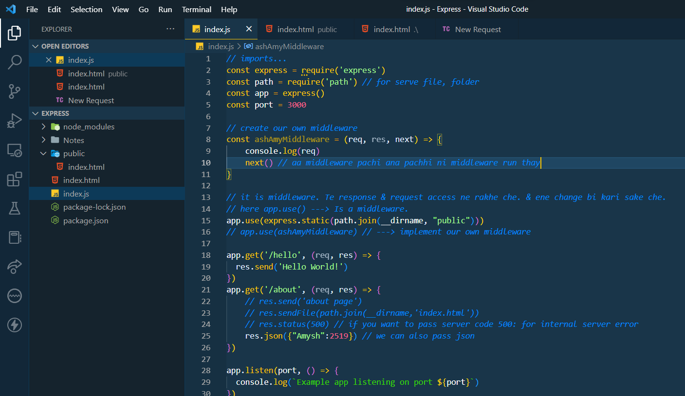



Pass any parameter.

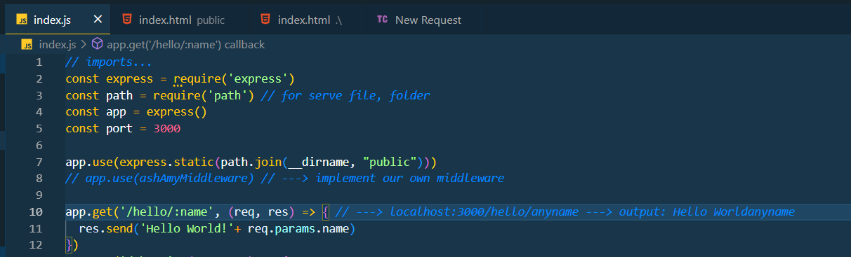

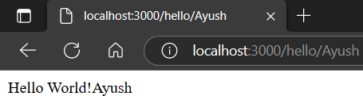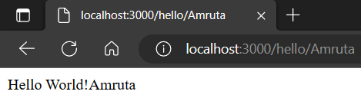

Blog Express folder

File structure:

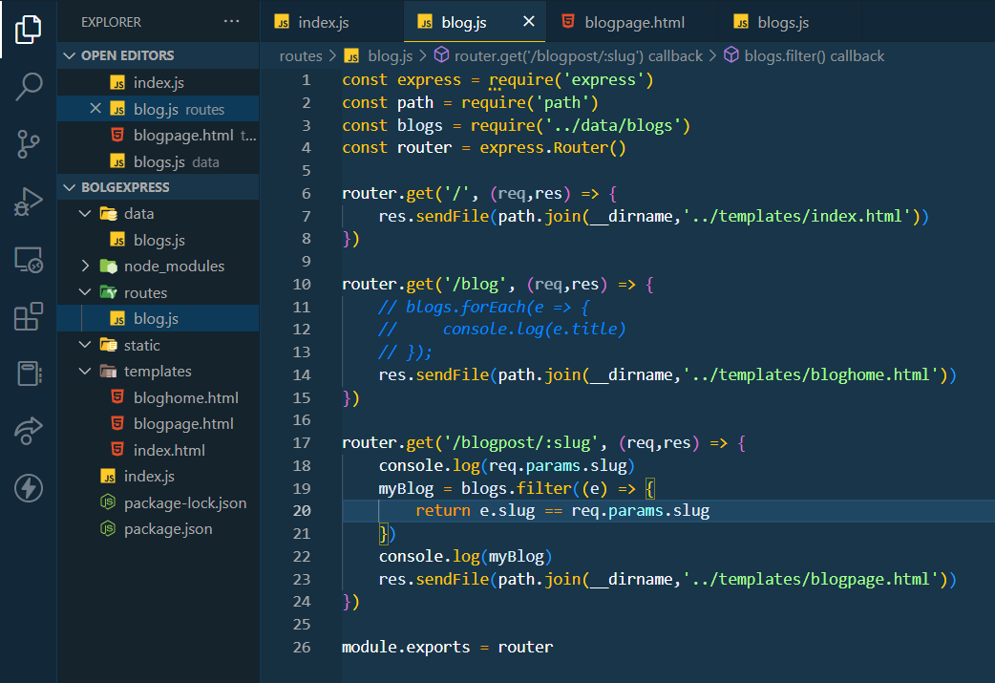

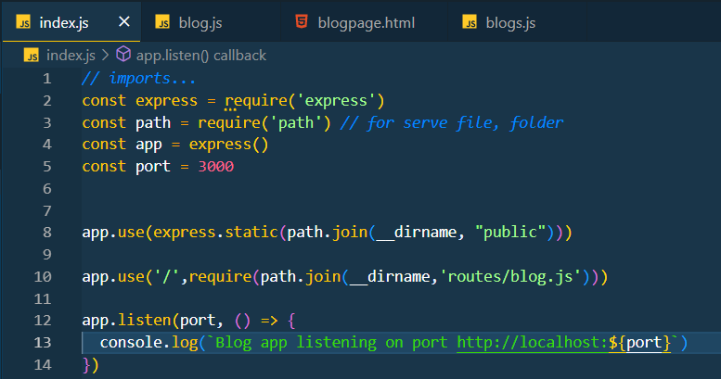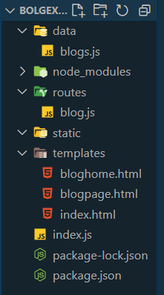s

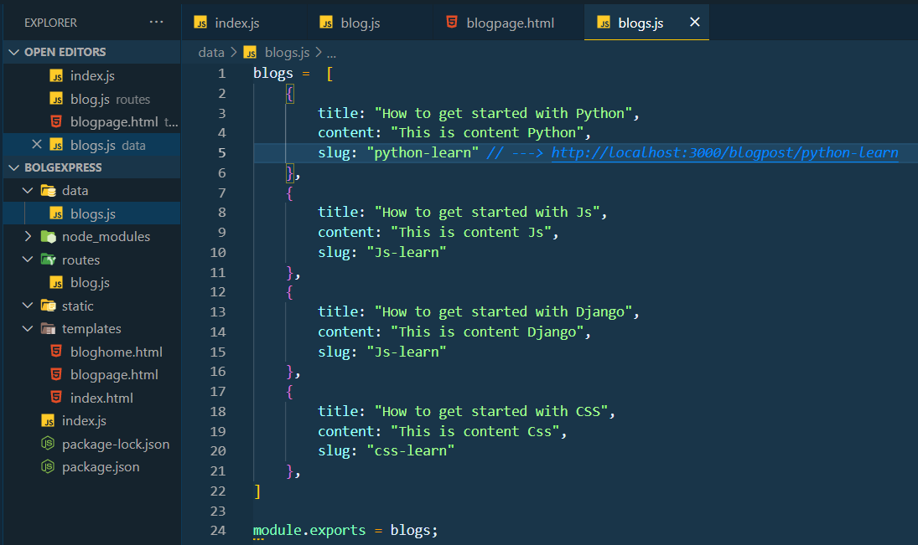

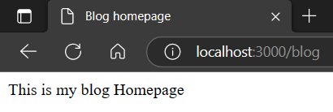  
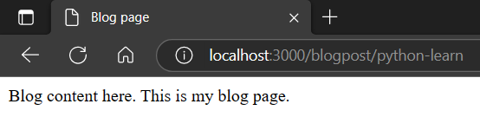  
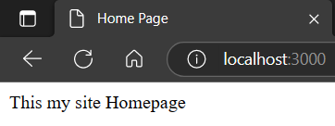

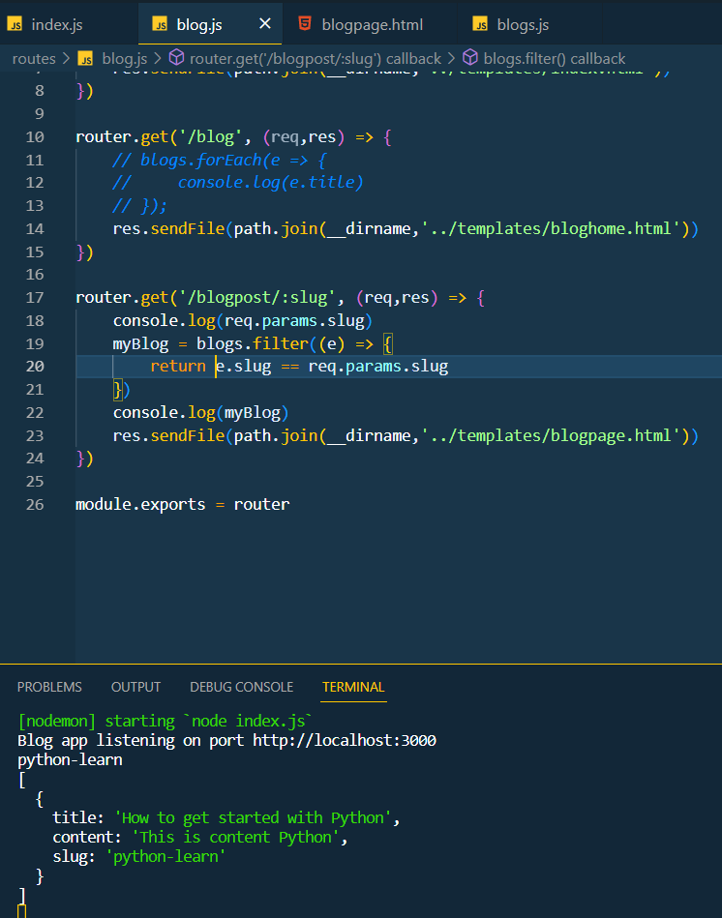

* Now use with database we use: [mongoose.](https://mongoosejs.com/)
* Which is use to connect with database.

Now, we use handlebars.

* Express handlebars & (Is a npm package)
* Handlebars (Is templating engine which is very helpful for JavaScrip templating)

$ npm install express-handlebars

[Follow this docs in above project](https://github.com/ericf/express-handlebars)

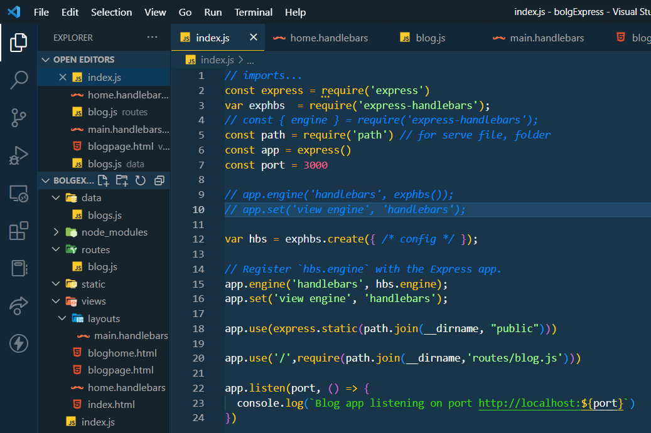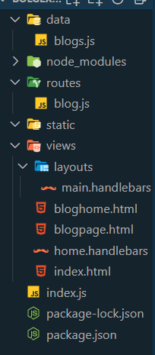s

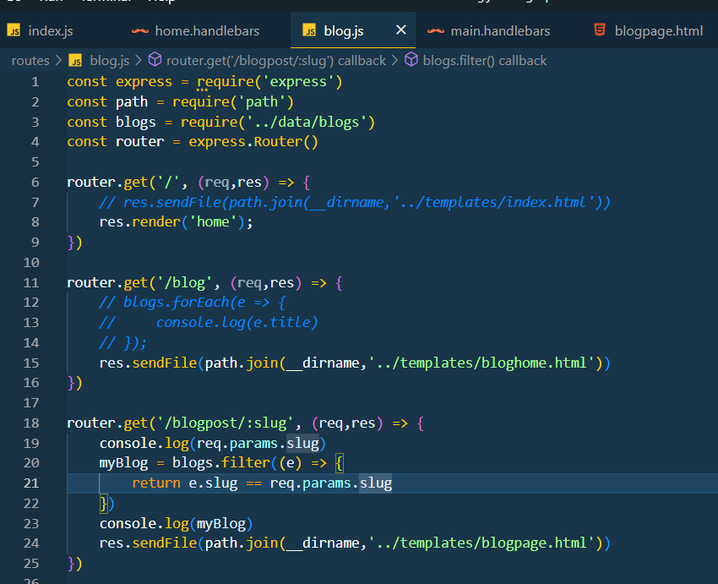

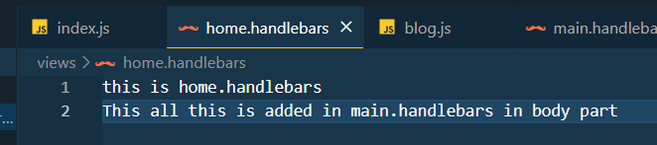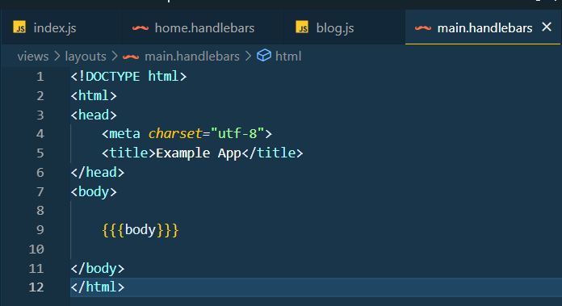Output:

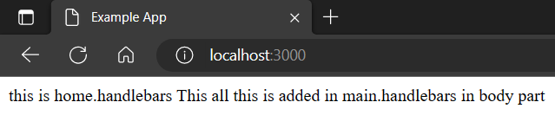

**Extra:**

Why Express js is used ?

Express is a node js web application framework that provides broad features for building web and mobile applications. It is used **to build a single page, multipage, and hybrid web application**. It's a layer built on the top of the Node js that helps manage servers and routes.

* Now create other files in view folder.

- blogHome.handlebars

- blogPage.handlebars

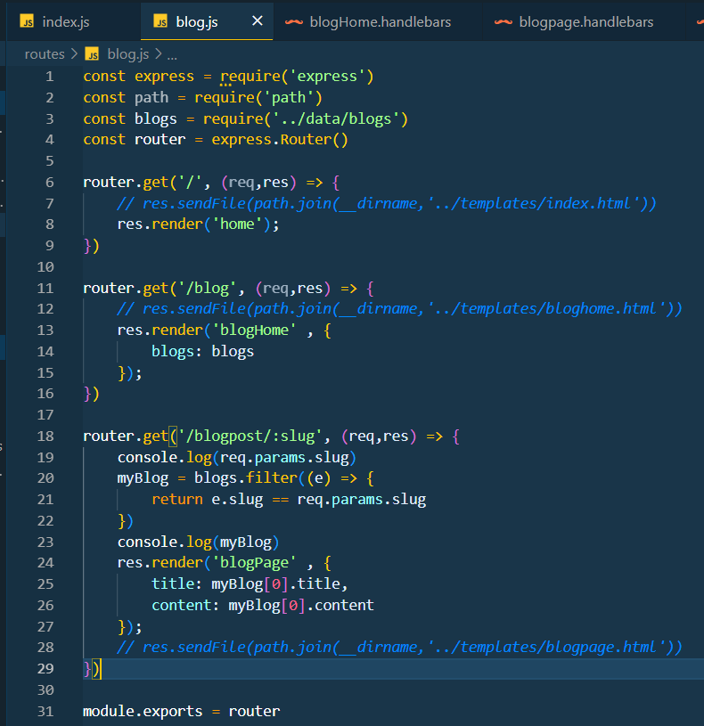

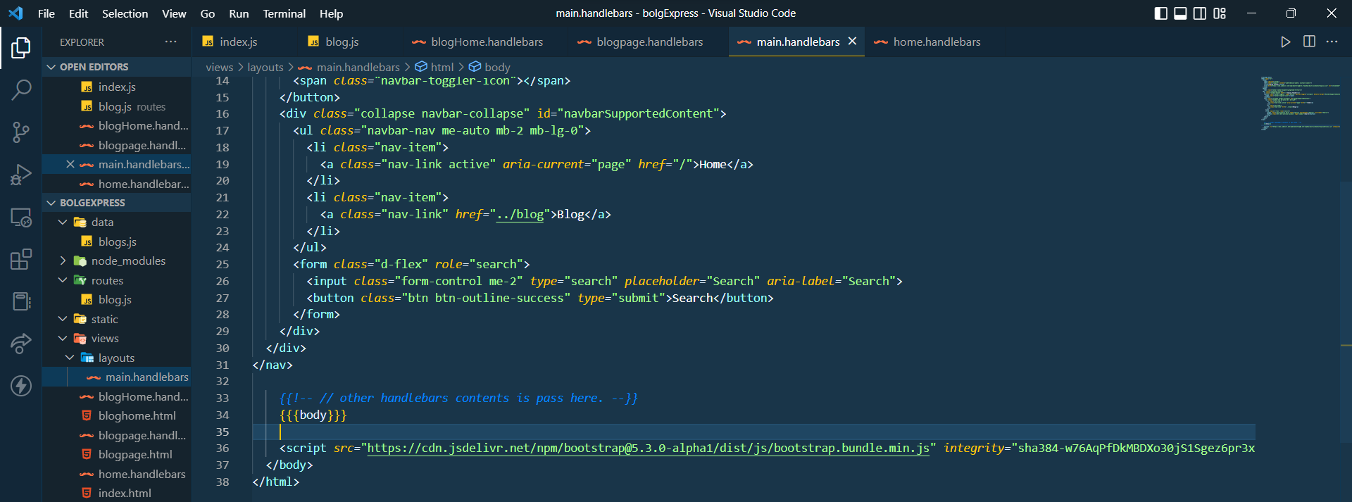

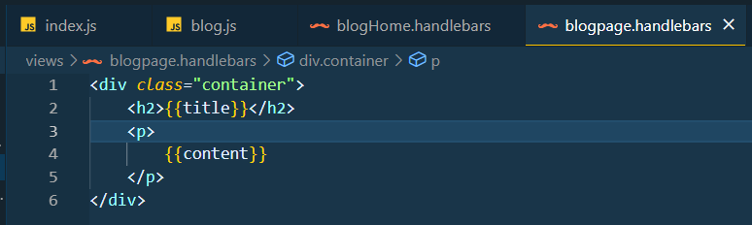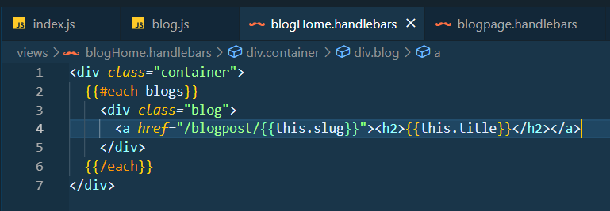

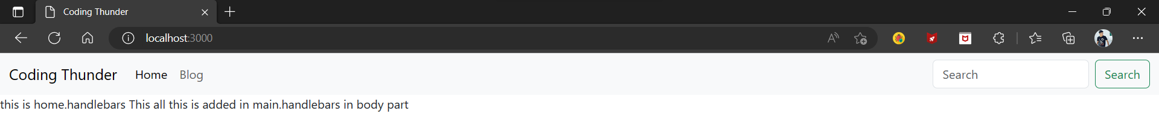

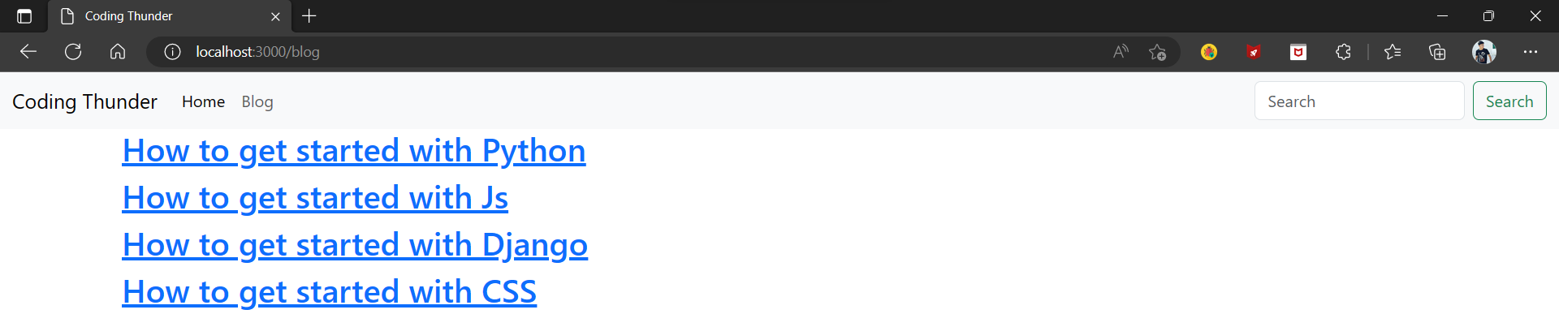

Click any one of link.

