**PROJECT TITLE- “SCHOOL MANAGEMENT**”

**DBMS: MySQL**

**Host : localhost**

**User: root**

**Password: tiger**

**DataBase: mysql**

**Table Structure: As per the Screenshot given below:**

**Table:Student**

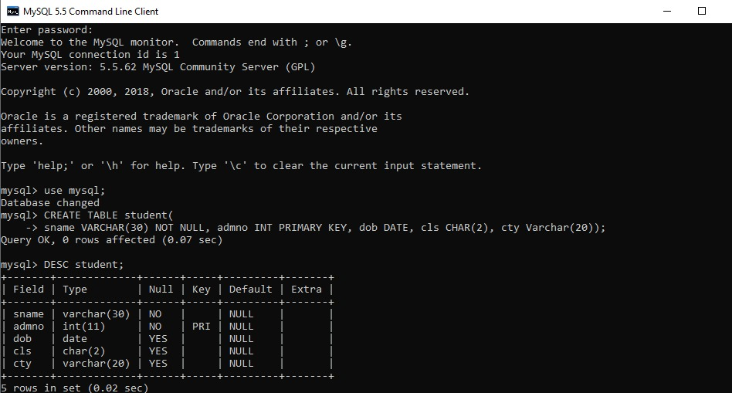

**Table: Emp**

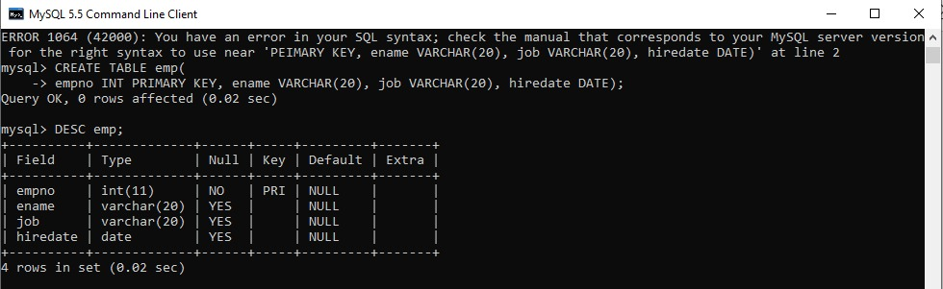

**Table:Fee**

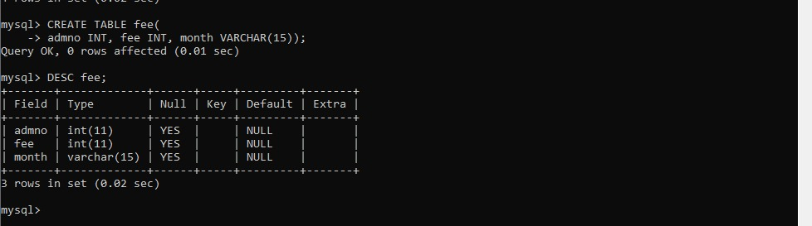

**Table:Exam**

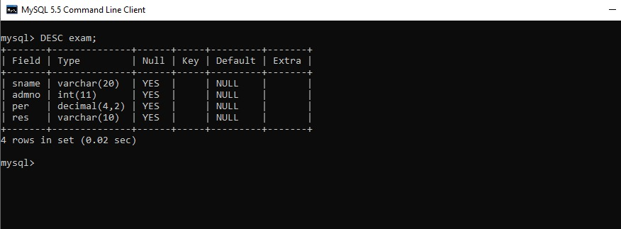

**Python Code:**

import os

import platform

import mysql.connector as my

#import pandas as pd

#from pandas import DataFrame

def selection():

db= my.connect(host='localhost',user='root',passwd='',database='mysql')

cursor = db.cursor()

print("------------------------------------\nWELCOME TO SCHOOL MANAGEMENT SYSTEM\n------------------------------------")

print("1.STUDENT MANAGEMENT")

print("2.EMPLOYEE MANAGEMENT")

print("3.FEE MANAGEMENT")

print("4.EXAM MANAGEMENT")

ch=int(input("\nEnter your choice(1-4):"))

if ch==1:

print("\nWELCOME TO STUDENT MANAGEMENT SYSTEM\n")

print("a. NEW ADMISSION")

print("b. UPDATE STUDENT DETAILS")

print("c. ISSUE TC")

c=input("Enter your choice(a-c): ")

print("\nInitially the details are...\n")

display1()

if c=='a':

insert1()

print("\nModified details are...\n")

display1()

elif c=='b':

update1()

print("\nModified details are...\n")

display1()

elif c=='c':

delete1()

print("\nModified details are...\n")

display1()

else:

print("Enter correct choice...!!")

elif ch==2:

print("WELCOME TO EMPLOYEE MANAGEMENT SYSTEM")

print("a. NEW EMPLOYEE")

print("b. UPDATE STAFF DETAILS")

print("C. DELETE EMPLOYEE")

c=input("Enter your choice(a-c): ")

if c=='a':

insert2()

print("\nModified details are...\n")

display2()

elif c=='b':

update2()

print("\nModified details are...\n")

display2()

elif c=='c':

delete2()

print("\nMdified details are...\n")

display2()

else:

print("Enter correct choice...!!")

elif ch==3:

print("WELCOME TO FEE MANAGEMENT SYSTEM")

print("a. NEW FEE")

print("b. UPDATE FEE")

print("c. EXEMPT FEE")

c=input("Enter your choice(a-c): ")

if c=='a':

insert3()

elif c=='b':

update3()

elif c=='c':

delete3()

else:

print("Enter correct choice...!!")

elif ch==4:

print("WELCOME TO EXAM MANAGEMENT SYSTEM")

print("a. EXAM DETAILS")

print("b. UPDATE DETAILS")

print("c. EXEMPT DETAILS")

c=input("Enter your choice(a-c): ")

if c=='a':

insert4()

elif c=='b':

update4()

elif c=='c':

delete4()

else:

print("Enter correct choice...!!")

else:

print("Enter correct choice...!!")

def insert1():

sname = input("Enter Student Name : ")

admno = int(input("Enter Admission No : "))

dob = input("Enter Date of Birth(yyyy-mm-dd) : ")

cls = input("Enter class for admission : ")

cty = input("Enter City : ")

db = my.connect(host= 'localhost', user= 'root', passwd='', database= 'mysql')

cursor = db.cursor()

sql="INSERT INTO student(sname,admno,dob,cls,cty)VALUES('{}',{},'{}','{}','{}')".format(sname,admno,dob,cls,cty)

try:

cursor.execute(sql)

db.commit()

except:

db.rollback()

db.close()

def display1():

try:

db= my.connect(host= 'localhost', user= 'root', passwd='', database= 'mysql')

cursor = db.cursor()

sql= "SELECT * FROM student"

cursor.execute(sql)

results= cursor.fetchall()

for c in results:

sname= c[0]

admno= c[1]

dob= c[2]

cls= c[3]

cty= c[4]

print("(sname= '{}', admno= {}, dob='{}', cls= '{}',cty= '{}')".format(sname,admno,dob,cls,cty))

except:

print("Error: unable to fetch data")

db.close()

def update1():

try:

db= my.connect(host= 'localhost', user= 'root', passwd='', database= 'mysql')

cursor = db.cursor()

sql= "SELECT * FROM student"

cursor.execute(sql)

results= cursor.fetchall()

for c in results:

sname= c[0]

admno= c[1]

dob= c[2]

cls= c[3]

cty= c[4]

except:

print("Error: unable to fetch data")

print()

tempst= int(input("Enter Admission No : "))

temp= input("Enter new class:")

try:

sql= "UPDATE student SET cls= '{}' WHERE admno= {}".format(temp,tempst)

cursor.execute(sql)

db.commit()

except Exception as e:

print(e)

db.close()

def delete1():

try:

db= my.connect(host= 'localhost', user= 'root', passwd='', database= 'mysql')

cursor = db.cursor()

sql= "SELECT * FROM student"

cursor.execute(sql)

results= cursor.fetchall()

for c in results:

sname= c[0]

admno= c[1]

dob= c[2]

cls= c[3]

cty= c[4]

except:

print("Error: unable to fetch data")

temp= int(input("\nEnter admno to be deleted: "))

try:

sql= "DELETE FROM student WHERE admno= {}".format(temp)

ans= input("Are you sure you want to delete the record(y/n) : ")

if ans=='y' or ans=='Y':

cursor.execute(sql)

db.commit()

except Exception as e:

print(e)

db.close()

def insert2():

ename= input("Enter Employee Name: ")

empno= int(input("Enter Employee No: "))

job= input("Enter Designation: ")

hiredate= input("Enter date of joining: ")

db = my.connect(host= 'localhost', user= 'root', passwd='', database= 'mysql')

cursor = db.cursor()

sql="INSERT INTO emp(ename,empno,job,hiredate)VALUES('{}',{},'{}','{}')".format(ename,empno,job,hiredate)

try:

cursor.execute(sql)

db.commit()

except:

db.rollback()

db.close()

def display2():

try:

db= my.connect(host= 'localhost', user= 'root', passwd='', database= 'mysql')

cursor = db.cursor()

sql= "SELECT * FROM emp"

cursor.execute(sql)

results= cursor.fetchall()

for c in results:

ename= c[0]

empno= c[1]

job= c[2]

hiredate= c[3]

print("(ename= '{}', empno= {}, job='{}', hiredate= '{}')".format(ename,empno,job,hiredate))

except:

print("Error: unable to fetch data")

db.close()

def update2():

try:

db= my.connect(host= 'localhost', user= 'root', passwd='', database= 'mysql')

cursor = db.cursor()

sql= "SELECT * FROM emp"

cursor.execute(sql)

results= cursor.fetchall()

for c in results:

ename= c[0]

empno= c[1]

job= c[2]

hiredate= c[3]

except:

print("Error: unable to fetch data")

print()

tempst= int(input("Enter Employee No : "))

temp= input("Enter new Designation:")

try:

sql= "UPDATE emp SET job= '{}' WHERE empno= {}".format(temp,tempst)

cursor.execute(sql)

db.commit()

except Exception as e:

print(e)

db.close()

def delete2():

try:

db= my.connect(host= 'localhost', user= 'root', passwd='', database= 'mysql')

cursor = db.cursor()

sql= "SELECT * FROM emp"

cursor.execute(sql)

results= cursor.fetchall()

for c in results:

ename= c[0]

empno= c[1]

job= c[2]

hiredate= c[3]

except:

print("Error: unable to fetch data")

temp= int(input("\nEnter empno to be deleted: "))

try:

sql= "DELETE FROM emp WHERE empno= {}".format(temp)

ans= input("Are you sure you want to delete the record(y/n) : ")

if ans=='y' or ans=='Y':

cursor.execute(sql)

db.commit()

except Exception as e:

print(e)

db.close()

def insert3():

admno= int(input("Enter adm no: "))

fee= float(input("Enter fee amount: "))

month= input("Enter Month: ")

db = my.connect(host= 'localhost', user= 'root', passwd='', database= 'mysql')

cursor = db.cursor()

sql="INSERT INTO fee(admno,fee,month)VALUES({},{},'{}')".format(admno,fee,month)

try:

cursor.execute(sql)

db.commit()

except:

db.rollback()

db.close()

def display3():

try:

db= my.connect(host= 'localhost', user= 'root', passwd='', database= 'mysql')

cursor = db.cursor()

sql= "SELECT * FROM fee"

cursor.execute(sql)

results= cursor.fetchall()

for c in results:

admno= c[0]

fee= c[1]

month= c[2]

print("(admo= {}, fee= {}, month='{}')".format(admno,fee,month))

except:

print("Error: unable to fetch data")

db.close()

def update3():

try:

db= my.connect(host= 'localhost', user= 'root', passwd='', database= 'mysql')

cursor = db.cursor()

sql= "SELECT * FROM fee"

cursor.execute(sql)

results= cursor.fetchall()

for c in results:

admno= c[0]

fee= c[1]

month= c[2]

except:

print("Error: unable to fetch data")

print()

tempst= int(input("Enter Admission No : "))

temp= input("Enter new class:")

try:

sql= "UPDATE fee SET month= '{}' WHERE admno= {}".format(temp,tempst)

cursor.execute(sql)

db.commit()

except Exception as e:

print(e)

db.close()

def delete3():

try:

db= my.connect(host= 'localhost', user= 'root', passwd='', database= 'mysql')

cursor = db.cursor()

sql= "SELECT * FROM fee"

cursor.execute(sql)

results= cursor.fetchall()

for c in results:

admno= c[0]

fee= c[1]

month= c[2]

except:

print("Error: unable to fetch data")

temp= int(input("\nEnter Admission no to be deleted: "))

try:

sql= "DELETE FROM fee WHERE admno= {}".format(temp)

ans= input("Are you sure you want to delete the record(y/n) : ")

if ans=='y' or ans=='Y':

cursor.execute(sql)

db.commit()

except Exception as e:

print(e)

db.close()

def insert4():

sname= input("Enter Student Name: ")

admno= int(input("Enter Admission No: "))

per= float(input("Enter percentage: "))

res= input("Enter result: ")

db = my.connect(host= 'localhost', user= 'root', passwd='', database= 'mysql')

cursor = db.cursor()

sql="INSERT INTO exam(sname,admno,per,res)VALUES('{}',{},{},'{}')".format(sname,admno,per,res)

try:

cursor.execute(sql)

db.commit()

except:

db.rollback()

db.close()

def display4():

try:

db= my.connect(host= 'localhost', user= 'root', passwd='', database= 'mysql')

cursor = db.cursor()

sql= "SELECT * FROM exam"

cursor.execute(sql)

results= cursor.fetchall()

for c in results:

sname= c[0]

admno= c[1]

per= c[2]

res= c[3]

print("(sname= '{}', admno= {}, per= {}, res='{}')".format(sname,admno,per,res))

except:

print("Error: unable to fetch data")

db.close()

def update4():

try:

db= my.connect(host= 'localhost', user= 'root', passwd='', database= 'mysql')

cursor = db.cursor()

sql= "SELECT * FROM exam"

cursor.execute(sql)

results= cursor.fetchall()

for c in results:

sname= c[0]

admno= c[1]

per= c[2]

res= c[3]

except:

print("Error: unable to fetch data")

print()

tempst= int(input("Enter Admission No : "))

temp= input("Enter new result:")

try:

sql= "UPDATE exam SET res= '{}' WHERE admno= {}".format(temp,tempst)

cursor.execute(sql)

db.commit()

except Exception as e:

print(e)

db.close()

def delete4():

try:

db= my.connect(host= 'localhost', user= 'root', passwd='', database= 'mysql')

cursor = db.cursor()

sql= "SELECT * FROM exam"

cursor.execute(sql)

results= cursor.fetchall()

for c in results:

sname= c[0]

admno= c[1]

per= c[2]

res= c[3]

except:

print("Error: unable to fetch data")

temp= int(input("\nEnter Admission no to be deleted: "))

try:

sql= "DELETE FROM exam WHERE admno= {}".format(temp)

ans= input("Are you sure you want to delete the record(y/n) : ")

if ans=='y' or ans=='Y':

cursor.execute(sql)

db.commit()

except Exception as e:

print(e)

db.close()

selection()

insert1()

display1()

update1()

delete1()

insert2()

display2()

update2()

delete2()

insert3()

display3()

update3()

delete3()

insert4()

display4()

update4()

delete4()

**OUTPUT:**

**INSERT DETAILS**

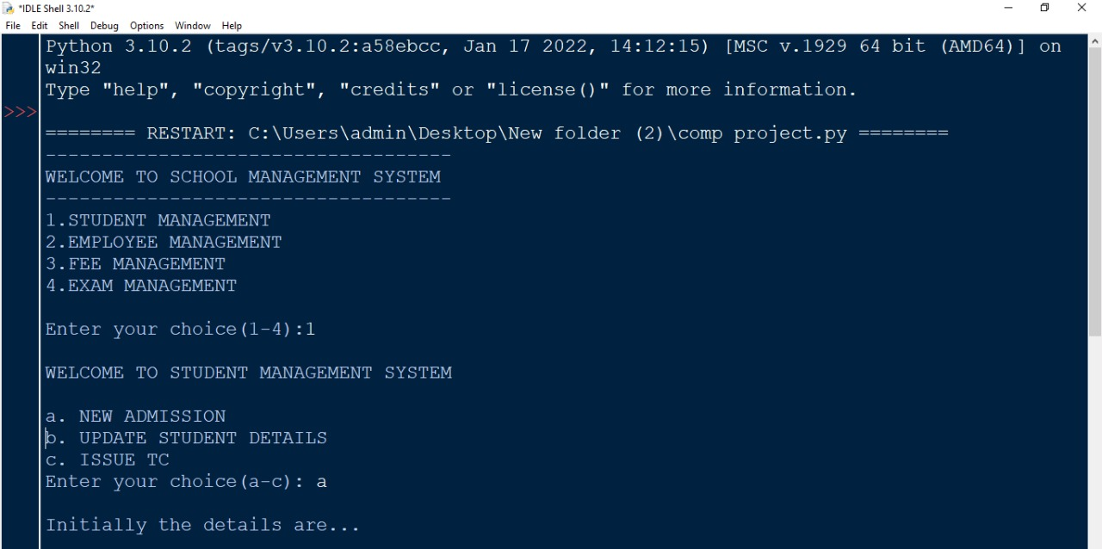

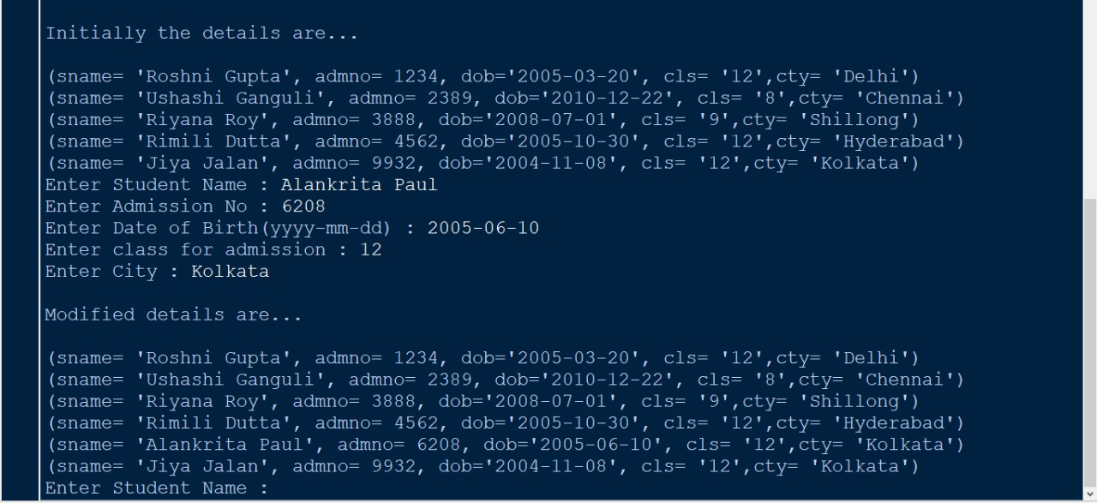

**UPDATE DETAILS**

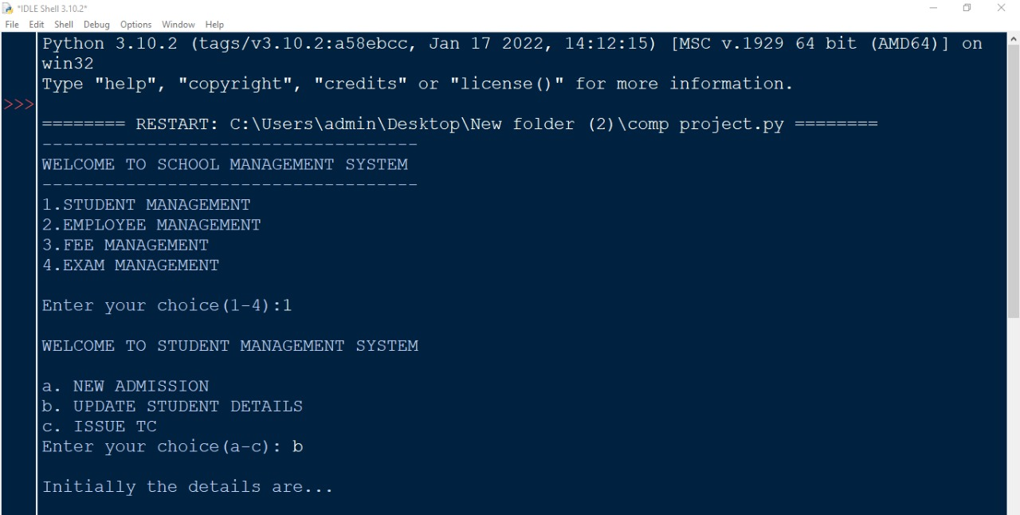

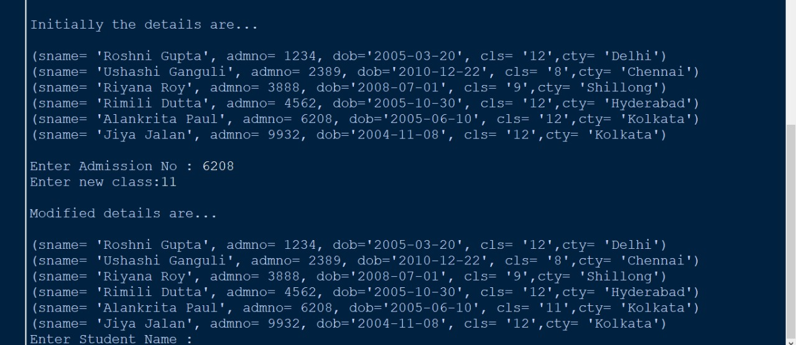

**DELETE DETAILS**



