1.What are the two values of the Boolean data type? How do you write them?

ANS: There are two Boolean values True and False. Values can be compared using comparison and suitable Boolean value would be computed.

Example:

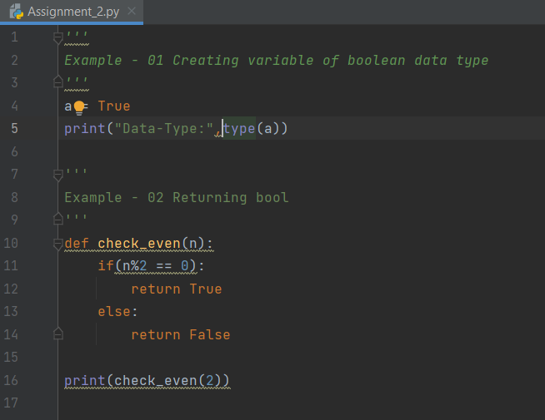

Output:

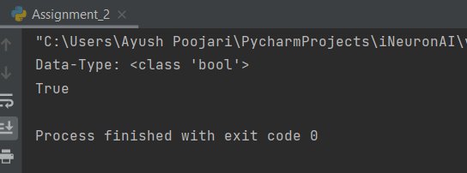

2. What are the three different types of Boolean operators?

ANS: Logical operators and, or and not are also referred to as Boolean operators. While and as well as or operator needs two operands, which may evaluate to true or false, not operator needs one operand evaluating to true or false.

Boolean and operator return true if both operands return true.

3. Make a list of each Boolean operator's truth tables (i.e. every possible combination of Boolean values for the operator and what it evaluate ).

4. What are the values of the following expressions?

(5 > 4) and (3 == 5) False

not (5 > 4) False

(5 > 4) or (3 == 5) True

not ((5 > 4) or (3 == 5)) False

(True and True) and (True == False) False

(not False) or (not True) True

5. What are the six comparison operators?

ANS:

These operators compare the values on either sides of them and decide the relation among them. They are also called Comparison operators or Relational operators.

|  |  |  |
| --- | --- | --- |
| **Operator** | **Description** | **Example** |
| == | If the values of two operands are equal, then the condition becomes true. | (a == b) is not true. |
| != | If values of two operands are not equal, then condition becomes true. | (a != b) is true. |
| <> | If values of two operands are not equal, then condition becomes true. | (a <> b) is true. |
| > | If the value of left operand is greater than the value of right operand, then condition becomes true. | (a > b) is not true. |
| < | If the value of left operand is less than the value of right operand, then condition becomes true. | (a < b) is true. |
| >= | If the value of left operand is greater than or equal to the value of right operand, then condition becomes true. | (a >= b) is not true. |
| <= | If the value of left operand is less than or equal to the value of right operand, then condition becomes true. | (a <= b) is true. |

6. How do you tell the difference between the equal to and assignment operators? Describe a condition and when you would use one.

ANS: The “=” is an assignment operator is used to assign the value on the right to the variable on the left. The '==' operator checks whether the two given operands are equal or not. If so, it returns true. Otherwise it returns false.

Example:

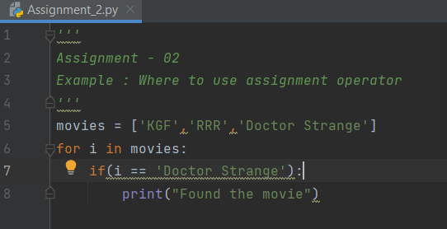

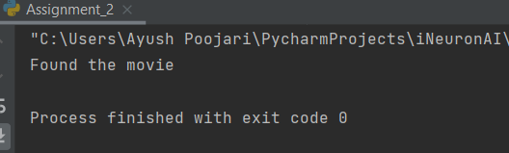

7. Identify the three blocks in this code:

spam = 0 Initialization

if spam == 10: Block-1

print('eggs')

if spam > 5: Block-2

print('bacon')

else: Block-3

print('ham')

print('spam')

print('spam')

8. Write code that prints Hello if 1 is stored in spam, prints Howdy if 2 is stored in spam, and prints Greetings! if anything else is stored in spam.

ANS:

Code:

*'''  
Assignment - 02  
8. Write code that prints Hello if 1 is stored in spam,  
prints Howdy if 2 is stored in spam, and prints Greetings! if anything else is stored in spam.  
'''*spam = 5  
if(spam == 1):  
 print("Hello")  
elif(spam == 2):  
 print("Howdy")  
else:  
 print("Greetings!")

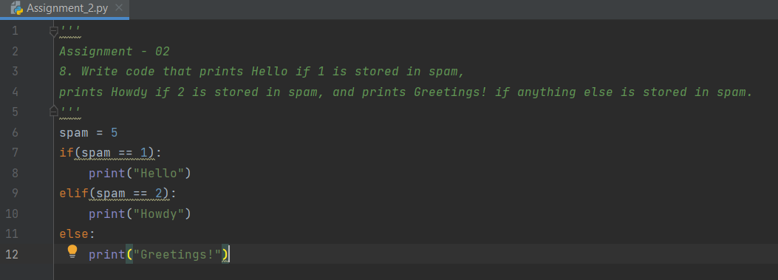

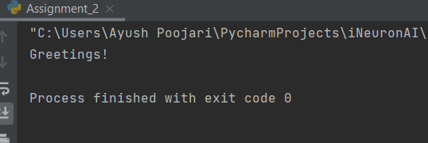

9.If your programme is stuck in an endless loop, what keys you’ll press?

ANS:

Ctrl + C key to exit and stop

In pycharm we can press Ctrl + F2 to stop its execution.

10. How can you tell the difference between break and continue?

ANS:

**break statement:** This statement terminates the smallest enclosing loop (i.e., while, do-while, for loop, or switch statement).

**continue statement:** This statement skips the rest of the loop statement and starts the next iteration of the loop to take place.

11. In a for loop, what is the difference between range(10), range(0, 10), and range(0, 10, 1)?

ANS:

In range(10) : It will start iterating from 0 to 9 – Therefore 10 stands for upper limit.

In range(0,10) : It will start iterating from 0 to 10 – lower limit/starting from 0 to 9

In range(0,10,1) : We have additional parameter which is jump that it takes in each iteration.

Example: In range(0,10,2) It will iterate as follow 0 , 2 , 4 , 6 , 8

12. Write a short program that prints the numbers 1 to 10 using a for loop. Then write an equivalent program that prints the numbers 1 to 10 using a while loop.

ANS:

*'''  
Assignment-02  
'''*print("Using For Loop:")  
for i in range(1,11):  
 print(i)  
  
i = 1  
print("Using While Loop:")  
while(i <= 10):  
 print(i)  
 i += 1

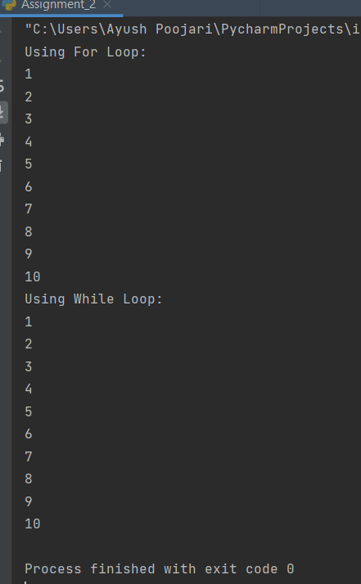

13. If you had a function named bacon() inside a module named spam, how would you call it after importing spam?

ANS:

