6th august

Frontend : Html, CSS, Js

Backend : php

Database : MySql

* Roommate Finder(RoomR)

1. Login page
2. Setup / preference page
3. Home (right or left swipe)()
4. Chatting page

Features

* + Intimation via whatsapp on login and password reset
  + Intimation when a match is found

20th august



Logo Colors:

1. Lavender #8B54FF
2. Off white / beige
3. Black

Login page (Phone number, password)

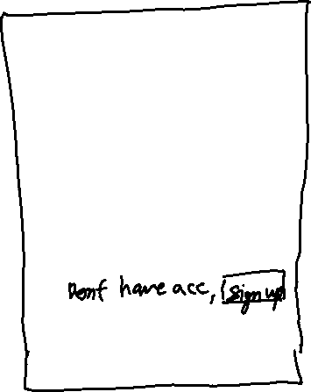





**Sign up page : (phone number,name,password,otp)**



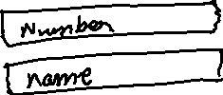

Ppt-analysis, module, architecture, demand