Scanning Electron Microscope

- The scanning electron microscope (SEM) employs a concentrated beam of high-energy electrons to produce multiple signals at the surface of solid samples.

- These signals, resulting from interactions between the electrons and the sample, provide details about the

  - sample's external morphology (texture).

  - chemical composition.

  - crystalline structure.

  - orientation of its materials.

- A secondary electron detector (SED) and a backscattered electron detector (BSD) are the two most common types of detectors used for high-resolution imaging in an SEM.
Concept:

- When electrons from the microscope interact with a sample, various other electrons, photons, and irradiations can be produced.

- The two types of electrons crucial for imaging are backscattered electrons (BSEs) and secondary electrons (SEs).

- Backscattered electrons are reflected back when the primary electron beam hits the sample, resulting from elastic interactions.

- In contrast, secondary electrons originate from the atoms within the sample and are produced by inelastic interactions.
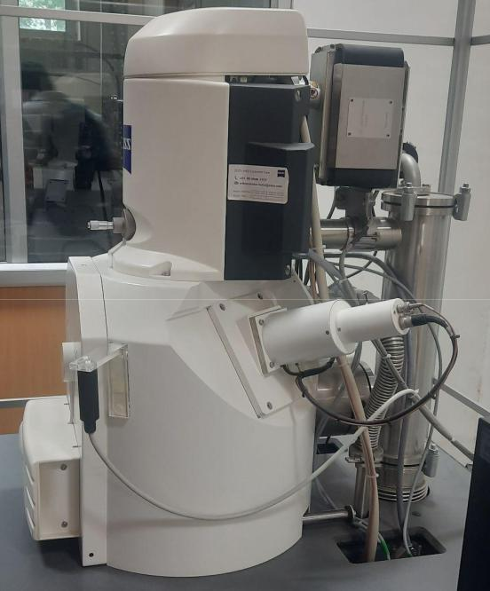

Fig.1. Schematic of SEM

Electron generation in SEM:

- Field emission gun – This device generates a strong electric field, extracting electrons from their atoms to produce high-resolution images.
- Thermionic filament – Located inside the microscope, this tungsten filament heats to white-heat temperatures, emitting electrons.

- Cerium hexaboride cathode.
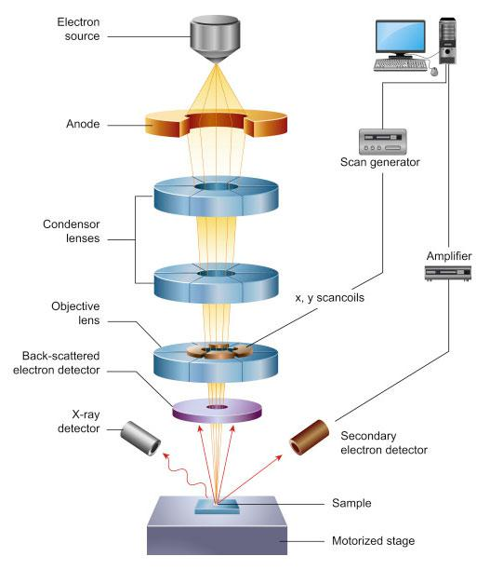

Fig.2. Schematic of SEM

- Electrons are produced at the top of the column in the electron gun and accelerated down the column at a specified voltage (1 keV – 30 keV).

- Condenser lenses and apertures help to narrow the beam diameter.

- The objective lens, the final lens in the column, focuses the beam onto the sample surface.

- The beam diameter in an SEM can vary from less than 1 nanometer to 20 nanometers, depending on the electron gun type, accelerating voltage, and lens configuration.

- The sample is placed on a stage within the chamber area, and both the column and chamber are kept under vacuum by a series of pumps.

- The electron beam's position on the sample is controlled by scan coils positioned above the objective lens.

- These coils allow the beam to scan across the sample's surface in the X-Y plane. As the beam scans, it interacts with the sample, producing different signals like secondary

electrons, backscattered electrons, and characteristic X-rays. These signals are subsequently detected by appropriate detectors.

- Magnification is determined by the size of the scanned area, where higher magnifications correspond to smaller scanned areas.

- The number of pixels within a given scan area can also be adjusted, influencing the perceived resolution of the image.
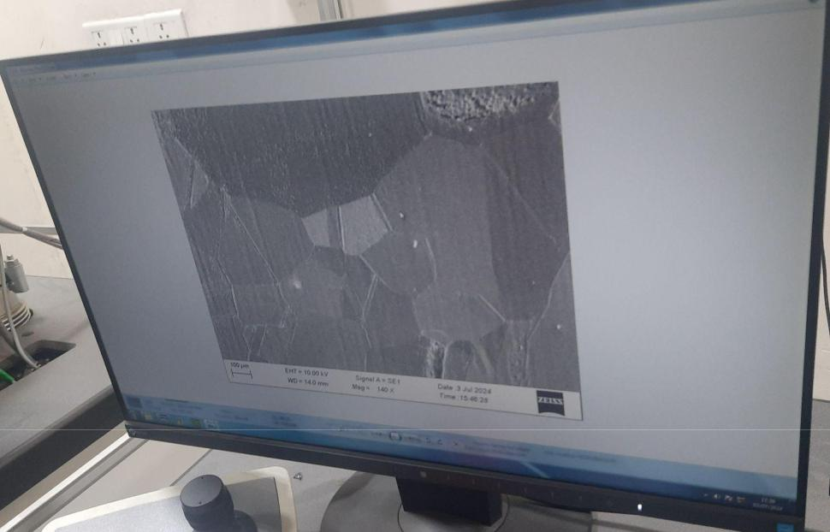

Fig.3. SEM image of graphene

Transmission Electron Microscope

Unlike optical microscopes, which rely on light in the visible spectrum, TEM can reveal stunning detail at the atomic scale by magnifying nanometer structures up to 50 million times. This is because electrons can have a significantly shorter wavelength (about 100,000 times smaller) than that of visible light when accelerated through a strong electromagnetic field, thus increasing the microscope resolution by several orders of magnitude. To form a TEM image, a high energy electron beam is accelerated through an extremely thin “electron transparent” sample, typically thinner than 100 nm. A series of electromagnetic lenses and apertures are placed throughout the microscope’s column to focus the beam on the sample, minimize distortions, and magnify the resulting image onto a phosphor screen or a specialized camera. The two major types of TEM instruments are the conventional TEM (also referred to simply as TEM) and the STEM (scanning transmission electron microscope).

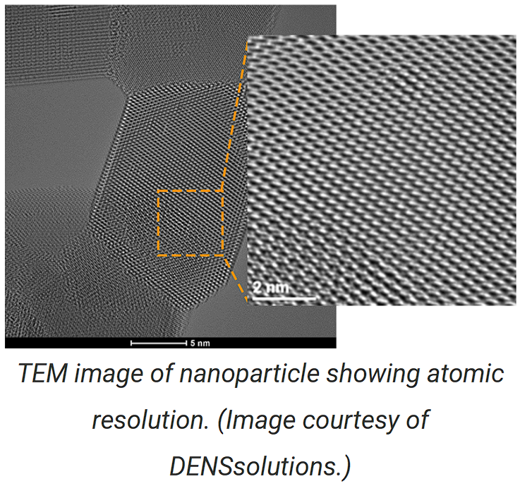

Components of the Transmission Electron Microscope:
Accelerating Voltage
Is the electric field potential applied to the electron gun to accelerate the electron beam through the microscope column and ultimately the sample. Higher accelerating voltages correspond to smaller electron wavelengths and improved resolution.
- Electron Gun: Located at the top of the column, it uses a high voltage source (80–300 kV) to set the kinetic energy of the electron beam.
- Column Components: Contains electromagnetic lenses and apertures to focus and magnify the electron beam and image.
- Vacuum System: Maintains the required vacuum levels for optimal beam transmission.
- User Controls: Key settings include sample stage position, magnification, objective lens current, beam current, and aperture/detector selection.
- Automation: Most components are computer-controlled for ease of use.
- Detectors:
  - Digital Detectors: CCD detectors capture images digitally.
  - Fluorescent Viewing Screen: Retractable for manual viewing.
  - X-ray Detector: Analyzes sample composition near the objective lens.
  - EELS: Electron energy-loss spectrometers analyze energy loss at the column's end.

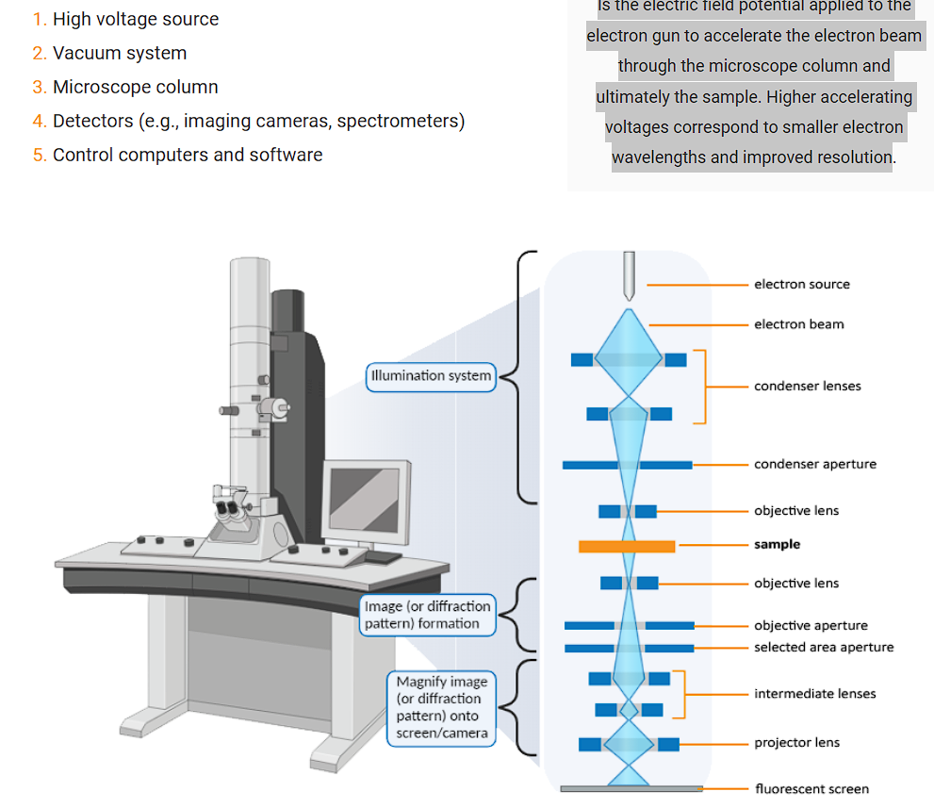

Vacuum Pump:
Purpose of Vacuum System: Ensures the electron beam interacts only with the specimen by maintaining a high vacuum in the column.
Types of Vacuum Pumps:
- Roughing Pumps:
  - Reduce pressure from atmospheric to low vacuum (~0.01 mbar).
  - Used for specimen load lock chambers and backing high vacuum pumps.
  - Mechanically noisy due to large air volumes.
- High Vacuum Pumps (Backed):
  - Achieve ultra-high vacuum (10−5^{-5}−5 to 10−10^{-10}−10 mbar).
  - Examples: Turbo pumps, diffusion pumps.
  - Operate intermittently to reduce vibrations after the required vacuum is reached.
- High Vacuum Pumps (Unbacked):
  - Ion pumps maintain ultra-high vacuum in the electron gun chamber.
  - Use differential pumping apertures to protect the electron gun from contamination.
The TEM needs to be kept permanently under vacuum unless it is being serviced or repaired. Samples are inserted and removed via an airlock system that takes the pressure from atmosphere (~ 10⁵ Pa) down to ~10⁻⁵ Pa in a matter of minutes – truly extraordinary!

Electron Gun
Electron Source (Gun): Essential for producing high-resolution TEM images, characterized by brightness, spatial coherence, and temporal coherence.
Types of Electron Guns:
- Thermionic Guns:
  - Mechanism: Heat a filament (tungsten wire or ceramic crystal like LaB6/CeB6) to emit electrons.
  - Wehnelt Cylinder: Focuses and localizes the electron beam.
  - Comparison:
    - Ceramic crystals emit electrons at lower temperatures, producing brighter beams with better temporal coherence.
    - Require higher vacuum and are more expensive but offer longer lifetimes and better spatial resolution.
- Field Emission Guns (FEGs):
  - Mechanism: Use tunneling induced by a strong electric field on a sharp tungsten tip.
  - No Wehnelt Cylinder: Beam focusing is handled by two anodes.
  - Advantages: Brighter and more coherent beams, ideal for high-resolution applications.
Types of FEGs:
- Cold FEGs: Emit electrons purely through tunneling.
- Schottky FEGs: Assisted by thermionic emission due to a zirconium oxide coating on the tip, reducing the work function and enhancing electron emission.
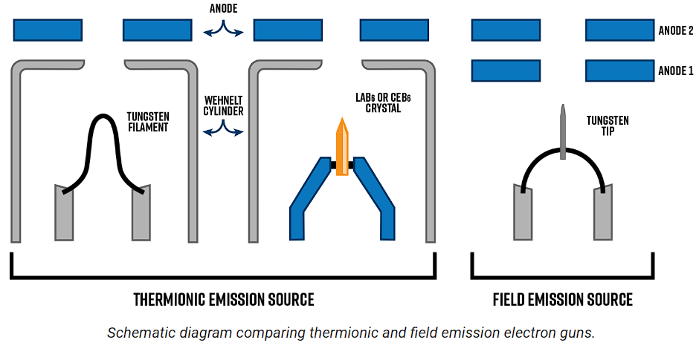
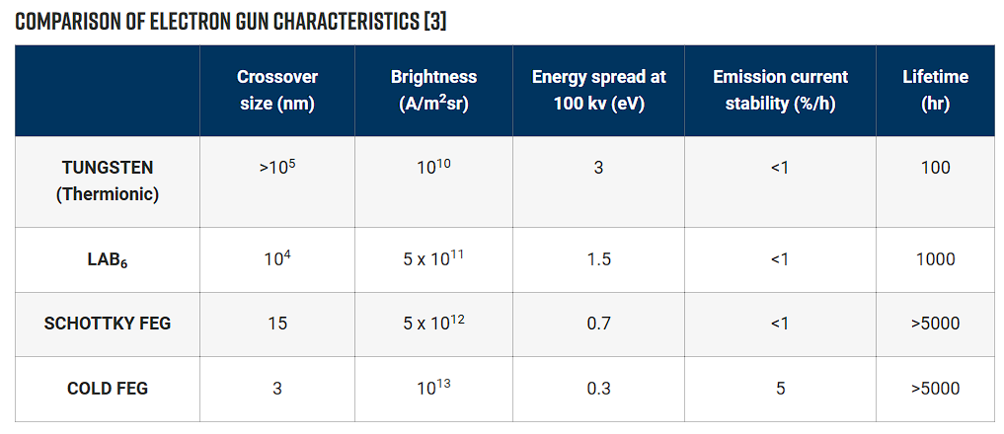
Illumination system
In TEM mode, the condenser lenses are adjusted to form a broad beam at the sample that is several micrometers in diameter [3]. The upper pole piece of the objective lens can act as a third condenser lens to create an even more parallel beam. This is ideal for generating sharp diffraction patterns and stronger image contrast.
For STEM mode, the opposite is needed. Instead, the illumination system acts to form a convergent beam (probe) at the specimen entrance surface. Images are formed by scanning the focused probe across the field of view. The condenser aperture is inserted to define the probe’s convergence angle, α.
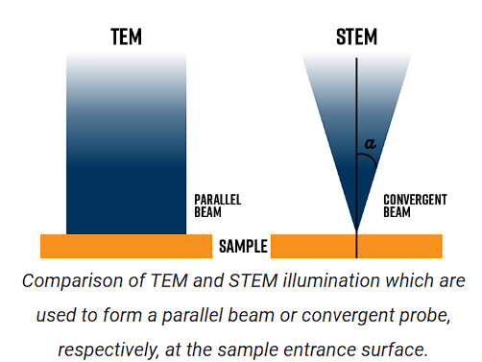
Electromagnetic lenses
Electromagnetic lenses are composed of two major components: the copper wire coils and the pole piece(s). Current passing through the coils creates a magnetic field within the column. The magnetic field is asymmetric: weakest in the center and strongest toward the edges, which acts to focus off-axis electrons and form the beam cross-over.
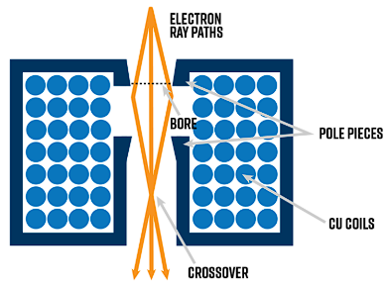
Objective Lens
- Objective Lens Role: The most critical lens in TEM, responsible for forming images and diffraction patterns (DPs), which are magnified onto a screen or camera.
- Image Formation:
  - TEM images correspond to the transmitted electrons exiting the specimen.
  - The back focal plane (BFP) holds the diffraction pattern, while the image plane recombines the electrons to form the image.
- High-Resolution Imaging:
  - Requires minimizing the focal length of the objective lens to maximize magnification.
  - The specimen must be positioned close to the objective lens (small object distance).
- Lens Construction:
  - Complex "split" designs use separate coils for upper and lower pole-pieces to independently control field strength.
  - This setup minimizes object distance and provides space for X-ray spectrometers and various sample holders (e.g., double-tilt, in-situ, cooling).
- Mode Switching:
  - In STEM mode, the upper pole-piece forms the convergent probe.
  - In TEM mode, the lower pole-piece forms the image while the upper pole-piece aids parallel beam formation.
- Focus Adjustment:
  - The lens operates at a constant current to reduce aberrations.
  - Focus is adjusted by modifying the Z-height of the specimen using the goniometer.
  - The eucentric plane defines the standard object plane for the lens; proper Z-height positioning ensures focus and reference values for the lens.

Intermediate and projector Lense:

The intermediate and projector lenses magnify the image or diffraction pattern onto the viewing screen. Multiple intermediate lenses are used to adjust the degree of magnification of the image or DP produced by the objective lens. The projector lens is the final lens in the column that projects the image/DP onto the viewing screen or camera.

Electron-Sample Interactions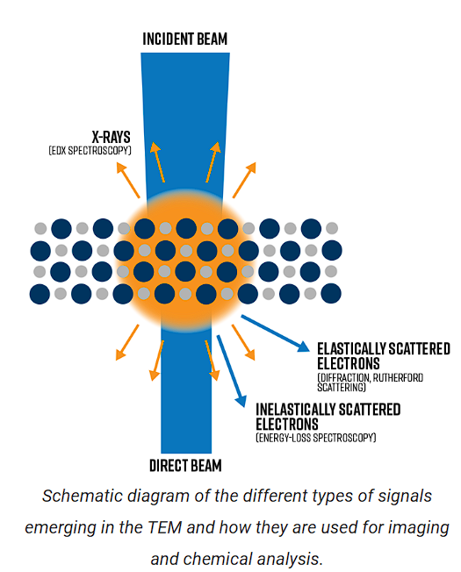

Elastic scattering
- Elastic Scattering: Involves no energy transfer to incident electrons.
- Types of Elastic Scattering:
  - Low-Angle Scattering: Caused by interactions with the electron cloud.
  - High-Angle (Rutherford) Scattering: Caused by Coulombic attraction to the positively charged nucleus.
- In Crystalline Materials:
  - Atoms are arranged in a 3D lattice structure.
  - Elastic scattering occurs at characteristic angles (Bragg angles) corresponding to unique lattice spacings (d-spacings).
- Diffraction Patterns:
  - Contain information about the crystalline structure, including symmetry, lattice spacings, strain, and defects.
  - Polycrystalline/Amorphous Materials: Produce diffuse ring patterns:
    - Ring radii indicate lattice spacings.
    - Increased diffuseness suggests smaller crystallite sizes.

Amplitude contrast TEM images
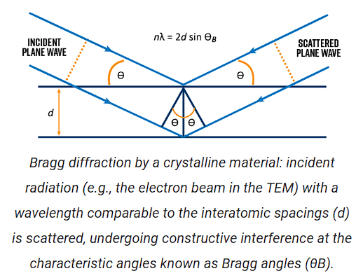
- Amplitude Contrast in TEM: The amplitude of transmitted electrons can be altered by two main mechanisms:
  - Mass-Thickness Variations: Differences in the mass or thickness of the sample across the field of view.
  - Inhomogeneities in Diffracting Conditions: Variations in Bragg conditions across the field.
- Effect of Mass-Thickness Variations:
  - These variations cause high-angle scattering (Rutherford scattering).
  - High-angle scattered electrons are excluded by placing the objective aperture around the direct beam (optic axis), resulting in a bright field (BF) image.
- Bright Field Image:
  - Shows mass-thickness contrast, where areas with higher mass or thickness appear darker in the image.

Inelastic scattering

Unlike elastic scattering, inelastic scattering is characterized by a measurable loss of energy to the incident electrons – on the order meV (1000 meV = 1 eV) up to several hundred eV, which represent a small fraction of the incident beam energy.

There are many types of signals in TEM that arise from inelastic scattering. Pairing this data along with high resolution images provides powerful, correlative data that only a S/TEM can deliver. This “holistic” approach to materials characterization that the modern-day S/TEM provides (namely the ability to perform analytical nano-analysis of composition, chemistry, and bonding) is what makes the technique so useful for nanotechnology and materials science applications.

Inelastic scatter generates energy-loss electrons, X-ray emission, secondary electron emission, and sometimes visible light emission (i.e., cathodoluminescence or CL). The two most popular inelastic signals analyzed in the TEM are energy-loss electrons measured via electron energy-loss spectroscopy (EELS), and characteristic X-rays detected with energy-dispersive X-ray spectroscopy (i.e., EDS or EDX spectroscopy).

X-ray Spectroscopy

X-ray spectroscopy is one of the most popular chemical analyses that can be performed in the TEM or STEM. An EDX spectra provides a snapshot of the elements present in the sample.

Characteristic X-rays are produced when an incident electron penetrates to the inner-shell electrons. If enough energy is transferred from the incident electron to the inner-shell electron, then the atom in the sample will become ionized. This excited state involves a “hole” being left behind in the inner shell. For the atom to relax back to the ground state, it must fill the hole with an outer-shell electron by emitting an X-ray with the same energy as the energy difference between the inner and outer shells. Because each element has unique energy levels within each electron shell, characteristic X-rays are representative of the sample composition.

X-Ray Diffraction
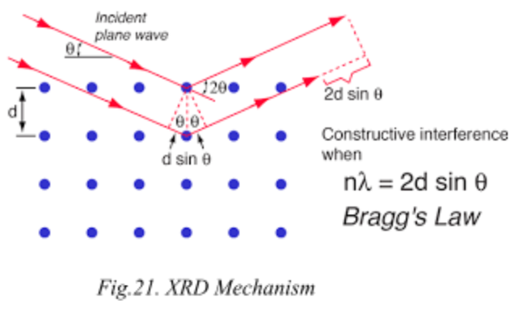
X-ray diffraction is one of the methods used to determine the orientation of the Silicon Wafers. XRD can calculate the crystallite size of a crystal. Based on the amount of light diffracted, we can calculate the interatomic distance using Bragg's Law and, hence, determine the orientation of the silicon wafers. By shifting in the graph, we can determine the strain of the material. If all the peaks shift in the same direction, the material will have a homogeneous strain.

The processes followed for the following measurements were:

- The setup consists of a movable source, a mount, and a movable receiver. The complete setup is sealed in glass. The light used is generated from Cu (Kα) excitation, which has a wavelength of 1.54 Å, which is comparable to diffraction from the slit formed by the crystalline structure of the wafers.

- The Silicon substrate was cleaned and mounted on the scanning plate.

- The angle of reference was taken, and then it was put to scan by keeping the receiver constant and sweeping the angle with the help of a movable source.

- After data collection, the machine performed noise reduction and graph generation. We found the peaks and identified the natural silicon wafer.

Sample | Observed Peak | Calculated ‘d’ | Type of Wafer
 |  | (nλ=2dsinθ), n=1 | (100, 110, 111)
Sample 1 | 28.3° | 3.16 Å | 111
Sample 2 | 69.0° | 1.36 Å | 100
