Get familiar with ec council and updated with it’s latest updates

what this course is or not
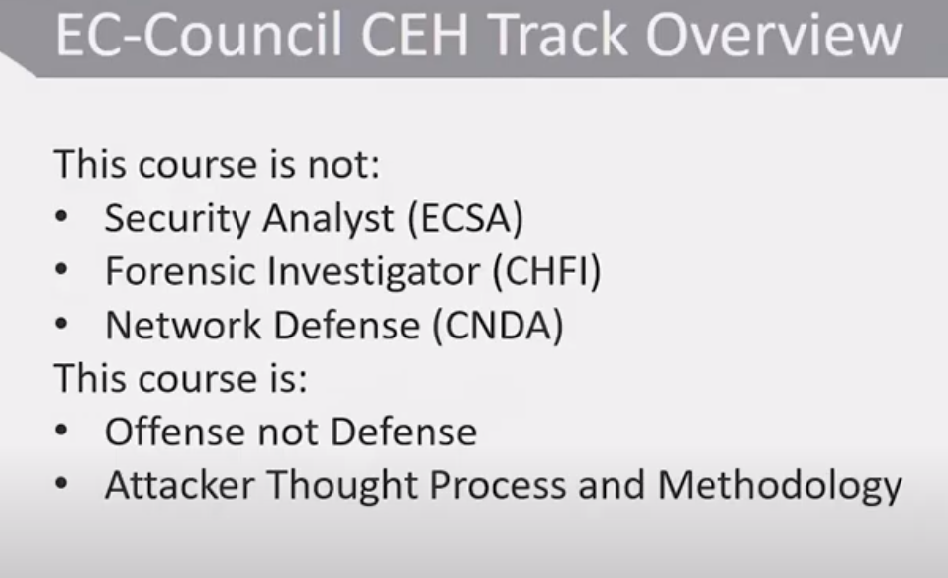

cybersecurity – the policy of protecting an organisations by preventing, detecting and respond to modern attacks.

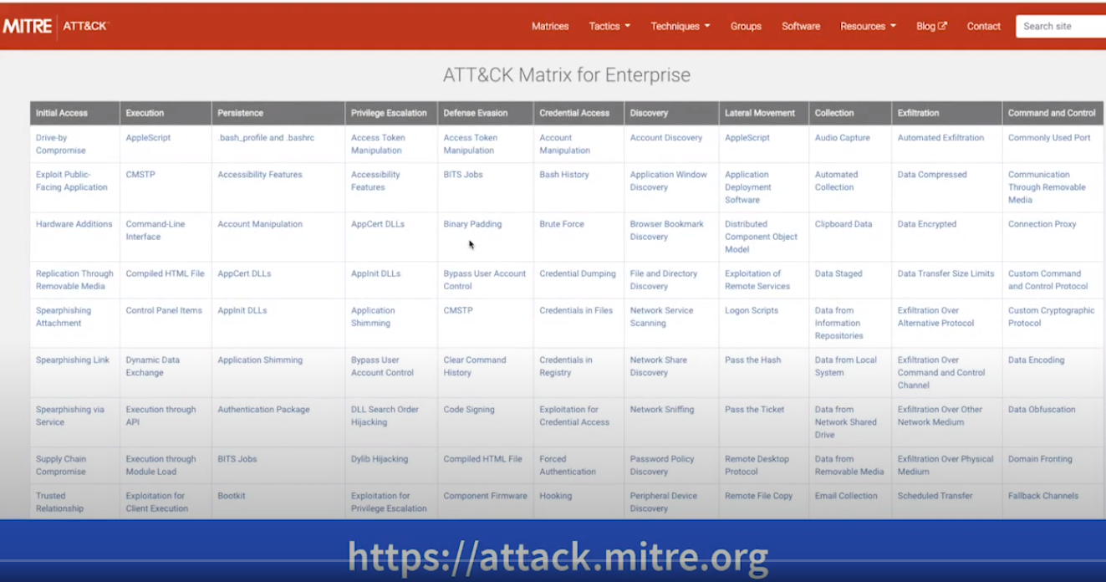
Techniques and common konwledge framwork

link :- https://attack.mitre.org

MALWARE THREATS
- VIRUSES
- WORMS
- SPYWARE
- TROGENS
- BACKDOORS
- RANSOMWARE and many more …

for example-:

MASTER BOOT RECORD INFECTION -:
this is the original method to attack in some cases boot drive, in other words by attacking boot record hard drive or ssd (any type of mother media device)

FILE INFECTION -: it it usually rely on executing file on compromise system that includes an executable file like .exe file and other windows executable file and specific images for MAC OS and Lnux as well.

MACRO INFECTION :- this allows to exploit different type of scripting services on computer. If u remember a long time ago a virus called i love you this virus is an example of Macro Infection

CLUSTER :- it is the type of virus that can modified Directories table and choose so that it can point a user or system process to the malware and not the actual program.

MULTIPARTITE :- this targeting both the boot sector and also program files.

RANSOMWARE :- this is the malware that actually preventig user from accessing their system and personal file because the threat actor encrypt either some data or some specific directories or the whole system or even master boot recurence so that u can’t even boot your device in some cases.
And what they do a man ransom a payment in order to regain access and send u a decryption key

There are several ways to ransomware infect your computer :-

1. Email
2. Social Engineering
3. SMB(wannaCry & Nyeta)
4. Malvertising
one of the most common method is through malicious spam or phising attacks and malicious advertisement (malvertising),.

TROJANS:
types of trojans:
- Command shell
- GUI
- HTTP/HTTPS
- Document Trojans
- Defacement
- Botnet – based
- VNC( Virtual Network Computing)
- Remote Access
there is also other types of trojans :
- Data Hiding
- Banking Trojans
- Denial of Service (DoS)
- FTP
- Software-Disabling
- Convert channel

the most popular one is remote access trogen or RAT. There is many tools for RAT
and it is usually set in up as a client-server infrastructure
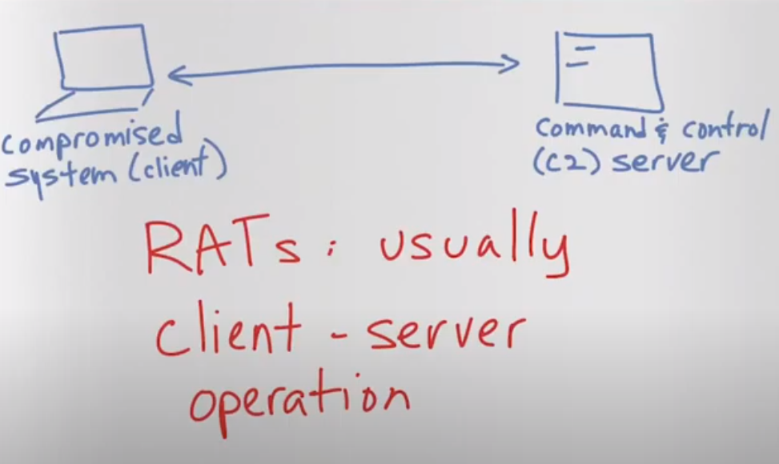
so u have command and control server to control command or sendig command to the compromised system.

Another is Data Hiding trojans and the idea behind these type of trojans is a malware to actually hide user’s data, sometimes these type of malware is also consider as ransonware in this case is actually hidding them instead of encrypting them.

Banking or E-banking trojans which is designed to perform an operartion against E-Banking and ZeUs is an example of that and many more are there as well.

Security software Disablers is a malware designed to Attack and Kill anti-virus or anti-malware functionality or software as well as in some cases firewall (personal firewall or even traditional firewall)
the Goal of disabling these process in order to make thing easy for an attacker to control a system.

You also have Keystrokes Loggers or KEYLOGGERS which are either software or hardware that can be use to record everything that a persion typing, communication between u and your collagues and call worker all those are actually been recorded.
And in some of cases actually recorded even mouse movement, mouse clicking ,websites that are visiting and an application or program is open.


.

SPYWARE is another form of malicious code that is simillar to a trojans.
It is actually install with your concern, in lots of cases it is acually install at the moment that either piece of hardware(let say laptop, desktop, tablet, mobile) has been created.
In other words it suplies chain attacks so that u may have compromising at the begining.
So Spyware has been grown to a big problem usually it is used for two purpose either
SURVILANCE or ADVERTISEMENT(malicious advertisement or target advertisement).

Many times Spyware sites or Malware sites and vendors uses DROPPERS in order to hide or drop Spyware and Malware component from the victim computers.
Basically a Dropper is standalone program(hardware or software able to operate independentely of other hardware or software) that drops different types of standalone Malware to a system.
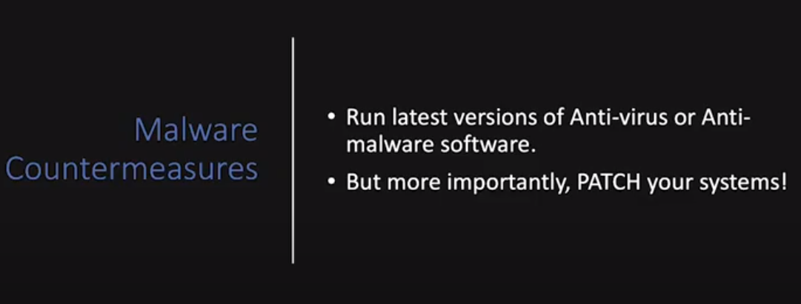
Prevention is always better than cure

some (high level ) technics that can be also done in order to scan malwares :

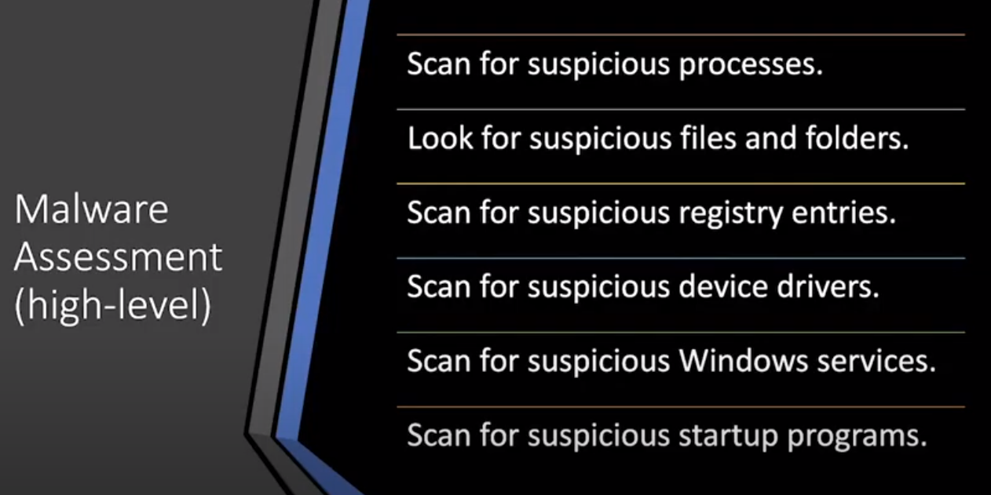
process monitoring record every temperory processes that are running such as name of the process make in a change. You can also specify filter to naro down the specific criteria with in a system wheither it is windows, linux or MACos

IN LINUX: $ps aux
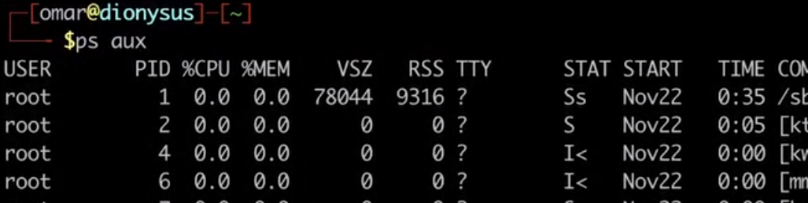
IN UNIX: $ netstat
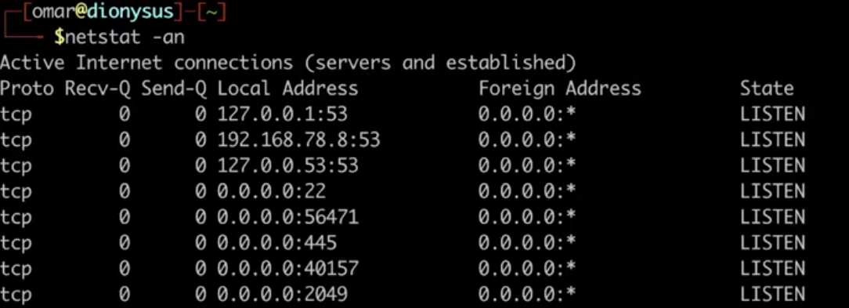
IN Windows: TASK MANAGER

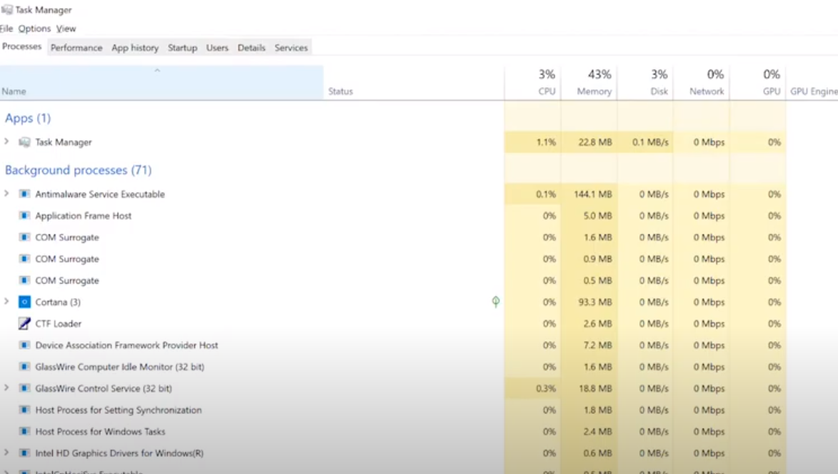
WE ALSO HAVE

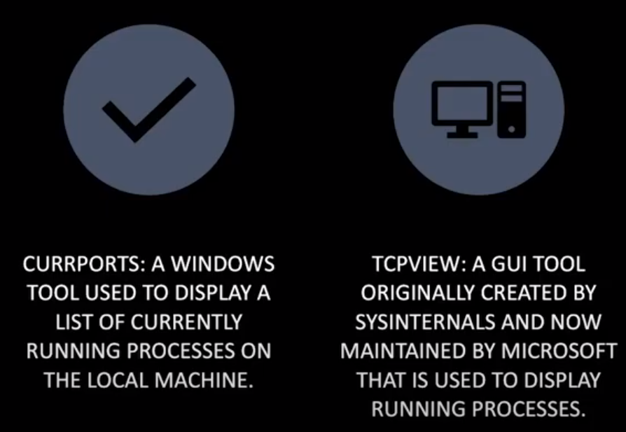
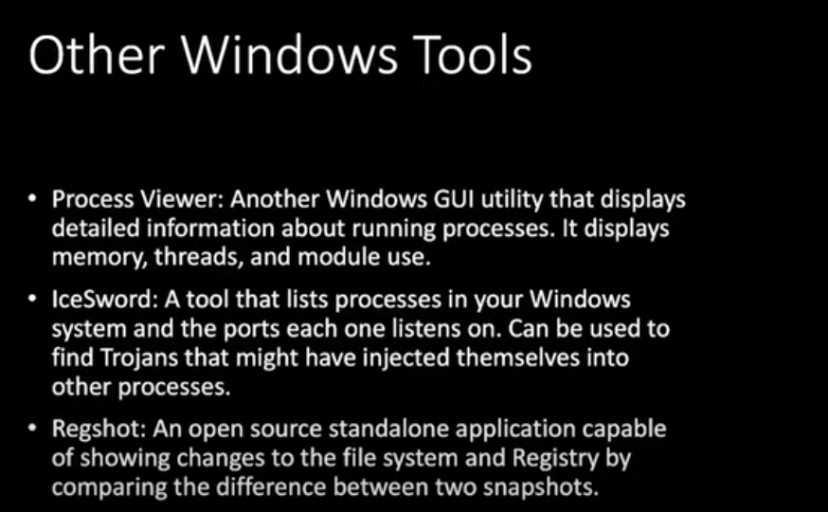
You can also analyse malware by doing static and Dynamic analysis
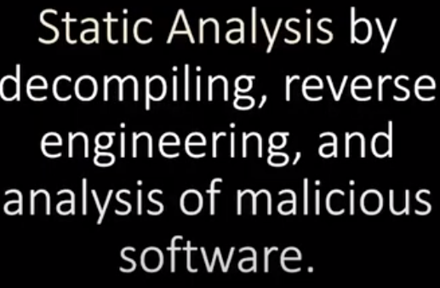
we can also use tools like IDA pro, EVAN’s Debugger (edb), OllyDebugger these Debuggers also use to anlyse Binary Codes whenever source code is not available, some of tools are very very expensive but they are extremely powerful when it come to reverse Engieering and to understanding actually how the Malware are.

Many techniques can be use to make these assembly by an attacker

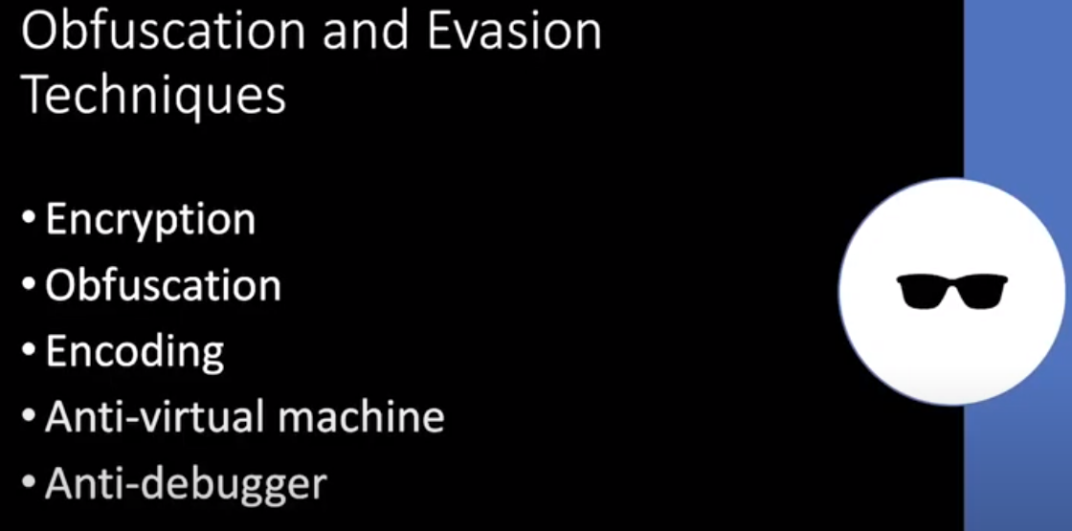
DYNAMIC Analysis
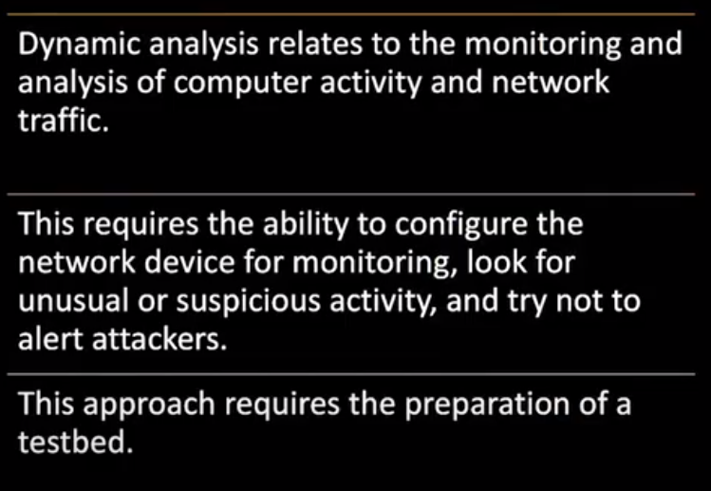
you can atually create a vm and install a guest operating system in vm that is affected by the Malware then copy the malware and install it in the guest operating system and prepare for analysis you can actually use many different tools like:
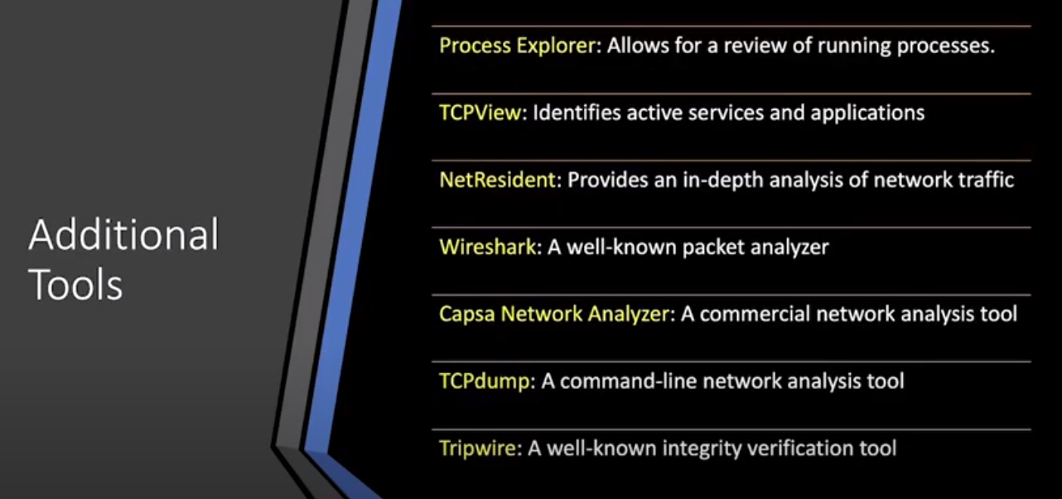
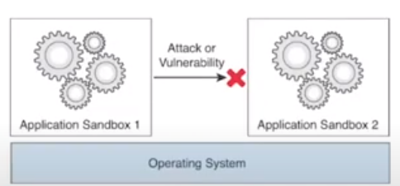
or you can use sandBoxing.
More modern sand Boxing capabilities that allows you to see how the malware behaving, potentialsin in different command and control communication that is actually trying to do. And the able to do reverse Engineering that Malware


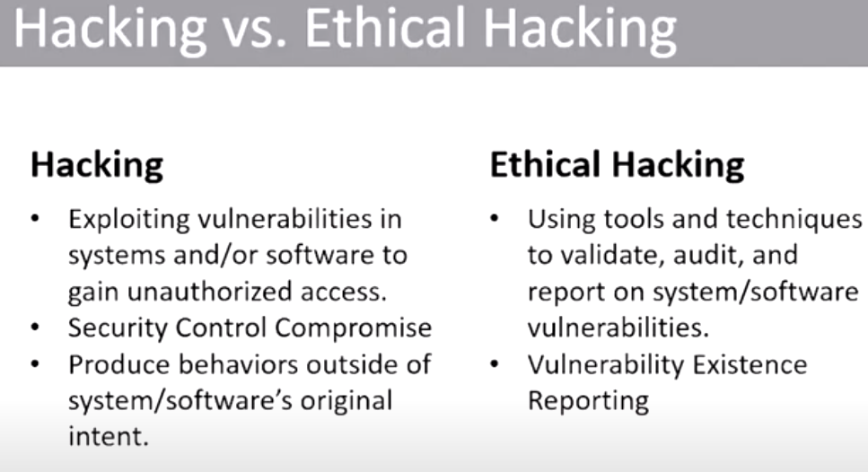
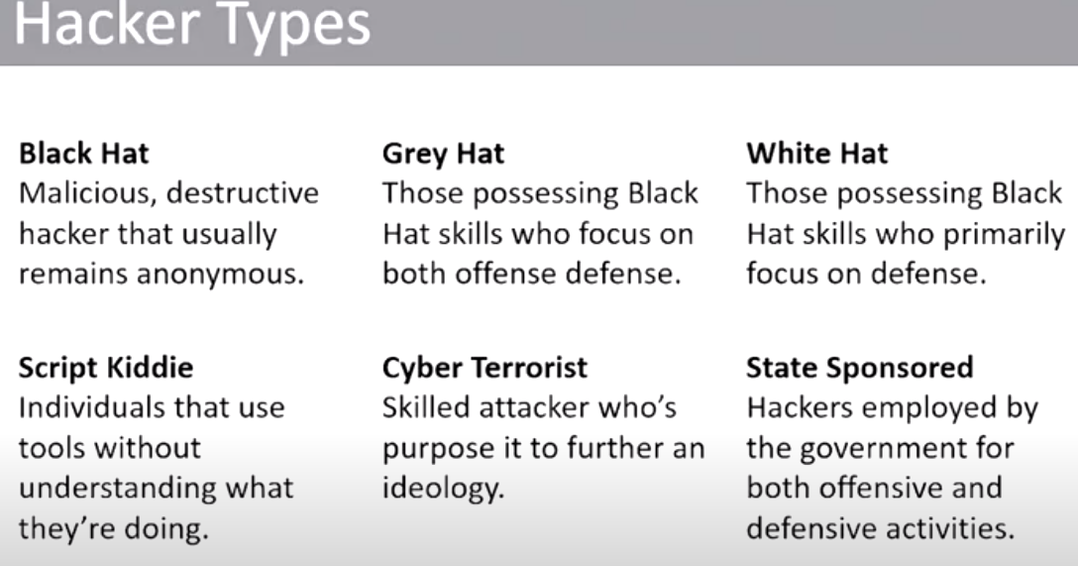


you will be responsible for creating a legal document like contracts, SoWs(statement of works), MSA(masters service agreement), NDAs (Non Discloser agreement) that either your client or you may signed in unilateral, bilateral or multilateral ways.
Contracts is one of the most important document in pentesting engagement that spacify the terms of an agreement and how you will get paid and also provide a clear documentation of services that would be performed.
The document should specific and easy to understand and a legal advise from a lawyer.

LEGAL DOCUMENT:
- contracts
- SOWs
- MSAs
- NDAs

contracts is one of most important document. It specify the terms like how will you get paid for that pentesting, and also it provide a clear documentation of services which would be perform.
The document should be neet and clean and easy to read without any ambigudious.

Statement of work :
- activities that would be performed.
- pentesting time line
- SCOPE
- location of work
- techanical and non techanical requirement.
NOTE:- AN SOWs can be standalone document or a part of MSA

NDA are legal document contract between u and the organisation which hire u for a pen Testing.
It could be UNILATERAL, BYLATERAL and MULTI-LATERAL.


Some most popular methodology in IT:
1. The Penetration Testing Execution Standard. (See the guide)
http://www.pentest-standard.org/index.php/PTES_Technical_Guidelines
2. OWASP testing methodology or a guide (see the guide)
3. NIIST (special publication 800-115) https://nvlpubs.nist.gov/nistpubs/Legacy/SP/nistspecialpublication800-115.pdf

4. Open Source Security Testing Methodology Manual (OSSTMM)
https://www.isecom.org/reasearch

PEN TESTING LIFECYCLE

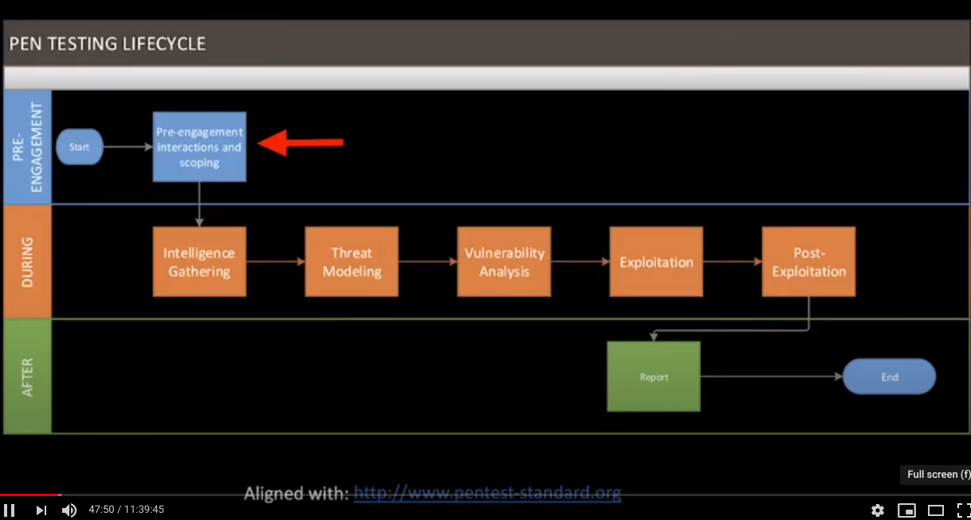
EC COUNCIL METHODOLOGY
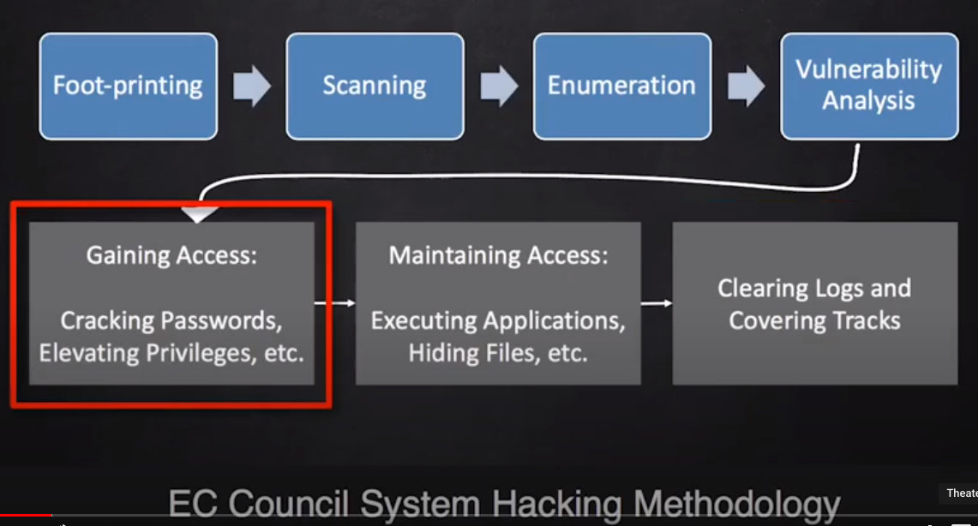



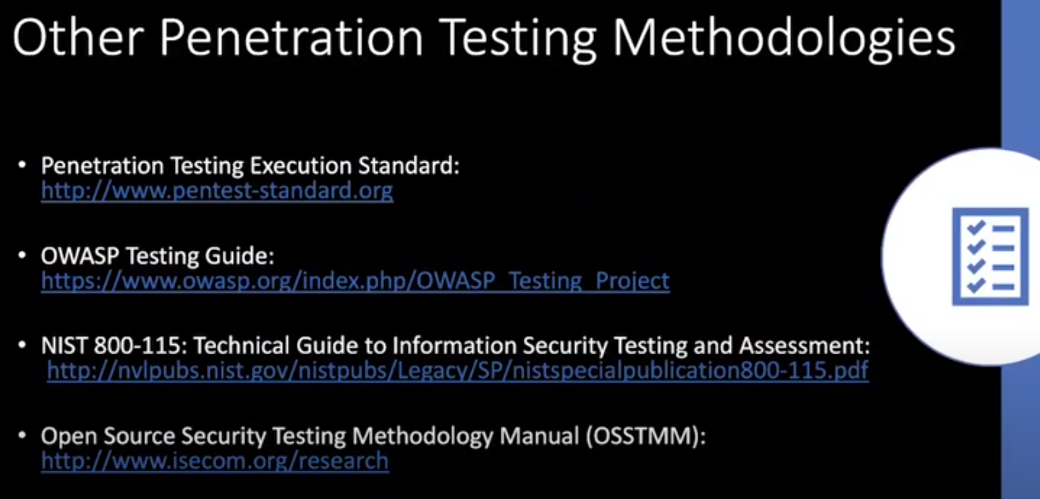


Attack can be classified in four buckets
1. Operating System
2. Application
3. ShrinkWrap Code
4. Misconfiguration

Operating System Attacks:

Purpose : Gain access to the system by exploiting a flaw in the operating system itself.

Vectors:
- Buffer overflows - Protocol implementation
- Software defects - Authentication Schemes
- Patch level

Application Attacks:
Purpose: Gain access to the system by exploiting a flaw in the application on the system.
Vectors:
- Buffer Overflows - XSS
- Bugs - DoS
- SQL Injection - MitM

Shrinkwrap Code : this is some unique technique, it’s attack on operating system or application directly after it’s installation. This is the defect that is exist in code

Purpose : Gain access to the system by exploiting a vulnerbility in a product immediatly after its initial installation.

Example:
- software Defect in version 1.0
- Defect in example CGI script
- Default password

Misconfiguration :
Purpose: Gain access to the system by exploiting a misconfiguration of an application.

Examples :
- improper permissions of SQL users
- Access-List permit all

cyber security policies are about some guiding principle and also tell about shape some behavior of an organisation.
It is also to provide some guidince and aslo tell about implementation Roadmap. It is actually going to protect information, assets, ststem e.t.c.
the main objective of cyber security policies is to protect Orfganisation, Employees, Customers and its partner from any type of harm.

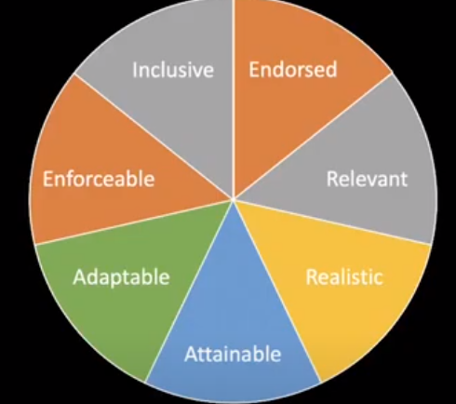

if any one is not present then it can be consider as useless.
Policies should be easy to read and easy to understand, if it is not understandable easily then it will be useless .

LETS GET DIVE INTO HACKING



Foot printing is the process to gather information about your target (computer system or owner ).

1. Collect : information about target and its network -
* Web searches, facebook, twitter, DNS, Whois.
* phone calls , Enumerations
* Passive scanning.
2. Dertermine: OS Version, Application Version
3. Research Vulnerabilities

NOTE : Try multiple Search Engine to gather more information because rating priority could be different of a search on different Search Engine (recomended).
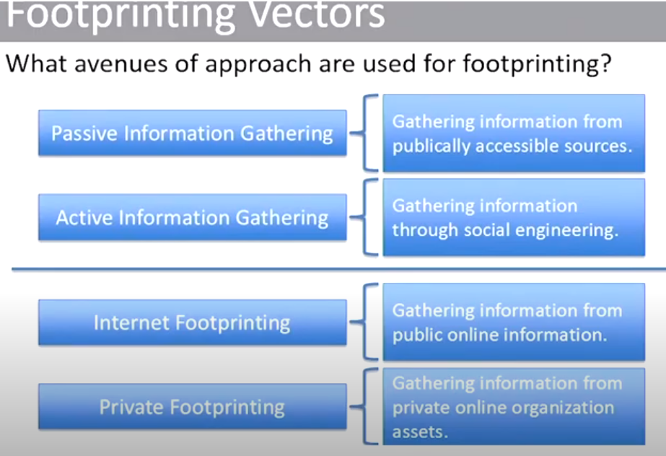
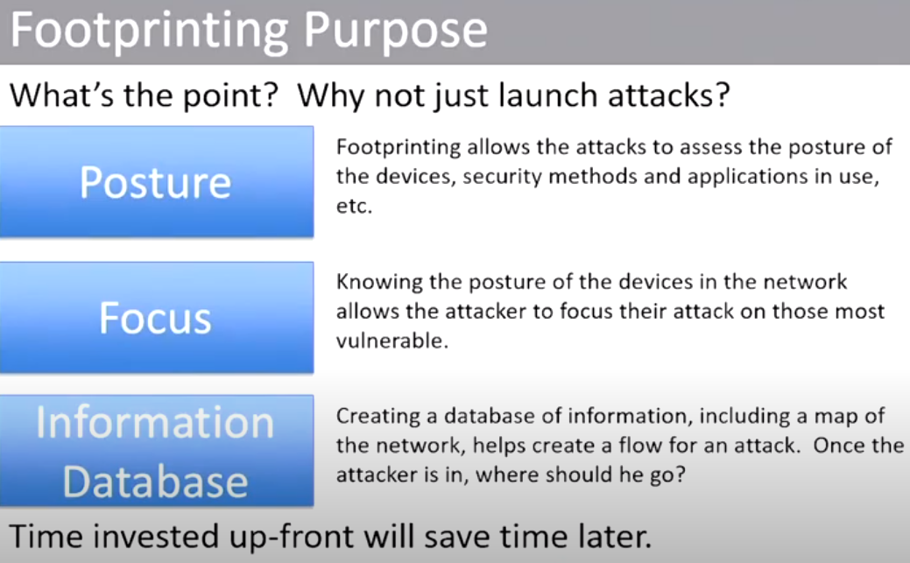
NOTE : No need to put all the gathered informastion on your head. Write it down on notepad or another text editor so that all the infos are together during penetration testing and u can use step by guide
SO what are the information we are trying to gather. We classifed it in three -
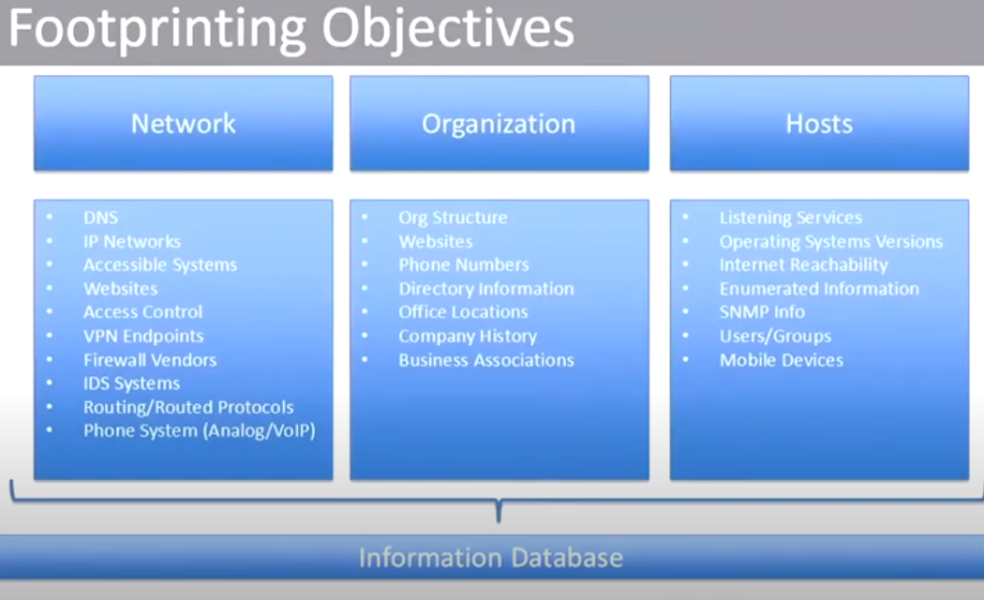
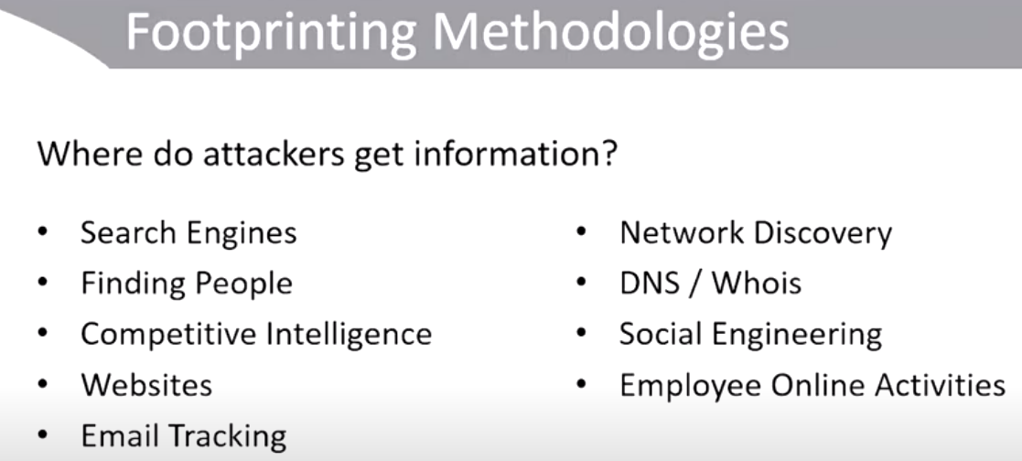
Attackers methodology

DNS – (Domain Network Service) is required to get ip address of the websites so that it can go there and get some data. so it has to be publically available as well as the network of the company is using have tobe publically available so the gathering information from publically available souce is important for when you planning attack to any organiagtion.

You should also know the people information who is working for that organisation (we can collect information from social media like facebook, twitter, linkedIn, and etc this can also help for authentication attack), as well as phone number (In case if you need to make a call to the organisation to gathering information by social engineering )and websites that is running for that organisation.
On host side you should know what services are running there and what port is open (i.e – port 80 for web server), version of services and other information.

Here is an example of footprinting
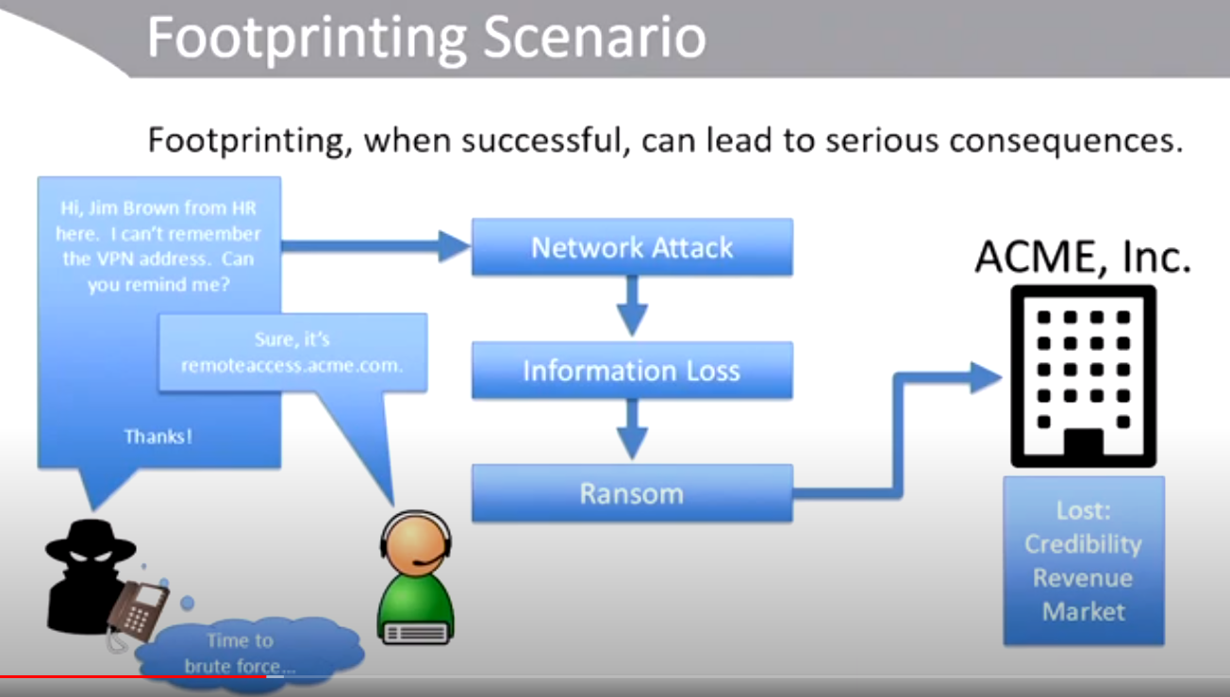
in this case attack tell that he is jim brown from HR. How he knows that jim brown is working for this organisation in HR. he probably check his profile on linkedIn and get information about him and by using his name he gather more information from organisation by social engineering.
And then he is able to do attack.

SERCH ENGINE

search engines are the popular place to go for gathering information as a first step.
Let says we want information about apple and go on the google and search for apple but this could be more effective when we use some keyword for search.
i.e – site : apple..com
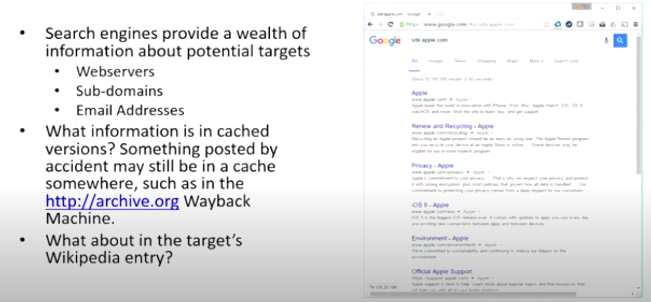
hop on map and search for office, head office and branches and search ceo
and other managers information. These information could be very helpful when you are planning for attack.
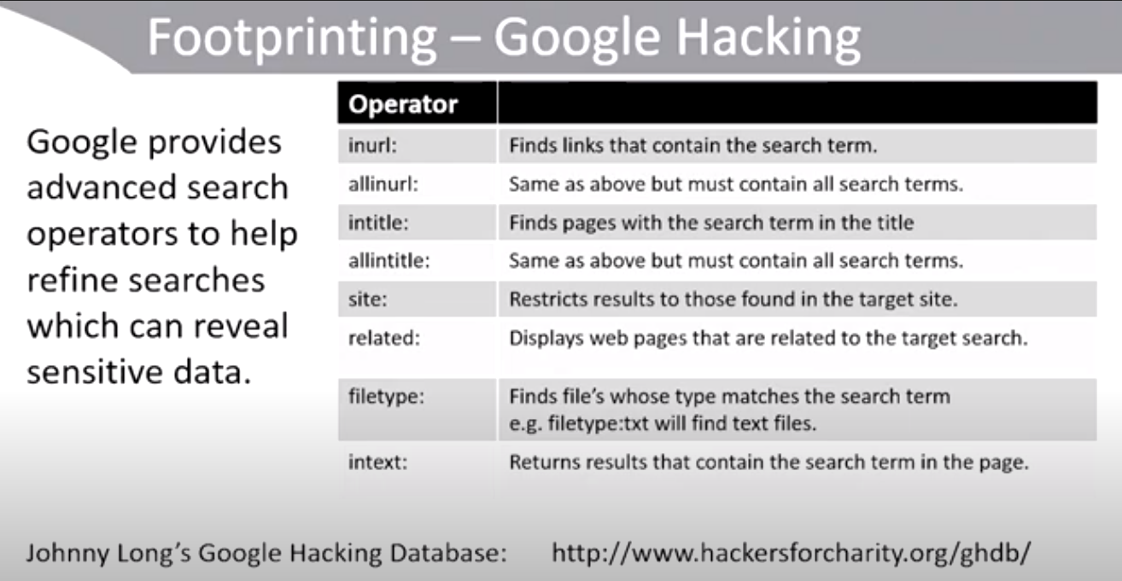
There are some keyword or operator for advance search in google these can reveals sensitive data.
Now once we have the target name then finding people work for the target (A good to search on linkedIn). Once we have the name then then we should try to get more information about him like -
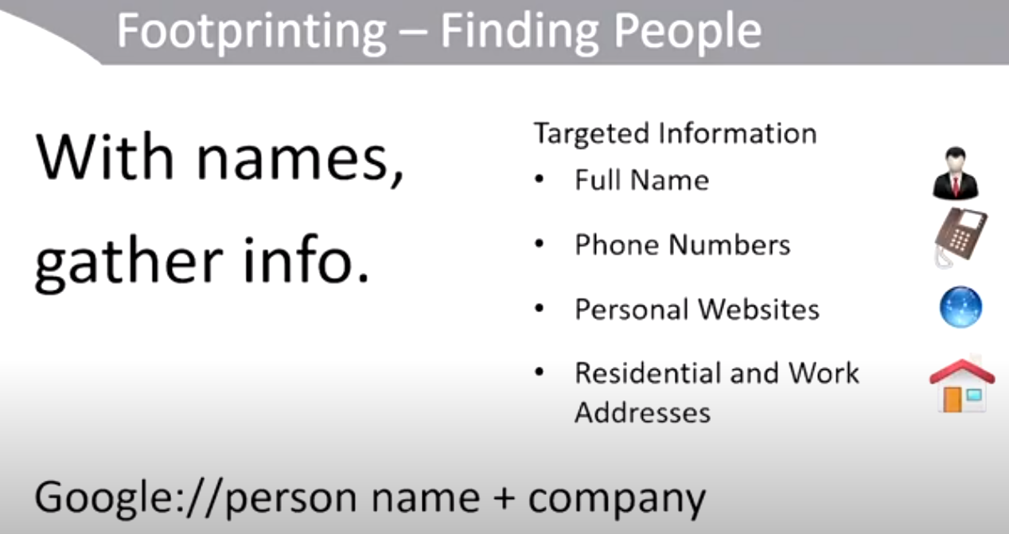
there are some other people searching websites.
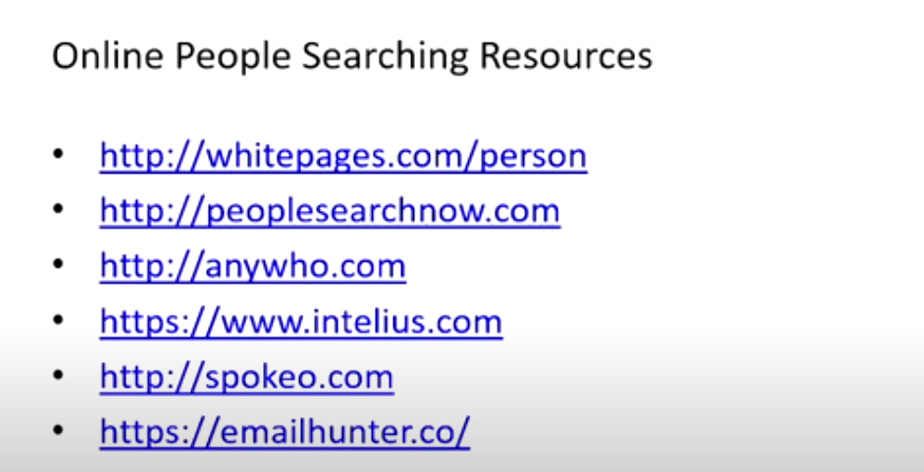
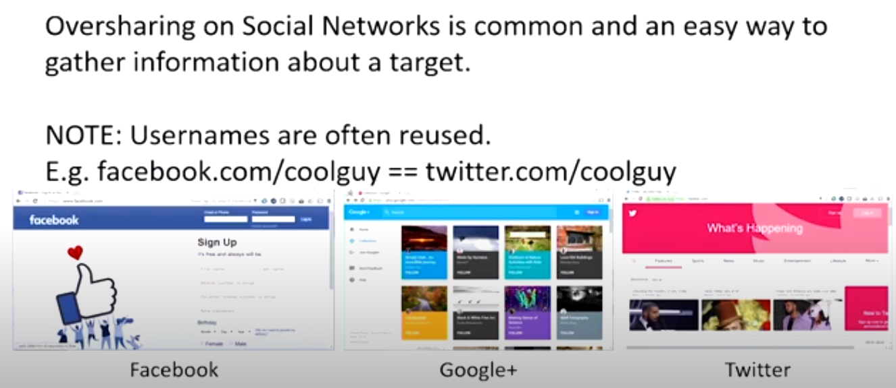
COMPETITIVE INTELLIGENCE
competitive intelligence ca give you a view into a company simply by talking to their competitors
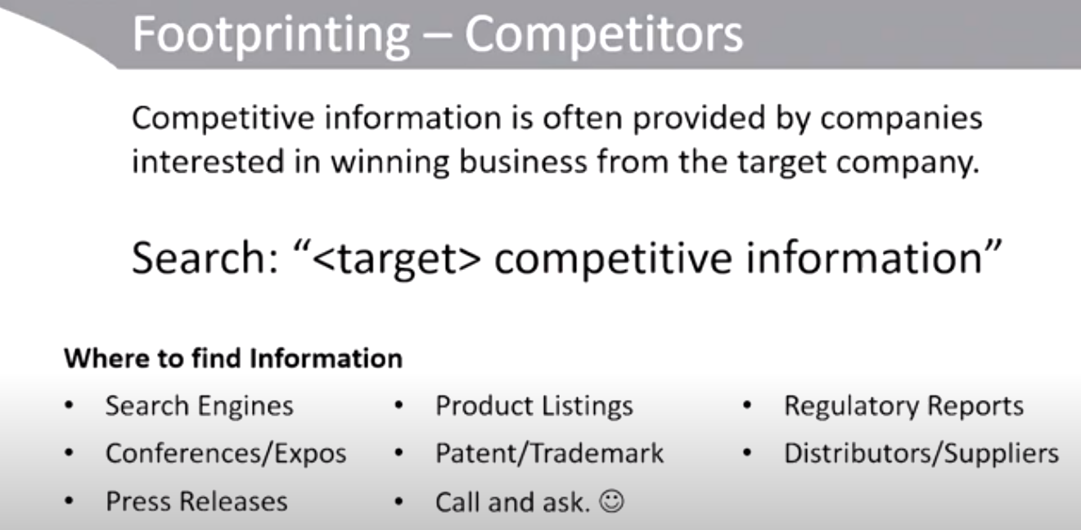
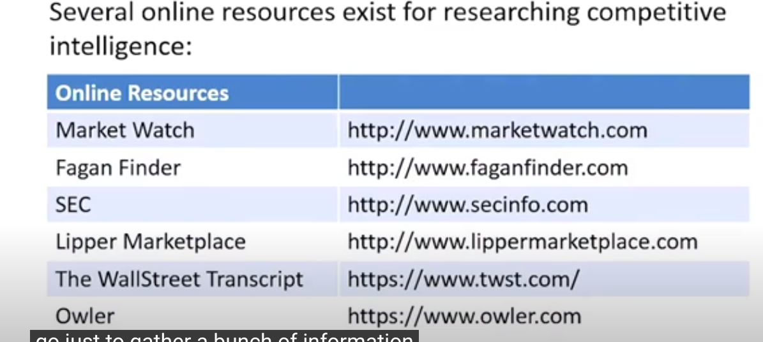
NOTE footprinting is all about narrowing our attack. What should i do, where should i search vulnerbility, what website, what services and all.

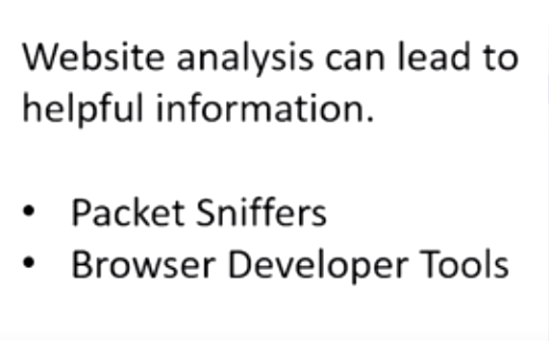
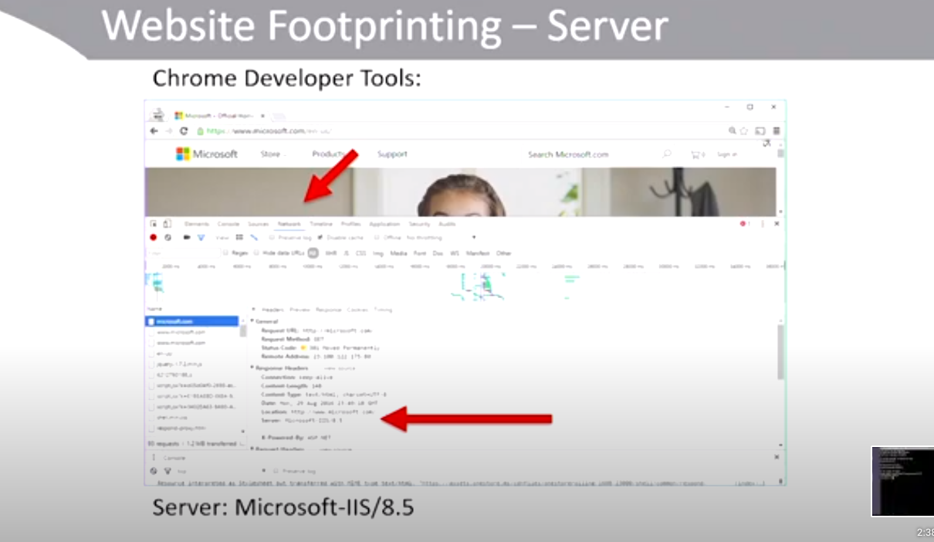
when i clicked on network and refresh the page then i can get lot of information, In this case microsoft server is running on iis 8.5 this can be very helpful once i get this information then if i were to attack on microsoft then i will focused on iis 8.5 and trying to exploit some vulnerbility on iis 8.5 version.

Some other tools to analyse website.
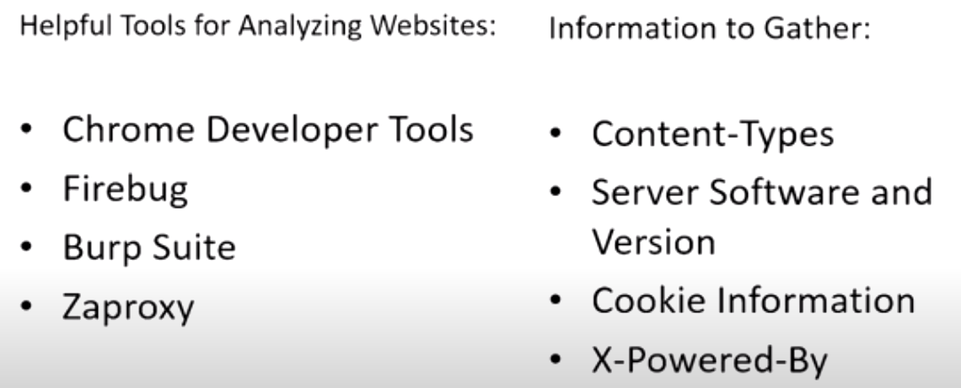
same inoformation you can get from sniffer in this case wireshark
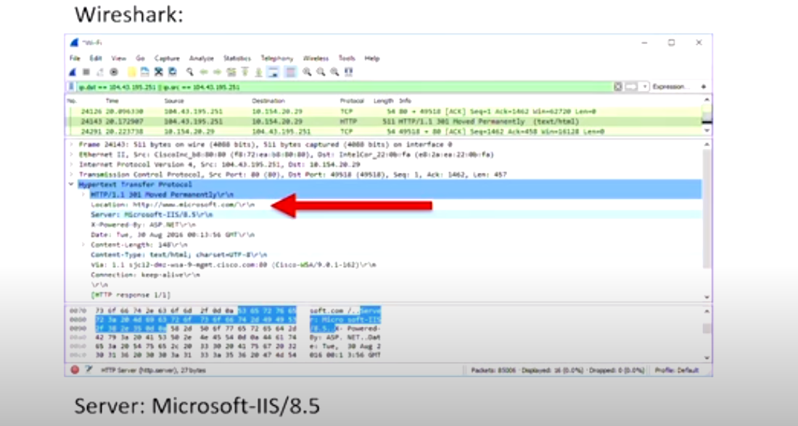
Another way is telnet and nc

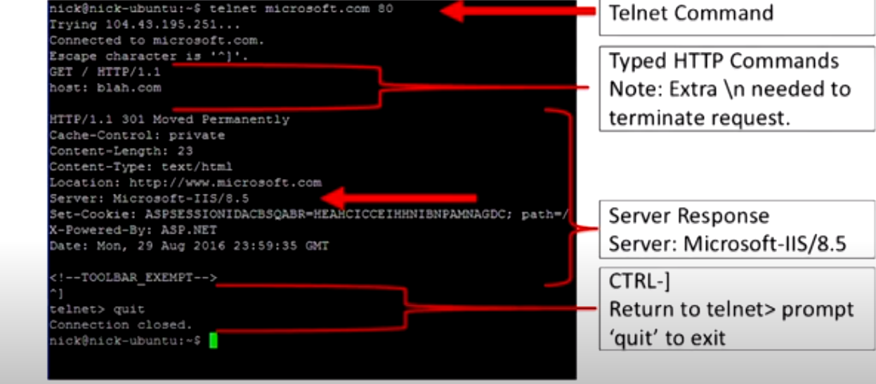
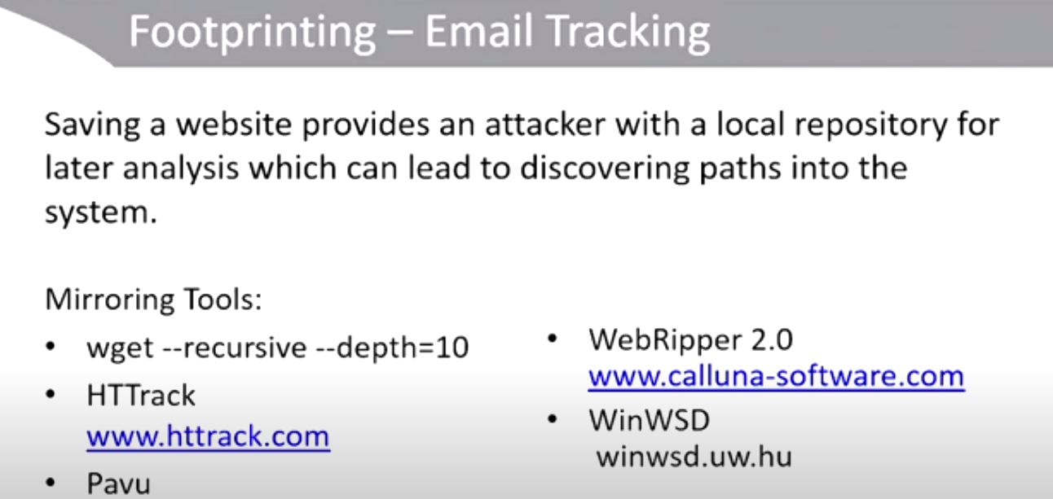
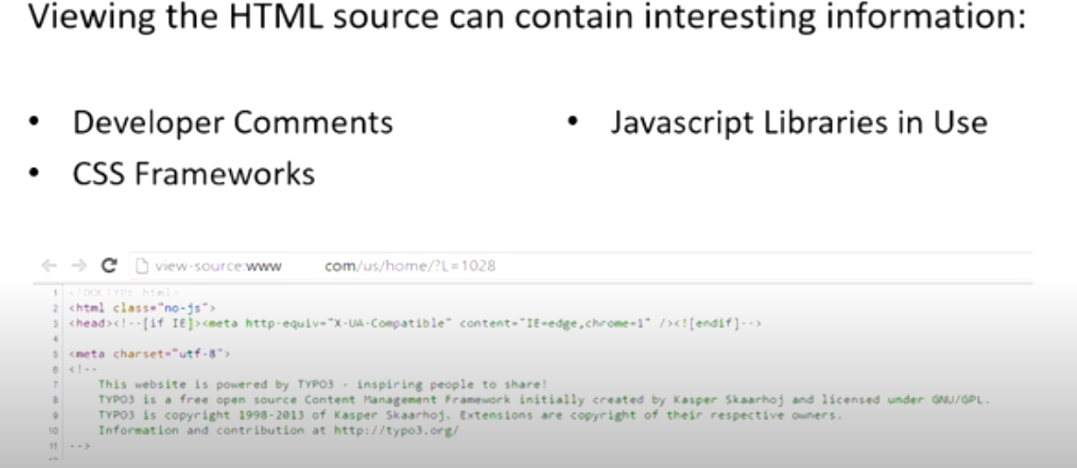
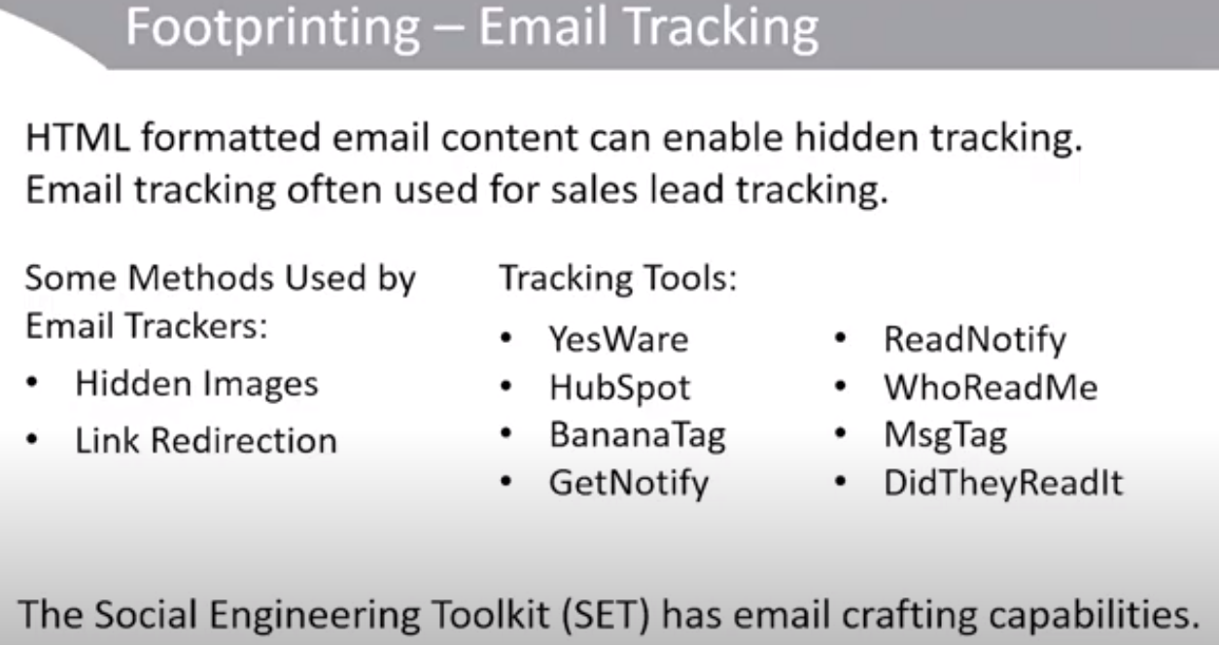
1:15

