1. INTRODUCTION AND SETUP

ENVIRONMENT SETUP:

at first you should install node and also set up npm package manager
if you have done these then you can check by using command line or powershell
$ node –version
$npm –version
now you should install any editor like vs code
now next thing you gonna have to install react read docs install by using npm
$ npm install -g create-react-app
NOTE : “-g” is for globally install

Now before you started you have o install react developer tools chrome extension

Now we ready to start project, so select a directory and craete react app
$ create-react-app <name>
eg: create-react-app demo
this will create a lot of packages, files and folders.
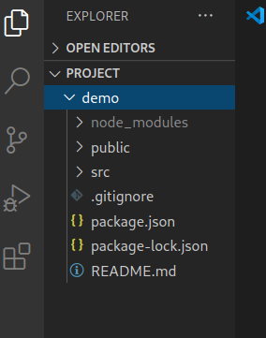
Now open your project in visual studio code.

node_module : where all projects related library to be installed.
Package.json file : this holds the whole information about our app, as well as dependencies.

Package-lock.json file: this file stores kind of current state of what’s in node_module , what’s required and stuff like that. We never required modify it except deleting it, as sometime if you have a conflict or something’s not working related to your project , then you can delete that then run npm install it’s going to reinstall it .

Now next thing you should install react router inside your project
$ npm install react-router –save

this will install the package to node_module and update it also in package.json file (so that when we open this project in another system then node_module will not there so if it is modified to package.json then we can install all the packages by running command $ npm install this will create node_module and install all the packages.)

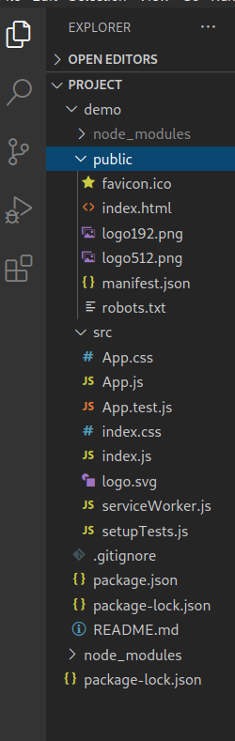
public directory in which HTML,CSS , JAVASCRIPT , IMAGES content present.Src directory where all react componert and file exist.

Now to run our app on browser run command
$ npm start

2. GETTING STARTED WITH REACTJS

you can also delete App.js and write your own component.
So let’s delete and get started

i’m gonna delete App.js and App.css file and create new Application.js and Application.css file
open Application.js file and import react component and create class and export class so that we will use it in another file.
import React, {Component} from 'react'
class Application extends Component{

}

export default Application

now open index.js and remove the import of App.js and then import Application.js
import Application from './Application';

now call or mount Application in render ( in ES6 we call it like HTML tag with angle bracket <Application />)

ReactDOM.render(
<React.StrictMode>
<Application />
</React.StrictMode>,
document.getElementById('root')
);

One essential method to call component is render so go to Application.js file and add render method this will return html, text or variable.

class Application extends Component{
render(){
return "Hello world! ";
}

}

// we can also use parenthesis to use all html content
return(
<h1>Hello world! <h1/>
);

NOTE : In this method we can not use multiple tag this will give a compilation error there should be one wrapper tag in which we can use multilple tags

for eg :
<h1> hello world!<h1/>
<span > this <span/>
this will give an error
so we have to wrap it in one common tag like
<div>
<h1>Hello wold! <h1/>
<span> this <span/>
<div/>

we can also use to declare a variable and use it
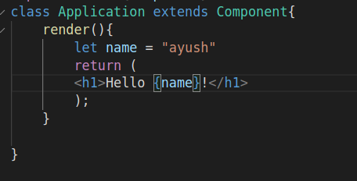

output: Hello ayush!

this is a basic method to render HTML, JS content

Next we gonna talk about life-cycle of an application.let’s see some methods for life cycle later on we will discuss more about it.
1. constructure :
which take an argument props , it can instantiate the parrent class by running super with the props. This is going to only be run when the application program is instantiated, not every time it re-render.

The life cycle of component is basically a string of function that get called to determine based on variable changes or whether somethings need to updated or re-render

componentWillMount(props, state){

}
componentDidMount(props, state) {
console.log(“Mounted with ” props, state); // this will give output in console undefined, undefined at place of props , state
}

There is a few methods that is called duing a state changes which are:-
componentwillReceiveProps(props ) {

}// this will actually gets called before it mounts because it will receive properties

when it is mount and every time it re-render as well or property changes.

componentWillUpdate(props, state)
{ } // these are the properties in state that it will update

componentDidUpdate(props, state)
{ } // this is the safer way to handle component updates, componentDidUpdate get triggered when a re-render happens as well.

you can access current property by this.props.<property name> and in argument props are old property

so these method is triggered during the life cycle of an application , we can also write our own methods some simplest ways are there--

constructure(props){
super(props);

this.state = {
count : 0;
}
}
handleClick = () => {// this is the method which will be called onClick button
console.log (“clicked”); // this will print clicked in the console when we clicked
}
render(){

let {count} = this.state; // it gets the count variable from the state

return(
<div>
<h1> hello u have cliicked this {count} times</h1>
<span><button onClick = {(e) =>this.handleClick() } >Click me</button></span>

// here ‘e’ is event when ‘(e) => ‘ is not there then as soon as it mounts it called that function and i does not do anything else
<div/>

);

}

Now we wanto update count when we clicked ,
So here is another built in method to react component called setState and this takes object as a parameter and optional callback,

constructure(props){
super(props);

this.state = {
count : 0;
}
}
handleClick = () => {
this.setState({count: this.state.count + 1});
}
render(){

let {count} = this.state;

return(
<div>
<h1> hello u have cliicked this {count} times</h1>
<span><button onClick = {(e) =>this.handleClick() } >Click me</button></span>

<div/>

);

}
Now you can see when you click button count get updated.

Next we will use componentDidUpdate method to see how it’s work.

constructure(props){
super(props);

this.state = {
count : 0;
}
}
handleClick = () => {
this.setState({count: this.state.count + 1});
}
componentDidUpdate(Props, state){
console.log(“updated from” state “to” this.state);
}
render(){

let {count} = this.state;

return(
<div>
<h1> hello u have cliicked this {count} times</h1>
<span><button onClick = {(e) =>this.handleClick() } >Click me</button></span>

<div/>

);

}
this wil print n the console privious state nd current state.
Note: as we know componentDidUpdate called each time when state chnges, so when we add setState method (this.setState({count: this.state.count + 1}); ) then it will cause of an infinite loop update, cause of give an error.

Write a function call when count is more than 10 it wil called and print the best score is 10

constructure(props){
super(props);

this.state = {
count : 0,
overTen : false
}
}
handleClick = () => {
this.setState({count: this.state.count + 1});
}
componentDidUpdate(Props, state){
if (this.state.count >10){
this.setState({overTen: true});
}
}
render(){

let {count} = this.state;

return(
<div>
<h1> hello u have cliicked this {count} times</h1>
{(this,state.overTen) ?
<h2> high score is 10 </h2>
}
<span><button onClick = {(e) =>this.handleClick() } >Click me</button></span>

<div/>

);

}

we can also do this by mount or call another js file :-
let’s create a new file along with Application.js called Highscore.js and edit it

import React, {conmponent} from react

class HighsScore{

render () {

//we will define property overTen when it is mounted or called

if (this.props.overTen){
return (
<h2> high score is 10 </h2>
we can also call a function property that we create during call
<button onClick = {(e) => this.props.onReset()}>reset</button>

); }

}
}
export default HighScore

now we will call this in Application.js instead of using {(this,state.overTen) ?
<h2> high score is 10 </h2>
}

call it like
<HighScore
// here will pass property that we have used
overTen = {this.state.overTen}
onReset = {(e) => this.resetCount(e) }
/>

Now we have to define resetCount funtion before using it

resetCount (e){
this.setState {(
count : 0;
overTen = false;
)};
}

by doing this when will click more than 10 times it will show high score is 10 and a reset button that will allow to reset all data

HOW TO IMPORT CSS INTO REACT COMPONENT

simply you can create a folder of css in src directory and then create a file like style.css and do styling in it and to call it you can simply import it in Application.js like
import “path of css file”

NOW WE WILL BUILD A BASIC CALCULATOR

Now we want to create a simple react webapp

so lt’s start with creating new react app by create-react-app <app_name>

now we see there is lot of things that we use repeatitively like nav and pre-setup of any pages, in contact form we call input field multiple time, in any list we call div multiple time and so on.
But when we are working with react we have to think like react. So now we will create a single .js file call it multiple time rather hard code of html or other.

So first we will create a component folderin src folder and inside it create assets(for image and logo), common (for reusable) and pages (for indivisual pages) folder.

First create a pagewrapper.js file in component folder and edit it with navs and pre-setup of pages

i.e -

import React, {Component} from 'react';
import {Link} from 'react-router-dom';
class PageWrapper extends Component{

render(){
return(
<div>
<nav className="navbar navbar-expand-lg navbar-dark fixed-top" id="mainNav">
<div className="container">
<Link className="navbar-brand js-scroll-trigger" to="/"><img src="img/navbar-logo.svg" alt="" /></Link >
<button className="navbar-toggler navbar-toggler-right" type="button" data-toggle="collapse" data-target="#navbarResponsive" aria-controls="navbarResponsive" aria-expanded="false" aria-label="Toggle navigation">
Menu
<i className="fas fa-bars ml-1"></i>
</button>
<div className="collapse navbar-collapse" id="navbarResponsive">
<ul className="navbar-nav text-uppercase ml-auto">
<li className="nav-item"><Link className="nav-link js-scroll-trigger" to="/services">Services</Link ></li>
<li className="nav-item"><Link className="nav-link js-scroll-trigger" to="/portfolio">Portfolio</Link ></li>
<li className="nav-item"><Link className="nav-link js-scroll-trigger" to="/about">About</Link ></li>
<li className="nav-item"><Link className="nav-link js-scroll-trigger" to="/team">Team</Link ></li>
<li className="nav-item"><Link className="nav-link js-scroll-trigger" to="/contact">Contact</Link ></li>
</ul>
</div>
</div>
</nav>
{this.props.children}
</div>
)
}
}

export default PageWrapper;

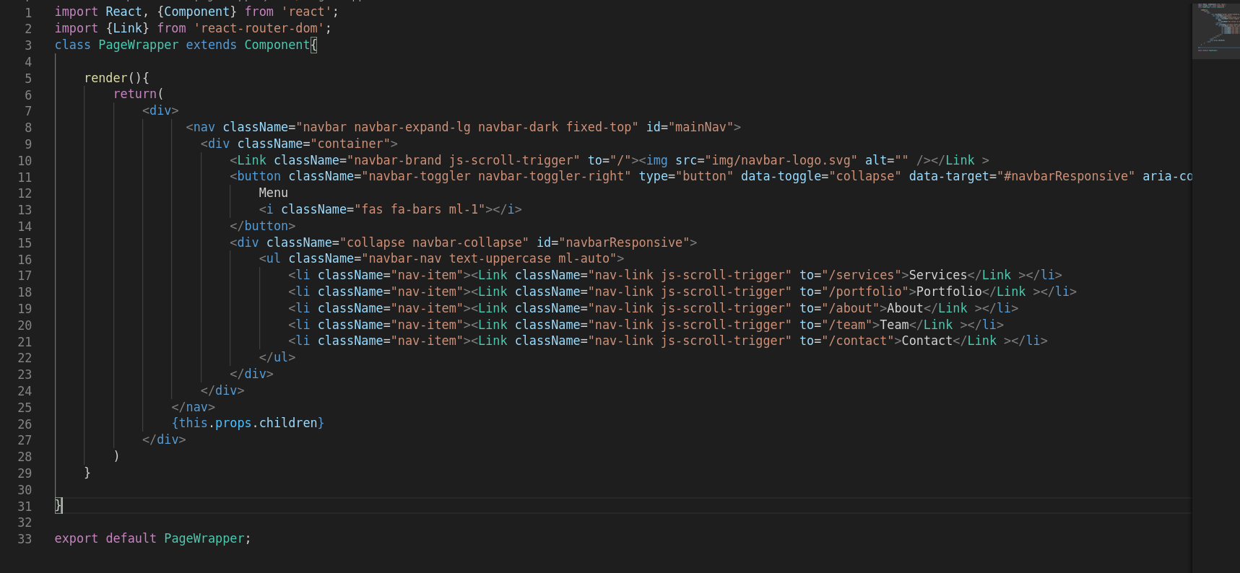
then next create reusable things like header, footer in common folder

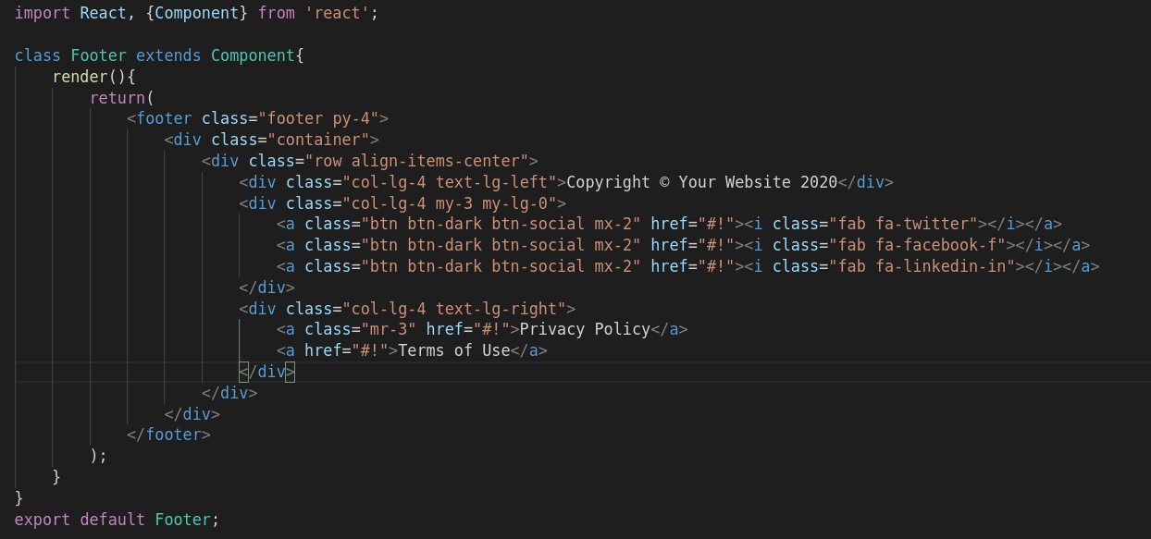

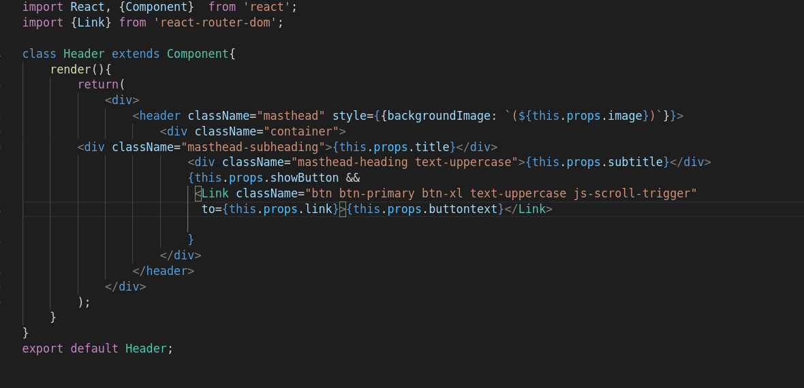
now we can call header in multiple page and set some props also according to pages like title , subtitle, background image and others
i.e -

<Header
title="Welcome To Our Studio!"
subtitle="It's Nice To Meet You"
link="/services"
buttontext="Tell me more"
image={image}
showButton={true}
/>

if no any props tobe changed in indivisual page like footer (this is same for all pages) then we can call it by simply adding

<Footer/>

Now next thing we have to create a team page in which all team should be mentioned like


so we create a file called team.js and inside it instead of making three column for team member we will create another file called teamMember.js and inside it we will create a single team member and we wiil call it three time in team.js file as a column and also we pass different name, work and image props by using array for different team menmber.

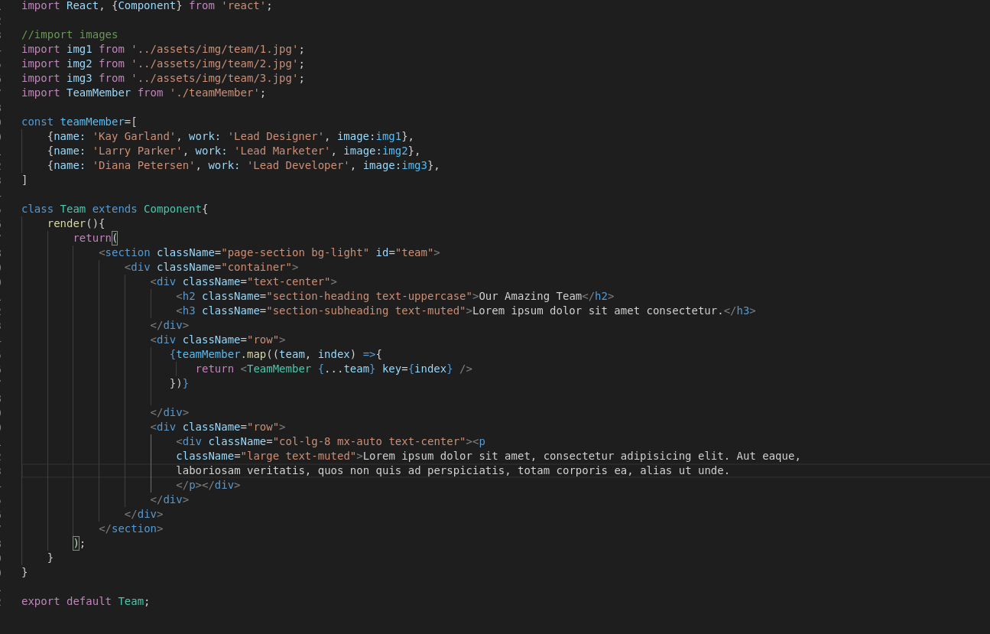
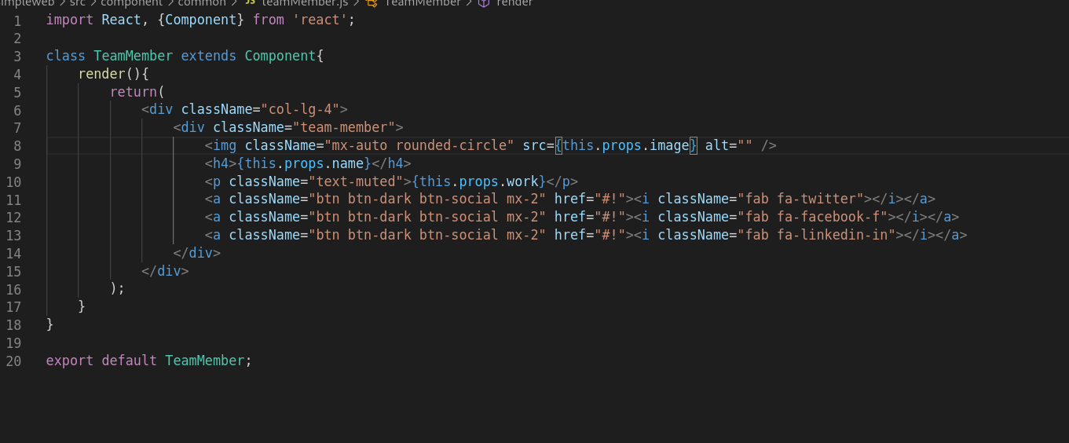

as you can see we have created an array in team.js called teammember and stored props and pass these props in teamMember.js by this.props.name and so on.
And the we have called it in team.js file in a row and passed array by using map.

Like this we can create portfolio page, services page.

we will create a portfolio.js file and portfolioItem.js file (for single item and reuse it multiple times). And then we will call portfolioItem.js from portfolio.js file.
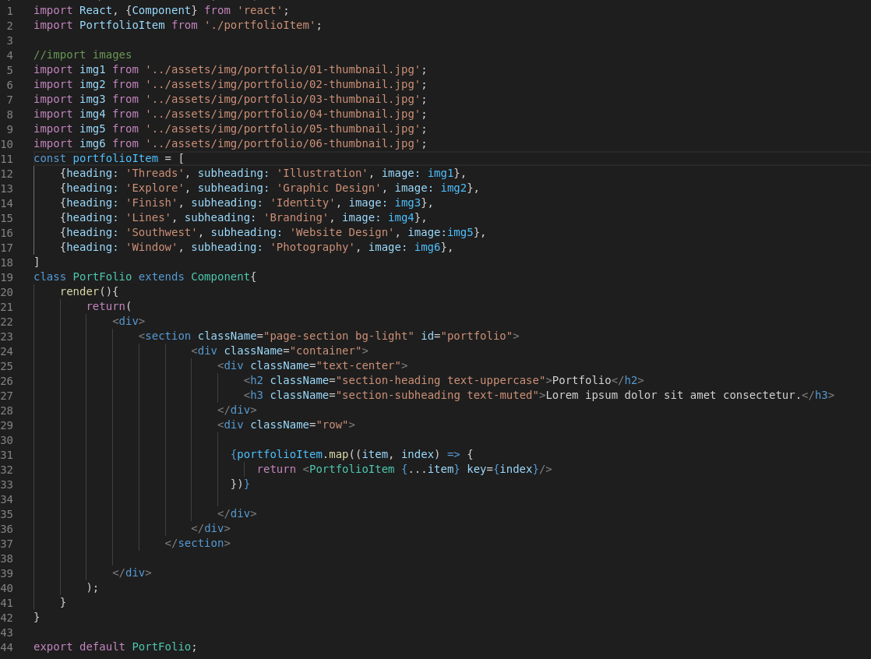

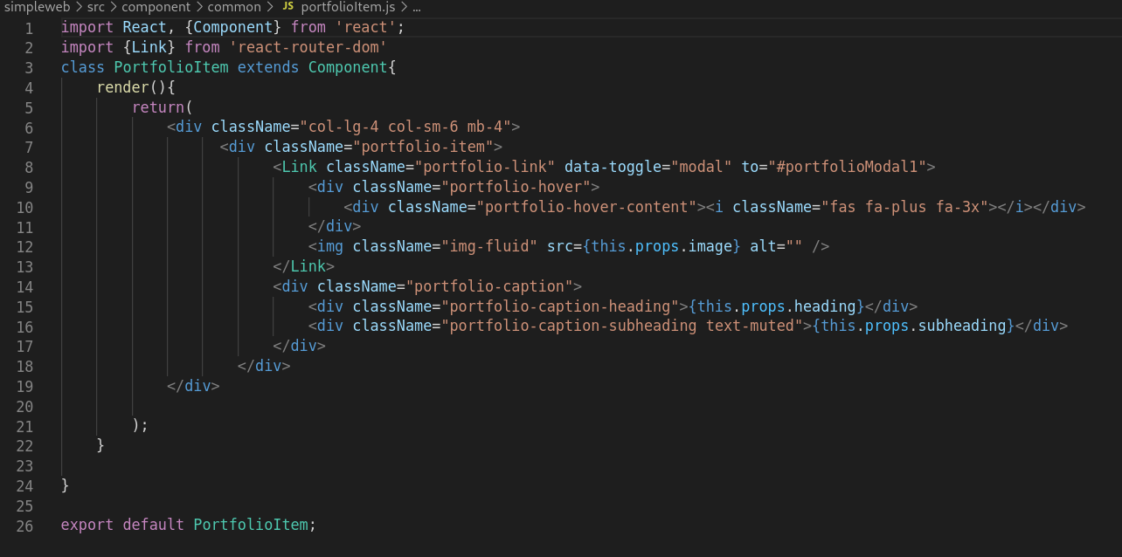
Now next services
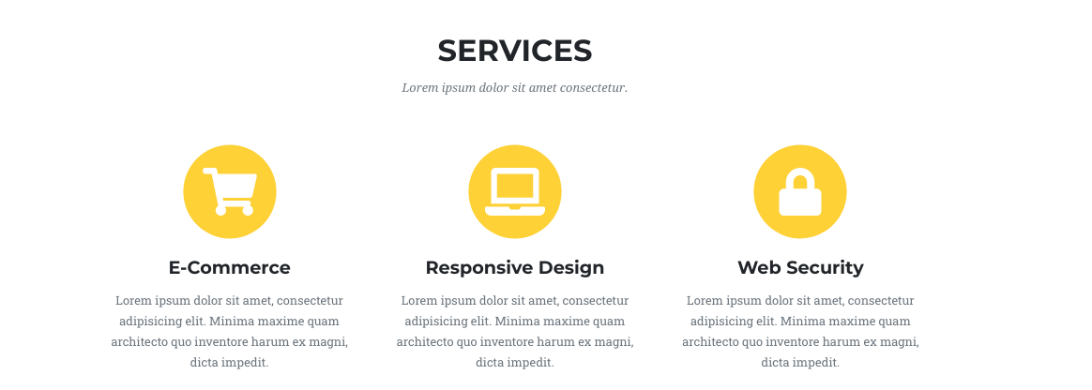
similarlly,
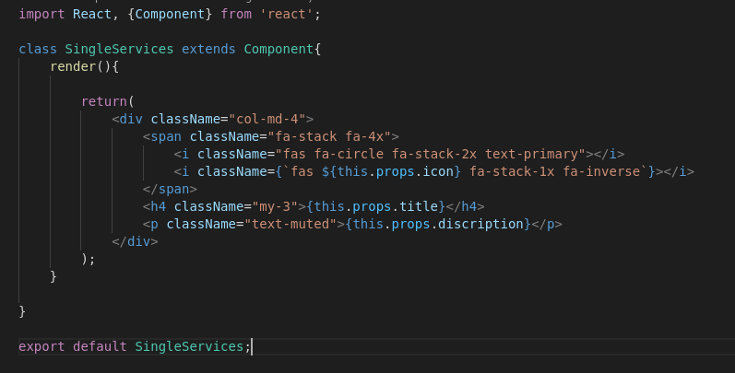

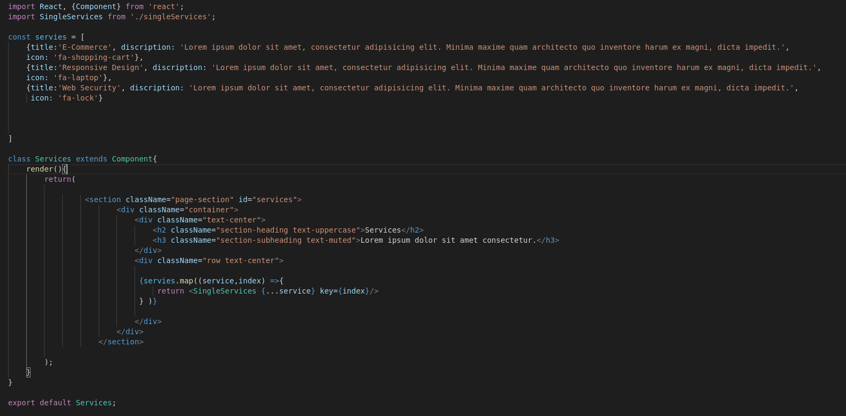
Now create a timeline page
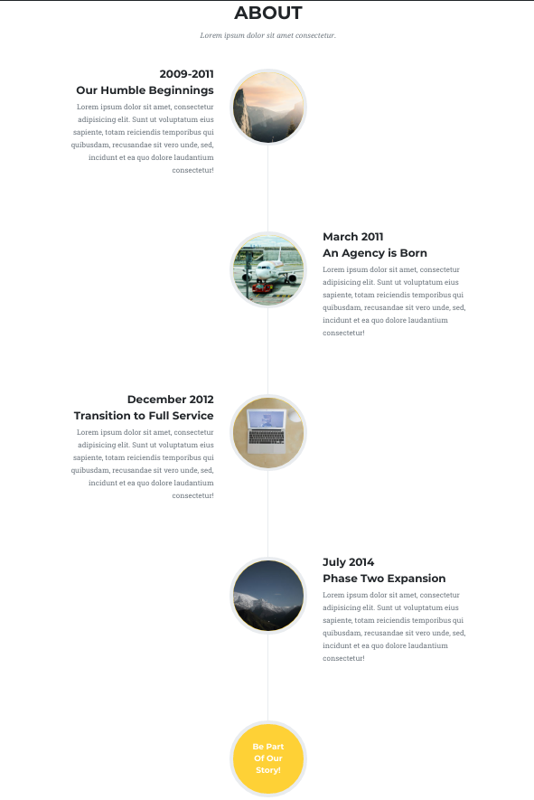
So create timeline.js file and edit with
import React, {Component} from 'react';

class Timeline extends Component{
render(){
return(
<section className="page-section" id="about">
<div className="container">
<div className="text-center">
<h2 className="section-heading text-uppercase">About</h2>
<h3 className="section-subheading text-muted">Lorem ipsum dolor sit amet consectetur.</h3>
</div>
<ul className="timeline">
<li>
<div className="timeline-image"><img className="rounded-circle img-fluid" src="/img/about/1.jpg" alt="" /></div>
<div className="timeline-panel">
<div className="timeline-heading">
<h4>2009-2011</h4>
<h4 className="subheading">Our Humble Beginnings</h4>
</div>
<div className="timeline-body"><p className="text-muted">Lorem ipsum dolor sit amet, consectetur adipisicing elit. Sunt ut voluptatum eius sapiente, totam reiciendis temporibus qui quibusdam, recusandae sit vero unde, sed, incidunt et ea quo dolore laudantium consectetur!</p></div>
</div>
</li>
<li className="timeline-inverted">
<div className="timeline-image"><img className="rounded-circle img-fluid" src="/img/about/2.jpg" alt="" /></div>
<div className="timeline-panel">
<div className="timeline-heading">
<h4>March 2011</h4>
<h4 className="subheading">An Agency is Born</h4>
</div>
<div className="timeline-body"><p className="text-muted">Lorem ipsum dolor sit amet, consectetur adipisicing elit. Sunt ut voluptatum eius sapiente, totam reiciendis temporibus qui quibusdam, recusandae sit vero unde, sed, incidunt et ea quo dolore laudantium consectetur!</p></div>
</div>
</li>
<li>
<div className="timeline-image"><img className="rounded-circle img-fluid" src="/img/about/3.jpg" alt="" /></div>
<div className="timeline-panel">
<div className="timeline-heading">
<h4>December 2012</h4>
<h4 className="subheading">Transition to Full Service</h4>
</div>
<div className="timeline-body"><p className="text-muted">Lorem ipsum dolor sit amet, consectetur adipisicing elit. Sunt ut voluptatum eius sapiente, totam reiciendis temporibus qui quibusdam, recusandae sit vero unde, sed, incidunt et ea quo dolore laudantium consectetur!</p></div>
</div>
</li>
<li className="timeline-inverted">
<div className="timeline-image"><img className="rounded-circle img-fluid" src="/img/about/4.jpg" alt="" /></div>
<div className="timeline-panel">
<div className="timeline-heading">
<h4>July 2014</h4>
<h4 className="subheading">Phase Two Expansion</h4>
</div>
<div className="timeline-body"><p className="text-muted">Lorem ipsum dolor sit amet, consectetur adipisicing elit. Sunt ut voluptatum eius sapiente, totam reiciendis temporibus qui quibusdam, recusandae sit vero unde, sed, incidunt et ea quo dolore laudantium consectetur!</p></div>
</div>
</li>
<li className="timeline-inverted">
<div className="timeline-image">
<h4>
Be Part
<br />
Of Our
<br />
Story!
</h4>
</div>
</li>
</ul>
</div>
</section>
);
}
}
export default Timeline;

Now all reusable page are created except contact page we will do it later on
for we create a page called home.js inside pages folder and call all these pagewrapper first then header (with title , subtitle, backgroundImage and others), services, team, portfolio and footer

And then a about.js file in which we will call header, timeline, team and footer.

NOTE : pagewrapper is coommon or all the pages so we will wrap pagewrapper in App.js file so that it work for all the pages that we will rounting.
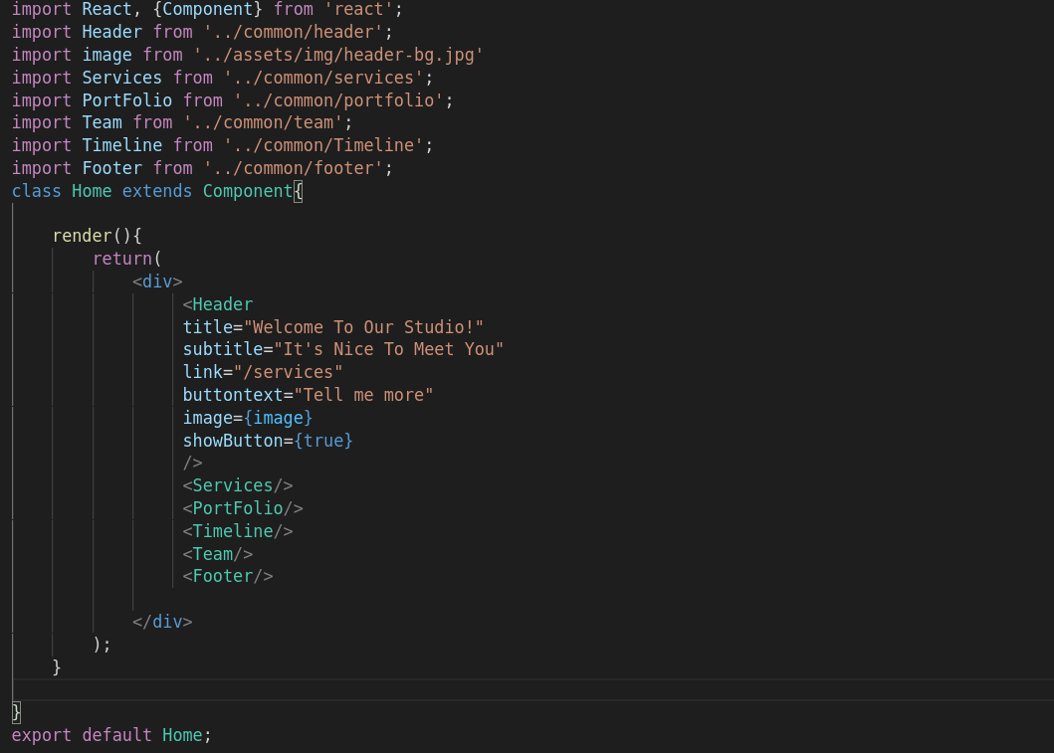
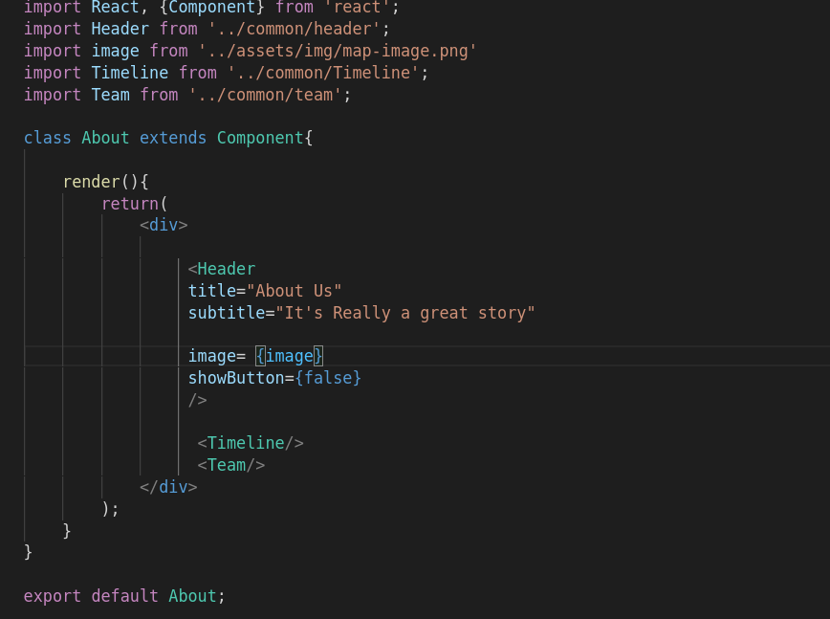

Now next we will have to route these pages by router.

So first we have to install npm react router by
$npm install --save react-router-dom
then in App.js import it first and then wrap pagewrapper in BrowserRouter and then write Routes like -

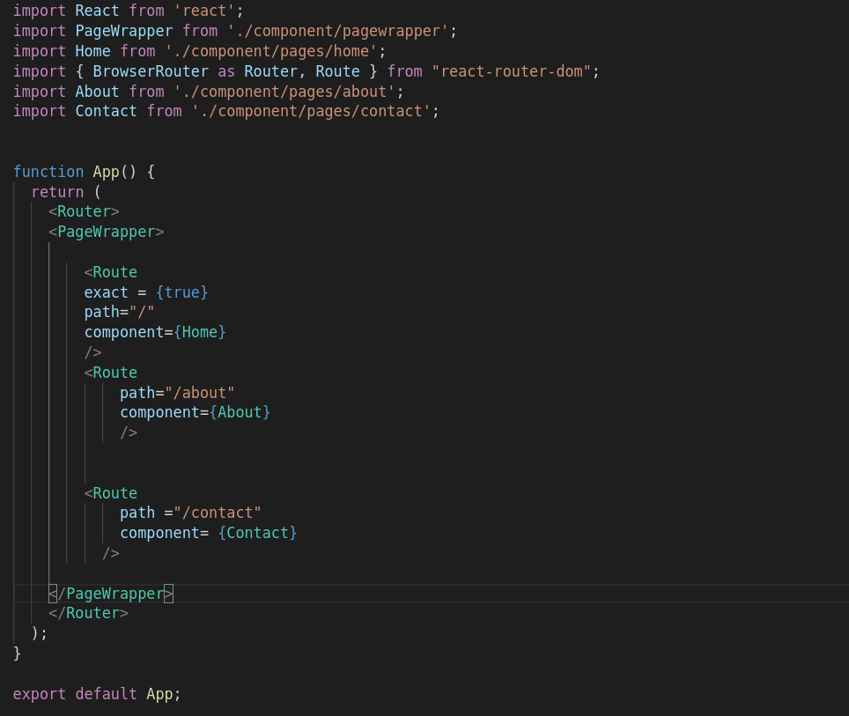
we have create Routes for contact also but we haven’t created page yet so next we will do the contact page
so again just like before we will create a contact.js file in pages and instead of creating indivisual input field for name email and others we will create a template or page called field.js in common folder and the we will call it for each input field.
But this time it will not be easy just like before because we have to created form in which to column are there like this-

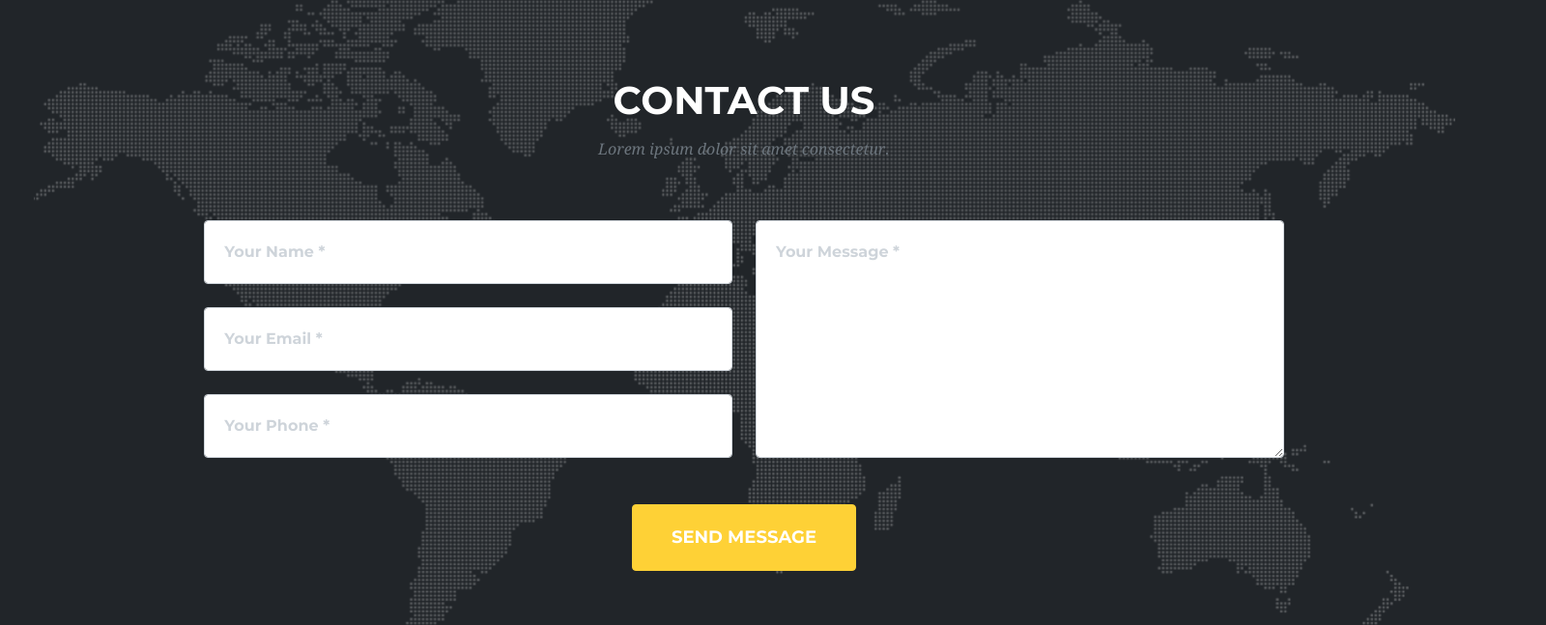
So instead of creating a simple array like before this time we will create a section in array like

const field={
sections: [
[
{name: 'name', type: 'text', elementName: 'input', placeholder: 'Your Name *', val_message: 'Please enter your name.'},
{name: 'email', type: 'email', elementName: 'input', placeholder: 'Your Email *', val_message: 'Please enter your email.'},
{name: 'phone', type: 'tel', elementName: 'input', placeholder: 'Your Phone no *', val_message: 'Please enter your phone no.'},
],
[
{name: 'message', elementName: 'textarea', placeholder: 'Please Message Here *', val_message: 'Please enter your message.'},

]

]
}

then we have create a constructure in contact class so that we can store input field date at the time when it is filled by state.

constructor(props){
super(props);

this.state = {
name: '',
email: '',
phone: '',
message: ''
}
}

and inside field.js edit it like -
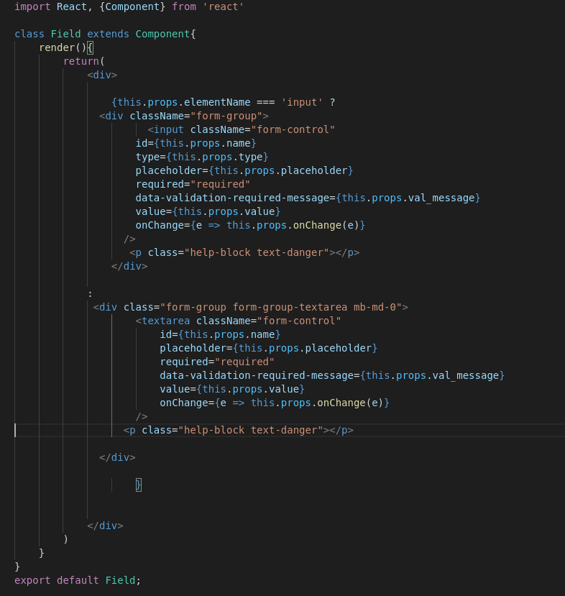
and inside input field we have used to property value and onChange which is using the property that
we will define in contact.js during call of this field

And what will it do ?
Value will save input data in respective field and onChange property will update the value of input when it s changed by using setState property

and then call this field by using map in contact.js

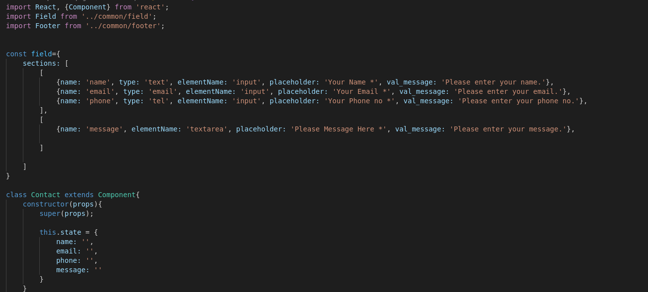
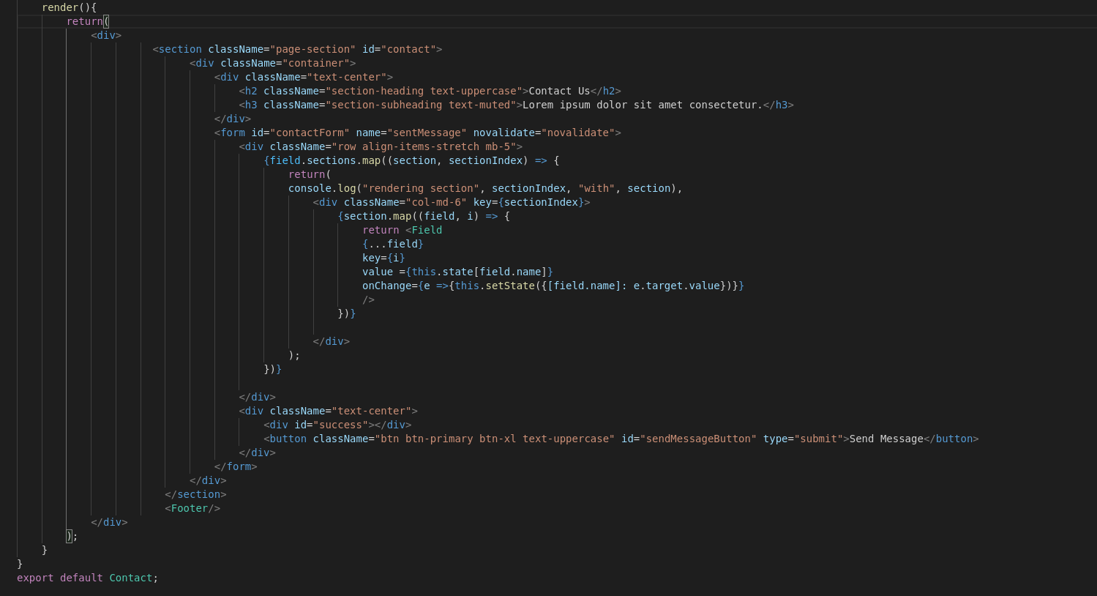

Now next thing we learn about formik package which is a form framework and by using that we don’t required this constructure and submitForm function we can do these things by using formik
In order to install formik we have to pass a command
$ npm install –save formik
once it is installed then we will import it in contact.js
import {withFormik} from ‘formik’;
then we have wrap exported contact with withFormik() and write object in it then modify field.js according to formik.

Field.js
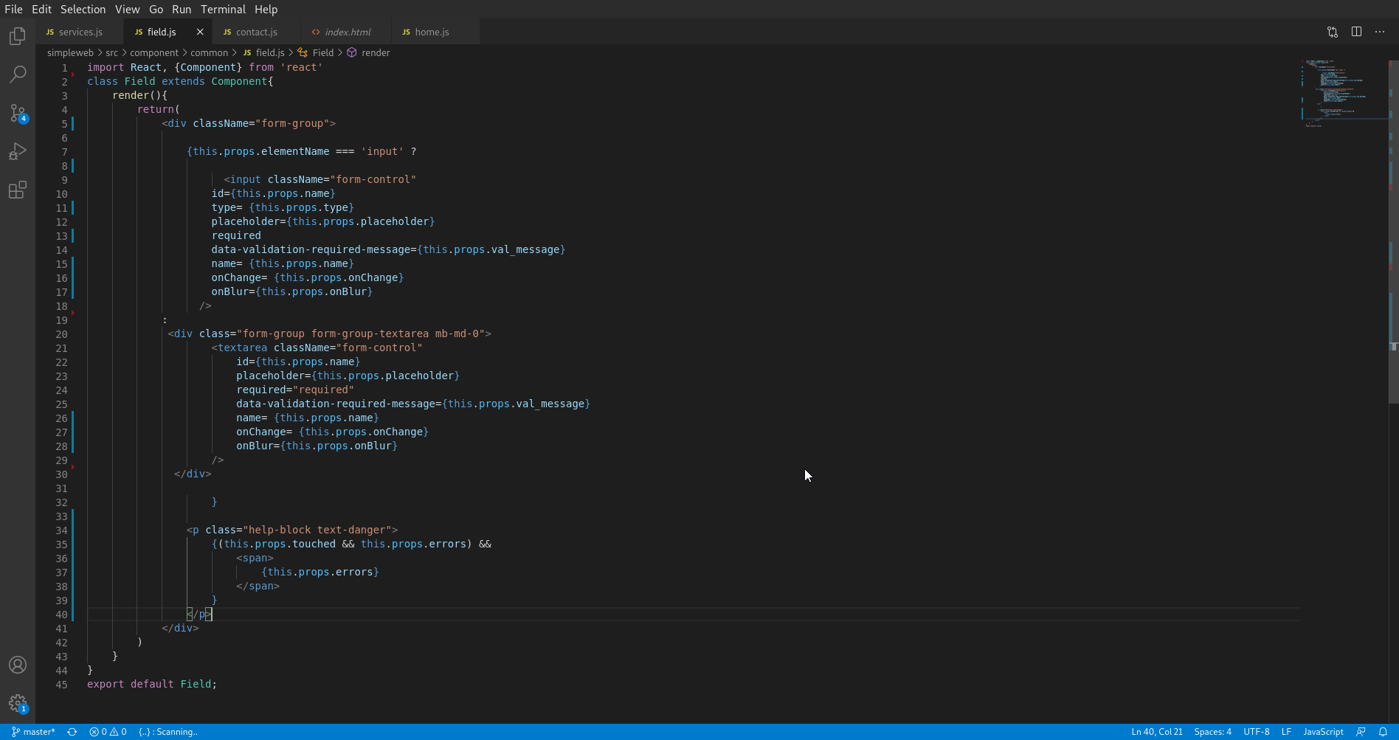
contact.js
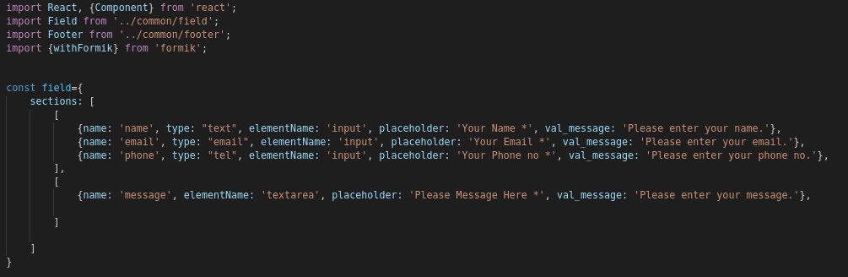
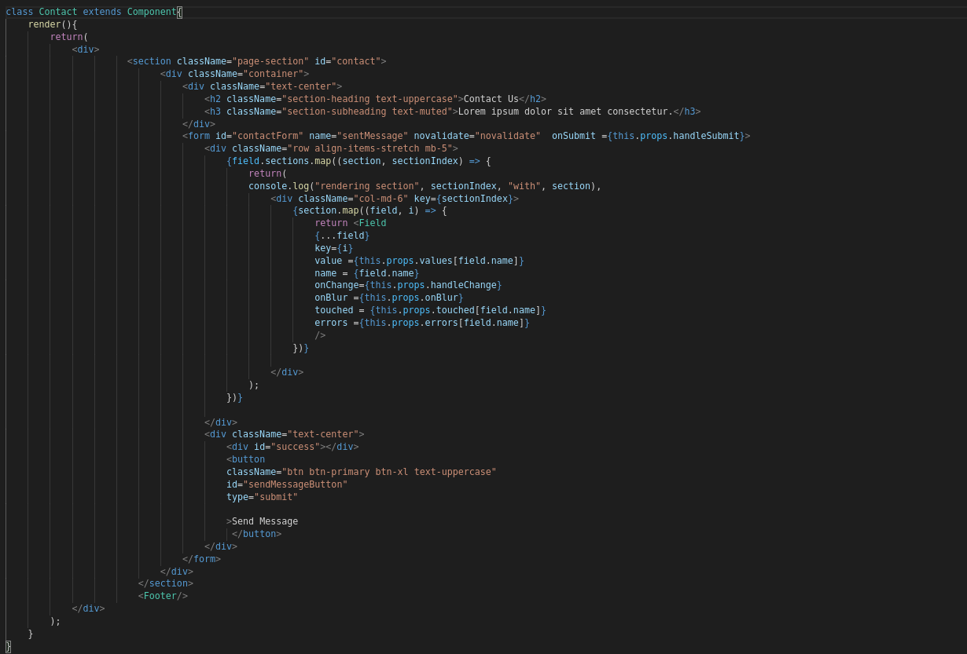
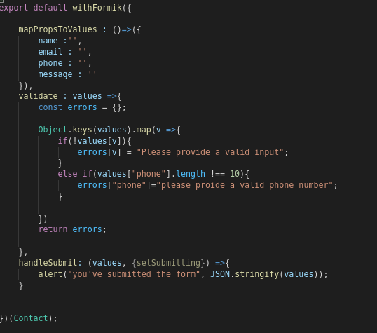
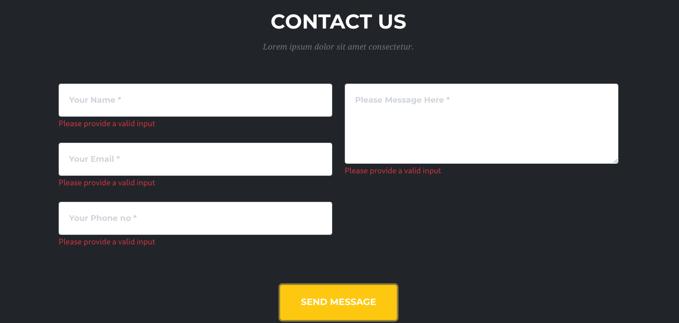
As we can see all validation and another things are working.

Now next we will look up cool validation schema called yup that provides validation to our form. So at first we have install it.
$ npm install –save yup
once it get installed remove the validation that we have done earlier and import yup.
Import * as Yup from ‘yup’; (NOTE- here ‘*’ symbol for importing all property in yup).

Then define all the validationschema like -
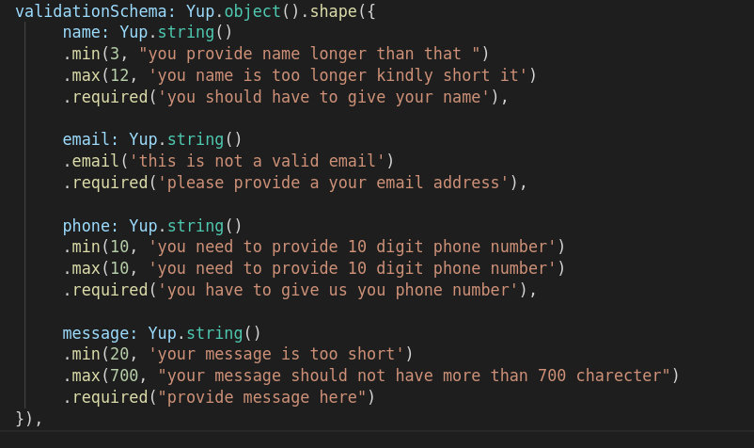
NOW IT DONE AND NEXT WE SHOULD HAVE TO MOVE ON FOR BACKEND.

REST API WITH LOOPBACK

At first we have to install MongoDB on our system
you can look the installation process for indivisual operating system on docs LINK
Then install loopback-cli on our system. Go through documentation and create project after installation done

Once it is done run command node . Or npm start to start server
$ node .
Browse your REST API at http://0.0.0.0:3000/explorer
Web server listening at: http://0.0.0.0:3000/

we can see the REST API URL now when we open this.

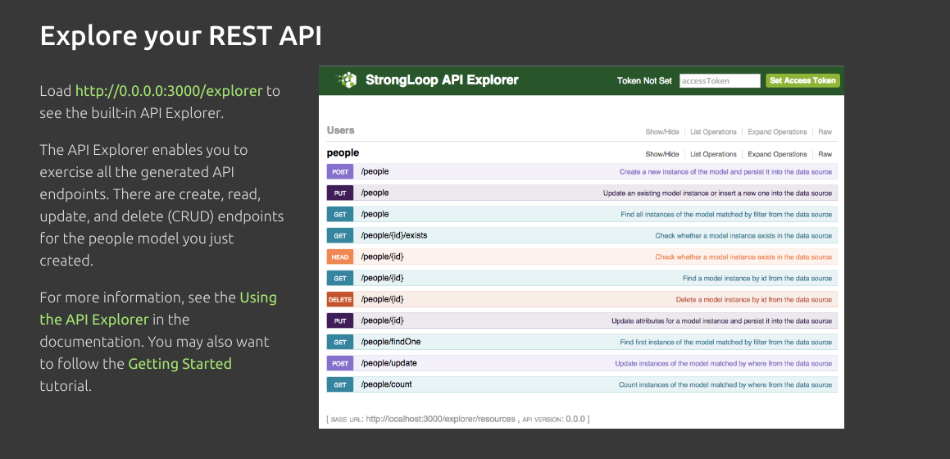
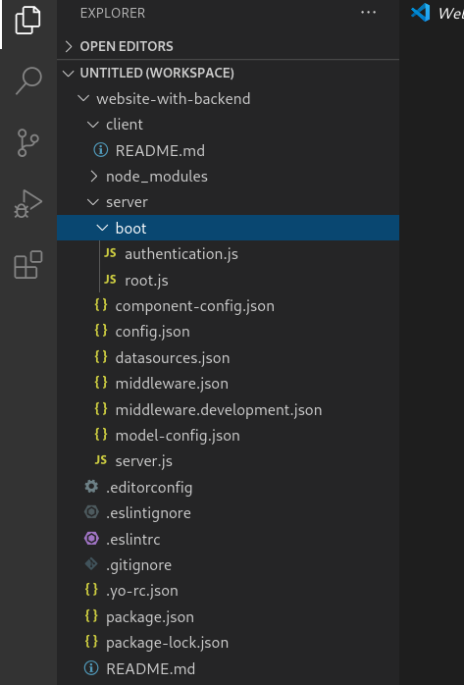
now let’s jump into code

we have package.json in which all the information, dependencies , scripts are available.
We component-config.json for components and config.json for configuration of our Rest Api, datasource.json for connecting to database, middleware json file , model-config.json for our model configuration (there is already some built in model that we have seen on web explorer page) and server.js file in which we will write code and every time when we run app it will compiled .

Now next we will creating a new custom model. For this Go through documentation.

When you create a model then you can see a new directory named common is created in
which 2 files are there
1. <model_name>.js
2. <model_name>.json

i.e when i create a model for profile it will create profile.json and profile.js in profile,json file all the property and field that we have create during creation of model are there

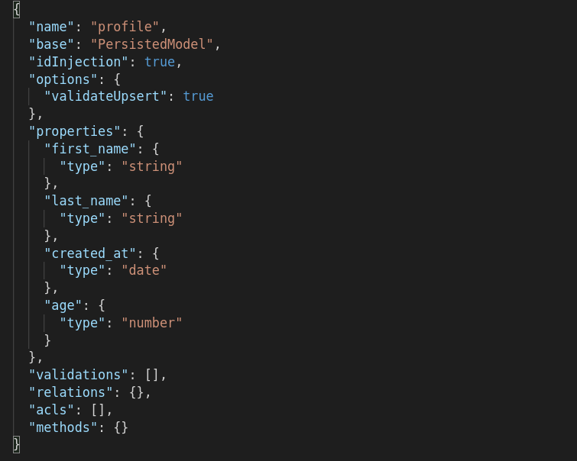
we can actually create or modify with our own for example we want to add some property the simply add

"birth_date": {
"type": "date"
},

"history": {
"type": ["object"]
}

and profile.js file is used only when we want to add custom end points

