Assignment-11

“Constructors and Inheritance”

Part A – Constructors

Student – Default and Parameterized Constructor
Create a Java class named Student with Student ID, Student Name, Course, and Age. Implement a default constructor, a parameterized constructor accepting all four values, and displayDetails(). Create a Main class and demonstrate both constructors.
class Student {
int studentId;
String studentName;
String course;
int age;
// Default Constructor
Student() {
studentId = 0;
studentName = "Unknown";
course = "Not Assigned";
age = 0;
}
// Parameterized Constructor
Student(int studentId, String studentName, String course, int age) {
this.studentId = studentId;
this.studentName = studentName;
this.course = course;
this.age = age;
}
void displayDetails() {
System.out.println("Student ID: " + studentId);
System.out.println("Student Name: " + studentName);
System.out.println("Course: " + course);
System.out.println("Age: " + age);
System.out.println();
}
}
public class StudentDemo {
public static void main(String[] args) {
Student s1 = new Student();
Student s2 = new Student(
101,
"Haidar Raj Ali",
"BTech CSE AI & ML",
19
);
System.out.println("Student 1 - Default Constructor");
s1.displayDetails();
System.out.println("Student 2 - Parameterized Constructor");
s2.displayDetails();
}
}
Expected Output:
Student 1 - Default Constructor
Student ID: 0
Student Name: Unknown
Course: Not Assigned
Age: 0
Student 2 - Parameterized Constructor
Student ID: 101
Student Name: Haidar Raj Ali
Course: BTech CSE AI & ML
Age: 19

Employee – Default, Parameterized and Copy Constructor
Create an Employee class with employee ID, name, designation, and salary. Implement a default constructor, a parameterized constructor, and a copy constructor. Display the details of all three Employee objects.
class Employee {
int employeeId;
String name;
String designation;
double salary;
// Default Constructor
Employee() {
employeeId = 0;
name = "Unknown";
designation = "Not Assigned";
salary = 0.0;
}
// Parameterized Constructor
Employee(int employeeId, String name, String designation, double salary) {
this.employeeId = employeeId;
this.name = name;
this.designation = designation;
this.salary = salary;
}
// Copy Constructor
Employee(Employee e) {
this.employeeId = e.employeeId;
this.name = e.name;
this.designation = e.designation;
this.salary = e.salary;
}
void displayDetails() {
System.out.println("Employee ID: " + employeeId);
System.out.println("Name: " + name);
System.out.println("Designation: " + designation);
System.out.println("Salary: " + salary);
System.out.println();
}
}
public class EmployeeDemo {
public static void main(String[] args) {
Employee e1 = new Employee();
Employee e2 = new Employee(
101,
"Haidar Raj Ali",
"Software Developer",
50000
);
Employee e3 = new Employee(e2);
System.out.println("Employee 1 - Default Constructor");
e1.displayDetails();
System.out.println("Employee 2 - Parameterized Constructor");
e2.displayDetails();
System.out.println("Employee 3 - Copy Constructor");
e3.displayDetails();
}
}
Expected Output:
Employee 1 - Default Constructor
Employee ID: 0
Name: Unknown
Designation: Not Assigned
Salary: 0.0
Employee 2 - Parameterized Constructor
Employee ID: 101
Name: Haidar Raj Ali
Designation: Software Developer
Salary: 50000.0
Employee 3 - Copy Constructor
Employee ID: 101
Name: Haidar Raj Ali
Designation: Software Developer
Salary: 50000.0

Part B – Inheritance

3. Single Inheritance – Person and Student
Create a parent class Person with Name, Age, Email, and displayPersonDetails(). Create a child class Student with Student ID, Course, and displayStudentDetails(). Implement single inheritance, use super() to call the parent constructor, create a Student object, and display both personal and academic details.
class Person {
String name;
int age;
String email;
Person(String name, int age, String email) {
this.name = name;
this.age = age;
this.email = email;
}
void displayPersonDetails() {
System.out.println("Name: " + name);
System.out.println("Age: " + age);
System.out.println("Email: " + email);
}
}
class InheritanceStudent extends Person {
int studentId;
String course;
InheritanceStudent(String name, int age, String email,
int studentId, String course) {
super(name, age, email);
this.studentId = studentId;
this.course = course;
}
void displayStudentDetails() {
displayPersonDetails();
System.out.println("Student ID: " + studentId);
System.out.println("Course: " + course);
}
}
public class SingleInheritanceDemo {
public static void main(String[] args) {
InheritanceStudent s = new InheritanceStudent(
"Haidar Raj Ali",
19,
"haidar@example.com",
101,
"BTech CSE AI & ML"
);
System.out.println("Student Details");
System.out.println("----------------");
s.displayStudentDetails();
}
}
Expected Output:
Student Details
----------------
Name: Haidar Raj Ali
Age: 19
Email: haidar@example.com
Student ID: 101
Course: BTech CSE AI & ML

4. Multilevel Inheritance – Employee, Manager and ProjectManager
Create a multilevel inheritance structure Employee → Manager → ProjectManager. Use Employee ID, Employee Name, Basic Salary, Department, Team Size, Project Name, and Project Duration. Create constructors in all three classes and use super() to invoke parent constructors. Display complete Project Manager details.
class MultiEmployee {
int employeeId;
String employeeName;
double basicSalary;
MultiEmployee(int employeeId, String employeeName, double basicSalary) {
this.employeeId = employeeId;
this.employeeName = employeeName;
this.basicSalary = basicSalary;
}
}
class Manager extends MultiEmployee {
String department;
int teamSize;
Manager(int employeeId, String employeeName, double basicSalary,
String department, int teamSize) {
super(employeeId, employeeName, basicSalary);
this.department = department;
this.teamSize = teamSize;
}
}
class ProjectManager extends Manager {
String projectName;
int projectDuration;
ProjectManager(int employeeId, String employeeName, double basicSalary,
String department, int teamSize,
String projectName, int projectDuration) {
super(employeeId, employeeName, basicSalary, department, teamSize);
this.projectName = projectName;
this.projectDuration = projectDuration;
}
void displayDetails() {
System.out.println("Project Manager Details");
System.out.println("-----------------------");
System.out.println("Employee ID: " + employeeId);
System.out.println("Employee Name: " + employeeName);
System.out.println("Basic Salary: " + basicSalary);
System.out.println("Department: " + department);
System.out.println("Team Size: " + teamSize);
System.out.println("Project Name: " + projectName);
System.out.println("Project Duration: " + projectDuration + " months");
}
}
public class MultilevelInheritanceDemo {
public static void main(String[] args) {
ProjectManager pm = new ProjectManager(
201,
"Haidar Raj Ali",
75000,
"Artificial Intelligence",
8,
"Smart Education System",
12
);
pm.displayDetails();
}
}
Expected Output:
Project Manager Details
-----------------------
Employee ID: 201
Employee Name: Haidar Raj Ali
Basic Salary: 75000.0
Department: Artificial Intelligence
Team Size: 8
Project Name: Smart Education System
Project Duration: 12 months

Part C - Output Screenshot :-
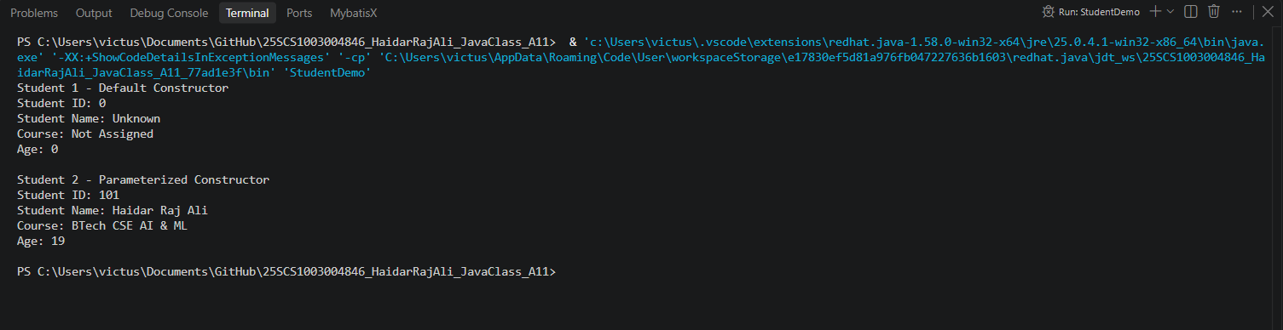StudentDemo.java
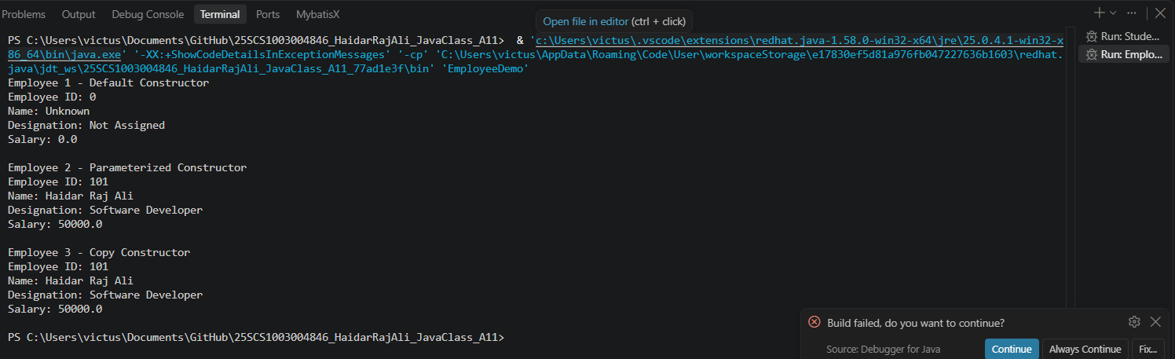EmployeeDemo.java
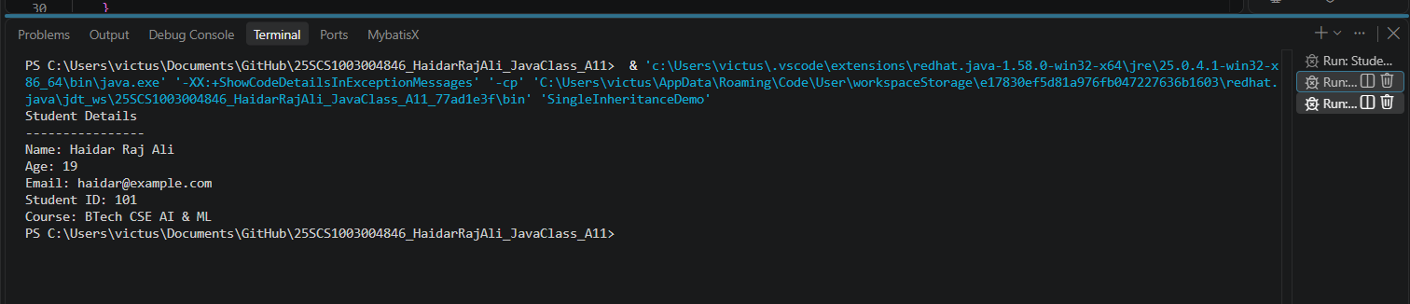SingleInheritanceDemo.java

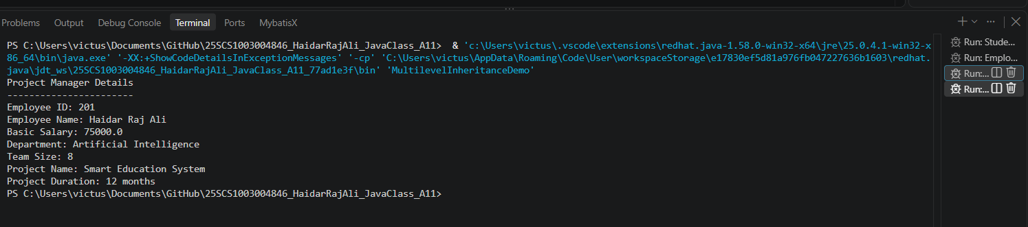MultilevelInheritanceDemo.java

GitHub Repository :-
https://github.com/haidarali13-web/25SCS1003004846_HaidarRajAli_JavaClass_A11

