Experiment 6
Student Name: Ayush Yadav UID: 25IMC13004
Branch: MCA (AI & ML) Section/Group: 25MAM_KAR-1_A
Semester: II Date of Performance: 24/02/26
Subject Name: Technical Training Subject Code: 25CAP-652

Experiment Aim: Learn how to create, query, and manage views in SQL to simplify database queries and provide a layer of abstraction for end-users.
Tools used: Oracle / MS SSMS / PostgreSQL
Objectives:
- Data Abstraction: To understand how to hide complex table joins and calculations behind a simple virtual table interface.
- Enhanced Security: To learn how to restrict user access to sensitive columns by providing views instead of direct table access.
- Query Simplification: To master the creation of views that pre-join multiple tables, making reporting easier for non-technical users.
- View Management: To understand the syntax for creating, altering, and dropping views, as well as the naming conventions required for efficient data access.
Experiment Steps:
CREATE TABLE Departments (
dept_id INTEGER PRIMARY KEY,
dept_name VARCHAR(50)
);
INSERT INTO Departments (dept_id, dept_name) VALUES
(1, 'HR'),
(2, 'IT'),
(3, 'Finance');
CREATE TABLE Employees (
emp_id INTEGER PRIMARY KEY,
emp_name VARCHAR(50),
city VARCHAR(50),
salary INTEGER,
status VARCHAR(20),
dept_id INTEGER REFERENCES Departments(dept_id)
);
INSERT INTO Employees (emp_id, emp_name, city, salary, status, dept_id) VALUES
(101, 'Rahul', 'Delhi', 50000, 'Active', 1),
(102, 'Anita', 'Mumbai', 60000, 'Active', 2),
(103, 'Aman', 'Chandigarh', 45000, 'Inactive', 2),
(104, 'Priya', 'Delhi', 70000, 'Active', 3);
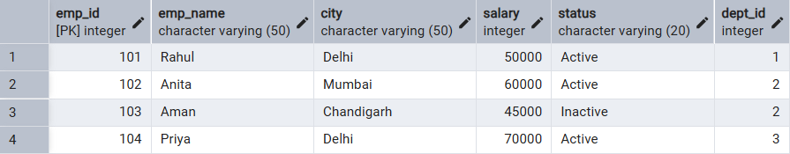
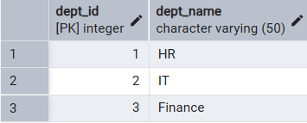

Step 1: Creating a Simple View for Data Filtering
Implementing a view to provide a quick list of active employees without exposing the entire table structure.

CREATE VIEW Active_Employees_View AS
SELECT emp_id, emp_name, city, salary
FROM Employees WHERE status = 'Active';
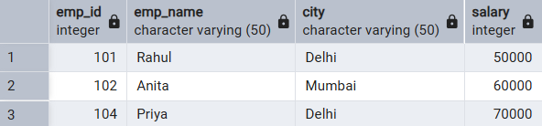

Step 2: Creating a View for Joining Multiple Tables

Simplifying the retrieval of data distributed across Employees and Departments tables.

CREATE OR REPLACE VIEW Employee_Department_View AS
SELECT e.emp_id, e.emp_name, e.city, e.salary, d.dept_name
FROM Employees e JOIN Departments d
ON e.dept_id = d.dept_id;
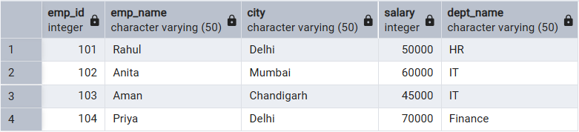

Step 3: Advanced Summarization View
Creating a view to provide department-level statistics automatically.

CREATE VIEW Department_Summary_View AS
SELECT d.dept_name,
COUNT(e.emp_id) AS total_employees,
AVG(e.salary) AS average_salary,
SUM(e.salary) AS total_salary
FROM Employees e JOIN Departments d
ON e.dept_id = d.dept_id GROUP BY d.dept_name;
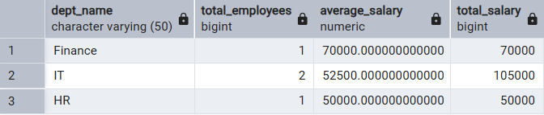

Outcomes:
- Abstraction Proficiency: Students will be able to create and query views to simplify efficient data access and abstraction.
- Security Implementation: Students will understand how to use views for data masking and providing restricted access to sensitive information.
- Syntactic Accuracy: Students will demonstrate the correct syntax for creating and querying views, ensuring logical clarity in naming conventions.
- Real-world Application: Students will be able to design views for practical domains like Library Management Systems or Payroll Systems to demonstrate functionality.

