Experiment 4
Student Name: Ayush Yadav UID: 25IMC13004
Branch: MCA (AI & ML) Section/Group: 25MAM_KAR-1_A
Semester: II Date of Performance: 03/02/26
Subject Name: Technical Training Subject Code: 25CAP-652

Title: Implementation of Iterative Control Structures using FOR, WHILE, and LOOP in PostgreSQL
- Aim:
  - To understand and implement iterative control structures in PostgreSQL conceptually, including FOR loops, WHILE loops, and basic LOOP constructs, for repeated execution of database logic.

- Software Requirements:
  - PostgreSQL (Database Server)
  - pgAdmin
  - OS: Windows

- Objective:
- To understand why iteration is required in database programming
- To learn the purpose and behavior of FOR, WHILE, and LOOP constructs
- To understand how repeated data processing is handled in databases
- To relate loop concepts to real-world batch processing scenarios
- To strengthen conceptual knowledge of procedural SQL used in enterprise systems.

- Procedure of the Practical:
  - Start the system.
  - Open pgAdmin.
  - Create and select the database in which you want to perform the experiment.
  - Establish connection to the database using Alt+Shift+Q.
  - Run the following queries given in Experiment Steps (5).
- Experiment Steps:

Example 1: FOR Loop – Simple Iteration
For Loop (simple iteration):
DO $$
BEGIN
FOR i IN 1..6 LOOP
RAISE NOTICE 'Number: %', i;
END LOOP;
END $$;
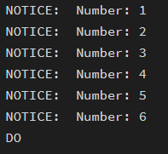

Example 2: FOR Loop with Query (Row-by-Row Processing)
do $$
declare
emp_record record;
begin
for emp_record in
select emp_id, emp_name, salary from employee
loop
raise notice 'Employee: %, Salary: %',
emp_record.emp_name, emp_record.salary;
end loop;
end;
$$;
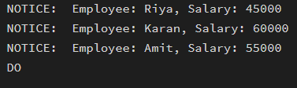

Example 3: WHILE Loop – Conditional Iteration
do $$
declare
v_count int := 0;
begin
while v_count < 3 loop
raise notice 'Validation attempt: %', v_count;
v_count := v_count + 1;
end loop;
end;
$$;
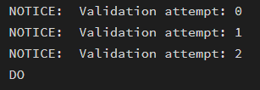

Example 4: LOOP with EXIT WHEN
do $$
declare
v_count int := 0;
begin
loop
raise notice 'Checking schema iteration: %', v_count;
if v_count = 2 then
exit;
end if;
v_count := v_count + 1;
end loop;
end;
$$;
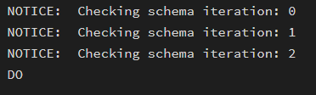

Example 5: Salary Increment Using FOR Loop
do $$
declare
emp_record record;
begin
for emp_record in
select emp_id, salary from employee
loop
update employee
set salary = salary + 2000
where emp_id = emp_record.emp_id;
end loop;
end;
$$;

Before:
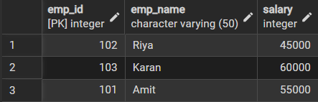
After:
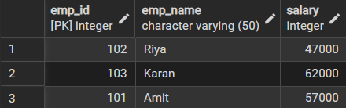

Example 6: Combining LOOP with IF Condition
do $$
declare
order_rec record;
begin
for order_rec in
select customer_name, price from orders
loop
if order_rec.price > 50000 then
raise notice 'High value order by %', order_rec.customer_name;
else
raise notice 'Normal order by %', order_rec.customer_name;
end if;
end loop;
end;
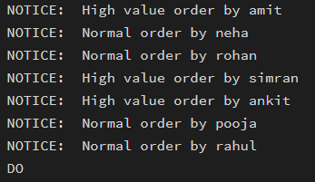
$$;
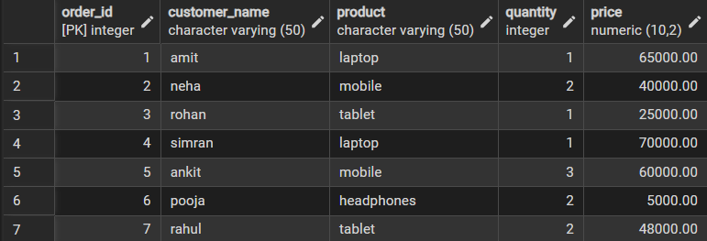

- Learning Outcome
  - Understanding of how iterative control structures work in PostgreSQL at a conceptual level.
  - Usage of loops in database systems, such as workflow engines, complex decision cycles, validation loops, etc.
  - Foundational knowledge required for writing procedural logic in enterprise-grade applications.

