Worksheet 10

Student Name: Ayush Yadav UID: 25IMC13004
Branch: MCA (AI & ML) Section/Group: 25MAM 1 A
Semester: 2 Date of Performance: 21-04-2026
Subject Name: Technical Training -I Subject Code: 25CAP-652

Experiment Aim:

To implement Transaction Control Language (TCL) commands in PostgreSQL using COMMIT, ROLLBACK, and SAVEPOINT for maintaining data consistency and controlling transactions.

Tools used: PostgreSQL

Objectives:

- Transaction Management: To understand the use of TCL commands in PostgreSQL.
- Rollback Operations: To revert unwanted changes using ROLLBACK.
- Savepoint Usage: To create checkpoints within transactions using SAVEPOINT.
- Data Integrity: To maintain consistency during multiple database operations.

Theory:

Transaction Control Language (TCL) commands are used to manage transactions in a database. A transaction is a sequence of SQL operations performed as a single logical unit. PostgreSQL supports TCL commands such as COMMIT, ROLLBACK, and SAVEPOINT to ensure reliability, consistency, and recovery in case of errors.

Experiment Steps:

Step 1: Creating Table

Query:
CREATE TABLE Payroll ( emp_id INT PRIMARY KEY, emp_name VARCHAR(50),
salary DECIMAL(10,2) CHECK(SALARY > 0)
);

Step 2: Inserting Sample Data

Query:
INSERT INTO Payroll VALUES (1, 'Amit', 30000),
(2, 'Neha', 40000),
(3, 'Ravi', 50000);

SELECT * FROM Payroll;

Output:
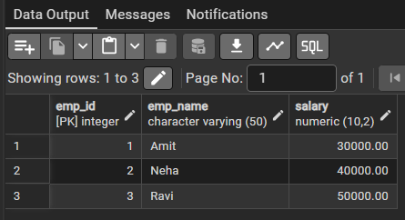

Step 3: Using ROLLBACK

Query:
-- using rollback begin;

UPDATE Payroll SET salary = -1000 WHERE emp_id = 3;

ROLLBACK;

UPDATE Payroll SET salary = 1000 WHERE emp_id = 3;

SELECT * FROM Payroll

Output:
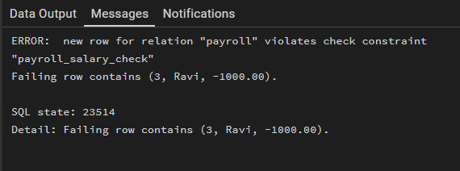
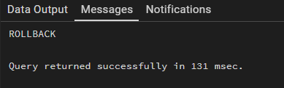

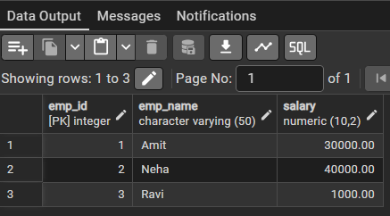

Step 4: Using SAVEPOINT

Query:

BEGIN;

UPDATE Payroll
SET salary = salary + 5000 WHERE emp_id = 1;

SAVEPOINT sp1;

UPDATE Payroll
SET salary = salary + 7000

WHERE emp_id = 2;

UPDATE Payroll SET salary = -1000 WHERE emp_id = 3;

ROLLBACK TO sp1;
SELECT * FROM Payroll; COMMIT;

Output:
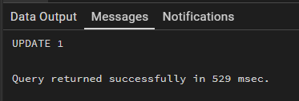
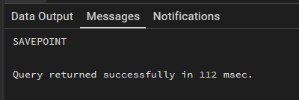

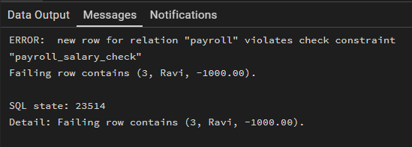
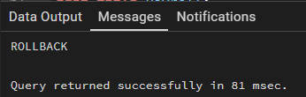
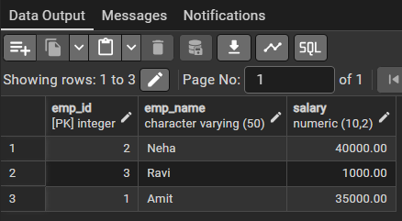

Outcomes:
- Students will be able to use TCL commands in PostgreSQL.
- Students will understand transaction rollback mechanisms.
- Students will learn to use SAVEPOINT for partial rollback.
- Students will maintain data consistency during transactions.

