Experiment 8
Student Name: Ayush Yadav UID: 25IMC13004
Branch: MCA (AI & ML) Section/Group: 25MAM_KAR-1_A
Semester: II Date of Performance: 24/02/26
Subject Name: Technical Training Subject Code: 25CAP-652

Experiment Aim: To apply the concept of Stored Procedures in database operations in order to perform tasks like insertion, updating, deletion, and retrieval of data efficiently, securely, and in a reusable manner within the database system.

Objectives: Apply stored procedure concepts for database operations.

Experiment Steps:
- Created Employees Table:
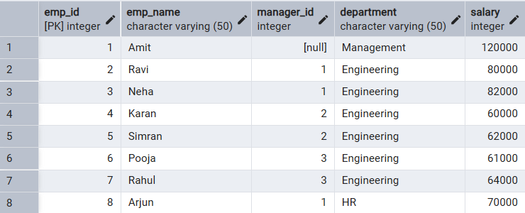
- Inserted Stored procedure:
CREATE OR REPLACE PROCEDURE add_employee(
p_id INT,
p_name VARCHAR,
p_manager INT,
p_dept VARCHAR,
p_salary INT
)
LANGUAGE plpgsql
AS $$
BEGIN
INSERT INTO Employees VALUES (p_id, p_name, p_manager, p_dept, p_salary);
END;
$$;
Call:
CALL add_employee(9, 'Ankit', 2, 'Engineering', 65000);

- Update stored procedure:
create or replace Procedure UPDATE_SALARY_PROCC(IN P_EMP_ID int, INOUT P_SALARY numeric(20,3) , OUT STATUS
varchar(20))
AS
$$
DECLARE
CURR_SAL NUMERIC(20,3);
BEGIN
SELECT SALARY+P_SALARY INTO CURR_SAL FROM employees WHERE EMP_ID = P_EMP_ID;
IF NOT FOUND THEN
RAISE EXCEPTION 'EMPLOYEE NOT FOUND';
END IF ;
UPDATE employees
SET SALARY = CURR_SAL WHERE EMP_ID = P_EMP_ID;
P_SALARY:= CURR_SAL;
STATUS :='SUCCESS';
EXCEPTION
WHEN OTHERS THEN
IF SQLERRM LIKE '%EMPLOYEE NOT FOUND%' THEN
STATUS:='EMPLOYEE NOT FOUND';
END IF;
END;
$$ LANGUAGE PLPGSQL ;
Call:
DO
$$
DECLARE
EMP_ID INT :=3;
STATUS VARCHAR(20);
SALARY NUMERIC(20,3):=525;
BEGIN
CALL UPDATE_SALARY_PROCC(EMP_ID ,SALARY , STATUS);
RAISE NOTICE 'YOUR STATUS IS % AND THE UPDATED SALARY IS %',STATUS , SALARY;
END;
$$

- Delete stored procedure:
CREATE OR REPLACE PROCEDURE delete_employee(
p_id INT
)
LANGUAGE plpgsql
AS $$
BEGIN
DELETE FROM Employees
WHERE emp_id = p_id;
END;
$$;
Call:
CALL delete_employee(5);

Outcomes:
- Learned how to create and call stored procedures for insert, update, and delete operations.
- Practiced using IN, OUT, and INOUT parameters in PL/pgSQL.
- Gained experience with error handling using exceptions.
- Improved efficiency and reusability of database operations.
- Connected stored procedures with SQL joins for data retrieval and analysis.

