Worksheet 1

Student Name: Ayush Yadav UID: 25IMC13004
Branch:MCA (AI&ML) Section/Group:1/A
Semester:2nd Date of Performance:13/01/2026
Subject Name:- DBMS LAB Subject Code:

1. Aim of the Session

To design and implement a sample database system using DDL, DML, and DCL commands for managing departments, employees, and projects, and to apply role-based access control for secure data handling.

2. Software Requirements
- PostgreSQL (Database Server)
- pgAdmin
- Windows Operating System

3. Objective of the Session

After completing this practical, the student will be able to:
- Understand the use of DDL commands to create and modify database structures.
- Perform DML operations such as INSERT, UPDATE, DELETE, and SELECT.
- Implement relationships using primary and foreign keys.
- Apply DCL commands to manage roles and privileges.
- Analyze input and output of SQL queries in a real database environment.

4. Practical / Experiment Steps

Design the database schema for Department, Employee, and Project tables.

Create tables using appropriate constraints.

Insert sample records into tables.

Perform update and delete operations.

Retrieve data using SELECT queries.

Create a role and grant/revoke privileges.

Alter and drop database objects.

5. Procedure of the Practical

(i) Start the system and log in to the computer.

(ii) Open PostgreSQL software.

(iii) create database CompanyDB;

(iv) Create tables using DDL commands.

(i) create table Department

create table Department(

Dept_id int primary key,

Dept_name varchar(20) not null unique

);

(ii) create table Employee

create table Employee(

Emp_id int primary key ,

Emp_name varchar(20)not null,

Emp_email varchar(20) unique not null,

Emp_phone varchar(20) unique not null,

Dept_id int ,

foreign key (Dept_id)references Department(Dept_id)

);

(iii) create table Project

create table Project(

Proj_id integer primary key,

Proj_name varchar(20) not null,

Proj_startDate varchar(20) not null,

Proj_EndDate varchar(20) not null,

Proj_Assign_Emp int,

foreign key (Proj_Assign_Emp) references Employee(Emp_id)

);

(iv) Insert records using DML commands.

insert into Department values

insert into Department (Dept_id,Dept_name)

values

(1, 'Human Resources'),

(2, 'Engineering'),

(3, 'Marketing'),

(4, 'Finance');

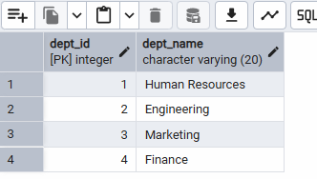

(v) insert into Employee values

insert into Employee (Emp_id,Emp_name,Emp_email,Emp_phone,Dept_id)

values

(101, 'Amit Sharma', 'amit@gmail.com', '9876543210', 2),

(102, 'Neha Verma', 'neha@gmail.com', '9123456780', 2),

(103, 'Rohit Singh', 'rohit@gmail.com', '9988776655', 1),

(104, 'Priya Mehta', 'priya@gmail.com', '9090909090', 3),

(105, 'Ram Sen', 'Ram@gmail.com', '555555555', 4);

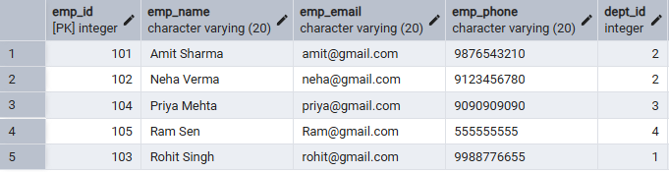

(vi) insert into Project values

insert into Project(Proj_id, Proj_name, Proj_startDate, Proj_EndDate, Proj_Assign_Emp)

values

(1, 'AI Chatbot', '2026-01-01', '2026-06-30', 101),

(2, 'E-Commerce App', '2026-02-01', '2026-07-31', 102),

(3, 'HR Portal', '2026-03-15', '2026-05-30', 103),

(4, 'Marketing Website', '2026-01-20', '2026-04-20', 104),

(5, 'Finance Website', '2025-01-20', '2026-04-20', 105);

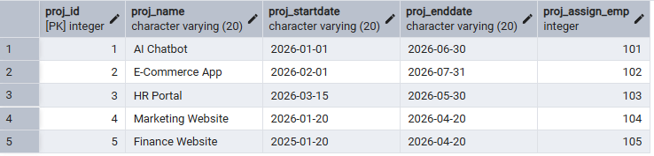

(vii) Update and delete records.

update Employee set Dept_id=4 where Emp_id=103;

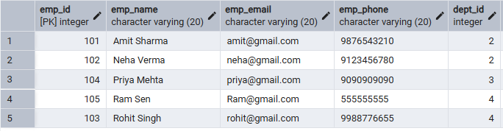

delete Employee Data Emp=105

-- But the problem is, I was assigned project to employee .First, i need to delete or update project .Then I will delete employee

delete from Project where Proj_Assign_Emp=105;

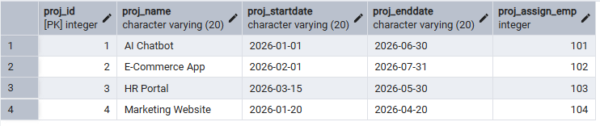

delete from Employee where Emp_id=105;

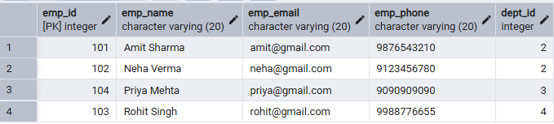

(viii) Create role and assign privileges.

create role CEO login password 'CEO';

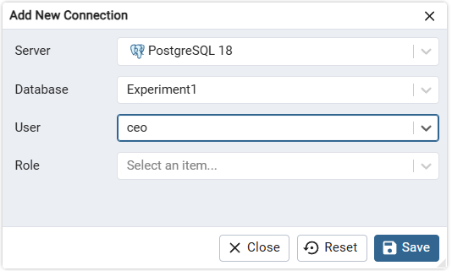

grant select on Employee, Department, Project to CEO;

revoke select on Department from CEO;

(ix) Alter and drop table.

alter table Employee add Address varchar(30);

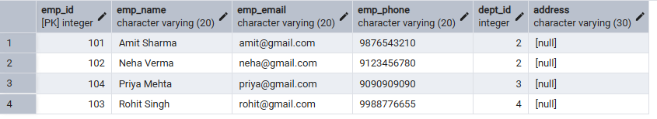

(x) drop table Project;

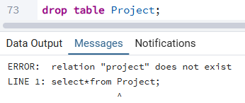

6. I/O Analysis (Input / Output)

Input:

• Department, Employee, and Project table creation queries
• Records inserted into all tables using INSERT commands
• Update query to modify employee department
• Delete queries to remove project and employee records
• Role creation and privilege assignment queries
• ALTER and DROP table commands

Output:

• Department, Employee, and Project tables created successfully
• Records inserted, updated, and deleted correctly
• Referential integrity maintained between tables
• Data displayed correctly using SELECT queries
• Role-based access verified using GRANT and REVOKE
• Table structure modified and project table dropped successfully

Screenshots of execution and obtained results are attached.

7.Learning Outcomes
- Understood the basics of relational database design using tables, keys, and relationships.
- Learned to apply primary and foreign key constraints to maintain data integrity.
- Gained hands-on experience with INSERT, UPDATE, and DELETE operations.
- Understood role-based access control using GRANT and REVOKE.
- Learned how to create read-only users for secure data access.
- Practiced ALTER TABLE and DROP TABLE commands for schema management.

